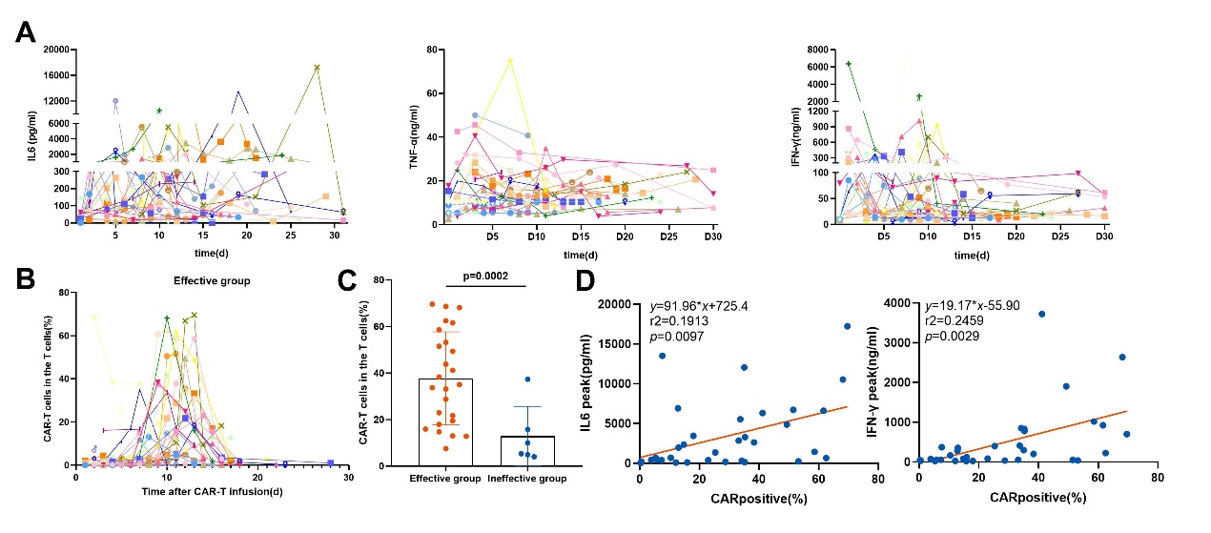
Fig. Kinetics of cytokines and pharmacokinetics of CLL1 CAR-T cells
(A) Cytokine levels in the peripheral blood of each patient at different time points. (B) Kinetics of CAR-T cells in the peripheral blood of individual patients, as measured by flow cytometry; data were recorded until the cut-off data or the point at which follow-up was discontinued; different symbols represent different patients. (C) A comparison of peak CAR-T cell numbers in the peripheral blood between responding and non-responding patients. (D) The association between peak CAR-T cell numbers and peak serum biomarkers values for IL-6 AND IFN-γ.

