SUPPLEMENTARY DATA
Figure S1 (A) Kinase assay showing time-dependent inhibition of ABL1 activity by UVI5008 (5 μM). (B) Western blot of ABL1-BCR downstream signaling in K562 cells treated with UVI5008 or imatinib (5 μM) for 2, 8, and 24 h. (C) Western blot of BCL-XL expression after treatment as in (B). (D) CASPASE-3/7/8/9 activity after UVI5008 treatment (5 μM, 24 h). (E) Cell cycle assessment in K562 cell lines upon treatment with UVI5008 (5 μM) at 2, 8, 24, and 48 h. Histogram shows cell cycle phase distribution.
Figure S2 (A) Experimental pose of ibrutinib inside the BTK binding site (PDBid:5P9J). The green line indicates p–p interactions, purple arrows H-bonds, and the black line a covalent bond. (B) CETSA analysis of BTK. The stability of the binding was assessed at different temperatures: 4, 25, 37, 44, 53, 59, 67, 75, 80, and 85°C at 5 μM, and 4, 25, 37, 44, 53, 59, 67, and 70°C at 0.5 μM and 1 μM. (C) Venn diagram of upregulated genes (fold change ≥ 2, p < 0.05) shared across Mec-1, Mino, and Granta-519 cells (n = 5591); GO enrichment of the top 15 biological pathways (right) .D) Venn diagram of downregulated genes (fold change ≤ −2, p < 0.05) shared across cell lines (n = 2443); GO enrichment of the top 10 pathways (right).
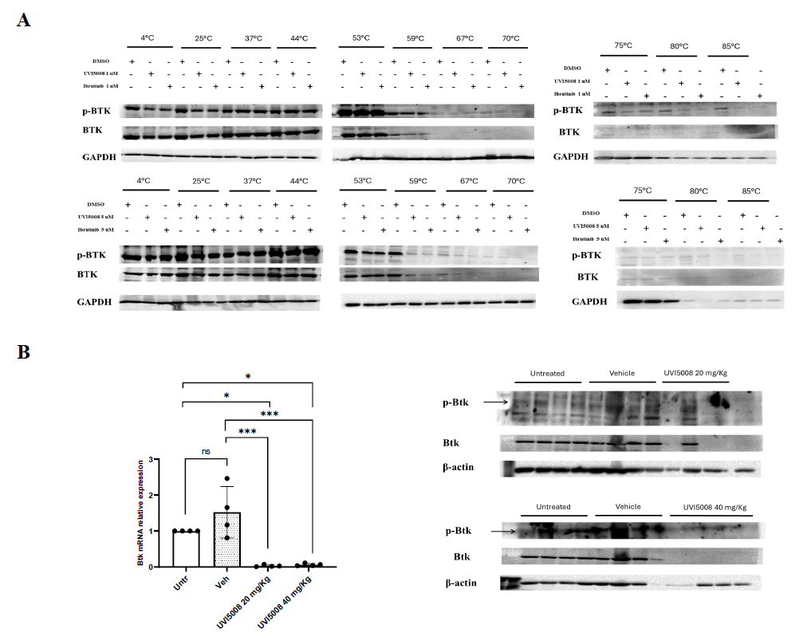
Figure S3 (A) CETSA analysis of BTK and phosphorylated BTK (p-BTK) target engagement in Mec-1 cells. Cells were treated with UVI5008 or Ibrutinib at concentrations of 1 and 5 μM and subjected to a temperature gradient (4°, 25°, 37°, 44°, 53°, 59°, 67°, 70°, 75°, 80°, and 85°C). Protein stability of total BTK and p-BTK was assessed by immunoblotting. B) In vivo modulation of BTK signaling by UVI5008. Total BTK and phosphorylated BTK (p-BTK) protein levels were analyzed in mice treated with UVI5008 at doses of 20 mg/kg and 40 mg/kg by immunoblotting. In parallel, BTK mRNA expression was evaluated by quantitative real-time PCR (RT-qPCR) as an additional control.
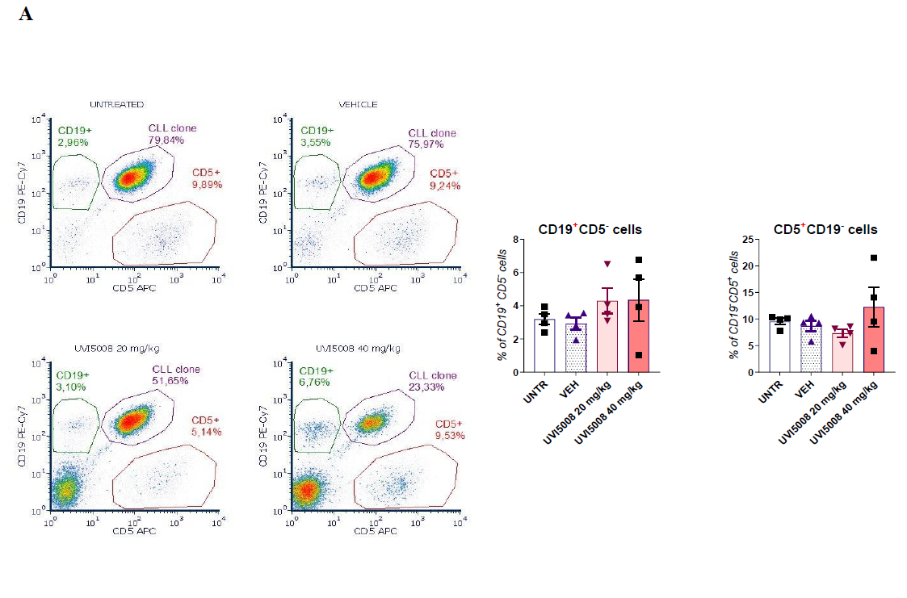
Figure S4 (A) Representative flow cytometry dot plots of splenocytes isolated from mice receiving the indicated treatments, stained for CD19 and CD5 (left) Percentage of CD19+ CD5- cells (left) and CD5+CD19- cells (right) measured in the spleen of mice.

