Supplemental Online Content
Key exclusion criteria 2
Supplemental Figure 1. Study design 3
Supplemental Figure 2. Platelet responses (defined as platelet counts ≥50 × 10⁹/L) at Week 10 across prespecified subgroups. 4
Supplemental Figure 3. Proportion of patients with a sustained platelet response (platelet count ≥50 × 10⁹/L maintained for ≥6 weeks without rescue therapy) between Weeks 5 and 12 across prespecified subgroups. 5
Supplemental Figure 4. Platelet counts at each scheduled visit during the 12-week double-blind placebo-controlled treatment period and the 12-week open-label extension 6
Supplemental Table 1. Study sites and principal investigators. 7
Supplemental Table 2. Dose adjustment algorithm for hetrombopag/placebo during the double-blind placebo-controlled treatment period and for hetrombopag during the open-label period 8
Supplemental Table 3. Proportion of responders at each weekly visit from Weeks 3 to 12 during the double-blind placebo-controlled treatment period 9
Supplemental Table 4. Durability of platelet responses during the 24-week hetrombopag treatment period 10
Supplemental Table 5. Adverse events leading to dose reduction or interruption during the 12-week double-blind, placebo-controlled treatment period and the entire 24-week treatment period. 11
Supplemental Table 6. Grade ≥3 adverse events during the 12-week double-blind, placebo-controlled treatment period and the entire 24-week treatment period 12
Supplemental Table 7. Treatment-related adverse events during the 12-week double-blind, placebo-controlled treatment period and the entire 24-week treatment period 13
Supplemental Table 8. Serious adverse events during the 12-week double-blind, placebo-controlled treatment period and the entire 24-week treatment period 15

Key exclusion criteria
Key exclusion criteria included secondary thrombocytopenia from causes including, but not limited to, myelodysplastic syndrome, acute leukemia, early aplastic anemia, Fanconi syndrome, von Willebrand disease, antiphospholipid syndrome, thrombotic thrombocytopenic purpura, or systemic lupus erythematosus. Patients were also excluded for Evans syndrome, hereditary thrombocytopenia (e.g., Wiskott–Aldrich syndrome), bone marrow biopsy showing myelofibrosis or another primary cause of thrombocytopenia, or documented non-response to prior TPO-RAs (eltrombopag, romiplostim, avatrombopag). Additional exclusions included prior TPO-RA use within 30 days, rituximab use within 3 months, or a history of arterial or venous thrombosis (e.g., transient ischemic attack, myocardial infarction, deep vein thrombosis, pulmonary embolism). Laboratory exclusion criteria included ALT, AST, or ALP levels >1.5× the upper limit of normal (ULN), or total bilirubin or serum creatinine levels >1.2× ULN.

Supplemental Figure 1. Study design
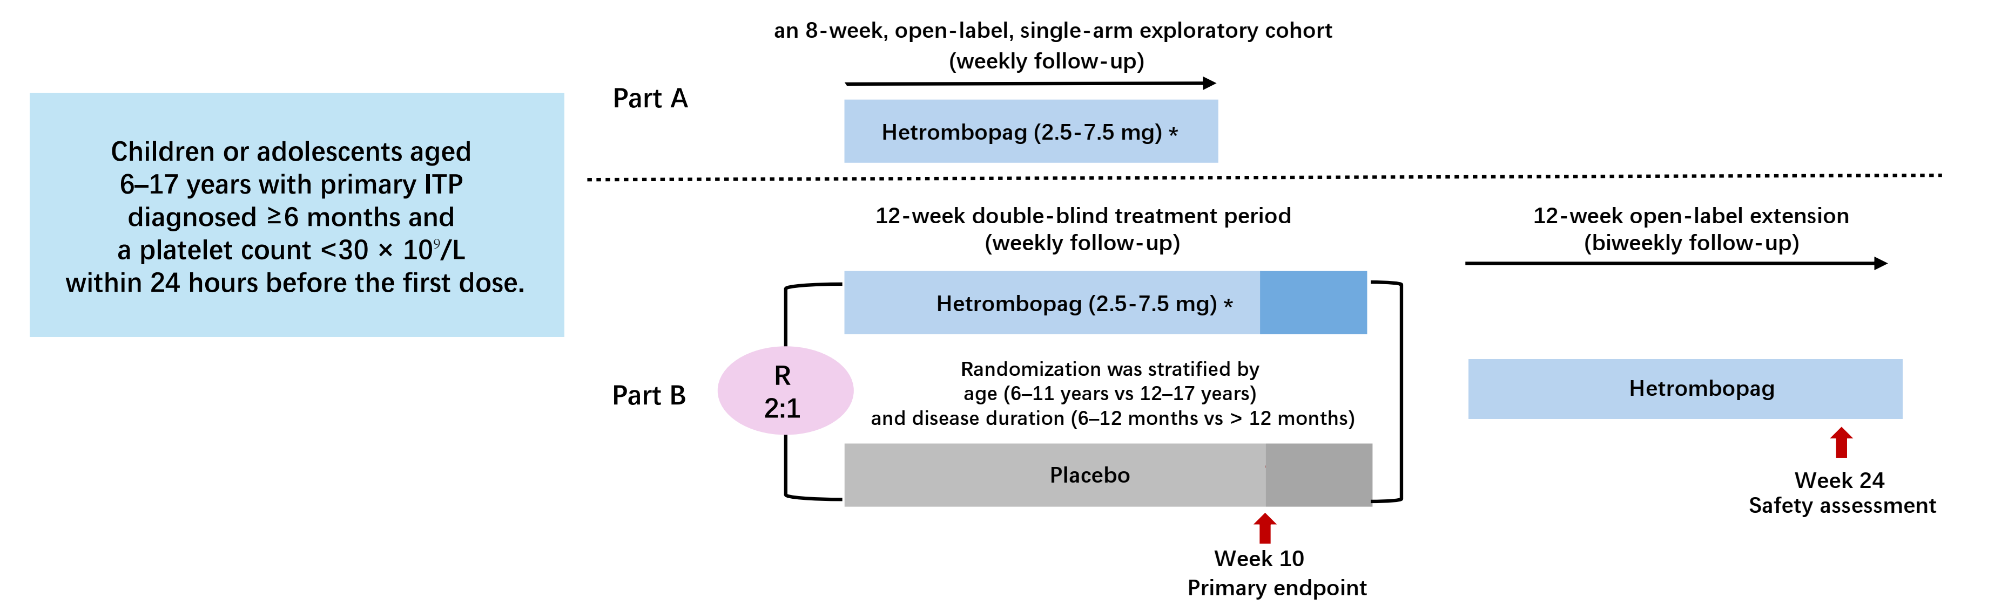
R, randomization.
* Hetrombopag (or placebo) was initiated at 2.5 mg once daily and could be titrated as needed, up to a maximum of 7.5 mg once daily, to maintain platelet counts between 50 × 10⁹/L and 250 × 10⁹/L.

Supplemental Figure 2. Platelet responses (defined as platelet counts ≥50 × 10⁹/L) at Week 10 across prespecified subgroups.
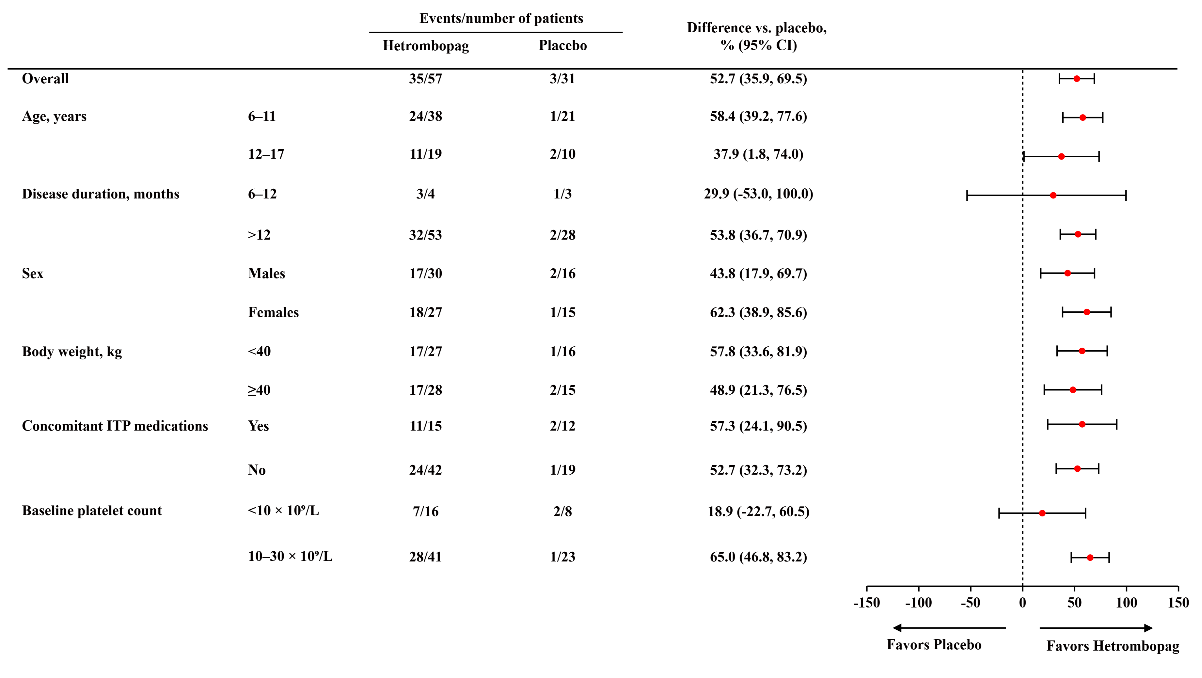
ITP, immune thrombocytopenia; CI, confidence interval.

Supplemental Figure 3. Proportion of patients with a sustained platelet response (platelet count ≥50 × 10⁹/L maintained for ≥6 weeks without rescue therapy) between Weeks 5 and 12 across prespecified subgroups.
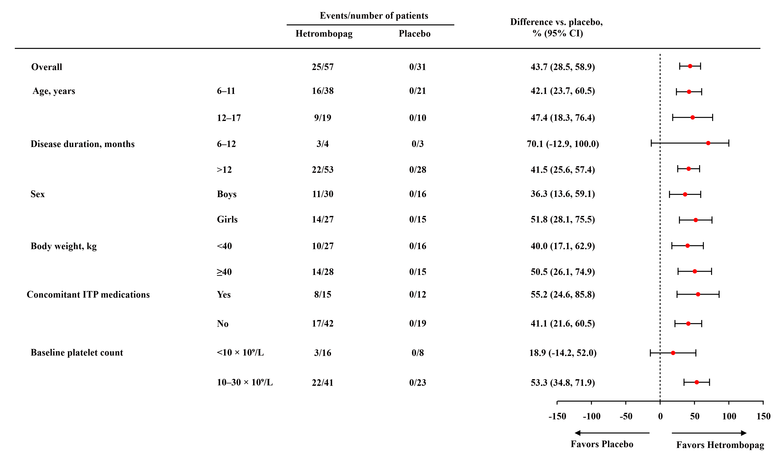
ITP, immune thrombocytopenia; CI, confidence interval.

Supplemental Figure 4. Platelet counts at each scheduled visit during the 12-week double-blind placebo-controlled treatment period and the 12-week open-label extension
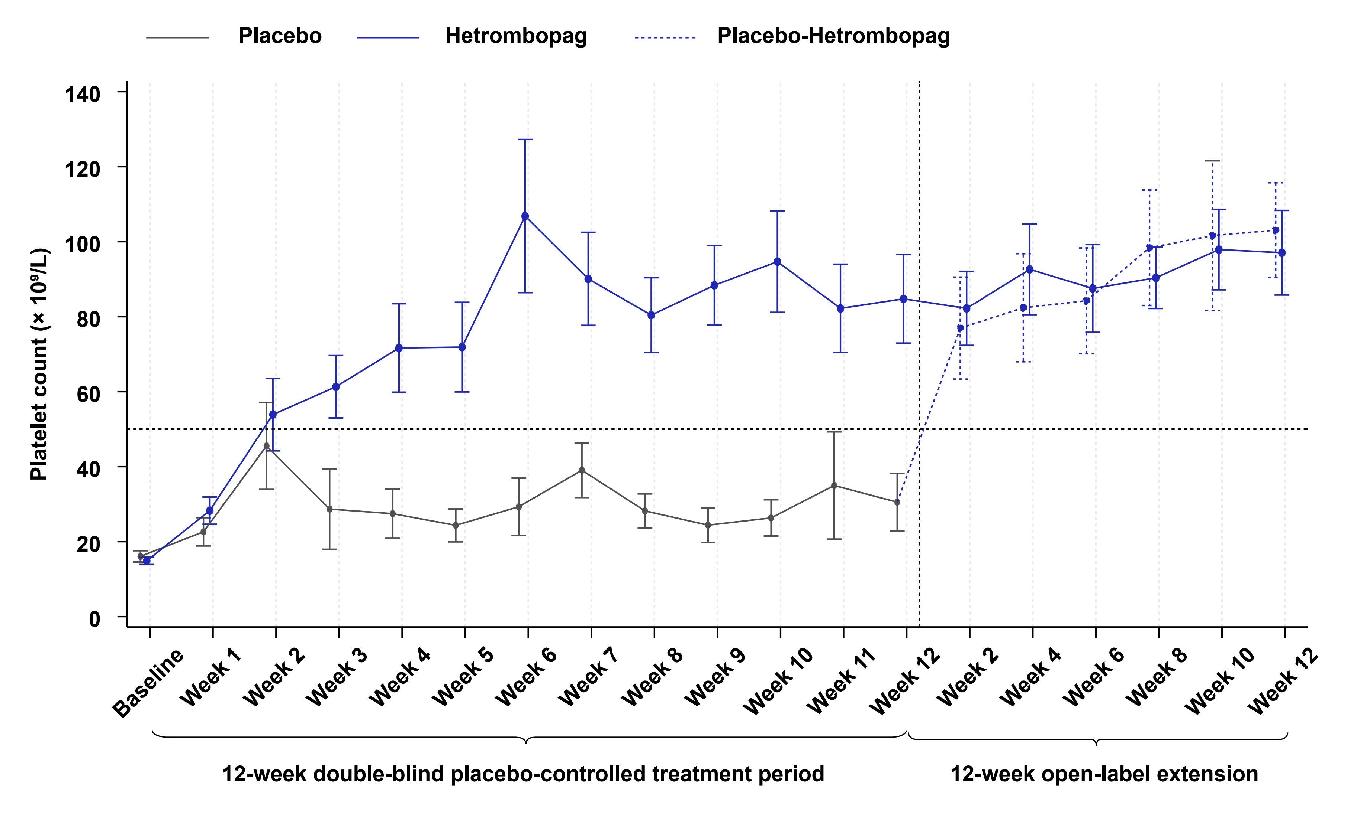
Data are presented as mean ± standard error (SE).

Supplemental Table 1. Study sites and principal investigators.
Study site | Principal investigator | Patients enrolled
Beijing Children’s Hospital, Capital Medical University | Tianyou Wang | 7
Children’s Hospital of Fudan University | Xiaowen Zhai | 6
Guangzhou Women and Children’s Medical Center, Guangzhou Medical University | Wenge Hao | 5
West China Second University Hospital, Sichuan University | Ju Gao | 11
Children’s Hospital of Chongqing Medical University | Jie Yu | 8
The First Affiliated Hospital of Zhengzhou University | Yufeng Liu | 10
Institute of Hematology & Blood Diseases Hospital, Chinese Academy of Medical Sciences & Peking Union Medical College | Yumei Chen | 3
Union Hospital, Tongji Medical College, Huazhong University of Science and Technology | Heng Mei | 3
The First Affiliated Hospital, Jiangxi Medical College, Nanchang University | Fei Li | 3
Children’s Hospital of Soochow University | Shaoyan Hu | 8
Shanghai Children’s Hospital | Hui Jiang | 6
Henan Children’s Hospital | Wei Liu | 2
Chengdu Women’s and Children’s Central Hospital | Min Zhou | 6
Women and Children’s Hospital, Qingdao University | Hui Liang | 8
The First Affiliated Hospital of Xinjiang Medical University | Mei Yan | 2

Supplemental Table 2. Dose adjustment algorithm for hetrombopag/placebo during the double-blind placebo-controlled treatment period and for hetrombopag during the open-label period
Study period | Current dose | Platelet count | Dose adjustment
Weeks 0–2  (double-blind placebo-controlled treatment period) | 2.5 mg once daily | < 50 × 10⁹/L | Maintain dose; increase only if necessary
 |  | 50–150 × 10⁹/L | Continue 2.5 mg once daily
 |  | 150–250 × 10⁹/L | Reduce to 2.5 mg every other day
 |  | ≥ 250 × 10⁹/L | Interrupt treatment; resume at 2.5 mg every other day once platelet count decreases to ≤ 100 × 10⁹/L
Weeks 3–12  (double-blind placebo-controlled treatment period)  Weeks 1–12  (Extension period) | 2.5 mg once daily | < 50 × 10⁹/L | Increase to 3.75 mg once daily
 |  | 50–150 × 10⁹/L | Continue 2.5 mg once daily
 |  | 150–250 × 10⁹/L | Reduce to 2.5 mg every other day
 |  | ≥ 250 × 10⁹/L | Interrupt treatment; resume at 2.5 mg every other day once platelet count decreases to ≤ 100 × 10⁹/L
 | 3.75 mg once daily | < 50 × 10⁹/L | Increase to 5 mg once daily
 |  | 50–150 × 10⁹/L | Continue 3.75 mg once daily
 |  | 150–250 × 10⁹/L | Reduce to 2.5 mg once daily
 |  | ≥ 250 × 10⁹/L | Interrupt treatment; resume at 2.5 mg once daily once platelet count decreases to ≤ 100 × 10⁹/L
 | 5 mg once daily | < 50 × 10⁹/L | Increase to 7.5 mg once daily
 |  | 50–150 × 10⁹/L | Continue 5 mg once daily
 |  | 150–250 × 10⁹/L | Reduce to 3.75 mg once daily
 |  | ≥ 250 × 10⁹/L | Interrupt treatment; resume at 3.75 mg once daily once platelet count decreases to ≤ 100 × 10⁹/L
 | 7.5 mg once daily | < 50 × 10⁹/L | Maintain 7.5 mg once daily
 |  | 50–150 × 10⁹/L | Continue 7.5 mg once daily
 |  | 150–250 × 10⁹/L | Reduce to 5 mg once daily
 |  | ≥ 250 × 10⁹/L | Interrupt treatment; resume at 5 mg once daily once platelet count decreases to ≤ 100 × 10⁹/L
Note: During the double-blind placebo-controlled treatment period, platelet counts were assessed weekly at scheduled visits. Additional assessments were performed on Day 5 and Day 10 (±1 day), and results from certified local (non-study site) laboratories were accepted for dose adjustment decisions. Based on platelet trends and safety considerations, more frequent monitoring could be implemented if necessary. While dose modifications generally followed the above algorithm, investigators were allowed to temporarily withhold or accelerate adjustments based on individual platelet responses and safety profiles.

Supplemental Table 3. Proportion of responders at each weekly visit from Weeks 3 to 12 during the double-blind placebo-controlled treatment period
Endpoints | Hetrombopag (n = 57) | Placebo (n = 31) | Difference vs placebo  % (95% CI) ᵃ | OR (95% CI); P value ^{b}
Responders at Week 3, n (%) | 26 (45.6) | 4 (12.9) | 32.1 (14.1–50.2) | 6.6 (2.2–19.9); 0.0008
Responders at Week 4, n (%) | 26 (45.6) | 4 (12.9) | 32.8 (13.8–51.7) | 6.2 (1.9–20.3); 0.0025
Responders at Week 5, n (%) | 25 (43.9) | 2 (6.5) | 36.7 (20.4–53.0) | 13.3 (2.8–62.9); 0.0011
Responders at Week 6, n (%) | 38 (66.7) | 4 (12.9) | 53.3 (35.2–71.5) | 16.5 (4.9–55.2); <0.0001
Responders at Week 7, n (%) | 35 (61.4) | 8 (25.8) | 35.8 (15.0–56.6) | 5.4 (1.9–15.0); 0.0014
Responders at Week 8, n (%) | 36 (63.2) | 6 (19.4) | 44.1 (24.7–63.4) | 8.6 (2.9–25.1); <0.0001
Responders at Week 9, n (%) | 37 (64.9) | 3 (9.7) | 55.4 (38.3–72.4) | 21.2 (5.9–75.9); <0.0001
Responders at Week 10, n (%) | 38 (66.7) | 4 (12.9) | 54.4 (36.7–72.1) | 16.5 (4.7–58.6); <0.0001
Responders at Week 11, n (%) | 38 (66.7) | 4 (12.9) | 54.4 (36.7–72.1) | 16.5 (4.9–55.9); <0.0001
Responders at Week 12, n (%) | 35 (61.4) | 7 (22.6) | 38.5 (18.5–58.5) | 6.5 (2.3–17.9); 0.0003
A treatment response was defined as a platelet count ≥50 × 10⁹/L.
ª Other binary efficacy endpoints during the core treatment period were analyzed using Mehrotra and Railkar’s minimum-risk (MR) method, adjusting for the randomization stratification factor (age group: 6–11 vs 12–17 years). Missing data were handled using non-responder imputation (NRI).
^{b} Generalized estimating equations (GEE) were used to estimate model parameters. An unstructured (UN) covariance matrix was selected; if model convergence failed, a compound symmetry (CS) structure was applied. Fixed effects included treatment group, baseline platelet count, stratification factor (age group: 6–11 vs 12–17 years), scheduled visit, and the treatment group × visit interaction. Patients were treated as a random effect.
OR, odds ratio; CI, confidence interval.

Supplemental Table 4. Durability of platelet responses during the 24-week hetrombopag treatment period
Endpoints | Hetrombopag  (n = 57)
Patients with response in ≥75% of assessments, n (%) | 15 (26.3)
95% CI ª | (15.5, 39.7)
Maximum continuous duration of response
No. of patients ᵇ | 52
Median duration (range), days | 44.5 (8.0-160.0)
Total duration of response
No. of patients ᵇ | 52
Median duration (range), days | 85.0 (8.0-160.0)
ª 95% CI was calculated using the Clopper-Pearson method.
^{b} Number of patients who achieved a platelet count response (≥50 × 10⁹/L) at consecutive scheduled visits.

Supplemental Table 5. Adverse events leading to dose reduction or interruption during the 12-week double-blind, placebo-controlled treatment period and the entire 24-week treatment period.
AEs, n (%) | Placebo-controlled period (Weeks 0-12) |  | Entire treatment period (Weeks 0-24)
AEs, n (%) | Hetrombopag  (n = 57) | Placebo  (n = 31) | Hetrombopag  (n = 57) | Placebo-Hetrombopag  (n = 31)
AEs leading to dose reduction or interruption | 6 (10.5) | 0 | 9 (15.8) | 1 (3.2)
Platelet count increased | 5 (8.8) | 0 | 6 (10.5) | 1 (3.2)
Gastroenteritis | 1 (1.8) | 0 | 1 (1.8) | 0
Partial seizures | 0 | 0 | 1 (1.8) | 0
Eczema | 0 | 0 | 1 (1.8) | 0
Treament-related AEs to dose reduction or interruption | 5 (8.8) | 0 | 7 (12.3) | 1 (3.2)
Platelet count increased | 4(7.0) | 0 | 5(8.8) | 1(3.2)
Gastroenteritis | 1(1.8) | 0 | 1(1.8) | 0
Eczema | 0 | 0 | 1(1.8) | 0
AE, adverse event.

Supplemental Table 6. Grade ≥3 adverse events during the 12-week double-blind, placebo-controlled treatment period and the entire 24-week treatment period
AEs, n (%) | Placebo-controlled period (Weeks 0-12) |  | Entire treatment period (Weeks 0-24)
AEs, n (%) | Hetrombopag  (n = 57) | Placebo  (n = 31) | Hetrombopag  (n = 57) | Placebo-Hetrombopag  (n = 31)
Any grade ≥ 3 AE | 7 (12.3) | 7 (22.6) | 12 (21.1) | 7 (22.6)
Immune thrombocytopenia# | 3 (5.3) | 6 (19.4) | 6 (10.5) | 6 (19.4)
Pneumonia | 2 (3.5) | 0 | 2 (3.5) | 0
Anaemia | 0 | 1 (3.2) | 0 | 1 (3.2)
Haemorrhage intracranial | 1 (1.8) | 0 | 1 (1.8) | 0
Brain oedema | 1 (1.8) | 0 | 1 (1.8) | 0
Febrile convulsion | 1 (1.8) | 0 | 1 (1.8) | 0
Hypertriglyceridaemia | 1 (1.8) | 0 | 1 (1.8) | 0
Upper respiratory tract infection | 0 | 0 | 2 (3.5) | 0
Epstein-Barr virus infection | 0 | 0 | 1 (1.8) | 0
Systemic lupus erythematosus | 0 | 0 | 1 (1.8) | 0
Subcutaneous haematoma | 0 | 1 (3.2) | 0 | 0
Adenoidal hypertrophy | 0 | 0 | 1 (1.8) | 0
Subcutaneous haematoma | 0 | 0 | 0 | 1 (3.2)
Any grade ≥ 3 treatment related AE | 0 | 1 (3.2) | 0 | 1 (3.2)
Anaemia | 0 | 1 (3.2) | 0 | 1 (3.2)
AE, adverse event.
# This preferred term, ‘immune thrombocytopenia,’ denotes an exacerbation of ITP compared with baseline, characterized by more severe bleeding manifestations and worsening clinical presentation.

Supplemental Table 7. Treatment-related adverse events during the 12-week double-blind, placebo-controlled treatment period and the entire 24-week treatment period
 | Placebo-controlled period (Weeks 0-12) |  | Entire treatment period (Weeks 0-24)
AEs, n (%) | Hetrombopag  (n = 57) | Placebo  (n = 31) | Hetrombopag  (n = 57) | Placebo-Hetrombopag  (n = 31)
Any treatment-related AE | 15 (26.3) | 7 (22.6) | 22 (38.6) | 12 (38.7)
Grade ≥3 treatment-related AE | 0 | 1 (3.2) | 0 | 1 (3.2)
Treatment-related SAEs | 0 | 0 | 0 | 0
Treatment-related AEs leading to dose reduction/interruption | 5 (8.8) | 0 | 7 (12.3) | 1 (3.2)
Treatment-related AEs leading to dose discontinuation | 0 | 0 | 0 | 0
Common treatment-related AEs (≥2 patients in any treatment group)
Platelet count increased | 4 (7.0) | 0 | 5 (8.8) | 1 (3.2)
Blood lactate dehydrogenase increased | 3 (5.3) | 2 (6.5) | 3 (5.3) | 4 (12.9)
ALT increased | 3 (5.3) | 0 | 7 (12.3) | 2 (6.5)
AST increased | 2 (3.5) | 0 | 5 (8.8) | 0
Blood bilirubin increased | 2 (3.5) | 1 (3.2) | 2 (3.5) | 1 (3.2)
Hyperuricaemia | 2 (3.5) | 2 (6.5) | 2 (3.5) | 3 (9.7)
Hepatic function abnormal | 2 (3.5) | 0 | 2 (3.5) | 0
Eczema | 1 (1.8) | 0 | 2 (3.5) | 0
Electrocardiogram abnormal | 1 (1.8) | 2 (6.5) | 4 (7.0) | 2 (6.5)
Treatment-related other events of special interest † | 5(8.8) | 0 | 10 (17.5) | 2(6.5)
ALT increased | 3(5.3) | 0 | 7(12.3) | 2(6.5)
AST increased | 2(3.5) | 0 | 5(8.8) | 0
Hepatic function abnormal | 2(3.5) | 0 | 2(3.5) | 0
† Based on safety findings from prior exploratory studies and clinical trials of eltrombopag and hetrombopag in adult ITP, the following were predefined as other events of special interest: hepatic function abnormalities, thromboembolic events, cataracts, QT-interval prolongation, and myelofibrosis.
AE, adverse event; ALT, alanine aminotransferase; AST, aspartate aminotransferase; SAE, serious adverse event.

Supplemental Table 8. Serious adverse events during the 12-week double-blind, placebo-controlled treatment period and the entire 24-week treatment period
SAEs, n (%) | Placebo-controlled period (Weeks 0-12) |  | Entire treatment period (Weeks 0-24)
SAEs, n (%) | Hetrombopag  (n = 57) | Placebo  (n = 31) | Hetrombopag  (n = 57) | Placebo-Hetrombopag  (n = 31)
Any SAEs | 6 (10.5) | 4 (12.9) | 10 (17.5) | 4 (12.9)
Immune thrombocytopenia# | 3 (5.3) | 4 (12.9) | 5 (8.8) | 4 (12.9)
Pneumonia | 2 (3.5) | 0 | 2 (3.5) | 0
Haemorrhage intracranial | 1 (1.8) | 0 | 1 (1.8) | 0
Brain oedema | 1 (1.8) | 0 | 1 (1.8) | 0
Febrile convulsion | 1 (1.8) | 0 | 1 (1.8) | 0
Pyrexia | 1 (1.8) | 1 (3.2) | 1 (1.8) | 1 (3.2)
Epstein-Barr virus infection | 0 | 0 | 1 (1.8) | 0
Upper respiratory tract infection | 0 | 0 | 1 (1.8) | 0
Systemic lupus erythematosus | 0 | 0 | 1 (1.8) | 0
Adenoidal hypertrophy | 0 | 0 | 1 (1.8) | 0
SAE, serious adverse event.
# This preferred term, ‘immune thrombocytopenia,’ denotes an exacerbation of ITP compared with baseline, characterized by more severe bleeding manifestations and worsening clinical presentation.

