A first-in-class bifunctional antibody targeting CD20 and CD37 remodels the immune microenvironment in relapsed or refractory B-cell malignancies
Supplementary materials
A first-in-class bifunctional antibody targeting CD20 and CD37 remodels the immune microenvironment in relapsed or refractory B-cell malignancies 1
List of Investigators 2
Supplementary results 3
Figure 3
Figure S1. Changes in cytokines over PSB202 treatment 3
Figure S2. Pharmacodynamic effects in vitro and in vivo of PSB202 on selected biomarkers 4
Figure S3. Supplementary single-cell transcriptomic analyses 5

List of Investigators
Principal Investigator | Site | Country | Enrolled Patients
Weili Zhao | Ruijin Hospital Affiliated to Shanghai Jiaotong University School of Medicine | China | 6
Zengjun Li, Yuping Sun | Cancer Hospital Affiliated to Shandong First Medical University | China | 2
Keshu Zhou | Henan Cancer Hospital | China | 2
Yun Zeng, Hui Wu | First Affiliated Hospital of Kunming Medical University | China | 2
Lindsay Roerker | Memorial Sloan Kettering Koch Center | USA | 2
Peter Tan | One Clinical Research | Australia | 1

Supplementary results

Figure

Figure S1. Changes in cytokines over PSB202 treatment
Abbreviations: BLQ, below the quantitative lower limit; C4D1-Pre, cycle 4 day 1 dose-pre; C5D1-Pre, cycle 5 day 1 dose-pre; C6D1-Pre, cycle 6 day 1 dose-pre.

Figure S2. Pharmacodynamic effects in vitro and in vivo of PSB202 on selected biomarkers
(A) Cytotoxicity of PSB202 in four human lymphoma cells: WSU-DLCL2, Ramos, Raji, and Daudi. (B) ADCC and CDC effects of PSB202. (C) Antitumor effects of PSB202 in lymphoma xenograft models.
Abbreviations: ADCC, antibody-dependent cell-mediated cytotoxicity; CDC, complement-dependent cytotoxicity; BIW, twice a week; i.p., intraperitoneal; aDNP, anti-DNP hIgG1 isotype antibody; DS, drug substance; DS-S, DS components PSB102/PSB107; 2FF, 2-fluoro-L-fucose; G1-8, Group 1-8.
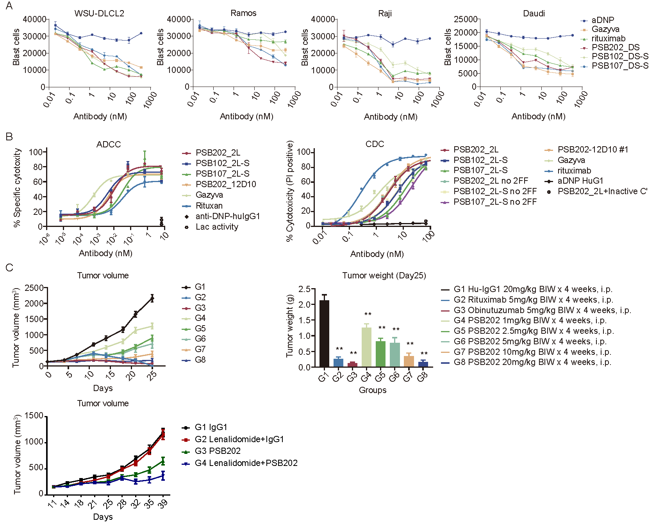

Figure S3. Supplementary single-cell transcriptomic analyses
(A) Density plots of canonical marker genes for major cell types. (B) UMAP of B cell subclusters. (C) Sample-specific distribution of B cell subsets in UMAP. (D) Heatmap of T cell marker genes.
Abbreviations: EC, endothelial cell; C1D1, cycle 1 day 1; CR, complete response; PD, disease progression; PR, partial response; UMAP, Uniform Manifold Approximation and Projection; tSNE2, t-Distributed Stochastic Neighbor Embedding, dimension 2t.
