Supplementary File

Pag. 2 List of participating centers and site PI.
Pag. 3 Detailed molecular characterization of leukemia cases.
Pag. 4 Supplementary Table 1. Detailed Risk stratification.
Pag. 5 Supplementary Table 2. Detailed chemotherapy schemes.
Pag. 6 Supplementary Table 3. Subgroup analysis of randomization.
Pag. 7 Supplementary Table 4. Cause of death of enrolled patients.
Pag. 8 Supplementary Figures.
Pag. 15 Study Protocol.
List of participating centers and site PI
Ancona: Dott. Paolo Pierani/Dott.ssa Simona Gobbi
Bari: Dott. Nicola Santoro
Bergamo: Dott. Massimo Provenzi
Bologna: Prof. Andrea Pession, Prof. Riccardo Masetti
Brescia: Dott. Fulvio Porta
Cagliari: Dott.ssa Rosaria Mura
Catania: Dott. Luca Lo Nigro
Catanzaro: Dott.ssa Caterina Consarino
Cosenza: Dott. Domenico Sperlì
Firenze: Dott. Tommaso Casini
Genova: Dott.ssa Concetta Micalizzi
Lecce: Dott.ssa Maria Assunta Tornesello
Monza: Prof. Carmelo Rizzari
Napoli Santobono Pausilipon: Dott. Giuseppe Menna
Napoli II Università: Prof.ssa Fiorina Casale/Prof.ssa Francesca Rossi
Padova: Dott.ssa Manuela Tumino
Palermo: Dott. Paolo D’Angelo
Parma: Dott.ssa Angelica Barone
Pavia: Dott. Marco Zecca
Perugia: Dott. Maurizio Caniglia
Pescara: Dott.ssa Daniela Onofrillo
Pisa: Dott.ssa Gabriella Casazza
Reggio Calabria: Dott.ssa Francesca Ronco
Rimini: Dott.ssa Roberta Pericoli
Roma Bambino Gesù: Prof. Franco Locatelli
Roma La Sapienza: Dott.ssa Annamaria Testi
San Giovanni Rotondo: Dott. Saverio La Dogana
Siena: Dott.ssa Daniela Galimberti
Torino: Prof.ssa Franca Fagioli
Trieste: Dott. Marco Rabusin
Verona: Dott. Simone Cesaro

Methods
Definitions:
- Complete response (CR): Bone marrow blasts < 5%; absence of blasts with Auer rods; absence of extramedullary disease; absolute neutrophil count > 1.0 x 10^9/L; platelet count > 80 x 10^9/L; independence from red blood cell transfusions
- Primary induction failure (PIF): Failure to achieve CR or CR with incomplete hematological recovery in patients who survive ≥ 7 days after completing initial treatment with persistent leukemia (>25% blasts) at bone marrow or peripheral level (bone marrow aspirate must be performed within 28 days from the start of the I ICE induction cycle). Patients with more than 5% blasts with hematological recovery after the II induction cycle will also be considered resistant.
- Relapse: Presence of bone marrow blasts ≥ 5%, or reappearance of blasts in the peripheral blood; or development of extramedullary disease (i.e. central nervous system, skin, testis, mammary gland, etc).

Results
In the 371 patients at diagnosis, we identified a molecular lesion in 248 cases (67%). In details, we identified 24/371 cases harboring a mutation at exon 12 of NPM1 gene (6.5%), 22/371 a FLT3-ITD mutation (6%), 7 of them with a concomitant NPM1 mutations (32%). Translocation (8;21) RUNX1::RUNX1T1 and inv(16) CBFB::MYH11 were found in 13.5% (50/371) and 12% (44/371) of cases, respectively. Sixty-seven (18%) AML cases were characterized by a KMT2A fusion with different partner genes, with the t(9;11) KMT2A::MLLT3 being the most recurrent (24/67, 36%), followed by t(10;11) KMT2A::MLLT10 (21/67, 31%), t(6;11) KMT2A::AFDN (11/67, 16%), t(11;19) KMT2A::ELL (6/67, 9%), t(X;11) SEPT6::KMT2A (2/67, 3%), t(11;19) KMT2A::ENL (1/67, 1.5%) and partial KMT2A duplication (2/67, 3%). In 15 patients, we found a NUP98 translocations (4%): in particular, 10 cases harbored the t(5;11) NUP98::NSD1 (67%) (6 out of these 10 had an additional FLT3-ITD mutation), 4 the t(11;12) NUP98::KDM5A (27%) and only one case the t(2;11) NUP98::HOXD13. Other chromosomal aberrations were rarer in our cohort, with t(16;16) CBFA2T3::GLIS2 accounting for 2.4% of cases (9/371), t(6;9) DEK::CAN 1.3% (5/371, co-occurring with FLT3-ITD in 3/5 cases), t(1;22) RBM15::MKL1 1.1% (4/371), t(3;5) NPM1::MLF1 0.5% (2/371, one concomitant with FLT3-ITD), t(16;21) FUS::ERG 0.5% (2/371). Finally, one case for each of the t(16;21) RUNX1::CBFA2T3, del(9) SET::NUP214, t(8;16) KAT6A::CREBBP and t(9;22) BCR::ABL1 rearrangements was also detected.

Supplementary Table 1. Detailed Risk stratification for AIEOP AML 2013 and comparison with prior protocol (AIEOP AML 2002).
Risk Group | AIEOP AML 2013 | AIEOP AML 2002
Standard Risk | CBFb abnormalities (without other genetic abnormalities) AND MFC-MRD<0.1% at EOI1 | Isolated anomalies of CBF-β in morphologic CR after the first induction course.
 | t(8;21)(q22;q22)
 | inv(16)(p13q22)/t(16;16)(p13;q22)
 | NPM1 (normal karyotype) AND MFC-MRD<0.1% at EOI1
Intermediate Risk | Normal Karyotype
 | t(9;11)(p22;q23) (without other genetic abnormalities)
 | t(1;11)(p32;q23)
 | t(11;19) (p13;q23)
 | t(16;21)(p11;q22)FUS::ERG, t(3;5)(q25;q34)
 | M7 with t(1;22), independently from patient's age at onset
 | patients not stratified in SR or HR
 | MFC-MRD at EOI1 > 0.1% but < 1% and MFC-MRD at EOI2 < 0.1%
High-risk | Complex karyotype (> 3 aberrations including at least one structural aberration) | All the others
 | Monosomal Karyotype (i.e., -7, -5)
 | t(9;11)(p22;q23) with other genetic abnormalities
 | 11q23/KMT2A rearrangements involving: t(11;17)(q23;q21), t(10;11)(p12;q23), t(4;11)(q21;q23), t(6;11)(q27;q23), t(x;11)
 | Rare genetic abnormalities: t(6;9)(p23;q34), t(8-16)(p11;p13), t(9;22)(q34;q11) t(5;11)NUP98::NSD1, t(4;11)MLL::ArgBP2
 | FLT3-ITD
 | inv(16)(p13q24) CBFA2T3::GLIS2
 | FAB M0, M6 and M7 (without t(1;22))
 | Infants (M7 with t(1;22) excluded)
 | Patients not in CR at the end of first induction
 | MFC-MRD at EOI1 > 1% or MFC-MRD at EOI2 >0.1%
 | Patients without SR criteria and WBC >100,000/mcl at diagnosis

Supplementary Table 2. Details on the chemotherapy courses employed in protocol AIOEP AML 2013 and in prior protocol (AIEOP AML 2002).
Scheme | AIEOP AML 2013 | AIEOP AML 2002/01
ICE | Idarubicin 10 mg/m2 1, 2, 3  Cytarabine 200 mg/m2 1, 2, 3, 4, 5, 6, 7  Etoposide 100 mg/m2 1, 2, 3, 4, 5 | Idarubicin 10 mg/m2 1, 2, 3  Cytarabine 200 mg/m2 1, 2, 3, 4, 5, 6, 7  Etoposide 100 mg/m2 1, 2, 3, 4, 5
FLA-My | Fludarabine 30 mg/m2 1, 2, 3, 4, 5  Cytarabine 2000 mg/m2 1, 2, 3, 4, 5  Myocet 50 mg/m2 1, 3, 5 | -
short MEC | Mitoxantrone 10 mg/m2 1, 2, 3, 4  Etoposide 100 mg/m2 1, 2, 3, 4, 5  Cytarabine 500 mg/m2 1, 2, 3, 4, 5 | -
AVE | Cytarabine 3000 mg/m2 BID 1, 2, 3  Etoposide 125 mg/m2 2, 3, 4, 5 | Cytarabine 3000 mg/m2 BID 1, 2, 3  Etoposide 125 mg/m2 2, 3, 4, 5
HAM | Cytarabine 3000 mg/m2 BID 1, 2, 3  Mitoxantrone 10 mg/m2 3, 4 | Cytarabine 3000 mg/m2 BID 1, 2, 3  Mitoxantrone 10 mg/m2 3, 4
HD Ara-C | Cytarabine 3000 mg/m2 BID 1, 2, 3 | Cytarabine 3000 mg/m2 BID 1, 2, 3
FLAMSA | Fludarabine 30 mg/m2 1, 2, 3, 4, 5  Cytarabine 2000 mg/m2 1, 2, 3, 4, 5  Amsacrine 100 mg/m2 1, 2, 3

Intrathecal therapy | Dose (mg)
Age (years) | MTX | Cytarabine | Methylprednisolone
<1 | 6 | 16 | 4
>1 and <2 | 8 | 20 | 6
>2 and <3 | 10 | 26 | 8
>3 | 12 | 30 | 10

Supplementary Table 3. Cumulative planned chemotherapy exposure by risk group in the AIEOP AML 2013 and AIEOP AML 2002/01 protocols.

Risk groups | AIEOP AML 2013 | AIEOP AML 2002/01
SR | Without HD-AraC  Cytarabine 39.9 g/m²  Idarubicin 30 mg/m²  Etoposide 1,500 mg/m²  Mitoxantrone 60 mg/m²  With HD-AraC  Cytarabine 57.9 g/m²  Idarubicin 30 mg/m²  Etoposide 1,500 mg/m²  Mitoxantrone 60 mg/m² | Cytarabine 56.8 g/m²  Idarubicin 60 mg/m²  Etoposide 1,500 mg/m²  Mitoxantrone 20 mg/m²
IR | Randomized to II ICE and no MFD  Cytarabine 48.8 g/m²  Idarubicin 60 mg/m²  Etoposide 1,500 mg/m²  Mitoxantrone 20 mg/m²  Fludarabine 150 mg/m²  Amsacrine 300 mg/m²  Randomized to FLA-My and no MFD  Cytarabine 57.4 g/m²  Idarubicin 30 mg/m²  Myocet 150 mg/m²  Etoposide 1,000 mg/m²  Mitoxantrone 20 mg/m²  Fludarabine 300 mg/m²  Amsacrine 300 mg/m²  Randomized to II ICE and MFD  Cytarabine 20.8 g/m²  Idarubicin 60 mg/m²  Etoposide 1,500 mg/m²  Randomized to FLA-My and MFD  Cytarabine 29.4 g/m²  Idarubicin 30 mg/m²  Myocet 150 mg/m²  Etoposide 1,000 mg/m²  Fludarabine 150 mg/m²
HR | Randomized to II ICE  Cytarabine 38.8 g/m²  Idarubicin 60 mg/m²  Etoposide 1,500 mg/m²  Mitoxantrone 20 mg/m²  Randomized to FLA-My  Cytarabine 47.4 g/m²  Idarubicin 30 mg/m²  Myocet 150 mg/m²  Etoposide 1,000 mg/m²  Mitoxantrone 20 mg/m²  Fludarabine 150 mg/m² | Cytarabine 38.8 g/m²  Idarubicin 60 mg/m²  Etoposide 1,500 mg/m²  Mitoxantrone 20 mg/m²

Supplementary Table 4. Subgroup analysis of randomization.
Group | Treatment | Number | Events | 3-yr EFS | 95% CI | p-value
HR | ICE | 93 | 30 | 69.1 | 58.4-77.5 | n.s.
 | FLA-My | 90 | 24 | 75.0 | 64.6-82.8
IR | ICE | 36 | 9 | 74.1 | 56.1-85.7 | n.s.
 | FLA-My | 39 | 10 | 73.4 | 56.1-84.8
Infants | ICE | 13 | 3 | 76.9 | 44.2-91.9 | n.s.
 | FLA-My | 13 | 3 | 76.9 | 44.2-91.9
KMT2A-rearrangement | ICE | 30 | 11 | 65.8 | 45.7-79.9 | n.s.
 | FLA-My | 32 | 9 | 74.3 | 55.0-86.3
FLT3-ITD | ICE | 12 | 3 | 75.0 | 40.8-91.2 | n.s.
 | FLA-My | 6 | 2 | 66.7 | 19.5-90.4
CBFA2T3::GLIS2 | ICE | 4 | 2 | 50.0 | 5.7-84.5 | n.s.
 | FLA-My | 5 | 3 | 40.0 | 5.2-75.3
M6/M7 | ICE | 15 | 3 | 43.1 | 11.7-85.3 | n.s.
 | FLA-My | 9 | 2 | 71.1 | 15.9-93.9

Supplementary Table 5. Causes of death of enrolled patients.
Cause of death | Number of patients | %
Sepsis | 12 | 52
TMA/VOD (after HSCT) | 3 | 13
Pneumonia | 2 | 8.5
Respiratory failure (after HSCT) | 2 | 8.5
Meningitis | 1 | 4.5
Cerebral haemorrhage | 1 | 4.5
GVHD | 1 | 4.5
CMV infection (after HSCT) | 1 | 4.5

Supplementary Figures.

Supplementary Figure 1. Genetics. Histogram graph reports the number of positive cases per rearrangement out of the 248 patients with a genetic marker at diagnosis.

Supplementary Figure 2. A. EFS of the whole cohort. B. DFS of the whole cohort.

Supplementary Figure 3. A. DFS by risk group. B. EFS by risk group. C. Sensitivity analysis (with censoring at transplantation) for EFS by risk group. D. Sensitivity analysis (with censoring at transplantation) for OS by risk group.
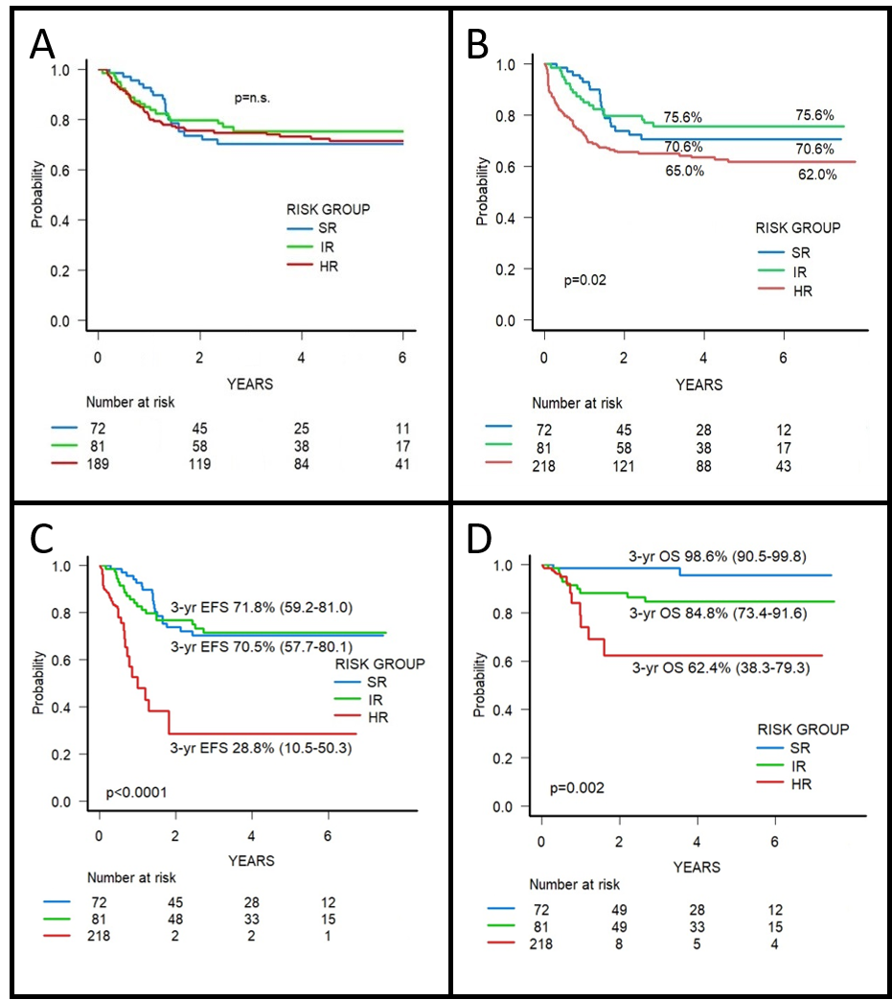

Supplementary Figure 4. EFS of SR patients according to treatment: SR1 before the amendment (4 total courses of chemotherapy); SR2 after the amendment (5 total courses of chemotherapy).
Supplementary Figure 5. EFS of HR patients by number of risk factors.
Supplementary Figure 6. EFS of IR patients by type of consolidation (allo-HSCT from MFD or chemo-only).
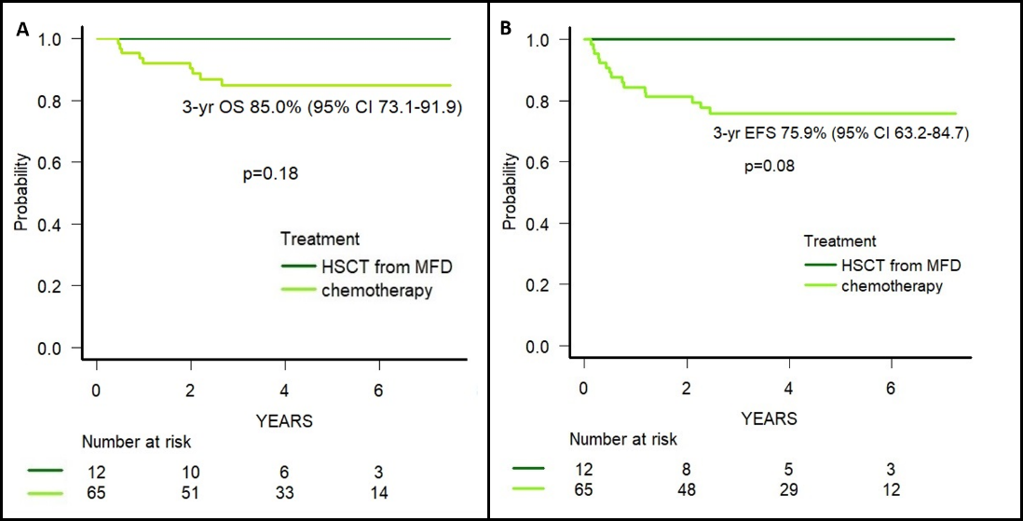

Supplementary Figure 7. 3-yr EFS of patents with t(8;21) allocated in the SR group according to qPCR-MRD reduction at EOI2 (1 patient did not have an available sample at this time-point).
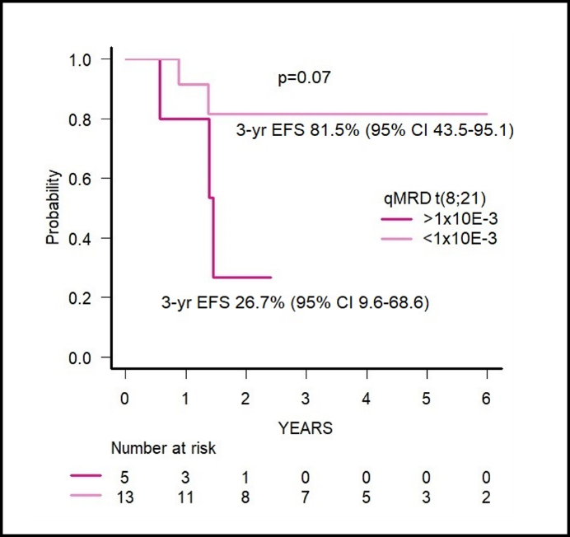

Supplementary Figure 8. A. OS after HSCT of all patients transplanted in CR1. B. EFS after HSCT of all patients transplanted in CR1. C. OS after HSCT by donor type. D. EFS after HSCT by donor type.

Supplementary Figure 9. 3-yr OS of patients experiencing PIF (i.e., those with >25% blasts at EOI1 or >5% blasts at EOI2).
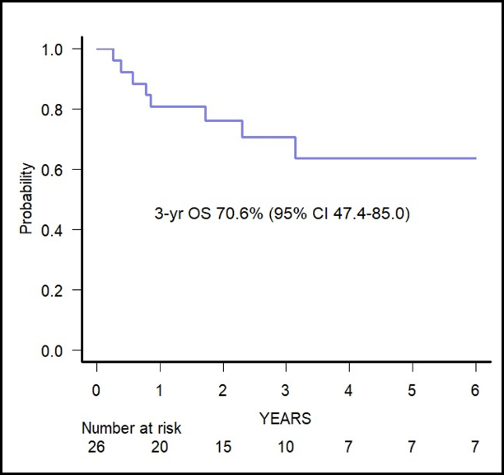



Associazione Italiana Ematologia Oncologia Pediatrica
Acute non Lymphoblastic Leukemia Working Group
Study Coordinator Prof. Franco Locatelli

Protocol LAM 2013/01

EudraCT Number: 2014-000652-28
Protocol identification code: LAM 2013/01
Responsible for the Protocol: Prof. Franco Locatelli
Open to Recruitment: 01.03.2015

Sponsor:
Associazione Italiana Ematologia Oncologia Pediatrica, Via Massarenti 11, 40138 Bologna, Italy
Tel. +39-0516364667
Fax. +39-051345759
Email: segreteria@aieop.org

Study National Coordinator (representing the Sponsor):
Prof. Franco Locatelli Hematology/Oncology
Ospedale Pediatrico Bambino Gesù, IRCCS Piazza S. Onofrio 4, 00166
Rome, Italy
Tel. +39-0668592678
Fax. +39-0668592292
Email: franco.locatelli@opbg.net

- AIEOP LAM 2013/01 STUDY COORDINATION

Responsible for the study: Prof. Franco Locatelli
Università degli Studi di Pavia
Director Dipartimento di Onco-ematologia e Medicina Trasfusionale Ospedale Pediatrico Bambino Gesù
Piazza Sant’Onofrio, 4
00165 Roma
Tel: +39 06 68592129
Fax: +39 06 68592292
E-mail: franco.locatelli@opbg.net www: http://www.aieop.org/

Data Center: CINECA
40033-Casalecchio di Reno - Bologna-Italy Tel: +39 051 6171467
Fax: +39 051 6171365
http://www.cineca.it/

Group member: Prof. Franco Locatelli (Roma) – Coordinator
Dott.ssa Franca Fagioli (Torino)
Prof Andrea Pession (Bologna)
Dott.ssa Angela Mastronuzzi (Roma)
Dott. Giuseppe Menna (Napoli)
Dott.ssa Concetta Micalizzi (Genova)
Dott. Paolo Pierani (Ancona)
Dott.ssa Caterina Putti (Padova)
Dott. Carmelo Rizzari (Monza)
Dott. Nicola Santoro (Bari)
Dott. Marco Zecca (Pavia)

Group consultants: Dott. Riccardo Masetti (Bologna)
Prof. Andrea Biondi (Monza)
Dott.ssa Barbara Buldini (Padova)
Dott.ssa Martina Pigazzi (Padova)

Protocol writing group: Prof. Franco Locatelli (Roma)
Prof. Giuseppe Basso (Padova)
Dott.ssa Barbara Buldini (Padova)
Dott. Angela Mastronuzzi (Roma)
Dott. Riccardo Masetti (Bologna)
Dott. Pietro Merli (Roma)
Dott.ssa Martina Pigazzi (Padova)

- SYNOPSIS

STUDY OBJECTIVES
The primary objective of the study is to achieve a 3-year event-free survival (EFS) superior by 5% to that of the previous study (AIEOP LAM 2002/01) without further use of autologous transplantation in intermediate-risk patients, while evaluating, through a randomized clinical trial, the efficacy of a second induction cycle based on the combination of Fludarabine/Ara-C and liposomal Doxorubicin (FLAMy cycle) compared to a conventional second cycle (ICE) in terms of reducing Minimal Residual Disease (MRD), an important parameter for stratifying patients for allogeneic hematopoietic stem cell transplantation. To observe a statistically significant difference in terms of MRD negativity (i.e. value less than 0.1%) of the order of 20% (65% vs 85%) between the standard induction treatment (ICE+ICE) and the experimental induction treatment (ICE+FLAMy), it is necessary to enroll approximately 90 patients per randomization arm; the total expected number of patients to be enrolled is therefore 230 (90 + 90 IR and HR; 50 SR). A 3-year recruitment is considered sufficient to address the primary objective of the study, with a follow-up period of at least 2 years (total study duration 5 years).

Secondary objectives are:
- To reduce the percentage of early deaths (ED) and deaths in complete remission in the present protocol compared to the previous national collaborative study AIEOP LAM 2002/01
- To stratify patients based on new biological-cytogenetic-molecular criteria and on early treatment response, evaluating the groups in terms of outcome (percentage of patients achieving complete remission, EFS, Overall Survival -OS- and Disease-Free Survival -DFS-);
- To reduce the treatment burden in 20% of patients who will be allocated to the Standard Risk (SR) group;
- To evaluate the efficacy of a stratification that combines molecular lesions and MRD clearance together with a second induction cycle with Mitoxantrone in place of Idarubicin in SR patients to improve the outcome (result not in line with the best international results in the previous study) of this subgroup of patients, in whom, moreover, 4 treatment cycles will be used instead of the 5 planned in the previous protocol;
- To evaluate the efficacy of consolidation based on the use of high-dose ARA-C associated with Amsacrine in intermediate-risk (Intermediate Risk IR) patients, in the absence of a matched family HLA donor (MFD);
- To evaluate the efficacy of allogeneic hematopoietic stem cell transplantation (HSCT) from a non-HLA-matched (MUD) or HLA-non-identical family (APLO) donor in first CR after 2 cycles of post-remission chemotherapy consolidation for High Risk (HR) patients in case of unavailability of an MFD;
- To use MRD monitoring by flow cytometry and, if indicated or necessary, using molecular biology approaches, to evaluate its prognostic impact after the first (TP1 point) and after the second (TP2 point) induction cycle.
- To collect and analyze data on the incidence and severity of infectious complications in patients enrolled in the present study.

STUDY DESIGN
Multicenter, prospective, clinical trial with randomized treatment for the second induction cycle for intermediate- or high-risk patients.

PATIENT SELECTION
Inclusion criteria:
- Patients with AML
- Patients aged 0 to 18 years (17 years and 364 days) at diagnosis.
- Informed consent signed by the parents or legal guardian of the minor affected by the leukemic disease.

Exclusion criteria:
- Down syndrome (Treatment according to AIEOP LAM 2002/02 Protocol)
- Acute Promyelocytic Leukemia (FAB M3) or t(15;17) with PML/RARα rearrangement (Treatment with ad hoc protocol)
- AML secondary to MDS
- LAM-t (therapy-related AML)
- Pregnancy or breastfeeding
- Pretreatment with anti-neoplastic agents or treatment with steroid drugs for more than 7 days
- Organ dysfunction: any organ dysfunction (WHO grade 4) that may interfere with the administration of the therapies provided by this protocol and determine potential inability to complete the protocol for any other reason than the above.

PATIENT STRATIFICATION
Patients enrolled will be stratified into 3 risk groups (i.e. standard risk, SR, intermediate risk, IR, or high risk, HR) according to the criteria reported in Table 1.

INTERIM ANALYSIS
An interim analysis is planned for this study for a preliminary evaluation of the safety and efficacy of the treatments used (see paragraph "Stopping rules").
In the first phase of the study, 76 patients will be recruited based on the inclusion and exclusion criteria described above. Upon reaching this number, enrollment will be stopped for one month to analyze the preliminary results.
The second phase will proceed with the recruitment of an additional 154 patients. The total number of patients to be recruited is 230.

STOPPING RULES¹
- Treatment-related induction mortality within the first 4 weeks of diagnosis > 5%
- Post-induction treatment-related mortality in patients who have achieved complete remission > 9%
- Achievement of remission after the first two induction cycles ≤ 8%

¹ The values reported were established based on the results obtained from the previous AIEOP AML 2002/01 Clinical Trial [12]

LAM 2013/01
Version 3.1 (January 26th, 2015)
Table 1. Stratification Criteria of the Protocol LAM 2013
 | STANDARD RISK (SR)  (expected 20-22%) | CBFβ anomalies (without other cytogenetic abnormalities) and MRD < 0.1% at TP1  - t(8;21)(q22;q22)/[inv(16)(p13q22)/t(16;16)(p13;q22)  Patients with normal karyotype and NPM-1 mutations with MRD < 0.1% at TP1
 | INTERMEDIATE RISK (IR)  (expected 50-55%) | Normal karyotype  t(9;11)/p22;q23) without other cytogenetic abnormalities  t(1;11)(p32;q23)  t(11;19) (p13;q23)  t(16;21)(p11;q22)FUS-ERG, t(3;5)(q25;q34)  Other cytogenetic abnormalities  M7 with t(1;22), regardless of patient age  Patients not otherwise stratifiable to SR and HR  MRD at TP1 > 0.1% but < 1% and with MRD at TP2 < 0.1%
 | HIGH RISK (HR)  (expected 25-30%) | Cytogenetic abnormalities associated with unfavorable outcome:  - Complex karyotype (>3 numerical or structural abnormalities)  - Monosomic karyotype, (-7, -5, other) §  - t(9;11)(p22;q23) associated with other cytogenetic abnormalities  - Cytogenetic abnormalities involving 11q23 not included in IR:: t(11;17)(q23;q21), t(10;11)(p12;q23), t(4;11)(q21;q23), t(6;11)(q27;q23), t(x;11)  - Rare cytogenetic abnormalities: t(6;9)(p23;q34), t(8-16)(p11;p13), t(9;22)(q34;q11) t(5;11)NUP98/NSD1, t(4;11)MLL/ArgBP2  FLT3-ITD  Patients with cytogenetically normal AML and with the CBFA2T3-GLIS2 fusion transcript  FAB M0, M6, M7 without t(1;22)  Infants (excluding patients with AML M7 with t(1;22) )  Patients not in complete morphological remission at the end of the first induction cycle MRD > 1% at TP1 or > 0.1% at TP2  Patients with non-SR criteria and WBC >100.000/μL

§ Monosomic karyotype: loss of at least two autosomes or loss of one autosome associated with at least one other structural abnormality (other than t(8;21) or inv(16)).

DATA COLLECTION PROCEDURES
Data collection will be carried out through the electronic compilation (data remote entry) of the forms (Mod.1.01 registration, diagnosis and AML therapy) by the patient's attending physician.

DIAGNOSTIC CONFIRMATION
Centralized morphological, cytochemical, immunophenotypic, molecular and cytogenetic (only for Centers without a cytogenetic laboratory) characterization.

TREATMENT PLAN
Patients will be stratified into 3 risk groups: standard (SR), intermediate (IR) and high (HR), in accordance with the criteria reported above.

Induction: the first induction chemotherapy cycle, common to all patients, is represented by the standard ICE regimen (Idarubicin, Etoposide, Cytarabine).
In accordance with the stratification criteria reported in Table 1, at the disease reassessment, for patients assigned to the SR group, no randomization is foreseen but a second induction cycle according to the short MEC -sMEC- regimen (Mitoxantrone, Etoposide, Cytarabine).
For IR and HR patients, the second induction will be randomized between a second cycle according to the ICE regimen and a FLAMy cycle that includes the use of a liposomal anthracycline (Liposomal Doxorubicin) in combination with high-dose Cytarabine and Fludarabine.
Consolidation: patients enrolled in the SR group will undergo chemotherapy consolidation using two blocks represented sequentially by the AVE (Cytarabine, Etoposide) and HAM (Cytarabine, Mitoxantrone) regimens.
For SR patients, no transplant option is foreseen, and treatment will conclude with the HAM regimen.
For the other risk groups, HLA family typing is indicated already at the end of the first induction. For patients assigned to the HR group, it is essential to proceed, in the absence of an MFD, to high-resolution typing and to activate the search for a MUD.
For the IR group, a consolidation according to the AVE regimen is foreseen at the end of the two induction cycles, followed, in the presence of an HLA-identical family donor, by allogeneic HSCT from MFD. In the absence of an MFD, two further consolidation cycles are foreseen according to the HAM and FLAMSA (Fludarabine, Amsacrine and Cytarabine) regimens.
In the presence of an MFD, the transplant procedure will be performed using a conditioning regimen based on the use of 3 alkylating drugs represented by Busulfan (BU), Cyclophosphamide (CY) and Melphalan (L-PAM).
Patients assigned to the HR group will undergo two consolidation cycles according to the AVE and HAM regimens. At the end of consolidation therapy, allogeneic HSCT from any donor is foreseen, preferably in the following order: MFD, MUD or HLA-partially matched family donor (APLO).
Patients unresponsive to the two induction cycles, therefore considered primary induction failure (PIF), will exit the Protocol and will be enrolled in treatment according to the AML-IBFM 2010 REL Protocol or any Experimental Clinical Trial depending on the judgment of the attending physician and in agreement with the Protocol Coordinator.

TREATMENT OUTLINE

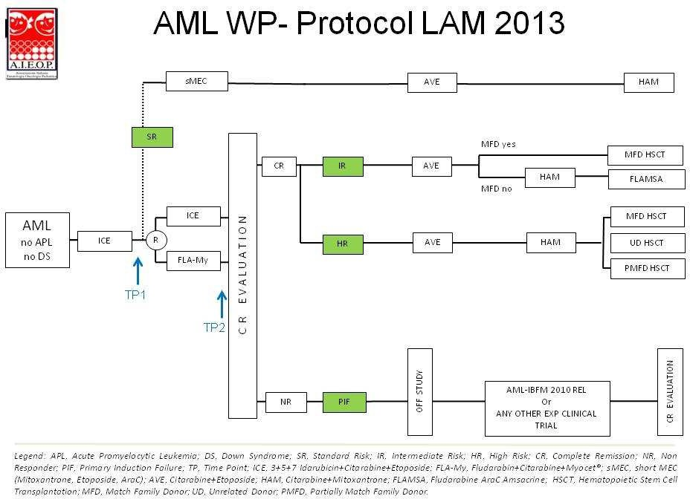

- RESPONSABILITIES AND PROTOCOL RULES

RESPONSIBILITIES
The responsibility for the treatment of patients enrolled in the protocol always and in any case lies with the Attending Physician of the Center, who is responsible for interpreting the clinical and laboratory data available to him and for using them in accordance with the provisions of this document.
With regard to the responsibility of the Study Coordinator, the Head of the Central Reference Laboratory and the Center where the patient is treated, it is necessary to specify that:
A. For clinical problems: the Protocol Coordinator is available to provide consultancy for the best application of the protocol, valuing the experience that derives from all participating Centers. The request for consultancy and the response must be formulated through written documents (sent by e-mail or fax), through which the traceability of the requests can be obtained. The final responsibility for the decision taken, however, falls on the Attending Physician of the Center.
B. For laboratory problems: in case of discrepancy between a datum provided by the Central Laboratory and the peripheral one, the heads of the two laboratories are required to promptly contact each other to clarify the reason for the discrepancy, proceeding, if possible, based on the availability of material, to the repetition of the investigation. In the event that it is not possible to resolve the non-concordance, the attending physician, as previously indicated, after informing the Study Coordinator, has the power to make the decision that he deems most appropriate in the primary interest of the patient.

OBLIGATION OF ATTENDING PHYSICIANS
To enroll in the study, it is necessary to obtain approval from the Local Ethics Committee.

CIVIL LIABILITY INSURANCE COVERAGE
For this study, an ad hoc insurance coverage will be stipulated, guaranteed by AIEOP-Associazione Italiana Oncologia Pediatrica.

USE OF INFORMATION AND PUBLICATION OF RESULTS
The right to disseminate and publish the results by the experimenters who conducted the study must be guaranteed, in compliance with the current provisions on the confidentiality of sensitive data and patent protection, and there must be no constraints on the dissemination and publication of the results by the promoter/sponsor.

AMENDMENTS TO THE CLINICAL PROTOCOL
A clinical protocol amendment means any modification made to the final draft of the protocol which, after being approved by the Investigator and the CE, can no longer be informally modified.

DATA MANAGEMENT AND DOCUMENT CONSERVATION
The Investigator must organize the conservation of patient identification codes (if provided) for at least 15 years after the end of the study. Patient dossiers (medical records) and other original data must be kept for a minimum period of 15 years.

CONTROL AND QUALITY ASSURANCE PROCEDURES
In order to guarantee the quality and reliability of the data collected and, consequently, of the results obtained, a series of procedures will have to be applied in accordance with the European Guidelines for Good Clinical Practice (CPMP/ICH/135/1995 and decree law of the Italian Ministry of Health of 15 July 1997).

CASE REPORT FORM (CRF)
All the information requested in the CRF (data collection form) is necessary for a correct final evaluation of the patients in the study. The Investigator must ensure the accuracy, completeness, legibility and timeliness of the data reported in this document. The data reported on the CRF must always be consistent with those of the original clinical documents; any differences must be explained. A computerized CRF is provided which must be compiled and made available to the study monitor.

STUDY MONITORING
The Study Director will identify the Monitor designated to follow the clinical study. The Monitor will guarantee the proper conduct of the study through frequent telephone contacts and monitoring visits with the responsible Investigator, in accordance with the European Union Guidelines for Good Clinical Practice received with Ministerial Decree 15 July 1997 and the Standard Operating Procedures of the Secretariat of the CE itself. Through these visits, the Monitor must keep the Coordinating Center updated on the progress of the study and verify, through reviews of hospital records and/or outpatient registers, the quality of the data reported on the CRFs. Finally, the Monitor must ensure that the study is conducted in adherence to the protocol for completeness of the recorded data, in compliance with the experimentation and according to the rules of Good Clinical Practice (GCP).
During the study, site visits will be conducted at the opening of recruitment at the Center, at least once a year and at the closure of recruitment. It is the prerogative of the Study Director to be able to suspend the participation of a Center in the Protocol in question if the Monitor reports non-compliance or non-adherence to the provisions for a correct conduct of the study according to Good Clinical Practice standards. A notification of the suspension will be sent to the National Observatory of Experiments and to the AIEOP Secretariat.

QUALITY ASSURANCE
The Coordinating Center of the study will ensure that the study is conducted in accordance with the rules of Good Clinical Practice (GCP) and reserves the right to carry out Quality Assurance (QA) inspections at the Experimental Center. In this case, the Experimental Center must make possible access to the study file, CRFs, original study documents and, where necessary, hospital records and/or outpatient registers. The Investigator must also show the Monitor and the personnel responsible for QA the informed consents signed by the patients enrolled in the study, ensuring that such personnel declare to have taken vision of them under the obligation of professional secrecy.

INVESTIGATOR'S RESPONSIBILITIES
The Investigator, as the study director, is aware that he is responsible for all actions delegated by him to other members of his staff designated to conduct the study. Except where specifically required, the term "Investigator" used in this protocol and on the CRFs refers to the Investigator or a qualified person designated by him who may therefore sign the study documents on his behalf. The Investigator agrees to conduct this study in full accordance with the principles of the Declaration of Helsinki (1964) and subsequent amendments, the European Guidelines for Good Clinical Practice (CPMP/ICH/135/1995) and the Italian Ministry of Health decree law of 15 July 1997.

- STAGES OF THE DISEASE
Onset
The diagnosis of AML in childhood is made when myeloid blasts are present in the BM in an amount greater than 20% (WHO) or by identifying myeloid blasts through a biopsy of a chloroma. Children with a t(8;21) or CBFβ abnormalities, even in the presence of a bone marrow blast count of less than 20%, should be considered to have low-blast AML and not MDS.

Remission
Induction treatment achieves complete remission (CR) of disease in over 80% of patients. The definition of treatment response and therefore disease remission is summarized in Table 6. CR is generally achieved through a phase of bone marrow hypoplasia, a condition not necessary only in FAB M3 AML (LAP). A recovering hypoplastic marrow in AML is sometimes indistinguishable from a marrow still partially infiltrated by blasts: the patient's clinical picture, CFM, and in some cases molecular biology, are important aids to the final judgment on the state of disease. In case of interpretative doubt or in case of low cellularity, the bone marrow aspirate should be repeated after about 1 week.

Relapse
The long-term prognosis for a child with relapsed or resistant AML is poor despite the possibility of achieving a second remission in more than half of cases, using the same drugs used in initial induction therapy. In particular, the presence of CBFβ abnormalities, a time interval between the end of treatment and relapse of disease greater than 6 months, and a blast percentage of less than 20% after the first cycle of reinduction therapy positively influence the prognosis of relapsed patients. Ongoing clinical trials include the use of new chemotherapeutic agents and/or new biological agents and/or allogeneic HSCT from any donor.
Refractory cases have a poor prognosis, with an overall survival of no more than 20%.

For the treatment of REC AML consult the AIEOP Protocol:
Trial AML I-BFM-SG 2010.

Table 2. Treatment response criteria
Category | Definition
Complete remission (CR) | Bone marrow blasts < 5%; absence of blasts with Auer rods; absence of extramedullary disease; absolute neutrophil count > 1.0 x 10^9/L; platelet count > 80 x 10^9/L; independence from red blood cell transfusions
Complete Remission with incomplete hematological Recovery (CRi) | All CR criteria except for residual neutropenia (< 1.0 x 10^9/L) or thrombocytopenia (< 80 x 10^9/L)
Treatment failure
Resistant disease/Primary induction failure | Failure to achieve CR or CRi in patients who survive ≥ 7 days after completing initial treatment with persistent leukemia (>25% blasts) at bone marrow or peripheral level (bone marrow aspirate must be performed within 28 days from the start of the I ICE induction cycle). Patients with more than 5% blasts with hematological recovery after the II induction cycle will also be considered resistant.
Death in aplasia | Death that occurs ≥ 7 days after completing initial treatment, while the patient is cytopenic: in patients with hypoplastic or aplastic marrow without evidence of persistent disease (< 42 days)
Death from undetermined causes | Death occurs before completion of therapy or within 7 days of this: or ≥ 7 days after completing the cycle without evidence of blasts in the periphery but in the absence of an available bone marrow assessment (< 42 days)
Relapse | Presence of bone marrow blasts ≥ 5%, or reappearance of blasts in the peripheral blood; or development of extramedullary disease (i.e. central nervous system, skin, testis, mammary gland, etc)

- OBJECTIVES, STUDY DESIGN AND TREATMENT REGIMES

STUDY OBJECTIVES
The primary objective of the study is to achieve a 3-year event-free survival (EFS) greater than 5% compared to that of the previous study (AIEOP AML 2002/01), without further use of autologous transplantation in intermediate-risk patients, while evaluating, through a randomized clinical trial, the efficacy of a second induction cycle in intermediate- and high-risk patients based on the combination of Fludarabine/Ara-C and liposomal Doxorubicin (FLAMy cycle) compared to a conventional second cycle (ICE) in terms of reducing Minimal Residual Disease (MRD), an important parameter for stratifying patients for the use of allogeneic hematopoietic stem cell transplantation. To observe a statistically significant difference in terms of MRD negativity (i.e., value less than 0.1%) between standard induction treatment (ICE+ICE) and experimental induction treatment (ICE+FLAMy) in the order of 20% (65% vs 85%), it is necessary to enroll approximately 90 patients per randomization arm; the total number of patients to be enrolled is therefore 230 (90 + 90 IR and HR; 50 SR). A 3-year recruitment period is considered sufficient to meet the primary objective of the study, with an observation period of at least 2 years (total study duration 5 years).

Secondary objectives are:
- To reduce the percentage of early deaths (ED) and deaths in complete remission in this protocol compared to the previous AIEOP LMA 2002/01 national collaborative study
- To stratify patients based on new biological-cytogenetic-molecular criteria and on early response to treatment, evaluating the groups in terms of outcome (percentage of patients achieving complete remission, EFS, Overall Survival (OS) and Disease-Free Survival (DFS));
- To reduce the treatment burden in the 20% of patients who will be allocated to the Standard Risk (SR) group;
- To evaluate the efficacy of a stratification that combines molecular lesions and MRD clearance together with a second induction cycle with Mitoxantrone instead of Idarubicin in SR patients to improve the outcome (result not in line with the best international results in the previous study) of this subgroup of patients, in which, however, 4 cycles of treatment will be used instead of the 5 planned in the previous protocol;
- To evaluate the efficacy of consolidation based on the use of high-dose ARA-C associated with Amsacrine in intermediate-risk (Intermediate Risk IR) patients, in the absence of a matched family HLA donor (MFD);
- To evaluate the efficacy of allogeneic hematopoietic stem cell transplantation (HSCT) from a non-HLA-matched unrelated donor (MUD) or non-identical HLA family donor (HAPLO) in CR1 after 2 cycles of post-remission chemotherapy consolidation for High Risk (HR) patients in the absence of an MFD;
- To use MRD monitoring by flow cytometry and, when indicated or necessary, using molecular biology approaches, to evaluate its prognostic impact after the first (TP1 point) and after the second (TP2 point) induction cycle.
- To collect and analyze data on the incidence and severity of infectious complications in patients enrolled in this study.

PATIENT STRATIFICATION
Patients enrolled will be stratified into 3 risk groups (i.e. standard risk, SR, intermediate risk, IR, or high risk, HR) according to the criteria reported in Table 1.

STUDY DESIGN
Multicenter, prospective clinical trial with randomized treatment for the second induction cycle for intermediate- or high-risk patients. The treatment plan will be structured according to the following lines:

Induction: the first induction chemotherapy cycle, common to all patients, is represented by the standard ICE scheme (Idarubicin, Etoposide, Cytarabine).
In accordance with the stratification criteria reported in Table 1, at the disease reassessment, for patients assigned to the SR group, no randomization is foreseen, but a second induction cycle according to the short MEC -sMEC- scheme (Mitoxantrone, Etoposide, Cytarabine).
For IR and HR patients, the second induction will be randomized between a second cycle according to the ICE scheme and a FLAMy cycle that provides for the use of a liposomal anthracycline (Liposomal Doxorubicin) in combination with high-dose Cytarabine and Fludarabine.

Consolidation: SR patients Undergo chemotherapy consolidation using two blocks in sequence: AVE scheme (Cytarabine, Etoposide) and HAM scheme (Cytarabine, Mitoxantrone). No transplant option is planned for SR patients and treatment concludes with the HAM scheme.
IR and HR patients undergo HLA typing of the family nucleus after the first induction.
For IR patients, after two induction cycles, consolidation with AVE is followed by HSCT from MFD if an HLA-matched family donor (MFD) is available. If an MFD is not available, they receive two additional consolidation cycles according to the HAM and FLAMSA schemes (Fludarabine, Amsacrine, and Cytarabine).
If an MFD is available, proceed to allogeneic HSCT from MFD using a conditioning regimen based on three alkylating agents: Busulfan (BU), Cyclophosphamide (CY), and Melphalan (L-PAM) after consolidation.
HR patients undergo two consolidation cycles according to the AVE and HAM schemes. After that they receive allogeneic HSCT from any donor, in the following order of preference: MFD, MUD, or partially HLA-matched family donor (HAPLO) after consolidation therapy.
Patients who do not respond to the two induction cycles will be considered PIF and will exit the protocol.
And they will be enrolled in treatment according to the AML-IBFM 2010 REL protocol or any experimental clinical trial based on the judgment of the attending physician and in agreement with the protocol coordinator.

INTERIM ANALYSIS
An interim analysis is planned for this study to preliminarily evaluate the safety and efficacy of the treatments used (see "Stopping rules" section).
Phase I of the study will enroll 76 patients based on the inclusion and exclusion criteria described above. Upon reaching this number enrollment will be stopped for one month to perform preliminary analysis of results.
In phase II an additional 154 patients will be enrolled. The total number of patients to be enrolled is 230.

STOPPING RULES²
The study may be stopped early if the following criteria are met:
- Induction treatment-related mortality within the first 4 weeks of diagnosis > 5%.
- Post-induction treatment-related mortality in patients who have achieved complete remission > 9%.
- Achievement of remission after the first two induction cycles ≤ 8%.

² The reported values were established based on the results obtained from the previous AIEOP AML 2002/01 clinical trial. [12]

GENERAL INFORMATION
Therapy begins after:

- Diagnosis formalization;
- Collection of samples for centralization
- Obtaining informed consent from the parents or legal guardians of the minor

Treatment Plan
All Cases:
- One ICE cycle as the first cycle of the induction phase
- Randomized choice between an additional ICE cycle and a FLA-Myocet cycle as the second induction cycle for all patients except SR patients, who will proceed with an sMEC cycle
- One AVE cycle for all patients as the first consolidation cycle
Subsequent Treatment:
- SR Patients:
One HAM cycle, followed by treatment discontinuation
- IR Patients with a Matched Family Donor:
Allogeneic transplant from Matched Family Donor after conditioning with Busulfan-Cyclophosphamide-Melphalan
- IR Patients without a Matched Family Donor:
One HAM cycle followed by one FLAMSA cycle, followed by treatment discontinuation
- HR Patients:
One HAM cycle followed by allogeneic transplant from Matched Family Donor, Unrelated Donor, or Partially Matched Family Donor, followed by treatment discontinuation

ELIGIBILITY CRITERIA
All centers are required to register all cases, regardless of treatment, with the AIEOP Operations Center using Form 1.01. This will allow for the control of any selection bias at the time of analysis of the protocol results.

INCLUSION CRITERIA
- Patients with AML
- Patients between the ages of 0 and 18 years (17 years and 364 days) at diagnosis
- Informed consent signed by parents or legal guardians

EXCLUSION CRITERIA
- Down syndrome (Treatment according to AIEOP AML 2002/02 Protocol)
- Acute Promyelocytic Leukemia (FAB M3) or t(15;17) with PML/RARα rearrangement (Treatment with ad hoc protocol)
- AML secondary to MDS
- Therapy-related AML (t-AML)
- Pregnancy or breastfeeding
- Pre-treatment with anti-blast drugs or treatment with steroid drugs for more than 7 days
- Organ dysfunction: Any organ dysfunction (WHO grade 4) that could interfere with the administration of the therapies provided by this protocol and determine potential inability to complete the protocol for any reason other than the above.

- CHEMOTHERAPY

ADJUSTMENT OF ANTI-BLAST THERAPY BASED ON AGE AND BODY WEIGHT
For children under 1 year of age or weighing less than 10 kg, drug doses should be calculated based on body weight using the following formula:
[weight (kg) x dose (per sqm)] divided by 30
The only exception to this modulation is the intravenous infusion of high-dose Ara-C, which should be administered to children under 2 years of age according to the following schedule:

AGE (MONTHS) | % DOSE/SQM
≤3 | 20
4-5 | 30
6-7 | 40
8-10 | 50
11-13 | 60
14-16 | 70
17-19 | 80
20-24 | 90
≥24 | 100

The rationale for reducing the Ara-C dose for children under 24 months of age is based on the following pharmacological considerations:
- Reduced deaminase activity;
- Reduced Ara-C clearance (reduced Ara-U transformation)
- Increased neurotoxicity because of high levels (>300 µM) reached during therapy with HD-Ara-C

Pre-Phase Treatment for Hyperleukocytosis
For patients with a white blood cell count (WBC) greater than 200.000/µl at diagnosis, pre-phase treatment with Ara-C alone at a dose of 40 mg/m2/day is recommended until the WBC count is less than 100,000/µl within 48-72 hours. If cytoreduction is not achieved, conventional treatment should be initiated.

Treatment Modulation
The interval between two consecutive treatments is 21 days, calculated from the first day of the cycle to the start of the next cycle.

In addition to clinical conditions, as assessed by bone marrow aspiration to evaluate disease status, the hematological parameters required for the start of the next cycle are: PMN ≥0.5 x 109/l and PLT ≥50 x 109/l.

INDUCTION
Each patient will undergo 2 cycles of induction chemotherapy. The first induction, common to all patients, regardless of the risk group in which they will be stratified, is according to the ICE (3+5+7) regimen. The second induction will vary depending on the risk class (SR patients will undergo a cycle according to the sMEC regimen) and the outcome of the randomization for IR and HR patients (according to ICE or FLA-DX).

ICE CICLE

DAY | 1 | 2 | 3 | 4 | 5 | 6 | 7 | 8 | 9 | 10 | 11 | 12 | 13 | 14 | → | 21 | → | → | 28
BM
ITT |  |  |  | (*) |  |  | (*) |  |  | (*) |  |  |  | (*)
Idarubicin
Etoposide (iv)
Ara-C (iv)
Idarubicine 10 mg/sqm/day in GS 5% iv in 4 hours (dd 1,2,3)
Cytarabine 200 mg/sqm/die in NS iv in ci for 24 hours (dd 1,2,3,4,5,6,7)
Etoposide 100 mg/sqm/die in NS iv in 1 hour (dd 1,2,3,4,5)
and
ITT
Age in years | Dose in mg
Age in years | MTX | ARA-C | PDN
< 1 | 6 | 16 | 4
>1 e <2 | 8 | 20 | 6
> 2 e <3 | 10 | 26 | 8
> 3 | 12 | 30 | 10

Intrathecal ²therapy (ITT) should be performed on day 1 of the ICE cycle (for patients without CNS disease at diagnosis, no other medicated lumbar punctures are planned during the first treatment cycle).
(*) For cases with CNS involvement at diagnosis, add to the day 1 ITT, on days 4, 7, 10,and 14 of the first ICE cycle, continuing until cerebrospinal fluid remission is achieved or until 2 consecutive negative lumbar punctures (performed at least 3 days apart) are obtained, both in the chemical-physical examination and in the morphological examination of the cerebrospinal fluid.

Hydration For the prevention of tumor lysis syndrome, please refer to the specific
paragraph. For patients with hyperleukocytosis.
Antiemetics The use of HT3 receptor antiemetics is recommended, to be administered
15 minutes before the start of chemotherapy; if episodes of vomiting >5/day, it is recommended to consider the association of dexamethasone at a dose of 10 mg/m2 (IV)
Visumetasone eye drops 1 drop per eye x 3 times/day from the beginning until 48 hours after the end
of Ara-C therapy.

Evaluation of Response to Induction
The evaluation of the bone marrow aspirate for both the first and second induction chemotherapy cycles will be performed on day 21 and, if the marrow is still aplastic, the bone marrow aspirate must be repeated again within and no later than day +28 from the start of the first ICE cycle. It is recommended to start the second induction cycle within 28 days from the start of the first induction cycle once the patient has reached a PMN count ≥0.5 x 109/l and a PLT count ≥50 x 109/l, except for special clinical conditions of the patient that make it appropriate or necessary to postpone the start of the second induction cycle (i.e. severe and life-threatening infections, organ toxicity incompatible with the administration of cytotoxic treatments, etc.).
PIF cases will immediately switch to a second-line protocol (I BFM- SG relapsed 2010) or to an experimental Clinical Trial at the discretion of the clinician, in agreement with the protocol coordinator.
Cases with CNS disease resistant to local therapy based on the intrathecal administration of cytotoxic drugs are considered off-study.

FLA-MY CYCLE

DAY | 1 | 2 | 3 | 4 | 5 | 6 | 7 | 8 | 9 | 10 | 11 | 12 | 13 | 14 | → | 21 | → | → | 28
BM
ITT |  |  |  | (*) |  |  | (*) |  |  | (*) |  |  |  | (*)
Fludarabine (iv)
Ara-C (iv)
Myocet®
Citarabine 2000 mg/sqm/day in NS iv for 3 hours (dd 1,2,3,4,5,6,7)
Fludarabine 30 mg/sqm/day in NS iv in 30 minutes (dd 1,2,3,4,5)
Myocet® 50 mg/sqm/die in GS 5% iv in 2 hours (dd 1,3,5)
and
ITT
Age in years | Dose in mg
Age in years | MTX | ARA-C | PDN
< 1 | 6 | 16 | 4
> 1 e <2 | 8 | 20 | 6
> 2 e <3 | 10 | 26 | 8
> 3 | 12 | 30 | 10

(*) only for CNS positive

SHORT MEC CYCLE (FOR SR PATIENTS)

DAY | 1 | 2 | 3 | 4 | 5 | 6 | 7 | 8 | 9 | 10 | 11 | 12 | 13 | 14 | 15 | 16 | 17 | 18 | 19 | 20 | 21
BM
ITT
Ara-C (iv)
Etoposide (iv)
Mitoxantrone (iv)
Ara-C 500mg/sqm in GS 5% iv in 3 hours (dd 1,2,3,4,5)
Etoposide 100 mg/sqm/day in NS iv in 1 hour (dd 1,2,3,4,5)
Mitoxantrone 10 mg/sqm/day in NS iv in 4 hours (dd 1,2,3,4)
Mitoxantrone has to be infused before Ara-C.
and
ITT
Age in years | Dose in mg
Age in years | MTX | ARA-C | PDN
< 1 | 6 | 16 | 4
> 1 e <2 | 8 | 20 | 6
> 2 e <3 | 10 | 26 | 8
> 3 | 12 | 30 | 10

HLA TYPING
As soon as information relating to the attribution of the risk range is available, all IR and HR patients must undergo HLA typing to search for a possible HLA-compatible family donor. In case of phenotypic identity, it is necessary to complete the typing with molecular investigations.
In the presence of a monozygotic twin, or in the case of possible syngeneic HSCT, the donor will be used, even if part of the graft-versus-leukemia effect may be missing.
For HR patients without a matched family donor, high-resolution HLA typing is required to activate the search for an unrelated donor (MUD) on national and international bone marrow donor registries. If no MUD is found for HR patients, and SCT is strongly indicated, family members should be typed at high resolution in preparation for a haploidentical donor transplant procedure.

CONSOLIDATION
This phase of treatment involves a first consolidation cycle according to the AVE scheme for all risk groups (SR, IR and HR). Subsequently, SR and HR patients must perform a second cycle of consolidation according to the HAM scheme; SR patients then discontinue therapy, while HR patients will then proceed to HSCT. In IR patients in the presence of an HLA-compatible family donor, after the first consolidation, transplantation from an MFD will be performed; in the absence of an MFD, these patients will have to undergo two further cycles of consolidation, according to the HAM and FLAMSA schemes (modified dosage for children under 2 years of age).

AVE CYCLE

DAY | 1 | 2 | 3 | 4 | 5 | 6 | 7 | 8 | 9 | 10 | 11 | 12 | 13 | 14 | 15 | 16 | 17 | 18 | 19 | 20 | 21
BM
ITT
Ara-C (iv)
Etoposide (iv)
Ara-C 3 g/sqm every 12 hours in GS 5% in 3 hours (dd 1,2,3)
Etoposide (Vepesid ®) 125 mg/sqm/day in NS iv in 1 hour (dd 2,3,4,5)
Every dose of Etoposide has to be infused 6 hours before Ara- C.
and
ITT
Age in years | Dose in mg
Age in years | MTX | ARA-C | PDN
< 1 | 6 | 16 | 4
> 1 e <2 | 8 | 20 | 6
> 2 e <3 | 10 | 26 | 8
> 3 | 12 | 30 | 10

Antiemetics The use of HT3 receptor antiemetics is recommended, to be administered
15 minutes before the start of chemotherapy. If episodes of vomiting >5/day occur, it is recommended to consider the association of dexamethasone at a dose of 10 mg/m2 (IV).
Visumetasone Eye Drops 1 drop per eye x 3 times/day from the beginning until 48 hours after the end of Ara-C therapy.

HAM CYCLE

DAY | 1 | 2 | 3 | 4 | 5 | 6 | 7 | 8 | 9 | 10 | 11 | 12 | 13 | 14 | 15 | 16 | 17 | 18 | 19 | 20 | 21
BM
ITT
Ara-C (iv)
Mitoxantrone (iv)
Ara-C 3 g/sqm every 12 hours in GS 5% iv in 3 hours (dd 1,2,3)
Mitoxantrone 10 mg/sqm/day in NS iv in 4 hours (dd 3,4)
Mitoxantrone of day 3 has to be infused before Ara-C.
and
ITT
Age in years | Dose in mg
Age in years | MTX | ARA-C | PDN
< 1 | 6 | 16 | 4
> 1 e <2 | 8 | 20 | 6
> 2 e <3 | 10 | 26 | 8
> 3 | 12 | 30 | 10

Antiemetics The use of HT3 receptor antiemetics is recommended, to be administered
15 minutes before the start of chemotherapy. If episodes of vomiting >5/day occur, it is recommended to consider the association of dexamethasone at a dose of 10 mg/m2 (IV).
Visumetasone Eye Drops 1 drop per eye x 3 times/day from the beginning until 48 hours after the end
of Ara-C therapy.

Patients who are proceeding to allogeneic stem cell transplantation (SCT) will undergo a pre-transplant evaluation

FLAMSA CYCLE

DAY | 1 | 2 | 3 | 4 | 5 | 6 | 7 | 8 | 9 | 10 | 11 | 12 | 13 | 14 | → | 21 | → | → | 28
BM
ITT
Fludarabine (iv)
Ara-C (iv)
Amsacrine
Cytarabine 2000 mg/sqm/day in NS iv for 4 hours (dd 1,2,3,4,5)
Fludarabine 30 mg/sqm/day in NS iv for 30 minutes (dd 1,2,3,4,5)
Amsacrine 100 mg/sqm/day in NS iv in 1 hour (dd 1,2,3)
Cytarabine has to be infused 4 hours after Fludarabine beginning.
and
ITT
Age in years | Dose in mg
Age in years | MTX | ARA-C | PDN
< 1 | 6 | 16 | 4
> 1 e <2 | 8 | 20 | 6
> 2 e <3 | 10 | 26 | 8
> 3 | 12 | 30 | 10

Antiemetics The use of HT3 receptor antiemetics is recommended, to be administered
15 minutes before the start of chemotherapy. If episodes of vomiting >5/day occur, it is recommended to consider the association of dexamethasone at a dose of 10 mg/m2 (IV).
Visumetasone Eye Drops 1 drop per eye x 3 times/day from the beginning until 48 hours after the end of Ara-C therapy.

- ALLOGENIC HEMATOPOIETIC STEM CELL TRANSPLANTATION

DONOR SELECTION
The following individuals can be selected as donors:
- HLA-genotypically identical siblings;
- HLA-phenotypically identical siblings (usually one parent);
- Siblings or parents who differ by one HLA locus (siblings, one parent);
- Unrelated donors (UD) with complete HLA identity to the recipient or with a limited (allelic or antigenic) disparity at a single locus of the four considered in the selection algorithm (loci A, B, C, and DRB1);
- HLA-partially matched family donors for patients treated in or referred to centers with an active haploidentical transplant program.
The final choice of the best donor for the transplant patient is made by the transplant center that will perform the procedure.
The following individuals are considered ineligible for donation:
- Potential donors who are unable to tolerate the procedure due to psychological, physiological, or medical reasons;
- Individuals with an increased anesthetic risk due to pre-existing diseases;
- Individuals with transmissible diseases (infectious or immune-mediated).

CONDITIONING REGIMEN

The conditioning regimen should only be initiated if the patient is in complete remission (CR) (assessed by bone marrow (BM) and platelet (PL) counts) and has good clinical condition following recovery from the previous consolidation phase.

The conditioning regimen will consist of the following schedule:

DAY | -9 | -8 | -7 | -6 | -5 | -4 | -3 | -2 | -1 | 0 | +1 | +2 | +3
BY
CY
L-PAM
BU 0,8-1,2 mg/kg iv (according to weight) 4 times/day for 4 days (dd -8, -7, -6, -5)
CY 60 mg/kg/day for 2 days (dd -4, -3)
L-PAM 140 mg/sqm/day in 1 day (d -2)

Busulfan dose according to body weight
Body weight | <9Kg | 9-15.9 Kg | 16-22.9 Kg | 23-33.9 Kg | >34 Kg
Busulfan dose | 1,0  mg/Kg | 1,2  mg/Kg | 1,1  mg/Kg | 0,95  mg/Kg | 0,8  mg/Kg

BU will be administered intravenously (IV) at a dose modulated based on the recipient's body weight (from 0.8 to 1.2 mg/Kg/dose) four times a day (16 total doses) for 4 consecutive days. The dose will be adjusted based on plasma drug levels. In case of obesity, ideal body weight should be considered; in this case, special attention should be paid to monitoring busulfanemia. However, monitoring of drug plasma levels after the first administration of BU is recommended for all patients. Anticonvulsant prophylaxis is recommended in all patients, but especially in subjects over 6 years of age, during Busulfan administration. Drugs that can be used for this purpose are valproic acid, carbamazepine, levetiracetam, and diazepam at usual dosages.
CY will be administered at a dose of 60 mg/Kg on each of the 2 consecutive days. In case of obesity, ideal body weight should be considered. The drug will be administered in 5% glucose solution (250 ml/m2) over 1 hour. In order to reduce and, at best, eliminate the incidence of metabolic problems or hemorrhagic cystitis, it is recommended to start hydration with a balanced saline solution at least 12 hours before CY infusion, which should be continued for at least 24 hours after the last dose of CY, at a dose of 3000 ml/m2 (in children weighing less than 10 Kg: 150 ml/Kg). Always to prevent acrolein-induced hemorrhagic cystitis, it is recommended to administer sodium mercaptoethanesulfonate (MESNA) at a dose at least equal to 150% of the daily dose of CY.
The L-PAM drug is distributed in vials containing 50 mg of lyophilized powder to be dissolved in the appropriate solvent.10 ml of solution containing 50 mg of -PAM are obtained. The amount to be infused must be diluted in saline solution (do not use glucose solution). The infusion time of L-PAM must be 20 minutes. The patient must be hydrated and monitored on the day of therapy, as usual.
In case of body weight <12 kg, the Melphalan dose should be corrected as follows:
[weight (kg) x dose (per m2)] divided by 30
A one-day break is planned between the administration of the last chemotherapeutic agent and the infusion of hematopoietic stem cells.

BUSULFANEMIA
The dosage of the blood concentration of BU will be carried out at the Clinical Pharmacology Laboratory of the IRCCS Policlinico San Matteo Foundation in Pavia. The plasma values that have been shown to be both effective and free of significant side effects are between 600 and 900 ng/mL.

HSC INFUSION
Allogeneic hematopoietic stem cells will be infused intravenously, with, in the case of a sample obtained from bone marrow, a filter capable of blocking any fibrin aggregates, bone spicules or adipose tissue residues. In order to preserve the greatest possible number of hematopoietic stem cells, while avoiding any problems of circulatory overload, it is recommended to infuse allogeneic stem progenitors in 2 hours and, optimally, within 4 hours of aspiration.

- SAFETY

9.1 List of Relevant Adverse Events (AEs) (Including Most Common SAEs)
The following list includes all Adverse Events (AEs) that are considered clinically relevant as they provide essential information for evaluating the toxicity profile and should be reported even if they do not meet SAE criteria.
1. Infective:
- Life-threatening infections
- Proven, probable, or possible fungal infections (according to EORTC criteria)
- Central nervous system infections
- Severe local infections:
- Soft tissue infection (including perianal cellulitis)
- Infection along the course of the central venous catheter (CVC)
2. Gastrointestinal:
- Gastrointestinal hemorrhage (> grade 3)
- Gastrointestinal ulcer (> grade 3)
- Intestinal perforation
- Necrotizing enterocolitis
- Other gastrointestinal complications requiring surgical intervention
3. Hepatobiliary:
- Severe liver failure with jaundice, hyperammonemia, metabolic acidosis
- Increased plasma levels of transaminases and/or bilirubin (grade 4 only)
- Veno-occlusive disease (VOD)
4. Pancreatic:
- Acute pancreatitis (abdominal pain >72 hours and increased lipase/amylase >grade 3 (>2.0x UNL))
- Pancreatic calculi (if requiring surgical intervention)
5. Metabolic/Endocrine:
- Symptomatic SIADH (Na+ <120 mmol/l and neurological symptoms such as lethargy, disorientation, seizures)
6. Cardiac:
- Symptomatic heart failure and/or ejection fraction < 40% (> grade 3)
- Symptomatic cardiac arrhythmia requiring treatment (> grade 3)
7. Renal:

- Kidney stones (requiring surgical intervention)
- Acute kidney failure (requiring dialysis)
- Chronic kidney failure (reduction in glomerular filtration rate > 50%)
8. Skeletal:
- Fracture
9. Dermatological:
- Generalized exfoliative dermatitis
10. Neurological:
- Seizures
- Paresis or paralysis
- Altered state of consciousness (> grade 3)
- Severe psychosis requiring treatment
- Stroke
- Cerebral hemorrhage
- Signs of (leuko)encephalopathy on MRI (including Posterior Reversible Encephalopathy Syndrome (PRES))
11. Drug-Induced Adverse Reaction:
- Allergic reaction with symptoms of shock
- Allergic reaction without symptoms of shock

9.2 Definition of SAE (Including Exceptions)
A Serious Adverse Event (SAE) is defined as any sign, symptom, or medical condition that:
- Results in death
- Is life-threatening (defined as an event in which the patient was at risk of death at the time of the event; does not refer to an event that hypothetically could have caused death if it had been more severe)
- Requires or prolongs hospitalization
- Results in persistent or significant disability/incapacity
- Is a congenital anomaly or birth defect in offspring.
Exceptions: The following events should not be considered SAEs (note that the recommendations provided in the list below cannot exhaustively include all possible clinical events, but are examples of the most common expected adverse events that should not be reported as SAEs).

- Hospitalization that occurs under the following circumstances:
a) Scheduled for medical/surgical procedures specified in the protocol
b) For clinical events that, in the medical and scientific judgment, do not pose an immediate or hypothetical life-threatening risk
c) For diagnostic tests
d) Scheduled before enrollment in the clinical trial
e) Planned for other life circumstances that do not concern health status and do not require medical or surgical intervention (e.g., lack of housing, financial problems, family or administrative problems)

Hospitalization for
o Infections that are not immediately life-threatening (except for proven, probable, or possible fungal infections, severe local infections, central nervous system infections),
o Parenteral nutrition or IV rehydration due to mucositis, inappetence/anorexia, or vomiting/diarrhea.

The most common life-threatening events are defined as follows:
- Cardiocirculatory failure requiring catecholamine/positive inotropic therapy
- Respiratory failure requiring intubation/ventilation
- Other clinical situations requiring immediate intervention, such as:
  - Gastrointestinal bleeding or perforation requiring immediate surgery
  - Cerebral abscess/hemorrhage requiring immediate neurosurgery

An event that requires intervention to prevent a life-threatening situation is not "life-threatening" by definition (e.g., dialysis for acute renal failure).

9.3 Reporting of Relevant AEs and SAEs
The center must promptly report the SAE to the national coordinating center; if on weekends or holidays, the report must be made no later than the next business day.

Relevant adverse events, as listed in section 13.1, that do not meet the SAE criteria above, must be reported within 4 weeks of becoming aware of them. Reporting is done via a specific "form" on the website. Follow-up of each toxicity episode identified as an SAE (or SUSAR) is required in a specific form.

Any other adverse event that, in accordance with the Summary of Product Characteristics (SmPC), is a common side effect of the drugs used in the protocol and is neither severe nor included in the list in section 13.1 should not be reported.
Events related exclusively to leukemia progression are not defined as SAEs.
SAE reporting is limited to events that occur within 1 month of the end of protocol-based treatment.

9.4 Definition and Reporting of SUSAR
In order to define a SUSAR ("Suspected Unexpected Serious Adverse Event"), it is necessary to ascertain the causality (suspected/unsuspected relationship to the study drug) and predictability (expected/unexpected) of an adverse event. The first determination of causality of the event must be made by the center reporting the episode. The national protocol coordinator must provide their own reassessment of the causality and predictability of the event based on the drug-specific information documents (SPMC, SmPC) and immediately forward the SUSAR to the Sponsor. The Sponsor notifies the SUSAR to all national coordinators who forward it to their respective competent authorities, clinicians, and ethics committees of the participating centers, in accordance with national regulations.
Reporting by the treating center is done via a specific "form" on the WEB site.

