Supplement for:
Standard-of-care ciltacabtagene autoleucel in earlier versus later lines of therapy for relapsed or refractory multiple myeloma: a nationwide registry analysis
Gagelmann et al.

Content
Supplementary Methods and Results – pp. 3-5
Supplementary Tables – p. 6
Supplementary Figures – pp. 7-8
DRST members contributing to this study – p. 9

Supplementary Methods and Results
Probabilistic identification of functional high-risk disease.
The IMWG-consensus definition of functional high-risk (FHR) multiple myeloma — progression-free survival after frontline therapy (PFS1) <18 months — cannot be computed directly from DRST because the date of frontline therapy initiation and the date of first progression are not captured as separable fields. We therefore used a two-step probabilistic strategy to identify FHR patients across the entire cohort.
Training label. Among the patients with documented prior autologous stem-cell transplantation (ASCT) – the canonical anchor for end-of-frontline therapy in transplant-eligible RRMM – we derived a registry-observable reference label by dichotomizing the ASCT-to-cilta-cel interval at 24 months. This threshold places a strict upper bound on PFS1: any patient with ASCT-to-cilta-cel <24 months must have had PFS1 below 24 months. For the Late-group training label, we used an extended definition (ASCT-to-cilta-cel <36 months OR mean months-per-post-ASCT-line <9 months) to capture FHR biology in patients whose originally rapid PFS1 was followed by multiple subsequent lines before CAR T-cell therapy.
Group-specific models. Preliminary analysis using a cohort-wide model revealed that the dominant predictor in the general logistic regression was confounded in the Late-line group, where heavily pretreated patients with originally rapid PFS1 but multiple subsequent lines have long total observation times that mask their underlying FHR biology. We therefore fitted two L2-penalized logistic regression models with class-balancing. For the Early group, a general model used 12 baseline predictors (diagnosis-to-infusion interval, number of prior lines, ISS stage, extramedullary disease, composite high-risk cytogenetics, ECOG ≥2, refractory disease status at infusion, and age at infusion). For the Late group, a velocity-based model used 16 predictors prioritizing features that capture early disease dynamics independent of total observation time: lines-per-year since diagnosis, mean months-per-line, number of prior lines, ISS stage, extramedullary disease, composite high-risk cytogenetics, ECOG ≥2, refractory disease status at infusion, prior CAR T-cell exposure (ide-cel), prior CD38 exposure, and age at infusion. Continuous predictors were z-score standardized; missing covariates were median-imputed.
Model performance. The general model achieved a 5-fold stratified cross-validated area under the ROC curve (AUC) of 0.89; the Late-specific velocity model achieved a cross-validated AUC of 0.93. Internal calibration within the training sets was adequate, with median posterior probability of 0.83 in observed FHR patients versus 0.16 in non-FHR patients for the general model.
Application and threshold calibration. The fitted general model was applied to all Early-group patients and its classification threshold calibrated to a 20% target prevalence in the overall cohort, centered on the published real-world range for RRMM/CAR-T cohorts (15-30%; Corre et al., Leukemia 2020; Hashmi et al., Blood Cancer Journal 2026). The Late-specific model was applied to all Late-group patients and its threshold calibrated to a strict 15% target prevalence within the Late group, deliberately chosen to isolate the biologically most distinct FHR subgroup – the concentration corresponding to the PFS1 <18-month threshold reported in newly-diagnosed RRMM (Corre 2020) – rather than the ~25-30% enrichment typical of CAR T-cell referral cohorts (Hashmi et al.). This strict calibration reflects the recognition that CAR T-cell cohorts are inherently enriched for FHR biology through clinician-driven referral patterns, and that a conservative threshold yields the cleanest biological separation for identifying residual prognostic signal.
Sensitivity analyses. Sensitivity analyses varying the Late-group prevalence target between 15% and 35% showed a monotonically attenuating effect size (HR 1.69 at 15%, 1.24 at 20%, 1.26 at 25%, 1.11 at 30%, 1.10 at 35%) supporting the 15% calibration as the threshold at which the FHR signal is most clearly separated from general treatment-refractoriness phenotypes. Directional consistency was preserved across all tested thresholds. Analogous sensitivity analyses for the Early-group model showed directional consistency of the null finding (no significant residual penalty) across thresholds of 15-30%.

Supplementary Tables
Table S1. Bridging therapy regimens administered prior to ciltacabtagene autoleucel infusion, stratified by treatment line.
Counts and percentages are reported for the 159 of 601 patients (26%) in whom regimen-level bridging therapy details were prospectively captured in DRST.
Bridging therapy class | Overall  (N=159) | Early  (N=47) | Late  (N=112)
Proteasome inhibitor-based regimens
Any PI-containing regimen | 78 (49%) | 25 (53%) | 53 (47%)
Carfilzomib-based | 58 (36%) | 20 (43%) | 38 (34%)
Bortezomib-based | 19 (12%) | 5 (11%) | 14 (12%)
Anti-CD38 monoclonal antibody-containing
Daratumumab or isatuximab | 56 (35%) | 24 (51%) | 32 (29%)
Immunomodulatory drug (IMiD)-containing
Lenalidomide, pomalidomide, or thalidomide | 49 (31%) | 20 (43%) | 29 (26%)
SLAMF7-directed monoclonal antibody
Elotuzumab-containing | 24 (15%) | 11 (23%) | 13 (12%)
Classical cytotoxic chemotherapy
Alkylator or combination chemotherapy | 26 (16%) | 6 (13%) | 20 (18%)
Radiotherapy as part of bridging
Any radiotherapy | 61 (10%) | 10 (6%) | 51 (12%)
T-cell–redirecting and other novel agents
Talquetamab | 35 (22%) | 0 | 35 (31%)
Teclistamab | 1 (<1%) | 0 | 1 (<1%)
Selinexor-containing regimens | 6 (4%) | 0 | 6 (5%)
Venetoclax-containing regimens | 4 (3%) | 0 | 4 (4%)
Abbreviations: ADC, antibody–drug conjugate; BCMA, B-cell maturation antigen; BsAb, bispecific antibody; EMA, European Medicines Agency; FDA, US Food and Drug Administration; GPRC5D, G-protein–coupled receptor family C group 5 member D; IMiD, immunomodulatory drug; MM, multiple myeloma; PI, proteasome inhibitor; SLAMF7, signaling lymphocytic activation molecule family member 7.

Supplementary Figures.
Figure S1. PFS by functional high risk (FHR) status.
Kaplan-Meier estimates of PFS in (A) the Early-line cohort (1-3 prior lines) and (B) the Late-line cohort (>3 prior lines), stratified by predicted FHR status. Shaded bands represent 95% confidence intervals (log-log transformation); vertical tick marks denote censored observations. 6- and 12-month landmark PFS estimates with 95% confidence intervals are shown in each panel, with numbers at risk below.

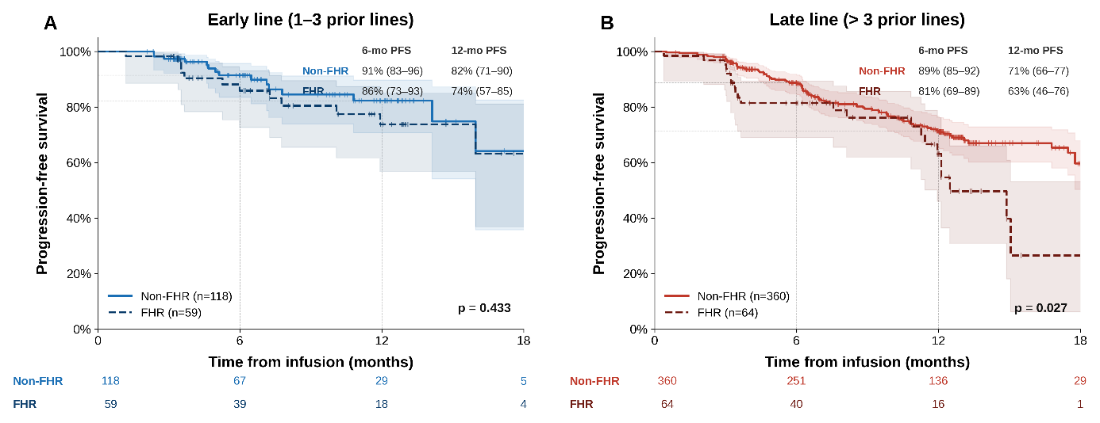

Figure S2. Bridging outcomes.
Kaplan-Meier estimates of PFS in (A) the Early-line bridging cohort (1-3 prior lines; n=47), (B) the Late-line bridging cohort (>3 prior lines; n=112), and (C) the subgroup receiving talquetamab-containing bridging regardless of original line assignment (n=35). Shaded bands represent 95% confidence intervals (log-log transformation); vertical tick marks denote censored observations. 6- and 12-month landmark PFS estimates with 95% confidence intervals are shown in each panel, with numbers at risk below.
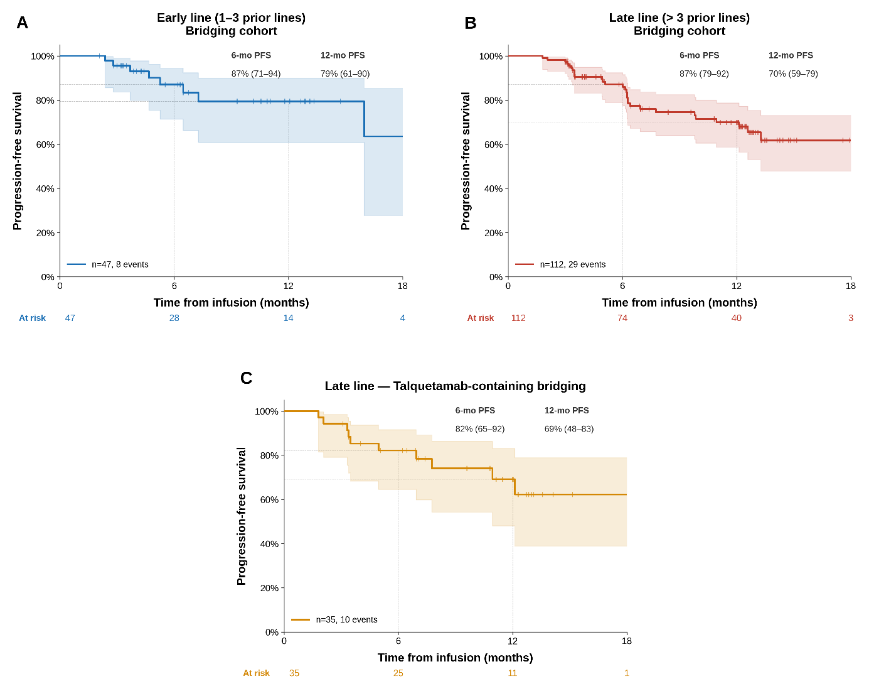

DRST members contributing to this study
Universitätsklinikum Würzburg, 85 patients
Universitätsklinikum Leipzig, 76 patients
Universitätsklinikum Köln, 70 patients
Charité - Universitätsmedizin Berlin, 68 patients
Universitätsklinikum Heidelberg, 57 patients
Universitätsklinikum Freiburg, 42 patients
Universitätsklinikum Essen, 32 patients
Universitätsklinikum Carl Gustav Carus a. d. TU Dresden, 31 patients
Universitätsklinikum Hamburg-Eppendorf, 30 patients
Universitätsklinikum Tübingen, 25 patients
Universitätsklinikum Regensburg, 18 patients
Universitätsklinikum Schleswig-Holstein / Campus Kiel, 14 patients
Universitätsklinikum Hamburg-Eppendorf, Klinik für Stammzelltransplantation, 12 patients
TUM Universitätsklinikum, Klinikum rechts der Isar, 11 patients
Med. Hochschule Hannover, 9 patients
Knappschaft Kliniken Universitätsklinikum Bochum, 7 patients
Klinikum Chemnitz gGmbH, 6 patients
Robert-Bosch-Krankenhaus, 4 patients
Asklepios Klinik St. Georg, 2 patients
Univ.-Klinikum Gießen und Marburg GmbH, 2 patients
Universitätsklinikum Halle (Saale), 1 patient
Universitätsklinikum Magdeburg A. ö. R., 1 patient
Klinikum Nürnberg Nord, 1 patient
Universitätsklinikum Erlangen, 1 patient

