Supplementary Method S1: Materials & methods for ex-vivo experiments
Library preparation and sequencing
All DNA fragments were subjected to end-repairing, A-tailing and ligation with indexed sequencing adapters sequentially. Libraries were then amplified by PCR and purified using Agencourt AMPure XP beads. DNA libraries were pooled for hybridization using customized xGen lockdown probes (Integrated DNA Technologies) for whole-exome genes (xx tissue samples only) and Target enrichment was performed using a panel of 475 Haematolymphoid tumor-related genes separately (47 parallel tissue, CSF and plasma samples). Captured libraries were subjected to PCR amplification with KAPA HiFi HotStart ReadyMix (KAPA Biosystems) with optimized protocols. The purified library was quantified using the KAPA Library Quantification Kit (KAPA Biosystems), and its fragment size distribution was analyzed using a Bioanalyzer 2100. Enriched libraries were amplified and subjected for NGS on Illumina Novaseq platforms (Illumina) using paired-end sequencing in a testing laboratory (Nanjing Geneseeq Technology, Inc., Nanjing, China) accredited by the Clinical Laboratory Improvement Amendments (CLIA) and the College of American Pathologists (CAP). The depth of coverage of the 475 panel was 1000x and for WES was 200x, which was controlled by data collection software (Illumina). Specifically, ctDNA underwent end-repairing, A-tailing, adapter ligation, and size selection using Agencourt AMPure XP beads (Beckman Coulter). The libraries were then subjected to PCR amplification and purification before targeted enrichment.

DNA extraction from tumor tissues, cerebrospinal fluid and plasma
Next-generation sequencing (NGS) was done on samples from tumor tissue, CSF, and plasma. The tumor tissue cell content of formalin-fixed, paraffin-embedded (FFPE) sections from PCNS-LBCL patients was determined by a pathologist. DNA was extracted from FFPE specimen using QIAamp DNA FFPE Tissue Kit (Qiagen), according to the manufacturers’ protocols. Sequencing libraries were prepared using the KAPA Hyper Prep Kit (KAPA Biosystems). Genomic DNA was sheared into 200-350 bp fragments using the Covaris M220 instrument (Covaris). Cerebrospinal fluid (CSF) samples were collected and transported to the laboratory at 4°C, and cfDNA was extracted from the supernatants of CSF samples (1,800 g × 10 min) within 48 h of collection. The median volume of CSF samples used for cfDNA extraction was 2ml (range, 1–5 ml). Peripheral blood (8-10 ml) was collected at specified intervals in Streck cfDNA Blood Collection Tubes and processed within 48 hours to isolate ctDNA. Oral swab DNA was prepared by QIAamp DNA Mini Kit(Qiagen) as control for germline mutations. CtDNA was extracted from CSF and plasma using a Circulating Nucleic Acid Kit (Qiagen, Hilden, Germany) following the manufacturer’s protocol and stored at -80°C until further analysis. Fragment distribution was determined on a Bioanalyzer 2100 using a High Sensitivity DNA Kit (Agilent Technologies, Santa Clara, CA, USA). The DNA quality was assessed using NanoDrop 2000 (Thermo Fisher Scientific), and the quantity was measured using dsDNA HS Assay Kit (Life Technologies) on Qubit 2.0. Tumor genomic DNA was extracted and fragmented into ~300 to 350 bp to prepare sequencing libraries.

Sequencing data processing
FASTQ files were processed with Trimmomatic for quality control. 2 samples failed quality checks and were excluded from the study. Sequencing data were mapped to the Human Genome version 19(hg19) using the Burrows-Wheeler Aligner. PCR duplicates were removed by Picard (available at: https://broadinstitute.github.io/picard/) and the Genome Analysis Toolkit (GATK) was used to perform local realignments around indels and base quality recalibration. single nucleotide variants (SNVs) and insertions/deletions (INDELs) were called by VarScan2 and HaplotypeCaller/UnifiedGenotyper in GATK, germline mutations were excluded by comparing matched oral swab DNA, and with the mutant allele frequency (MAF) cutoff as 0.5% and a minimum of three unique mutant reads. Common SNPs were removed using dbSNP and the 1000 Genome project. The resulting somatic variants were further filtered through an in-house list of recurrent sequencing errors that were generated from over 10,000 normal control samples on the same sequencing platform. Annotation was conducted using ANNOVAR.
Copy number variations (CNVs) were called as losses or gains relative to the overall sample-wide estimated ploidy. Arm gain or loss was called when more than 50% of the chromosome have copy number gain or loss. Gene fusion (common fusion regions/introns captured in the target panel) was called using DELLY. Structural variants were detected using FACTERA with the default parameter.
Likely germline mutations were identified using a computational prediction method, namely Toseq (Genseeq Technology), which is an algorithm developed using machine learning based on past archived patients’ mutational features.

PDX model
Fresh surgical specimens were enzymatically dissociated into single-cell suspensions, and 5×10⁵ cells were stereotactically implanted into the brains of 6-8-week-old female NOD.Cg-Prkdc^{scid}Il2rg^{tm1Sug}/JicCrl (NOG) mice (Charles River, Shanghai, China). Using a stereotaxic apparatus, mice were immobilized and the Bregma point was identified as the reference point, followed by localization of the Lambda suture to ensure horizontal skull alignment. After calibration, the microinjector was positioned at stereotaxic coordinates (ML: +3.0 mm, AP: -1.0 mm, DV: -2.0 mm relative to Bregma) and cells were infused intracranially at a rate of 0.2 μl/min. Mice were monitored at least three times a week and sacrificed when neurological symptoms became critical or more than 20% body weight loss was noted compared to that at implantation.
For in vivo experiments, the mice were treated with either vehicle, Orelabrutinib (20mg/kg, i.p.) (M10095, Abmole, Houston, TX, USA), Ibrutinib (20mg/kg, i.p.) (M1825, Abmole, Houston, TX, USA), Zanubrutinib (20mg/kg, i.p.) (M10025, Abmole, Houston, TX, USA) for 3 weeks or treated with either vehicle, Orelabrutinib (20mg/kg, i.p.), MTX (10mg/kg, i.p.) (M2228, Abmole, Houston, TX, USA), or the combination for 3 weeks. All animal studies were approved by the Animal Experimentation Ethics Committee of Fudan University (2023-HSYY-241-JZS). The animal study was also conducted in accordance with the Animal Research: Reporting of In Vivo Experiments guidelines and the ARRIVE guidelines.

Cell culture
HEK293T cells, U2932 cells and TMD8 cells were purchased from National Collection of Authenticated Cell Cultures. Cells were recently authenticated by STR profiling and characterized by mycoplasma detection and cell vitality detection. HEK293T cells were cultured in Dulbecco’s modified Eagle’s medium (DMEM) (C11995500, Gibco, Carlsbad, CA, USA) with 10% FBS, 2 mM L-glutamine, and antibiotics. U2932 cells and TMD8 cells were cultured in RPMI 1640 (C11875500, Gibco, Carlsbad, CA, USA) with 10% FBS, 2 mM L-glutamine, and antibiotics. Cells were grown at 37 °C in a humidified atmosphere containing 5% CO₂. Primary lymphoma cells from patient-derived samples and PDX models were sorted using anti-human CD19 Microbeads (130050301, Miltenyi, Bergisch Gladbach, Germany), and were were cultured in serum-free EF20 medium which is composed of Neurobasal medium with 1x B27 supplement (Gibco, Carlsbad, CA, USA), 0.25x N2 (Gibco, Carlsbad, CA, USA), L-glutamine (3 mM, Gibco, Carlsbad, CA, USA), 1x Antibiotic-Antimycotic (Gibco, Carlsbad, CA, USA), 20ng/ml recombinant human EGF (Stem Cell, Vancouver, Canada), and 20ng/ml recombinant human FGF (Stem Cell, Vancouver, Canada).

Flow cytometry analyses
For flow cytometry, surface antigens of primary cell suspensions were stained with fluorophore-conjugated antibodies in FACS buffer for 30 min at 4 °C in the dark. For intracellular staining, cells were stimulated with 30 nM PMA (P1585, Sigma–Aldrich, St. Louis, MO, USA) and 1 μM ionomycin (M3621, Abmole, Houston, TX, USA) in the presence of 2 μg/ml brefeldin A (M2294, Abmole, Houston, TX, USA) for 4–6 h at 37 °C. Following surface staining, the cells were fixed with fixation buffer (554655, BD, New Jersey, USA), and intracellular staining was performed using 1x permeabilization buffer (554723, BD, New Jersey, USA) for 30 min at RT. The following fluorescently labeled antibodies were used for cell staining: Annexin V Apoptosis Detection Kit (AD11, Dojindo, Kumamoto, Japan), APC-conjugated anti-human CD19 antibody (302211, BioLegend, San Diego, CA, USA), FITC-conjugated anti-human CD19 antibody (302256, BioLegend, San Diego, CA, USA). PerCP-conjugated anti-human Ki67 antibody (350520, BioLegend, San Diego, CA, USA). Data were acquired using CytoFLEX flow cytometer and analyzed with CytExpert or FlowJo 10.8.1 software.

High performance liquid chromatography-mass spectrometry
The high performance liquid chromatography-mass spectromy (HPLC-MS) method was utilized to quantify drug concentrations in plasma and brain tissue. Plasma samples were isolated from mice peripheral blood by centrifugation at 3,000 × rpm for 10 minutes, while brain tissue samples were homogenized. All samples were treated with pre-chilled acetonitrile, incubated for 1 hour, and centrifuged at 14,000 × rpm for 10 minutes to remove protein precipitates. After lyophilization, the samples were reconstituted in an organic phase:aqueous phase (4:1) solution. Quantitative analysis was performed using an ACQUITY UPLC I-Class/Xevo TQ-XS IVD system (Waters, Framingham, Massachusetts, USA). Quantification was achieved by establishing calibration curves using reference standards of orelabrutinib, ibrutinib, and zanubrutinib, followed by computational derivation of drug concentrations, respectively.

Plasmids
pCMV3-BTK-Myc plasmid (HG10578-CM) and pCMV3-PIM1-HA plasmid (HG11537-CY) were purchased from Sino Biological Inc (Beijing, China). pcDNA3.1+/C-(K)-MYD88-DYK plasmid (OHu21475) was purchased from Genescript (Nanjing, China). The MYD88-L265P mutation was constructed using primer pair 5’- GCCCATCAGAAGCGACCGATCCCCA-3’ and 5’- TGATGGGGATCGGTCGCTTCTGATG-3’. PIM1-S36A mutation was constructed using primer pair 5’-AAGGAGCCCCTGGAGGCGCAGTACC-3’ and 5’-TGGTACTGCGCCTCCAGGGGCTCCT-3’. PIM1-S261A mutation was constructed using primer pair 5’-AGAGGGTCTCTGCAGAATGTCAGCA-3’ and 5’-GATGCTGACATTCTGCAGAGACCCT-3’.

Quantitative real-time PCR
Total RNA was extracted using TRIzol (12183555, Invitrogen, CA, USA) according to the manufacturer’s instructions. Total cellular RNA was reverse transcribed using oligo(dT) primers and M-MLV reverse transcriptase (AE301-02, Transgen Biotech, Beijing, China). qPCR was carried out using FastStart Universal SYBR Green Master MIX (Roche) on QuantStudio 3 Real-Time PCR system (Applied Biosystems). Relative mRNA expression was calculated using the 2^{−∆∆Ct} method and normalized to GAPDH gene. The PCR primer sequences were as follows:
GAPDH forward, 5ʹ- GTCTCCTCTGACTTCAACAGCG-3ʹ;
GAPDH reverse, 5ʹ- ACCACCCTGTTGCTGTAGCCAA-3ʹ;
MYD88 forward, 5ʹ- GAGGCTGAGAAGCCTTTACAGG-3ʹ;
MYD88 reverse, 5ʹ- GCAGATGAAGGCATCGAAACGC-3ʹ;
PIM1 forward, 5ʹ- TCTACTCAGGCATCCGCGTCTC-3ʹ;
PIM1 reverse, 5ʹ- CTTCAGCAGGACCACTTCCATG-3ʹ.

Lentivirus production and PIM1 overexpression
HEK293T cells are transfected with pMD2.G, psPAX2 and PIM1 lentiviral overexpression plasmids. Collect the virus-containing supernatant 48h after transfection, and concentrate the virus using Lentivirus Concentration Solution (LT007, GeneCopoeia, China). Viral particles are aliquoted and stored at -80 °C for later use. For TMD8 cells infection, PIM1 overexpression viral particles were added to the cells together with 8 μg/mL polybrene. After 48h, cells were screened with puromycin (HY-B1743A, MedChemExpress, NJ, USA) for subsequent experiments.

Bioluminescence imaging and analysis
A total of 2 × 10⁵ U2932-luc cells were injected into NOG mice brain via stereotaxic apparatus. The infiltration of lymphoma cells was monitored on days 7, 14, 21 and 28 after transplantation. For bioluminescence imaging, mice were anesthetized and injected with 150 mg/kg of D-luciferin (i.p., 15mg/ml in PBS). Imaging was completed between 10 and 15 min after injection and was performed with AniView 100/600X in Vivo Imaging System coupled to live image acquisition and analyzed with AniView X Software (BLT Photon Technology, Guangdong, China).

Western blot and immunoprecipitation (IP) analyses
Proteins were extracted from cells with RIPA lysis buffer (R0020, Solarbio, Beijing, China). The protein concentrations were measured using BCA protein assay kits (P0012, Beyotime Technology, Shanghai, China). For co-immunoprecipitation (Co-IP) assays, cells were harvested and lysed in ice-cold lysis buffer containing 50 mM Tris-HCl (pH 7.4), 150 mM NaCl, 1 mM EDTA, 1% Triton X-100, 0.25% sodium deoxycholate, 10% glycerol, and 100 μM phenylmethylsulfonyl fluoride (PMSF) supplemented with a protease inhibitor cocktail for 30 min at 4°C. To evaluate ubiquitination levels, cells were incubated with 10 μM proteasome inhibitor MG132 (C2211, Sigma-Aldrich, St. Louis, MO, USA) for 6 h before harvesting, with MG132 additionally incorporated into the lysis buffer. Following lysis, cellular debris was removed by centrifugation at 12,000 × rpm for 30 min at 4°C. The clarified protein supernatants were subsequently incubated with antibody-conjugated magnetic beads overnight at 4°C under continuous rotation. Immunoprecipitated complexes were washed five times with lysis buffer to minimize nonspecific binding and subjected to immunoblot analysis. The protein extracts were separated by SDS-polyacrylamide gel electrophoresis (SDS‒PAGE) and subjected to immunoblot analysis. Images were obtained with GE Amersham Imager 600 chemiluminescence imaging system (GE, USA). Anti-beta-actin antibody (66009-1-Ig, Proteintech, Wuhan, China), Anti-MYD88 antibody (ab133739, Abcam, Cambridge, UK), Anti-PIM1 antibody (ab300453, Abcam, Cambridge, UK), Anti-BTK antibody (ab208937, Abcam, Cambridge, UK), anti-DDDDK-tag antibody (PM020, MBL, Beijing, China), anti-HA-tag antibody (561, MBL, Beijing, China), anti-Myc-tag antibody (562, MBL, Beijing, China) were used as primary antibodies.

Immunofluorescence staining
For immunofluorescence staining, tissues or cells were fixed in 4% paraformaldehyde for 15 min at room temperature, perme- abilized with 0.5% Triton X-100 for 15 min, and blocked with 3% BSA for 30 min at 37◦C. Anti-PIM1 antibody (ab308006, Abcam, Cambridge, UK) and Anti-BTK antibody (8547T, Cell Signaling Technology, MA, USA) were used as primary antibodies, and multiple immunofluorescence staining kit (abs50012, Absin, Shanghai, China) was adopted for fluorescence staining. Antifade mounting medium containing DAPI (S2110, Solarbio, Beijing, China) was used for slide mounting. Images were acquired via a THUNDER Imager (Leica, Germany) and co-localization analysis was performed by ImageJ 1.54 software.

Supplementary Method S2: Designs, Inclusion & exclusion criteria for clinical studies
Clinical study design
In the prospective cohort, MTD was determined as the dose estimated by isotonic regression to have toxicity probability closest to the predefined target toxicity probability of 0.3. RP2D was determined based on the safety and clinical benefit by the investigator. Details of BOIN design are outlined in Supplementary Methods.
To further confirm the efficacy of orelabrutinib for ND-PCNS-LBCL, we performed a retrospective study by analyzing the clinical cohorts in real world practice. Two retrospective cohorts were compared: cohort A, where patients received ORMD regimen as the frontline therapy at cycle (C) 1, and cohort B, where patients received RMD regimen at C1.
Both studies were approved by Institutional Review Board of Huashan Hospital, Fudan University (KY2021-726, KY2023-677) and registered at Clinicaltrial.gov (NCT05036577, NCT06115824) respectively, in adhering to the principles of the Declaration of Helsinki and Good Clinical Practices. Informed consents were obtained from each participant or their legal guardian.

Regimen combination
In phase 1 dose-escalation portion, patients who achieved confirmed/unconfirmed complete response (CR/CRu) at the end of induction therapy received the same dose of orelabrutinib maintenance until completion of 1 year maintenance, consent withdrawal of disease progression and unacceptable toxicity, death, or loss of following-up.
The dose was escalated if the dose-limiting toxicity (DLT) rate was less than 0.236, or de-escalated if the DLT rate exceeded 0.358, or retained the current dose if the DLT rate fell between 0.236 and 0.358. DLT was defined as any grade 4 hematologic toxicity, grade 3 febrile neutropenia, grade 3 thrombocytopenia, and any grade 3 non-hematologic toxicity unresponsive to supportive care measures within the first induction cycle, according to National Cancer Institute-Common Terminology Criteria for Adverse Events (NCI-CTCAE) version 5.0¹.
Dose modifications of orelabrutinib were allowed based on grade ≥3 TRAEs². Orelabrutinib delay of up to 28 days was permitted, while only two Orelabrutinib reductions were allowed³. If the AE leading to dose reductions were resolved and did not re-occur in two subsequent cycles, Ore could be resumed to the initial dose. For patients developing liver and kidney injury after treatment, the dose of MTX in the subsequent cycles should be modified upon the patients’ glomerular filtration rate (GFR), or postponed until liver or kidney function has returned to normal after symptomatic treatment⁴. No dose modifications were permitted for rituximab and dexamethasone. Details of the dose modification rules were provided in Supplementary Methods.
For the patients achieving CR/CRu at the end of induction therapy in the retrospective cohorts, hematopoietic stem cell transplantation, or routine consolidation of previous regimen, or close following-up without consolidation were the subsequent treatment per patients’ status and intention.
In retrospective portion, RMD cohort was subdivided into RM^{low}D (n=59) and RM^{high}D (n=37) group by the cutoff MTX dose at 5.5 g/m², whose median dose was 4.25±0.74 g/m² and 7.47±0.95 g/m², respectively. No significant difference of MTX dose was showed in ORMD (4.21±0.76 g/m²) and RM^{low}D cohorts.

The inclusive & exclusive criteria of clinical studies
The eligible patients were required to be 18-75 years old, with a histologically confirmed PCNS-LBCL, >10 mm lesion in enhanced brain magnetic resonance imaging (eMRI) at diagnosis and without previous systemic treatment. The patients’ performance status (PS) was ≤3 according to Eastern Cooperative Oncology Group (ECOG), with predicted survival ≥3 months and adequate organ function. Patients with prior organ transplants, immunotherapies, whole brain radiotherapy, HIV infection, retinal/vitreous or CSF involvement only were excluded.
Phase I dose-escalating study
Inclusion criteria | 1) No previous systemic treatment for primary central nervous system lymphoma;  2) Histologically proven diagnosis of diffuse large B-cell lymphoma (DLBCL); adequate tissue samples remain available after being utilized for diagnostic and preservation purposes.  3) Aged: 18-75 years;  4) ECOG performance status (PS) ≤3;  5) Predicted survival of 3 months or more;  6) Adequate function of the important organs as evident by the following criteria：  a) Blood routine examination within the past 7 days (or 14 days if pegylated myeloid growth factor was administered) without growth factor support therapy or blood transfusion indicated: absolute neutrophil count ≥1.0 × 10⁹/L, platelet ≥75 × 10⁹/L, and hemoglobin ≥80 g/L.  b) Biochemical: Total bilirubin (TBIL) ≤1.5 × upper limit of normal (ULN), or TBIL ≤3 × ULN (in confirmed Gilbert's syndrome with direct bilirubin within the normal range); aspartate aminotransferase or alanine aminotransferase ≤2.5 × ULN; serum creatinine within the normal range; estimated glomerular filtration rate ≥70 ml/min.  c) Coagulation function: International normalized ratio ≤1.5 times × ULN; activated partial thromboplastin time ≤1.5 times × ULN.  7) Being tolerated to lumbar puncture and/or had an Ommaya reservoir in place.；  8) Be willing and able to provide written informed consent for the trial, and comply with all aspects of the protocol.
Exclusion criteria | 1) Invasion outside the CNS confirmed by physical examination;  2) Uncontrolled or important cardiovascular disease：  a) Within 6 months prior to the initial administration of the investigational drug, participants experienced New York Heart Association (NYHA) class III-IV congestive heart failure, unstable angina, myocardial infarction, or clinically significant or treatable arrhythmias identified at screening, with left ventricular ejection fraction (LVEF) <50%; if patients had controlled symptoms of coronary artery disease, were not taking anticoagulants/antiplatelet drugs, or had only taken one anticoagulant or antiplatelet drug orally for more than 6 months, and met other inclusion criteria, they were eligible for enrollment in this study, with close monitoring of bleeding risk during treatment;  b) Primary cardiomyopathies (such as dilated cardiomyopathy, hypertrophic cardiomyopathy, arrhythmogenic right ventricular cardiomyopathy, restrictive cardiomyopathy, and unclassified cardiomyopathy);  c) A history of clinically significant QTc interval prolongation or QTc interval >470 ms for females and >480 ms for males during screening;  d) Difficult-to-control hypertension (blood pressure remains uncontrolled despite the use of two or more antihypertensive medications at maximum tolerated doses, including diuretics, for at least 1 months, or requires three or more antihypertensive medications to achieve effective control);  3) Active bleeding within 2 months before screening, or current use of anticoagulant/antiplatelet medications for less than 6 months, or the investigator perceives a clear bleeding tendency (such as bleeding esophageal varices or active ulcerative lesions);  4) History of stroke or intracranial bleeding within 6 months before screening, excluding sequelae of intracranial bleeding after surgery;  5) History of organ transplantation or allogeneic bone marrow transplantation;  6) Undergoing surgical procedures within 6 weeks before screening, with diagnostic procedures not considered as surgical procedures exempt from this exclusion criterion.  7) Use of anti-tumor herbal medicines (such as FuFangBanMaoJiaoNang) within 4 weeks before screening;  8) Active or uncontrolled hepatitis B virus (HBV) infection (HBsAg positive and/or HBcAb positive with positive HBV DNA), HCV Ab positive, or HIV positive. Patients meeting the following criteria can be enrolled if receiving prophylactic anti-HBV treatment (such as entecavir or tenofovir):  a) HBsAg positive with negative HBV DNA titre  b) HBsAg negative, HBsAb negative, HBcAb positive, and negative HBV DNA titre  9) Uncontrolled active systemic fungal, bacterial, viral, or other infections (defined as persistent symptoms/signs related to infection, despite appropriate antibiotic or other treatment, or requiring intravenous antibiotic therapy);  10) Receipt of live vaccines or immunomodulatory agents within 4 weeks before enrollment;  11) Requirement for concurrent use of moderate to strong inhibitors or inducers of cytochrome P450 CYP3A;  12) Known hypersensitivity to apatinib or excipients (hydroxypropyl methylcellulose acetate succinate, mannitol, croscarmellose sodium, hydroxypropyl cellulose, colloidal silicon dioxide, and magnesium stearate), including anaphylaxis or anaphylactoid reactions;  13) Clinically significant gastrointestinal abnormalities that may affect drug intake, transport, or absorption (such as dysphagia, chronic diarrhea, intestinal obstruction, etc.), or total gastrectomy subjects;  14) History or current diagnosis of conditions such as pulmonary fibrosis, interstitial pneumonia, pneumoconiosis, radiation pneumonitis, drug-related pneumonia, or severe impairment of lung function;  15) Chronic liver damage, severe fatty liver, or alcoholic liver disease；  16) Be willing to undergo autologous stem cell transplantation;  17) Pregnant or lactating women, or fertile women unwilling to use contraception during the entire study period or within 180 days after the last dose of the study drug (serum pregnancy test results must be negative within 14 days before the start of the study drug treatment for women of childbearing potential). Non-surgically sterilized men unwilling to use contraception during the entire study period and within 180 days after the last dose of the study drug;  18) Life-threatening conditions or severe organ dysfunction deemed unsuitable for participation in the trial by the investigator;  19) Any psychiatric or cognitive disorders that may limit understanding of the informed consent, compliance with the study procedures, or adherence to the study treatment.  20) Invasion limited to the retina and vitreous;  21) Presence of prior whole-brain radiotherapy for primary central nervous system lymphoma.
Retrospective study
Inclusion criteria | 1)Histologically or cytologically confirmed diagnosis of primary diffuse large B-cell lymphoma of the central nervous system (PCNS-LBCL);  2)Completion of at least 2C of systematic chemotherapy at Huashan Hospital.  3)Methotrexate plus rituximab-based regimen ± orelabrutinib as the first-line treatment;  4)Presence of a well-defined enhancing lesion on CT or MRI, visible on at least two axial slices with a thickness of ≥5 mm, with both perpendicular diameters >10 mm;  5)Age: 18-75 years;  6)ECOG PS ≤3;  7) No significant organ dysfunction, and able to tolerate combined immunochemotherapy
Exclusion criteria | 1)Secondary central nervous system lymphoma;  2)Unable to evaluate the initial response.  3)Prior treatment with oral anti-tumor agents or radiotherapy before chemotherapy with methotrexate plus rituximab ± orelabrutinib;  4)No evaluable brain lesions on imaging;  5) Patients with immunodeficiency or HIV infection;  6)Patients with incomplete clinical outcome data;  7) Uncontrolled or significant cardiovascular diseases, including uncontrolled diabetes, severe cardiac, pulmonary, hepatic, or renal insufficiency.

Study endpoints
For the dose-escalation in the prospective cohort, the primary endpoint was to determine DLT and the RP2D of orelabrutinib and MTX in ND PCNS-LBCL. The second endpoints included ORR which was defined as the proportion of patients with CR/CRu and PR as the best response on the basis of investigator-assessed response, CRR which was defined as the proportion of patients who showed CR/CRu, duration of PFS and OS according to the revised response criteria for malignant lymphoma⁵. The other second endpoints included DoR, TTR, disease control rate (DCR) and time to failure (TTF).
For the retrospective cohort, the primary objective was to evaluate the efficacy of ORMD regimen measured as ORR and CRR. The secondary endpoints included PFS and OS. Safety and toxicity profiles were also the secondary end points and were assessed with NCI-CTCAE v.5.0¹.

Assessment of clinical responses
The tumor was assessed using eMRI and CSF cytology according to International PCNS-LBCL Collaborative Group (IPCG) guidelines⁶, at the baseline and every two cycles during induction therapy, and every twelve weeks afterwards. Safety assessments included physical examination, vital signs, ECOG PS, routine blood tests, blood biochemistry tests, electrocardiography, echocardiography, and AEs. AEs were monitored from the first dose of the study drug until 28 days after the last dose of the study drug and were graded according to NCI-CTCAE v.5.0¹. Involvement of deep brain regions were defined as the lesion involving periventricular areas, basal ganglia, brainstem, and cerebellum⁷. Detailed procedure of prophylactic measures and treatment of intraocular / CSF involvement were provided in Supplementary Methods.

Biomarker detection
In prospective phase I portion, WES was conducted on fresh or FFPE tumor samples with paired plasma ctDNA which was detected by a customized 475-gene panel relating to B-cell malignancies at the disease onsets⁸. CSF was sampled for ctDNA analysis at predefined time points: baseline, C3D-1, C5D-1, C7D-1, and every 3 months afterwards. To determine the orelabrutinib concentrations, supplementary CSF and plasma samples were collected 3 hours after the oral dose of orelabrutinib on C3D1, when the concentration in CSF and peripheral blood reached the steady state.
Somatic mutations were visualized using the R package "maftools"⁹. Driver genes were identified across CSF, plasma and tissue samples using the OncodriveCLUST algorithm¹⁰. As reported in previous studies, if ≥1 mutant variant detected in CSF-ctDNA was also identified in patient-matched tissue, or at least one mutant variant detected in CSF-ctDNA was canonical driver mutation in DLBCL, the patient were classified as CSF-ctDNA positive at relative time points^{8,11-14}.

Statistical analysis
An α level of 0.05 was used for all statistical tests. All statistical analyses were performed using SPSS software (version 26.0; IBM Corp., Armonk, NY, USA), GraphPad Prism (version 8.0.1, GraphPad Software, San Diego, USA), SAS (version 9.4; SAS Institute, Cary, North Carolina) and R software (version 4.3.1; R Foundation for Statistical Computing, Vienna, Austria).
In the prospective dose-escalation cohort, the sample size was determined to be 12-20 patients according to BOIN design algorithm. Demographic characteristics were described and efficacy were analyzed in the full analysis set comprising patients who received at least one dose of the study drug following the intention to treat principle (ITT). The safety analysis set included patients who received the study drug at least once and underwent at least one safety assessment. DLT set comprised patients who completed the first cycle of induction therapy.
Continuous variables were described by means and standard deviations (SD) if normally distributed, and by medians and interquartile ranges if normality cannot be assumed. Categorical variables were described using frequency and percentage per category. All experiments were carried out with n ≥ 3 biological replicates. Multiple group comparisons were performed with a one-way analysis of variance (ANOVA), following Tukey’s test. Two group comparisons were performed with paired two-tailed t-test. The correlation between groups was determined by Pearson’s correlation test. For the panel with 475 gene set related to B-cell malignancies across the three samples, McNemar’s test was applied, and Cohen’s Kappa Coefficient was employed to assess the consistency of mutations.
The survival rates were analyzed by the Kaplan-Meier method. The Clopper–Pearson method was used to calculate the two-sided 95% confidence intervals for ORR, CRR, and DCR which was defined as the proportion of patients achieving CR, PR, and stable disease values. DoR, PFS, OS, TTR and TTF, along with their associated two-sided 95% CIs were calculated using Kaplan–Meier method. Comparisons for DoR, PFS, OS, TTR, and TTF were conducted using log-rank test, with corresponding p-values calculated to assess statistical significance.
Propsensity matching analysis (PSM) was implemented to the retrospective cohort to balance the baseline characteristics covariance between the OMD and ORMD cohorts, where covariates included sex, subtype of DLBCL, surgery type, β2-microglobulin, Ki67, MTX dosage, transplantation consolidation, IELSG and MSKCC prognostic scores were compromised in the PSM model. Before conducting PSM, two variables with missing value, β2-microglobulin and Ki67 underwent systematic multiple imputation procedures. The matching metric was chosen as cardinality, with the average treatment effect on the treated as target estimand desired, and matching ratio was set as 1:2. Balance criterion was tolerance threshold for standardized differences ≤0.05 SD across all covariates, solver highs algorithm was utilized for optimal solution convergence. The matched dataset was subsequently analyzed using multivariable Cox proportional hazards regression model and multivariable logistic regression model. The PSM was implemented via the matchIt R package and multiple imputation was executed using the mice R package.

Supplementary Method S3: The decision of dose escalation and de-escalation
The decision of dose escalation and de-escalation involves only a simple comparison of the observed dose-limiting toxicity (DLT) rate at the current dose with a pair of fixed, prespecified dose escalation, and de-escalation boundaries. Specifically, let $\hat{p}$ denote the observed DLT rate at the current dose, defined as
$$\hat{p}=\frac{the number of patients experiencing DLT at the current dose}{the total number of patients treated at the current dose}$$
• If $\hat{p}$ ≤0.236, escalate the dose;
• if $\hat{p}$ >0.359, de-escalate the dose;
• otherwise, retain the current dose.
Orelabrutinib has J dose levels, whereas methotrexate has K levels. Let p_{jk} denote the true DLT probability of the combination dose (j, k). For purpose of overdose control, the BOIN design employs a dose elimination or early stopping rule as follows: eliminate combination dose (j, k) and higher levels from further examination if $P_{r} \left(p_{jk}>0.3\left|data\right.\right) >0.95$ and at least three patients are treated on dose (j, k).
Decision table of dose escalation, de-escalation, and elimination boundaries in the BOIN design with a target DLT probability of 0.3:
Scenarios | Number of patients treated at current dose
Scenarios | 1 | 2 | 3 | 4 | 5 | 6
Escalate if No. of DLTs ≤ | 0 | 0 | 0 | 0 | 1 | 1
De-escalate if No. of DLTs ≥ | 1 | 1 | 2 | 2 | 2 | 3
Eliminate if No. of DLTs ≥ | NA | NA | 3 | 3 | 4 | 4

Supplementary Method S4: Dose modifications for orelabrutinib
Orelabrutinib | Modification
Initial dose | 200 mg/day or 150 mg/day
Dose level –1 | reduced by 50 mg/day compared with the initial dose
Dose level –2 | reduced by 50 mg/day compared with the dose –1

Hematologic toxicities
Absolute neutrophil count (ANC) <0.5 × 10⁹/L (grade 4) persisting for more than 7 days (or earlier if clinically indicated). | Orelabrutinib should be suspended (with weekly monitoring of complete blood count) until ANC recovers to ≤grade 1 toxicity or baseline levels, then resume at the original dose; if recurrence, suspend orelabrutinib until recovery to ≤grade 1 toxicity or baseline levels, then resume at a reduced dose level.
ANC <1.0 × 10⁹/L (grade 3) with fever (a single temperature measurement >38.3°C or sustained temperature >38.3°C for more than 1 hour). | Orelabrutinib should be suspended (with weekly monitoring of complete blood count) until ANC recovers to ≤grade 1 toxicity or baseline levels and fever subsides, then resume at the original dose; if recurrence, suspend orelabrutinib until recovery to ≤grade 1 toxicity or baseline levels and resolution of fever symptoms, then resume at a reduced dose level.
Platelet <25 × 10⁹/L (grade 4) | Orelabrutinib should be suspended (with weekly monitoring of complete blood count) until platelet count recovers to ≤grade 1 toxicity or baseline levels, then resume at the original dose; if recurrence, suspend orelabrutinib until recovery to ≤grade 1 toxicity or baseline levels, then resume at a reduced dose level.
Platelet <50 × 10⁹/L (grade 3) with significant bleeding | Orelabrutinib should be permanently discontinued.
Nonhematologic toxicity
Grade 3 toxicity, expected to be manageable or recoverable with dose adjustment | Orelabrutinib should be suspended.
Grade 3 toxicity persists for more than 14 days | Orelabrutinib should be discontinued.
Grade 3 toxicity persists for ≤14 days and recovers to ≤grade 1 | Dose should be reduced by 1 level.
Grade 3 toxicity, with expected uncontrollable and irreversible toxicity after dose reduction (such as congestive heart failure) | Orelabrutinib should be discontinued.
Recurrent grade 3 toxicity | Suspend orelabrutinib until toxicity recovers to ≤grade 1, then reduce the dose level. If toxicity persists and does not recover to ≤grade 1 within 14 days, treatment should be discontinued.
QTc interval ≥480 and <500 ms | Continue the orelabrutinib with cardiac monitoring as clinically indicated.
QTc interval ≥500 ms | Orelabrutinib should be discontinued.

Supplementary Method S5: Dose modifications for methotrexate
For patients who experience dysfunction of liver and kidney after treatment with high-dose methotrexate (HD-MTX), the dosage of MTX for the next cycle needs adjustment if the patient’s liver and kidney function return to normal after treatment with MTX concentrations dropping to safe levels. The adjustment method is as follows: Adjust the MTX dosage based on the eGFR value obtained from renal function testing conducted before the start of the next treatment cycle. MTX dosage = MTX original dosage × eGFR value (ml/min) /100.

Supplementary Method S6: Time point of collecting CSF and peripheral blood samples for detecting Ore concentration
 | Time point * | Peripheral blood | CSF
Cycle 3 Day 1 | 01:30–02:00 hours | 3 ml | 1 ml
* time point of sample collection after dose of orelabrutinib

Supplementary Method S7: Prophylactic measures and treatment of intraocular or CSF involvement
All the patients were screened for the existence of infection diseases before the onset of immuno-chemotherapy. For the patients having >10³ hepatitis B virus (HBV)-DNA concentration, treatment of rituximab and Ore was held until HBV-DNA decreased to <10³ after antiviral therapy if the patients’ status were permitted. All the patients received orally trimethoprim-sulfamethoxazole 200mg/d as prophylaxis for pneumocystis jirovecii pneumonia, where the dose was adjusted according to the patient’s GFR.
For the patients pathologically confirmed intraocular or CSF involvement, serial intraocular injection of MTX and intrathecal injection of MTX and/or AraC was performed until the infiltrated lymphoma cells were undetectable by cytospin or fluorescence activating cell sorting analysis.

References
1. U.S. Department of Health and Human Service . Common Terminology Criteria for Adverse Events (CTCAE) U.S. Department of Health and Human Service; Washington, DC, USA: 2017. p.
2. Mohamed MR, Rich DQ, Seplaki C, et al. Primary Treatment Modification and Treatment Tolerability Among Older Chemotherapy Recipients With Advanced Cancer. JAMA Netw Open. 2024;7(2):e2356106.
3. Xu W, Zhou K, Wang T, et al. Orelabrutinib in relapsed or refractory chronic lymphocytic leukemia/small lymphocytic lymphoma patients: Multi-center, single-arm, open-label, phase 2 study. Am J Hematol. 2023;98(4):571-579.
4. Chen T, Liu Y, Wang Y, et al. Evidence-based expert consensus on the management of primary central nervous system lymphoma in China. J Hematol Oncol. 2022;15(1):136.
5. Cheson BD, Pfistner B, Juweid ME, et al. Revised response criteria for malignant lymphoma. J Clin Oncol. 2007;25(5):579-586.
6. Barajas RF, Politi LS, Anzalone N, et al. Consensus recommendations for MRI and PET imaging of primary central nervous system lymphoma: guideline statement from the International Primary CNS Lymphoma Collaborative Group (IPCG). Neuro Oncol. 2021;23(7):1056-1071.
7. Ferreri AJ, Blay JY, Reni M, et al. Prognostic scoring system for primary CNS lymphomas: the International Extranodal Lymphoma Study Group experience. J Clin Oncol. 2003;21(2):266-272.
8. Liang JH, Wu YF, Shen HR, et al. Clinical implications of CSF-ctDNA positivity in newly diagnosed diffuse large B cell lymphoma. Leukemia. 2024;38(7):1541-1552.
9. Mayakonda A, Lin DC, Assenov Y, Plass C, Koeffler HP. Maftools: efficient and comprehensive analysis of somatic variants in cancer. Genome Res. 2018;28(11):1747-1756.
10. Tamborero D, Gonzalez-Perez A, Lopez-Bigas N. OncodriveCLUST: exploiting the positional clustering of somatic mutations to identify cancer genes. Bioinformatics. 2013;29(18):2238-2244.
11. Li N, Wang BX, Li J, et al. Perioperative circulating tumor DNA as a potential prognostic marker for operable stage I to IIIA non-small cell lung cancer. Cancer. 2022;128(4):708-718.
12. Qiu B, Guo W, Zhang F, et al. Dynamic recurrence risk and adjuvant chemotherapy benefit prediction by ctDNA in resected NSCLC. Nat Commun. 2021;12(1):6770.
13. Reddy A, Zhang J, Davis NS, et al. Genetic and Functional Drivers of Diffuse Large B Cell Lymphoma. Cell. 2017;171(2):481-494 e415.
14. Wright GW, Huang DW, Phelan JD, et al. A Probabilistic Classification Tool for Genetic Subtypes of Diffuse Large B Cell Lymphoma with Therapeutic Implications. Cancer Cell. 2020;37(4):551-568 e514.

Supplementary Figure S1
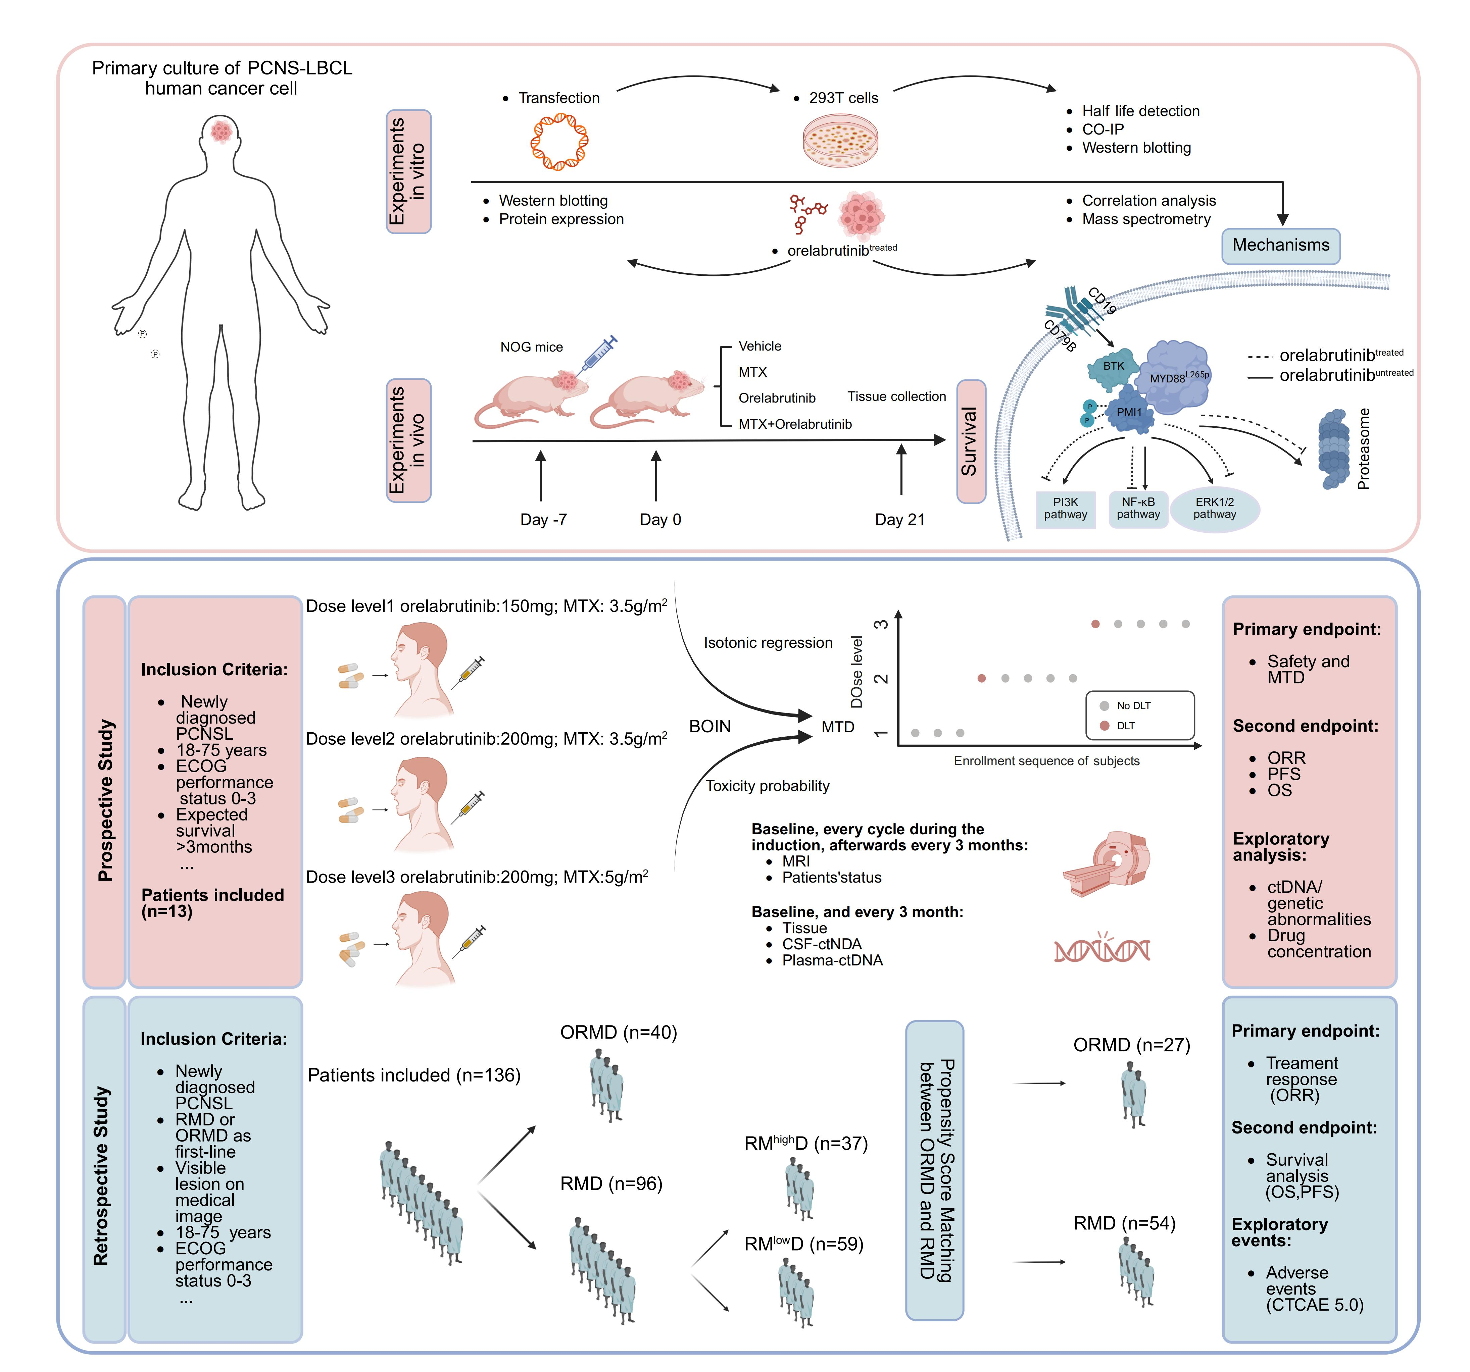
Supplementary Figure S1. Study Overview.
Upper panel, The workflow of laboratory experiments. In in-vivo animal experiments, PCNS-LBCL tumor cells were implanted into murine brain to generate PDX models. The function of BTKis on tumor cell growth were analyzed in either monotherapy or combined therapy. In in-vitro experiments, MyD88^{L265P} context was introduced into 293T cells. The underlying MyD88^{L265P} triggered mechanism was further investigated on MyD88^{L265P-}transfected cells and PCNS-LBCL cells from MyD88^{L265P}-patients or MyD88^{wt}-patients.
Lower panel, The workflow of clinical studies. A prospective BOIN based design was applied to determine the MTD of HD-MTX and orelabrutinib in 13 ND PCNS-LBCL patients. The efficacy and TRAEs of orelabrutinib incorporating regimen (n=40, ORMD) were further verified in comparison with orelabrutinib excluded regimen (n=96, RMD) in a real world cohort of ND PCNS-LNCL patients. After implementing PSM method, the baseline characteristic covariance were balanced between ORMD (n=27) and RMD (n=54) cohorts. Coefficiency of genetic mutations from tumor tissues, CSF-ctDNA and plasma-ctDNA was analyzed.
Supplementary Figure S2
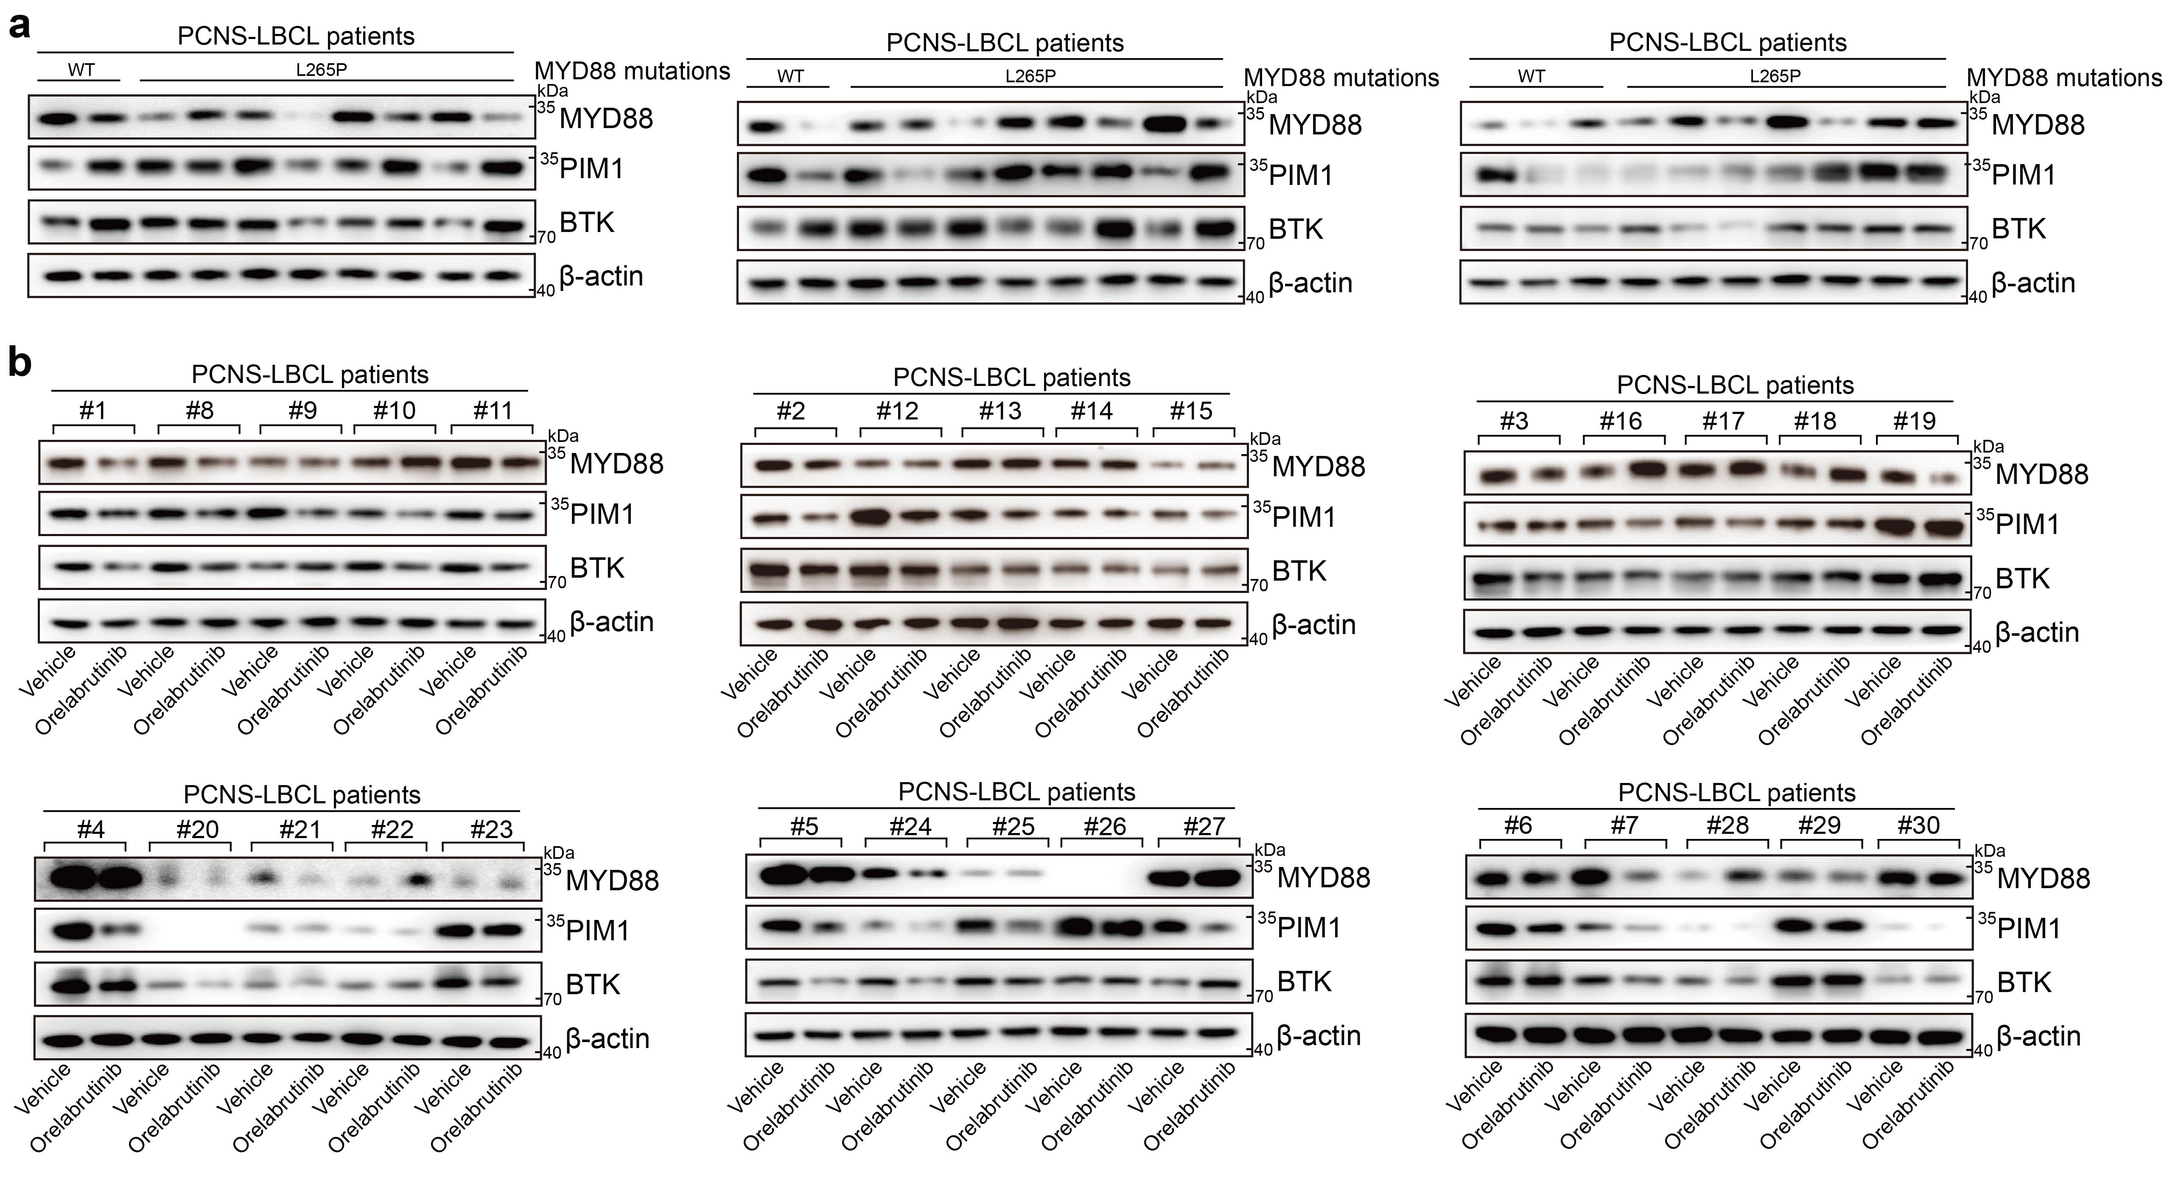
Supplementary Figure S2. Molecular mechanism of BTK-dependent regulation of PIM1 protein stability.
a, The protein levels of MYD88, PIM1, BTK and β-actin in MYD88^{WT} PCNS-LBCL tumor tissues and MYD88^{L265P} ones were detected by western blotting.
b, The primary PCNS-LBCL cells were treated with vehicle or orelabrutinib in vitro. The protein levels of MYD88, PIM1, BTK and β-actin were detected by western blotting (n=30).

Supplementary Figure S3
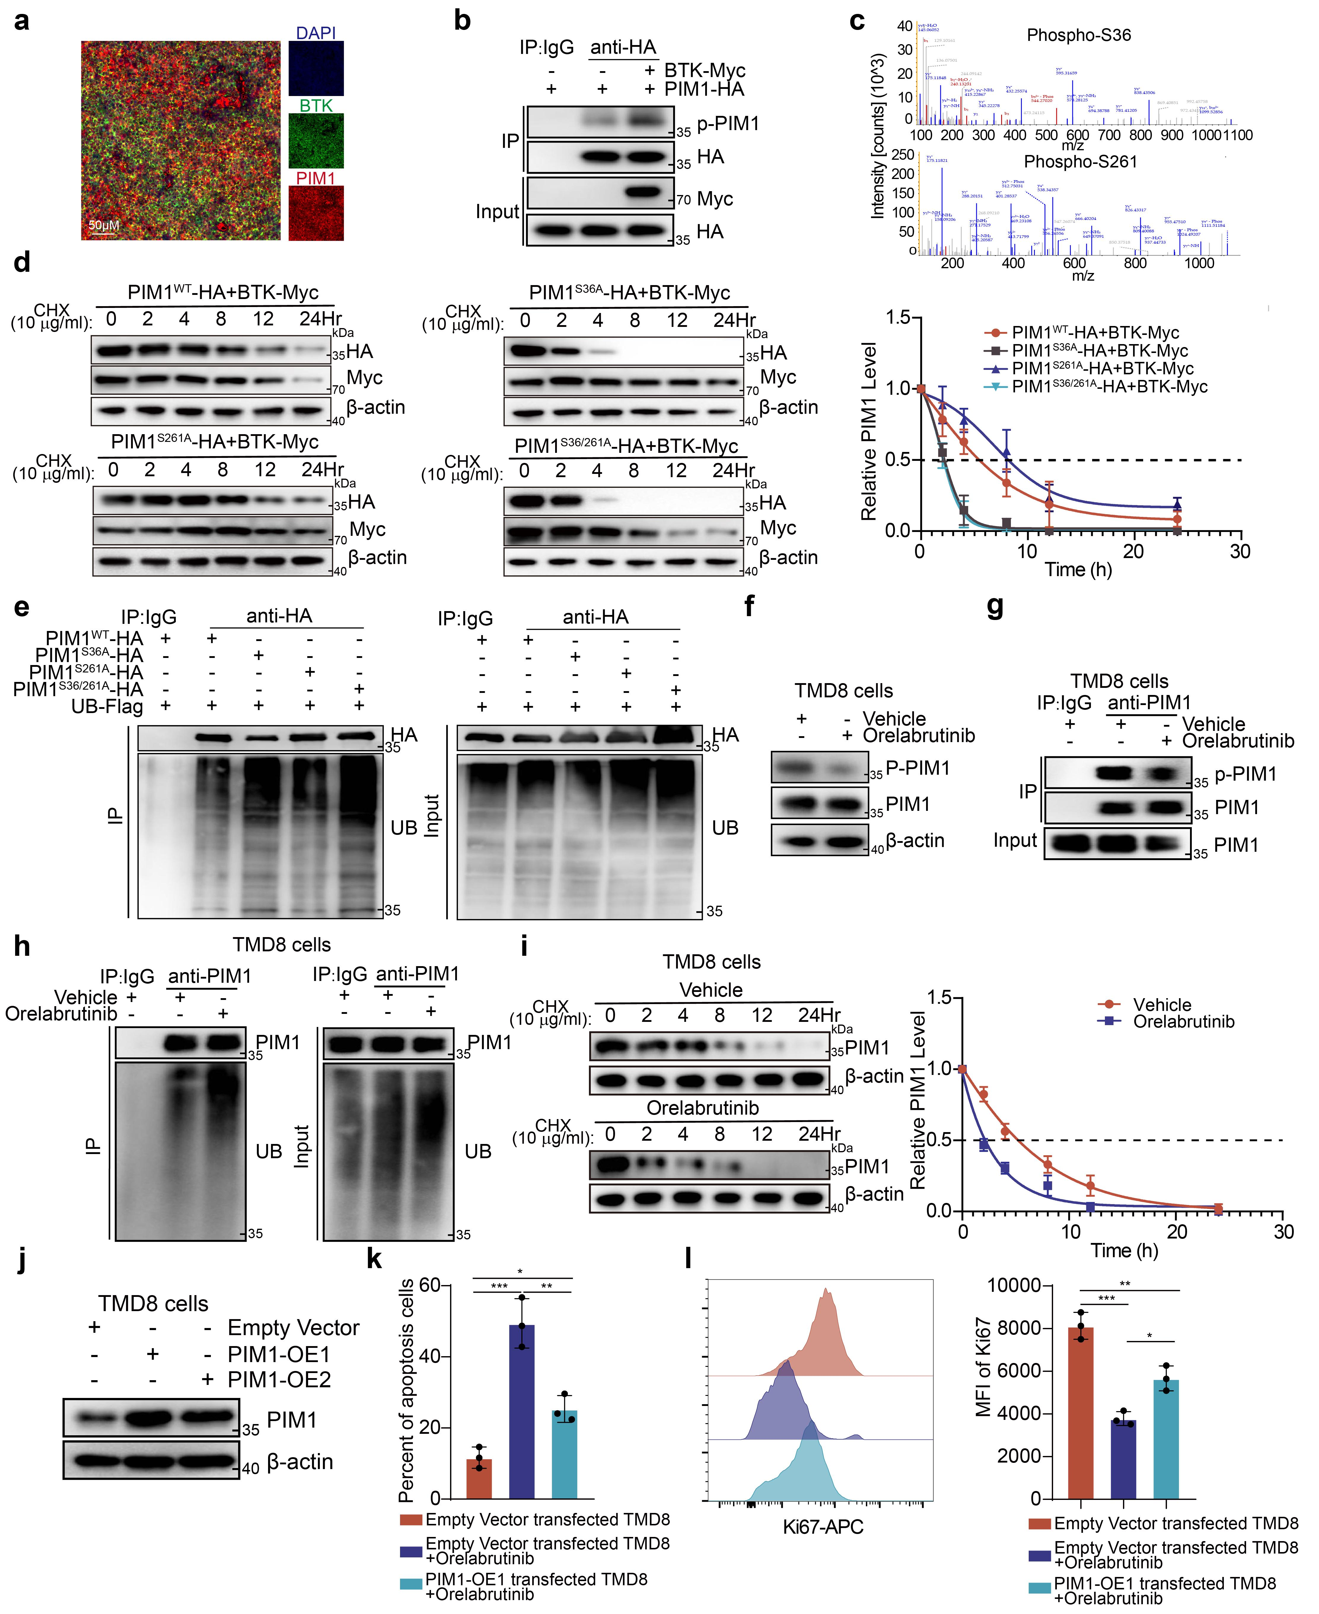
Supplementary Figure S3. BTK-mediated phosphorylation interferes with PIM1 ubiquitination and degradation.
a, Co-localization rate of PIM1 and BTK was detected by immunostaining (blue: DAPI, red: PIM1, green: BTK. Scale bar, 50 μm).
b, PIM1 phosphorylation was mediated by BTK. PIM1-HA with or without BTK-Myc plasmids were transfected into HEK293T cells. The cell extracts were immunoprecipitated with IgG or anti-HA Ab.
c, Mass spectrometry analysis identified the PIM1 phosphorylation at sites of S36 and S261.
d, Effect of BTK on the degradation of PIM1WT, PIM1S36A, PIM1S261A and PIM1S36/261A. HEK293T cells were transfected with PIM1^{WT}-HA, PIM1^{S36A}-HA, PIM1^{S261A}-HA, PIM1^{S36/261A}-HA and BTK-Myc plasmids and were incubated with CHX (10 μg/mL) for 0-24 hrs. Degradation curve of PIM1 level were fitted with 4-parameter logistic model
e, The ubiquitination levels of PIM1 protein were altered following mutations at different sites. HEK293T cells were transfected with PIM1^{WT}-HA, PIM1^{S36A}-HA, PIM1S261A-HA, PIM1^{S36/261A}-HA and UB-Flag plasmids. The cell extracts were immunoprecipitated with IgG or anti-HA Ab.
f, The expression of PIM1 and P-PIM1 was detected by western blotting in the TMD8 cells after orelabrutinib treatment.
g, PIM1 phosphorylation was mediated by BTK. TMD8 cells were treated with orelabrutinib for 24 hrs. The cell extracts were immunoprecipitated with IgG or anti-PIM1 Ab.
h, The ubiquitination levels of PIM1 protein were altered in the presence of orelabrutinib treatment. TMD8 cells were treated with orelabrutinib for 24 hrs. The cell extracts were immunoprecipitated with IgG or anti-PIM1 Ab.
i, Effect of orelabrutinib on the degradation of PIM1. TMD8 cells were treated with orelabrutinib for 24 hrs and incubated with CHX (10 μg/mL) for 0-24 hrs. Degradation curve of PIM1 level were fitted with 4-parameter logistic model.
j, After TMD8 cells were transfected with PIM1-overexpressing PIM1-OE1 and PIM1-OE2 viral particles for 48 hrs, the expression of PIM1 was determined by western blotting.
k, After treated with orelabrutinib in vitro for 24 hrs, the percentage of apoptotic cells in empty vector or PIM1-OE1 transfected TMD8 cells were quantified by flow cytometry using Annexin-V/PI staining. Data were analyzed with CytExpert software (n = 3 per group).
l, After treated with orelabrutinib in vitro for 24 hrs, the MFI of Ki67 in empty vector or PIM1-OE1 transfected TMD8 cells was measured by flow cytometry. Data were analyzed using FlowJo software (n = 3 per group).

Supplementary Figure S4
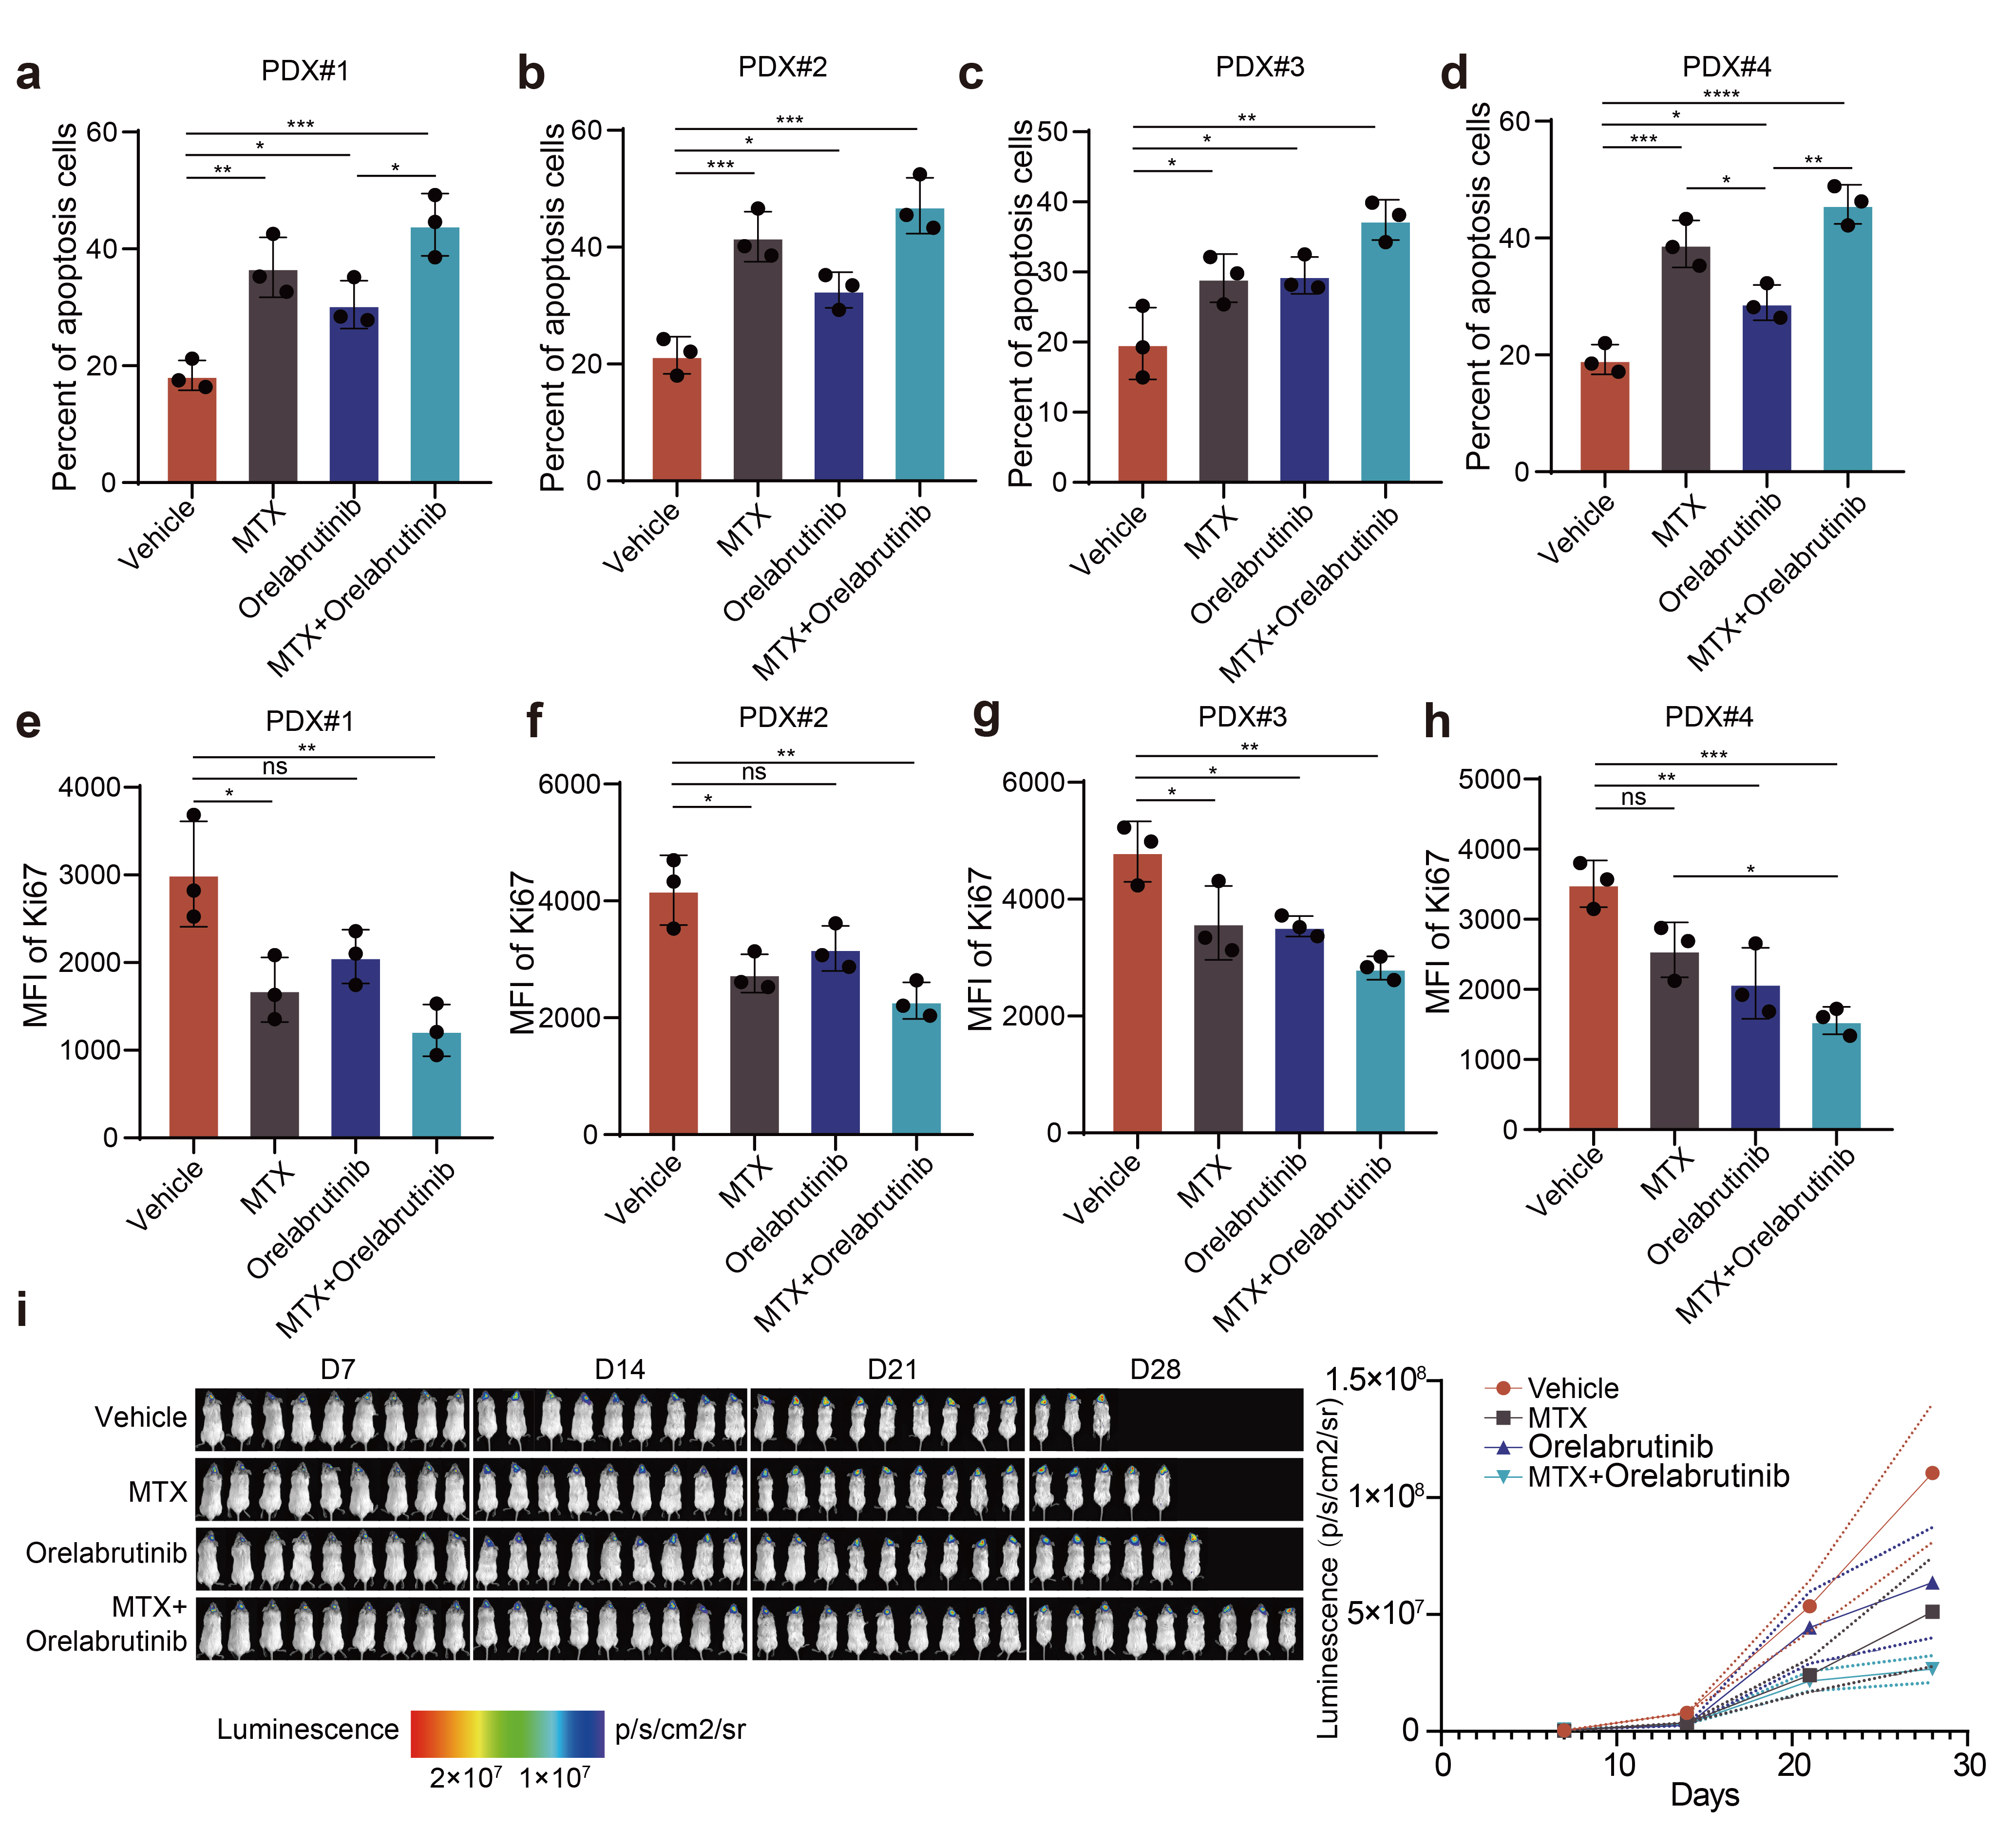
Supplementary Figure S4. BTKi promoted apoptosis of lymphoma cells and suppressed their proliferation.
a-d, The percentage of apoptotic primary lymphoma cells from the PDX#1-#4 models (a-d, respectively) which were treated with MTX and orelabrutinib for 24h in vitro, was assessed as Annexin V-positive cells by flow cytometry and CytExpert software (n=3 per group).
e-h, The MFI of Ki67 in primary lymphoma cells derived from the PDX#1-#4 models (e-h, respectively) which were treated with MTX and orelabrutinib for 24h in vitro, being assessed by flow cytometry and FlowJo software (n=3 per group).
i, The infiltration of U2932-luc cells in vivo was quantitatively monitored by a biophotonic imaging system in mice treated with MTX and orelabrutinib. Left: the infiltration of U2932-luc cells was monitored on days 7, 14, 21 and 28 after transplantation and representative images of indicated groups were shown. Right: quantification of tumor burden from mice via radiant efficiency (n = 10 per group).
Each dot represents one independent experiment. Bars, mean ± S.D. *p < 0.05, **p < 0.01, ***p < 0.001, ****p < 0.0001.
Supplementary Figure S5
Supplementary Figure S5. Kaplan-Meier survival analyses of the real-world cohort.
a, Kaplan-Meier curves for progression-free survival (PFS) and overall survival (OS) in the real-world cohort, including the ORMD group (n = 40) and the RMD group (n = 96).
b, Kaplan-Meier curves for PFS and OS in the methotrexate-based dose subgroup analysis of the real-world cohort, including the ORMD group (n = 40), the RM^{high}D group (n = 37), and the RM^{low}D group (n = 59).
# RM^{high}D and RM^{low}D were exploratorily defined using a methotrexate dose cutoff of 5.5 g/m².

Supplementary Figure S6
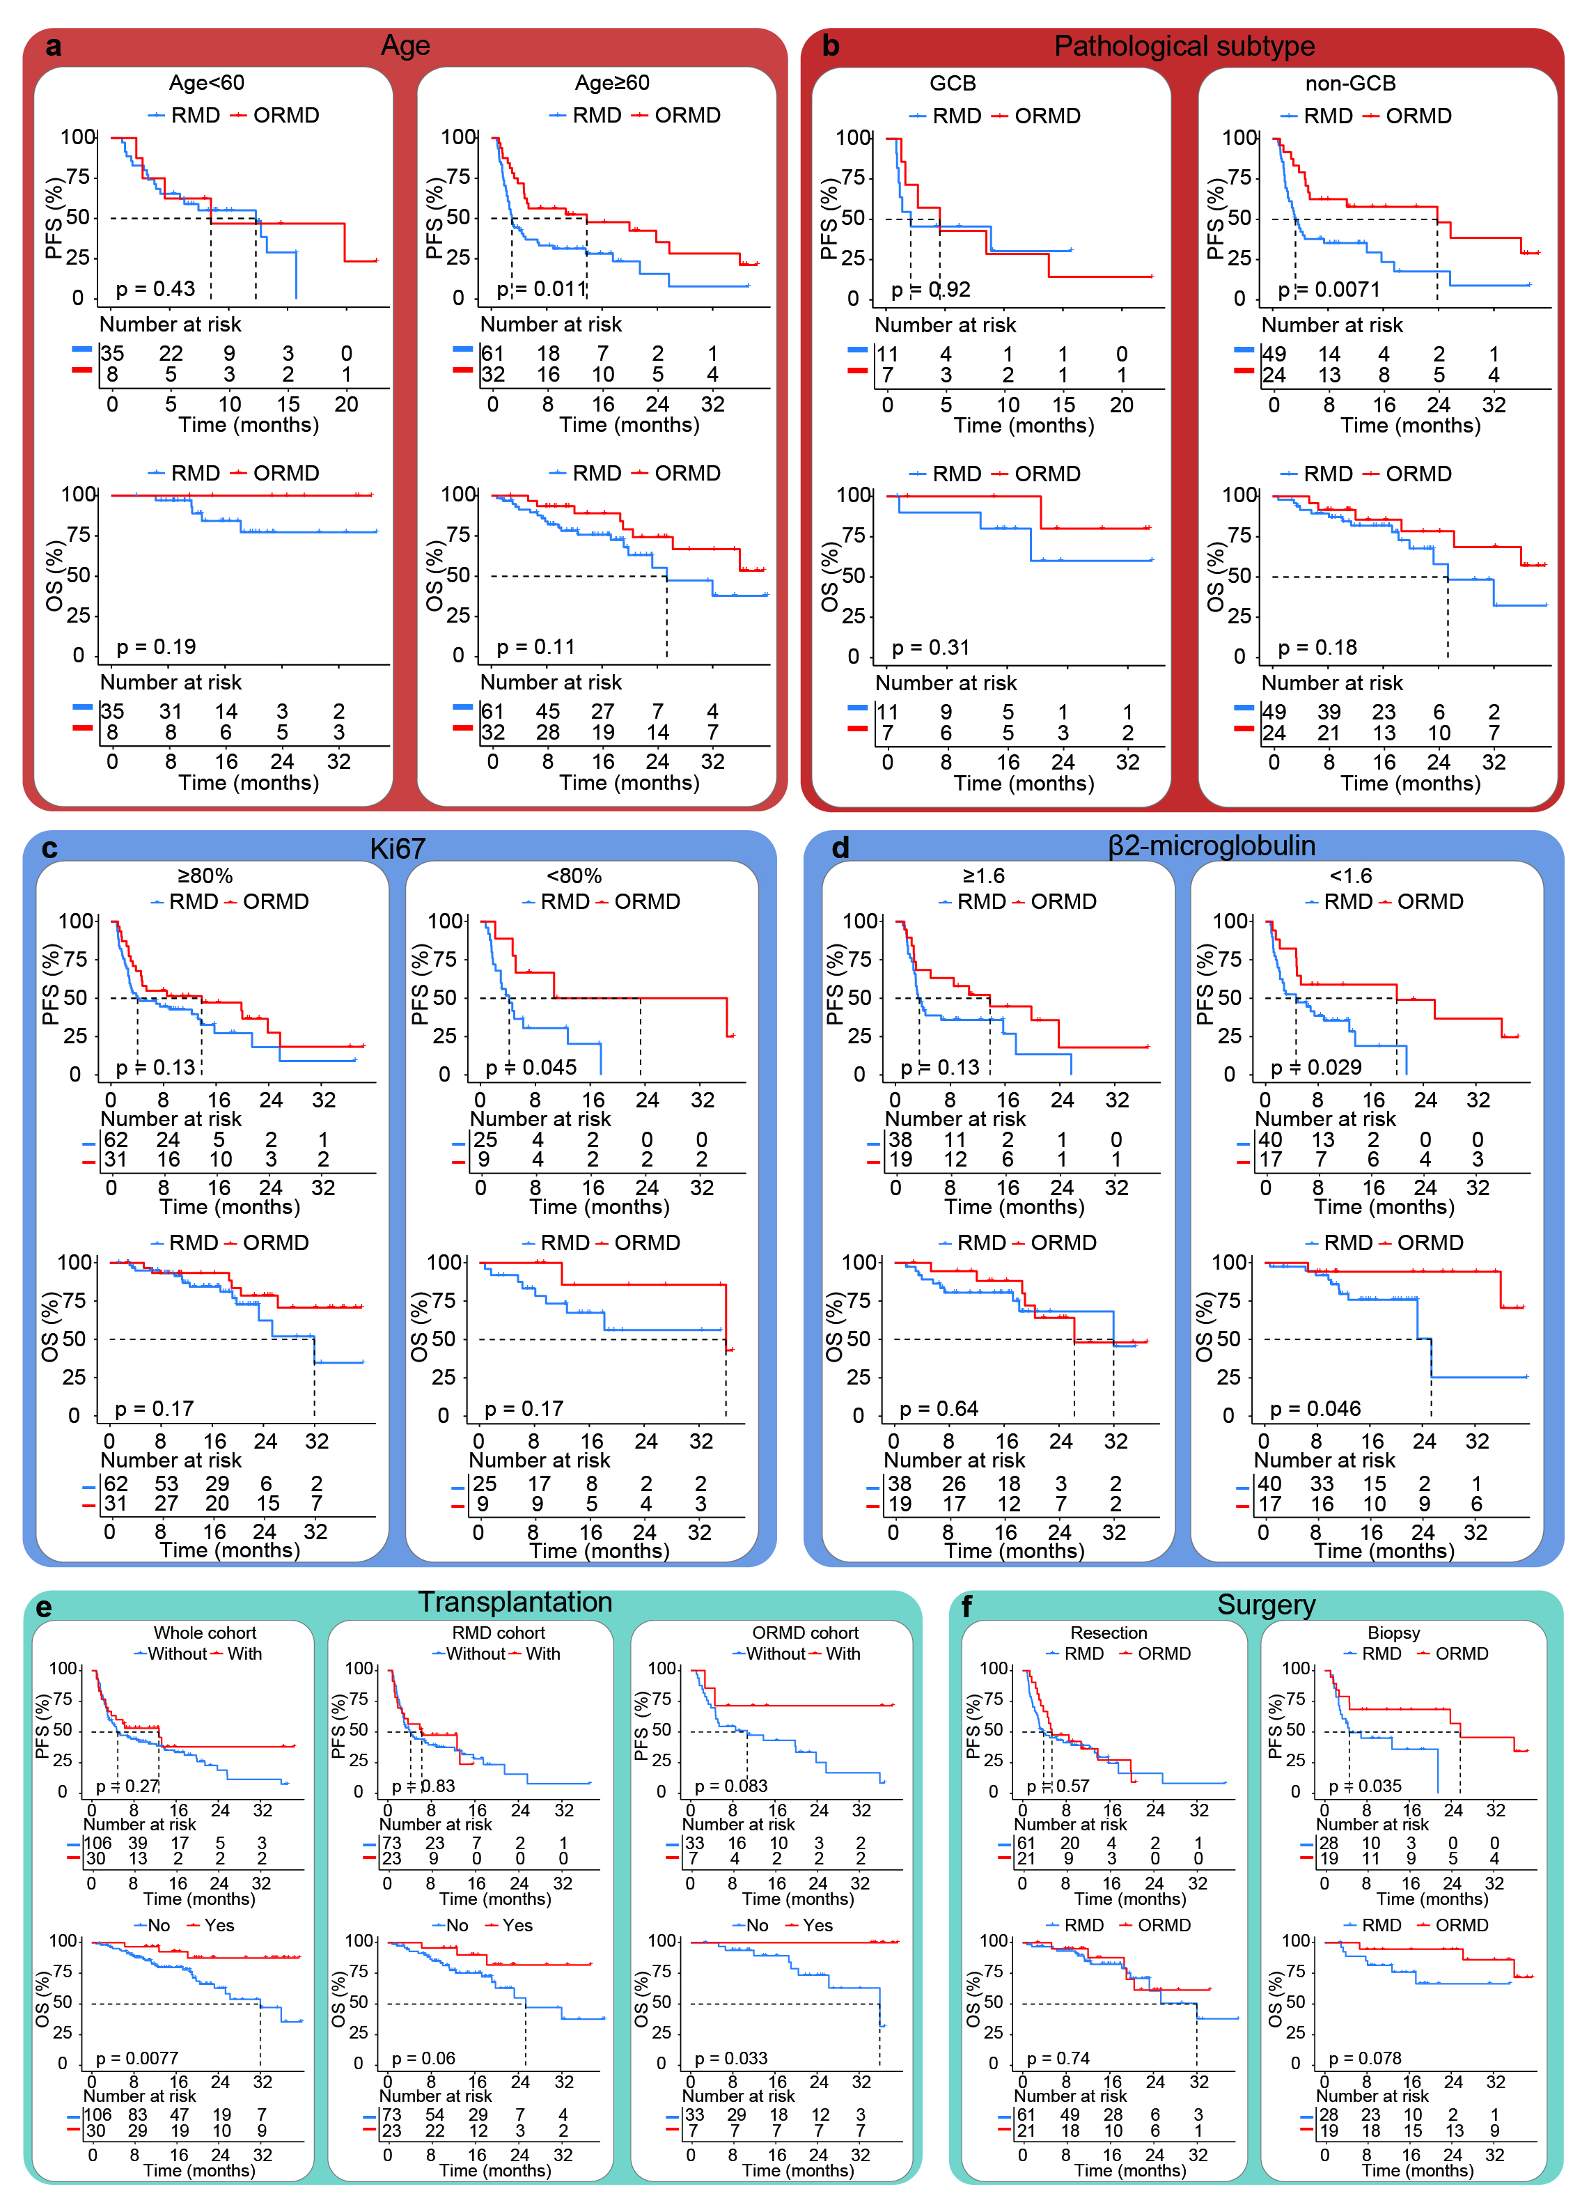
Supplementary Figure S6. Kaplan-Meier survival analyses of the cohorts with ORMD regimen and RMD regimens before propensity score matching.
a,b, Comparison of PFS and OS between the ORMD or RMD cohorts across various subgroups, including age (b. ≥60 years, n=93; <60 years, n=43) and pathological subtype (c. GCB, n=18; non-GCB, n=73) respectively.
c,d, Comparison of PFS and OS between the ORMD or RMD cohorts across various subgroups, including Ki-67 level (d. ≥80%, n=93; <80%, n=34), and β2-microglobulin levels (e. ≥1.62mg/L, n=57; <1.62mg/L, n=57) respectively.
e, Comparison of PFS and OS between the subgroups with transplantation and without transplantation (left panel: whole cohort; middle panel: RMD cohort; right panel: ORMD cohort).
f, Comparison of PFS and OS in the patients’ undergoing different surgery types (left panel: resection, n=82; right panel: stereotactic biopsy, n=47).

Supplementary Table S2. Baseline characteristics in prospective dose-escalating cohort (n=13)
Pt. | Demographic characteristics |  |  |  |  | Surgery type | No. of lesions | Deep inv. | LDH  (U/L) | Pathology characteristics |  |  |  |  |  | Abnormal clones |  |  | Outcomes
Pt. | Age  (y) | Sex | DL | ECOG | TH |  |  |  |  | COO | Ki67  (%+) | BCL2 | BCL6 | CMYC | GRª | BM | CSF | Intraocular | BR | TTR  (m) | R/R | TTP  (m)
I-01 | 59 | F | 1 | 1 | None | SB | 1 | Yes | 207 | non-  GCB | 80 | ND | + | ND | - | - | - | - | CR | 2.20 | Yes | 25.3
I-02 | 61 | M | 1 | 1 | None | SR | 1 | No | 164 | GCB | 80 | + | + | + | BCL6(+)  CMYC(+) | - | - | - | PD | 0.83 | Yes | 0.83
I-03 | 66 | M | 1 | 1 | None | SR | 3 | Yes | 183 | GCB | 80 | + | + | - | ND | - | - | - | CRu | 3.53 | No | /
I-04^{b} | 57 | M | 2 | 1 | None | SB | 1 | Yes | 223 | non-  GCB | 70 | + | - | - | ND | - | - | - | CR | 5.70 | No | /
I-05 | 63 | F | 2 | 2 | Gastric  tumor | SR | 2 | Yes | ND | non-  GCB | 70 | + | + | ND | - | - | - | - | SD | 0.93 | Yes | 2.30
I-06 | 43 | M | 2 | 2 | None | SR | 2 | Yes | 212 | non-  GCB | 80 | + | + | ND | ND | - | - | - | CR | 3.47 | Yes | 18.80
I-07 | 73 | M | 2 | 2 | None | SB | 1 | Yes | 247 | non-  GCB | 85 | + | + | + | ND | - | - | - | CR | 1.67 | No | /
I-08 | 65 | M | 2 | 1 | None | SR | 1 | Yes | 187 | non-  GCB | 90 | + | + | ND | BCL6(+) | - | - | - | CR | 2.43 | No | /
I-09 | 39 | F | 3 | 1 | None | SB | 3 | Yes | 232 | GCB | 90 | + | + | + | - | - | - | - | CR | 2.60 | No | /
I-10 | 65 | M | 3 | 3 | None | SR | 1 | No | 196 | non-  GCB | 50 | + | + | + | - | - | + | - | CR | 1.67 | Yes | 10.53
I-11 | 54 | F | 3 | 2 | None | SB | 2 | Yes | 143 | non-  GCB | 80 | ND | + | ND | ND | - | - | - | CR | 1.63 | No | /
I-12 | 65 | F | 3 | 1 | None | SR | 3 | Yes | 131 | non-  GCB | 60 | + | + | + | - | + | - | - | CRu | 1.67 | Yes | 3.77
I-13 | 39 | M | 3 | 1 | None | SR | 4 | Yes | 189 | GCB | 80 | + | ND | ND | - | - | - | - | PR | 0.80 | Yes | 7.77
ª Gene rearrangement detected by fluorescence in situ hybridization; ^{b} #I-04 Patient developed PD during the C1-2 because of the cycle delay due to covid-19 infection.
BM: bone marrow; BR:best response; COO: cell of origin classification; CR: complete response; CRu: complete response unconfirmed; DL: dose level; ECOG: eastern cooperative oncology group performance; GCB: germinal center B-cell; GR: gene rearrangement; m: months; inv.: involvement; ND: not determined; NE: not estimable; PD: progression disease; PR: partial response; Pt: patient; R/R: refractory or relapse; SB: stereotactic biopsy; SD: stable disease; SR: surgical resection; y: years; TH: tumor history; TTR: time to response; TTP: time to progression

Supplementary Table S3. Incidence of treatment-related adverse events (n = 13).
 | All grades  No.(%) | Grade 3  No.(%) | Grade 4
Any events | 13 (100.0) | 8 (61.5) | 0
Hematologic toxicity | 12 (92.3) | 8 (61.5) | 0
Lymphocyte count decreased | 12 (92.3) | 8 (61.5)
Anemia | 8 (61.5) | 0
Neutrophil count decreased | 7 (53.9) | 2 (15.4)
Leukocytosis | 6 (46.2) | 0
Platelet count decreased | 2 (15.4) | 0
Nonhematologic toxicity | 13 (100.0) | 4 (30.8) | 0
Hyperglycemia | 12 (92.3) | 2 (15.4)
Proteinuria | 9 (69.2) | 0
Hypoalbuminemia | 7 (53.8) | 0
Aspartatea minotransferase increased | 6 (46.2) | 1(7.7)
Alanine aminotransferase increased | 3 (23.1) | 1(7.7)
Hematuria | 2 (15.4) | 0
Fever | 1 (7.7) | 0
Lung infection | 1 (7.7) | 1 (7.7)
Urinary tract infection | 1 (7.7) | 0
Kidney injury | 2 (15.4) | 0

Supplementary Table S4. Concentration of orelabrutinib in CSF and plasma from the patients in dose-escalating cohort (mean±SD).
dose levels | free plasma (ng/ml) | CSF (ng/ml) | CSF/plasma (%)
1 | 33.50±12.02 | 16.35±0.92 | 51.65±15.77
2 | 68.80±36.62 | 36.22±24.04 | 53.90±17.14
3 | 73.00±41.39 | 54.80± 67.93 | 65.24±61.67

Supplementary Table S5. Efficacy outcomes in prospective dose-escalating phase I portion (n = 13).
Parameters | % (No.)
Best response in induction therapy (%)
CR, | 61.5 (8/13)
CRu | 15.4 (2/13)
PR | 7.7 (1/13)
SD | 7.7 (1/13)
PD | 7.7 (1/13)
Response rate (%)
CRR | 76.9 (10/13)
ORR | 84.6 (11/13)
DCR | 92.3 (12/13)
12months PFS rate (95%CI) | 61.5 (40-94.6)
Duration of outcome (months)
TTR (median, 95%CI) | 1.1, 0.9-NR
TTF (median, 95%CI) | 25.3, 7.8-NR
DoR (median, 95%CI) | 24.8, 17.7-NR
CR, complete response; CRu, unconfirmed complete response; PR, partial response; SD, stable disease; PD, progressive disease; CRR, complete response rate; ORR, overall response rate; DCR, disease control rate; TTR, time to response; TTF, time to failure; NR, not reached; PFS, progress free survival.

Supplementary Table S6. Evaluation of patients’ survival and treatment response in ORMD and RMD cohorts.
Outcome |  | ORMD  (n=40) | RMD  (n=96) | RM^{low}D  (n=59) | RM^{high}D  (n=37)
Survival | Median PFS (Months)  (95% CI) | 13.8  (4.8-35.9) | 4.4  (3.1-12.3) | 4.2  (3.0-13.6) | 6.2  (2.6-17.6)
Survival | Median OS (Months) (95% CI) | Not reached  (35.9-NE) | 32.0  (23.3-NE) | 32.0  (25.4-NE) | Not reached  (23.3-NE)
Survival | 1-Year PFS (%) (95% CI) | 51.6  (38.0-70.1) | 39.9  (30.9-51.4) | 38.7  (27.8-53.9) | 41.3  (27.7-61.7)
Survival | 1-Year OS (%) (95% CI) | 91.5  (82.6-100.0) | 82.4  (74.6-91.0) | 82.8  (73.2-93.8) | 83.1  (71.6-96.4)
Treatment response | PD rate (%)  (95% CI) | 15.0  (5.7-29.8) | 25.0  (16.7-34.9) | 27.1  (16.4-40.3) | 21.6  (9.8-38.2)
Treatment response | SD rate (%)  (95% CI) | 2.5  (0.1-13.2) | 14.6  (8.2-23.3) | 8.5  (6.0-25.0) | 24.3  (11.8-41.2)
Treatment response | PR rate (%)  (95% CI) | 22.5  (10.8-38.5) | 17.7  (10.7-26.8) | 22.0  (12.3-34.7) | 10.8  (3.0-25.4)
Treatment response | CRR (%)  (95% CI) | 60.0  (43.3-75.1) | 42.7  (32.7-53.2) | 42.4  (29.6-55.9) | 43.2  (27.1-60.5)
Treatment response | ORR (%)  (95% CI) | 82.5  (67.2-92.7) | 60.4  (49.9-70.3) | 64.4  (50.9-76.5) | 54.1  (36.9-70.5)
Abbreviations: NE, not estimable; OS, overall survival; PFS, progress free survival; CRR, complete response rate; PR, partial response; SD, stable disease; PD, progressive disease; ORR, overall response rate;
# RM^{high}D and RM^{low}D were exploratorily defined using a methotrexate dose cutoff of 5.5 g/m².
Supplementary Table S7: Baseline Characteristics of the patients in ORMD and RMD cohorts.
Characteristics | Before PSM |  |  | After PSM
Characteristics | ORMD  (n=40) | RMD  (n=96) | Std. Mean Diff | ORMD  (n=27) | RMD  (n=54) | Std. Mean Diff
MTX dosage  (g/m², mean±SD) | 4.21 ±0.76 | 5.49 ±1.78 | -1.668 | 4.32 ±0.77 | 4.35 ±0.92 | -0.043
β2-microglobulin level (mg/L, mean±SD) | 1.75 ±0.55 | 1.60 ±0.56 | 0.259 | 1.70 ±0.50 | 1.69 ±047 | 0.016
Ki67 level  (%, mean±SD) | 78.25 ±11.74 | 80.47 ±11.29 | -0.189 | 80.00 ±10.47 | 80.37 ±12.47 | -0.032
Sex
Male (%) | 47.50 | 58.33 | -0.217 | 59.29 | 59.26 | 0.000
Female (%) | 52.50 | 41.67 | 0.217 | 40.74 | 40.74 | 0.000
Pathological subtype
GCB (%) | 17.50 | 11.46 | 0.159 | 11.11 | 11.11 | 0.000.
Non-GCB (%) | 60.00 | 51.04 | 0.183 | 55.56 | 55.56 | 0.000
Not evaluable (%) | 22.50 | 37.50 | -0.359 | 33.33 | 33.33 | 0.000
Surgery type
Stereotactic biopsy (%) | 47.50 | 29.17 | 0.367 | 40.73 | 38.89 | 0.037
Surgical resection (%) | 52.50 | 63.54 | -0.221 | 59.26 | 57.41 | -0.170
Lumbar puncture & Vitrectomy (%) | 0.00 | 7.29 | -0.334 | 0.01 | 3.70 | -0.170
Transplantation
Without (%) | 82.50 | 76.00 | 0.170 | 85.19 | 87.04 | -0.049
With (%) | 17.50 | 24.00 | -0.170 | 14.81 | 12.96 | 0.049
IELSG
Low-risk | 15.00 | 19.79 | -0.134 | 11.11 | 11.11 | 0.000
Mid-risk | 72.50 | 69.79 | 0.061 | 77.78 | 77.78 | 0.000
High-risk | 12.50 | 10.42 | 0.063 | 11.11 | 11.11 | 0.000
MSKCC
Low-risk | 7.50 | 13.54 | -0.229 | 7.41 | 7.41 | 0.000
Mid-risk | 57.50 | 60.42 | -0.060 | 59.26 | 61.11 | -0.038
High-risk | 35.00 | 26.04 | 0.188 | 33.33 | 31.48 | 0.039
PSM: propensity score matching.

Supplementary Table S8. Incidence of TRAEs in ORMD and RMD cohorts.
Adverse events | ORMD(%) | RMD(%) | RMD(%)
Adverse events | ORMD(%) | RMD(%) | RM^{high}D | RM^{low}D
Lymphocyte count decreased | 80.00 | 93.48 | 100.00 | 89.47
Neutrophil count decreased | 7.50 | 2.17 | 2.86 | 1.75
White blood cell decreased | 12.50 | 6.52 | 2.86 | 8.77
Platelet count decreased | 20.00 | 23.91 | 25.71 | 22.81
Hyperglycemia | 90.00 | 68.13 | 57.14 | 75.00
Fever | 10.00 | 7.29 | 0.00 | 11.85
Infection | 22.50 | 14.58 | 8.10 | 18.64
Proteinuria | 51.28 | 25.00 | 21.88 | 26.79
Hematuria | 15.38 | 20.46 | 15.63 | 23.21
Hypoalbuminemia | 87.50 | 83.33 | 89.19 | 79.67
Aspartatea minotransferase increased | 40.00 | 48.96 | 64.86 | 38.98
Alanine aminotransferase increased | 32.50 | 66.67 | 70.27 | 64.41
Kidney injury | 7.50 | 5.21 | 5.41 | 5.085

# RM^{high}D and RM^{low}D were exploratorily defined using a methotrexate dose cutoff of 5.5 g/m².

Supplementary Table S9. Number of of all grades adverse events in ORMD and RMD groups.
 | ORMD(n=40) |  |  |  |  |  |  | RM^{low}D(n=59) |  |  |  |  |  |  | RM^{high}D(n=37) |  |  |  |  |  |  | RMD(n=96)
AE levels | 0 | 1 | 2 | 3 | 4 | 5 | NA | 0 | 1 | 2 | 3 | 4 | 5 | NA | 0 | 1 | 2 | 3 | 4 | 5 | NA | 0 | 1 | 2 | 3 | 4 | 5 | NA
Lymphocyte count decreased | 8 | 1 | 12 | 17 | 2 | 0 | 0 | 6 | 2 | 8 | 26 | 14 | 1 | 2 | 0 | 2 | 6 | 9 | 18 | 0 | 2 | 6 | 4 | 14 | 35 | 32 | 1 | 4
Neutrophil count decreased | 37 | 1 | 2 | 0 | 0 | 0 | 0 | 56 | 0 | 0 | 1 | 0 | 0 | 2 | 34 | 1 | 0 | 0 | 0 | 0 | 2 | 90 | 1 | 0 | 1 | 0 | 0 | 4
White blood cell decreased | 35 | 1 | 3 | 1 | 0 | 0 | 0 | 52 | 3 | 1 | 0 | 0 | 1 | 2 | 34 | 0 | 0 | 1 | 0 | 0 | 2 | 86 | 3 | 1 | 1 | 0 | 1 | 4
Platelet count decreased | 32 | 7 | 1 | 0 | 0 | 0 | 0 | 44 | 11 | 1 | 1 | 0 | 0 | 2 | 26 | 6 | 3 | 0 | 0 | 0 | 2 | 70 | 17 | 4 | 1 | 0 | 0 | 4
Hyperglycemia | 4 | 17 | 2 | 17 | 0 | 0 | 0 | 14 | 26 | 6 | 10 | 0 | 0 | 3 | 15 | 16 | 1 | 3 | 0 | 0 | 2 | 29 | 42 | 7 | 13 | 0 | 0 | 5
Fever | 36 | 3 | 0 | 1 | 0 | 0 | 0 | 52 | 5 | 2 | 0 | 0 | 0 | 0 | 37 | 0 | 0 | 0 | 0 | 0 | 0 | 89 | 5 | 2 | 0 | 0 | 0 | 0
Infection | 31 | 0 | 4 | 5 | 0 | 0 | 0 | 48 | 0 | 4 | 6 | 0 | 1 | 0 | 34 | 0 | 1 | 2 | 0 | 0 | 0 | 82 | 0 | 5 | 8 | 0 | 1 | 0
Proteinuria | 19 | 14 | 6 | 0 | 0 | 0 | 1 | 41 | 14 | 1 | 0 | 0 | 0 | 3 | 25 | 5 | 2 | 0 | 0 | 0 | 5 | 66 | 19 | 3 | 0 | 0 | 0 | 8
Hematuria | 33 | 6 | 0 | 0 | 0 | 0 | 1 | 43 | 13 | 0 | 0 | 0 | 0 | 3 | 27 | 5 | 0 | 0 | 0 | 0 | 5 | 70 | 18 | 0 | 0 | 0 | 0 | 8
Hypoalbuminemia | 5 | 25 | 10 | 0 | 0 | 0 | 0 | 12 | 32 | 15 | 0 | 0 | 0 | 0 | 4 | 21 | 12 | 0 | 0 | 0 | 0 | 16 | 53 | 27 | 0 | 0 | 0 | 0
Aspartatea minotransferase increased | 24 | 14 | 1 | 1 | 0 | 0 | 0 | 36 | 15 | 7 | 1 | 0 | 0 | 0 | 13 | 20 | 4 | 0 | 0 | 0 | 0 | 49 | 35 | 11 | 1 | 0 | 0 | 0
Alanine aminotransferase increased | 27 | 12 | 1 | 0 | 0 | 0 | 0 | 21 | 29 | 7 | 2 | 0 | 0 | 0 | 11 | 20 | 6 | 0 | 0 | 0 | 0 | 32 | 49 | 13 | 2 | 0 | 0 | 0
Kidney injury | 37 | 3 | 0 | 0 | 0 | 0 | 0 | 56 | 2 | 0 | 1 | 0 | 0 | 0 | 35 | 1 | 0 | 1 | 0 | 0 | 0 | 91 | 3 | 0 | 2 | 0 | 0 | 0
# RM^{high}D and RM^{low}D were exploratorily defined using a methotrexate dose cutoff of 5.5 g/m².

