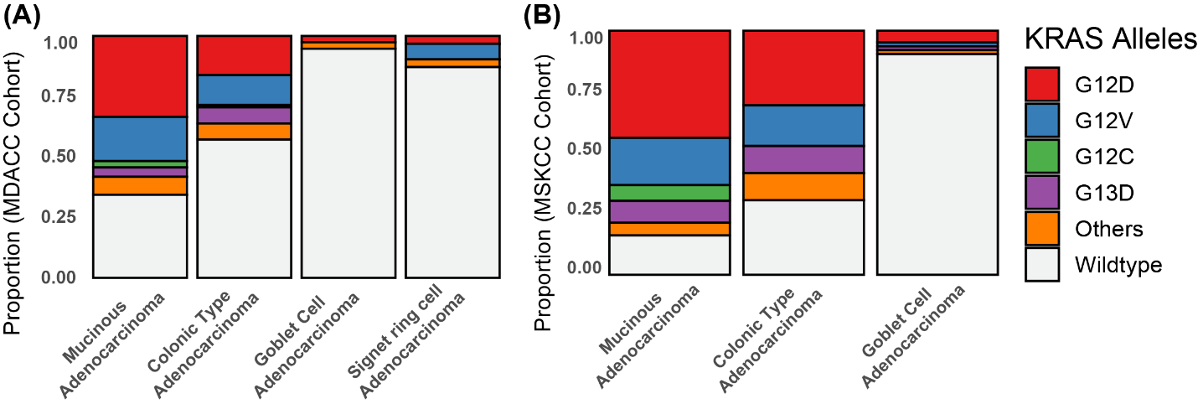
Supplemental Figures & Legends:

Supplemental Figure 1: KRAS mutant allele frequency. Distributions of different KRAS alleles across different tumor histologies in (A) MDACC and (B) MSKCC cohorts.
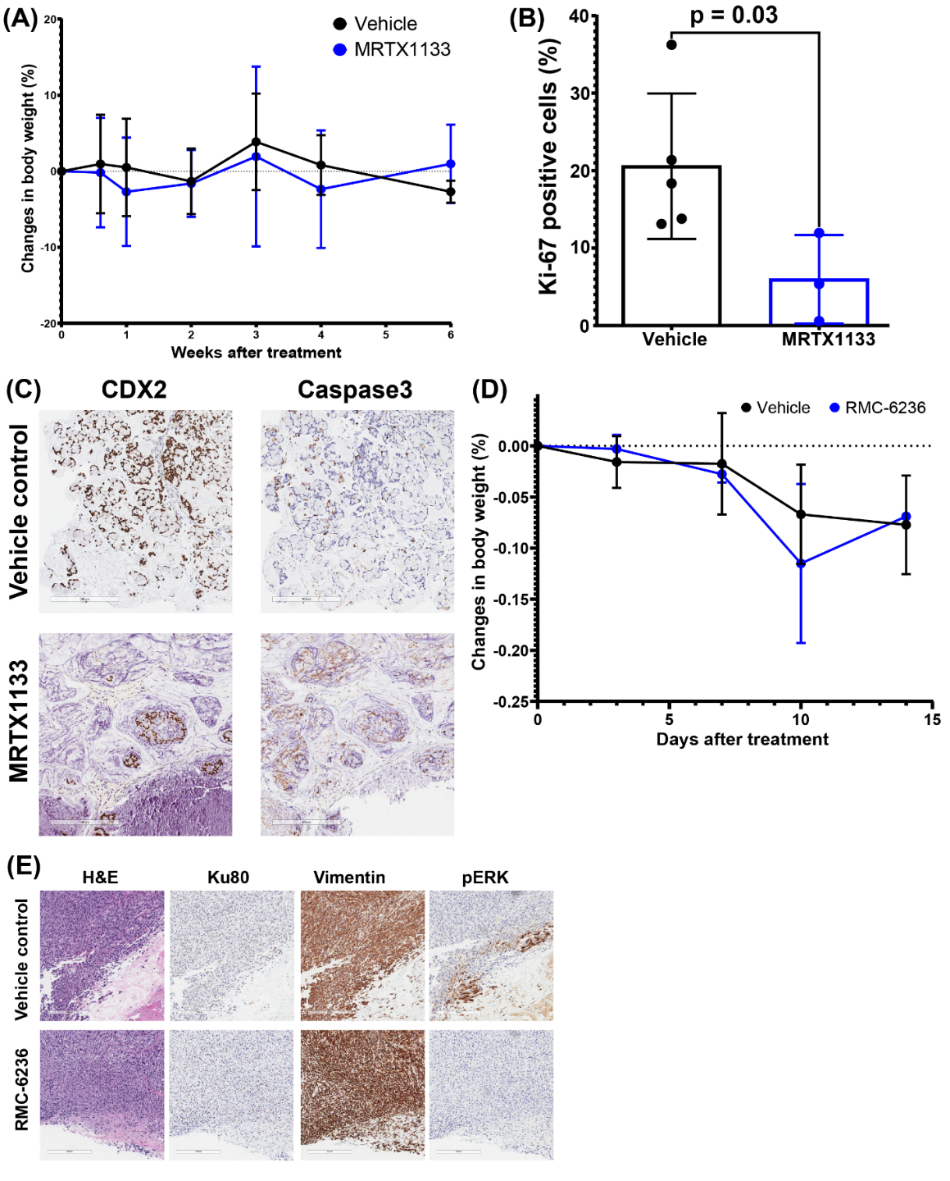
Supplemental Figure 2: Effects of KRAS inhibition in vivo. (A) Change in body weight for mice treated with MRTX1133 or control. (B) Fraction of cells positive for Ki67 following treatment with MRTX1133 or control. (C) CDX2 and Caspase3 staining after treatment with MRTX1133 or vehicle control, note the decrease in CDX2+ (tumor) cells and increase in caspase3 specifically in CDX2+ cells. (D) Change in body weight for mice treated with RMC-6236 or vehicle control. (E) Ku80 (marker of human cells), vimentin (marker of fibroblasts), and pERK IHC following treatment with RMC-6236 or vehicle control, note reduced presence of Ku80+ (human tumor) cells and decreased pERK following RMC-6236 treatment.
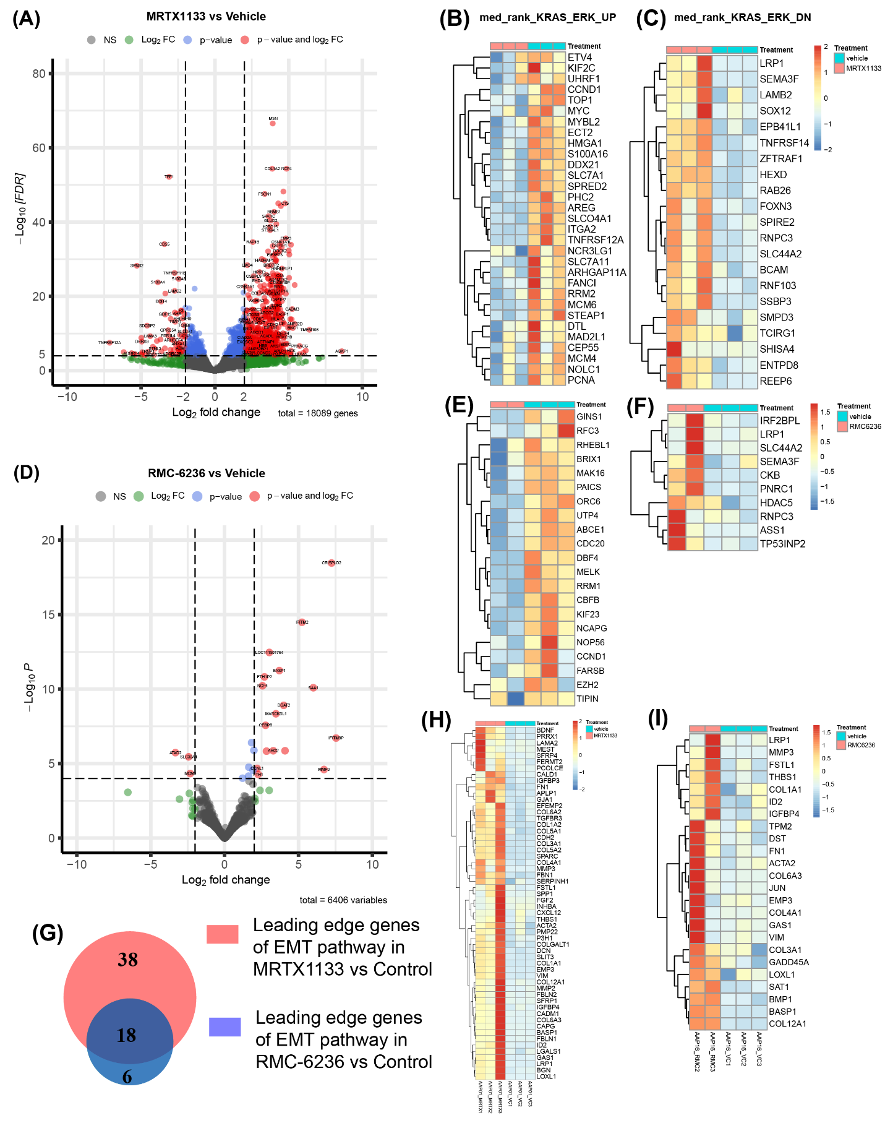
Supplemental Figure 3: Transcriptional effects of KRAS inhibition in vivo.
- Volcano plots from differential gene expression analyses performed between MRTX1133-treated tumors and vehicle control. Leading edge genes contributing enrichment scores of (B) KRAS-ERK_UP and (C) KRAS-ERK_Down gene sets in GSEA of MRTX1133 vs Control analysis. Note decreased expression of MYC, AREG, and CCND1 following MRTX1133 treatment. Volcano plots from differential gene expression analyses comparing RMC-6236-treated tumors to vehicle control. Leading edge genes contributing enrichment scores of (E) KRAS-ERK_UP and (F) KRAS-ERK_Down gene sets in GSEA of RMC-6236 treated tumors vs vehicle control. (G) A Venn diagram showing common and unique genes identified in the leading-edge genes of EMT pathway observed in GSEA analyses of MRTX1133-treatment vs vehicle control and RMC-6236-treatment vs vehicle control. Leading edge genes contributing enrichment scores of the EMT pathway in GSEA analyses of (I) MRTX1133-treatment vs vehicle, and (J) RMC-6236-treatment vs vehicle control.

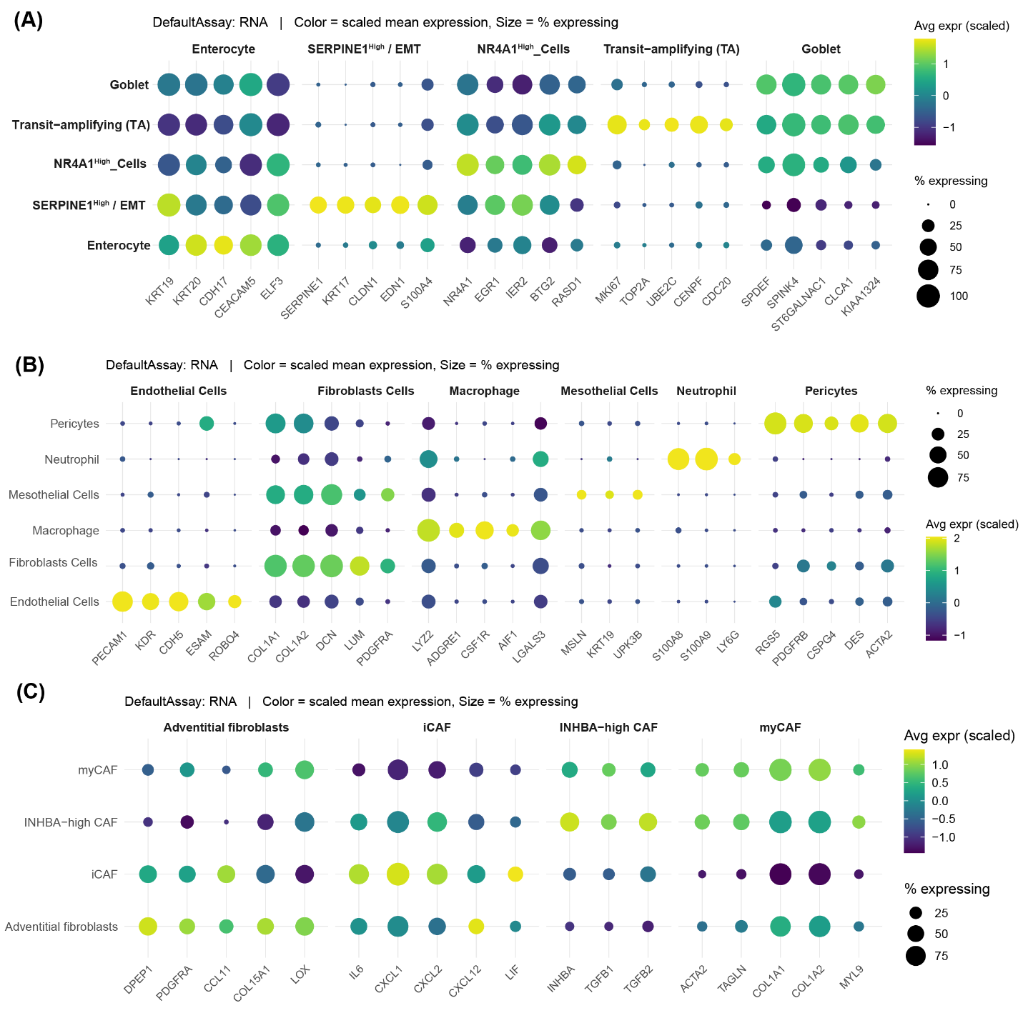
Supplemental Figure 4: Markers for epithelial, stromal, and fibroblast cell subtypes.
Dot plot identifying major subtypes of (A) epithelial cells, (B) Stromal cells, and (C) Fibroblast cells.
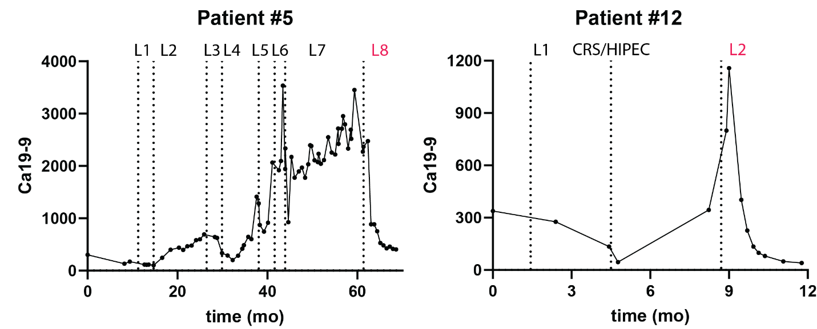
Supplemental Figure 5: Tumor Marker Response for Patients #5 and #12.
Serial measurement of Ca19-9 for patient #5 (A) and patient #12 (B). Vertical dashed lines indicate the start of a new line of chemotherapy (labeled L1, L2, ect) or surgical resection (labeled CRS/HIPEC). KRAS inhibitor was 8th line of therapy for patient #5 and 2nd line of therapy for patient #12 (red font).

Supplemental Table 1: Immunohistochemistry Quantification
Supplemental Table 2: Summary information for clinical cohort

