Supplementary figures
Supplementary Figure 1. Correlation patterns of transcription factors and their potential targets identified in the network analysis.
X-axis: transcription factors; Y-axis: target genes.
Green: expression in the original fibroblast in vitro samples; Red: expression after confrontation with tumor cells.
Affymetrix log₂(intensity) values are used for the plots.

Supplementary Figure 2. Inhibition scores as fraction of survived PC-3 cells after 72h co-cultivation with fibroblasts. The technique is described by Alkasalias et al. (2014).
Wh1
Cr9
PrNFB1
PrTFB2
PdSFB
PdHFB
HS68
PC3 alone
0.10
0.15
0.20
0.25
0.30
0.35
0.40
0.45
0.50

Supplementary Figure 3. Comparison of differential expression using raw gene expression values between low and high inhibitory cell lines in vitro (fold change values Wh1 vs. Cr9) and ex vivo (fold change values PrNFB1 vs. PrTFB2).
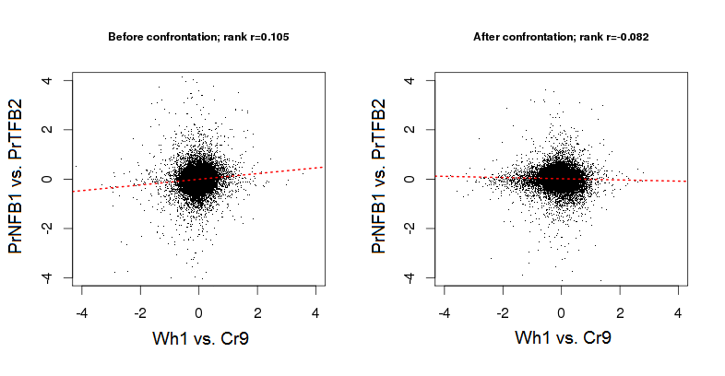

Supplementary Figure 4. Pathway scores from network enrichment analysis of most altered genes between low and high inhibitory cell lines in vitro (Wh1 vs. Cr9) and ex vivo (PrNFB1 vs. PrTFB2).
After ranking by fold change, top 30, 100, and 300 genes were derived for the network analysis.
A. Comparison of ex vivo and in vitro transcriptomes before and after confrontations in three DEG lists of different length.
B. Comparison of ex vivo transcriptomes before and after confrontations with the maximal (300) length gene of lists.
A
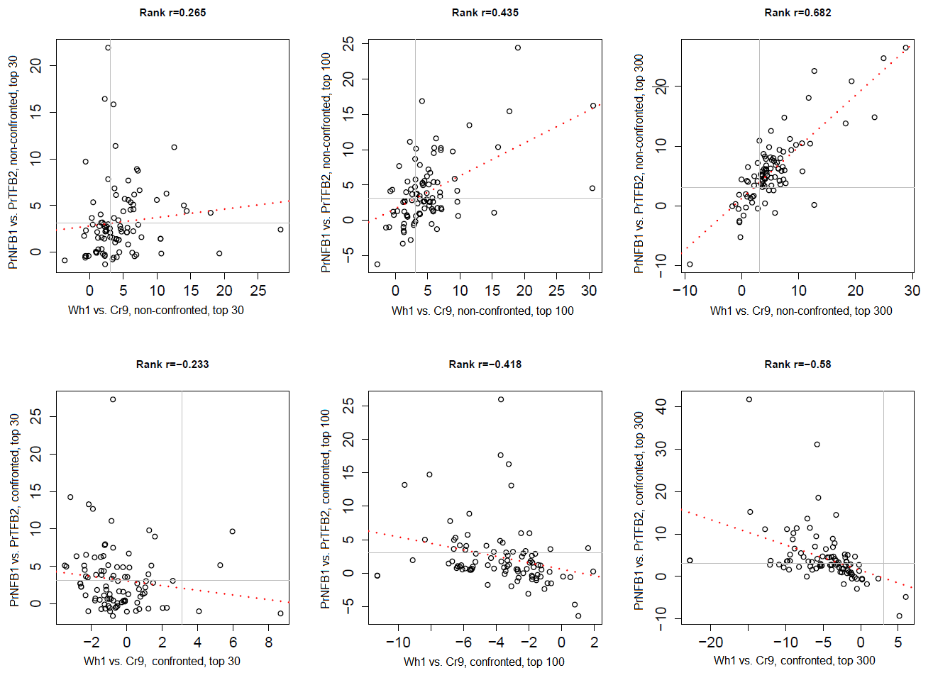
B

Supplementary Figure 5. Using co-expression to validate transcriptional regulation reported by database HTRIdb.
Upper pane: Distribution of estimates of significant co-expression (p-values adjusted by Benjamini and Hochberg, 1995) in pairs “transcription factor – target gene” from HTRIdb [15] within our microarray dataset.
Lower pane: Same distribution, but in randomly permuted pairs.
