Supplemental figure and figure legend
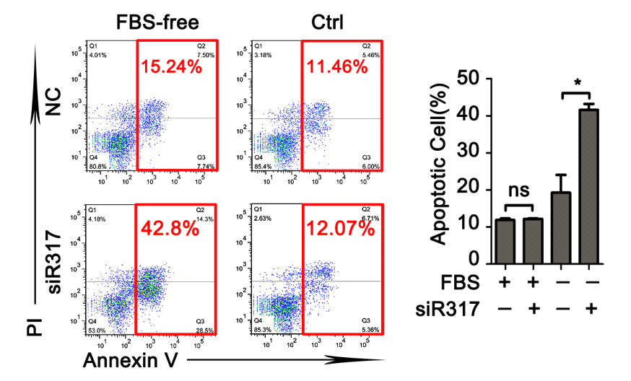
Figure S1. CD317 knockdown enhances serum deprivation-induced apoptosis in HepG2 cells. Representative graphs (left panel) and statistical analysis (Right panel) of cell apoptosis determined by flow cytometric evaluation in HepG2 cells. In brief, 36 h post transfection，cells were cultured in the indicated conditions for another 48 h and double stained with annexin V and PI to detect cell apoptosis. *P<0.05.

Figure S2. CD317 knockdown enhances serum deprivation-induced apoptosis in U266 cells. Representative graphs (left panel) and statistical analysis (Right panel) of cell apoptosis determined by flow cytometric evaluation in sp2/0 cells. **P<0.01.

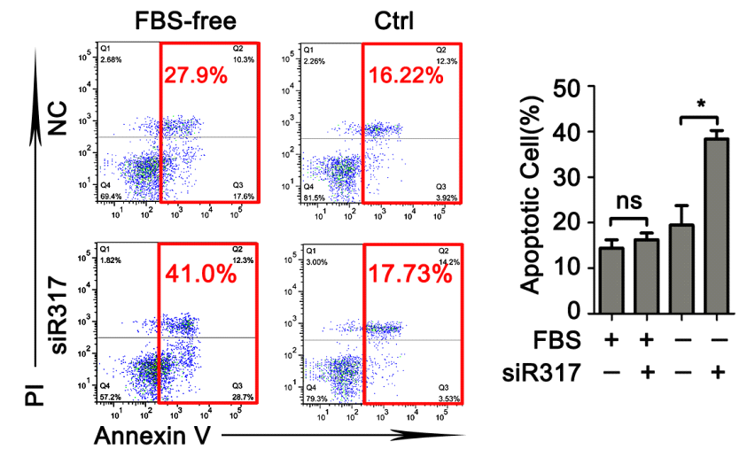
Figure S3. CD317 knockdown enhances serum deprivation-induced apoptosis in sp2/0 cells. Representative graphs (left panel) and statistical analysis (Right panel) of cell apoptosis determined by flow cytometric evaluation in sp2/0 cells. *P<0.05.
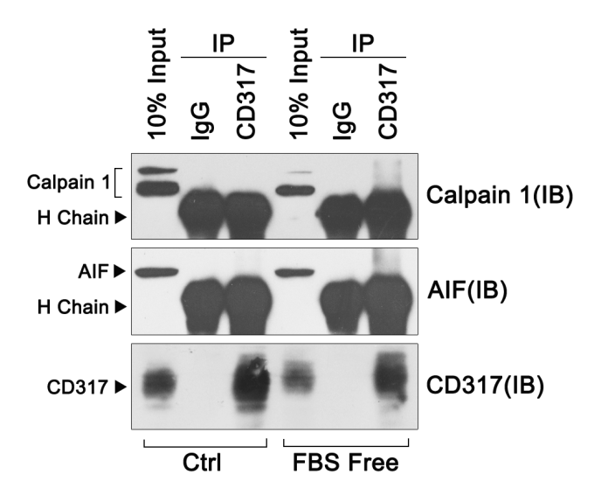
Figure S4. CD317 cannot bind with either AIF or Calpain 1. Hela cells were cultured in the indicated conditions. 24 h later, cell lysates were prepared and immunoprecipitated with anti-CD317 or control Ig. The precipitates and lysates were subjected to Western blotting with antibodies for the indicated antigens.

