Additional file
Supplementary Figure legends

Fig. S1 The correlation between ALX4 expression and methylation was analyzed using TCGA data set (www.cbioportal.com). A: Cohort1：TCGA, Cell 2015, n=552；Cohort2. B: TCGA, Provisional 2012, n=656.

Fig. S2 Analysis the relationship between ALX4 and Wnt/β-catenin suppression and activation genes in breast cancer using TCGA Database. (A) ALX4 was positively correlated with WIF1 expression (R = 0.503, P = 0.00). (B) ALX4 was negatively correlated with LEF1 expression (R = -0.062, P = 0.03). (C) AXL4 was positively correlated with the expression of the key members of “β-catenin degradation complex”.

Fig. S3 The illustration of full length human β-catenin promoter (-2760 bp to +27 bp) that was cloned into the PGL3-Basic luciferase reporter vector.

Fig. S4 Relationship between ALX4 expression and survival of breast cancer patients retrieved from public datasets（https://genome-cancer.soe.ucsc.edu/proj/site/xena）. (A) Survival analysis using TCGA dataset, the results showed that high expression of ALX4 predicted longer survival time (n=1080, p=0.00, 2 group). (B) Survival analysis using TCGA dataset the results showed that high expression of ALX4 predicted longer survival time (n=1080, p=0.03, 3 group).
Fig. S1

Fig. S2
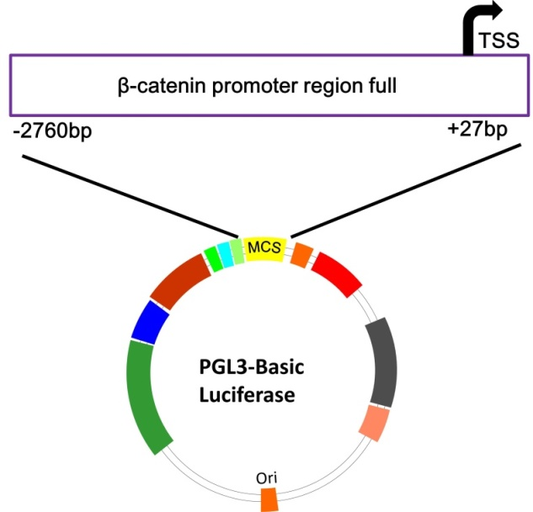
Fig. S3
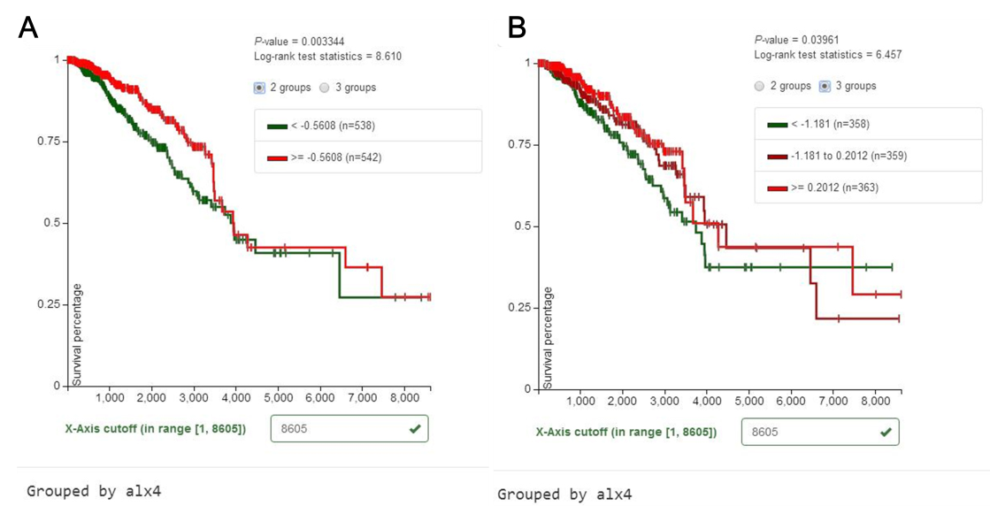
Fig. S4

Supplementary Tables

Table S1. Primers used in this study
Primer name | Primer sequence 5'-3' | Primer purpose
ALX4-qF | GCAGAACAGCTGCTACATCAAGAA | qPCR and RT-PCR
ALX4-qR | CAGTCGCTGGCGTAGATCTGTC | qPCR and RT-PCR
β-actin-qF | CCACGAAACTACCTTCAACTCC | qPCR and RT-PCR
β-actin-qR | GTGATCTCCTTCTGCATCCTGT | qPCR and RT-PCR
ALX4(MSP-M)-F | GTTAGGTATGAATGTTGAGATTTGC | MSP analysis
ALX4(MSP-M)-R | GAATCCCTATACTTTAACGACGAC | MSP analysis
ALX4(MSP-U)-F | TAGGTATGAATGTTGAGATTTGTGT | MSP analysis
ALX4(MSP-U)-R | CAAATCCCTATACTTTAACAACAAC | MSP analysis
ALX4(BSP)-F | AGTTAGGTATGAATGTTGAGATTTG | BSP analysis
ALX4(BSP)-R | AACTAAAACTTATTAAAAAAACCCC | BSP analysis
CTNNB1-F | GCGCCATTTTAAGCCTCTCG | qPCR and
CTNNB1-R | AAATACCCTCAGGGGAACAGG | qPCR
MMP7-qF | CATGATTGGCTTTGCGCGAG | qPCR
MMP7-qR | AGACTGCTACCATCCGTCCA | qPCR
MYC-qF | GCGAACACACAACGTCTTGG | qPCR
MYC-qR | TGAGCTTTTGCTCCTCTGCT | qPCR
CCND1-qF | GATGCCAACCTCCTCAACGA | qPCR
CCND1-qR | GGAAGCGGTCCAGGTAGTTC | qPCR
H-β₂m F | GCTGTCTCCATGTTTGATGTATCTG | qPCR
H-β₂m R | GCACGCTTAACTATCTTAACAAGCTTTG | qPCR
M-β₂m-F | AGGCTTCTCTTTTTCTCCTCTGCTG | qPCR
M-β₂m-R | TTTTCTCTCGACTTCGGTTGGATC | qPCR
CTNNB1-pF | GCTGCGATGCGGTACCGAACGAACCTTCTTTACAATACTGGCATAT | Promoter clone
CTNNB1-pR | GCGACTCGATCTCGAGACGCTGCTGCCACAGACCGAGAGGCTTAAAAT | Promoter clone

