Additional file 4
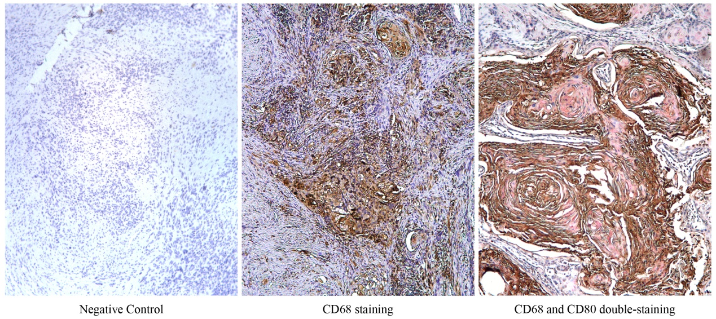
Additional file 2: Control images for the Chromogenic double staining with CD80 (pink)/CD68 (brown) in primary OSCC samples. Sections stained for hematoxylin were used as negative control. Sections stained with CD68 were used as single-positive control.

