Methods
Immunohistochemical quantitative analysis
Independent and non-repeating pictures were taken from each tissue slice for the quantification. Before scoring the images, IHC Profiler (https://sourceforge.net/projects/ihcprofiler/) plugins was installed on the ImageJ Software (https://imagej.nih.gov/ij/). As a general procedure, images were opened in ImageJ, followed by deconvolution used the newly optimized color deconvolution plugin. With the selection of the ‘H DAB’ vector on the color deconvolution popup window, IHC profiler automatically ploteds a histogram profile of the DAB image and the corresponding scoring log was displayed on the screen as followed. The flow chart representing the functioning of theworking algorithm designed for the macro is shown as follows. Images were assigned a score as negative (0), low positive (1+), positive (2+), and high positive (3+) by using ImageJ Software. QuantitativeQualitative data for each image was used for subsequent statistical analysis.

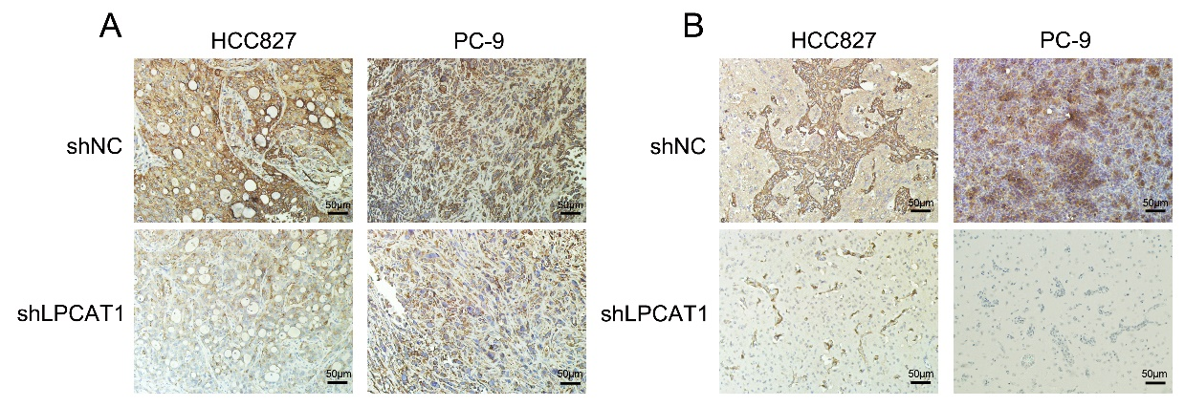
Figure S1. Representative IHC staining analysis of LPCAT1 in xenograft tumors (a) and brain metastasis tumors (b) (200×).

