Supplemental data
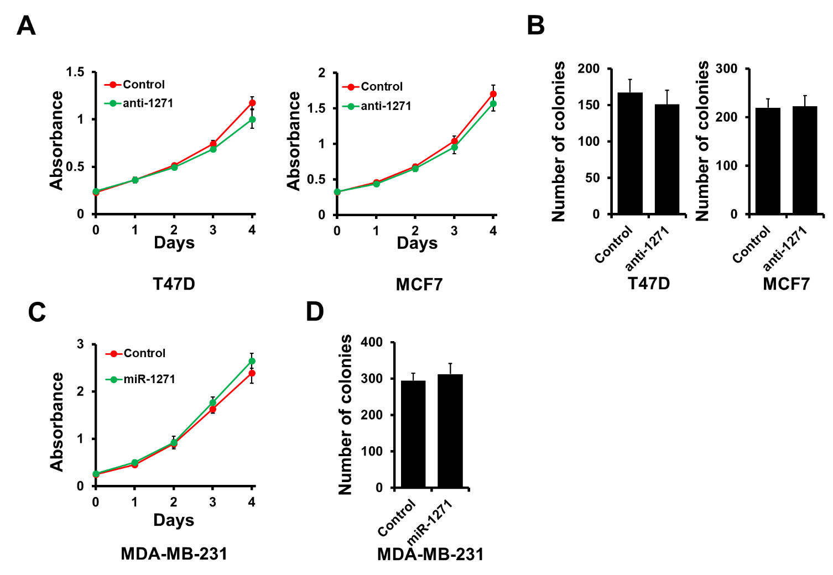
Figure S1. miR-1271 does not affect cell proliferation in breast cancer. A and B, MTT (A) and colony formation (B) analysis of cell proliferation in T47D or MCF7 cells transfected with miR-1271, as well as in control cells. C and D, MTT (C) and colony formation (D) analysis of cell proliferation in miR-1271-expressing MDA-MB-231 cells, as well as in control cells.

