The PDK1 inhibitor MP7 was synthetized as reported by Erlanson et al [1]. Only characterization data not yet published are reported here.
Scheme 1ª:
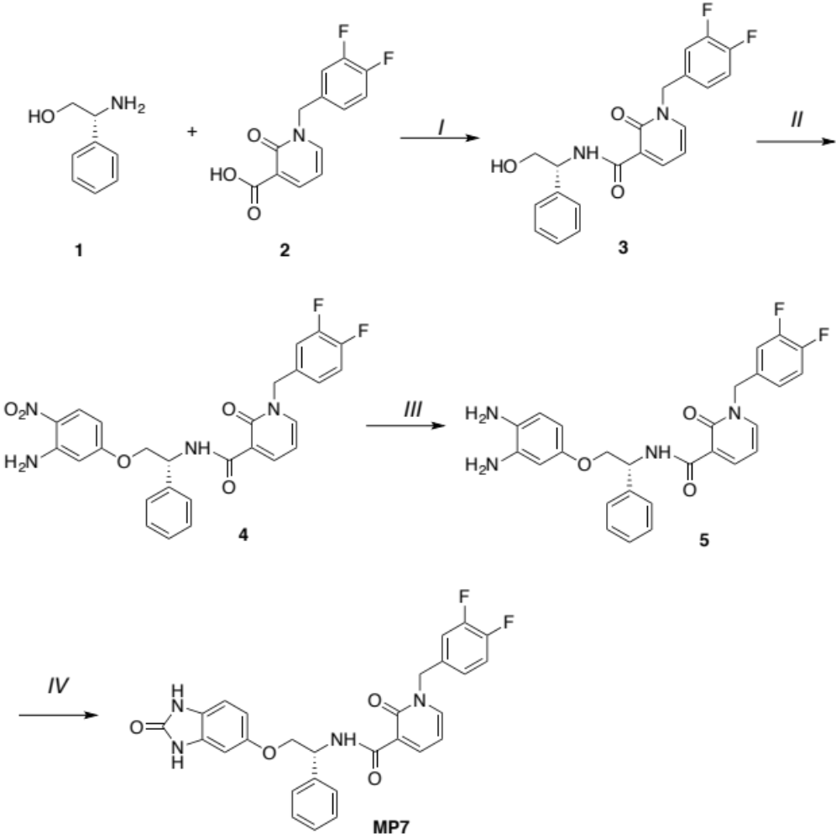

Reagents and conditions ª: I. TBTU, DIPEA, dry DMF, rt, 16 h; II. 5-fluoro-2-nitroaniline, NaH, DMF, rt, 16 h; III. Zn, HCl, MeOH–iPrOH (1:2), reflux, 2 h; IV. CDI, dry DMF, 60 °C, 4 h.

Compound 4:
¹H NMR (CDCl₃): δ 4.30-4.40 (m, 2H, CH₂OH); 5.16 (d, 1H, J = 14.8 Hz, CH); 5.20 (d, 1H, J = 14.8 Hz, CH); 5.56-5.61 (m, 1H, CH), 6.26 (d, 1H, J = 2.4 Hz, Ar); 6.32 (dd, 1H, J = 2.4, 9.6 Hz, Ar); 6.46 (t, 1H, J = 6.9 Hz, Ar); 7.04-7.05 (m, 1H, Ar); 7.14-7.21 (m, 2H, Ar); 7.30-7.34 (m, 2H, Ar); 7.38-7.41 (m, 2H, Ar); 7.45-7.48 (m, 2H, Ar); 7.53 (dd, 1H, J = 2.3, 6.9 Hz, Ar); 8.05 (d, 1H, J = 9.6 Hz; Ar); 8.56 (dd, 1H, J = 2.2, 6.9 Hz, Ar), 10.51 (d, 1H, J = 7.6 Hz, NH) ppm.
Compound 5:
¹H NMR (CDCl₃): δ 4.16-4.24 (m, 2H, CH₂); 5.10-5.22 (m, 2H, CH₂); 5.50-5.55 (m, 1H, CH); 6.27 (dd, 1H, J = 2.4, 8.4 Hz, Ar); 6.35 (d, 1H, J = 2.4 Hz, Ar); 6.41 (t, 1H, J = 6.8 Hz, Ar); 6.59 (d, 1H, J = 8.4 Hz, Ar); 7.02-7.05 (m, 1H, Ar); 7.12-7.19 (m, 2H, Ar); 7.24-7.28 (m, 1H, Ar); 7.24-7.28 (m, 2H, Ar); 7.45-7.49 (m, 3H, Ar); 8.52 (dd, 1H, J = 2.0, 7.2 Hz, Ar); 10.47 (d, 1H, J = 7.6 Hz, NH) ppm.

MP7:
¹³C NMR (CDCl₃): δ 163.54; 162.15; 156.86; 154.40; 151.76; 149.34; 144.34; 140.65; 139.48; 132.49; 129.90; 128.80; 127.80; 127.29; 124.33; 123.50; 121.97; 118.05; 117.40; 109.72; 108.74; 107.36; 97.74; 71.76; 53.24; 52.03 ppm.
¹⁹F NMR (CDCl₃): δ - 136.01 (d, 1F, J = 24 Hz); - 137.60 (d, 1F, J = 24 Hz) ppm.

MP7 was also subjected to FRET-based Z′-Lyte assay (Invitrogen) against PDK1 direct, showing an IC₅₀ value of 10.8 nM.

1. Erlanson, D.A., et al., Discovery of a potent and highly selective PDK1 inhibitor via fragment-based drug discovery. Bioorg Med Chem Lett, 2011. 21(10): p. 3078-83.

