Supplementary Materials
1. Table S1
Table S1 The evaluation of some significant genes.
Gene | HCC-LM3 |  |  |  | SMMC-7721
Gene | NC* | PB2* | Fold# |  | NC* | PB2* | Fold#
PKM2 | 0.99 | 0.39 | 2.57 |  | 1.03 | 0.29 | 3.53
LDH-A | 1.01 | 0.48 | 2.11 |  | 1.01 | 0.48 | 2.11
LDH-B | 1.00 | 0.29 | 3.40 |  | 1.02 | 0.29 | 3.49
AMPK-A1 | 0.95 | 0.39 | 2.42 |  | 1.08 | 0.53 | 2.04
HIF-1A | 0.96 | 0.38 | 2.52 |  | 1.02 | 0.54 | 1.89
HSP90AA1 | 1.03 | 0.20 | 5.23 |  | 1.00 | 0.45 | 2.23
HSP90AB1 | 1.01 | 0.22 | 4.49 |  | 0.98 | 0.57 | 1.73
*The mean value of qPCR results in Figure 2C.
#Fold = mean (NC group) / mean (PB2group).

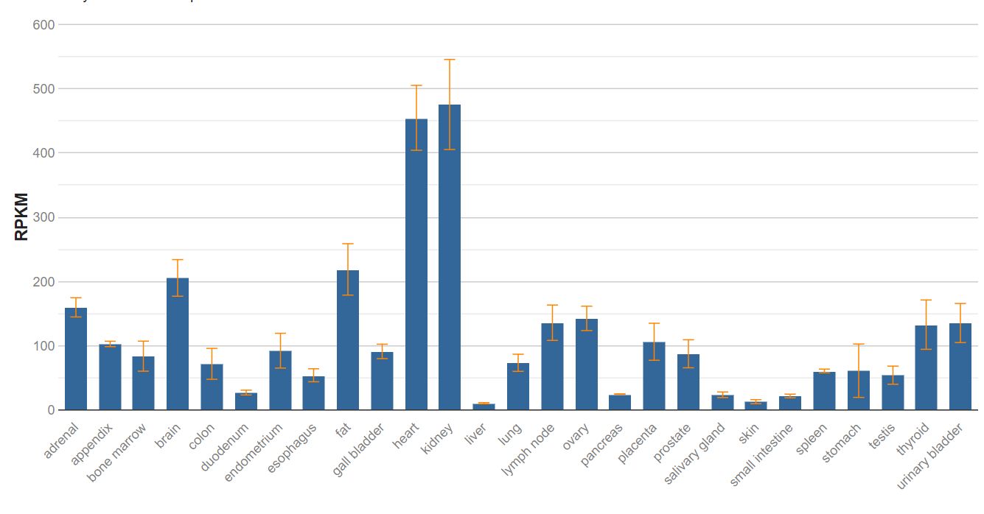
2. Figure S1
Figure S1: The expression levels of LDH-B mRNA in different tissues. The expression of LDH-B is low in liver. (The image was downloaded from GenBank: https://www.ncbi.nlm.nih.gov/gene/3945#gene-expression)
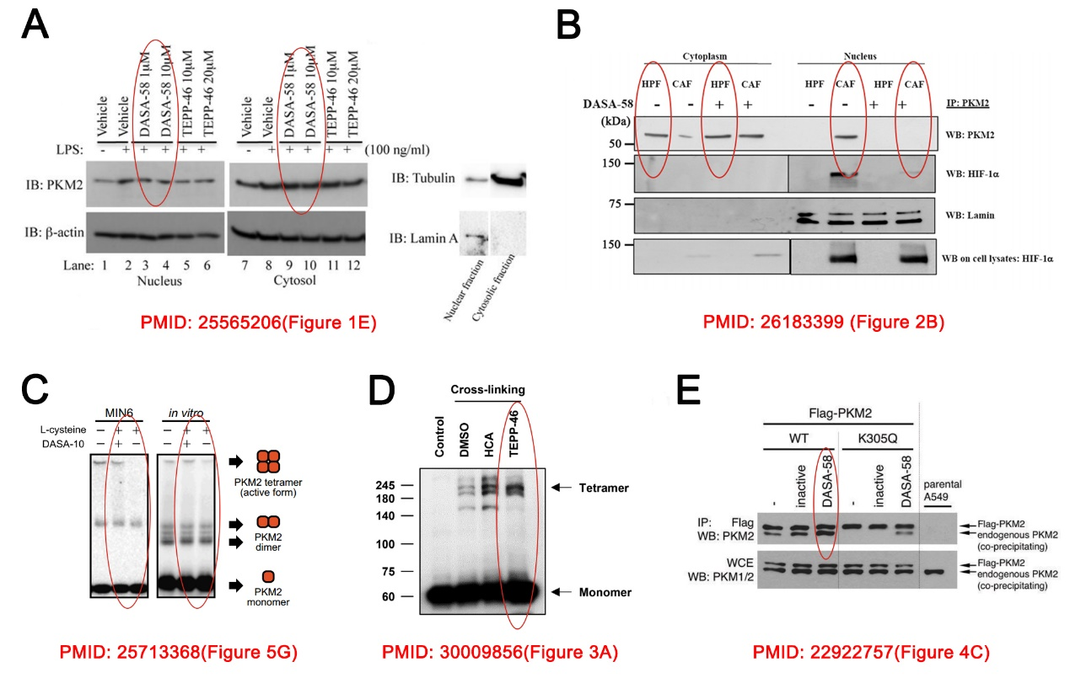
3. Figure S2
Figure S2：The effect of PKM2 activators on PKM2 protein level. (A, B) DASA-58 treatment can increase PKM2 levels in the cytoplasm and decrease PKM2 levels in the nucleus. (C) DASA-10 increased the PKM2 tetramer level, while the PKM2 monomer level didn’t change. (D) TEPP-46 increased both the PKM2 tetramer and PKM2 monomer levels. (E) DASA-58 can promote the interaction between exogenous PKM2 and endogenous PKM2.

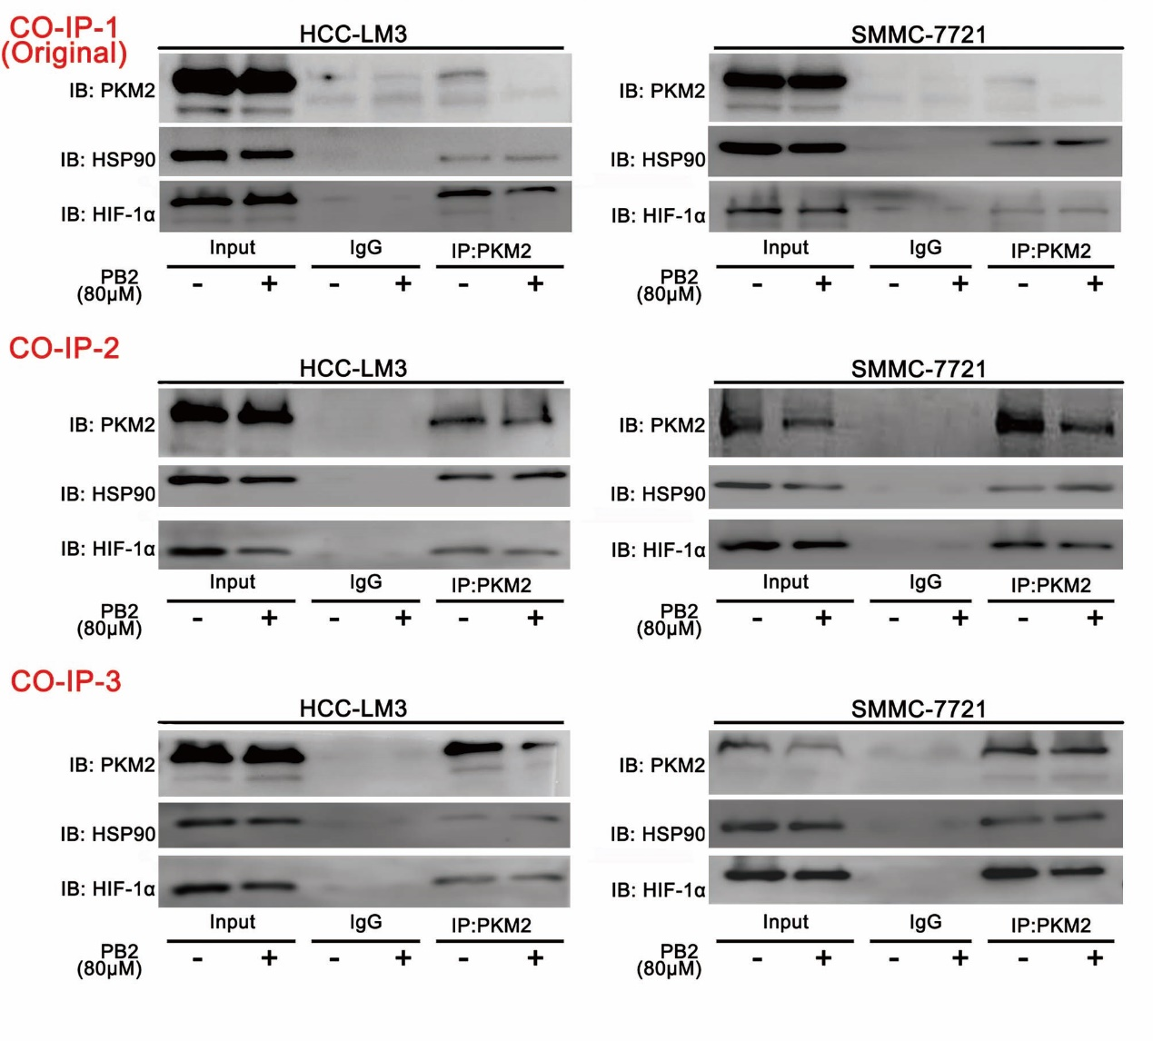
4. Figure S3
Figure S3: The three independent co-IP assay results during the study. CO-IP-1 were the 1st and original images for Figure 4B, which were not ideal so that made readers confused. While the 2nd and the 3rd results were better than the 1st one. Therefore, the 2nd results were used for layout in revised Figure 4B.

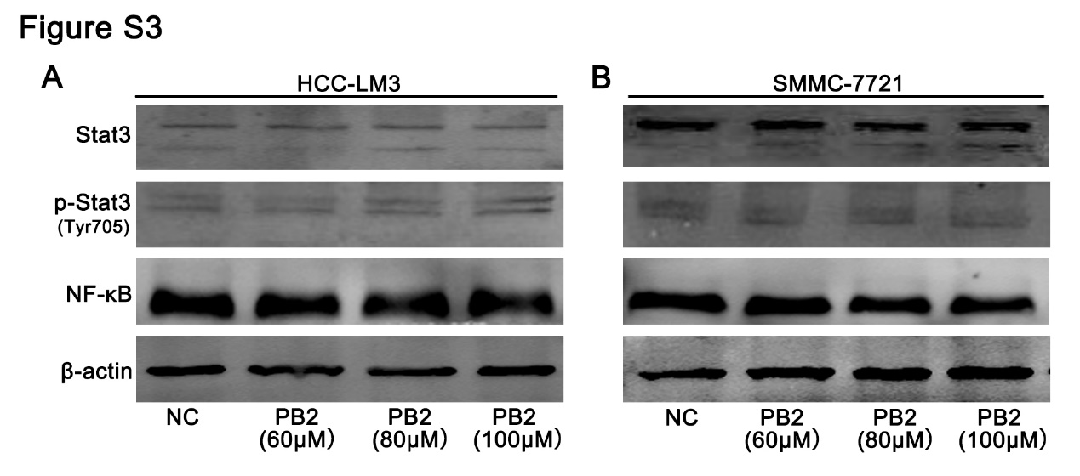
5. Figure S4
Figure S4: Effects of Stat3 and NF-κB on HIF-1α expression by PB2 treatment. (A, B) Both HCC-LM3 and SMMC-7721 cells were treated with 60, 80 or 100 μM PB2, and the protein levels of Stat3, p-Stat3(Tyr705) and NF-κB were detected.

