Supporting Information

Curcuminoid WZ35 synergize with cisplatin by inducing ROS production and inhibiting TrxR1 activity in gastric cancer cells

Wei He^{1#}, Yiqun Xia^{2#}, Peihai Cao^{1#}, Lin Hong¹, Tingting Zhang¹, Xin Shen¹, Peisen Zheng¹, Huanpei Shen¹, Guang Liang¹*, Peng Zou¹*

¹ Chemical Biology Research Center, School of Pharmaceutical Sciences, Wenzhou Medical University, Wenzhou, Zhejiang 325035, China
² Department of Digestive Diseases, The First Affiliated Hospital of Wenzhou Medical University, Wenzhou, Zhejiang 325035, China

* Corresponding author: Peng Zou, Ph.D
Address: Chemical Biology Research Center, School of Pharmaceutical Sciences, Wenzhou Medical University, Wenzhou 325035, China
Tel: +86-577-86699892; Fax: +86-577-86689982
E-mail: zoupeng123@163.com

* Co-corresponding author: Guang Liang, Ph.D
Address: Chemical Biology Research Center, School of Pharmaceutical Sciences, Wenzhou Medical University, Wenzhou 325035, China
Tel: +86-577-86699892; Fax: +86-577-86689982
E-mail: wzmuliangguang@163.com

# These authors contributed equally to this work

Supplementary Figures and Legends

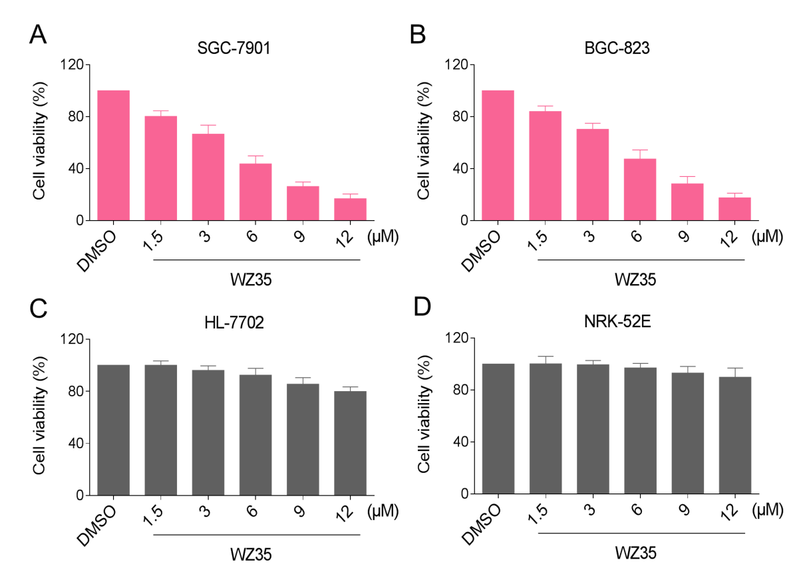
Figure S1. WZ35 selectively inhibits the growth of gastric cancer cells. (A-B) SGC-7901 or BGC-823 cells were treated with WZ35 at the indicated doses. At 24 h after treatment, the cell viability was determined by MTT assay. (C-D) HL-7702 or NRK-52E cells were treated with WZ35 at the indicated doses. At 24 h after treatment, the cell viability was determined by MTT assay.

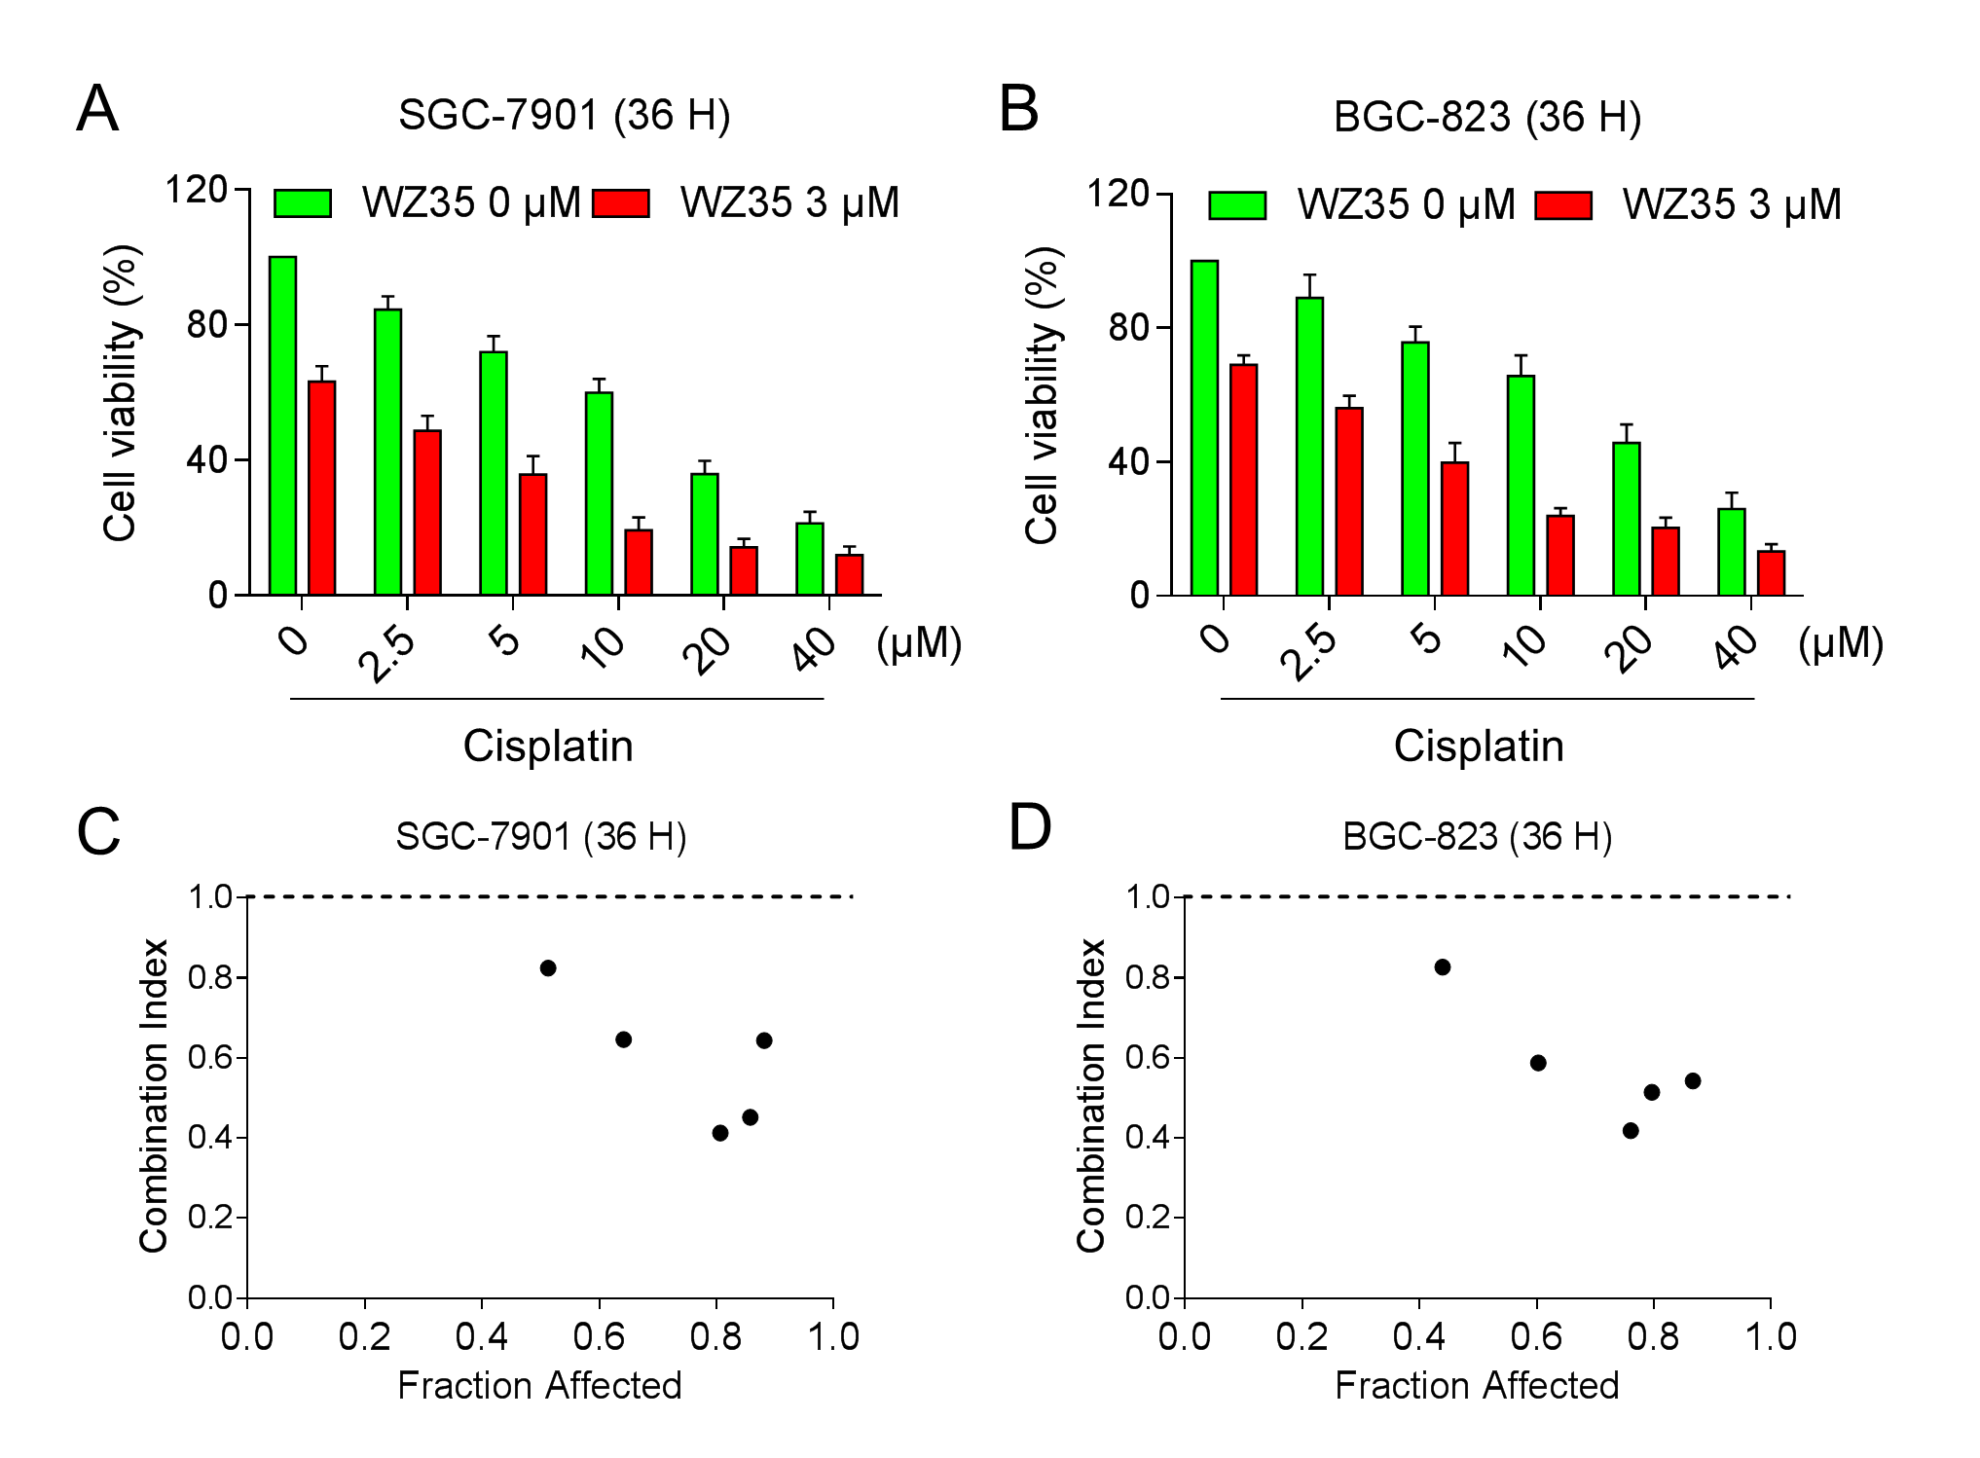
Figure S2. WZ35 synergistically increased the cytotoxicity of cisplatin in gastric cancer cells. (A-B) SGC-7901 or BGC-823 cells were treated with WZ35 or cisplatin alone or their combination at the indicated doses. At 36 h after treatment, the cell viability was determined by MTT assay. (C-D) The combination index (CI) values of WZ35 combined with cisplatin were calculated using the calcusyn software.

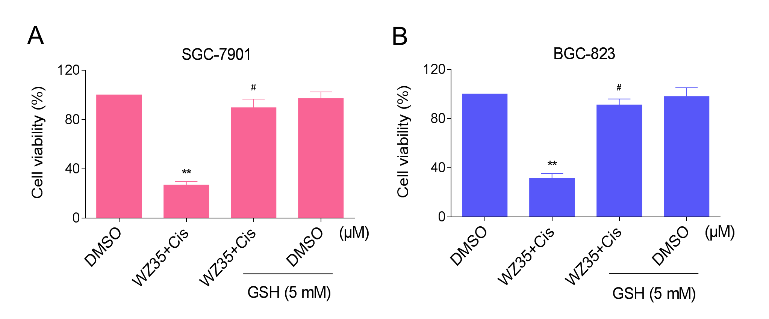
Figure S3. Pretreatment with GSH markedly attenuated the combined treatment-induced cell growth inhibition in gastric cancer cells. (A-B) SGC-7901 or BGC-823 cells were pretreated with 5 mM GSH for 2 h before exposure to WZ35 and cisplatin combination. At 24 h after treatment, the cell viability was determined by MTT assay.

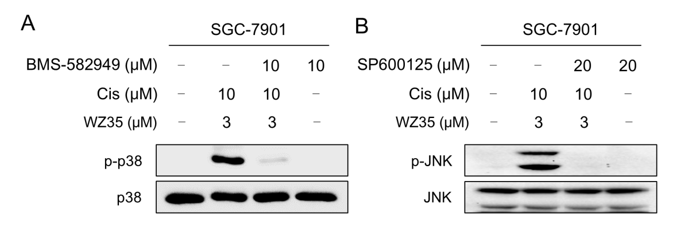
Figure S4. The inhibiting efficiencies of p-p38 and p-JNK by BMS-582949 and SP600125 respectively. (A-B) SGC-7901 cells were pretreated with BMS-582949 (10 μM) or SP600125 (20 μM) for 2 h before exposure to WZ35 and cisplatin combination. At 12 h after treatment, the protein levels of p-p38, p38, p-JNK and JNK were determined by western blot.

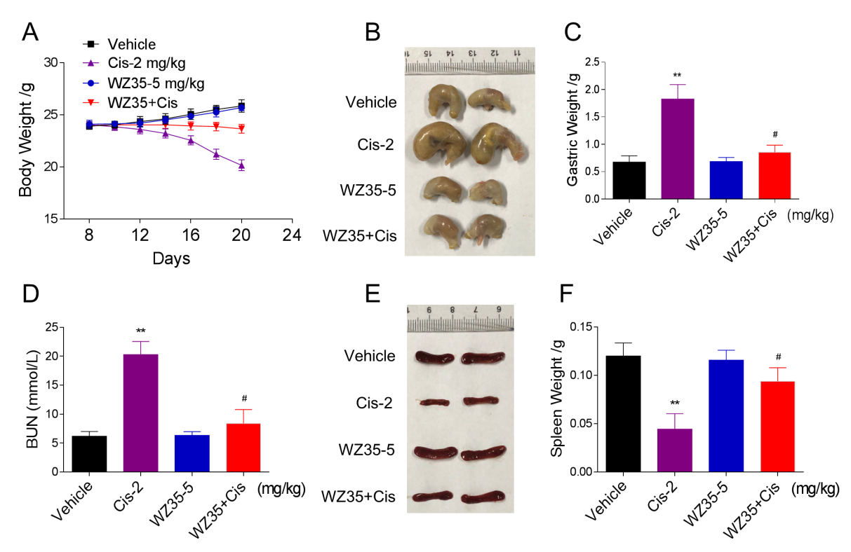
Figure S5. WZ35 reduced the toxicity of cisplatin in vivo. (A) The body weight of ICR mice during the experiment. (B-C) The gastric weight of mice after treatment. (D) The levels of serum blood urea nitrogen (BUN). (E-F) The spleen weight of mice after treatment.

