Inhibition of RNA Polymerase III Transcription by Triptolide Attenuates Colorectal Tumorigenesis

Xia Liang^{1,#}, Renxiang Xie^{2,#}, Jinfeng Su^{1,#}, Bingqi Ye², Saisai Wei³, Zhibing Liang¹, Rongpan Bai², Zhanghui Chen⁴, Zhongxiang Li^{1,*}, Xiangwei Gao^{2,*}.
1, Medical Research Institute, Baoan Maternal and Child Health Hospital, Jinan University, Shenzhen, 518102, China.
2, Department of Public Health, Zhejiang University School of Medicine, Hangzhou, 310058, China.
3, Sir Run-Run Shaw Hospital, Zhejiang University School of Medicine, Hangzhou, 310058, China.
4, Affiliated Central People’s Hospital of Zhanjiang, Guangdong Medical University, Zhanjiang, 524045, China.
# These authors contributed equally.
* Correspondence should be addressed to: Xiangwei Gao, Ph.D., xiangweigao@zju.edu.cn; or Zhongxiang Li, Ph.D., zhongxiangli@gmail.com.

Running Title: Triptolide targets Pol III.

SUPPLEMENTARY INFORMATION
Supplementary Tables
Supplementary Figures

Supplementary table 1. Primers used in this study.
Gene name | Primer name | Sequence
Human β-actin | H-ACTB-F | 5’-CACGATGGAGGGGCCGGACTCATC-3’
Human β-actin | H-ACTB-R | 5’-TAAAGACCTCTATGCCAACACAGT-3’
Human 5S rRNA | H-5S-F | 5’-GGCCATACCACCCTGAACGC-3’
Human 5S rRNA | H-5S-R | 5’-CAGCACCCGGTATTCCCAGG-3’
Human Leu tRNA | H-Leu-F | 5’-CAGGATGGCCGAGCGGT-3’
Human Leu tRNA | H-Leu-R | 5’-TCAGGAGTGGGATTCGAAC-3’
Human Tyr tRNA | H-Try-F | 5’-CCTTCGATAGCTCAGCTGGT-3’
Human Tyr tRNA | H-Try-R | 5’-CGACCTAAGGATGTCCACAAAT-3’
Human 7SL RNA | H-7SL-F | 5’-CAAAACTCCCGTGCTGATCA-3’
Human 7SL RNA | H-7SL-R | 5’-GGCTGGAGTGCAGTGGCTAT-3’
Human Brf1 | H-Brf1-F | 5’-TCTCAGACTCCATCCGCGAAT-3’
Human Brf1 | H-Brf1-R | 5’-GCGTTCTCCCTCATCCACA-3’
Human TBP | H-TBP-F | 5’-CCACTCACAGACTCTCACAAC-3’
Human TBP | H-TBP-R | 5’-CTGCGGTACAATCCCAGAACT-3’
Human Bdp1 | H-Bdp1-F | 5’-TATTTGAGCGCGGTTCTACAAC-3’
Human Bdp1 | H-Bdp1-R | 5’-AAAGTCAGTTCCTACCATGCTG-3’
Human POLR3D | H-POLR3D-F | 5’-GGCCGTCCAGAAGTGATCC-3’
Human POLR3D | H-POLR3D-R | 5’-CATCCACTGTCTTATCCCAGTTC-3’
Mouse β-actin | Mβ-actin-F | 5’-GCAGATGTGGATCAGCAAGC-3’
Mouse β-actin | Mβ-actin-R | 5’-AGCTCAGTAACAGTCCGCC-3’
Mouse 5S rRNA | H-5S-F | 5’-GGCCATACCACCCTGAACGC-3’
Mouse 5S rRNA | H-5S-R | 5’-CAGCACCCGGTATTCCCAGG-3’
Mouse Leu tRNA | H-Leu-F | 5’-GTCAGGATGGCCGAGTGGTCTAAG-3’
Mouse Leu tRNA | H-Leu-R | 5’-CCACGCCTCCATACGGAGAACCAGAAGACCC-3’
Mouse Tyr tRNA | H-Try-F | 5’-CCTTCGATAGCTCAGCTGGTAGAGCGGAGG-3’
Mouse Tyr tRNA | H-Try-R | 5’-CGGAATTGAACCAGCGACCTAAGGATGTCC-3’
Mouse 7SL RNA | H-7SL-F | 5’-GTGTCCGCACTAAGTTCGG-3’
Mouse 7SL RNA | H-7SL-R | 5’-TATTCACAGGCGCGATCC-3’
Human Brf1-FLAG | H-Brf1F-F | ATCGAAGCTTGCCACCATGACGGGCCGCGTGTG
Human Brf1-FLAG | H-Brf1F-R | TAGCGAATTCGCGTAGCCGTCGTCCTCATCG
Human TBP-FLAG | H-TBPF-F | ATCGAAGCTTGCCACCATGGATCAGAACAACAGCCTG
Human TBP-FLAG | H-TBPF-R | TAGCGAATTCGCCGTCGTCTTCCTGAATCC
Human POLR3D-FLAG | H-POLR3DF-F | ATCGAAGCTTGCCACCATGTCGGAAGGAAACGCCG
Human POLR3D-FLAG | H- POLR3DF -R | TAGCGAATTCGCCCGGTGTTTGTGATCCAAG

Supplementary table 2. Details of the CRC samples used in this study.
Patient number | Gender | History of chemotherapy | Type of lesion | Primary lesion site | Lymph node metastasis | Distant metastasis | Stage (AJCC)
1 | Male | None | Adenocarcinoma | Colon | None | None | II
2 | Female | None | Adenocarcinoma | Colon | None | None | II
3 | Male | None | Adenocarcinoma | Colon | Yes | None | III
4 | Female | None | Adenocarcinoma | Colon | Yes | Yes | IV
5 | Female | None | Adenocarcinoma | Colon | Yes | None | III
6 | Male | None | Adenocarcinoma | Colon | Yes | None | III
7 | Male | None | Adenocarcinoma | Colon | Yes | Yes | IV
8 | Male | None | Adenocarcinoma | Colon | None | None | II
9 | Male | None | Adenocarcinoma | Colon | None | None | II
10 | Female | None | Adenocarcinoma | Colon | None | None | II

Supplementary Figure 1. The effect of triptolide on liver function.
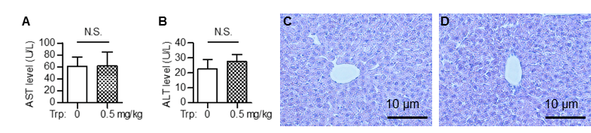
(A, B) Mice treated with or without triptolide (0.5 mg/kg) for 1 week and the blood level of AST (A) and ALT (B) was determined. (C, D) HE staining pictures of liver tissue sections from mouse treated without (C) or with (D) triptolide (100×).

Supplementary Figure 2. Triptolide induces G2 cycle arrest and apoptosis in HCT116 cells.
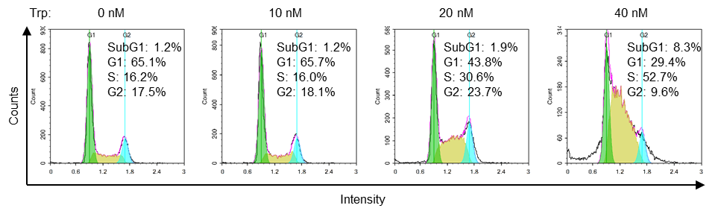
HCT116 cells were incubated with triptolide at different concentrations for 24 h and the cell cycle was determined. Cell percentage at G0/G1, S, G2, and sub-G1 phases was calculated and analyzed.

Supplementary Figure 3. Triptolide inhibits Pol III transcription in HCT116 cells.
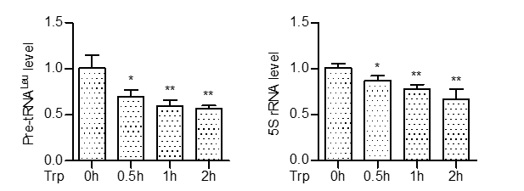
HCT116 cells were incubated with 40 nM triptolide for the indicated time. The mRNA level of 5S rRNA and pre-tRNA^{Leu} was measured by real-time qPCR.

Supplementary Figure 4. The effect of triptolide on the growth of normal organoids.
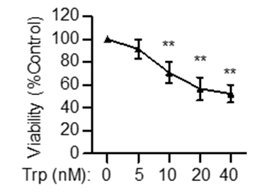
Organoids isolated from wild type mouse were treated with different concentration of triptolide for 72 hours and cell viability (ATP level) was measured. ** P<0.01.

