The DNA sequence of HCT116 KO cells, which was knockout six base-pairs (CGATTC) and led to no expression of ACLY protein.
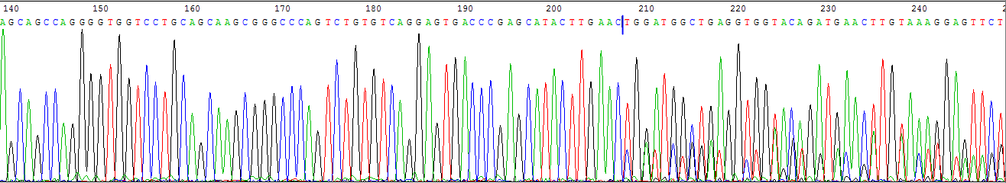

The DNA sequence result was blasted by NCBI.
