Supplementary materials
For
SP600125 enhances C-2-induced cell death by the switch from autophagy to apoptosis in bladder cancer cells
Haiyang Yu, Chun-Li Wu, Xiangyu Wang, Qianhong Ban, Chunhua Quan, Mengbo Liu, Hangqi Dong, Jinfeng Li, Gi-Young Kim, Yung Hyun Choi, Zhenya Wang, Cheng-Yun Jin

Figure Legend for Supplementary Data

Supplementary Figure 1. C-2 significantly induced apoptosis in human bladder cancer cells. (A) A dose-dependent induction of apoptosis by C-2 was demonstrated through flow cytometric analysis of Annexin V/PI stain assay. (B) The protein levels of Caspase9 were determined by western blotting assay at indicated concentrations for 24 h. For A, data are shown as mean ± s.d. (n = 3); **P < 0.01; ***P < 0.001 compared with control (Student’s t test).

Supplementary Figure 2. C-2-induced autophagy is associated with JNK pathway. The total of JNK and c-Jun were analyzed by western blotting at indicated concentration or treated with 4 μM of C-2 at indicated time points in BIU87 and EJ cells.

Supplementary Figure 3. Resisting C-2 induced apoptosis by p62 activated Nrf2 pathway in early time. The mRNA levels of NQO1, TrxR and IDH1 in BIU87 cells were detected by quantitative RT-PCR. Data are shown as mean ± s.d. (n = 3); ***P < 0.001 compared with control (Student’s t test).

Supplementary Figure 4. SP600125 block JNK-SQSTM1/p62-mediated Nrf2 anti-apoptotic pathway. (A) Western blotting assay showed the effect of SP600125 (10 μM) on the expression changes of Nrf2 protein in BIU87 cells incubated with 4 μM of C-2 for 6 h. (B) Western blotting assay showed the effect of JNK siRNA (20 nM) on expression of Nrf2 protein in BIU87 cells.

Supplementary Figure 1

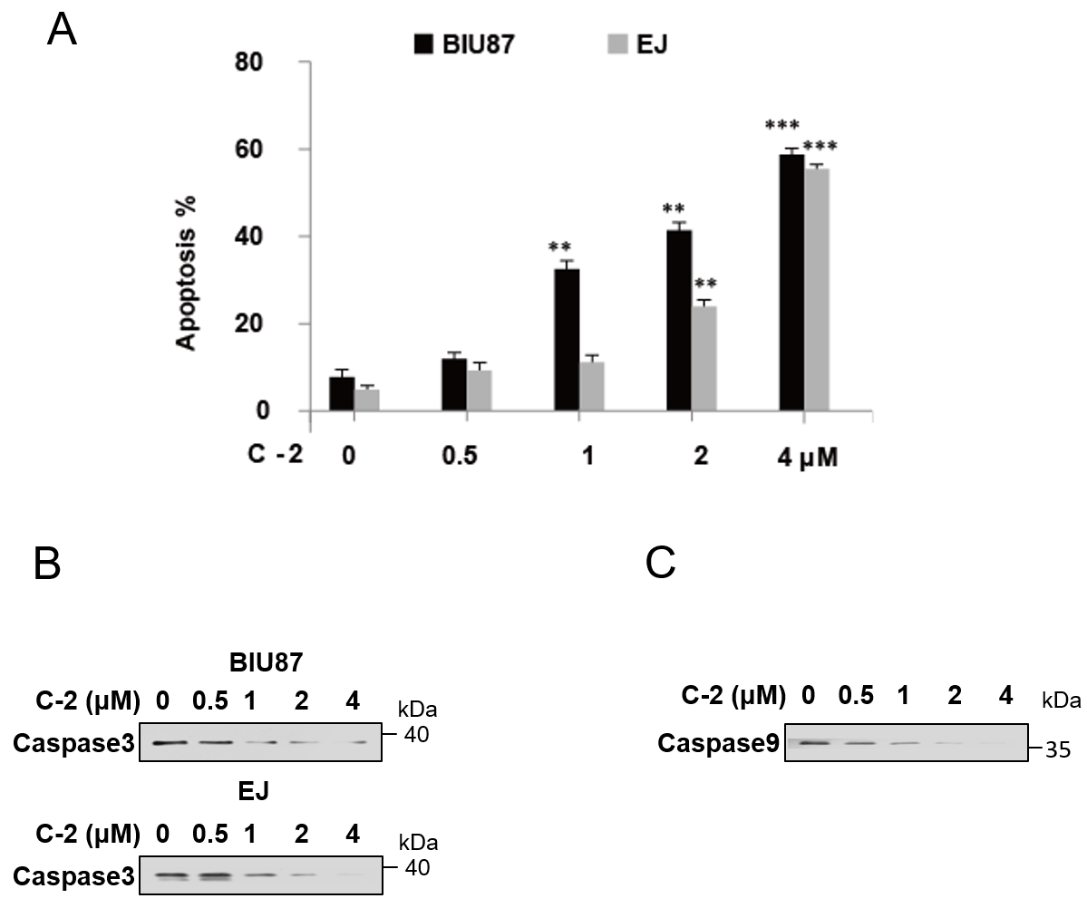

Supplementary Figure 2

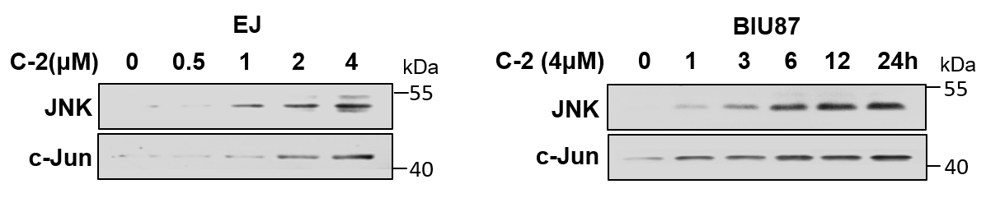

Supplementary Figure 3

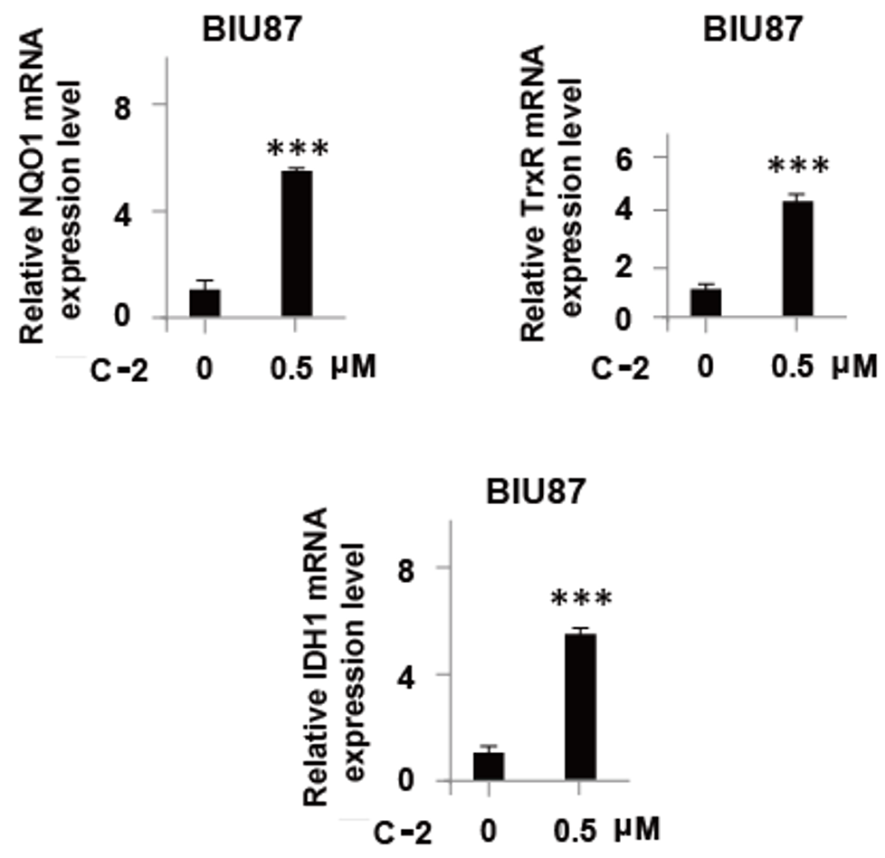

Supplementary Figure 4

