SUPPLEMENTAL MATERIAL

A SUMOylation-dependent HIF-1α/CLDN6 negative feedback mechanism mitigates hypoxia-induced breast cancer metastasis

Yiyang Jia¹, Yantong Guo¹, Qiu Jin¹, Huinan Qu¹, Da Qi¹, Peiye Song¹, Xiaoli Zhang¹, Xinqi Wang¹, Wenhong Xu¹, Yuan Dong¹, Yingying Liang¹, Chengshi Quan²

1 The Key Laboratory of Pathobiology, Ministry of Education, College of Basic Medical Sciences, Jilin University, 126 Xinmin Avenue, Changchun, Jilin, 310021, People's Republic of China.
2 The Key Laboratory of Pathobiology, Ministry of Education, College of Basic Medical Sciences, Jilin University, 126 Xinmin Avenue, Changchun, Jilin, 310021, People's Republic of China. quancs@jlu.edu.cn.

Supplemental figures

Figure.S1 Construction of MDA-MB-231 cell line with stable overexpression of CLDN6
a RT-PCR and western blot verified CLDN6 overexpression in CLDN6-overexpressed MDA-MB-231 cells; b Localization of exogenous CLDN6 in MDA-MB-231 cells by fluorescence microscopy.

Figure.S2 Western blotting indicating that CLDN6 overexpression downregulates HIF-1α target gene expression. a Detection of Glut1, EPO and SOX2 in MDA-MB-231/vec and MDA-MB-231/CLDN6 cells. b Detection of Glut1, EPO and SOX2 in SkBr-3/vec and SkBr-3/CLDN6 cells. * p<0.05

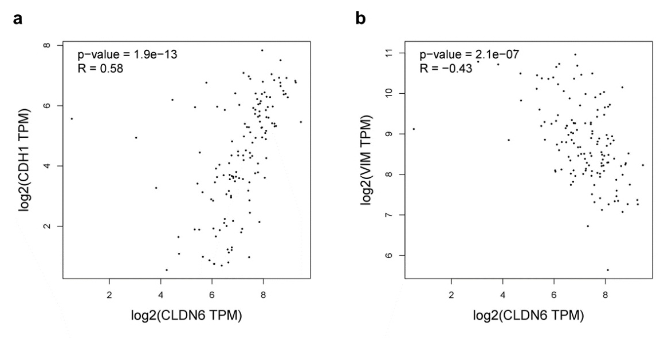
Figure.S3
The correlation between CLDN6 and EMT factors. a The correlation between CLDN6 and E-cadherin; b The correlation between CLDN6 and Vimentin.

Figure.S4
CLDN6 inhibits HIF-1α deSUMOylation by down-regulating SENP1. a Heatmap of SENPs expression in MDA-MB-231/Vec and MDA-MB-231/CLDN6 cells; b Comparison of global SUMOification levels between MDA-MB-231/Vec and MDA-MB-231/CLDN6 cells; c Comparison of global SUMOification levels between and MDA-MB-231/CLDN6 and SENP1-OE MDA-MB-231/CLDN6 cells; d WB analysis indicates that SENP1 up-regulated the WT but not MUT HIF-1α expression.

Figure.S5
CLDN6 down-regulates SENP1 expression by blocking the nuclear translocation of β-catenin. a The correlation between CLDN6 and β-catenin; b Evaluating the degradation rate of β-catenin by treating cells with CHX for 0, 1, 2 or 4 hours; c MDA-MB-231/Vec and MDA-MB-231/CLDN6 cells were treated with to MG-132 assess whether β-catenin is degraded by ubiquitin proteasome pathway.

Figure.S6
CLDN6 does not affect the expression of HIF-2α.

Table S1

Clinicopathological correlation of CLDN6 expression in human breast cancers

Characteristics of patients |  | CLDN6 Expression |  |  | p
 |  | Low | High | Total | p
Age (n=50) | ≤50 | 12 | 19 | 31 | 0.369
Age (n=50) | ＞50 | 5 | 14 | 19 | 0.369
TNM Stage (n=50) | II | 4 | 15 | 19 | 0.130
TNM Stage (n=50) | III | 13 | 18 | 31 | 0.130
Histologic Grade (n=43) | 1 | 7 | 11 | 18 | 0.847
Histologic Grade (n=43) | 2-3 | 9 | 16 | 25 | 0.847

Table S2

Clinicopathological correlation of SENP1 expression in human breast cancers

Characteristics of patients |  | SENP1 Expression |  |  | p
 |  | Low | High | Total | p
Age (n=50) | ≤50 | 11 | 20 | 31 | 0.923
Age (n=50) | ＞50 | 7 | 12 | 19 | 0.923
TNM Stage (n=50) | II | 10 | 9 | 19 | 0.055
TNM Stage (n=50) | III | 8 | 23 | 31 | 0.055
Histologic Grade (n=43) | 1 | 9 | 9 | 18 | 0.141
Histologic Grade (n=43) | 2-3 | 7 | 18 | 25 | 0.141

Table S3

Clinicopathological correlation of HIF-1α expression in human breast cancers

Characteristics of patients |  | HIF-1α Expression |  |  | p
 |  | Low | High | Total | p
Age (n=50) | ≤50 | 20 | 11 | 31 | 0.280
Age (n=50) | ＞50 | 15 | 4 | 19 | 0.280
TNM Stage (n=50) | II | 15 | 4 | 19 | 0.280
TNM Stage (n=50) | III | 20 | 11 | 31 | 0.280
Histologic Grade (n=43) | 1 | 12 | 6 | 18 | 0.856
Histologic Grade (n=43) | 2-3 | 16 | 9 | 25 | 0.856

Primers

Genes | Primer Sequence
CLDN6 | 5'-CTGCCCATGTGGAAGGTGAC-3'
CLDN6 | 5'-GGTAGACCAGCAAGCCGAAC-3'
HIF-1α | 5'-TTCCAGTTACGTTCCTTCGATCA-3'
HIF-1α | 5'-TTTGAGGACTTGCGCTTTCA-3'
SENP1 | 5'-ATCAGGCAGTGAAACGTTGGAC-3'
SENP1 | 5'-GCAGGCTTCATTGTTTATCCCA-3'
VEGFA | 5'-AAGGAGGAGGGCAGAATCAT-3'
VEGFA | 5'-ATCTGCATGGTGATGTTGGA-3'
EPO | 5'-TCATCTGTGACAGCCGAGTC-3'
EPO | 5'-TTTGGTGTCTGGGACAGTGA-3'
Glut1 | 5'-ACAACCAGACATGGGTCCAC-3'
Glut1 | 5'-TAACGAAAAGGCCCACAGAG-3'
SOX2 | 5'-AAATGGGAGGGGTGCAAAAGAGGAG-3'
SOX2 | 5'-CAGCTGTCATTTGCTGTGGGTGATG-3'
VHL | 5'-CGTAGCGGTTGGTGACTTG-3'
VHL | 5'-CCCTGGTTTGTTCCTCTGAC-3'
PHD1 | 5'-CCTGAATCAGAACTGGGACGTT-3'
PHD1 | 5'-CGGCCCTCAGGGAAGATC-3'
PHD2 | 5'-GCTTTGTTTGCCCCAGAGTATT-3'
PHD2 | 5'-GAATGTCCCTCCCAATCCTTAAT-3'
PHD3 | 5'-GCCAGCGGTTTACCTGATAGAT-3'
PHD3 | 5'-TTCCCTCGCTGTGCTCCTA-3'
HK2 | 5'-CCAGTTCATTCACATCATCAG-3'
HK2 | 5'-CTTACACGAGGTCACATAGC-3'
18s rRNA | 5'-CGGCGACGACCCATTCGAAC-3'
18s rRNA | 5'-GAATCGAACCCTGATTCCCCGTC-3'
CLDN6 (ChIP) | 5'-GTGGTGAAGCGGAGTCTCAA-3'
CLDN6 (ChIP) | 5'-GTCTCTCCAACACGCACACT-3'
SENP1 (ChIP) | 5'-CCCATTCTCTGTCACTGGAGT-3'
SENP1 (ChIP) | 5'-GGGTTTCCTCCCCTGTCAAA-3'
β-Actin | CATCCACGAAACTACCTTCAACTCC
β-Actin | GAGCCGCCGATCCACACG

Antibodies

CLDN6 Rabbit Polyclonal antibody (Bioworlde, BS3107 )
HIF-1α Mouse monoclonal antibody (Abcam, ab1)
HIF-2α Rabbit polyclonal antibody (Abcam, ab199)
SENP1 Rabbit polyclonal antibody (Proteintech, 25349-1-AP)
SUMO1 Rabbit Polyclonal antibody (Proteintech, 10329-1-AP)
Glut1 Rabbit Polyclonal antibody (Proteintech, 21829-1-AP)
EPO Rabbit Polyclonal antibody (Proteintech, 17908-1-AP)
SOX2 Rabbit Polyclonal antibody (Cell signaling technology, 3579)
E-Cadherin Rabbit Polyclonal antibody (Cell signaling technology, 3195)
N-Cadherin Rabbit Polyclonal antibody (Cell signaling technology, 13116)
Vimentin Rabbit Polyclonal antibody (Cell signaling technology, 5741)
VHL Rabbit Polyclonal antibody (Proteintech, 16538-1-AP)
PHD1 Rabbit Polyclonal antibody (Proteintech, 12984-1-AP)
PHD2 Rabbit Polyclonal antibody (Proteintech, 20368-1-AP)
PHD3 Rabbit Polyclonal antibody (Proteintech, 18325-1-AP)
FLAG Mouse monoclonal antibody (Proteintech, 66008-1-AP)
β-Catenin Mouse monoclonal antibody (Proteintech, 66379-1-AP)
α-Tubulin Rabbit polyclonal antibody (Proteintech, 11224-1-AP)
Lamin A/C Rabbit polyclonal antibody (Affinity, AF6056)
ATP1A1 Rabbit polyclonal antibody (Proteintech, 14418-1-AP)
GAPDH Mouse Monoclonal antibody (Proteintech, 60004-1-Ig)
β-Actin Mouse monoclonal antibody (Proteintech, 60008-1-AP)
CLDN6 | Bioworlde，USA | 1:1000 | Rabbit
HIF-1α | Abcam，USA | 1:500 | Mouse
HIF-2α | Abcam，USA | 1:1000 | Rabbit
SENP1 | Proteintech，CN | 1:1000 | Rabbit
SUMO1 | Proteintech，CN | 1:1000 | Rabbit
Glut1 | Proteintech，CN | 1:1000 | Rabbit
EPO | Proteintech，CN | 1:1000 | Rabbit
SOX2 | Cell signaling, USA | 1:1000 | Rabbit
E-Cadherin | Cell signaling, USA | 1:1000 | Rabbit
N-Cadherin | Cell signaling, USA | 1:1000 | Rabbit
Vimentin | Cell signaling, USA | 1:2000 | Rabbit
VHL | Proteintech, CN | 1:1000 | Rabbit
PHD1 | Proteintech, CN | 1:1000 | Rabbit
PHD2 | Proteintech, CN | 1:1000 | Rabbit
PHD3 | Proteintech, CN | 1:1000 | Rabbit
FLAG | Proteintech, CN | 1:2000 | Mouse
β-Catenin | Proteintech, CN | 1:2000 | Mouse
α-Tubulin | Abcam, USA | 1:5000 | Rabbit
Lamin A/C | Affinity, CN | 1:2000 | Mouse
ATP1A1 | Proteintech, CN | 1:1000 | Rabbit
GAPDH | Proteintech, CN | 1:5000 | Mouse
β-Actin | Proteintech，CN | 1:10000 | Mouse

