Supplementary Material

Progranulin induces immune escape in breast cancer via up-regulating PD-L1 expression on tumor-associated macrophages (TAMs) and promoting CD8⁺T cell exclusion
Wenli Fang¹, Ting Zhou¹, He Shi¹, Mengli Yao¹, Dian Zhang¹, Husun Qian¹, Qian Zeng¹, Yange Wang¹, Fangfang Jin¹, Chengsen Chai¹, Tingmei Chen^{1*}

¹ Key Laboratory of Clinical Laboratory Diagnostics (Ministry of Education), College of Laboratory Medicine, Chongqing Medical University, Chongqing 400016, PR China.
* Correspondence: tingmeichen@cqmu.edu.cn.

A
B
Fig. S1 PGRN regulates CD86 and CD206 expression on macrophages
(A-B) RAW264.7 cells were treated with PGRN and LPS or IL-4. CD86 (A) and CD206 (B) expression were tested by flow cytometry. Representative histograms are shown.

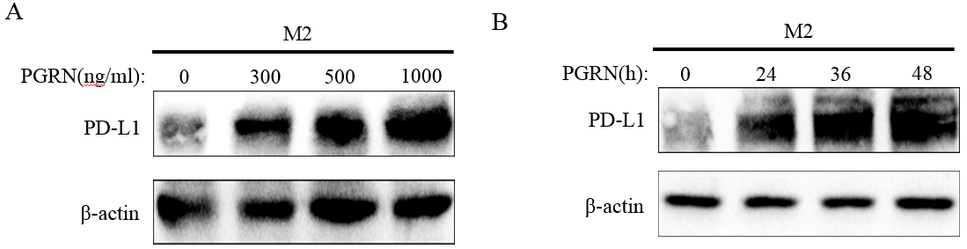
Fig. S2 The expression of PD-L1 on M2 treated with PGRN
(A-B) After being treated with PGRN in different dose (A) and time (B), western blotting was used to show PD-L1 expression in M2.

