Table S1 Primer sequences used in qRT-PCR
Genes | Primer sequences (5’-3’)
BBOX1-AS1 | F: CAGACTCCTGCTTTGCTCTT
 | R: GGAAGCATCTTCTCAGCTTCT
MELK | F: GCCTGCCATATCCTTACTGG
 | R: TGGCTGTCTCTAGCACATGG
miR-27a-5p | F: TGTATTTTAGTCGTGGCGATA
 | R: ATAACGACTCACGCCTATAATC
GAPDH | F: AGCCACATCGCTCAGACAC
 | R: GCCCAATACGACCAAATCC
U6 | F: ATTGGAACGATACAGAGAAGATT
 | R: GGAACGCTTCACGAATTTG

Figure S1
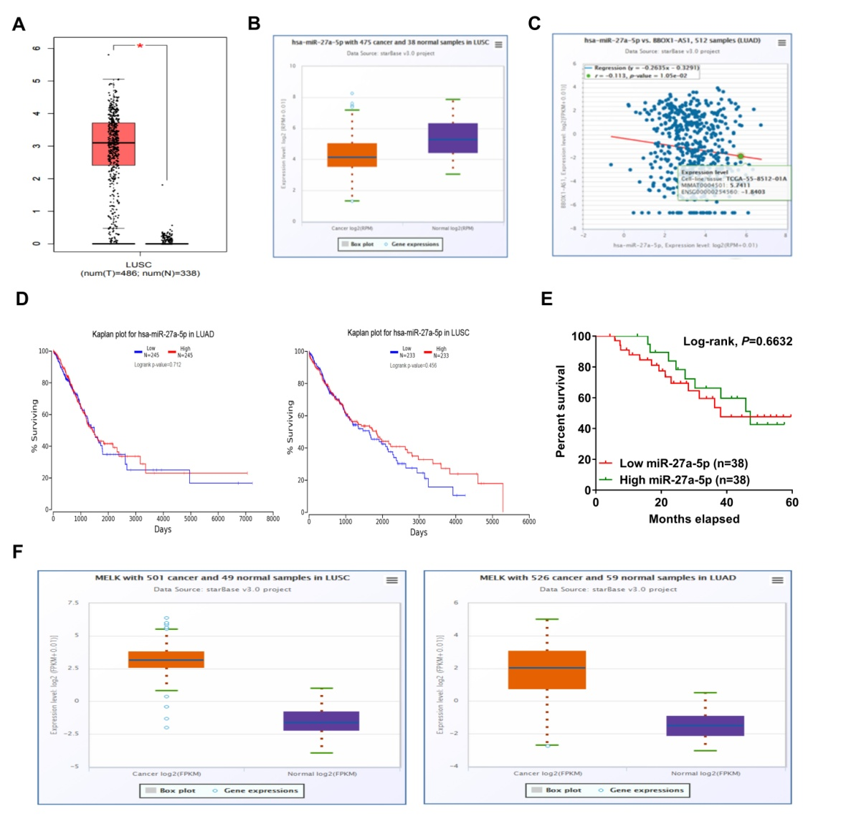
Figure S1 (A) GEPIA website shows the expression of BBOX1-AS1 in LUSC. (B) starBase Pan-Cancer Analysis Platform reveals the expression of miR-27a-5p in LUSC. (C) starBase Pan-Cancer Analysis Platform was used to analyze the correlation between miR-27a-5p and BBOX1-AS1 in lung cancer tissues. (D) Kaplan-Meier survival plots using the TCGA LUAD and LUSC patients by expression value of miR-27a-5p. (E) Kaplan-Meier survival curve was used to determine the correlation between overall survival and miR-27a-5p expression in NSCLC. (F) GEPIA database displays the expression of MELK mRNA in LUSC and LUAD.
Figure S2

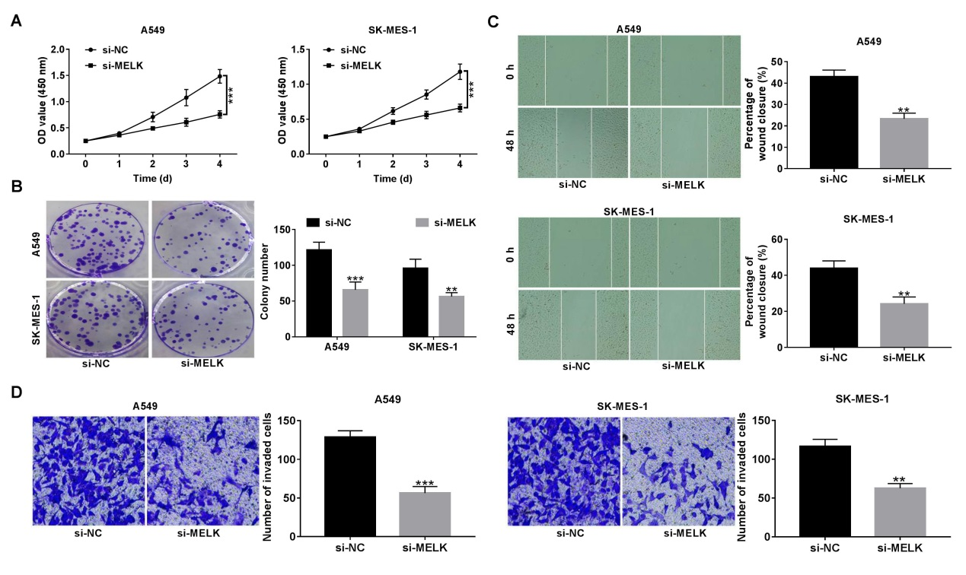
Figure S2 MELK promotes cell proliferation, migration and invasion in NSCLC. (A-D) A549 and SK-MES-1 cells were transfected with si-NC or si-MELK, followed by CCK-8 assay of cell viability (A), colony forming assay (B), wound healing assay of cell migration (C) and transwell assay of cell invasion. **P < 0.01, ***P < 0.001.

