Supplemental Data for

SHOX2 cooperates with STAT3 to promote breast cancer metastasis through the transcriptional activation of WASF3

Yong Teng, Reid Loveless, Elayne M Benson, Li Sun, Austin Y Shull, Chloe Shay

Correspondence to: Yong Teng, yong.teng@emory.edu

This file includes:
Supplementary Figures 1-6 and Figure legends

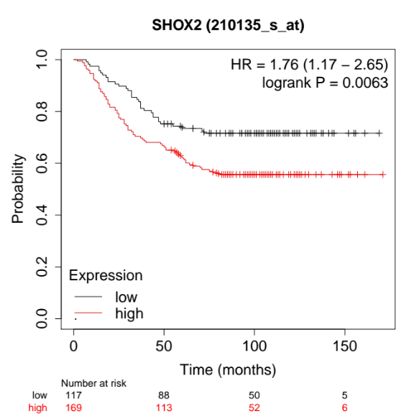
Supplementary Figures S1. Relapse-free survival of SHOX2 expression in GSE2034.

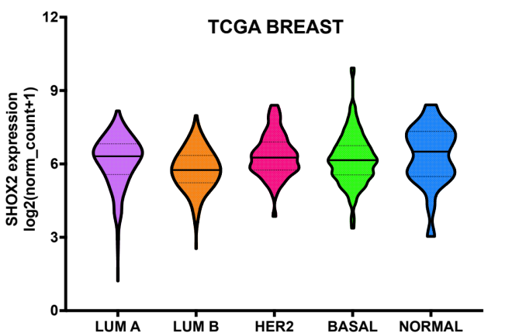
Supplementary Figures S2. The expression of SHOX2 in breast cancer molecular subtypes from the TCGA breast cancer cohort.

Supplementary Figures S3. The putative binding site(s) of SHOX2 (ATTA(N)nTAAT) on the promoters of WASF family genes.

Supplementary Figures S4. Promoter analysis showing high-density CpG sites (red) and multiple SHOX2 binding sites (ATTA(N)nTAAT) (boxes) on the WASF3 gene promoter.

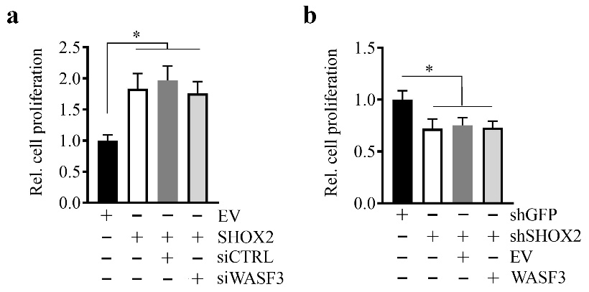
Supplementary Figures S5. Cell proliferation determined in SHOX2 overexpressing T47D cells with or without the WASF3 knockdown (a) and in SHOX2 knockdown MDA-MB-231 cells with or without WASF3 overexpression (b). siCTRL: a non-targeting siRNA; EV: an empty vector; * p<0.05.

Supplementary Figures S6. The protein levels of E-cadherin in xenograft tumors derived from the indicated gene-modified MDA-MB-231 cells determined by IHC. Representative E-cadherin immunostaining and quantitative data are shown. *p<0.05; **p<0.01

