Supplemental Information

Figure S1.

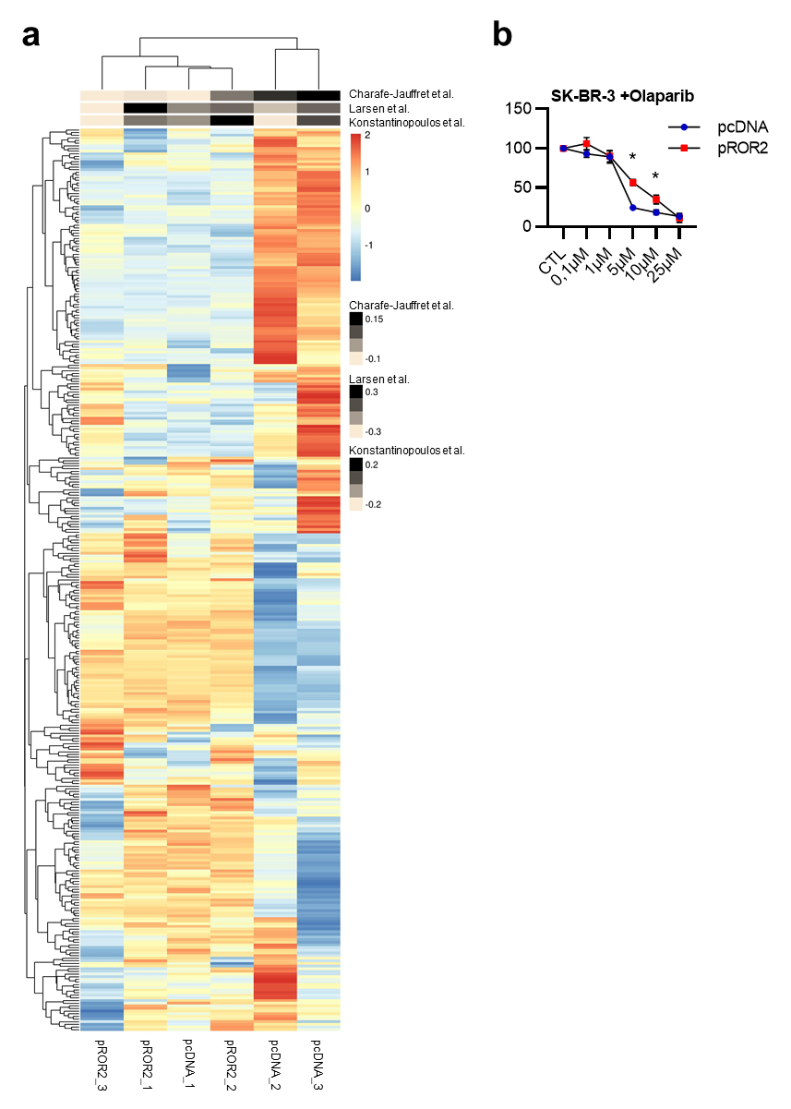

Fig. S1: BRCAness signature in SK-BR-3 cells. a, GSVA analysis for three independently published BRCAness gene expression signatures for SK-BR-3 cells overexpressing either an empty vector (pcDNA) or ROR2 overexpression plasmid (pROR2). Shown are three biological replicates each. b, MTT assay: SK-BR-3 pcDNA and pROR2 cells were treated for 96 h with the indicated concentrations of olaparib (mean±SD, n=3, *p<0.05).

Figure. S2.
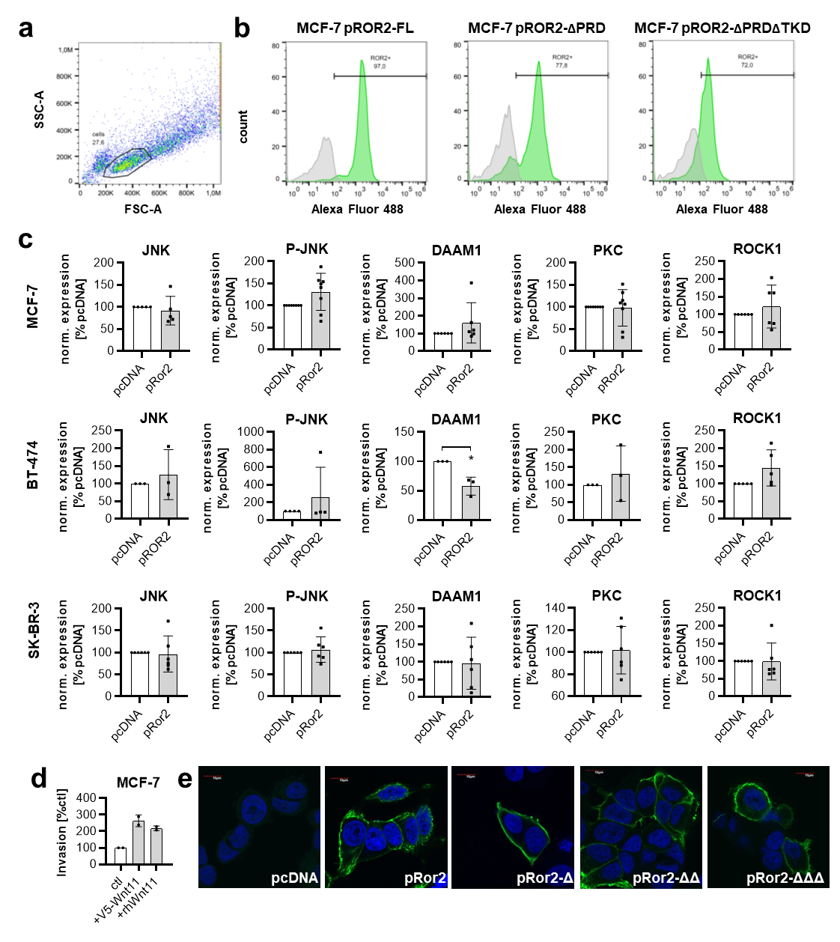

Fig. S2: Modulation of the WNT11 and ROR2 expression in MCF-7 cells. a+b, MCF-7 cells stably transfected with either ROR2 full-length (pROR2-FL) or C-terminal deletion constructs were analyzed by flow cytometry for their ROR2 expression. Cell populations were gated based on FSC vs SSC plots (a) and representative histograms for the expression of ROR2 (green) in comparison to the isotype control (grey) in the gated cell population are shown (b). c, Western Blot: Densitometric quantification of the indicated proteins in MCF-7, BT-474 and SK-BR-3 cells overexpressing either empty vector (pcDNA) or human ROR2 (pROR2). Protein expression was normalized on the housekeeping protein (mean±SD, *p<0.01). All significant values were marked with an asterisk. d, Invasion assay of MCF-7 cells transiently transfected with V5-tagged WNT11 (mean±SD, n=2). e, Confocal microscopy: Immunofluorescence staining of MCF-7 cells transfected with the serial N-terminal ROR2 deletion constructs (blue: DAPI, green: ROR2). Scale bar: 10 µm

Figure. S3.

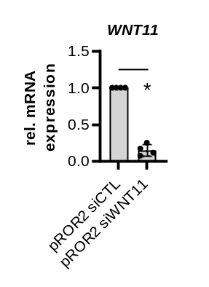
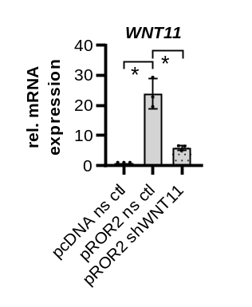
a
b

Fig. S3: Knockdown of WNT11 in MCF-7 pROR2 cells. a, qRT-PCR: WNT11 knockdown was confirmed in MCF-7 cells stably overexpressing either a non-sense control (ns ctl) or a shRNA directed against WNT11 (mean±SD, n=3, *p<0.05). Significance was calculated with a one-way ANOVA with Dunnett‘s multiple comparison test. b, WNT11 expression was measured by qRT-PCR in MCF-7 pROR2 cells transiently transfected with a control siRNA (siCTL) or siRNA against WNT11 (siWNT11) (mean±SD, n=4, *p<0.001).

Figure. S4.

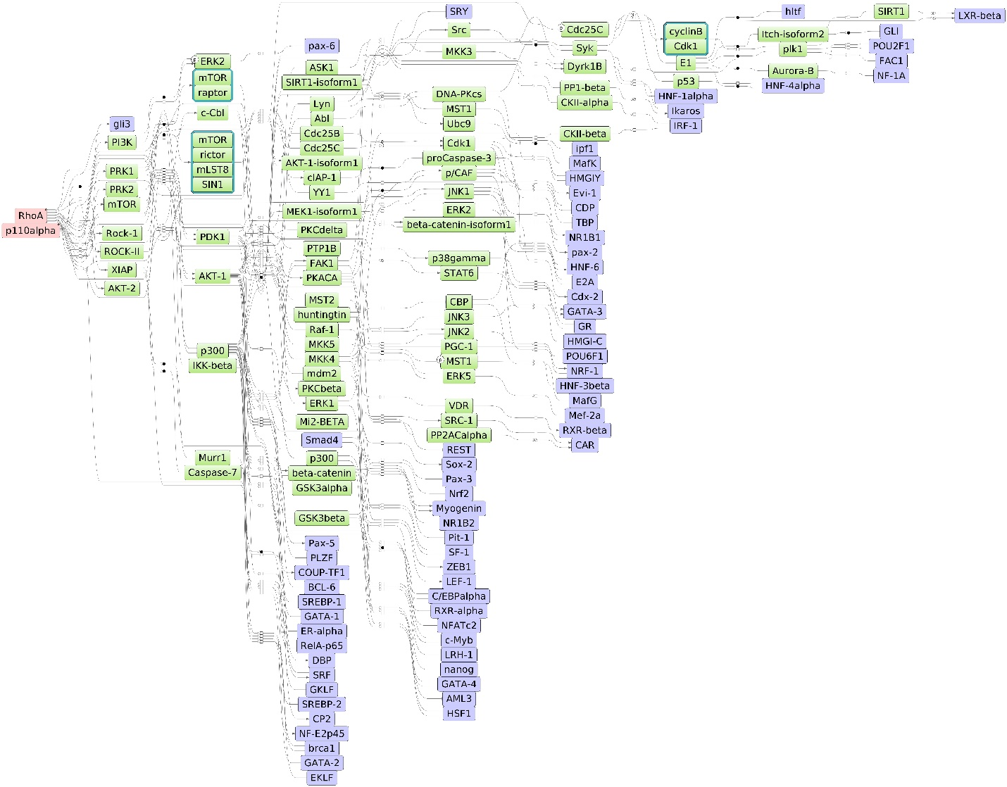

Fig. S4: PIK3CA and RHOA are master regulators of ROR2 signaling. Master regulatory network based on RNA-Seq data of MCF-7 pcDNA vs pROR2 cells. Red: master regulators, purple: regulated transcription factors, green; connecting molecules.

Table S1.
Antibodies used for RPPA.

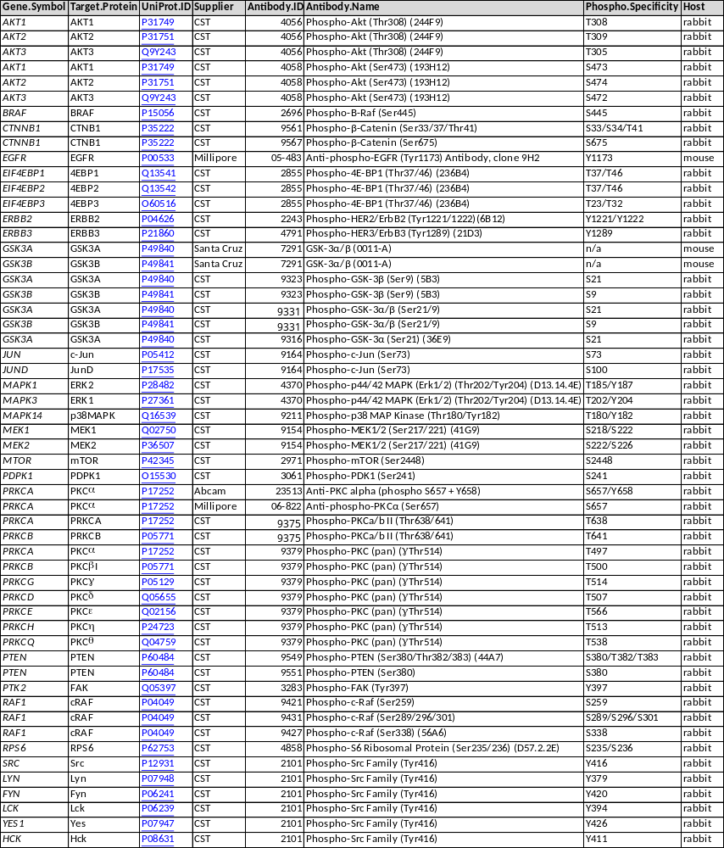

Table S2.
Antibodies used for western blots.

Gene.Symbol | Supplier | Antibody.ID | Host
DAAM1 | santa cruz | sc-100942 | mouse
GAPDH | santa cruz | sc-32233 | mouse
HSP90 | santa cruz | sc-13119 | mouse
JNK | CST | 9252 | rabbit
P-JNK | santa cruz | sc-6254 | mouse
PKC | santa cruz | sc-10800 | mouse
RHOA | santa cruz | sc-418 | mouse
ROCK1 | santa cruz | sc-17794 | mouse
ROCK2 | santa cruz | sc-398519 | mouse
ROR2 | santa cruz | sc-98486 | rabbit
ROR2 | santa cruz | sc-80329 | mouse
TUBA | Millipore | 05-829 | mouse
V5-Tag | CST | 13202 | rabbit
WNT11 | abcam | ab31962 | rabbit

Table S3.
Primers used for quantitative real-time PCR.

primer | sequence forward primer (5'-3') | sequence reverse primer (5'-3')
hsWNT4_fw/rv150 | CTGAAGGAGAAGTTTGATGGTG | TGTCCTGCTCACAGAAGTC
hsWNT5A_fw/rv109 | AGGGCTCCTACGAGAGTGCT | GACACCCCATGGCACTTG
hsWNT6_fw/rv150 | GGAGCGTTTAAAGGACACTG | GATACTAACCTCACCCACCA
hsWNT11_fw/rv102 | CTCGGAACTCGTCTATCTG | GTTGGATGTCTTGTTGCAC
hsROR2_fw/rv143 | TTCTTCTTGGTTTGCATGTG | CTGATCTCTTTGAGTTTGGC
hsHPRT1_fw/rv89 | TATGCTGAGGATTTGGAAAGG | CATCTCCTTCATCACATCTCG
hsGNB2L1_fw/rv84 | AACCCTATCATCGTCTCCT | CAATGTGGTTGGTCTTCAG

Table S4.
Master regulator analysis of MCF-7 pcDNA siWNT11 versus pROR2 siCTL cells.

Gene Symbol | Master molecule name | FDR
RHOA | RhoA(h) | 0,002
RAD23A | Rad23A(h) | 0,002
CUX1 | CDP(h) | 0,002
UBE2K | HIP2(h) | 0,002
AMER1 | FAM123B(h) | 0,003
CREBBP | CBP(h) | 0,004
NR3C1 | GR(h) | 0,005
CEBPA | C/EBPalpha(h) | 0,005
CHUK | IKK-alpha:IKK-beta{p}:(IKK-gamma)2 | 0,006
IKBKB | IKK-alpha:IKK-beta{p}:(IKK-gamma)2 | 0,006
IKBKG | IKK-alpha:IKK-beta{p}:(IKK-gamma)2 | 0,006
RARA | NR1B1(h) | 0,006
PIK3CA | p110alpha(h) | 0,007
PKN2 | PRK2(h) | 0,009
CASP6 | proCaspase-6(h) | 0,01
PRSS1 | trypsin-1(h) | 0,01
EP300 | p300(h) | 0,011
NLRC4 | CLAN(h) | 0,011
INS | insulin(h) | 0,011
PHLPP1 | PHLPP(h) | 0,012
PHLPP2 | phlpp2(h) | 0,012
PIK3CD | p110delta(h) | 0,013
MECOM | Evi-1(h) | 0,013
RARB | NR1B2(h) | 0,013
CASP1 | Caspase-1(h) | 0,014
CAMK2A | CamKII(h) | 0,015
CAMK2B | CamKII(h) | 0,015
CAMK2D | CamKII(h) | 0,015
CAMK2G | CamKII(h) | 0,015
RAC3 | Rac3(h) | 0,015
RHOG | RhoG(h) | 0,015
REST | REST(h) | 0,015
HNF4A | HNF-4alpha(h) | 0,015
RAC2 | Rac2(h) | 0,016
NEK2 | Nek2A(h) | 0,017
TRIM32 | HT2A(h) | 0,017
TGFBR2 | TGFbetaR-II(h) | 0,018
GATA3 | GATA-3(h) | 0,019
HSF1 | HSF1(h) | 0,019
NANOG | nanog(h) | 0,02
HTT | huntingtin(h) | 0,021
ROCK2 | ROCK-II(h) | 0,022
FURIN | PACE(h) | 0,022
ESR1 | ER-alpha(h) | 0,022
PDPK1 | PDK1-isoform2(h) | 0,023
EGF | EGF:ErbB1{pY}:ErbB2{pY}:Src | 0,023
EGFR | EGF:ErbB1{pY}:ErbB2{pY}:Src | 0,023
ERBB2 | EGF:ErbB1{pY}:ErbB2{pY}:Src | 0,023
SRC | EGF:ErbB1{pY}:ErbB2{pY}:Src | 0,023
NFATC2 | NFATc2(h) | 0,025
MYB | c-Myb(h) | 0,025
CDC42 | Cdc42-isoform2(h) | 0,026
PPP1CB | PP1-beta(h) | 0,027
CDK1 | Cdk1(h) | 0,027
CASP7 | proCaspase-7(h) | 0,029
RELA | RelA-p65(h) | 0,029
PRKCD | PKCdelta(h){pT507}{pS645}{pS664} | 0,03
IGF1R | IGF-1R(h) | 0,03
CASP2 | Caspase-2(h) | 0,031
HMGA1 | HMGIY(h) | 0,031
PTK2B | Pyk2-isoform1(h) | 0,032
FRAT1 | Frat1(h) | 0,032
PRKCG | PKCgamma(h) | 0,033
SUMO1 | sumo1(h) | 0,033
AKT1 | AKT(h){ub}n | 0,034
AKT2 | AKT(h){ub}n | 0,034
PRKCI | PKCiota(h) | 0,036
DRD1 | D1(h) | 0,036
PDK1 | pyruvate dehydrogenase (lipoamide) kinase isozyme 1, mitochondrial(h) | 0,037
BAX | Bax(h) | 0,038
CASP10 | Caspase-10(h) | 0,04
SENP5 | Senp5-isoform1(h) | 0,04
DLG4 | PSD-95(h) | 0,04
DUSP22 | JKAP(h) | 0,042
MTOR | mTOR(h):rictor(h) | 0,042
RICTOR | mTOR(h):rictor(h) | 0,042
EPHB2 | EPHB2(h) | 0,042
SGK1 | SGK-1(h){pT256} | 0,042
FAS | Fas(h) | 0,044
BRCA1 | brca1(h) | 0,045
SAE1 | Aos1(h):SAE2-isoform1(h) | 0,045
UBA2 | Aos1(h):SAE2-isoform1(h) | 0,045
PPP1R9B | neurabin-II(h) | 0,047
MUL1 | MAPL(h) | 0,048
SQSTM1 | p62(h) | 0,049

Table S5.
Master regulator analysis of MCF-7 pcDNA siWNT11 versus pROR2 siWNT11 cells.

Gene Symbol | Master molecule name | FDR
PRSS1 | trypsin-1(h) | 0,001
RHOA | RhoA(h) | 0,002
CUX1 | CDP(h) | 0,003
IGF1R | IGF-1R(h) | 0,003
EGF | EGF:ErbB1{pY}:ErbB2{pY}:Src | 0,008
EGFR | EGF:ErbB1{pY}:ErbB2{pY}:Src | 0,008
ERBB2 | EGF:ErbB1{pY}:ErbB2{pY}:Src | 0,008
SRC | EGF:ErbB1{pY}:ErbB2{pY}:Src | 0,008
YY1 | YY1(h) | 0,01
ESR1 | ER-alpha(h) | 0,01
DUSP22 | JKAP(h) | 0,011
NR3C1 | GR(h) | 0,011
CEBPA | C/EBPalpha(h) | 0,011
PPP1CB | PP1-beta(h) | 0,012
PPP1R9B | neurabin-II(h) | 0,012
MYB | c-Myb(h) | 0,014
MECOM | Evi-1(h) | 0,015
PRKCD | PKCdelta(h),PKCdelta(h){pT507}{pS645}{pS664} | 0,016
RARA | NR1B1(h) | 0,018
GATA3 | GATA-3(h) | 0,02
RARB | NR1B2(h) | 0,02
CHUK | IKK-alpha:IKK-beta{p}:(IKK-gamma)2 | 0,021
IKBKB | IKK-alpha:IKK-beta{p}:(IKK-gamma)2 | 0,021
IKBKG | IKK-alpha:IKK-beta{p}:(IKK-gamma)2 | 0,021
INS | insulin(h) | 0,021
NANOG | nanog(h) | 0,021
LMTK2 | KPI-2(h) | 0,022
NFATC2 | NFATc2(h) | 0,022
KRAS | K-Ras(h) | 0,023
PTK2B | Pyk2-isoform1(h) | 0,023
NEK2 | Nek2A(h),Nek2A(h){p} | 0,024
CASP2 | proCaspase-2(h) | 0,024
GABPA | GABP-alpha(h) | 0,024
HSF1 | HSF1(h) | 0,024
DRD1 | D1(h) | 0,026
GABPB1 | GABP-beta(h) | 0,026
RAD23A | Rad23A(h) | 0,027
AMER1 | FAM123B(h) | 0,027
HMGA1 | HMGIY(h) | 0,027
PPP1CA | PP1-alpha(h),PP1-alpha1(h),PP1-alpha2(h) | 0,03
RAC3 | Rac3(h) | 0,034
RHOG | RhoG(h) | 0,034
PPP1CC | PP1-gamma1(h) | 0,035
ICMT | ICMT(h) | 0,035
BAIAP2 | IRSp53(h) | 0,036
IRS4 | IRS-4(h) | 0,037
DUSP10 | MKP-5-isoform1(h) | 0,038
ARHGDIA | RhoGDI-1(h) | 0,038
HTT | huntingtin(h) | 0,039
RAC2 | Rac2(h) | 0,039
RELA | RelA-p65(h) | 0,042
CDC42 | Cdc42-isoform1(h),Cdc42-isoform2(h) | 0,043
FURIN | PACE(h) | 0,0435
CAMK2A | CamKII(h) | 0,045
CAMK2B | CamKII(h) | 0,045
CAMK2D | CamKII(h) | 0,045
CAMK2G | CamKII(h) | 0,045
ROCK2 | ROCK-II(h) | 0,047
FAS | Fas(h) | 0,047

