Supplementary Table S1. Automatic definition of cell types by NanoString nSolver Software
Cell Type | Gene | Cell Type | Gene
B-Cells | BLK | Macrophages | CD68
 | MS4A1 |  | CD163
 | TNFRSF17 |  | CD84
 | CD19 | Mast Cells | TPSAB1
CD8 T Cells | CD8A |  | MS4A2
 | CD8B | Neutrophils | S100A12
CD45 | PTPRC |  | CSF3R
Cytotoxic Cells | GZMB |  | FCGR3A
Cytotoxic Cells | PRF1 | NK 56dim Cells | IL21R
Cytotoxic Cells | KLRK1 | NK 56dim Cells | KIR3DL2
Cytotoxic Cells | GZMH | NK 56dim Cells | KIR3DL1
Cytotoxic Cells | KLRD1 | NK 56dim Cells | KIR_Inhibiting_Subgroup_2
Cytotoxic Cells | GNLY | NK cells | XCL2
Cytotoxic Cells | GZMA |  | NCR1
Cytotoxic Cells | CTSW | T-Cells | CD3E
Cytotoxic Cells | KLRB1 |  | CD3D
DC | CD209 |  | CD6
 | HSD11B1 |  | SH2D1A
 | CCL13 |  | CD3G
Exhausted CD8 | CD244 | Th1 Cells | TBX21
Exhausted CD8 | EOMES | Treg | FOXP3
Exhausted CD8 | LAG3

Supplementary Table S2. Automatic definition of immune pathways by NanoString nSolver Software
Pathway | Gene | Pathway | Gene | Pathway | Gene
Adhesion | ITGA6 | Cell Functions | TP53 | Chemokines | IL13RA2
 | ITGA2 |  | IL13RA2 |  | IRF1
 | ITGB2 |  | IL13RA1 |  | STAT6
 | ITGA4 |  | IRF1 |  | CCL20
 | EPCAM |  | STAT6 |  | IFI27
 | ITGA2B |  | RRAD |  | TNFRSF1B
 | CEACAM6 |  | HSD11B1 |  | IL1B
 | CEACAM8 |  | PSEN1 |  | IL8
 | ICAM3 |  | FAS |  | LTA
 | ITGB3 |  | CD70 |  | TNFRSF1A
 | ITGAM |  | TNFSF18 |  | LTBR
 | ITGAX |  | LCK |  | IFI16
 | ITGA5 |  | CD5 |  | STAT1
 | MCAM |  | SOCS1 |  | STAT5B
 | CEACAM1 |  | IFNG |  | CXCL9
 | ITGAL |  | IL4 |  | CCL5
 | ITGB1 |  | IFNGR1 |  | CXCL3
 | ITGAE |  | IL2 |  | CXCL10
 | ITGB4 |  | IL11 |  | CCR4
 | ICAM2 |  | CR2 |  | STAT3
 | ICAM4 |  | CXCL9 |  | TNFRSF13B
 | ITGA1 |  | IRF4 |  | TNFSF4
 | ICAM1 |  | CCR5 |  | KLRB1
 | VCAM1 |  | CXCL10 |  | CXCR1
 | ALCAM |  | IDO1 |  | CCR1
Antigen Processing | THBS1 |  | TBX21 |  | CX3CR1
 | PSMB9 |  | TARP |  | CXCR3
 | HLA-A |  | CCR4 |  | CXCR2
 | CD8A |  | IL5 |  | CCR3
 | TAP1 |  | RORC |  | CCR7
 | HLA-DMB |  | GATA3 |  | CXCR4
 | HLA-DRA |  | CD19 |  | CMKLR1
 | HLA-DRB3 |  | EPCAM |  | XCR1
 | HLA-DRB4 |  | GZMB |  | CXCR6
 | HLA-DPB1 |  | CTLA4 |  | STAT2
 | HLA-DPA1 |  | ICOS |  | IFIT2
 | HLA-C |  | BTLA |  | IFIT1
 | HLA-DQA1 |  | KLRB1 |  | PPBP
 | HLA-B |  | KLRC1 |  | CXCL5
 | HLA-DOB |  | ADORA2A |  | IFI35
 | CD1E |  | CCR1 |  | CCL8
 | HLA-DMA |  | CXCR3 |  | CEACAM8
 | PSMB7 |  | CXCR4 |  | IRF8
 | TAP2 |  | PTGDR2 |  | STAT4
 | HLA-DQB1 |  | F2RL1 |  | CCL7
 | MR1 |  | BLK |  | CCL23
 | TAPBP |  | CD3E |  | CX3CL1
B-cell Functions | FAS |  | EOMES |  | IFNAR2
 | CD70 |  | GZMA |  | PSMB8
 | TNFSF18 |  | MS4A1 |  | CSF2RB
 | CD5 |  | CD68 |  | IL2RG
 | SOCS1 |  | MME |  | CCL21
 | IL11 |  | TNFRSF17 |  | IL6ST
 | CR2 |  | CD8A |  | CXCL1
 | IRF4 |  | LAG3 |  | CXCL2
 | CD19 |  | GZMH |  | CCL11
 | CTLA4 |  | LAIR2 |  | CCL18
 | BLK |  | GZMM |  | CCL24
 | CD3E |  | CD1D |  | CCL4
 | MS4A1 |  | STAT4 |  | CCL1
 | CD1D |  | IL18RAP |  | CCL19
 | TNFRSF14 |  | CD8B |  | MS4A2
 | CD80 |  | CD1A |  | CCL22
 | CD86 |  | IL3RA |  | CXCL6
 | CD27 |  | CD7 |  | CCL16
 | CXCR5 |  | DPP4 |  | CCL17
 | ADA |  | FOXP3 |  | CCL26
 | RAG1 |  | IL18 |  | CCL13
 | CD38 |  | IL4R |  | IL22RA1
 | CD79B |  | IL18R1 |  | IL11RA
 | CD274 |  | IL21R |  | TNFSF12
 | PTPRC |  | ICOSLG |  | IFNL2
Cell Cycle | THBS1 |  | EGR1 |  | IL32
 | CDKN1A |  | LCP1 |  | CCL15
 | BIRC5 |  | IL12A |  | IL17RB
 | BID |  | IL12B |  | A2M
 | TNFSF10 |  | NEFL |  | CXCL14
 | ABL1 |  | NRP1 |  | IL17B
 | CCND3 |  | TPSAB1 |  | ILF3
 | CXCR4 |  | CD1C |  | CCL25
 | ATM |  | MSR1 |  | CXCR5
 | CASP3 |  | IL13 |  | XCL2
 | BAX |  | TNFRSF14 |  | CCL27
 | BCL2 |  | CD6 |  | C1QBP
 | NUP107 |  | KLRD1 |  | CCL14
 | MYD88 |  | AICDA |  | CXCL16
TLR | TLR2 |  | CD209 |  | CXCL11
 | TLR3 |  | CD47 |  | IL19
 | TLR7 |  | CD80 |  | CKLF
 | TLR9 |  | IL3 |  | IL22RA2
 | TLR5 |  | IL12RB2 |  | CXCL12
 | TLR4 |  | CD86 |  | CCL2
 | TLR6 |  | KIT |  | CCL3
 | TLR1 |  | CD27 |  | IRF2
 | TLR10 |  | SYT17 |  | CXCL13
 | TLR8 |  | TIGIT |  | TNFSF15
TIS Signature | STAT1 |  | KIR3DL2 |  | CCRL2
 | CXCL9 |  | RPS6 |  | CCL28
 | CCL5 |  | AKT3 | CT Antigen | SEMG1
 | IDO1 |  | F13A1 |  | PRAME
 | CMKLR1 |  | CD1B |  | ROPN1
 | CXCR6 |  | KIR3DL3 |  | MAGEA1
 | CD8A |  | KLRC2 |  | MAGEA3
 | LAG3 |  | LILRB1 |  | CTAG1B
 | HLA-E |  | KLRF1 |  | MAGEB2
 | CD276 |  | ITGA1 |  | SYCP1
 | PDCD1LG2 |  | LAMP3 |  | CT45A1
 | HLA-DQA1 |  | HAVCR2 |  | MAGEA12
 | CD27 |  | DOCK9 |  | MAGEA4
 | TIGIT |  | GZMK |  | GAGE1
 | PSMB10 |  | CHIT1 |  | MAGEC1
 | CD274 |  | CXCR5 |  | MAGEC2
Complement | C2 |  | CSF3 |  | SPA17
 | C6 |  | KLRK1 |  | DDX43
 | C1R |  | CXCL11 |  | CTAGE1
 | C1S |  | ADA |  | PASD1
 | C1QB |  | RAG1 |  | BAGE
 | C8G |  | CD3G |  | PRM1
 | C9 |  | IL17RA |  | SSX1
 | C5 |  | EWSR1 |  | SSX4
 | C8B |  | USP9Y |  | PBK
 | C8A |  | SMAD2 |  | SPANXB1
 | C7 |  | PMCH |  | SPACA3
 | C4BPA |  | ANP32B |  | CTCFL
 | CCL25 |  | SMPD3 |  | SPO11
 | C1QA |  | LIF | Transporter Functions | FAS
 | C4B |  | NCR1 |  | ANXA1
Cytotoxicity | GNLY |  | CD2 |  | TNFSF11
 | HLA-A |  | KLRG1 |  | FYN
 | GZMB |  | KIR3DL1 |  | MERTK
 | PRF1 |  | KIR_Inhibiting_Subgroup_2 |  | CD36
 | GZMA |  | KIR_Inhibiting_Subgroup_1 |  | CTSW
 | GZMH |  | KIR_Activating_Subgroup_1 |  | ITGAM
 | GZMM |  | KIR_Activating_Subgroup_2 |  | CD163
 | HLA-C |  | CD38 |  | CRP
 | HLA-B |  | TNFSF14 |  | PECAM1
 | GZMK |  | CD79B |  | APOE
Leukocyte Functions | IFNG |  | PLA2G6 |  | NT5E
 | VEGFA |  | CD274 |  | CD47
 | HCK |  | BATF |  | SIGLEC1
 | SH2D1B |  | MPPED1 |  | ATG7
 | THBD |  | PTPRC |  | CD44
 | CX3CL1 |  | IL12RB1 |  | ATG16L1
 | LCP1 |  | MAF |  | ATG10
 | FUT7 |  | OSM |  | LAMP1
IFN-g Signature | STAT1 |  | LTK |  | FCGR2A
 | IFNG |  | REPS1 |  | MFGE8
 | CXCL9 |  | GTF3C1 | Regulation | BCL6
 | CXCL10 |  | FUT5 |  | IRF1
 | IDO1 |  | FEZ1 |  | STAT6
 | HLA-DRA |  | PDGFC |  | THBS1
Cytokines | PTGS2 | Senescence | CDKN1A |  | CDH1
 | IL13RA1 |  | IGF1R |  | RELB
 | OAS3 |  | SERPINB2 |  | NFATC2
 | IL1B |  | ABL1 |  | ITGB2
 | IL8 |  | PRKCD |  | CD34
 | CSF2 |  | IRF5 |  | CTSG
 | IL1A |  | PLAU |  | LILRB2
 | SPP1 |  | HRAS |  | ELANE
 | CD70 |  | EGR1 |  | IL1B
 | TNFSF10 |  | FN1 |  | IL8
 | NOD2 |  | ETS1 |  | CSF2
 | IFNG |  | CD44 |  | TCF7
 | LTB | TNF Superfamily | TNFRSF11A |  | FAS
 | IL2 |  | TNFRSF1B |  | CD40LG
 | IL11 |  | TNFRSF4 |  | CDKN1A
 | IL17A |  | TNFRSF11B |  | TGFB1
 | CCL5 |  | FAS |  | BID
 | CCR5 |  | TNF |  | CD40
 | VEGFA |  | TNFRSF1A |  | SPN
 | CXCL10 |  | CD70 |  | TNFSF10
 | IDO1 |  | TNFRSF9 |  | RUNX3
 | CCR4 |  | TNFSF10 |  | ABL1
 | IL5 |  | TNFRSF10B |  | LCK
 | IL7R |  | TNFRSF18 |  | STAT1
 | CCR1 |  | TNFSF18 |  | STAT5B
 | JAK3 |  | TNFAIP3 |  | CD5
 | JAK1 |  | TNFSF11 |  | CARD11
 | TYK2 |  | LTB |  | IL4
 | JAK2 |  | TNFRSF13B |  | IL2
 | EBI3 |  | TNFSF4 |  | IL2RA
 | CSF3R |  | TNFRSF12A |  | LYN
 | IL1R2 |  | TNFRSF17 |  | CXCL9
 | IL1RN |  | TNFRSF8 |  | IRF4
 | FOXP3 |  | TNFRSF13C |  | REL
 | IL4R |  | TNFRSF14 |  | IL15
 | IL10RA |  | TNFSF12 |  | CXCL3
 | IL2RB |  | TNFSF13B |  | CXCL10
 | IL6R |  | TNFSF13 |  | TBX21
 | IL12A |  | TNFSF8 |  | CCR4
 | IL12B |  | TNFSF14 |  | IL5
 | IL13 |  | TNFRSF10C |  | STAT3
 | IL23R |  | TNFSF15 |  | SMAD3
 | IL22 | T-cell Functions | TP53 |  | ITGA4
 | IFNL1 |  | IL13RA2 |  | CD19
 | IL12RB2 |  | IL13RA1 |  | HLA-A
 | IL26 |  | IRF1 |  | CD160
 | IL21 |  | STAT6 |  | CD247
 | IL9 |  | FAS |  | KLRC1
 | IL5RA |  | CD70 |  | PDCD1
 | HLA-DOB |  | TNFSF18 |  | CXCR1
 | CCL3L1 |  | LCK |  | CCR1
 | IL24 |  | CD5 |  | CXCR2
 | TNFSF8 |  | SOCS1 |  | CCR7
 | CCR2 |  | IFNG |  | CXCR4
 | TNFSF14 |  | IL4 |  | C3AR1
 | FLT3LG |  | IL2 |  | JAK3
Interleukins | IL6 |  | IL11 |  | JAK1
 | IL1B |  | CXCL9 |  | TYK2
 | IL8 |  | IRF4 |  | JAK2
 | IL10 |  | CCR5 |  | STAT2
 | IL1A |  | CXCL10 |  | INPP5D
 | TNF |  | IDO1 |  | LAG3
 | TGFB1 |  | TBX21 |  | CCL8
 | IFNG |  | CCR4 |  | EGR2
 | IL4 |  | IL5 |  | ICAM3
 | IL11 |  | CTLA4 |  | IRF8
 | IL17A |  | CCR1 |  | STAT4
 | IL15 |  | CXCR3 |  | CCL23
 | IL5 |  | F2RL1 |  | IFITM1
 | IL17F |  | CD3E |  | CD8B
 | IL1RN |  | EOMES |  | CD3D
 | IL18 |  | CD8A |  | CD7
 | IL12A |  | LAG3 |  | DPP4
 | IL12B |  | CD1D |  | CD96
 | TGFB2 |  | STAT4 |  | FCGR3A
 | IL7 |  | IL18RAP |  | COL3A1
 | IFNA1 |  | CD8B |  | NOTCH1
 | IL13 |  | CD7 |  | RORA
 | IL16 |  | DPP4 |  | ICOSLG
 | IFNL1 |  | FOXP3 |  | CCL21
 | IL23A |  | IL18 |  | FCGR2B
 | IL27 |  | IL4R |  | TAL1
 | IL25 |  | IL18R1 |  | CXCL1
 | IL26 |  | EGR1 |  | CXCL2
 | IL21 |  | LCP1 |  | HMGB1
 | IL32 |  | IL12A |  | IL12A
 | IL34 |  | IL12B |  | ITGAL
 | IFNA2 |  | CD1C |  | RUNX1
 | IL17B |  | IL13 |  | ITGB1
 | IFNA8 |  | TNFRSF14 |  | FCER1G
 | IL19 |  | AICDA |  | TNFRSF13C
 | IL24 |  | CD47 |  | CCL24
 | IFNA17 |  | CD80 |  | AMBP
 | IFNA7 |  | IL3 |  | C3
Macrophage Functions | CSF2 |  | IL12RB2 |  | TNFRSF14
 | PRKCE |  | CD86 |  | KLRD1
 | IFNG |  | CD27 |  | HLA-E
 | SLC11A1 |  | TIGIT |  | HLA-G
 | SYK |  | LILRB1 |  | HLA-C
 | F2RL1 |  | ITGA1 |  | CCL4
 | DPP4 |  | CXCR5 |  | CD47
 | TICAM1 |  | CXCL11 |  | CD80
 | LCP1 |  | ADA |  | CCL19
 | LBP |  | RAG1 |  | CXCL6
 | CD47 |  | CD3G |  | CCL16
 | CD80 |  | CD2 |  | IL3
 | PSEN2 |  | CD38 |  | NFATC3
 | CD86 |  | TNFSF14 |  | CD276
 | SBNO2 |  | CD274 |  | CD86
NK Cell Functions | IRF1 |  | PTPRC |  | CD200
 | IFNG |  | IL12RB1 |  | CMA1
 | KLRB1 |  | MAF |  | KIR3DL2
 | KLRC1 | M1 polarization | IL6 |  | ICAM2
 | CCR1 |  | TNF |  | CASP3
 | CXCR3 |  | CD40 |  | ICAM4
 | IL18RAP |  | IFNG |  | HLA-B
 | CD7 |  | IL2RA |  | SPINK5
 | IL18 |  | IL17A |  | LILRB3
 | IL18R1 |  | CXCL9 |  | KIR3DL3
 | IL12A |  | CXCL10 |  | LILRB1
 | IL12B |  | IL7R |  | ICAM1
 | KLRD1 |  | IL15RA |  | CD3EAP
 | IL12RB2 |  | CCR7 |  | HLA-DMA
 | KIR3DL2 |  | CD68 |  | SELL
 | KIR3DL3 |  | IL12B |  | ULBP2
 | KLRC2 |  | CD80 |  | PVR
 | LILRB1 |  | CCL19 |  | BAX
 | KLRF1 |  | CD86 |  | SELE
 | ITGA1 |  | NOS2A |  | KLRK1
 | KLRK1 |  | CXCL11 |  | LILRA1
 | CXCL11 | M2 polarization | TFRC |  | TNFSF13B
 | NCR1 |  | IL10 |  | VCAM1
 | CD2 |  | TGFB1 |  | CD3G
 | KLRG1 |  | IL4 |  | MICA
 | KIR3DL1 |  | ARG1 |  | CCL3
 | KIR_Inhibiting_Subgroup_2 |  | CXCR4 |  | AMICA1
 | KIR_Inhibiting_Subgroup_1 |  | MS4A1 |  | NFATC1
 | KIR_Activating_Subgroup_1 |  | CD36 |  | TNFSF13
 | KIR_Activating_Subgroup_2 |  | CD163 |  | KLRG1
 | IL12RB1 |  | MSR1 |  | KIR3DL1
Pathogen Defense | OAS3 |  | IL13 |  | KIR_Inhibiting_Subgroup_2
 | CTSG |  | MS4A2 |  | KIR_Inhibiting_Subgroup_1
 | IL1B |  | CCL13 |  | KIR_Activating_Subgroup_1
 | IL8 |  | HAVCR2 |  | KIR_Activating_Subgroup_2
 | CXCL10 |  | MRC1 |  | CD38
 | GNLY |  | CLEC7A |  | TNFSF14
 | PRF1 |  |  |  | IRF2
 | TYK2 |  |  |  | CD81
 | CD8A |  |  |  | PLA2G1B
 | IFNAR1 |  |  |  | MICB
 | CCL22 |  |  |  | SH2B2
 | PRG2

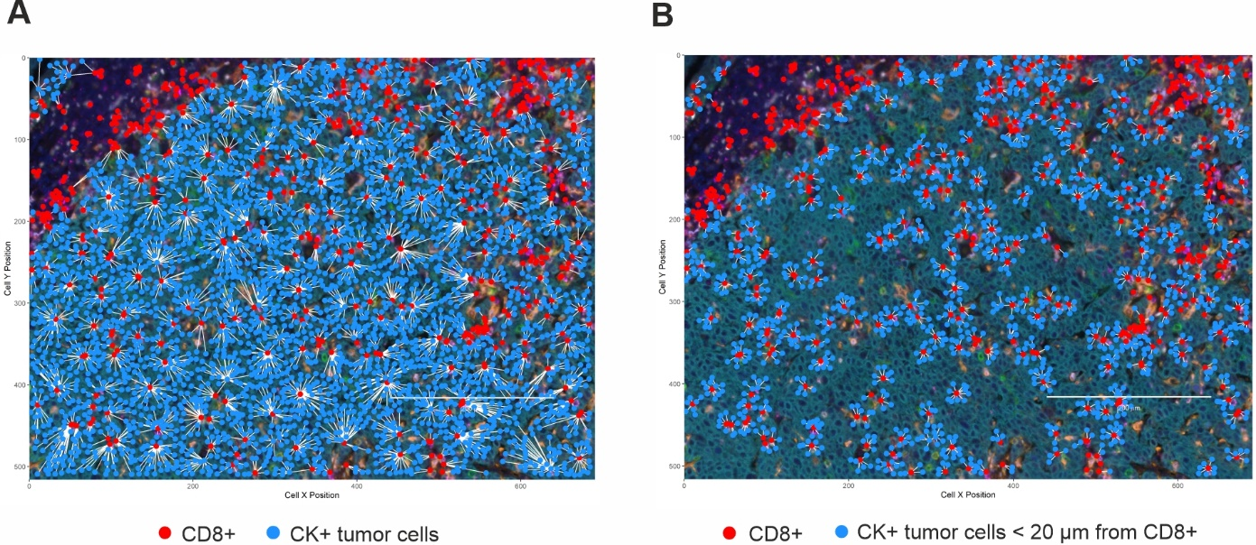
Supplementary Figure S1. Representative images of cell-to-cell distance analyses. (A) For mean distance between different cell subtypes, the nearest neighbors analysis was used. The mean distance between tumor cells (light blue dots) and the nearest CD8+ cells (red dots) is represented in the figure as an example. (B) The count within analysis was employed to calculate the percentage of reference cells, among the total number of reference cells, which are present within a 20 µm radius from at least one cell of a different phenotype. The percentage of tumor cells (light blue dots) within a 20 μm radius from a CD8+ T lymphocyte (red dots) is represented in the figure as an example. Original magnification X20.

Supplementary Table S3. Differentially expressed genes (DEGs) between HPV-positive and HPV-negative (used as baseline) OPSCC patients
DEGs | Log2 fold change | BH.p.value | Gene.sets
C8G | 3.99 | 0.000105 | Complement
CXCL14 | -2.1 | 0.000222 | Chemokines
GZMH | 2.5 | 0.000326 | Cell Functions, Cytotoxicity
IL17RB | 2.84 | 0.000326 | Chemokines
IDO1 | 1.88 | 0.000649 | Cytokines, IFN-γ, T-Cell Functions, Tumor-Inflammation Signature
GZMA | 1.46 | 0.000925 | Cell Functions, Cytotoxicity
S100A12 | -2.42 | 0.00104 | Inflammation, Chemotaxis
KLRC1 | 1.51 | 0.00106 | NK Cell Functions, Regulation
MARCO | 1.79 | 0.00196 | Macrophage Functions
TRAF2 | 1.31 | 0.00196 | TNF signalling
IL32 | 1.05 | 0.00225 | Chemokines, Interleukins
CD8A | 1.58 | 0.00242 | Antigen Processing, Pathogen Defense, T-Cell Functions, Tumor-Inflammation Signature
CD8B | 2.08 | 0.00242 | Regulation, T-Cell Functions
F2RL1 | -1.57 | 0.00661 | Macrophage Functions, T-Cell Functions
FEZ1 | -1.27 | 0.00661 | Cell Functions
PRF1 | 1.13 | 0.00693 | Cytotoxicity, Pathogen Defense
CXCL9 | 1.58 | 0.00693 | Chemokines, IFN-γ, Regulation, T-Cell Functions, Tumor-Inflammation Signature
CCL5 | 1.41 | 0.00693 | Chemokines, Cytokines, Tumor-Inflammation Signature
MST1R | 1.44 | 0.00693 | Macrophage Functions
KLRK1 | 1.43 | 0.00806 | NK Cell Functions, Regulation
GNLY | 1.43 | 0.013 | Cytotoxicity, Pathogen Defense
FADD | -1.3 | 0.0152 | Apoptosis
IL12RB2 | 1.74 | 0.0176 | Cytokines, NK Cell Functions, T-Cell Functions
MUC1 | 1.45 | 0.022 | Cell Functions
VEGFC | -1.44 | 0.022 | Angiogenesis
CXCR3 | 1.03 | 0.0246 | Chemokines, NK Cell Functions, T-Cell Functions
IL8 | -1.7 | 0.0253 | Chemokines, Cytokines, Interleukins, Pathogen Defense, Regulation
EOMES | 1.19 | 0.0253 | T-Cell Functions
ICAM4 | 1.74 | 0.0257 | Adhesion, Regulation
GZMK | 1.14 | 0.0257 | Cell Functions, Cytotoxicity

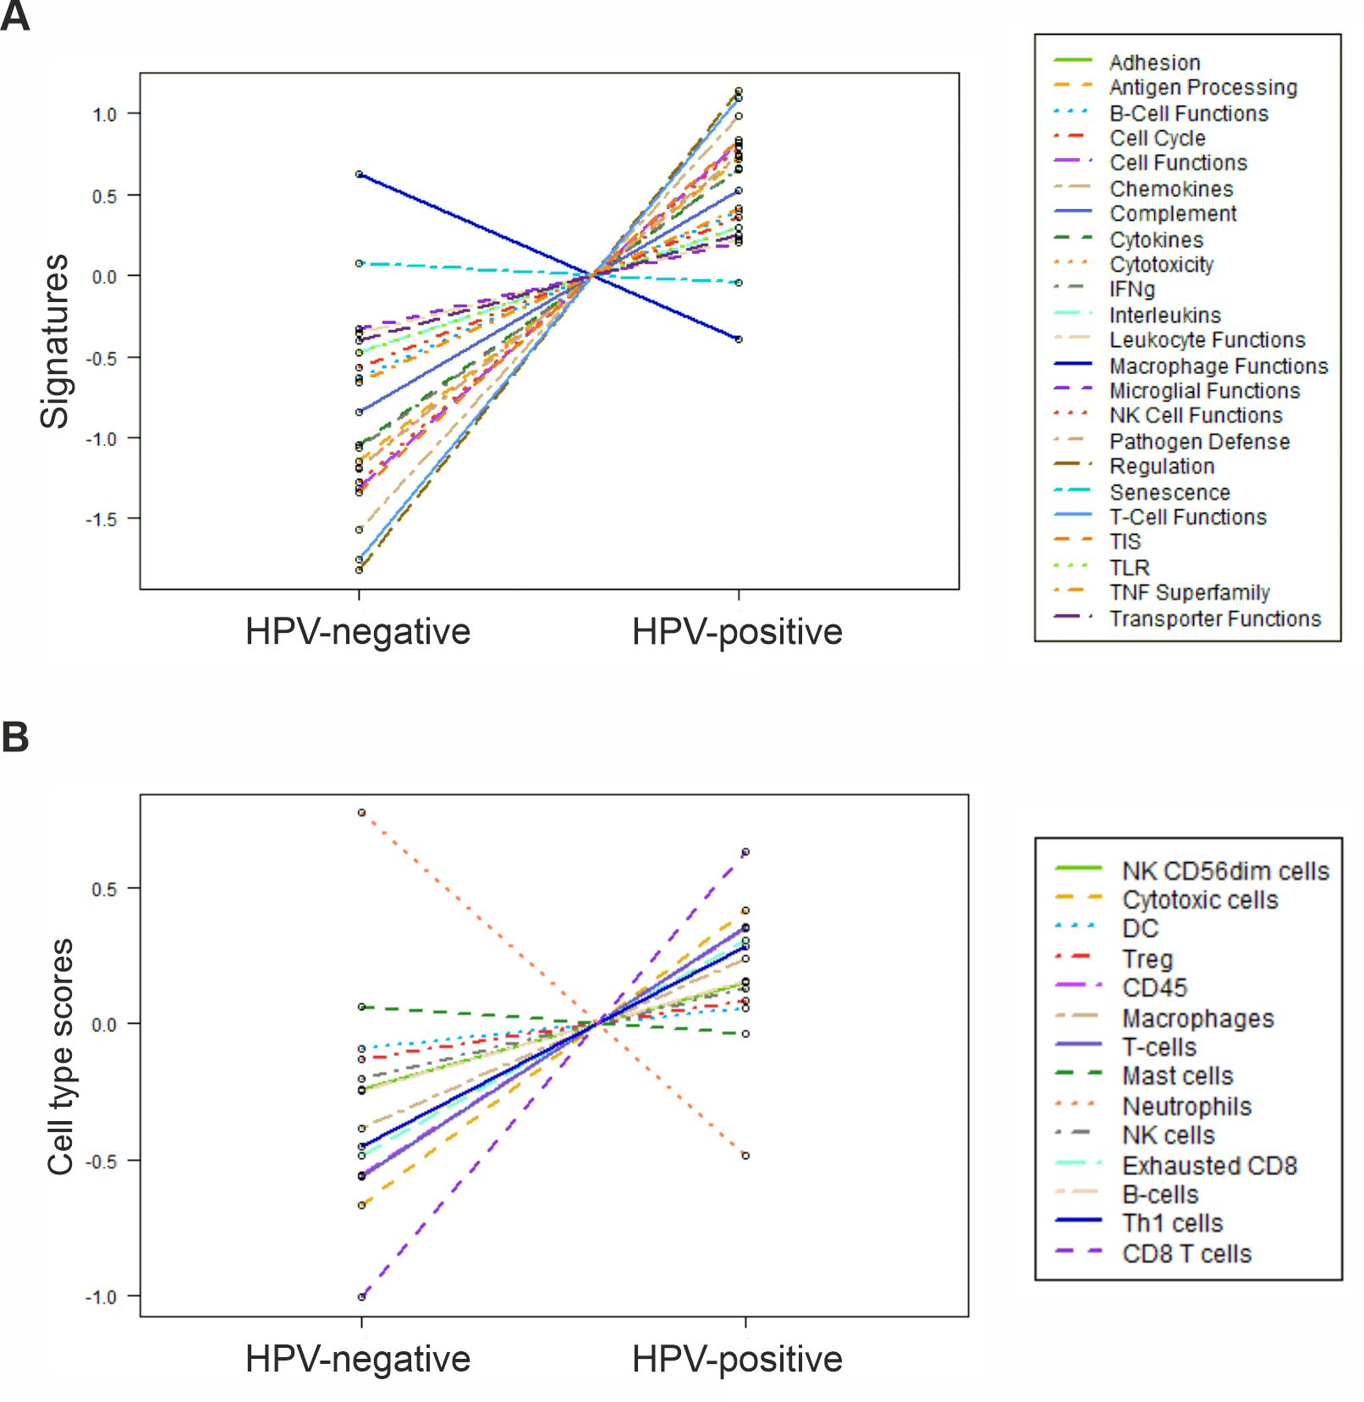

Supplementary Figure S2. Differential expression of immune-related pathways and cell type genes in HPV-positive and HPV-negative OPSCC. Trend plots depicting differential expression of predefined (A) pathway genes and (B) gene expression-based cell types in HPV-positive and HPV-negative OPSCC.

Supplementary Table S4. Correlation analysis between immune cell populations in HPV-positive and HPV-negative primary tumors and metastases.
 |  | Spearman's Rho | Significance  (2-tailed) | 95% Confidence Intervals
 |  | Spearman's Rho | Significance  (2-tailed) | Inferior | Superior
HPV-positive primary tumors | CD68+ vs CD68+PD-L1+ | 0.686 | 0.000 | 0.380 | 0.857
HPV-positive primary tumors | CD68+ vs CD68+CD163+PD-L1+ | 0.630 | 0.001 | 0.292 | 0.828
HPV-positive primary tumors | CD68+CD163+ vs CD68+PD-L1+ | 0.578 | 0.003 | 0.216 | 0.801
HPV-positive primary tumors | CD68+CD163+ vs CD68+CD163+PD-L1+ | 0.634 | 0.001 | 0.298 | 0.830
HPV-positive primary tumors | CD8+CD103+ vs CD68+PD-L1+ | 0.477 | 0.019 | 0.078 | 0.744
HPV-positive primary tumors | CD8+CD103+PD-1+ vs CD68+PD-L1+ | 0.410 | 0.047 | -0.005 | 0.704
HPV-positive primary tumors | CK+PD-L1+ vs CD8+CD103+ | 0.467 | 0.021 | 0.066 | 0.738
HPV-positive primary tumors | CK+PD-L1+ vs CD68+CD163+ | 0.487 | 0.016 | 0.091 | 0.750
HPV-positive primary tumors | CK+PD-L1+ vs CD68+PD-L1+ | 0.736 | 0.000 | 0.463 | 0.881
HPV-positive primary tumors | CK+PD-L1+ vs CD68+CD163+PD-L1+ | 0.743 | 0.000 | 0.475 | 0.885
HPV-positive primary tumors | CD68+ vs %CK+PD-L1+ among CK+ | 0.460 | 0.024 | 0.057 | 0.734
HPV-positive primary tumors | CD68+PD-L1+ vs %CK+PD-L1+ among CK+ | 0.750 | 0.000 | 0.487 | 0.888
HPV-positive primary tumors | CD68+CD163+PD-L1+ vs %CK+PD-L1+ among CK+ | 0.654 | 0.001 | 0.330 | 0.841
HPV-negative primary tumors | CD68+ vs CD68+PD-L1+ | 0.804 | 0.000 | 0.482 | 0.934
HPV-negative primary tumors | CD68+ vs CD68+CD163+PD-L1+ | 0.732 | 0.002 | 0.337 | 0.908
HPV-negative primary tumors | CD68+CD163+ vs CD68+PD-L1+ | 0.618 | 0.014 | 0.138 | 0.863
HPV-negative primary tumors | CD68+CD163+ vs CD68+CD163+PD-L1+ | 0.868 | 0.000 | 0.630 | 0.957
HPV-negative primary tumors | CD8+ vs CD68+PD-L1+ | 0.514 | 0.050 | -0.014 | 0.818
HPV-negative primary tumors | CD8+CD103+ vs CD68+PD-L1+ | 0.614 | 0.015 | 0.132 | 0.861
HPV-negative primary tumors | CD8+CD103+PD-1+ vs CD68+PD-L1+ | 0.514 | 0.050 | -0.014 | 0.818
HPV-negative primary tumors | CD8+PD-1+ vs CD68+PD-L1+ | 0.714 | 0.003 | 0.303 | 0.901
HPV-positive metastases | CD68+ vs CD68+PD-L1+ | 0.881 | 0.000 | 0.731 | 0.950
HPV-positive metastases | CD68+ vs CD68+CD163+PD-L1+ | 0.871 | 0.000 | 0.708 | 0.945
HPV-positive metastases | CD68+CD163+ vs CD68+PD-L1+ | 0.684 | 0.000 | 0.367 | 0.858
HPV-positive metastases | CD68+CD163+ vs CD68+CD163+PD-L1+ | 0.775 | 0.000 | 0.523 | 0.902
HPV-positive metastases | CD8+ vs CD68+PD-L1+ | 0.484 | 0.019 | 0.077 | 0.753
HPV-positive metastases | CD8+ vs CD68+CD163+PD-L1+ | 0.422 | 0.045 | -0.001 | 0.717
HPV-positive metastases | CD8+CD103+ vs CD68+PD-L1+ | 0.432 | 0.039 | 0.012 | 0.723
HPV-positive metastases | CD8+CD103+ vs CD68+CD163+PD-L1+ | 0.437 | 0.037 | 0.017 | 0.726
HPV-positive metastases | CD8+CD103+PD-1+ vs CD68+PD-L1+ | 0.476 | 0.022 | 0.066 | 0.748
HPV-positive metastases | CD8+CD103+PD-1+ vs CD68+CD163+PD-L1+ | 0.526 | 0.010 | 0.133 | 0.776
HPV-positive metastases | CK+PD-L1+ vs CD68+CD163+ | 0.619 | 0.002 | 0.266 | 0.826
HPV-positive metastases | CK+PD-L1+ vs CD68+PD-L1+ | 0.632 | 0.001 | 0.286 | 0.833
HPV-positive metastases | CK+PD-L1+ vs CD68+CD163+PD-L1+ | 0.590 | 0.003 | 0.223 | 0.811
HPV-positive metastases | CD68+ vs %CK+PD-L1+ among CK+ | 0.448 | 0.032 | 0.031 | 0.732
HPV-positive metastases | CD68+PD-L1+ vs %CK+PD-L1+ among CK+ | 0.668 | 0.000 | 0.342 | 0.851
HPV-positive metastases | CD68+CD163+PD-L1+ vs %CK+PD-L1+ among CK+ | 0.629 | 0.001 | 0.281 | 0.831
HPV-negative metastases | CD68+ vs CD68+PD-L1+ | 0.714 | 0.004 | 0.280 | 0.906
HPV-negative metastases | CD68+CD163+ vs CD68+PD-L1+ | 0.688 | 0.007 | 0.231 | 0.896
HPV-negative metastases | CD8+ vs CD68+PD-L1+ | 0.648 | 0.012 | 0.163 | 0.881
HPV-negative metastases | CD8+CD103+ vs CD68+PD-L1+ | 0.616 | 0.019 | 0.110 | 0.868
HPV-negative metastases | CD8+CD103+PD-1+ vs CD68+PD-L1+ | 0.629 | 0.016 | 0.131 | 0.874
HPV-negative metastases | CD8+PD-1+ vs CD68+PD-L1+ | 0.568 | 0.034 | 0.036 | 0.849
HPV-negative metastases | CK+PD-L1+ vs CD68+CD163+PD-L1+ | 0.639 | 0.014 | 0.146 | 0.877

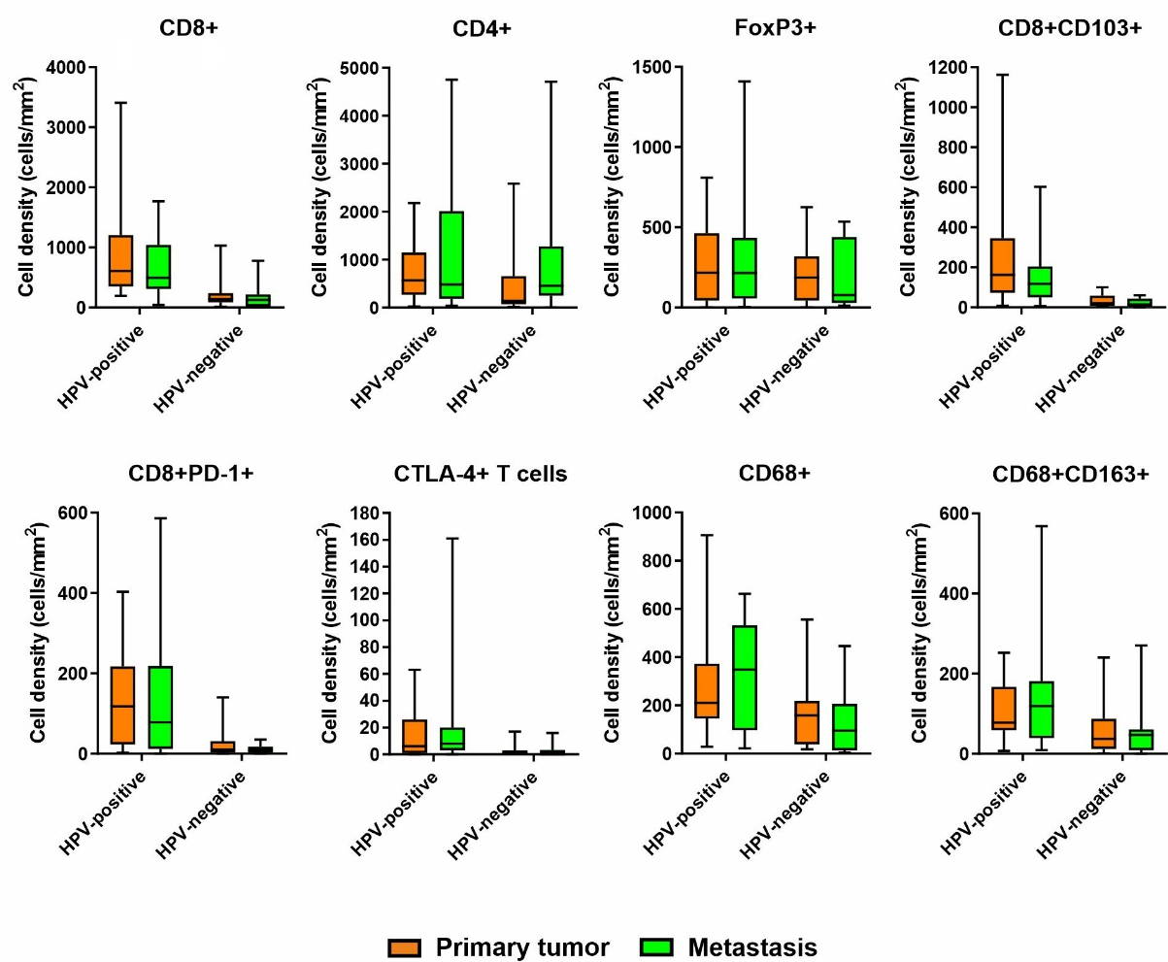

Supplementary Figure S3. Immune cells in primary tumors and related metastases. Density (number of cells/mm²) of different immune cell populations in HPV-positive and HPV-negative primary tumors and metastases.

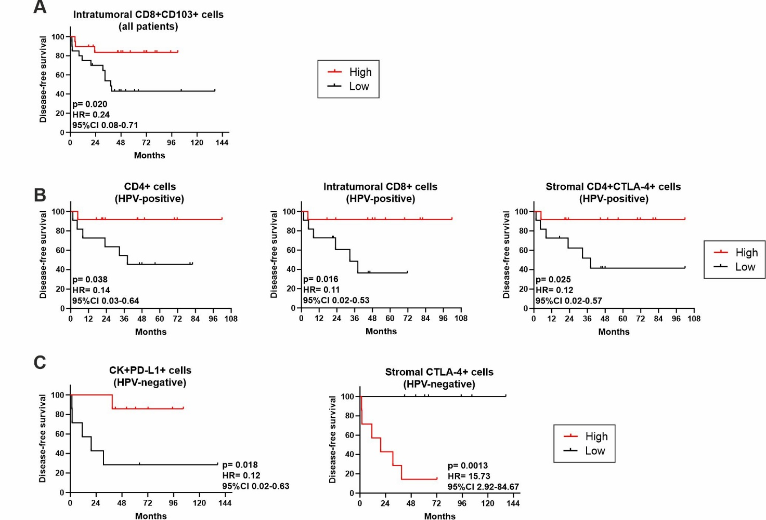

Supplementary Figure S4. The immune cell contexture of metastases correlates with patient outcome.
(A-C) Kaplan-Meier survival curves for disease-free survival according to the immune cell composition of (A) the entire cohort (n=39), (B) HPV-positive (n=24) and (C) HPV-negative (n=15) lymph node metastases. The median cut-off of each immune cell subset density was used to separate high and low infiltrated groups. Log-rank p values, hazard ratios (HR) and 95% confidence intervals (CI) are reported in each graph.

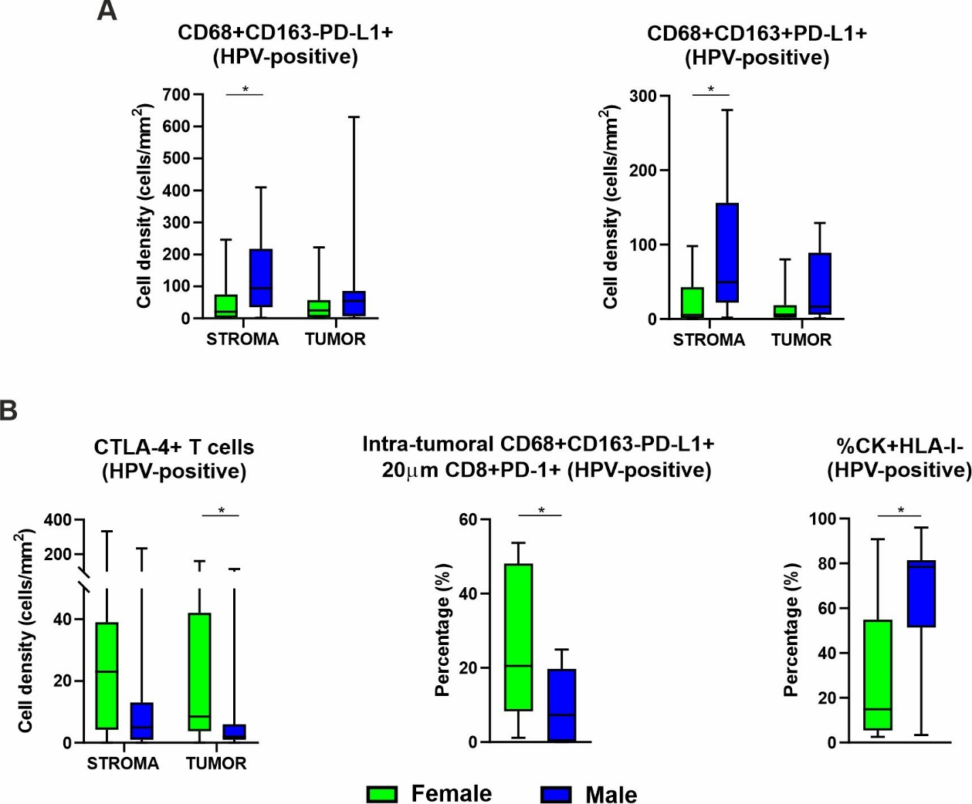

Supplementary Figure S5. The density of immune cells differs between females and males with HPV-positive lesions. Density (number of cells/mm²) of different immune cell populations in females and males with HPV-positive (A) primary tumors and (B) metastases.

