AADAC protects colorectal cancer liver colonization from ferroptosis through SLC7A11-dependent inhibition of lipid peroxidation-supplemental materials

Rongquan SUN^{1†}, Zhifei LIN^{1†}, Xiangyu WANG^{1†}, Lu LIU², Meisi HUO², Rui ZHANG¹, Jing LIN¹, Chao XIAO¹, Yitong LI¹, Wenwei ZHU¹, Lu LU¹, Jubo ZHANG², Jinhong CHEN¹*

Table of contents in supplemental materials
Category | Label | content
Figure | Supplementary fig. 1 | Supplementary figure of Fig.2
Figure | Supplementary fig. 2 | Supplementary figure of Fig.4
Table | Supplementary Table1 | Association between AADAC expression in liver metastasis and the clinical characteristics of CRLM patients (n=157) by Pearson’s χ2 tests
Table | Supplementary Table2 | Spearman correlation analysis of the association between AADAC expression in liver metastasis and various clinical characteristics
Table | Supplementary Table3 | Univariate Cox regression analysis of the association between clinicopathological characteristics and post-operative survival in CRLM patients
Table | Supplementary Table4 | Multivariate Cox regression analysis of the association between clinicopathological characteristics and post-operative survival in CRLM patients
Table | Supplementary Table5 | Primer sequences used in research
Table | Supplementary Table6 | Antibodies used in research

Methods
Enriched analysis, immunoblotting, survival analysis, GSH/GSSG ratio detection, MDA detection were described in text contents of the paper. Pearson’s χ2 tests, Spearman correlation analysis, Univariate Cox regression analysis, multivariate Cox regression analysis by SPSS Statistics 20 were used for clinical data analyses.
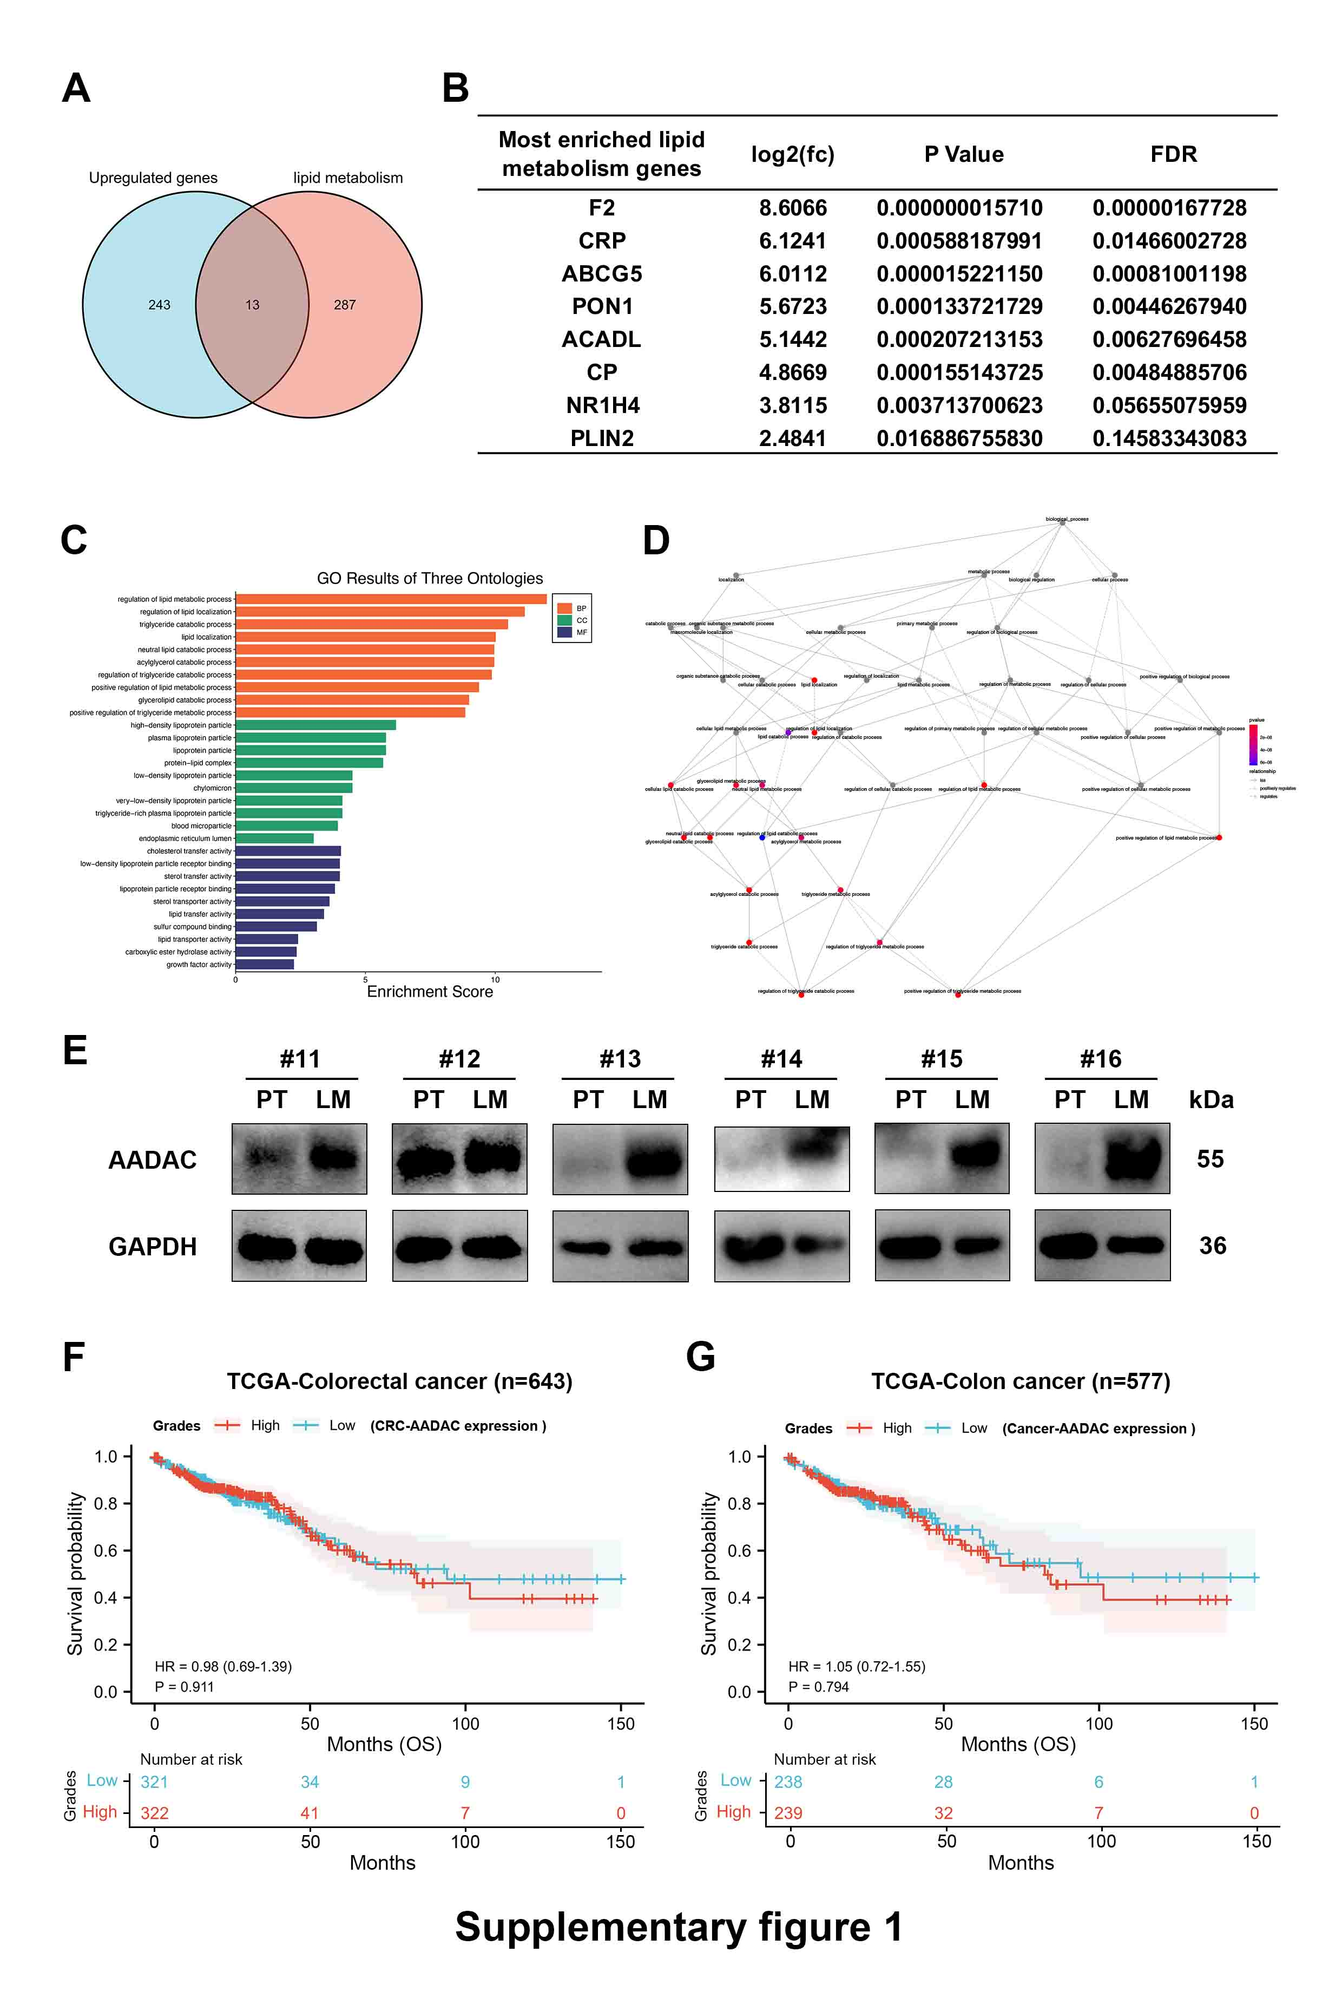
Supplementary fig. 1. (A) Venn diagram of significantly enriched lipid metabolism-related genes in 243 upregulated genes in LMs compared to PTs. (B) The other 8 genes of 13 lipid metabolism-related genes not shown in Fig2. (C) GO analysis of 13 enriched genes in (A). (D) GO plot of relationships between biological processes mediated by 13 genes in (A). (E) Protein expression of AADAC in paired PTs and LMs from CRLM patients (No.11-No.16). (F-G) Kaplan-Meier analysis of OS of patients with colorectal cancer (F) and colon cancer (G) with low and high AADAC expression from TGGA database. Log-rank test was used to determined p value. p value < 0.001 (***), p value < 0.01 (**), p value < 0,05 (*), ns (not significant).

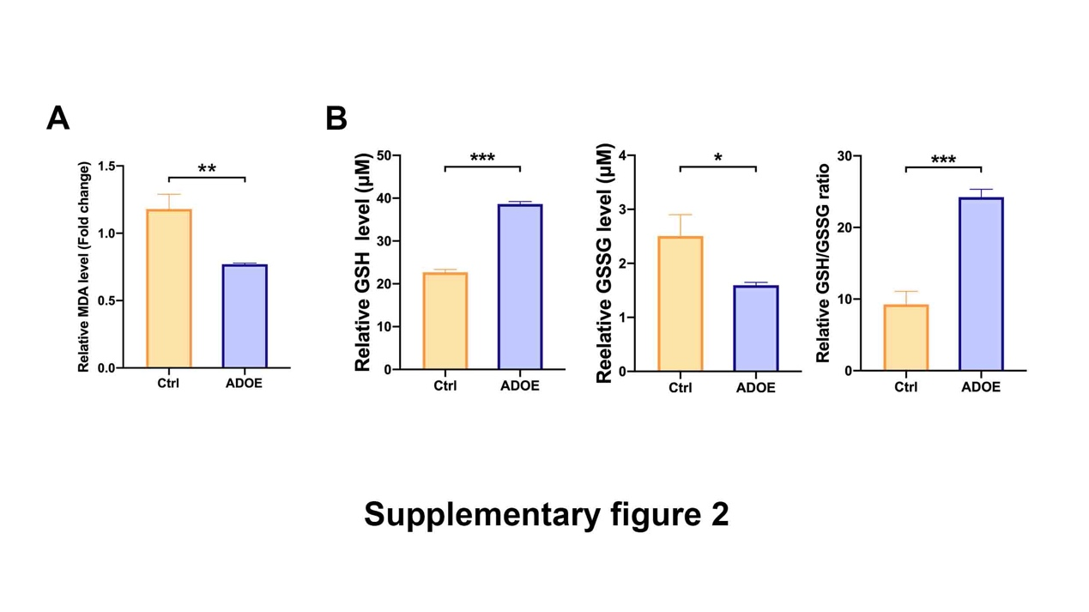
Supplementary fig. 2. (A) Relative MDA level in control and ADOE SW480 cells treated with 15 μM erastin. (B) Relative levels of GSH, GSSG and GSH/GSSG ratio of Ctrl and ADOE SW480 cells. Significance was calculated by two-tailed ratio t test (A, B). p value < 0.001 (***), p value < 0.01 (**), p value < 0,05 (*), ns (not significant).

Supplementary Table1. Association between AADAC expression in liver metastasis and the clinical characteristics of CRLM patients (n=157) by Pearson’s χ2 tests
Feature | Total | AADAC-Low (%) | AADAC-High (%) | p value
Total | 157 | 68 (43.3%) | 89 (56.7%)
Age (y)
< 60 | 78 (49.7%) | 32 (41%) | 46 (59%) | 0.566
≥ 60 | 79 (50.3%) | 36 (45.6%) | 43 (54.4%) | 0.566
Gender
Male | 104 (66.2%) | 48 (46.2%) | 56 (53.8%) | 0.314
Female | 53 (33.8%) | 20 (37.7%) | 33 (62.3%) | 0.314
number of liver metastases
1 | 64 (40.8%) | 30 (46.9%) | 34 (53.1%) | 0.455
>1 | 73 (59.2%) | 38 (47.9%) | 55 (52.1%) | 0.455
Metastasis in bilateral liver lobes
No | 90 (57.3%) | 43 (47.8%) | 47 (52.2%) | 0.191
Yes | 67 (42.7%) | 25 (37.3%) | 42 (62.7%) | 0.191
Size of metastasis
≤ 5cm | 140 (89.2%) | 63 (45%) | 77 (55%) | 0.221
> 5cm | 17 (10.8%) | 5 (29.4%) | 12 (70.6%) | 0.221
T classification
Tx | 1 (0.6%) | 0 (0) | 1 (100%) | 0.745
T2 | 16 (10.2%) | 7 (43.8%) | 9 (56.2%) | 0.745
T3 | 36 (22.9%) | 15 (41.7%) | 21 (58.3%) | 0.745
T4 | 1 (0.6%) | 1 (100%) | 0 (0) | 0.745
T4a | 86 (54.8%) | 39 (45.3%) | 47 (54.7%) | 0.745
T4b | 17 (10.8%) | 6 (35.3%) | 11 (64.7%) | 0.745
N classification
N0 | 33 (21%) | 17 (51.5%) | 16 (48 .5%) | 0.389
N1a | 15 (9.6%) | 9 (60%) | 6 (40%) | 0.389
N1b | 26 (16.6%) | 12 (46.2%) | 14 (53.8%) | 0.389
N1c | 36 (22.9%) | 15 (41.7%) | 21 (58.3%) | 0.389
N2a | 34 (21.7%) | 11 (32.4%) | 23 (67.6%) | 0.389
N2b | 13 (8.3%) | 4 (30.8%) | 9 (69.2%) | 0.389
Recurrence states
No | 71 (45.2%) | 27 (38%) | 44 (62%) | 0.225
Yes | 86 (54.8%) | 41 (47.7%) | 45 (52.3%) | 0.225
CRS score
Low | 82 (52.2%) | 39 (47.6%) | 43 (52.4%) | 0.261
High | 75 (47.8%) | 29 (38.7%) | 46(61.3%) | 0.261

Supplementary Table 2. Spearman correlation analysis of the association between AADAC expression in liver metastasis and various clinical characteristics
Variables | AADAC expression level
 | Spearman correlation | p value
Age | -0.024 | 0.770
Gender | 0.094 | 0.242
T classification | -0.043 | 0.596
N classification | 0.163 | 0.042
number of liver metastases | 0.107 | 0.181
Size of metastasis | 0.098 | 0.223
Recurrence states | -0.109 | 0.176
CRS score | 0.088 | 0.275

Supplementary Table 3. Univariate Cox regression analysis of the association between clinicopathological characteristics and post-operative survival in CRLM patients
Feature | p value | Hazard ratio (95% CI) | 95% confidence interval
LM-AADAC | 0.015 | 1.782 | 1.113~2.853
Age | 0.130 | 0.703 | 0.445~1.110
Gender | 0.906 | 0.972 | 0.601~1.571
T classification | 0.095 | 1.180 | 0.972~1.432
N classification | 0.009 | 1.220 | 1.051~1.417
number of liver metastases | 0.037 | 1.668 | 1.031~2.700
Metastasis in bilateral liver lobes | 0.018 | 1.735 | 1.099~2.741
Size of metastasis | 0.556 | 1.222 | 0.627~2.382
Recurrence states | 0.004 | 2.082 | 1.265~3.426
CRS score group | 0.12 | 1.437 | 0.910~2.268
CRS score | 0.183 | 1.173 | 0.928~1.482

Supplementary Table 4. Multivariate Cox regression analysis of the association between clinicopathological characteristics and post-operative survival in CRLM patients
Feature | p value | Hazard ratio (95% CI) | 95% confidence interval
LM-AADAC | 0.007 | 1.976 | 1.200~3.256
N classification | 0.032 | 1.183 | 1.015~1.380
number of liver metastases | 0.577 | 1.205 | 0.626~2.320
Metastasis in bilateral liver lobes | 0.237 | 1.457 | 0.781~2.717
Recurrence states | <0.005 | 2.611 | 1.560~4.370

Supplementary Table 5. Primer sequences used in research
Gene | Primer sequence
AADAC-Forward Primer | ATCGCTGTACCTTCTGATTGTG
AADAC-Reverse Primer | ATCGCTGTACCTTCTGATTGTG
GAPDH-Forward Primer | GGAGCGAGATCCCTCCAAAAT
GAPDH-Reverse Primer | GGCTGTTGTCATACTTCTCATGG
AADAC sh1-Forward Primer | CCGGCGTATCAACCAACTACAGATTCTCGAGAATCTGTAGTTGGTTGATACGTTTTTG
AADAC sh1-Reverse Primer | AATTCAAAAACGTATCAACCAACTACAGATTCTCGAGAATCTGTAGTTGGTTGATACG
AADAC sh2-Forward Primer | CCGGCGTCCGCATATACATACCCAACTCGAGTTGGGTATGTATATGCGGACGTTTTTG
AADAC sh2-Reverse Primer | AATTCAAAAACGTCCGCATATACATACCCAACTCGAGTTGGGTATGTATATGCGGACG
SLC7A11 sh1-Forward Primer | CCGGCCTGTCACTATTTGGAGCTTTCTCGAGAAAGCTCCAAATAGTGACAGGTTTTTG
SLC7A11 sh1-Reverse Primer | AATTCAAAAACCTGTCACTATTTGGAGCTTTCTCGAGAAAGCTCCAAATAGTGACAGG
SLC7A11 sh2-Forward Primer | CCGGCCTGCGTATTATCTCTTTATTCTCGAGAATAAAGAGATAATACGCAGGTTTTTG
SLC7A11 sh2-Reverse Primer | AATTCAAAAACCTGCGTATTATCTCTTTATTCTCGAGAATAAAGAGATAATACGCAGG

Supplementary Table 6. Antibodies used in research
Name | Manufacturer | Catalog number
AADAC | Proteintech | 26634-1-AP
NRF2 | Proteintech | 66504-1-Ig
ACSL4 | Proteintech | 66617-1-Ig
GAPDH | Proteintech | 60004-1-Ig
HO-1 | Proteintech | 66743-1-Ig
TFR2 | Abcam | Ab185550
GPX-4 | Abcam | Ab125066
ATF4 | Abcam | Ab184909
SLC7A11 | Abcam | Ab-37185
AKT | Abcam | Ab8805
anti-DDDDK-Tag pAb | Abclone | AE004

