The detail information about Ythdf3^{-/-} C57BL/6 mouse.
1. Mouse Information
Name | C57BL/6-Ythdf3^{tm1cyagen}
Serial Number | KOCMP-06061-Ythdf3
Gene | Ythdf3
NCBI ID | 229096
Strain | C57BL/6
Type | Conventional knockout

2. gRNA target sequence
gRNA1 (matching forward strand of gene): AGTCACAAATAGTTACTTGAAGG
gRNA2 (matching forward strand of gene): AAACATATACTGTGAAGCGTTGG

3. Delivery Information
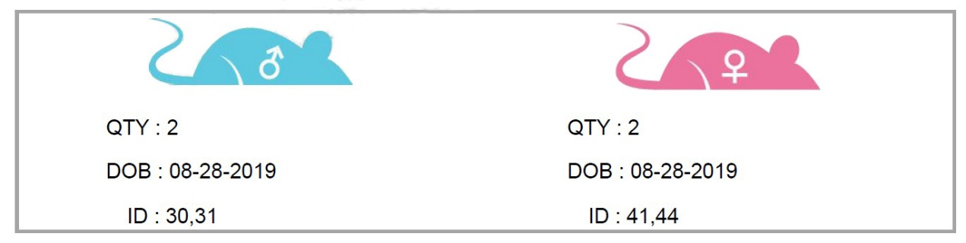

4. Genotyping Strategy

