Fig. S1 High expression of circRUNX1 is related to advanced TNM stage and differentiation grade.
A Relative differential expression of circRUNX1 in pathological stages I+II (n=17) and III+IV (n=37) ESCC tissues was measured by qRT-PCR. B Relative differential level of circRUNX1 in well/moderate differentiation grade (n=35) and poor differentiation grade (n=19) ESCC tissues measured by qRT-PCR. *P < 0.05, **P < 0.01, ***P < 0.001.

Fig. S2 CircRUNX1 overexpression promotes ESCC progression.
A Overexpression efficiency of circRUNX1 in ESCC cells was detected by qRT-PCR. B The relative expression of RUNX1 mRNA was detected by qRT-PCR after circRUNX1 overexpression. C CCK-8 assays were performed to evaluate the cell viability after overexpressing circRUNX1. D The proliferation abilities of KYSE150 and TE1 cells were evaluated by colony formation assays. E EdU assays detected the effect of circRUNX1 overexpression on cell proliferation (Magnification × 100. Scale bar: 1 00 μm). F Transwell assays were performed to evaluate cell migration and invasion after overexpressing circRUNX1. G Migration abilities of KYSE150 and TE1 cells after overexpressing circRUNX1 were evaluated by wound healing assay. H Quantification of the number of colonies from colony formation assays. *P < 0.05, **P < 0.01, ***P < 0.001.
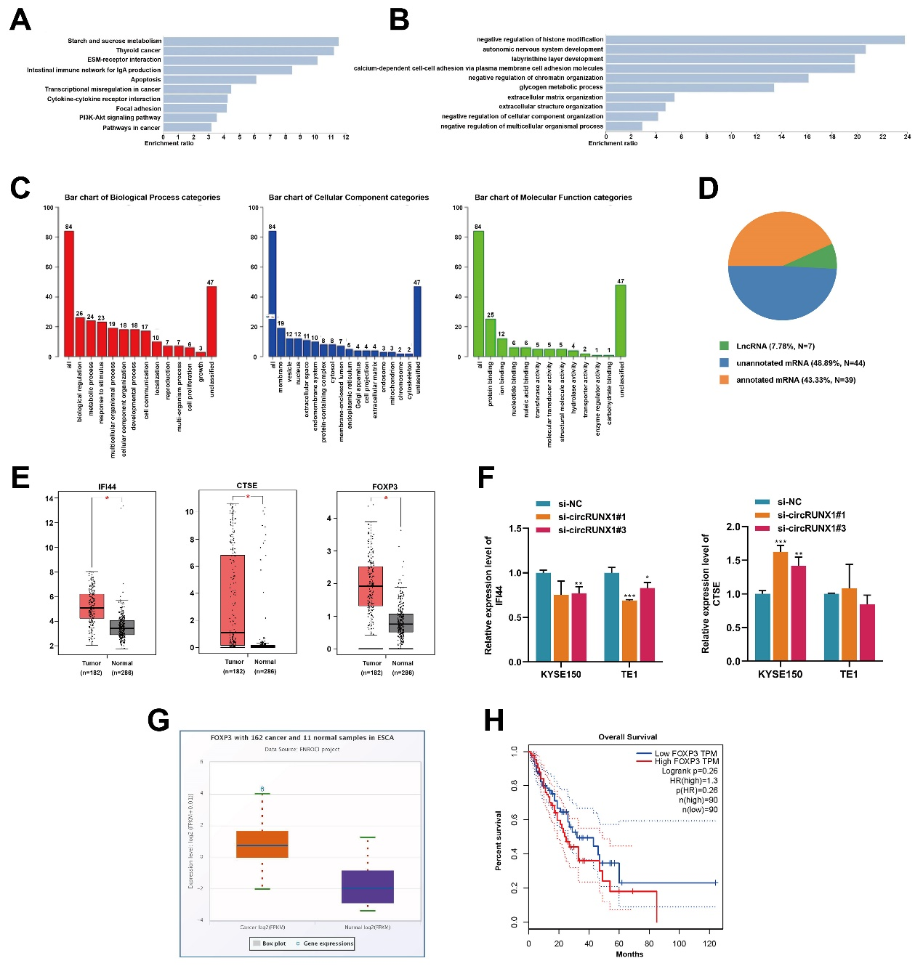
Fig. S3 FOXP3 is a downstream target of circRUNX1.
A and B KEGG pathway enrichment analysis of differentially expressed mRNAs after silencing circRUNX1. C GO function analysis of differentially expressed mRNAs after silencing circRUNX1. D Pieplot showing the classification of differentially expressed genes regulated by circRUNX1. E The expression of three genes in ESCC was predicted from GEPIA. F Relative mRNA levels of IFI44 and CTSE were detected in ESCC cells with circRUNX1 knockdown using qRT-PCR. G The differential expression of FOXP3 in ESCC was predicted from Targetscan. H The relationship between FOXP3 expression and overall survival of ESCC patients was predicted from GEPIA. *P < 0.05, **P < 0.01, ***P < 0.001.

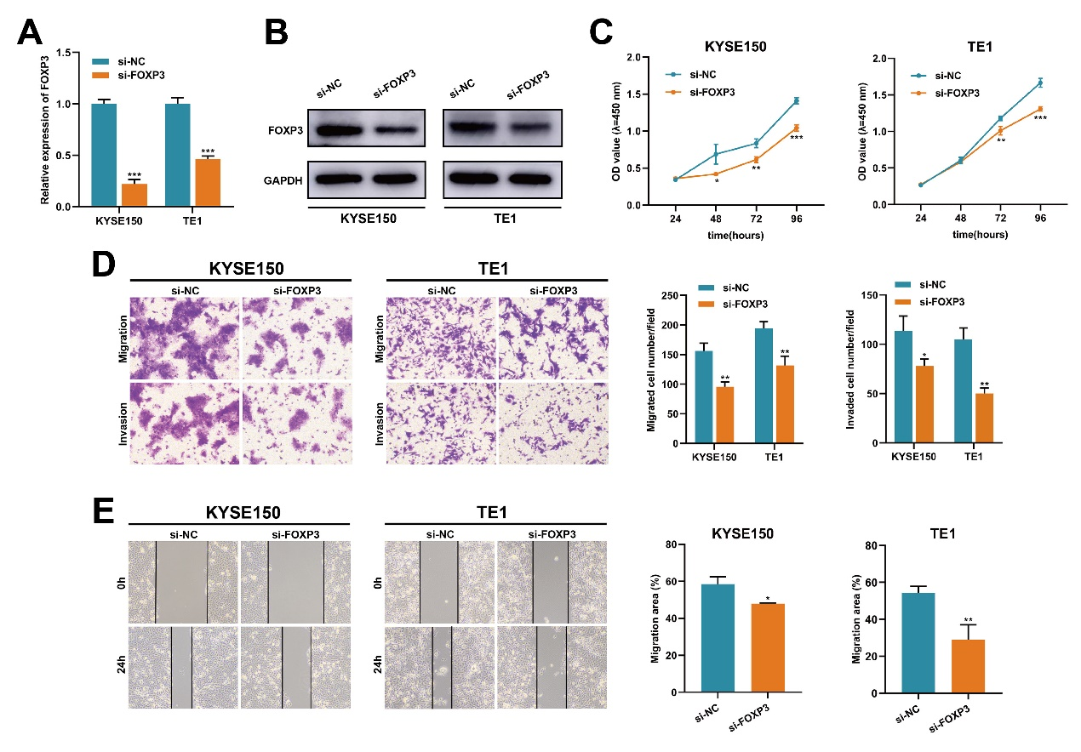
Fig. S4 FOXP3 knocking down inhibits ESCC cell proliferation and metastasis.
A and B FOXP3 knockdown efficiencies were examined in KYSE150 and TE1 cells by qRT-PCR (A) and western blot (B). C CCK-8 assays were performed to investigate ESCC cell proliferation ability after silencing of FOXP3. D and E Wound healing and Transwell assays were conducted to examine the role of FOXP3 in ESCC cell migration and invasion. *P < 0.05, **P < 0.01, ***P < 0.001.
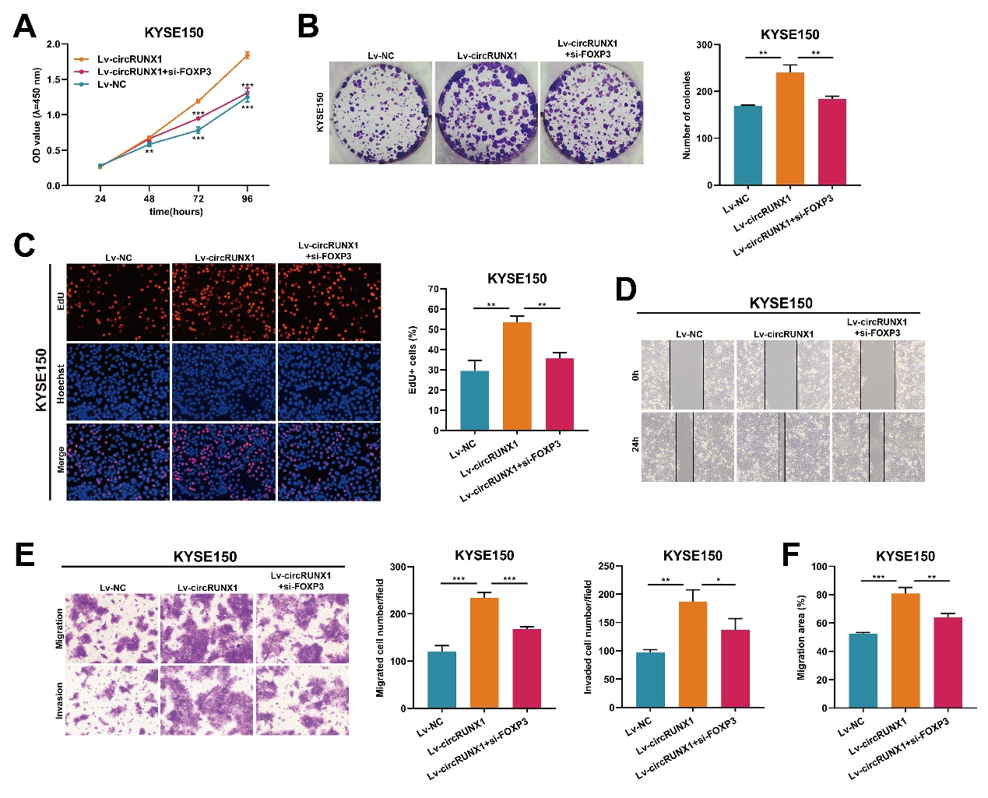
Fig. S5 CircRUNX1 facilitates ESCC cell progression by regulating FOXP3 in vitro.
A-C CCK-8 (A), colony formation (B), and EdU assays (C) were performed to determine the proliferation ability of circRUNX1 and FOXP3 in KYSE150 cells. D-F Wound healing and transwell assays were performed to determine the proliferation ability of circRUNX1 and FOXP3 in KYSE150 cells. *P < 0.05, **P < 0.01, ***P < 0.001.

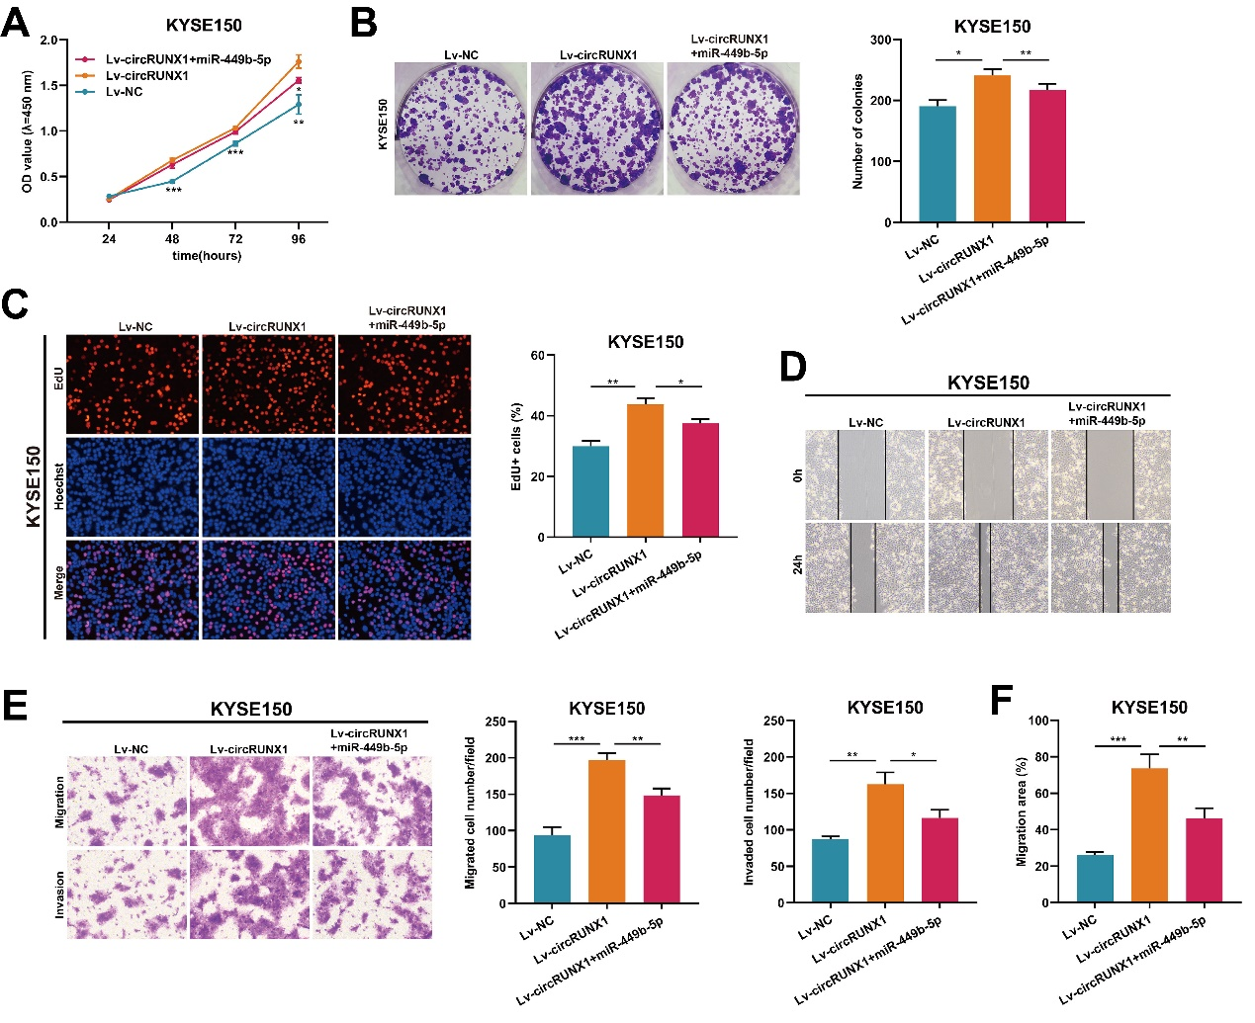
Fig. S6 CircRUNX1 functions as a miR-449b-5p sponge in ESCC cells.
A-C Cell proliferation was observed in CCK-8 (A), colony formation (B), and EdU assays (C) after transfecting miR-449b-5p mimics with circRUNX1 overexpression in KYSE150 cells. D-F Wound healing and transwell assays detected the migratory capacity after transfecting miR-449b-5p mimics with circRUNX1 overexpression in KYSE150 cells. *P < 0.05, **P < 0.01, ***P < 0.001.

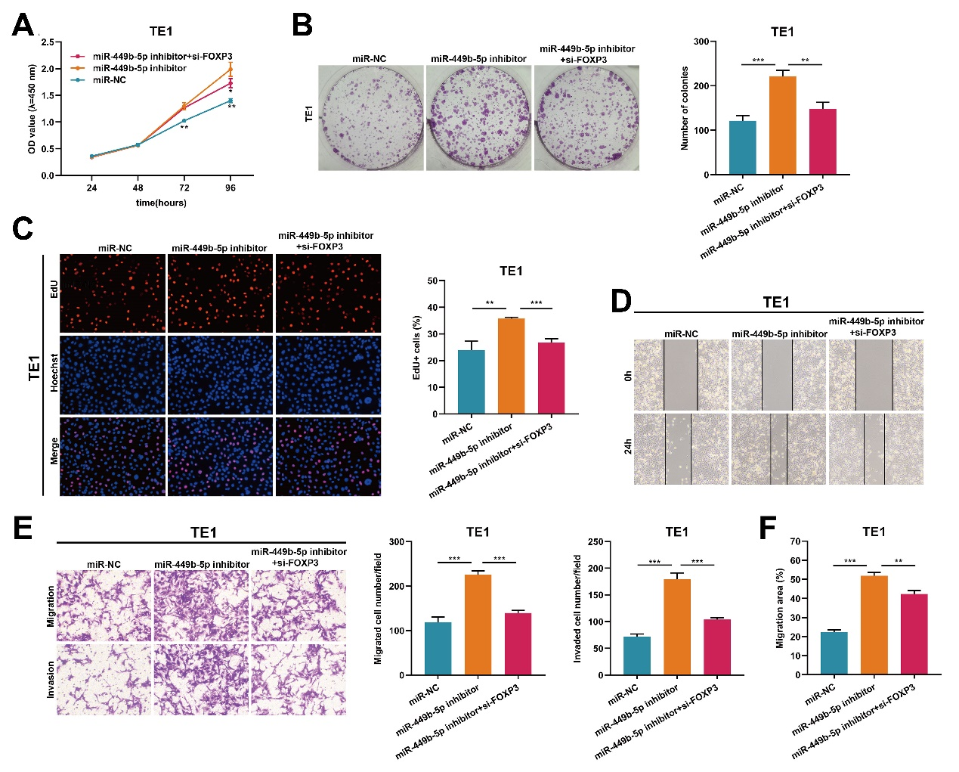
Fig. S7 The cancer-inhibiting effect of miR-449b-5p in ESCC cells can be reversed by FOXP3.
A-C Assessment of the proliferation of TE1 cells transfected with miR-NC, miR-449b-5p inhibitor, or cotransfected with miR-449b-5p inhibitor and si-FOXP3 by CCK-8 (A), colony formation (B), and EdU assays (C). D-F Assessment of the migration and invasion of TE1 cells transfected with miR-NC, miR-449b-5p inhibitor, or cotransfected with miR-449b-5p inhibitor and si-FOXP3 by wound healing and transwell assays. *P < 0.05, **P < 0.01, ***P < 0.001.

Fig. S8 A Relative expression of seven candidate circRUNX1 binding proteins in ESCC tissues was predicted from GEPIA.

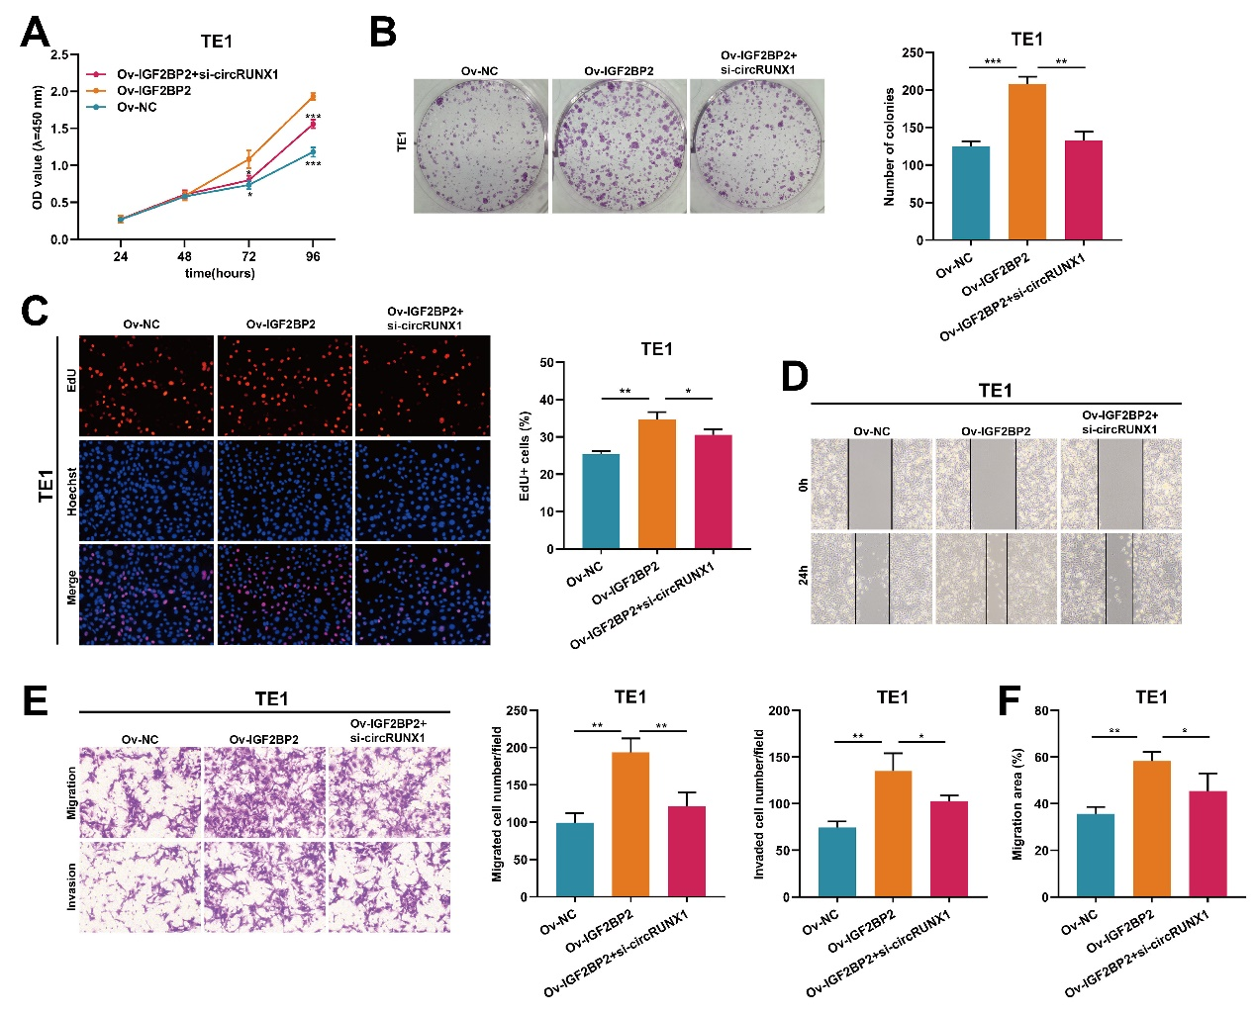
Fig. S9 Depletion of circRUNX1 rescues the promotive effect of IGF2BP2 overexpression on malignant behaviors in ESCC cells.
A-C The proliferation ability of TE1 cells with IGF2BP2 overexpression or IGF2BP2 overexpression plus circRUNX1 depletion was assessed by CCK-8 (A), colony formation (B), and EdU assays (C). D-F The migration and invasion abilities of TE1 cells with IGF2BP2 overexpression or IGF2BP2 overexpression plus circRUNX1 depletion were assessed by wound healing and transwell assays. *P < 0.05, **P < 0.01, ***P < 0.001.

Table S1. Sequences of siRNA and shRNA used in this study.
Gene name | Probe (5’-3’)
si-circRUNX1#1 | GAGTCAGATGCAGGGGAAA
si-circRUNX1#2 | GTCAGATGCAGGGGAAAAG
si-circRUNX1#3 | CAGATGCAGGGGAAAAGCT
si-FOXP3 | GGCTGCACCCAAAGCCTCA
sh-IGF2BP2 | AGTGAAGCTGGAAGCGCATAT
hsa-miR-449b-5p mimics |  | AGGCAGUGUAUUGUUAGCUGGC
hsa-miR-449b-5p inhibitor |  | AGGCAGUGUAUUGUUAGCUGGC

Table S2. Primers used in this study.
Name
  Primer sequences(5'-3')
circRUNX1 | divergent-F: AGTCAGATGCAGGGGAAAAGC
 | divergent-R: CTGCCGATGTCTTCGAGGTT
 | convergent-F: TCGGCAGAAACTAGATGATCAGA
 | convergent-R: ATCTGACTCTGAGGCTGAGG
has_circ_0000799 | F: CAGAATTGGTACCATGGGCG
 | R: CACCCTCTTCAACCCCTCAT
has_circ_0003218 | F: GGAGATCCCCAAGAGTGTCA
 | R: TGAGTGGTGTTGTGTCAGGA
has_circ_0069981 | F: CCACGTTGATGAGCGAACAA
 | R: GATCTTCCAGCCACAACCAC
has_circ_0000657 | F: GGACCAGGCCATTGTTGATC
 | R: AGGTGTAGGAAGACTGTGGC
has_circ_0005019 | F: GCTCAAGTACATGCACGACC
 | R: AGAAGTTCTCACCAGGCTC
has_circ_0001860 | F: CAGCTGTCAGATGGGTCAGA
 | R: TGGTGCTCTCTTCCTCTTCA
has_circ_0000266 | F: CCATCTGTCCCTCTCCATCC
 | R: TCTCTGAGAACACTGCAGCA
RUNX1 | F: GGAAGTCAACCTCTGCTGCT
 | R: CGGACCACAGAGCACTTTCT
FOXP3 | F: GTGGCCCGGATGTGAGAAG
 | R: GGAGCCCTTGTCGGATGATG
CTSE | F: CTGGCCCTTCCGACAAGATT
 | R: TCCACGAAGTCCAGTAGGGT
IFI44 | F: GCCTGTGCAGGGATGACATA
 | R: AGCCACATGTACCACACCAG
IGF2BP2 | F: AGCTAAGCGGGCATCAGTTTG
 | R: CCGCAGCGGGAAATCAATCT
GAPDH | F: CAGGAGGCATTGCTGATGAT
 | R: GAAGGCTGGGGCTCATTT
U6
  F: CTCGCTTCGGCAGCACA
  R: AACGCTTCACGAATTTGCGT
miR-6751-3p | GACTGAGCCTCTCTCTCTCCAG
miR-762 | TAATCATATGGGGCTGGGGCC
miR-760 | ATATCGGCTCTGGGTCTGTGG
miR-7160-5p | ATATGCTGAGGTCCGGGCTGT
miR-8070 | CATGTGATTGACGGCTGACTCCA
miR-6884-5p | CGAGAGGCTGAGAAGGTGATGTTG
miR-4296 | CGATGTGGGCTCAGGCTCA
miR-6846-5p | ATATGGGGGCTGGATGGGGTA
miR-34c-5p | GCGAGGCAGTGTAGTTAGCTGATTG
mir-449a | ACGTGGCAGTGTATTGTTAGCTGGT
miR-449b-5p | AGGCAGTGTATTGTTAGCTGGC
miR-2682-5p | CAGGCAGTGACTGTTCAGACGTC
miR-4270 | CGATATCAGGGAGTCAGGGGAG
miR-6754-5p | ATACCAGGGAGGCTGGTTTGGA

Table S3. Information of top 8 circRNAs in ESCC tissues.
Gene name | Transcript name | Biotype | Mapped circRNA ID | Exon/intron Count | log₂(Foldchange) | P-value
BPTF | ENST00000321892 | circRNA | hsa_circ_0000799 | 23,24,25,26,27,28,29 | 12.222 | 2.88E-270
BMPR2 | ENST00000374580 | circRNA | hsa_circ_0003218 | 2,3 | 12.144 | 8.71E-260
RUNX1 | ENST00000300365 | circRNA | hsa_circ_0002360 | 5,6 | 11.781 | 5.85E-216
MTHFD2L | ENST00000395759 | circRNA | hsa_circ_0069981 | 2,3,4,5 | 11.674 | 1.91E-204
MCTP2 | ENST00000456504 | circRNA | hsa_circ_0000657 | 2 | 11.559 | 1.14E-192
CHSY1 | ENST00000254190 | circRNA | hsa_circ_0005019 | 2 | 11.559 | 1.14E-192
ZCCHC7 | ENST00000336755 | circRNA | hsa_circ_0001860 | 2 | 11.433 | 1.33E-180
FAM53B | ENST00000494792 | ciRNA | novel_circ_0000266 | 6 | 11.433 | 1.33E-180
ciRNA: circulated by intron, circRNA: circulated by exon

Table S4. The correlation between circRUNX1 and ESCC clinicopathological features.
 | CircRUNX1 expression |  | P-value
 | High (n=27) | Low (n=27) | P-value
Gender
Male | 17 | 19 | 0.7734
Female | 10 | 8
Age
≤ 65 years | 6 | 12 | 0.1480
> 65 years | 21 | 15
Tumor size
≤ 3 cm | 12 | 9 | 0.5772
> 3 cm | 15 | 18
Differentiation grade
Well+Moderate | 13 | 22 | 0.0214*
Poor | 14 | 5
TNM stage
I+II | 4 | 13 | 0.0177*
III + IV | 23 | 14
Lymphatic metastasis
Absent | 11 | 14 | 0.5857
Present | 16 | 13

Table S5. The correlation between IGF2BP2 and ESCC clinicopathological features.
 | IGF2BP2 expression |  | P-value
 | High (n=21) | Low (n=20) | P-value
Gender
Male | 14 | 14 | >0.9999
Female | 7 | 6
Age
≤ 65 years | 6 | 9 | 0.3048
> 65 years | 15 | 11
Tumor size
≤ 3 cm | 7 | 11 | 0.2146
> 3 cm | 14 | 9
Differentiation grade
Well+Moderate | 15 | 12 | 0.5204
Poor | 6 | 8
TNM stage
I+II | 4 | 5 | >0.9999
III + IV | 17 | 15
Lymphatic metastasis
Absent | 5 | 12 | 0.0278*
Present | 16 | 8

