Supplementary Materials
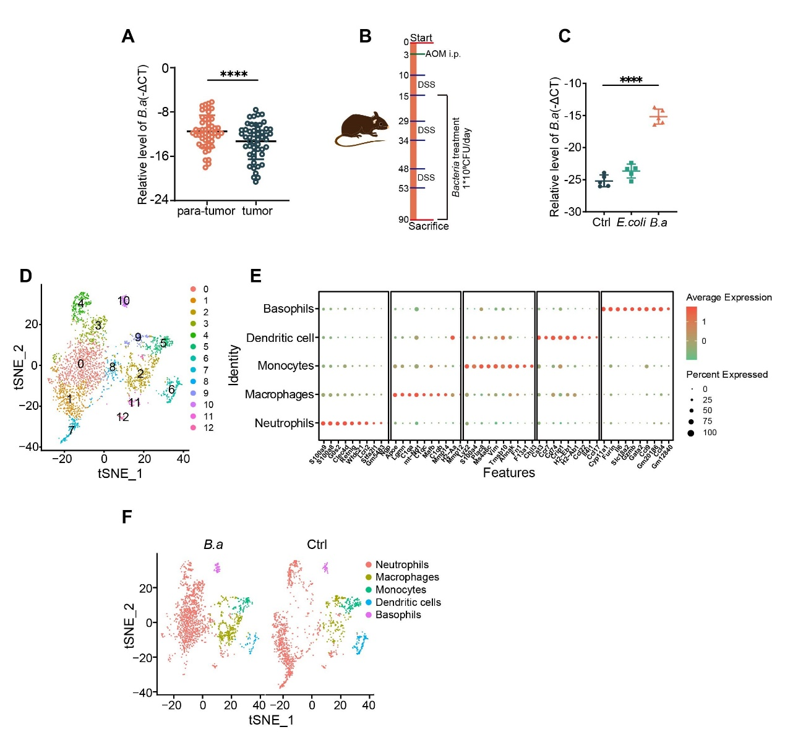
Figure S1. Supplementation of B. adolescentis suppressed colorectal tumorigenesis and increased infiltration of macrophages. (A) The relative abundance of B.adolescentis was determined in tumor or para-tumor tissue of CRC by qRT-PCR. (B) Experimental model of AOM/DSS mice model. (C) The relative abundance of B.adolescentis was determined by qRT-PCR in feces of AOM/DSS mice. (D) tSNE plots of scRNA-seq data from tumor-infiltrating myeloid cells after treatment with B.adolescentis or vehicle (PBS). (E) The top expression markers of myeloid cells. (F) tSNE plot of scRNA-seq data from tumor-infiltrating myeloid cells of B.adolescentis or vehicle (PBS) groups. The independent experiment was repeated three times. Data are shown as mean ± SD. **** P < 0.0001, Wilcoxon matched-pairs signed-rank test (A), ANOVA test(C).
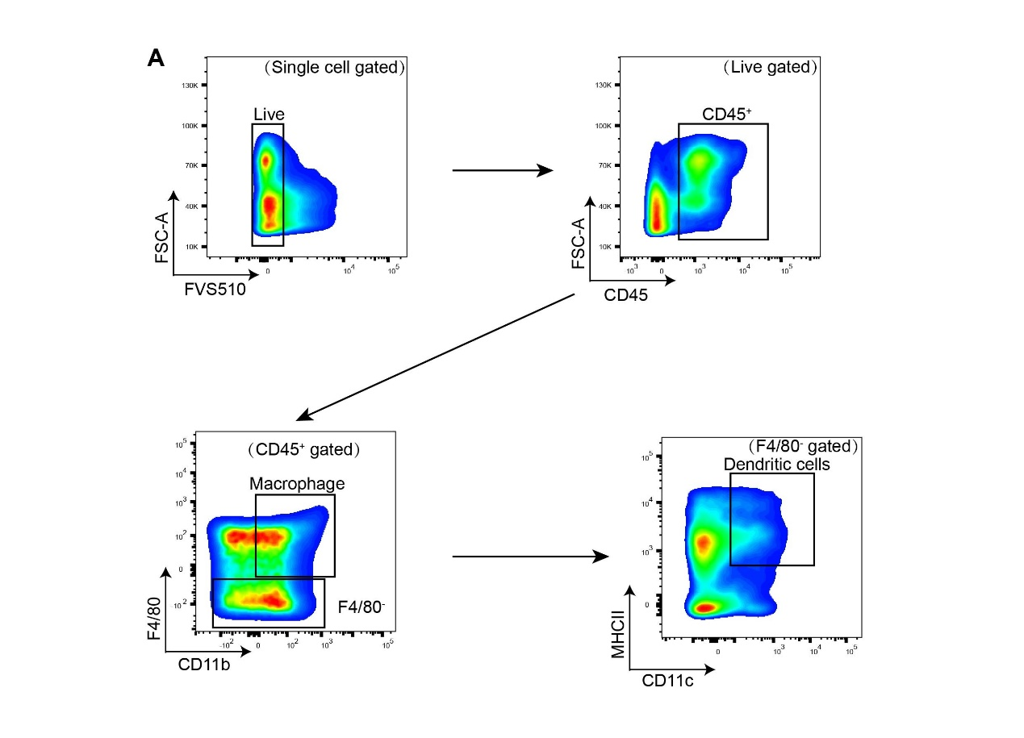
Figure S2. Gating strategy of macrophages and dendritic cells. (A) We utilized Fixable viability stain 510 to gate the live cells (FVS⁻ cells) gated on single cells. Then we identified the immune cells by CD45 gated on live cells. Macrophages were determined by F4/80 and CD11b gated on CD45⁺ cells and dendritic cells were determined by CD11c and MHCII gated on CD45⁺F4/80⁻ cells.
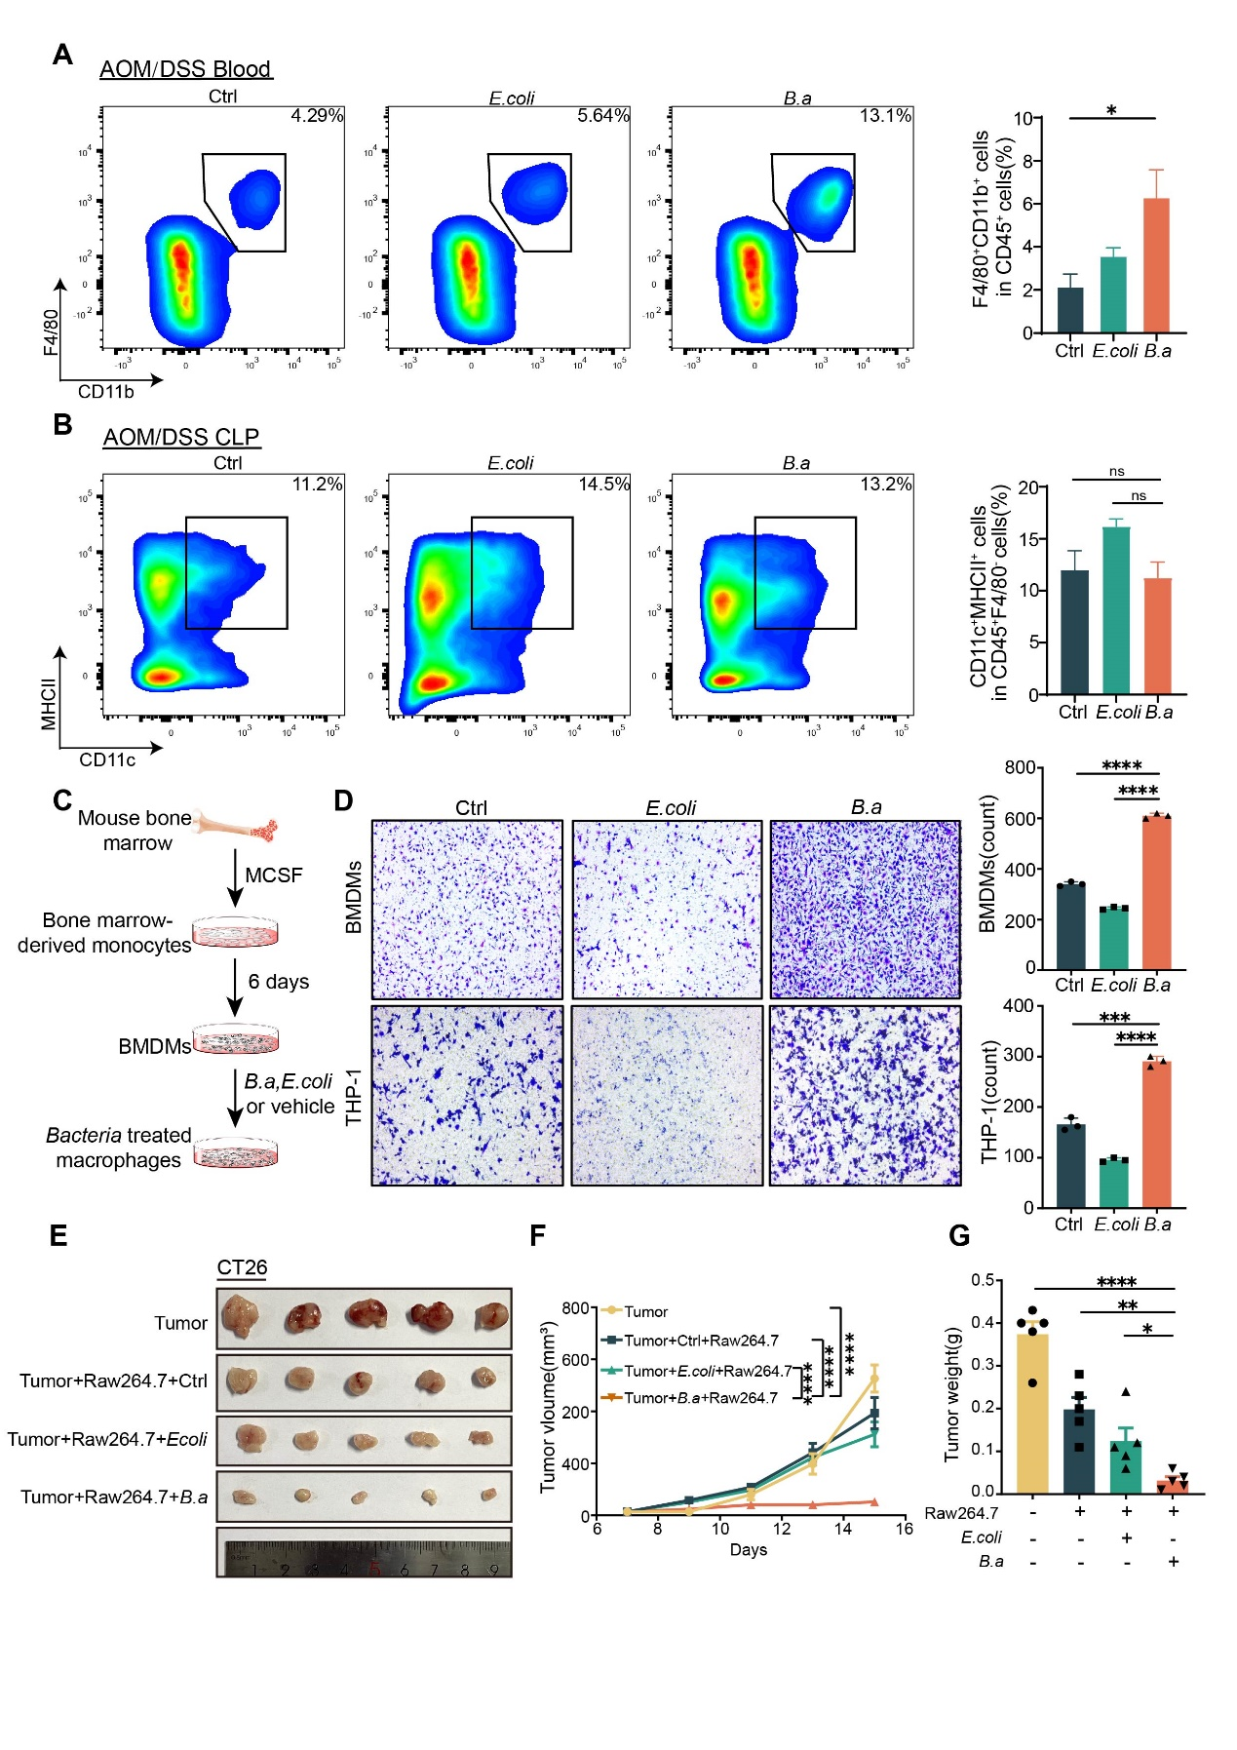
Figure S3. B.adolescentis recruited macrophages to suppress colorectal tumorigenesis. (A) Flow cytometry representation and percentage of macrophages in blood of AOM/DSS mice model. (B) Flow cytometry representation and percentage of dendritic cells in colorectal lamina propria of AOM/DSS mice model. (C) Schematic representation of BMDMs isolation and co-cultured with B.adolescentis, E. coli or vehicle (PBS). (D) The migration assay of BMDMs and THP-1 cells pretreated with B.adolescentis, E.coli or vehicle (PBS) for 24 hours. The migrated cells were quantified at 24 hours by counting in five fields. Scale bar, 100 μm. (E-G) Mouse macrophages Raw264.7 cells were pretreated with B.adolescentis, E.coli or vehicle (PBS), and injected into BALB/c mice combined with CT26 cells. Tumor volume and weight were recorded after 7 days. The independent experiment was repeated three times. Data are shown as mean ± SD. * P < 0.05, ** P < 0.01, **** P < 0.0001; ANOVA test (A, B, D, F, G).
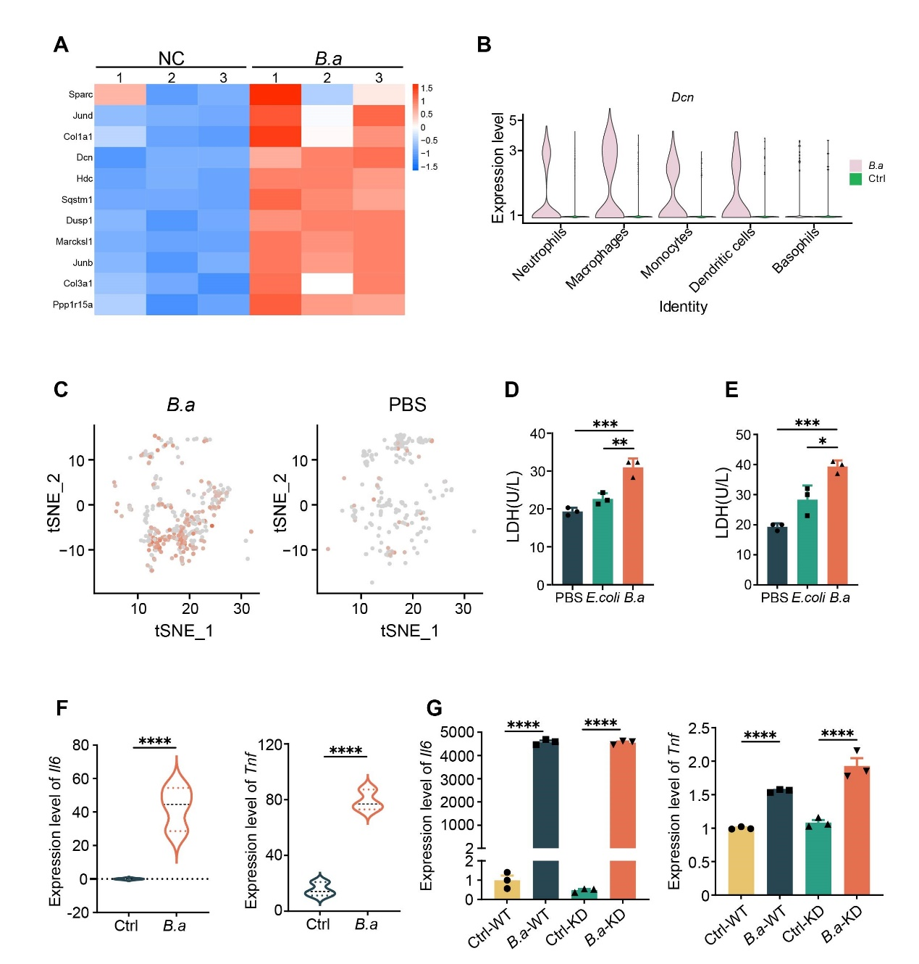
Figure S4. B.adolescentis facilitated the infiltration of Decorin⁺ macrophages to suppress CRC. (A) The heatmap of the 11 differentially expressed genes overlapped by differentially expressed genes of RNA-seq and macrophages in scRNA-seq. (B) The violin plots of the expression level of Dcn in scRNA-seq of different myeloid groups cells. (C) tSNE plots in scRNA-seq data of tumor-infiltrating DCN⁺ macrophages of B.adolescentis or vehicle (PBS) groups in AOM/DSS model. The orange dots represent DCN⁺ macrophages. (D-E) BMDMs pretreated with B.adolescentis, E. coli or vehicle (PBS) in vitro for 24 hours. And then the LDH in the medium was tested after BMDMs co-cultured with HCT116 (D) or CT26 (E) (BMDMs: cancer cells = 1:1) for 24 hours. (F) The levels of Il6 and Tnf in RNA-seq of BMDMs treated with B.adolescentis or vehicle (PBS). (G) The levels of Il6 and Tnf in WT or Dcn-KD Raw264.7 treated with B.adolescentis were determined by qRT-PCR. The independent experiment was repeated three times. Data are shown as mean ± SD, * P < 0.05, ** P < 0.01, *** P < 0.001, **** P < 0.0001; ANOVA test (D, E, G), Student t test (F).
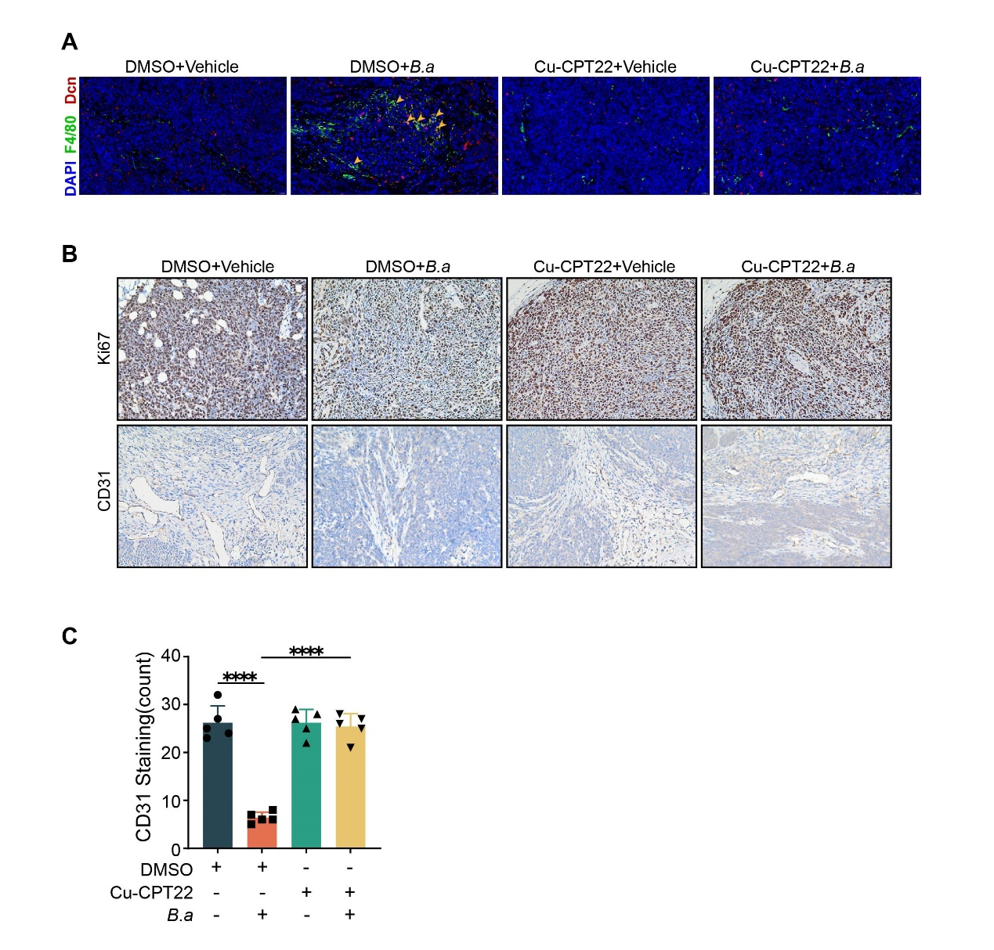
Figure S5. The activation of TLR2 is essential for inducing DCN⁺ macrophages by B.adolescentis. (A) The number of DCN⁺F4/80⁺ cells was examined by immunofluorescence in subcutaneous tumor experiment injected with or without 3 mg/kg Cu-CPT22. The yellow arrows indicate the positively stained cells. scale bars, 20 μm. (B) Representative images of immunostaining for Ki67 and CD31 in tumor tissue of subcutaneous tumor models with or without 3 mg/kg Cu-CPT22; black scale bars, 50 μm. (C) The positive ratio of CD31 in mice tumor tissue of subcutaneous tumor models. Data are shown as mean ± SD, ns: No statistical difference, **** P < 0.0001; ANOVA test (C).
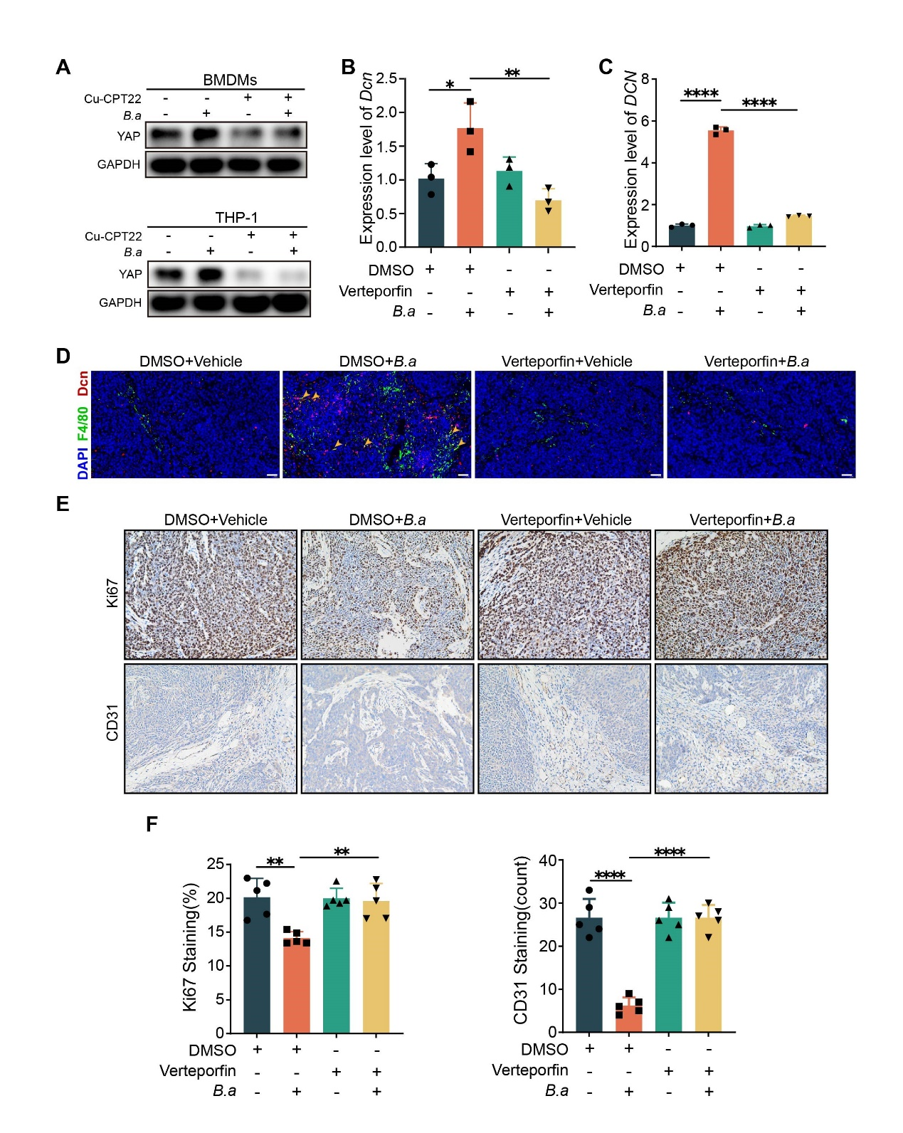
Figure S6. B.adolescentis regulated DCN⁺ macrophages through TLR2/YAP axis. (A) BMDMs and THP-1 cells were incubated with B.adolescentis or vehicle (PBS) for 24 hours with or without 25 μM Cu-CPT22. Protein level of YAP was tested by Western blot. (B-C) BMDMs (B) and THP-1 cells (C) cells were incubated with B.adolescentis or vehicle (PBS) for 24 hours with or without 1 μM verteporfin. mRNA level of Dcn (DCN) was tested by qRT-PCR; (D)The number of DCN⁺F4/80⁺ cells was examined by immunofluorescence in subcutaneous tumor experiment injected with or without 50 mg/kg verteporfin. The yellow arrows indicate the positively stained cells. scale bars, 20 μm. (E) Representative images of immunostaining for Ki67 and CD31 in tumor tissue of subcutaneous tumor models with or without 50 mg/kg verteporfin; black scale bars, 50 μm. (F) The positive ratio of Ki67 and CD31 in mice tumor tissue. The independent experiment was repeated three times. Data are shown as mean ± SD, * P < 0.05 ** P < 0.01 **** P < 0.0001, ANOVA test (B, C, F).
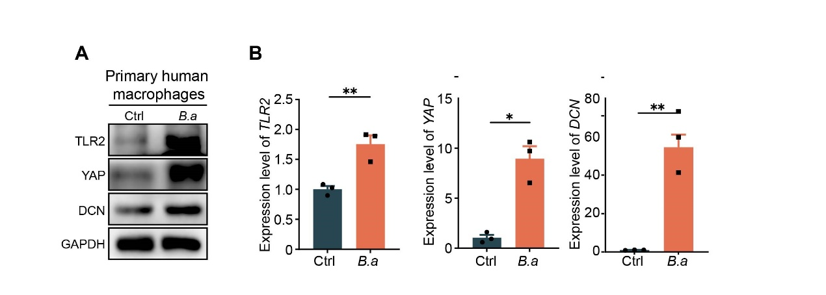
Figure S7 B.adolescentis activated TLR2/YAP/DCN in primary human macrophages. (A-B) Primary human macrophages were incubated with B.adolescentis or vehicle (PBS) for 24 hours. The protein and mRNA levels of TLR2/YAP/DCN were tested in primary human macrophages. The independent experiment was repeated three times. Data are shown as mean ± SD, * P < 0.05 ** P < 0.01, Student t test (B).
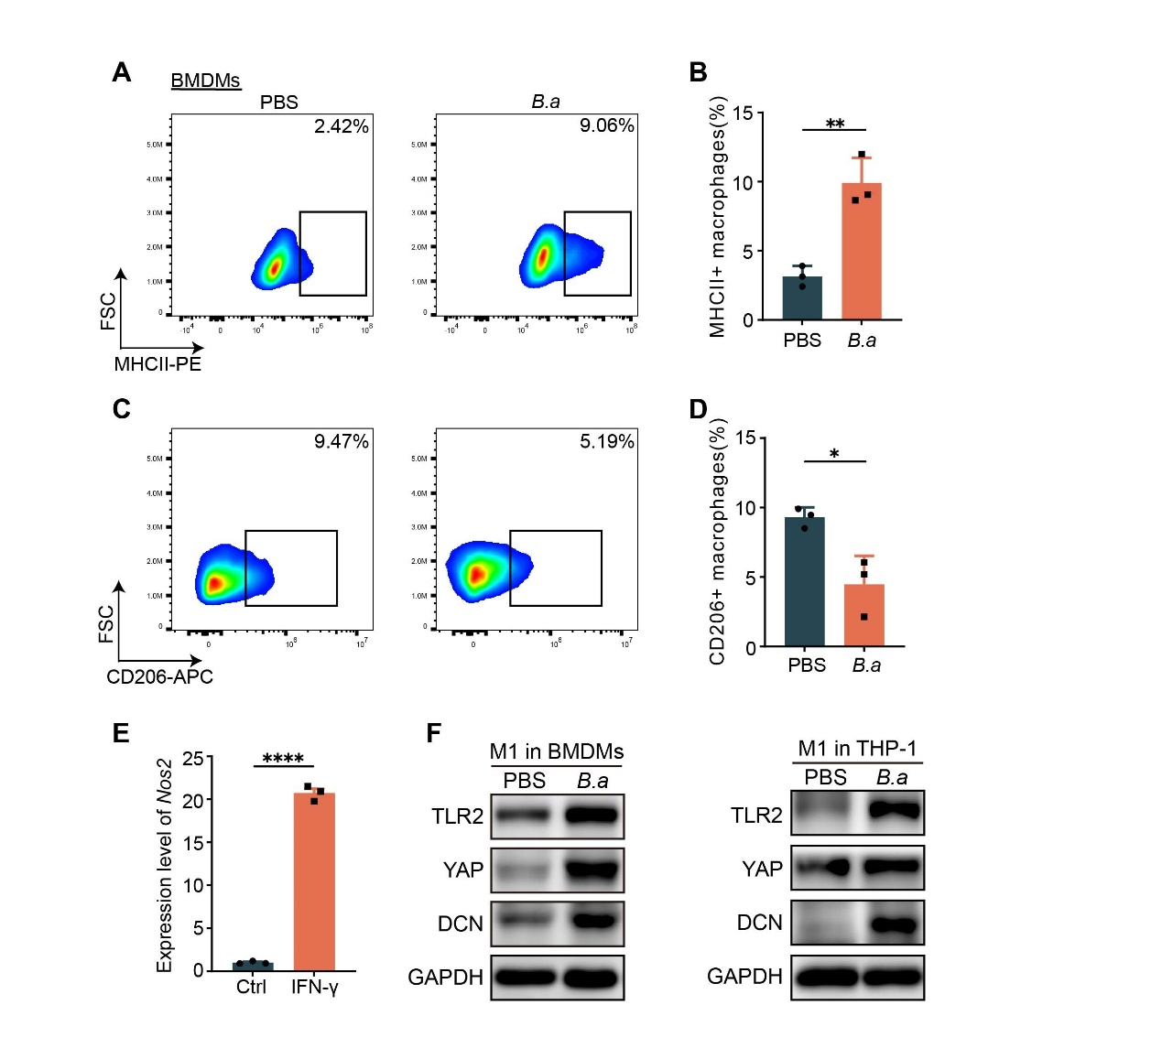
Figure S8 B.adolescentis activated TLR2/YAP/DCN in M1 macrophages. (A-D) Represent graphs and percentages of MHCII⁺ and CD206⁺ macrophages in B.adolescentis-treated BMDMs in vitro for 24 hours by flow cytometry. (E) The level of Nos2 in BMDMs treated with IFN-γ (100 ng/mL) for 24 hours in vitro was tested by qRT-PCR. (F) BMDMs and THP-1 cells were stimulated with IFN-γ (100 ng/mL) for 24 hours and then incubated with B.adolescentis for 24 hours. Protein levels of TLR2, YAP and DCN were tested by Western blot. The independent experiment was repeated three times. Data are shown as mean ± SD, * P < 0.05 ** P < 0.01 **** P < 0.0001, Student t test (B, D, E).

Supplementary Table S1: Primers used for validation the gene expression level
Primers | Sequencing(5ʹ–3ʹ)
B.adolescentis -F | CTCCGCCGCTGATCCGGAAGTCG
B.adolescentis -R | AACCAACTCGGCGATGTGGACGACA
universal Eubacteria 16s-F | CGGCAACGAGCGCAACCC
universal Eubacteria 16s-R | CCATTGTAGCACGTGTGTAGCC
Mouse Gapdh-F | AACGACCCCTTCATTGAC
Mouse Gapdh-R | TCCACGACATACTCAGCA
Mouse Decorin-F | TCTTGGGCTGGACCATTTGAA
Mouse Decorin-R | CATCGGTAGGGGCACATAGA
Mouse Tlr2-F | GCAAACGCTGTTCTGCTCAG
Mouse Tlr2-R | AGGCGTCTCCCTCTATTGTATT
Mouse Tlr4-F | ATGGCATGGCTTACACCACC
Mouse Tlr4-R | GAGGCCAATTTTGTCTCCACA
Mouse Tlr5-F | GCAGGATCATGGCATGTCAAC
Mouse Tlr5-R | ATCTGGGTGAGGTTACAGCCT
Mouse Tlr9-F | ATGGTTCTCCGTCGAAGGACT
Mouse Tlr9-R | GAGGCTTCAGCTCACAGGG
Mouse Tlr13-F | GTTGTAACCTGGATGCCTAAGAC
Mouse Tlr13-R | GGCCTCTGTCAAGTTGGTGA
Mouse Sparc-F | TGGGAGAATTTGAGGACGGTG
Mouse Sparc-R | GAGTCGAAGGTCTTGTTGTCAT
Mouse Jund-F | GAAACGCCCTTCTATGGCGA
Mouse Jund-R | CAGCGCGTCTTTCTTCAGC
Mouse Col1a-F | GCTCCTCTTAGGGGCCACT
Mouse Col1a-R | ATTGGGGACCCTTAGGCCAT
Mouse Sqstm1-F | AGGATGGGGACTTGGTTGC
Mouse Sqstm1-R | TCACAGATCACATTGGGGTGC
Mouse Dusp1-F | GTTGTTGGATTGTCGCTCCTT
Mouse Dusp1-R | TTGGGCACGATATGCTCCAG
Mouse Marcksl1-F | CAATGGAGACTTAACCCCCAAG
Mouse Marcksl1-R | GGCCACTCAATTTGAAAGGCT
Mouse Junb-F | TCACGACGACTCTTACGCAG
Mouse Junb-R | CCTTGAGACCCCGATAGGGA
Mouse Ppp1r15a-F | GAGGGACGCCCACAACTTC
Mouse Ppp1r15a-R | TTACCAGAGACAGGGGTAGGT
Mouse Col3a1-F | CTGTAACATGGAAACTGGGGAAA
Mouse Col3a1-R | CCATAGCTGAACTGAAAACCACC
Mouse Hdc-F | CGTGAATACTACCGAGCTAGAGG
Mouse Hdc-R  Mouse Il6-F  Mouse Il6-F  Mouse Tnf-F  Mouse Tnf-F | ACTCGTTCAATGTCCCCAAAG  TAGTCCTTCCTACCCCAATTTCC  TTGGTCCTTAGCCACTCCTTC  CCCTCACACTCAGATCATCTTCT  GCTACGACGTGGGCTACAG
Human Β-ACTIN-F | AGAGCTACGAGCTGCCTGAC
Human Β-ACTIN-R | AGCACTGTGTTGGCGTACAG
Human Decorin-F | ATGAAGGCCACTATCATCCTCC
Human Decorin-R | GTCGCGGTCATCAGGAACTT
Human TLR2-F | GTTGCAAGCAGGATCCAAAGG
Human TLR2-R | TGAGCTGCCCTTGCAGATAC

