ADDITIONAL FILE 1
SUPPLEMENTARY FIGURES

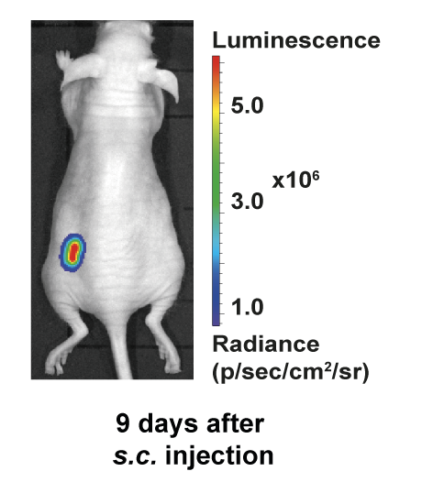

Fig. S1. In vivo bioluminescence (BLI) imaging of subcutaneous primary tumour. BLI monitoring of subcutaneous primary tumour formation 9 days after s.c. injection of 143B-luc⁺ cells. The bioluminescent signal is represented as radiance (photon/s/cm²/sr).

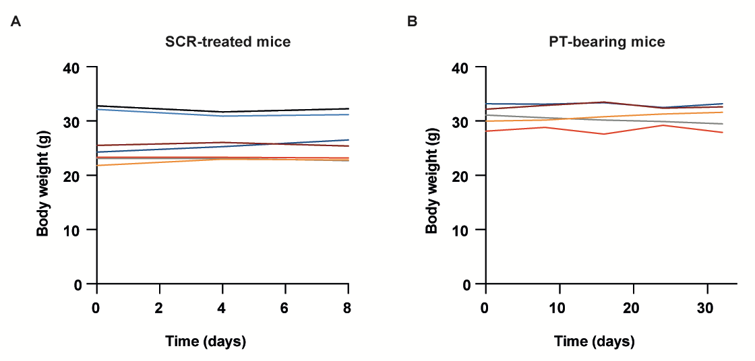

Fig. S2. Body weight analysis in SCR-treated and PT-bearing mice. A Monitoring of body weight over 8 days in the SCR-treated mice. B Monitoring of body weight over 30 days in the PT-bearing mice.

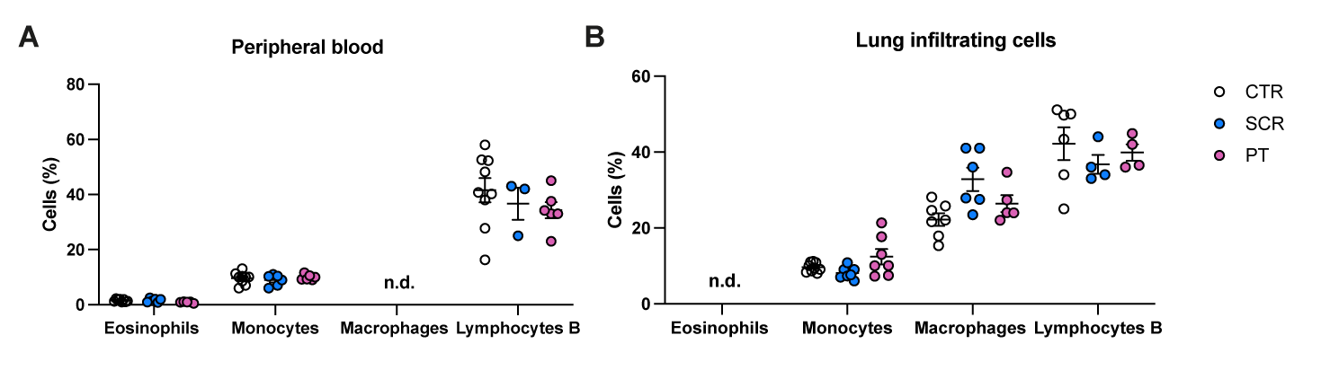
Fig. S3. Flow cytometric quantification of infiltrating immune cells in the peripheral blood (A) and in the lungs (B) of control, SCR-treated and PT-bearing mice (n=5-6, per group).
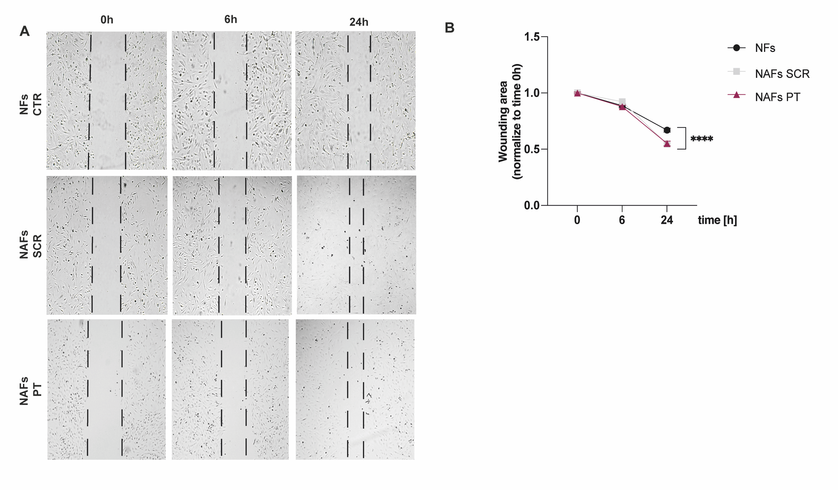
Fig. S4. Cell migration (wound healing) assay in primary cultures of fibroblasts isolated from lungs of untreated (NFs), SCR-treated (NAFs^{SCR}) and PT-bearing mice (NAFs^{PT}). A Representative images of scratch closure assay of lung fibroblasts monolayers at 0, 6 and 24 h. B Quantification of scratch closure assay expressed as the remaining area uncovered by the cells. The scratch is at time point 0 h was set to 1. ****p<0.0001 significantly different when compared with NFs using a non-parametric Kruskal-Wallis test (n=3).

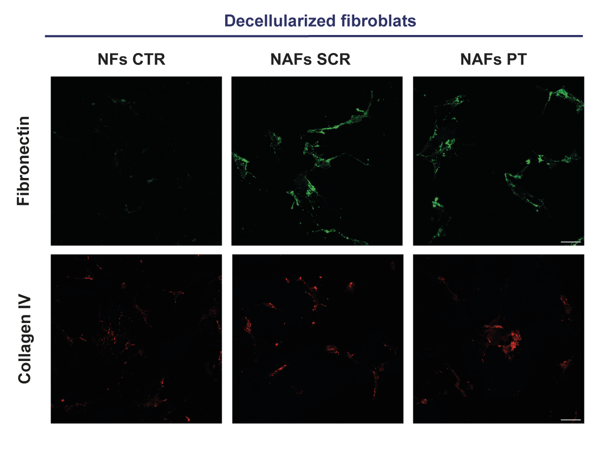
Fig. S5. Fibronectin and collagen IV depositions in decellularized lung fibroblast cell sheets from SRC-treated, PT-bearing mice and CTR mice. Representative immunofluorescence images of decellularized lung fibroblasts stained for fibronectin and collagen IV at x20 magnification (Scale bar: 50 µm) from CTR, SCR-treated or PT-bearing mice (n=3).

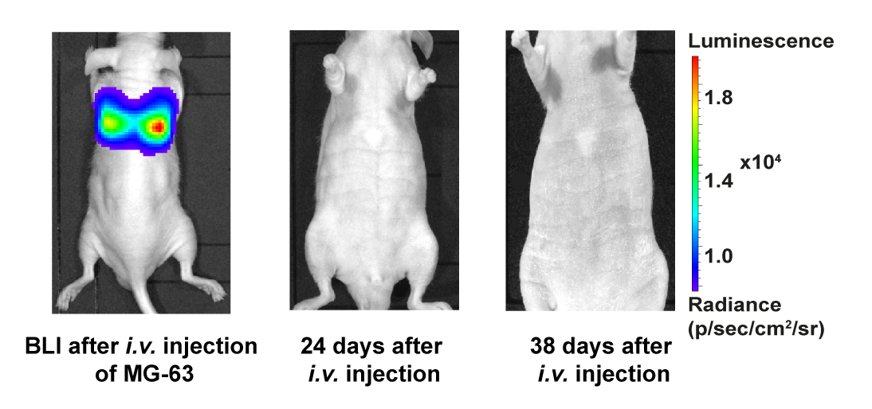

Fig. S6. In vivo longitudinal bioluminescence (BLI) imaging of pre-treated mice with MG-63-derived secretome following i.v. injection of MG-63-luc⁺ cells (1.5 x 10⁶ cells). BLI images acquired immediately after the i.v. injection of MG-63-luc⁺ cells showing the arrival of tumour cells to the lungs and BLI images at days 24 and 38 after i.v. injection of cells without evidence of lung metastasis formation. The bioluminescent signal is represented as radiance (photon/s/cm²/sr).

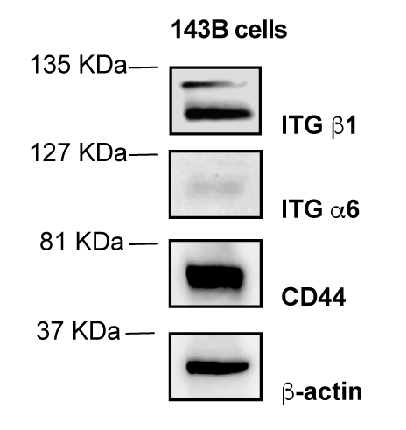
Fig. S7. Western blot analysis of key cell adhesion proteins in 143B cells. Representative western blot of ITG β1, ITG α6 and CD44 proteins in 143B cells.

