Supplementary Materials for
Combined IL6 and CCR2 Blockade Potentiates Antitumor Activity of NK Cells in HPV-Negative Head and Neck Cancer
Yang F et al
Corresponding author: Yong Teng, yong.teng@emory.edu

This PDF file includes:
Supplementary Tables S1 to S8 and Supplementary Figures S1 to S4
Table captions:
Table S1. HNSCC Patient cohort information of GSE164690
Table S2. HNSCC Patient cohort information of GSE139324
Table S3. DEGs in NK cells based on GSE164690 scRNA-seq data (see attached Excel)
Table S4. DEGs in NK cells based on GSE139324 scRNA-seq data (see attached Excel)
Table S5. DEGs in tumor cells (HPV− vs. HPV+) based on GSE164690 scRNA-seq data (see attached Excel)
Table S6. Nineteen genes significantly co-expressed with IL6 in HPV- HNSCC cohort (see attached Excel)
Table S7. List of significantly altered pathways in IL6 high expressing HPV− HNSCC vs. IL6 low expressing HPV− HNSCC (see attached Excel)
Table S8. List of significantly altered pathways in IL6 high expressing HPV+ HNSCC vs. IL6 low expressing HPV+ HNSCC (see attached Excel)

Table S1. HNSCC patient cohort information of GSE164690
Patient ID | Gender | Age group | Smoking | Alcohol | Disease site | HPV status
1 | Male | 70-79 | Yes | No | Oral cavity | Negative
2 | Female | 60-69 | No | No | Oral cavity | Negative
3 | Male | 80-89 | No | No | Oral cavity | Negative
4 | Male | 50-59 | Yes | Yes | Oral cavity | Negative
5 | Female | 50-59 | Yes | Yes | Oral cavity | Negative
6 | Male | 30-39 | Yes | Yes | Oral cavity | Negative
7 | Male | 60-69 | Yes | Yes | Larynx | Negative
8 | Female | 70-79 | Yes | Yes | Oral cavity | Negative
9 | Female | 70-79 | Yes | Yes | Oral cavity | Negative
10 | Male | 50-59 | No | Yes | Oral cavity | Negative
11 | Male | 80-89 | No | No | Oral cavity | Negative
12 | Male | 50-59 | Yes | Yes | Oropharynx | Positive
13 | Male | 70-79 | No | No | Oropharynx | Positive
14 | Male | 50-59 | Yes | Yes | Oropharynx | Positive
15 | Female | 60-69 | Yes | NA | Oral cavity | Negative
16 | Male | 40-49 | Yes | Yes | Oropharynx | Positive
17 | Male | 50-59 | Yes | Yes | Oropharynx | Positive
18 | Male | 50-59 | Yes | Yes | Oropharynx | Positive

Table S2. HNSCC patient cohort information of GSE139324
Patient ID | Gender | Age | Smoking | Alcohol | Disease site | HPV status
1 | Male | 45 | Yes | Yes | Oral cavity | Negative
2 | Male | 50 | Yes | Yes | Floor of mouth | Negative
3 | Female | 66 | Former | Unknown | Floor of mouth | Negative
4 | Male | 48 | Yes | Yes | Buccal mucosa | Negative
5 | Male | 45 | Yes | Occasional | Tongue | Negative
6 | Male | 43 | Yes | No | Larynx | Negative
7 | Male | 74 | Yes | No | Lower gum | Negative
8 | Female | 60 | No | No | Tongue | Negative
9 | Male | 80 | No | No | Oral cavity | Negative
10 | Male | 56 | Yes | Yes | Tongue | Negative
11 | Female | 57 | Yes | No | Tongue | Negative
12 | Male | 35 | No | No | Tongue | Negative
13 | Male | 62 | Yes | Yes | Supraglottis | Negative
14 | Female | 77 | Yes | No | Mandable | Negative
15 | Female | 75 | Yes | Yes | Tongue | Negative
16 | Male | 55 | No | Yes | Tongue | Negative
17 | Male | 80 | No | No | Buccal mucosa | Negative
18 | Female | 69 | Yes | Yes | Floor of mouth | Positive
19 | Male | 68 | No | Occassional | Base of tongue | Positive
20 | Male | 62 | Former | Occassional | Base of tongue | Positive
21 | Male | 49 | Former | Unknown | Base of tongue | Positive
22 | Male | 66 | No | Occasional | Tonsil | Positive
23 | Male | 61 | Yes | Yes | Tongue | Positive
24 | Male | 52 | Former | No | Base of tongue | Positive
25 | Male | 75 | No | No | Tonsil | Positive
26 | Male | 59 | Yes | No | Tonsil | Positive

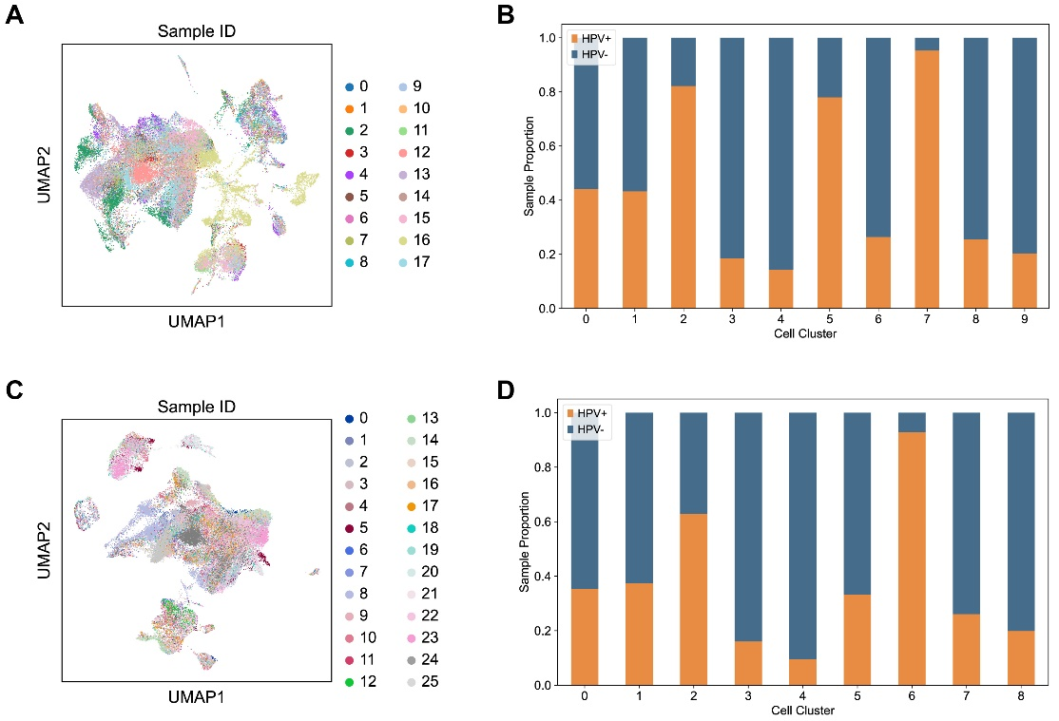
Figure S1. Bioinformatic analysis of immune cells based on the scRNA-seq data from GSE164690 and GSE139324. (A) Visualization of all analyzed cells using UMAP, colored by sample ID (GSE164690). (B) Proportion of HPV− samples and HPV+ samples in each cell cluster. (B) Proportion of HPV− samples and HPV+ samples in each cell cluster (GSE164690). (C) Visualization of all analyzed cells using UMAP, colored by sample ID (GSE139324). (D) Proportion of HPV− samples and HPV+ samples in each cell cluster (GSE139324).

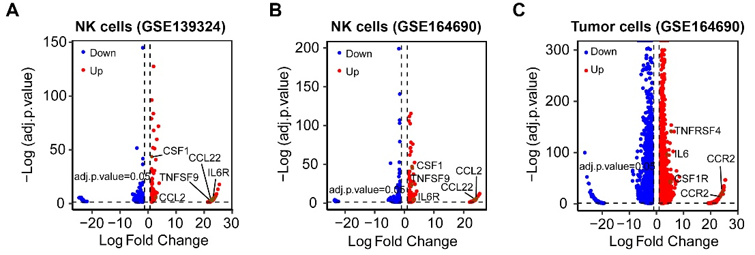
Figure S2. Volcano plots comparing DEGs in NK cells and tumor cells between the HPV− and HPV+ HNSCC cohorts. (A) Volcano plots of DEGs in NK cells in the HPV− HNSCC cohort vs. the HPV+ HNSCC cohort based on the GSE139324 and GSE164690 scRNA-seq data. (B) A volcano plot of DEGs in tumor cells in the HPV− HNSCC cohort vs. the HPV+ HNSCC cohort based on the GSE164690 scRNA-seq data.

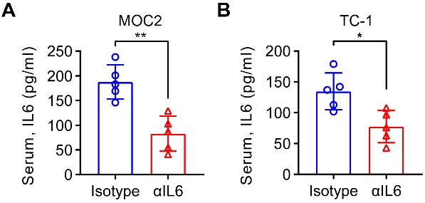
Figure S3. Changes in serum IL6 concentration in tumor-bearing C57BL/6 mice treated with αIL6 or IgG isotype. The quantitative data are shown from mice bearing MOC2 (A) or TC-1 (B) tumors. **p<0.01.

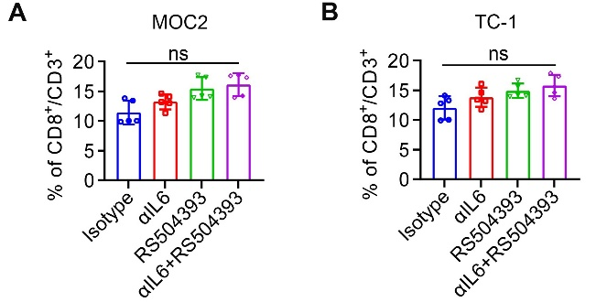
Figure S4. Percent of CD8⁺ T cells in mouse tumors treated with αIL6 and RS504393, alone or in combination. T cells were gated from live CD3⁺ population. Quantitative data are shown from mice bearing MOC2 (A) or TC-1 (B) tumors. ns: not significant.

