Supplementary Figures

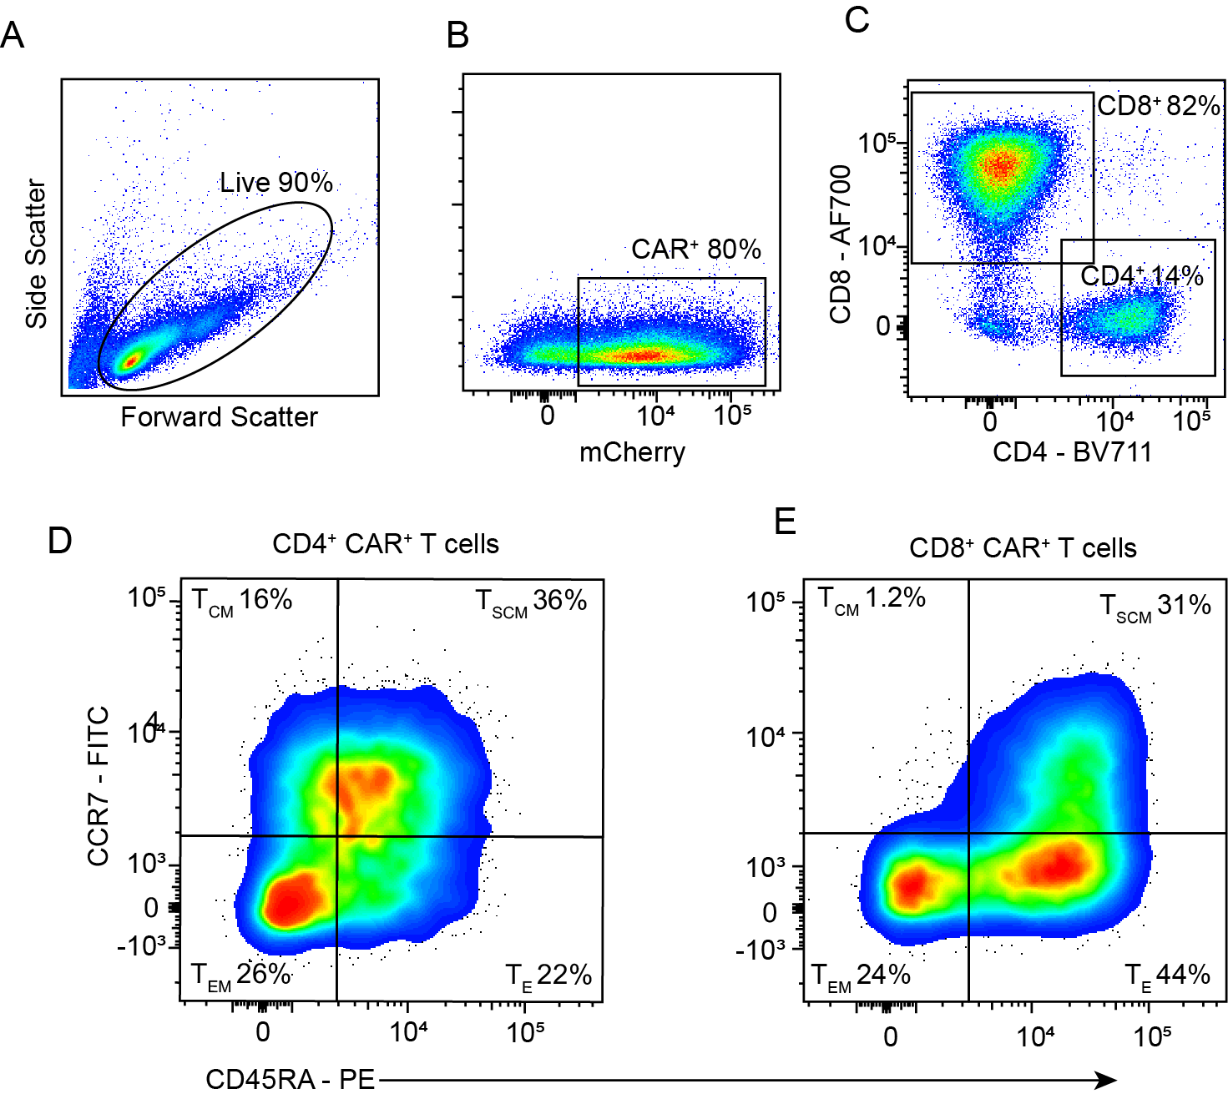

Supplementary Figure 1. Subpopulations within B7-H3 CAR T cells
Flow cytometry diagrams of CAR⁺ T cells at 12 days post transduction showing the frequency of CD4⁺ and CD8⁺ population in CAR⁺ T cells as well as the percentage of stem cell memory T cells (T_{SCM}, CD45RA⁺CCR7⁺), central memory T cells (T_{CM}, CD45RA⁻CCR7⁺), effector memory T cells (T_{EM}, CD45RA⁻CCR7⁻ ), and effector T cells (T_{E}, CD45RA⁺CCR7⁻ ) in CD4+ T cells and CD8+ T cells (n=3).

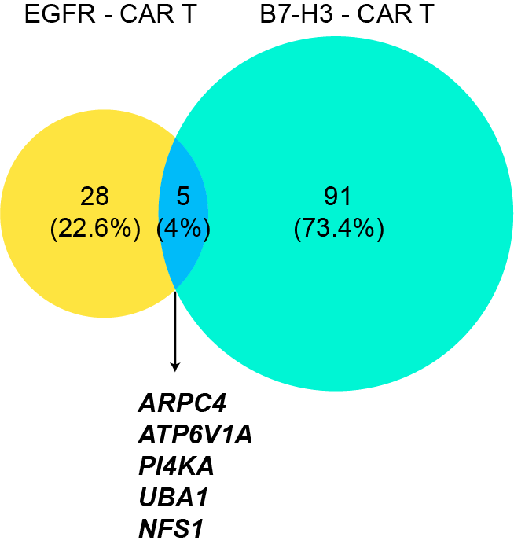

Supplementary Figure 2. Comparison of results from our screen and a previous published screen
Venn diagram showing the overlap between the sensitizing hits identified from our screen using B7-H3-targeting CAR T cells and the screen by Larson et al. using EGFR-targeting CAR T cells.

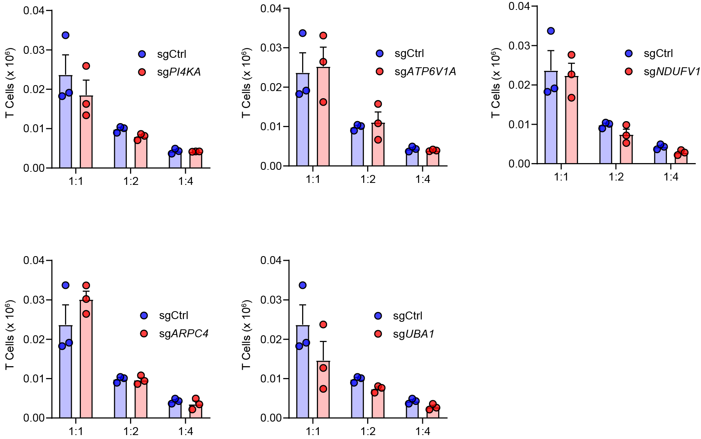

Supplementary Figure 3. CAR T cell numbers after co-culture
Quantifications of CAR T cell numbers by flow cytometry after 2-day co-culture with CRISPRi-U87 cells expressing the indicating sgRNAs at E: T ratios of 1:1, 1:2 and 1:4

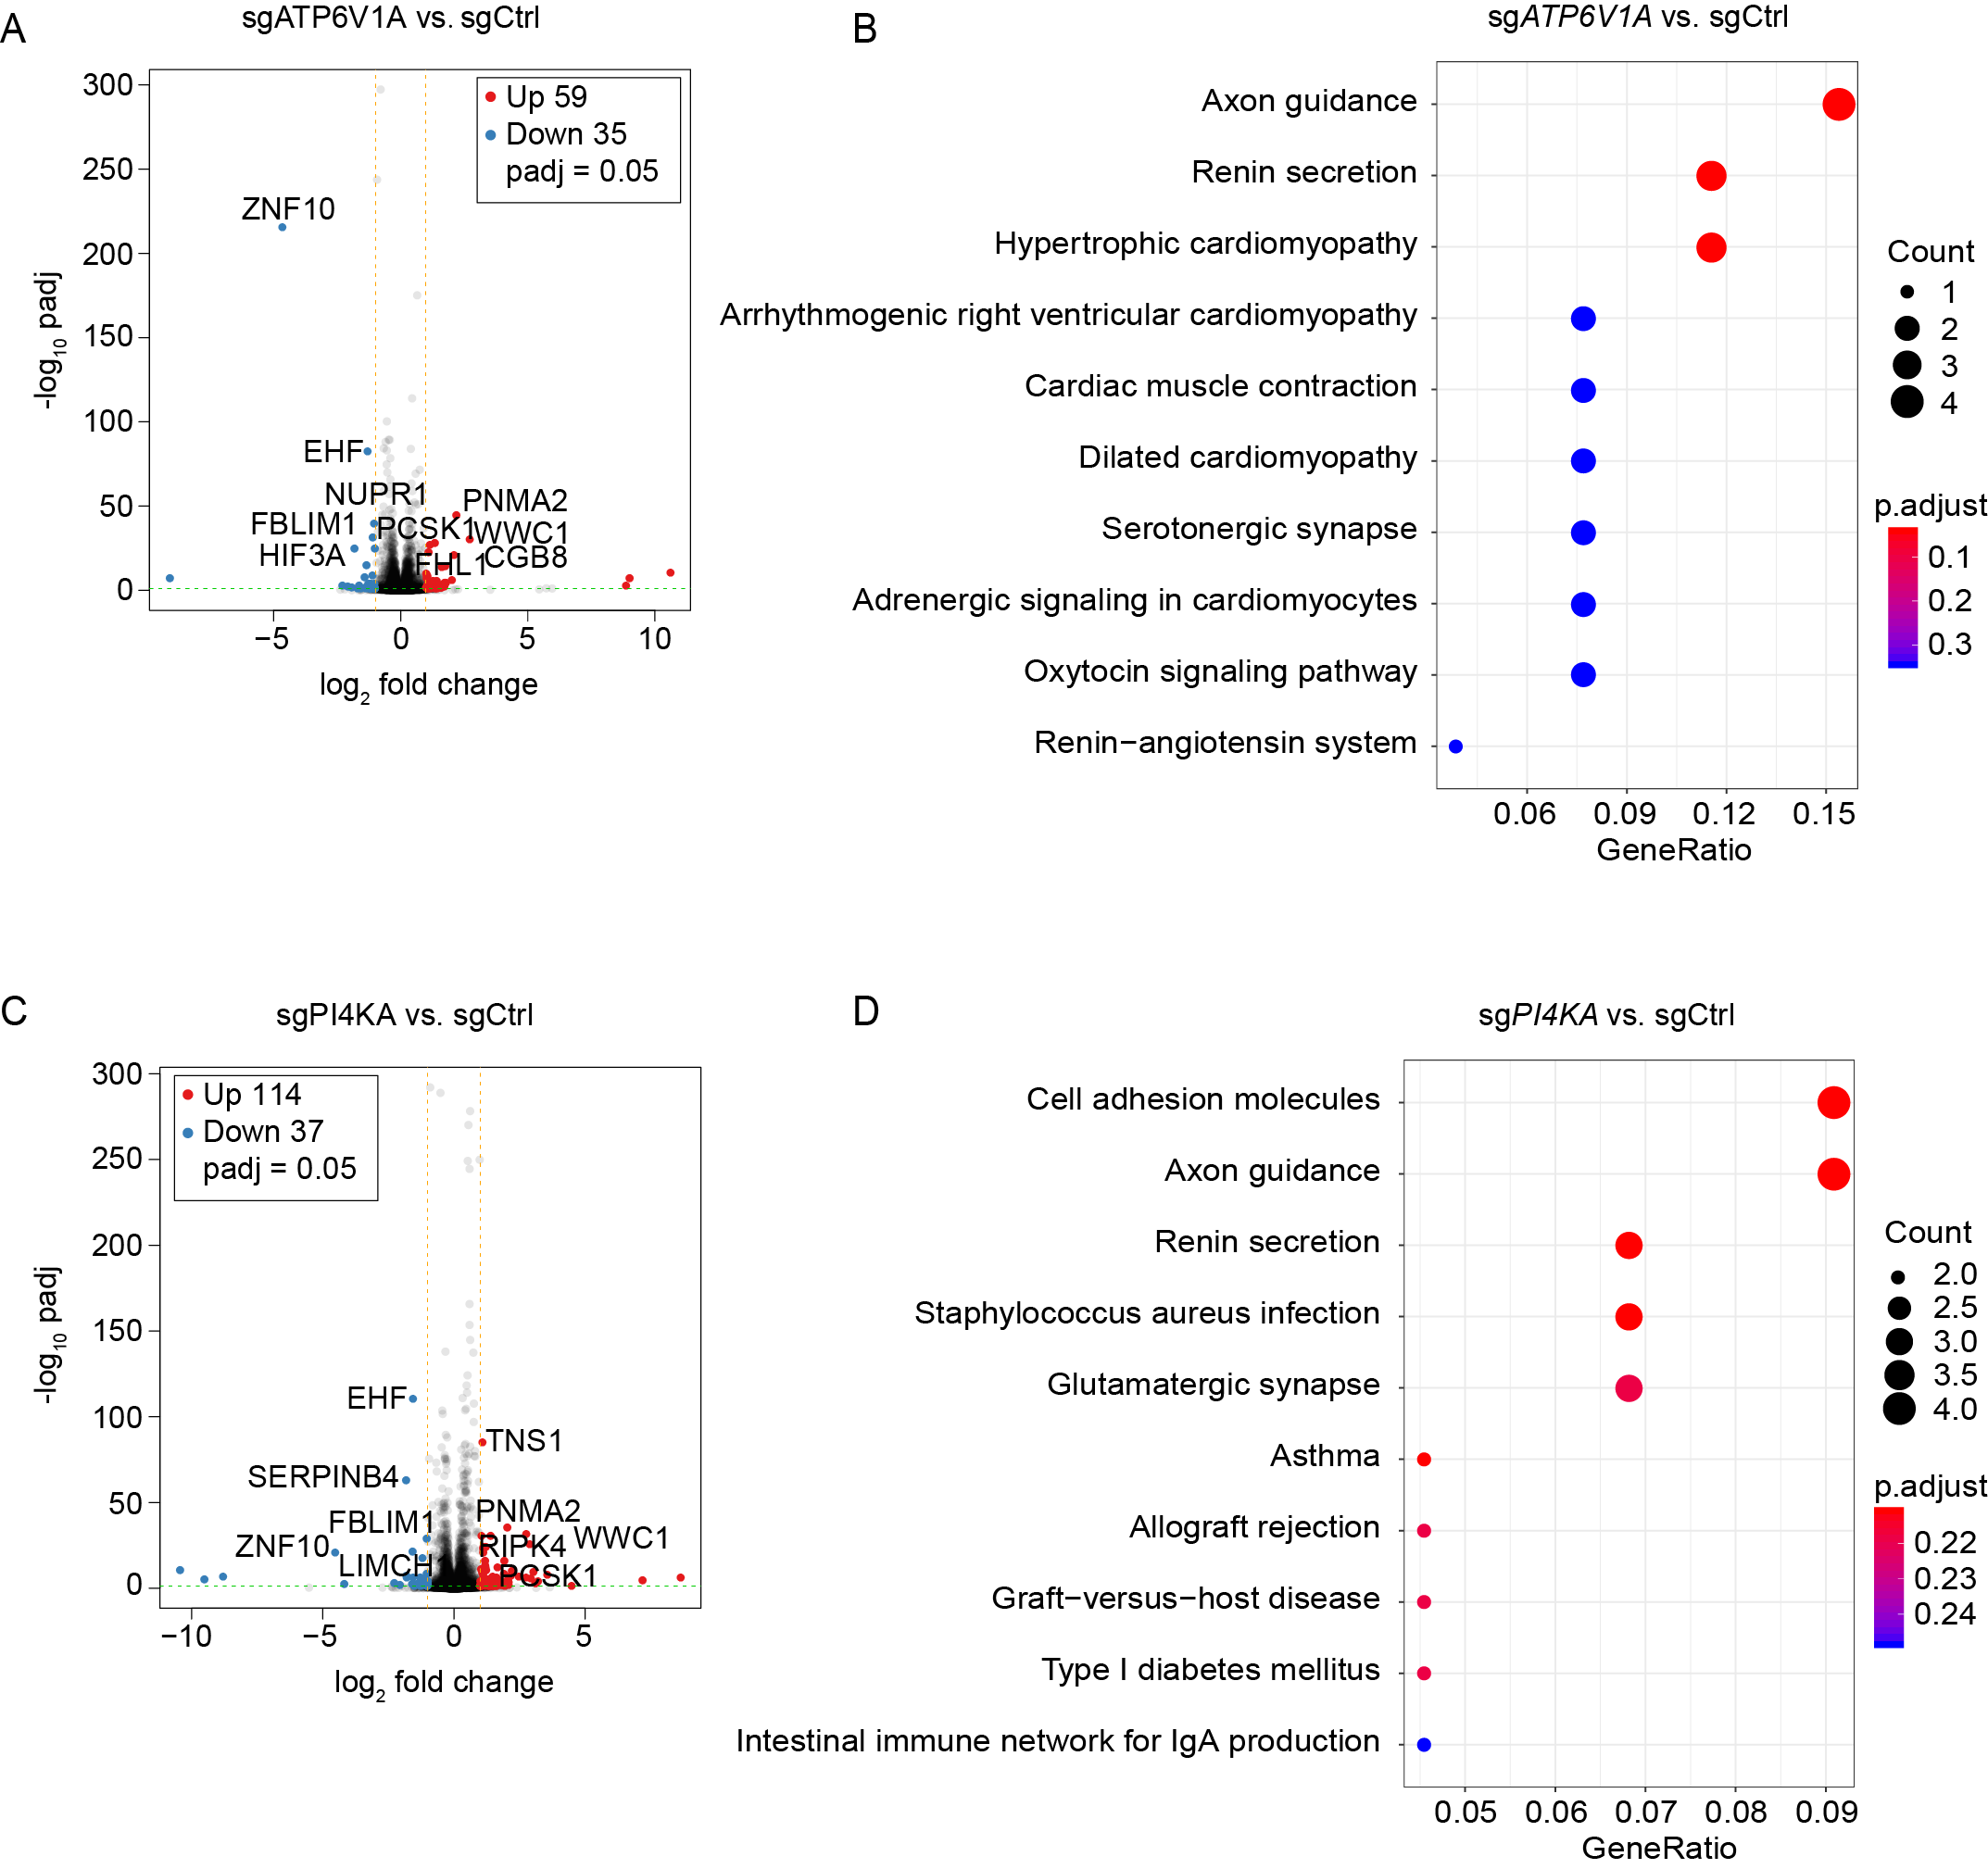

Supplementary Figure 4. Transcriptome analysis on ATP6V1A and PI4KA knockdown cells
A & B. Differentially expressed genes (A) and their enriched KEGG pathways (B) in ATP6V1A knockdown cells.
C & D. Differentially expressed genes (C) and their enriched KEGG pathways (D) in PI4KA knockdown cells.

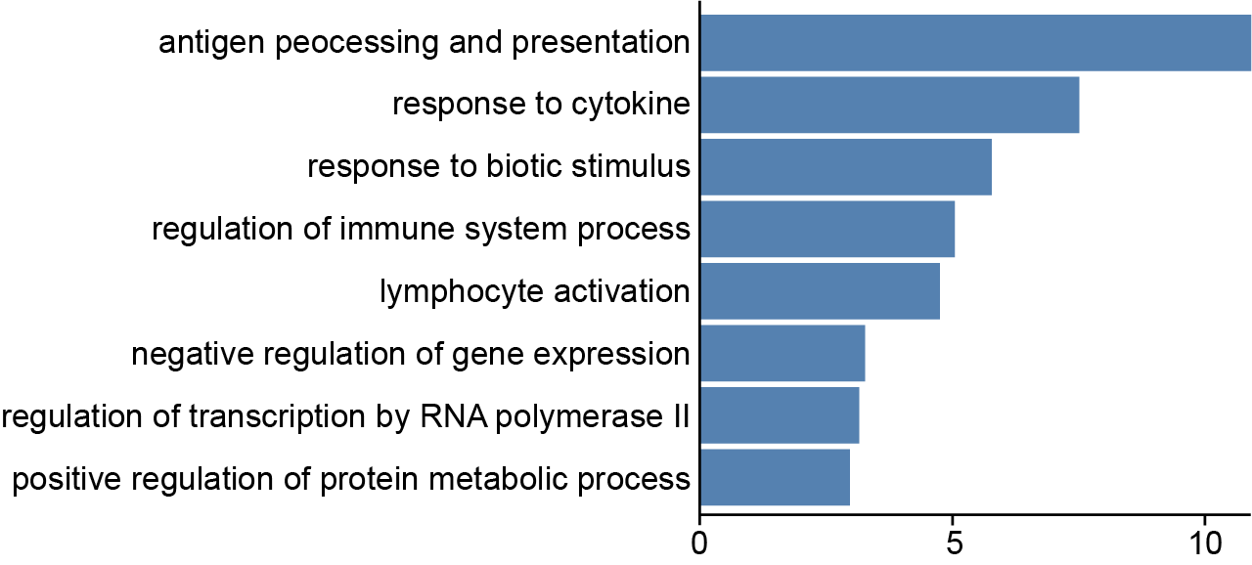

Supplementary Figure 5. GO enrichment analysis for top 50 upregulated genes in CD8+ T cell following TL1A cytokine treatment in vivo

