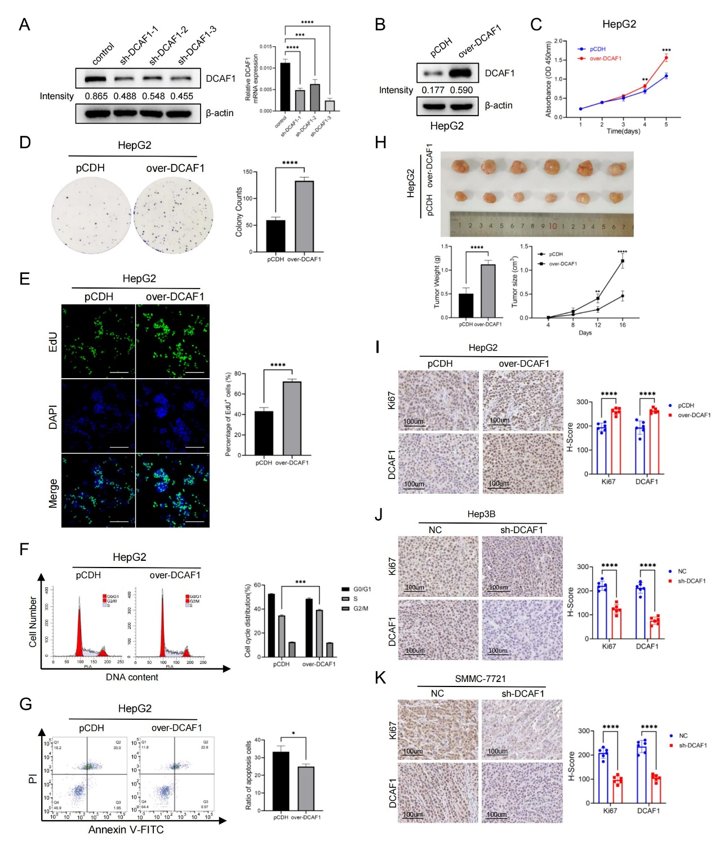
Figure S1 DCAF1 promotes HCC growth in vitro and in vivo. A-B The efficacy of DCAF1 knockdown in Hep3B cells and overexpression in HepG2 cells were verified by Western blot. C CCK8 assays in HepG2 cells after overexpression of DCAF1. D The colony formation results of HepG2 cells after DCAF1 overexpression. E EdU assay results of HepG2 cells after overexpression of DCAF1 (Bar=100μm). F Cell cycle analysis of HepG2 cells was conducted by flow cytometry. G The cell apoptosis ratio of HepG2 cells was detected by flow cytometry using an Annexin V-FITC/PI staining kit. H HepG2 cells with DCAF1 overexpression were transplanted on nude mice, and tumor volumes and tumor weights were recorded. I-K Representative IHC images of Ki67 and DCAF1 in the HepG2 (I)、Hep3B (J)、SMMC-7721 (K) subcutaneous xenograft model (Bar=100μm). Data are shown as the mean ± SD. * p < 0.05, ** p < 0.01, *** p < 0.001, **** p < 0.0001.
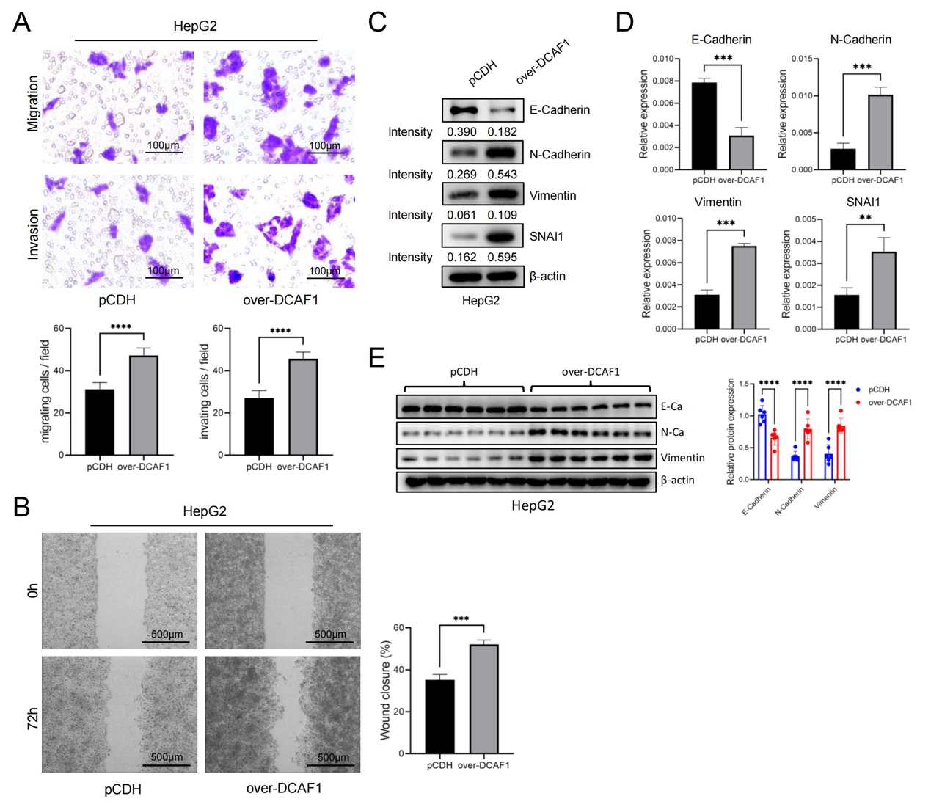
Figure S2 DCAF1 regulates cell migration and invasion in HepG2 cells and activates EMT. A Representative image of migrated and invaded HepG2 cells after DCAF1 overexpression (Bar=100μm). B Wound healing assays were performed to assess the effect of overexpression of DCAF1 on cell motility in HepG2 cells (Bar=500μm). C The expression levels of EMT markers in HepG2 cells after DCAF1 overexpression were detected by Western blot. D The mRNA expression levels of EMT markers in HepG2 cells after DCAF1 overexpression were detected by qRT‒PCR. E The expression of EMT marker proteins in HepG2 subcutaneous xenografts were assessed by Western blot. Data are shown as the mean ± SD. * p < 0.05, ** p < 0.01, *** p < 0.001, **** p < 0.0001.
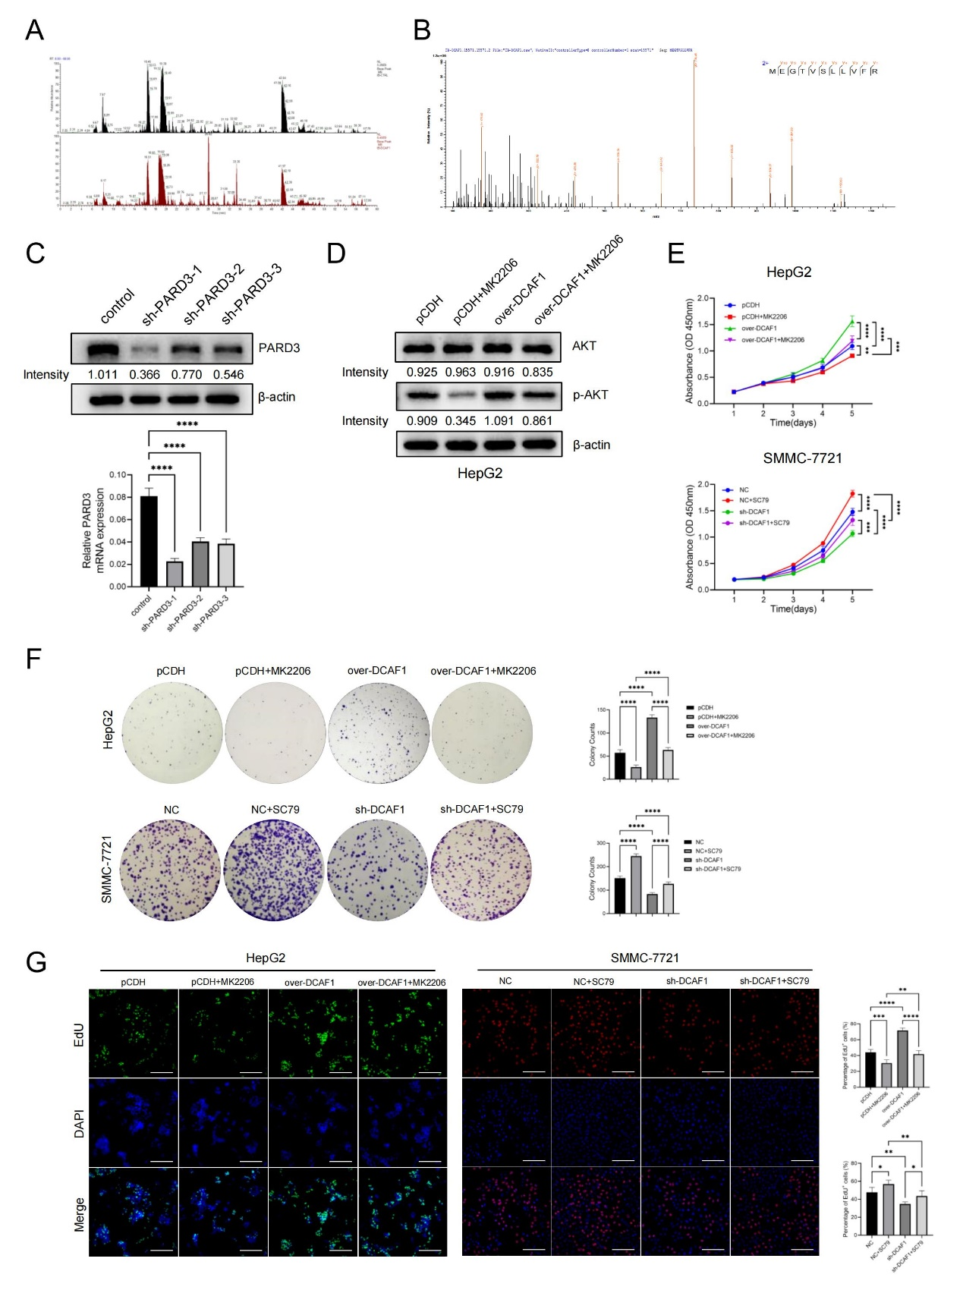
Figure S3 DCAF1 binds to PARD3 thus activating the Akt signaling pathway to promote HCC cell proliferation. A-B Mass spectrometry analysis. A The base peaks of mass spectrometry. B The mass spectrogram of a PARD3 unique peptide. C The efficacy of PARD3 knockdown in HepG2 cells verified by western blot and RT‒qPCR. D The protein levels of Akt and p-Akt in HepG2 cells with or without the Akt inhibitor were detected by Western blot. E-G CCK8 assays (E), colony formation assays (F) and EdU assays (G) indicated that the Akt activator could partly rescue the repressive effect on cell proliferation caused by DCAF1 knockdown in SMMC-7721 cells, while the Akt inhibitor could partly suppress the enhancing effect of DCAF1 overexpression on the proliferation of HepG2 cells (Bar=100μm). Data are shown as the mean ± SD. * p < 0.05, ** p < 0.01, *** p < 0.001, **** p < 0.0001.
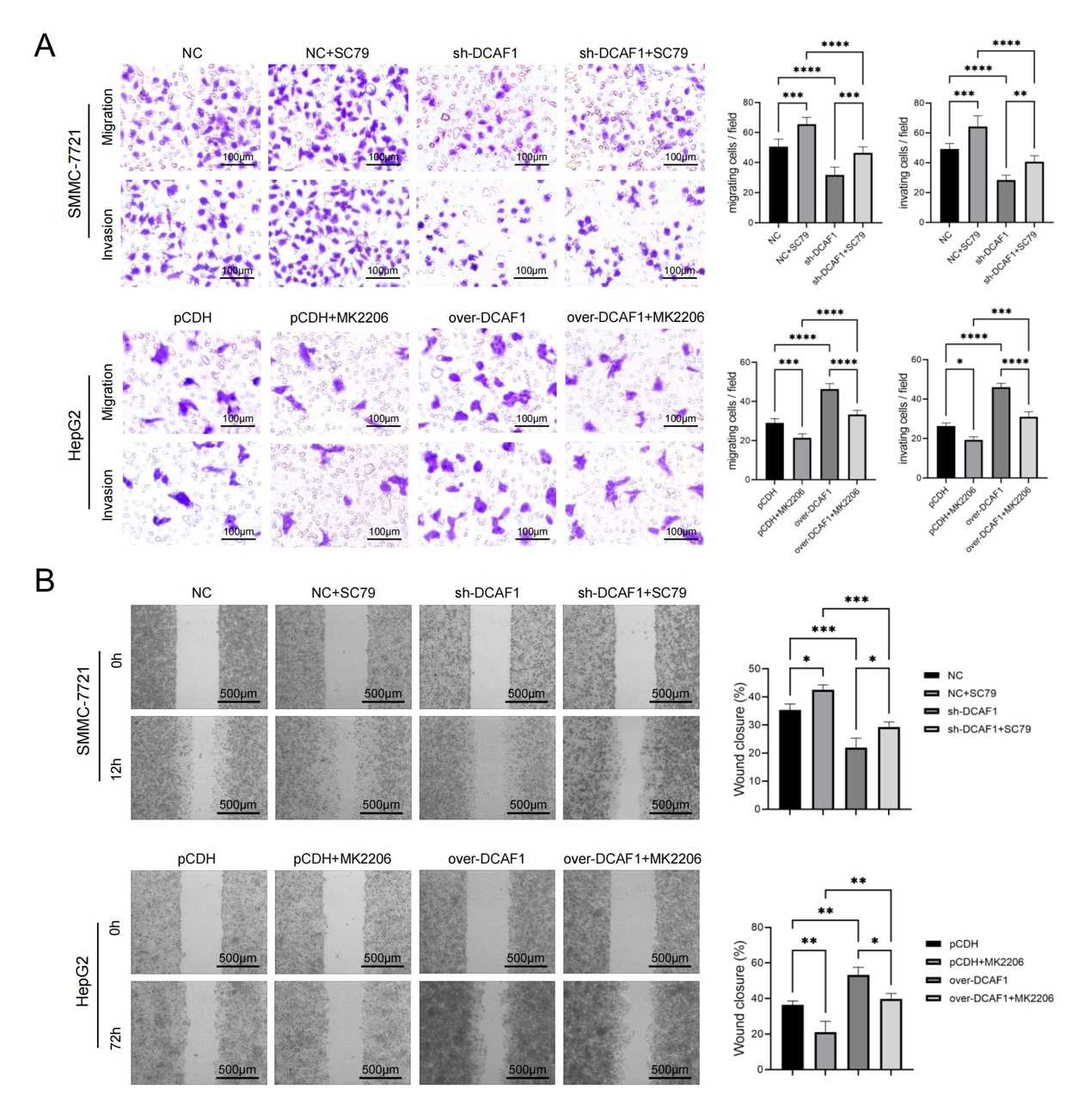
Figure S4 DCAF1 promotes HCC cell metastasis by activating the Akt signaling pathway. A-B Transwell assays A and wound-healing assays B indicated that the Akt activator could partly rescue the repressive effect on cell migration and invasion caused by DCAF1 knockdown in SMMC-7721 cells, while the Akt inhibitor could partly suppress the enhancing effect of DCAF1 overexpression on the migration and invasion of HepG2 cells (Bar=100μm (A), Bar=500μm (B)). Data are shown as the mean ± SD. * p < 0.05, ** p < 0.01, *** p < 0.001, **** p < 0.0001.

Supplementary Table 1 Sequences of shRNAs
Plasmid name | Target sequence
sh-DCAF1-1 | GCAGTGACCATGTCAAGTT
sh-DCAF1-2 | GGTGTCAGGAAAACCACTT
sh-DCAF1-3 | GCGCCAATAAACTTTACGTCA
sh-PARD3-1 | GGAATCCACGTAGTGCCTTTC
sh-PARD3-2 | GCACCTCAGAATGTATTTAGT
sh-PARD3-3 | GGGCAAATCCCAAGAGGAAGT

Supplementary Table 2 Design of DCAF1 deletion mutants
Designed segments |  | Actual segments
Name | Length | Type | Region | Structural domain
DCAF1(1-140aa) | 140
DCAF1(141-500aa) | 360 | Region | 141-500 | Protein kinase-like
DCAF1(141-500aa) | 360 | Region | 242-288 | Disordered Automatic Annotation
DCAF1(501-719aa) | 249 | Domain | 562-593 | Chromo
DCAF1(720-1090aa) | 371 | Domain | 846-878 | LisHPROSITE-ProRule Annotation
DCAF1(720-1090aa) | 371 | Region | 917-947 | Disordered Automatic Annotation
DCAF1(1091-1339aa) | 248 | Repeat | 1091-1130 | WD 1
DCAF1(1091-1339aa) | 248 | Region | 1091-1290 | WD repeat-like region
DCAF1(1091-1339aa) | 248 | Repeat | 1133-1174 | WD 2
DCAF1(1091-1339aa) | 248 | Repeat | 1176-1213 | WD 3
DCAF1(1091-1339aa) | 248 | Repeat | 1215-1247 | WD 4
DCAF1(1091-1339aa) | 248 | Motif | 1242-1249 | DWD box 1
DCAF1(1091-1339aa) | 248 | Repeat | 1248-1290 | WD 5
DCAF1(1091-1339aa) | 248 | Motif | 1278-1285 | DWD box 2
DCAF1(1340-1507aa) | 168 | Region | 1393-1507 | Disordered Automatic Annotation
DCAF1(1340-1507aa) | 168 | Region | 1418-1507 | Interaction with NF2

Supplementary Table 3 Primer names and sequences

Primer name | Sequence
PARD3- F | CAGGTGCATCGCTTGGAAC
PARD3- R | GCTGAGACATTGTTGGTGCC
DCAF1- F | GGAGGGAATTGTCGAGAATCTTT
DCAF1- R | GTTGGCAGCAATGTCTTGATTT
E-cadherin-F | ATTTTTCCCTCGACACCCGAT
E-cadherin-R | TCCCAGGCGTAGACCAAGA
N-cadherin-F | AGCCAACCTTAACTGAGGAGT
N-cadherin-R | GGCAAGTTGATTGGAGGGATG
Vimentin-F | AGTCCACTGAGTACCGGAGAC
Vimentin-R | CATTTCACGCATCTGGCGTTC
SNAI1-F | TCGGAAGCCTAACTACAGCGA
SNAI1-R | AGATGAGCATTGGCAGCGAG

Supplementary Table 4 Antibodies for Western blot
Antibody | Order | Catalog | Dilution | Manufacturer
anti-DCAF1 | Primary | 11612-1-AP | 1:1000 | Proteintech
anti-PARD3 | Primary | 11085-1-AP | 1:1000 | Proteintech
anti-Akt | Primary | 9272 | 1:4000 | CST
anti-p-Akt | Primary | 4060 | 1:1000 | CST
anti-Bcl-xL | Primary | 2764 | 1:1000 | CST
anti-Bcl-2 | Primary | 3498 | 1:1000 | CST
anti-E-Cadherin | Primary | 3195 | 1:1000 | CST
anti-N-Cadherin | Primary | A19083 Abclonal | 1:1000 | CST
anti-Vimentin  anti-SNAI1  anti-β-actin | Primary | 60330-1-Ig | 1:20000 | Proteintech
anti-SNAI1 | Primary | 13099-1-AP | 1:1000 | Proteintech
anti-β-actin | Primary | 66009-1-Ig | 1:20000 | Proteintech
anti-flag | Primary | 66008-4-Ig | 1:5000 | Proteintech
anti-Mouse | Secondary | 7076 | 1:2000 | CST
anti-Rabbit | Secondary | 7074 | 1:2000 | CST

Supplementary Table 5 Antibodies for Coimmunoprecipitation
Antibody | Catalog | Dilution | Manufacturer
anti-DCAF1 | 11612-1-AP | 4 ug for 1ml protein lysate | Proteintech
anti-PARD3 | 11085-1-AP | 4 ug for 1ml protein lysate | Proteintech
anti-flag | 20543-1-AP | 4 ug for 1ml protein lysate | Proteintech
Rabbit (DA1E) mAb IgG XP® Isotype Control | 3900 | 4 ug for 1ml protein lysate | CST

Supplementary Table 6 Antibodies for Immunofluorescence
Antibody | Order | Catalog | Dilution | Manufacturer
anti-DCAF1 | Primary | 11612-1-AP | 1:200 | Proteintech
Goat anti-Rabbit IgG (H+L) Cross-Adsorbed Secondary Antibody, Alexa Fluor™ 488 | Secondary | A-11008 | 1:200 | Invitrogen

Supplementary Table 7 Antibodies for IHC
Antibody | Order  Primary  Primary  Primary  Primary | Catalog | Dilution | Manufacturer
anti-DCAF1 | Primary  Primary  Primary  Primary | 11612-1-AP | 1:200 | Proteintech
anti-PARD3 | Primary | 11085-1-AP | 1:200 | Proteintech
anti-p-Akt | Primary | 4060 | 1:200 | CST
anti-Ki67 | Primary | 12202 | 1:200 | CST
anti-Rabbit/Mouse | Secondary | SP KIT-B3 | Directedly used used | MAXIM

Supplementary Table 8 Proteins identified by mass spectrometry that may interact with DCAF1
Protein IDs | Protein names | Gene names | Score | Sequence coverage [%] | Unique peptides | Fasta headers
Q16531 | DNA damage-binding protein 1 | DDB1 | 323.31 | 36.3 | 39 | sp|Q16531|DDB1_HUMAN DNA damage-binding protein 1 OS=Homo sapiens OX=9606 GN=DDB1 PE=1 SV=1
Q8TEW0 | Partitioning defective 3 homolog | PARD3 | 238.79 | 22.7 | 25 | sp|Q8TEW0|PARD3_HUMAN Partitioning defective 3 homolog OS=Homo sapiens OX=9606 GN=PARD3 PE=1 SV=2
O60313 | Dynamin-like 120 kDa protein, mitochondrial | OPA1 | 57.58 | 9.6 | 8 | sp|O60313|OPA1_HUMAN Dynamin-like 120 kDa protein, mitochondrial OS=Homo sapiens OX=9606 GN=OPA1 PE=1 SV=3
P28340 | DNA polymerase delta catalytic subunit | POLD1 | 46.027 | 6.8 | 7 | sp|P28340|DPOD1_HUMAN DNA polymerase delta catalytic subunit OS=Homo sapiens OX=9606 GN=POLD1 PE=1 SV=2
P35251 | Replication factor C subunit 1 | RFC1 | 39.649 | 6.4 | 6 | sp|P35251|RFC1_HUMAN Replication factor C subunit 1 OS=Homo sapiens OX=9606 GN=RFC1 PE=1 SV=4
P19474 | E3 ubiquitin-protein ligase TRIM21 | TRIM21 | 32.745 | 14.1 | 5 | sp|P19474|RO52_HUMAN E3 ubiquitin-protein ligase TRIM21 OS=Homo sapiens OX=9606 GN=TRIM21 PE=1 SV=1
Q9BW61 | DET1- and DDB1-associated protein 1 | DDA1 | 29.953 | 44.1 | 4 | sp|Q9BW61|DDA1_HUMAN DET1- and DDB1-associated protein 1 OS=Homo sapiens OX=9606 GN=DDA1 PE=1 SV=1
Q96N67;Q96HP0 | Dedicator of cytokinesis protein 7 | DOCK7 | 25.668 | 2 | 4 | sp|Q96N67|DOCK7_HUMAN Dedicator of cytokinesis protein 7 OS=Homo sapiens OX=9606 GN=DOCK7 PE=1 SV=4
Q6UN15 | Pre-mRNA 3-end-processing factor FIP1 | FIP1L1 | 18.763 | 4.9 | 2 | sp|Q6UN15|FIP1_HUMAN Pre-mRNA 3-end-processing factor FIP1 OS=Homo sapiens OX=9606 GN=FIP1L1 PE=1 SV=1
Q9UKM9 | RNA-binding protein Raly | RALY | 18.17 | 9.5 | 3 | sp|Q9UKM9|RALY_HUMAN RNA-binding protein Raly OS=Homo sapiens OX=9606 GN=RALY PE=1 SV=1
P47929 | Galectin-7 | LGALS7B | 17.111 | 16.9 | 2 | sp|P47929|LEG7_HUMAN Galectin-7 OS=Homo sapiens OX=9606 GN=LGALS7B PE=1 SV=2
O75127 | Pentatricopeptide repeat-containing protein 1, mitochondrial | PTCD1 | 14.663 | 2.7 | 2 | sp|O75127|PTCD1_HUMAN Pentatricopeptide repeat-containing protein 1, mitochondrial OS=Homo sapiens OX=9606 GN=PTCD1 PE=1 SV=2
Q9BU76 | Multiple myeloma tumor-associated protein 2 | MMTAG2 | 12.723 | 8 | 2 | sp|Q9BU76|MMTA2_HUMAN Multiple myeloma tumor-associated protein 2 OS=Homo sapiens OX=9606 GN=MMTAG2 PE=1 SV=1
Q9C0J8 | pre-mRNA 3 end processing protein WDR33 | WDR33 | 12.446 | 1.9 | 2 | sp|Q9C0J8|WDR33_HUMAN pre-mRNA 3 end processing protein WDR33 OS=Homo sapiens OX=9606 GN=WDR33 PE=1 SV=2
Q9Y3Y2 | Chromatin target of PRMT1 protein | CHTOP | 12.095 | 10.5 | 2 | sp|Q9Y3Y2|CHTOP_HUMAN Chromatin target of PRMT1 protein OS=Homo sapiens OX=9606 GN=CHTOP PE=1 SV=2
P46776 | 60S ribosomal protein L27a | RPL27A | 11.735 | 7.4 | 1 | sp|P46776|RL27A_HUMAN 60S ribosomal protein L27a OS=Homo sapiens OX=9606 GN=RPL27A PE=1 SV=2
O76021 | Ribosomal L1 domain-containing protein 1 | RSL1D1 | 11.666 | 4.3 | 2 | sp|O76021|RL1D1_HUMAN Ribosomal L1 domain-containing protein 1 OS=Homo sapiens OX=9606 GN=RSL1D1 PE=1 SV=3
P40937 | Replication factor C subunit 5 | RFC5 | 11.625 | 5.9 | 2 | sp|P40937|RFC5_HUMAN Replication factor C subunit 5 OS=Homo sapiens OX=9606 GN=RFC5 PE=1 SV=1
P12236 | ADP/ATP translocase 3 | SLC25A6 | 11.277 | 22.5 | 2 | sp|P12236|ADT3_HUMAN ADP/ATP translocase 3 OS=Homo sapiens OX=9606 GN=SLC25A6 PE=1 SV=4
Q8NEY8 | Periphilin-1 | PPHLN1 | 11.039 | 3.3 | 2 | sp|Q8NEY8|PPHLN_HUMAN Periphilin-1 OS=Homo sapiens OX=9606 GN=PPHLN1 PE=1 SV=2
P40938 | Replication factor C subunit 3 | RFC3 | 10.979 | 6.5 | 2 | sp|P40938|RFC3_HUMAN Replication factor C subunit 3 OS=Homo sapiens OX=9606 GN=RFC3 PE=1 SV=2
P52292 | Importin subunit alpha-1 | KPNA2 | 8.9922 | 2.8 | 1 | sp|P52292|IMA1_HUMAN Importin subunit alpha-1 OS=Homo sapiens OX=9606 GN=KPNA2 PE=1 SV=1
P27348 | 14-3-3 protein theta | YWHAQ | 7.463 | 15.9 | 1 | sp|P27348|1433T_HUMAN 14-3-3 protein theta OS=Homo sapiens OX=9606 GN=YWHAQ PE=1 SV=1
Q9Y2L9 | Leucine-rich repeat and calponin homology domain-containing protein 1 | LRCH1 | 7.3334 | 2.2 | 1 | sp|Q9Y2L9|LRCH1_HUMAN Leucine-rich repeat and calponin homology domain-containing protein 1 OS=Homo sapiens OX=9606 GN=LRCH1 PE=1 SV=3
O14818; Q8TAA3 | Proteasome subunit alpha type-7; Proteasome subunit alpha-type 8 | PSMA7; PSMA8 | 7.1891 | 4.4 | 1 | sp|O14818|PSA7_HUMAN Proteasome subunit alpha type-7 OS=Homo sapiens OX=9606 GN=PSMA7 PE=1 SV=1;sp|Q8TAA3|PSMA8_HUMAN Proteasome subunit alpha-type 8 OS=Homo sapiens OX=9606 GN=PSMA8 PE=2 SV=3
P09661 | U2 small nuclear ribonucleoprotein A | SNRPA1 | 7.0365 | 5.5 | 1 | sp|P09661|RU2A_HUMAN U2 small nuclear ribonucleoprotein A OS=Homo sapiens OX=9606 GN=SNRPA1 PE=1 SV=2
P35249 | Replication factor C subunit 4 | RFC4 | 6.8938 | 3.6 | 1 | sp|P35249|RFC4_HUMAN Replication factor C subunit 4 OS=Homo sapiens OX=9606 GN=RFC4 PE=1 SV=2
O95391 | Pre-mRNA-splicing factor SLU7 | SLU7 | 6.8715 | 2.9 | 1 | sp|O95391|SLU7_HUMAN Pre-mRNA-splicing factor SLU7 OS=Homo sapiens OX=9606 GN=SLU7 PE=1 SV=2
Q9NUK0 | Muscleblind-like protein 3 | MBNL3 | 6.6757 | 2.5 | 1 | sp|Q9NUK0|MBNL3_HUMAN Muscleblind-like protein 3 OS=Homo sapiens OX=9606 GN=MBNL3 PE=1 SV=2
Q9UKF6 | Cleavage and polyadenylation specificity factor subunit 3 | CPSF3 | 6.4624 | 1.5 | 1 | sp|Q9UKF6|CPSF3_HUMAN Cleavage and polyadenylation specificity factor subunit 3 OS=Homo sapiens OX=9606 GN=CPSF3 PE=1 SV=1
Q14694 | Ubiquitin carboxyl-terminal hydrolase 10 | USP10 | 6.4113 | 1.9 | 1 | sp|Q14694|UBP10_HUMAN Ubiquitin carboxyl-terminal hydrolase 10 OS=Homo sapiens OX=9606 GN=USP10 PE=1 SV=2
P61326; Q96A72 | Protein mago nashi homolog;Protein mago nashi homolog 2 | MAGOH; MAGOHB | 6.3168 | 7.5 | 1 | sp|P61326|MGN_HUMAN Protein mago nashi homolog OS=Homo sapiens OX=9606 GN=MAGOH PE=1 SV=1;sp|Q96A72|MGN2_HUMAN Protein mago nashi homolog 2 OS=Homo sapiens OX=9606 GN=MAGOHB PE=1 SV=1
Q7Z2W4 | Zinc finger CCCH-type antiviral protein 1 | ZC3HAV1 | 6.2809 | 1.7 | 1 | sp|Q7Z2W4|ZCCHV_HUMAN Zinc finger CCCH-type antiviral protein 1 OS=Homo sapiens OX=9606 GN=ZC3HAV1 PE=1 SV=3
P01877; P01876 | Immunoglobulin heavy constant alpha 2; Immunoglobulin heavy constant alpha 1 | IGHA2; IGHA1 | 6.2381 | 2.9 | 1 | sp|P01877|IGHA2_HUMAN Immunoglobulin heavy constant alpha 2 OS=Homo sapiens OX=9606 GN=IGHA2 PE=1 SV=4;sp|P01876|IGHA1_HUMAN Immunoglobulin heavy constant alpha 1 OS=Homo sapiens OX=9606 GN=IGHA1 PE=1 SV=2
Q9UMS4 | Pre-mRNA-processing factor 19 | PRPF19 | 6.2351 | 1.6 | 1 | sp|Q9UMS4|PRP19_HUMAN Pre-mRNA-processing factor 19 OS=Homo sapiens OX=9606 GN=PRPF19 PE=1 SV=1
Q15417 | Calponin-3 | CNN3 | 6.2215 | 4 | 1 | sp|Q15417|CNN3_HUMAN Calponin-3 OS=Homo sapiens OX=9606 GN=CNN3 PE=1 SV=1
P55199 | RNA polymerase II elongation factor ELL | ELL | 6.1156 | 1.8 | 1 | sp|P55199|ELL_HUMAN RNA polymerase II elongation factor ELL OS=Homo sapiens OX=9606 GN=ELL PE=1 SV=1
P35250 | Replication factor C subunit 2 | RFC2 | 6.08 | 2.3 | 1 | sp|P35250|RFC2_HUMAN Replication factor C subunit 2 OS=Homo sapiens OX=9606 GN=RFC2 PE=1 SV=3
Q6ZVX7 | F-box only protein 50 | NCCRP1 | 6.0772 | 4 | 1 | sp|Q6ZVX7|FBX50_HUMAN F-box only protein 50 OS=Homo sapiens OX=9606 GN=NCCRP1 PE=1 SV=1
Q13509 | Tubulin beta-3 chain | TUBB3 | -2 | 26 | 1 | sp|Q13509|TBB3_HUMAN Tubulin beta-3 chain OS=Homo sapiens OX=9606 GN=TUBB3 PE=1 SV=2
O14936 | Peripheral plasma membrane protein CASK | CASK | -2 | 1 | 1 | sp|O14936|CSKP_HUMAN Peripheral plasma membrane protein CASK OS=Homo sapiens OX=9606 GN=CASK PE=1 SV=3
O43663 | Protein regulator of cytokinesis 1 | PRC1 | -2 | 1.8 | 1 | sp|O43663|PRC1_HUMAN Protein regulator of cytokinesis 1 OS=Homo sapiens OX=9606 GN=PRC1 PE=1 SV=2
Q9Y285 | Phenylalanine--tRNA ligase alpha subunit | FARSA | -2 | 2.2 | 1 | sp|Q9Y285|SYFA_HUMAN Phenylalanine--tRNA ligase alpha subunit OS=Homo sapiens OX=9606 GN=FARSA PE=1 SV=3
Q86SR1 | Polypeptide N-acetylgalactosaminyltransferase 10 | GALNT10 | -2 | 1.5 | 1 | sp|Q86SR1|GLT10_HUMAN Polypeptide N-acetylgalactosaminyltransferase 10 OS=Homo sapiens OX=9606 GN=GALNT10 PE=1 SV=2
P0DP72 | V-set and immunoglobulin domain-containing protein 10-like 2 | VSIG10L2 | -2 | 1.4 | 1 | sp|P0DP72|VSXL2_HUMAN V-set and immunoglobulin domain-containing protein 10-like 2 OS=Homo sapiens OX=9606 GN=VSIG10L2 PE=3 SV=1
Q9NQW1 | Protein transport protein Sec31B | SEC31B | -2 | 0.7 | 1 | sp|Q9NQW1|SC31B_HUMAN Protein transport protein Sec31B OS=Homo sapiens OX=9606 GN=SEC31B PE=1 SV=1

