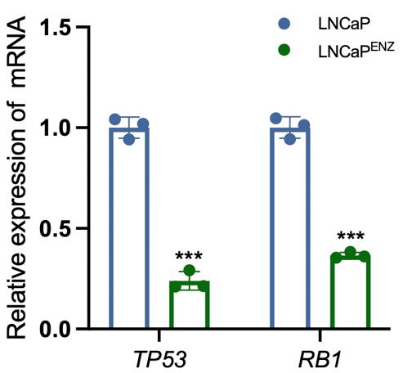
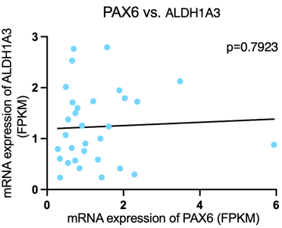
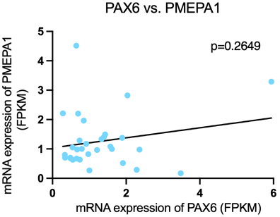
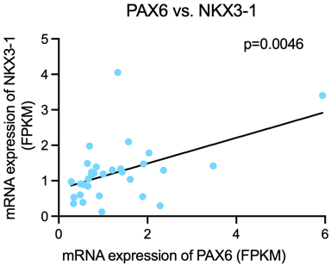
Response Fig. 1 The mRNA expression level of TP53 and RB1 was downregulated in LNCaP^{ENZ} cell compared to control.
Response Fig. 2 Correlation analysis of PAX6 with AR associated genes based on the Broad/Cornell 2012 cohort.

