Table S8. The binding sequence of HP1α and different histone marks.

Number | Motif (H3K27ac) | Sites | Width | E-value
1 | 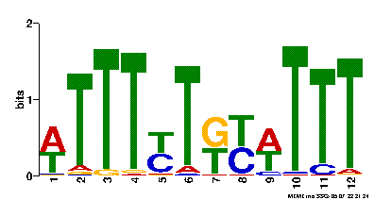 | 412 | 12 | 1.2e-323
2 | 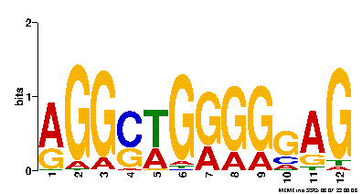 | 599 | 12 | 7.8e-256
3 | 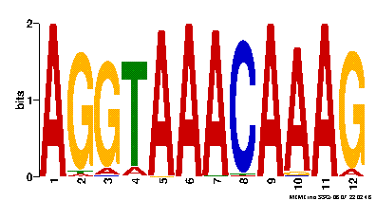 | 109 | 12 | 3.2e-205
4 | 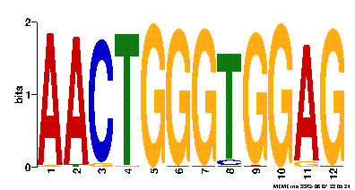 | 111 | 12 | 6.4e-208
5 | 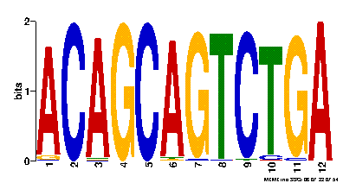 | 107 | 12 | 2.3e-201
6 | 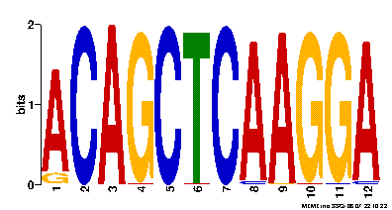 | 98 | 12 | 2.7e-191

Number | Motif (H3K27me3) | Sites | Width | E-value
1 | 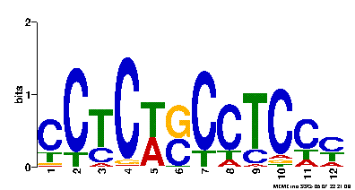 | 576 | 12 | 2.2e-61
2 | 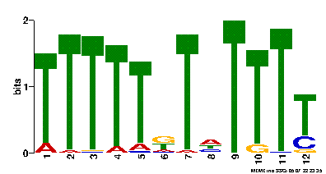 | 133 | 12 | 3.7e-54
3 | 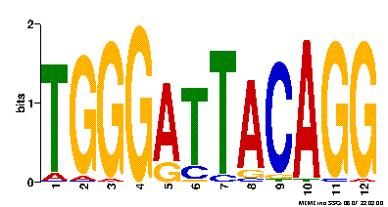 | 67 | 12 | 5.9e-37
4 | 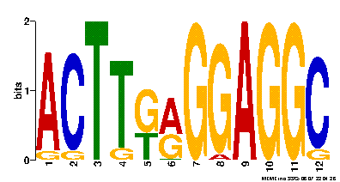 | 55 | 12 | 3.3e-25
5 | 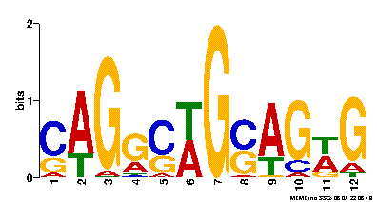 | 489 | 12 | 2.6e-17
6 |  | 38 | 12 | 3.0e-3

Number | Motif (H3K4me3) | Sites | Width | E-value
1 | 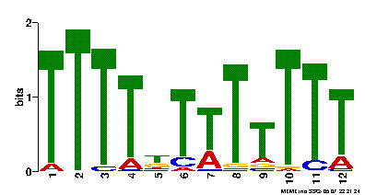 | 343 | 12 | 1.1e-185
2 | 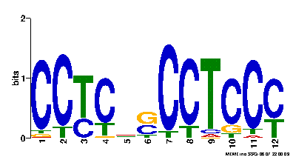 | 513 | 12 | 7.7e-155
3 | 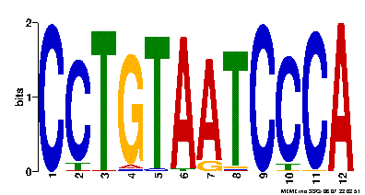 | 79 | 12 | 1.1e-103
4 | 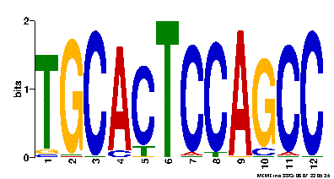 | 60 | 12 | 3.5e-51
5 | 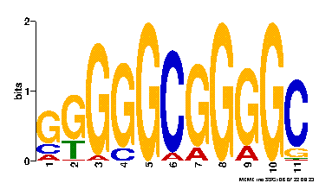 | 139 | 11 | 9.4e-44
6 | 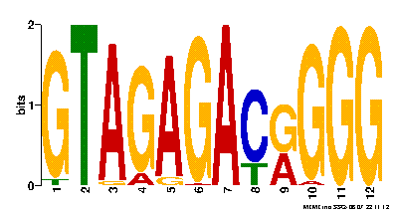 | 55 | 12 | 2.5e-42

Number | Motif (H3K9ac) | Sites | Width | E-value
1 | 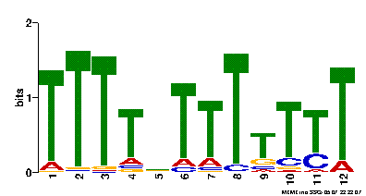 | 495 | 12 | 7.8e-362
2 | 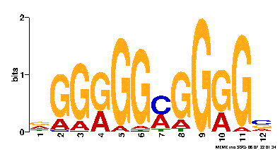 | 594 | 12 | 5.5e-165
3 | 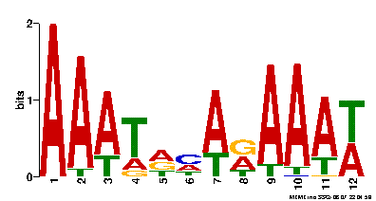 | 320 | 12 | 7.5e-99
4 | 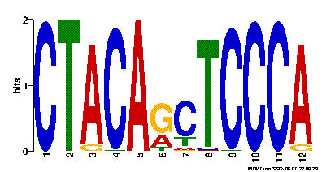 | 73 | 12 | 3.6e-68
5 | 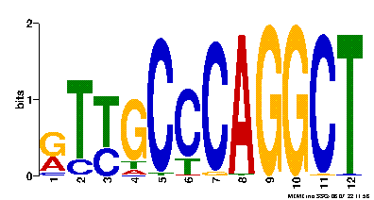 | 111 | 12 | 2.3e-57
6 | 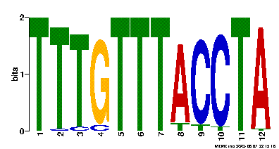 | 41 | 12 | 3.8e-53

Number | Motif (H3K9me3) | Sites | Width | E-value
1 | 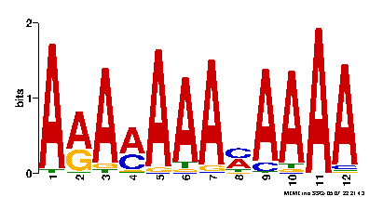 | 390 | 12 | 4.8e-498
2 | 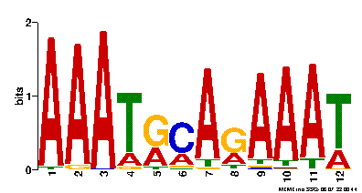 | 338 | 12 | 5.5e-321
3 | 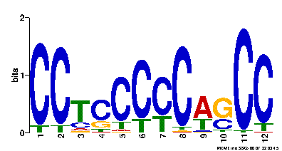 | 600 | 12 | 4.2e-275
4 | 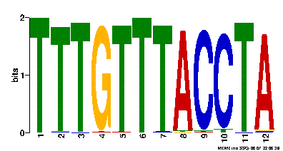 | 113 | 12 | 1.7e-259
5 | 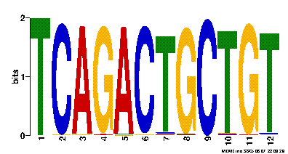 | 117 | 12 | 2.8e-238
6 | 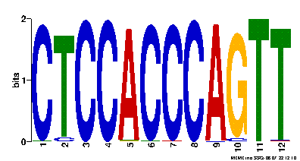 | 114 | 12 | 3.1e-237

Number | Motif (HP1α) | Sites | Width | E-value
1 | 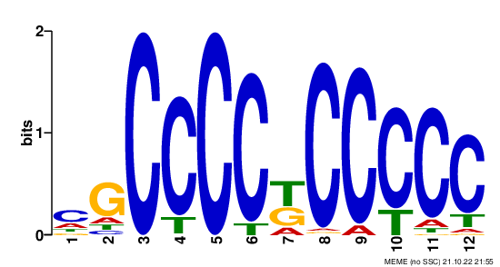 | 275 | 12 | 6.0e-148
2 | 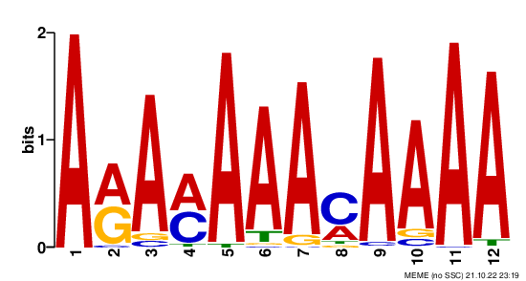 | 188 | 12 | 1.3e-137
3 | 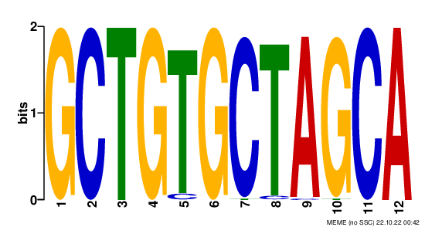 | 67 | 12 | 3.1e-126
4 |  | 67 | 12 | 7.8e-126
5 | 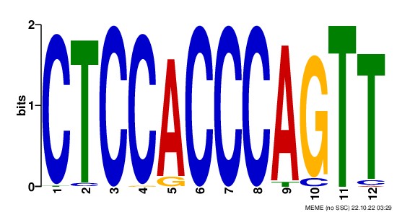 | 72 | 12 | 1.9e-119
6 | 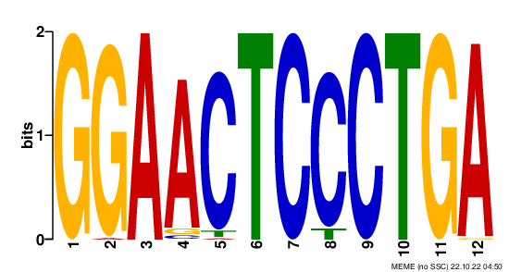 | 68 | 12 | 3.1e-237

