Supplementary information
This file includes:
Supplementary Tables and Unprocessed original images of gels in this article
1. Supplementary Tables
Table S1. The information of reagents employed in present study.
Table S2. Specific sequences of lentiviral shRNA and siRNA employed in the present study.
Table S3. Target gene symbols and corresponding primer sequences of qRT-PCR.
Table S4. The list of Immune checkpoints employed for analysis in Figure 1A.
Table S5. CGGA, TCGA and CMU sample information.
Table S6. Correlation analysis of immune checkpoints and type I, type II IFN signaling activation in GBM (CGGA: n = 144; TCGA: n = 168; and CMU dataset: n = 208).
Table S7. Potential transcription factor binding sites for p65 in CXCL1 promoter predicted by JASPAR.
Table S8. Potential transcription factor binding sites for p65 in CXCL5 promoter predicted by JASPAR.

Table S1. The information of reagents employed in present study.
REAGENT or RESOURCE |  | SOURCE |  |  | IDENTIFIER
Antibodies
IF: GFAP |  | Proteintech |  |  | 16825-1-AP
IF: PDL1 |  | Abcam |  |  | #ab213480
IF&WB: TNFRSF14 |  | Abcam |  |  | #ab62462  #ab47677
IF&WB: FAK |  | Cellsignalingtech. |  |  | #71433
WB: β-ACTIN |  | Abcam |  |  | #ab8226
WB: Phospho-FAK (Tyr397) |  | Cellsignalingtech. |  |  | #8556
WB: Phospho-NF-κB p65 (Ser536) |  | Cellsignalingtech. |  |  | #3033
WB&IF: NF-κB p65 |  | Cellsignalingtech. |  |  | #8242
WB: FLAG |  | Cellsignalingtech. |  |  | #14793
WB: p-IKBα |  | Cellsignalingtech. |  |  | #9246
WB: IKBα |  | Cellsignalingtech. |  |  | #4814
WB: MYC |  | Proteintech |  |  | 16286-1-AP
WB: GST |  | Proteintech |  |  | HRP-66001
WB: HIS |  | Proteintech |  |  | 66005-1-Ig
WB: GAPDH |  | Proteintech |  |  | 60004-1-Ig
WB: HistoneH3 |  | Proteintech |  |  | 68345-1-Ig
WB&IHC: IFN-gamma |  | ebioscience |  |  | MM700B
IHC: CXCL5 |  | ebioscience |  |  | PA5-115069
IHC: CXCL1 |  | Proteintech |  |  | 12335-1-AP
IHC: CD8 |  | Proteintech |  |  | 66868-1-Ig
IHC: ki67 |  | Proteintech |  |  | 27309-1-AP
IHC: CD3 |  | Proteintech |  |  | 17617-1-AP
IHC: IBA1 |  | Abcam |  |  | #ab178846
IHC: CD86 |  | Abcam |  |  | #ab220188
IHC: CD206 |  | Proteintech |  |  | 60143-1-Ig
IHC: Perforin |  | Cellsignalingtech. |  |  | #31647
Flow: CD45 |  | BD Pharmingen |  |  | #563891
Flow: CD11b |  | BD Pharmingen |  |  | #557000
Flow: F4/80 |  | BD Pharmingen |  |  | #565411
Flow: MHCII |  | BD Pharmingen |  |  | #557000
Flow: CD206 |  | R&D Systems |  |  | FAB25351R
Flow: CD3e |  | BD Pharmingen |  |  | #551163
Flow: CD4 |  | BD Pharmingen |  |  | #552051
Flow: CD8a |  | BD Pharmingen |  |  | #553030
Flow: IFN-γ |  | BD Pharmingen |  |  | #554412
Flow: TNF-α |  | BD Pharmingen |  |  | #554420
In vivo: TNFRSF14 |  | ebioscience |  |  | 16-5962-38
In vivo: PDL1 |  | BioXcell |  |  | BE0101
Biological samples
Individual human glioma tissue samples |  | China medical University |  |  | NA
Chemicals, Peptides, and Recombinant Proteins
Defactinib |  | MedChemExpress |  |  | HY-12289
DAPI |  | Solarbio |  |  | C0060
Recombinant IFN-γ |  | Proteintech |  |  | HZ-1301

Table S2. Specific sequences of lentiviral shRNA and siRNA employed in the present study.
Species | NO. | Sequences | GC%
Human | TNFRSF14-RNAi(sh#1) | tgGAGGAGACAATACCCTCAT | 47.37%
Human | TNFRSF14-RNAi(sh#2) | gcTGGTGCTGTATCTCACCTT | 47.37%
Mouse | Tnfrsf14-RNAi(sh#1) | gcATTTCAACAGGAAGTAAGA | 31.58%
Mouse | Tnfrsf14-RNAi(sh#2) | ccACAGACATATACCGCCCAT | 47.37%
Human | si-FAK-1 | GAUGUUGGUUUAAAGCGAUUUTT | 30.43%
Human | si-FAK-2 | CAACAGGUGAAGAGCGAUUAUTT | 39.13%

Table S3. Target gene symbols and primer sequences of qRT-PCR.
Gene |  | Primer sequence
Human TNFRSF14 | Forward | TTCTCTCAGGGAGCCTCGTCAT
 | Reverse | CTCACCTTCTGCCTCCTGTCTT
Mouse TNFRSF14 | Forward | CCAGGCTACTTCTGTGAGAACC
 | Reverse | CAGTCAGCACATACAGTGTCCTG
CCL2 | Forward | AGAATCACCAGCAGCAAGTGTCC
 | Reverse | TCCTGAACCCACTTCTGCTTGG
CCL3 | Forward | ACTTTGAGACGAGCAGCCAGTG
 | Reverse | TTTCTGGACCCACTCCTCACTG
CCL4 | Forward | GCTTCCTCGCAACTTTGTGGTAG
 | Reverse | GGTCATACACGTACTCCTGGAC
CXCL1 | Forward | AGCTTGCCTCAATCCTGCATCC
 | Reverse | TCCTTCAGGAACAGCCACCAGT
CXCL10 | Forward | GGTGAGAAGAGATGTCTGAATCC
 | Reverse | GTCCATCCTTGGAAGCACTGCA
IL8 | Forward | GAGAGTGATTGAGAGTGGACCAC
 | Reverse | CACAACCCTCTGCACCCAGTTT
CXCL5 | Forward | CAGACCACGCAAGGAGTTCATC
 | Reverse | TTCCTTCCCGTTCTTCAGGGAG
CXCL7 | Forward | TGCTCTGGCTTCCTCCACCAAA
 | Reverse | ACACATGCAGCGGAGTTCAGCA
CXCL16 | Forward | CCTATGTGCTGTGCAAGAGGAG
 | Reverse | CTGGGCAACATAGAGTCCGTCT
Human CD80 | Forward | CTCTTGGTGCTGGCTGGTCTTT
 | Reverse | GCCAGTAGATGCGAGTTTGTGC
Human iNOS | Forward | GCTCTACACCTCCAATGTGACC
 | Reverse | CTGCCGAGATTTGAGCCTCATG
Human IL-6 | Forward | AGACAGCCACTCACCTCTTCAG
 | Reverse | TTCTGCCAGTGCCTCTTTGCTG
Human CD163 | Forward | CCAGAAGGAACTTGTAGCCACAG
 | Reverse | CAGGCACCAAGCGTTTTGAGCT
Human CD206 | Forward | AGCCAACACCAGCTCCTCAAGA
 | Reverse | CAAAACGCTCGCGCATTGTCCA
Human 18S | Forward | ACCCGTTGAACCCCATTCGTGA
 | Reverse | GCCTCACTAAACCATCCAATCGG
Mouse CD80 | Forward | CCTCAAGTTTCCATGTCCAAGGC
 | Reverse | GAGGAGAGTTGTAACGGCAAGG
Mouse CD86 | Forward | ACGTATTGGAAGGAGATTACAGCT
 | Reverse | TCTGTCAGCGTTACTATCCCGC
Mouse IL-1beta | Forward | TGGACCTTCCAGGATGAGGACA
 | Reverse | GTTCATCTCGGAGCCTGTAGTG
Mouse CD163 | Forward | GGCTAGACGAAGTCATCTGCAC
 | Reverse | CTTCGTTGGTCAGCCTCAGAGA
Mouse CD206 | Forward | GTTCACCTGGAGTGATGGTTCTC
 | Reverse | AGGACATGCCAGGGTCACCTTT
Mouse GAPDH | Forward | CATCACTGCCACCCAGAAGACTG
 | Reverse | ATGCCAGTGAGCTTCCCGTTCAG

Table S4. The list of Immune checkpoints employed for analysis in Figure 1A.
No. | Immune checkpoints |  | No. | Immune checkpoints |  | No. | Immune checkpoints
1 | BTLA |  | 24 | CD86 |  | 47 | TNFRSF10C
2 | BTN1A1 |  | 25 | CD96 |  | 48 | TNFRSF10D
3 | BTN2A1 |  | 26 | CRTAM |  | 49 | TNFRSF11A
4 | BTN2A2 |  | 27 | CTLA4 |  | 50 | TNFRSF11B
5 | BTN2A3P |  | 28 | HAVCR1 |  | 51 | TNFRSF12A
6 | BTN3A1 |  | 29 | HAVCR2 |  | 52 | TNFRSF13B
7 | BTN3A2 |  | 30 | HHLA2 |  | 53 | TNFRSF13C
8 | BTN3A3 |  | 31 | ICOS |  | 54 | TNFRSF14
9 | BTNL2 |  | 32 | LGALS9 |  | 55 | TNFRSF17
10 | BTNL3 |  | 33 | LTA |  | 56 | TNFRSF18
11 | BTNL8 |  | 34 | LY9 |  | 57 | TNFRSF19
12 | BTNL9 |  | 35 | NCR3LG1 |  | 58 | TNFRSF1A
13 | CD160 |  | 36 | PDCD1 |  | 59 | TNFRSF1B
14 | CD226 |  | 37 | PDCD1LG2 |  | 60 | TNFRSF21
15 | CD244 |  | 38 | PVR |  | 61 | TNFRSF25
16 | CD27 |  | 39 | RTEL1-TNFRSF6B |  | 62 | TNFRSF4
17 | CD274 |  | 40 | SLAMF1 |  | 63 | TNFRSF8
18 | CD276 |  | 41 | SLAMF6 |  | 64 | TNFRSF9
19 | CD28 |  | 42 | SLAMF8 |  | 65 | TNFSF14
20 | CD40 |  | 43 | SLAMF9 |  | 66 | TNFSF4
21 | CD48 |  | 44 | TIGIT |  | 67 | VTCN1
22 | CD80 |  | 45 | TNFRSF10A
23 | CD84 |  | 46 | TNFRSF10B

Table S5. CGGA, TCGA and CMU sample information.
Database |  | CGGA | TCGA | CMU
Sequencing platform |  | Illumina Hiseq 2000 RNAseq | Illumina Hiseq 2000 RNAseq | Illumina Hiseq 2000 RNAseq
Total |  | 325 | 699 | 290
Age | Average (range) | 43.32（8-81） | 47.34 (14-89) | 68.7(21-84)
 | NA | 0 | 63 | 102
Sex | Male | 233 | 268 | 115
 | Female | 122 | 368 | 73
 | NA | 0 | 63 | 102
KPS score | Average (range) | 76.25  （20-100） | 84.29  (40-100) | 67.5  (0-100)
 | NA | 0 | 305 | 102
Primary/  recurrent | Primary | 241 | 619 | 130
Primary/  recurrent | Recurrent | 84 | 0 | 58
 | NA | 0 | 80 | 102
Grade | II | 109 | 223 | 68
 | III | 72 | 245 | 14
 | GBM | 144 | 168 | 208
 | NA | 0 | 63 | 0
IDH (GBM) | Wild | 96 | 149 | 165
 | Mutant | 32 | 12 | 10
 | NA | 16 | 7 | 115

Table S6. Correlation analysis of immune checkpoints and type I, type II IFN signaling activation in GBM (CGGA: n = 144; TCGA: n = 168; and CMU dataset: n = 208).
type I |  |  |  |  |  |  | type II
CGGA (P < 0.001) |  | TCGA (P < 0.001) |  | CMU (P < 0.001) |  |  | CGGA (P < 0.001) |  | TCGA (P < 0.001) |  | CMU (P < 0.001)
Gene | r | Gene | r | Gene | r |  | Gene | r | Gene | r | Gene | r
PDCD1LG2 | 0.6787 | BTN3A3 | 0.6872 | LGALS9 | 0.8372 |  | PDCD1LG2 | 0.7293 | CD86 | 0.6736 | CD226 | 0.7986
CD48 | 0.6682 | CD48 | 0.6750 | CD86 | 0.8268 |  | TNFRSF14 | 0.7070 | PDCD1LG2 | 0.6301 | TNFRSF14 | 0.7020
CRTAM | 0.6366 | LGALS9 | 0.6687 | CD48 | 0.8140 |  | TNFRSF1B | 0.6604 | BTN3A3 | 0.6185 | BTN2A2 | 0.6796
HAVCR2 | 0.6308 | BTN3A1 | 0.6677 | HAVCR2 | 0.7964 |  | HAVCR2 | 0.6200 | HAVCR2 | 0.6182 | TNFRSF1A | 0.6615
CD27 | 0.6299 | CD86 | 0.6493 | CD84 | 0.7645 |  | TNFRSF1A | 0.6178 | CD48 | 0.6178 | BTN2A1 | 0.6560
CD86 | 0.5886 | HAVCR2 | 0.6173 | SLAMF6 | 0.7279 |  | SLAMF8 | 0.6153 | BTN3A1 | 0.5999 | TNFRSF1B | 0.6446
TNFRSF14 | 0.5769 | CD80 | 0.6170 | CD96 | 0.7108 |  | CD86 | 0.6122 | TNFRSF14 | 0.5923 | CD48 | 0.6020
PDCD1 | 0.5734 | BTN3A2 | 0.5757 | ICOS | 0.6966 |  | CD48 | 0.6059 | LGALS9 | 0.5919 | TNFRSF10B | 0.5801
TNFRSF1B | 0.5693 | PDCD1LG2 | 0.5696 | TNFRSF1B | 0.6817 |  | PVRL2 | 0.5872 | TNFRSF1A | 0.5796 | TNFRSF12A | 0.5632
ICOS | 0.5568 | TNFRSF14 | 0.5666 | LY9 | 0.6790 |  | PDCD1 | 0.5715 | CD80 | 0.5708 | SLAMF1 | 0.5554
CD96 | 0.5483 | C10orf54 | 0.5042 | SLAMF1 | 0.6743 |  | TNFRSF12A | 0.5705 | BTN3A2 | 0.5614 | TNFRSF10A | 0.5536
LGALS9 | 0.5325 | CRTAM | 0.4896 | TNFRSF14 | 0.6735 |  | TNFRSF10A | 0.5595 | TNFRSF1B | 0.5564 | SLAMF8 | 0.5462
SLAMF8 | 0.5302 | CD96 | 0.4881 | CTLA4 | 0.6367 |  | CD40 | 0.5526 | SLAMF8 | 0.5077 | CRTAM | 0.5417
BTN3A2 | 0.5232 | TNFRSF1B | 0.4652 | ISG20 | 0.6292 |  | CD27 | 0.5358 | C10orf54 | 0.4870 | CTLA4 | 0.5284
CD80 | 0.5064 | ICOS | 0.4501 | BTN3A3 | 0.6150 |  | CRTAM | 0.5313 | CD96 | 0.4832 | CD80 | 0.5251
BTN3A3 | 0.4977 | SLAMF8 | 0.4453 | TIGIT | 0.6121 |  | CD226 | 0.5169 | CRTAM | 0.4806 | TNFRSF21 | 0.4966
CD244 | 0.4616 | CD40 | 0.4440 | CD80 | 0.5769 |  | BTN3A2 | 0.5164 | CD40 | 0.4747 | BTN3A1 | 0.4313
TNFRSF1A | 0.4496 | SLAMF6 | 0.4430 | PDCD1LG2 | 0.5705 |  | CD96 | 0.5108 | SLAMF6 | 0.4610 | CD40 | 0.4189
CD226 | 0.4478 | CD27 | 0.4109 | BTN2A2 | 0.5550 |  | ICOS | 0.4895 | CD226 | 0.4438 | TIGIT | 0.4078
SLAMF1 | 0.4426 | CD244 | 0.4105 | IRF9 | 0.5541 |  | TNFRSF10C | 0.4867 | ICOS | 0.4389 | TNFRSF10C | 0.3974
TNFRSF10A | 0.4386 | SLAMF1 | 0.4101 | TNFRSF10C | 0.5191 |  | LGALS9 | 0.4812 | TNFRSF11A | 0.4215 | BTN3A2 | 0.3934
C10orf54 | 0.4377 | TNFRSF1A | 0.4068 | BTN3A2 | 0.5072 |  | CD80 | 0.4769 | SLAMF1 | 0.4159 | PDCD1LG2 | 0.3876
TIGIT | 0.4274 | LY9 | 0.3989 | PDCD1 | 0.5008 |  | LY9 | 0.4525 | TNFRSF10C | 0.4130 | TNFRSF6B | 0.3839
PVRL2 | 0.4223 | CD226 | 0.3940 | NLRC5 | 0.4897 |  | SLAMF1 | 0.4422 | TNFRSF11B | 0.3984 | CD274 | 0.3797
CD40 | 0.4198 | CD84 | 0.3766 | TNFRSF10A | 0.4824 |  | C10orf54 | 0.4215 | CD244 | 0.3945 | TNFRSF9 | 0.3748
LY9 | 0.4132 | PDCD1 | 0.3606 | IFIT5 | 0.4802 |  | CD244 | 0.3885 | LY9 | 0.3900 | CD28 | 0.3715
TNFRSF10C | 0.3601 | TIGIT | 0.3435 | CD40 | 0.4760 |  | TNFRSF10D | 0.3877 | CD27 | 0.3822 | CD27 | 0.3701
TNFRSF11A | 0.3515 | BTN2A2 | 0.3429 | CD28 | 0.4715 |  | TNFSF14 | 0.3855 | CD84 | 0.3660 | PDCD1 | 0.3564
TNFRSF17 | 0.3306 | TNFRSF11B | 0.3299 | CD27 | 0.4703 |  | TNFSF4 | 0.3701 | TNFRSF10A | 0.3437 | TNFRSF18 | 0.3490
CD28 | 0.3281 | TNFRSF11A | 0.3217 | BTN3A1 | 0.4676 |  | TNFRSF11A | 0.3633 | CD274 | 0.3400 | CD84 | 0.3486
 |  | TNFRSF10C | 0.3057 | TNFRSF1A | 0.4410 |  | BTN3A3 | 0.3491 | PVRL2 | 0.3354 | TNFRSF4 | 0.3315
 |  |  |  | SLAMF8 | 0.4309 |  | TNFRSF10B | 0.3456 | BTN2A2 | 0.3240 | TNFSF14 | 0.3238
 |  |  |  | TNFSF14 | 0.4240 |  | TNFRSF9 | 0.3439 | PDCD1 | 0.3185 | CD86 | 0.3186
 |  |  |  | CD244 | 0.4011 |  | TNFRSF18 | 0.3372 | TNFRSF6B | 0.3180
 |  |  |  | CD226 | 0.3957 |  | SLAMF9 | 0.3330 | CD28 | 0.3095
 |  |  |  | CRTAM | 0.3771 |  | TNFRSF11B | 0.3283 | TIGIT | 0.3041
 |  |  |  | TNFRSF11A | 0.3642 |  | TIGIT | 0.3257

Table S7. Potential transcription factor binding sites for p65 in CXCL1 promoter predicted by JASPAR.
Matrix ID | Name | Score | Relative score | Start-End | Strand | Predicted sequence
MA0107.1 | MA0107.1.RELA | 15.26936 | 0.999999999 | 1922-1931 | + | GGGAATTTCC
MA0107.1 | MA0107.1.RELA | 11.98946 | 0.914170511 | 1947-1956 | + | CGGGCTTTCC
MA0107.1 | MA0107.1.RELA | 8.406022 | 0.820397913 | 859-868 | + | CTGAAATTCC

Table S8. Potential transcription factor binding sites for p65 in CXCL5 promoter predicted by JASPAR.
Matrix ID | Name | Score | Relative score | Start-End | Strand | Predicted sequence
MA0107.1 | MA0107.1.RELA | 15.26936 | 0.999999999 | 1910-1919 | + | GGGAATTTCC
MA0107.1 | MA0107.1.RELA | 9.43913 | 0.8474326 | 1935-1944 | + | TTGAGTTTCC
MA0107.1 | MA0107.1.RELA | 8.563163 | 0.824510021 | 1307-1316 | + | CGGACTTACC
MA0107.1 | MA0107.1.RELA | 8.403238 | 0.820325067 | 423-432 | + | TGAAGTTTCC
MA0107.1 | MA0107.1.RELA | 7.970129 | 0.808991315 | 414-423 | + | GTGAATTTCT

2.Unprocessed original images of gels in this article
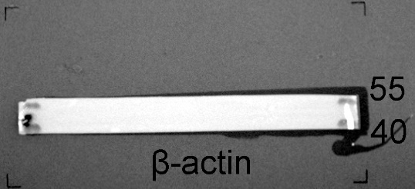
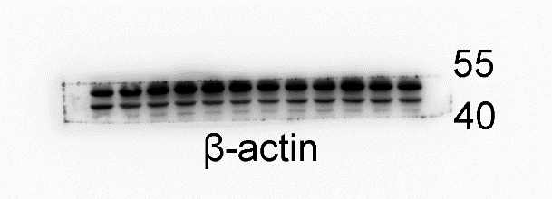
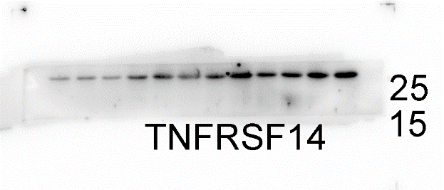
Source of Fig 1B
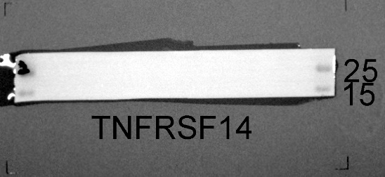
Source of Fig 1F

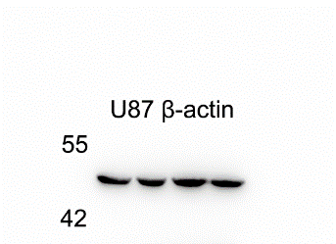
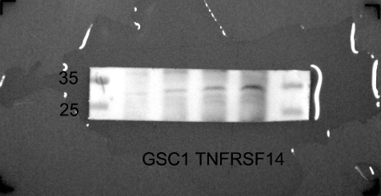
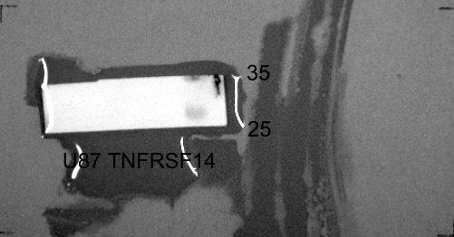
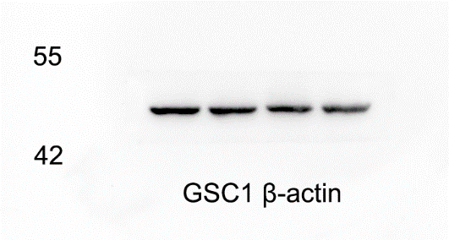
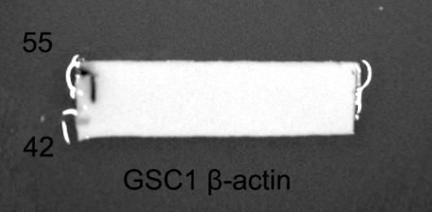
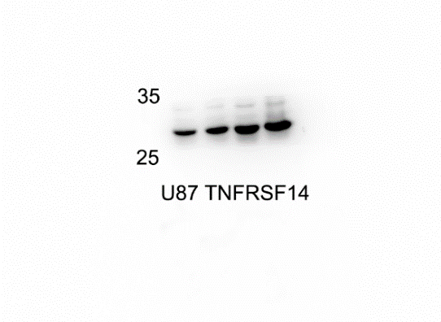

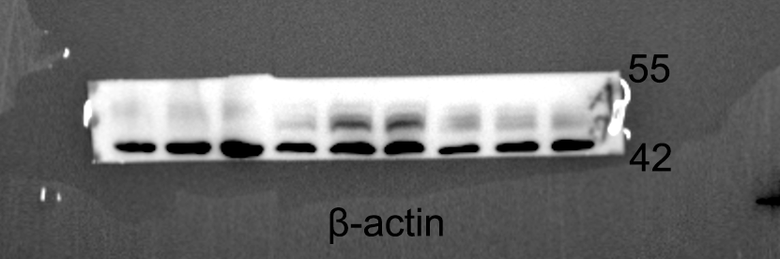
Source of Fig 1K
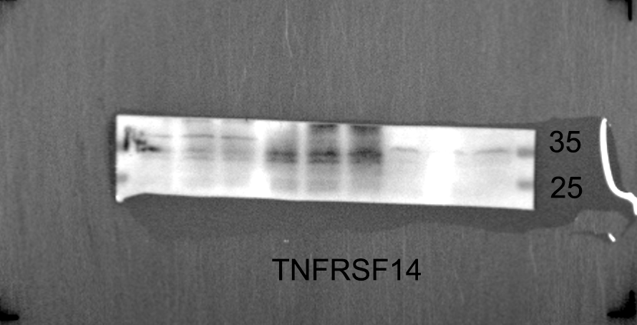

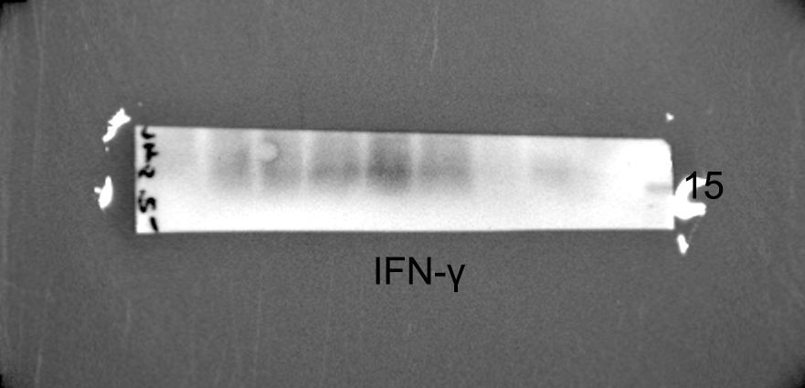
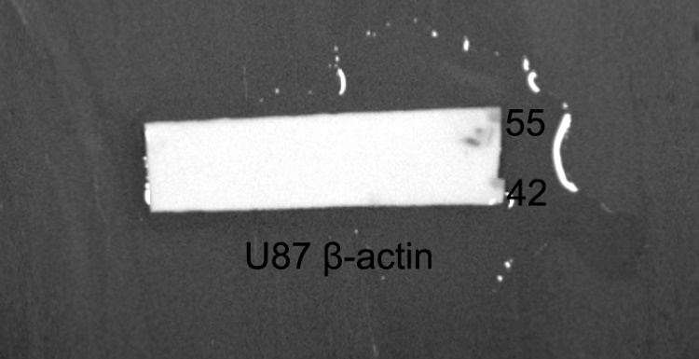
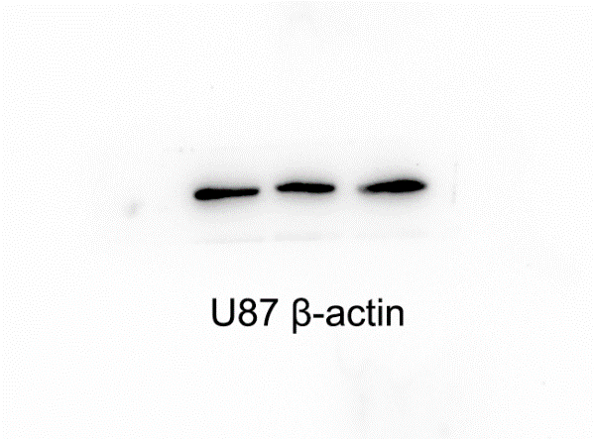
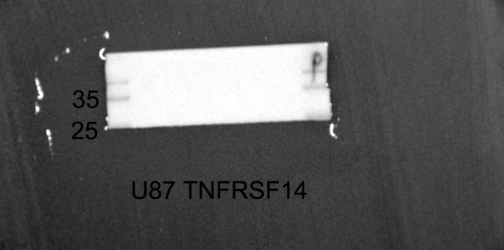
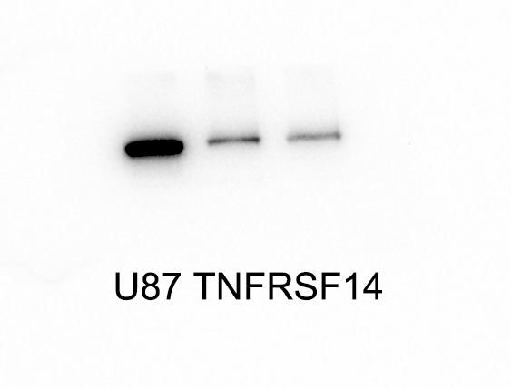
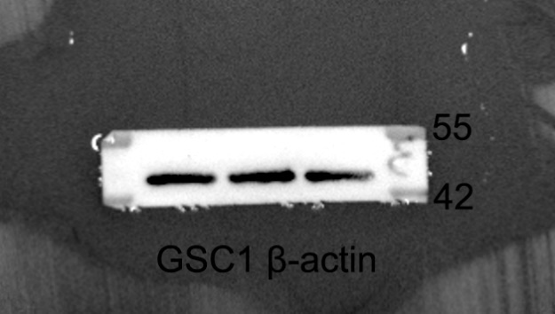
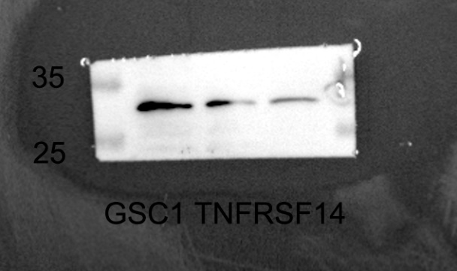
Source of Fig 2A

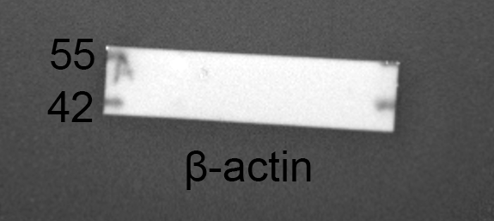
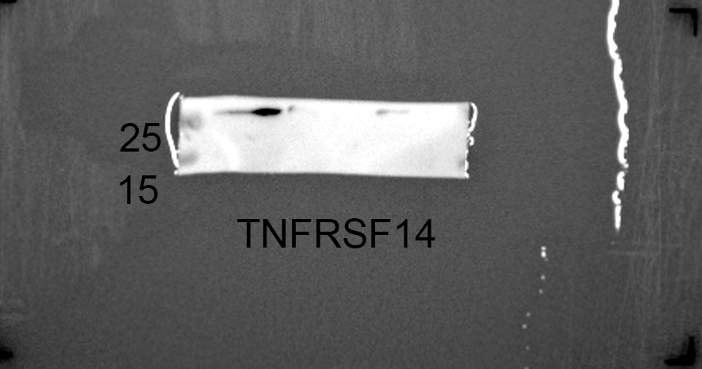
Source of Fig 2H
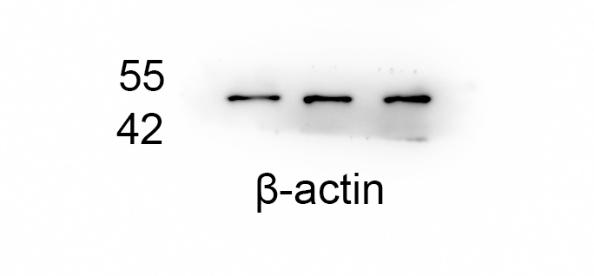
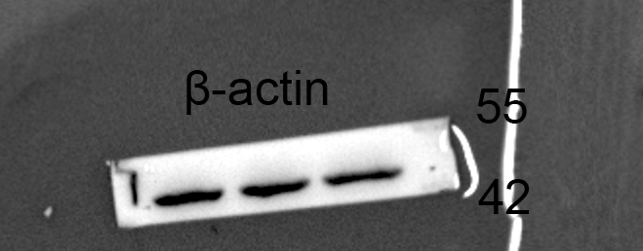
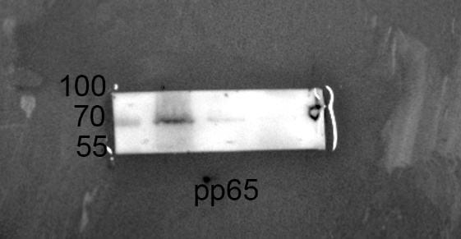
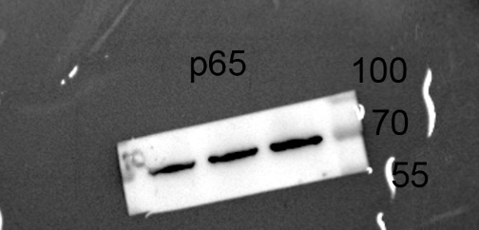
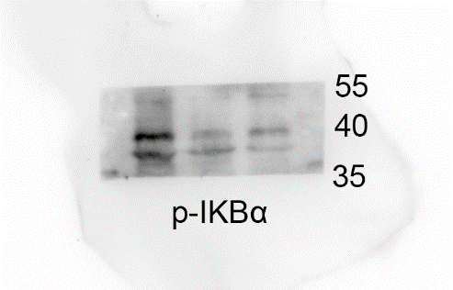
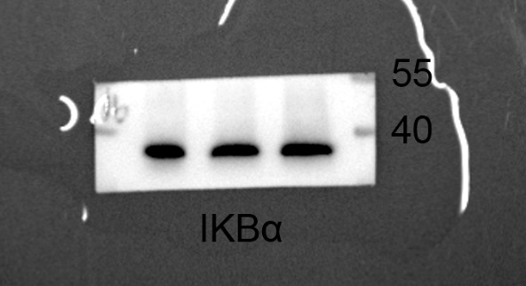
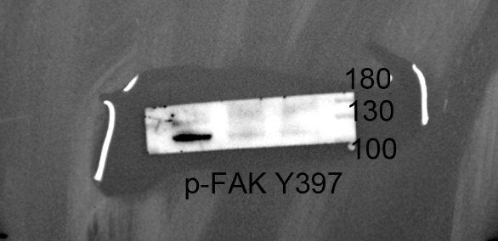
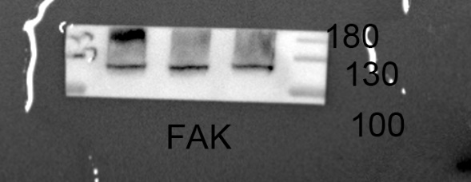
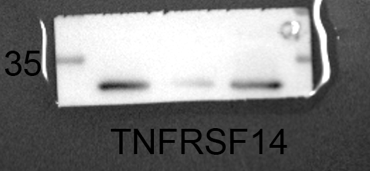
Source of Fig 4B left panel (GSC1)

Source of Fig 4B right panel (U87)
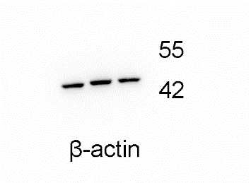
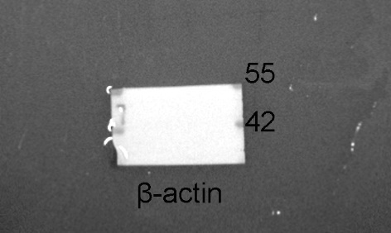
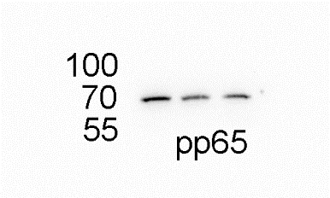
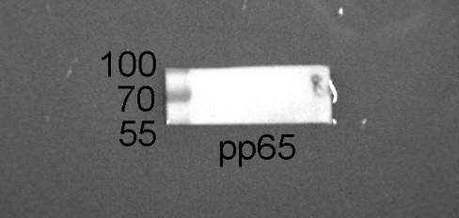
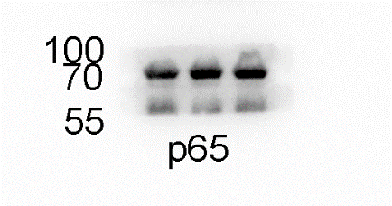
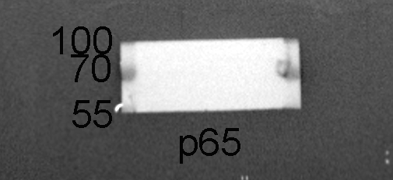
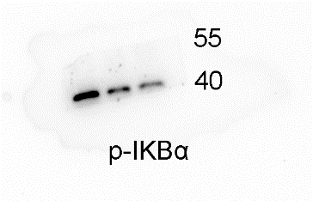
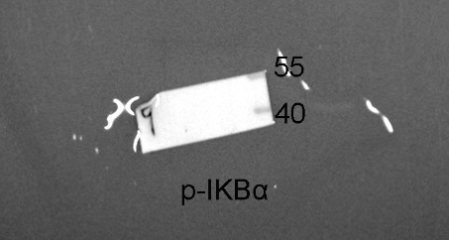
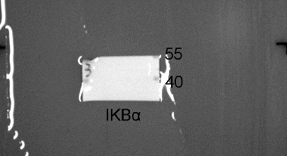
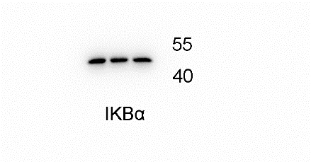
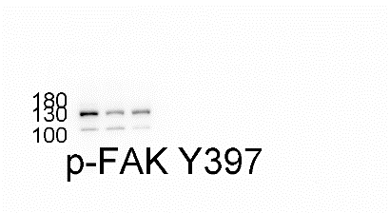
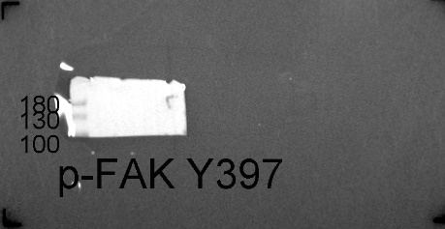
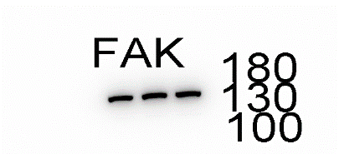
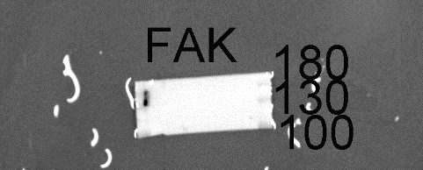
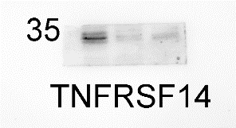
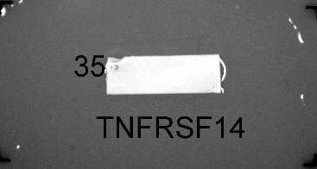
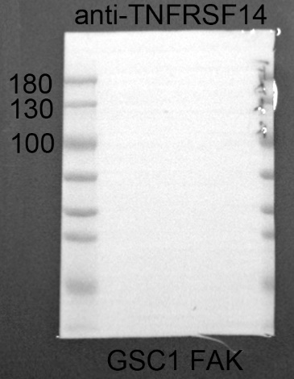
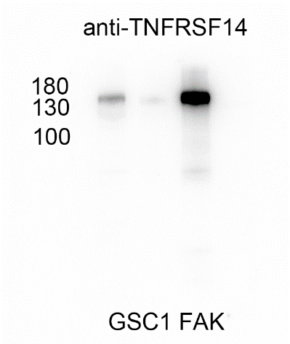
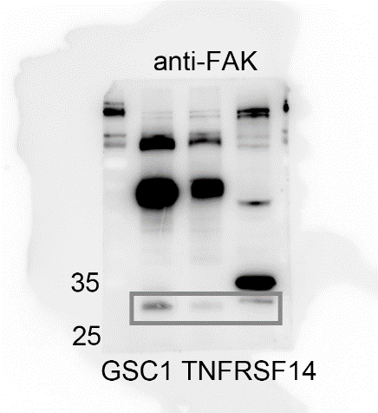
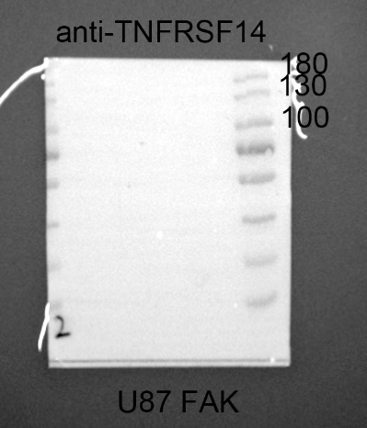
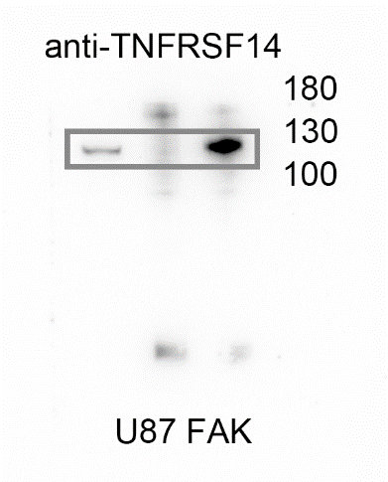
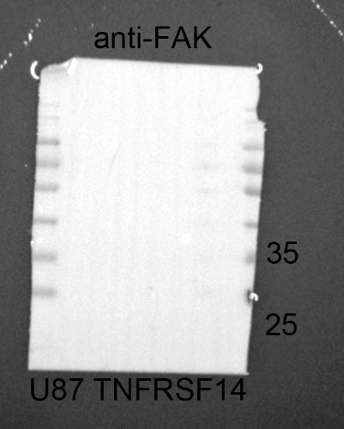
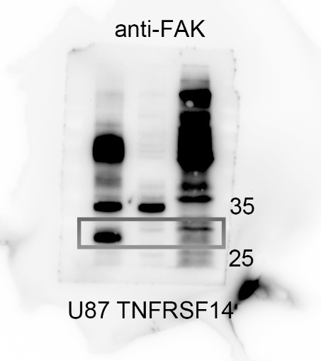
Source of Fig 4C

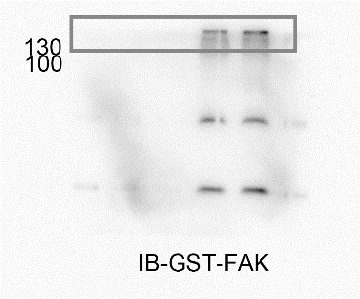
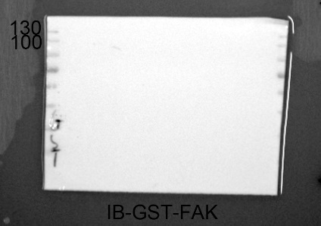
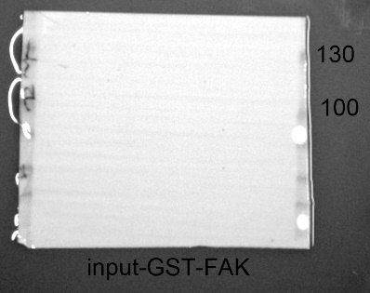
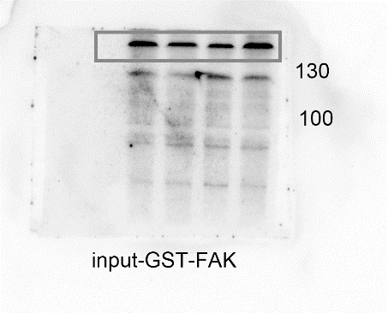
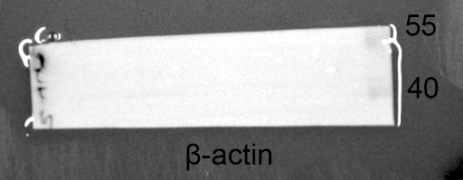
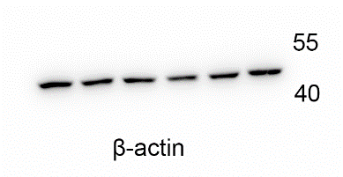
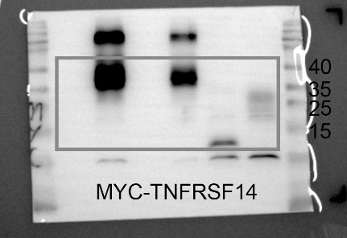
Source of Fig 4D

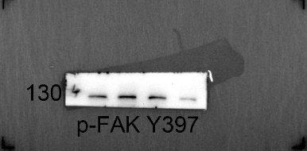
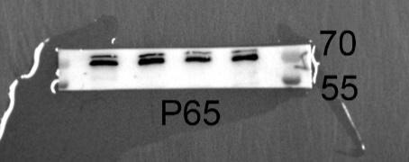
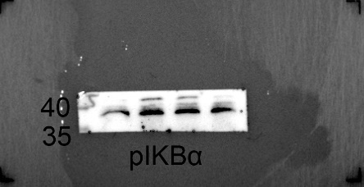
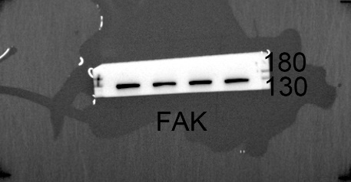
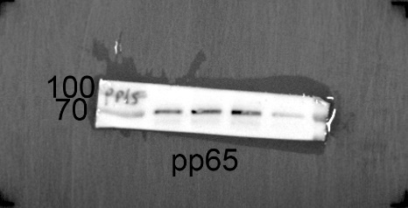
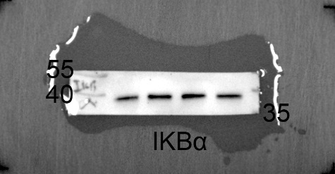
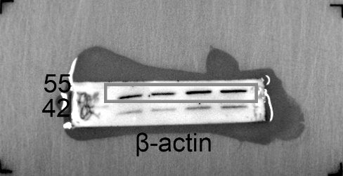
Source of Fig 4E

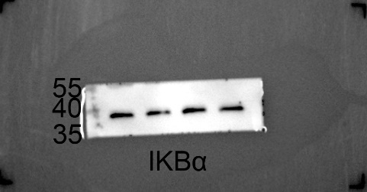
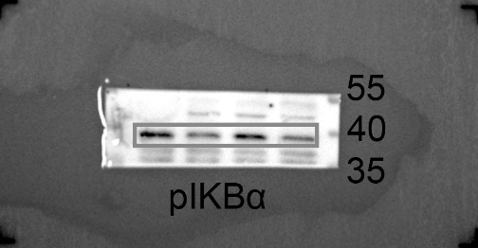
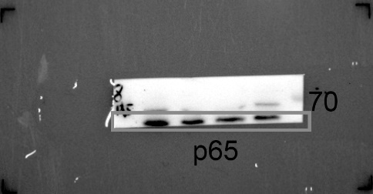
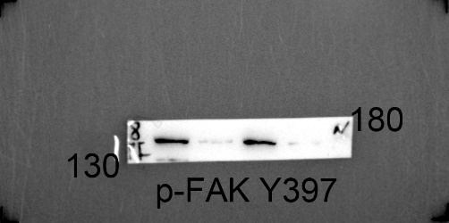
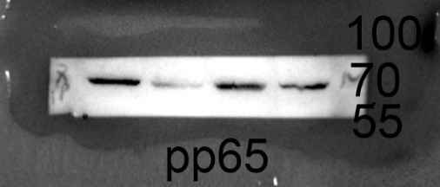
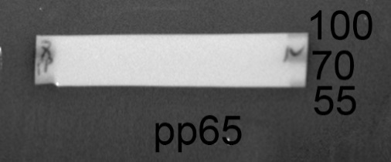
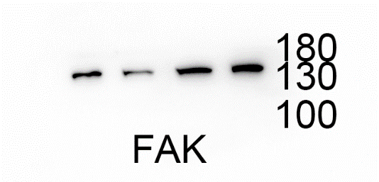
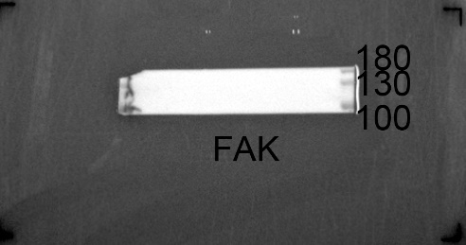
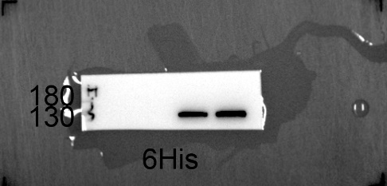
Source of Fig 4F
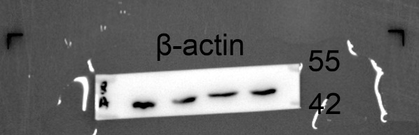
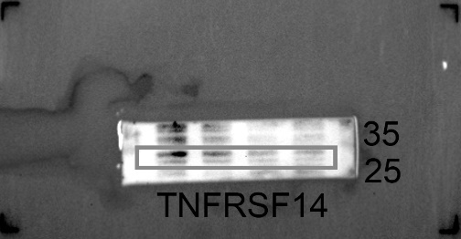
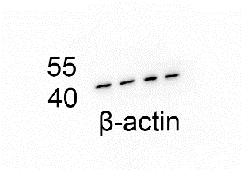
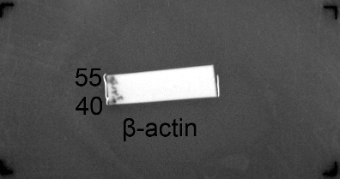
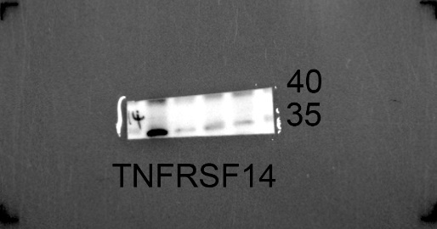
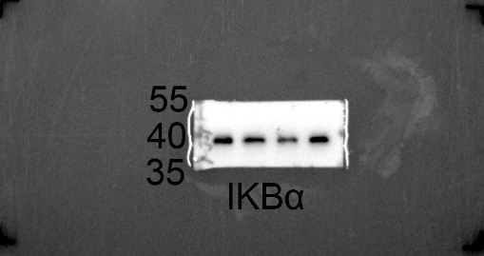
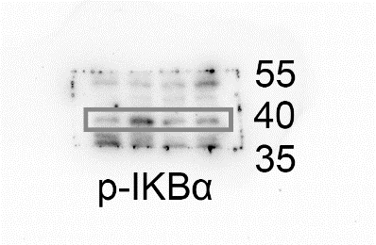
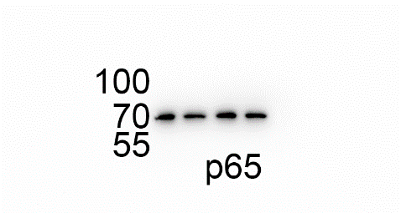
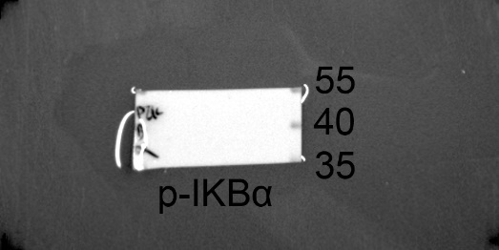
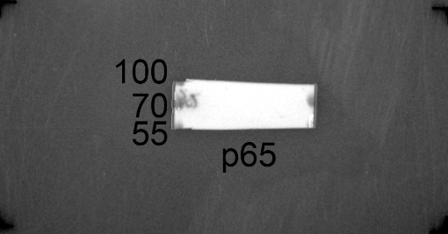
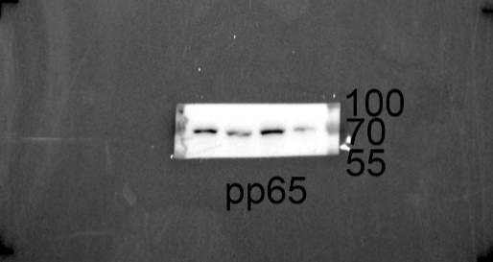
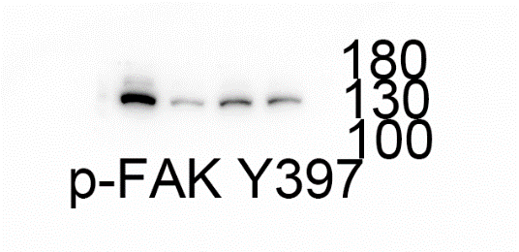
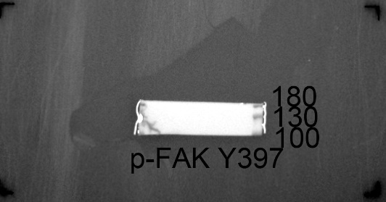
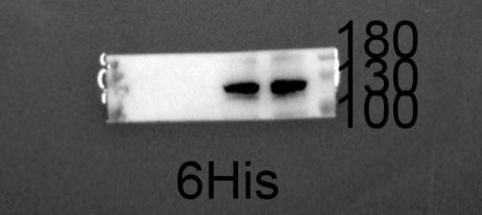
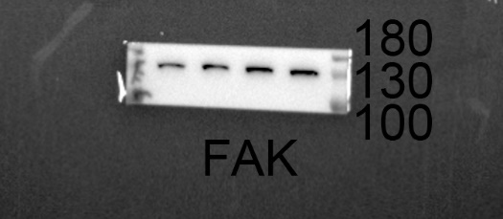
Source of Fig 4G

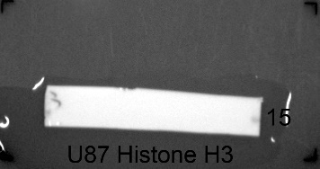
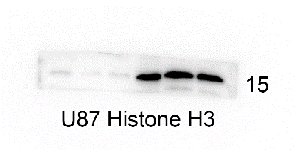
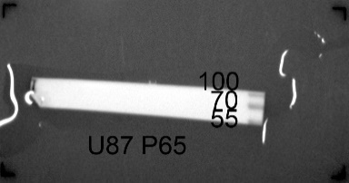
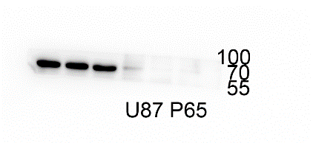
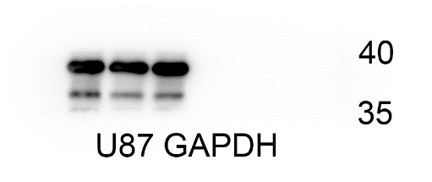
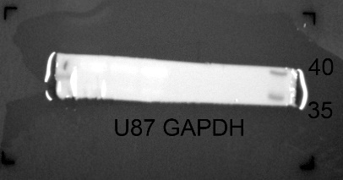
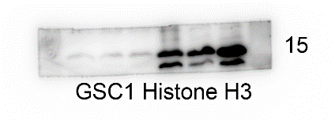
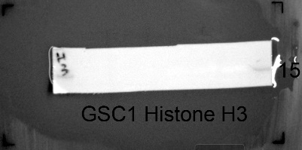
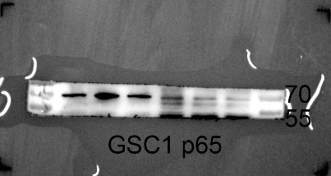
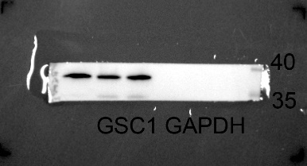
Source of Fig 4I

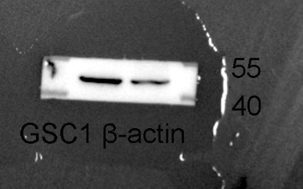
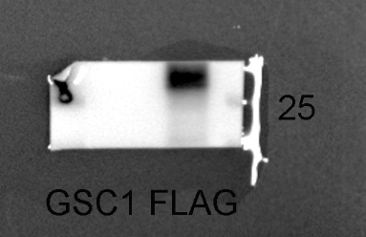
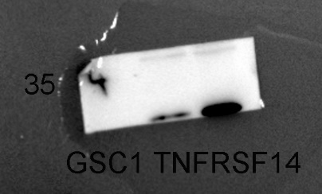
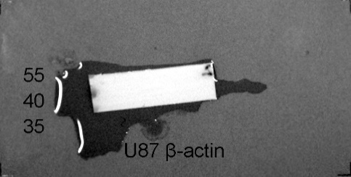
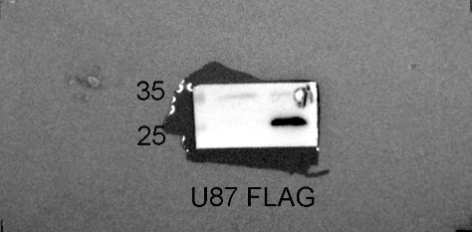
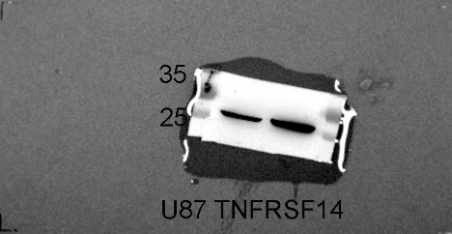
Source of Fig S2C

Source of Fig S1I
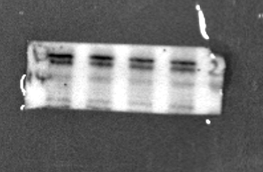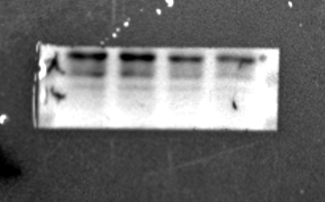
TNFRSF14 U87+IFNβ
TNFRSF14 U87+IFNα
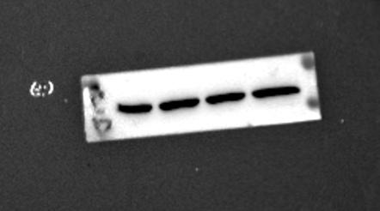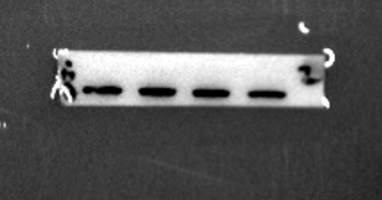
β-actin U87+IFNα
β-actin U87+IFNβ
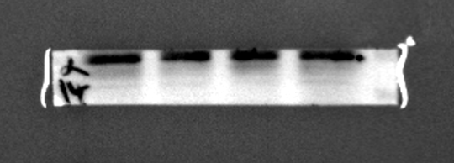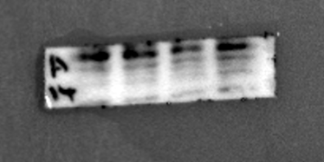
TNFRSF14 GSC1+IFNβ
TNFRSF14 GSC1+IFNα
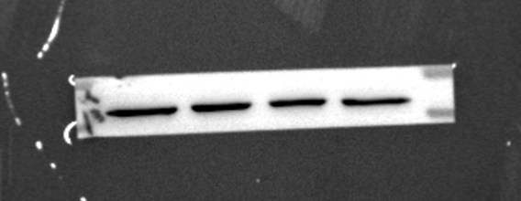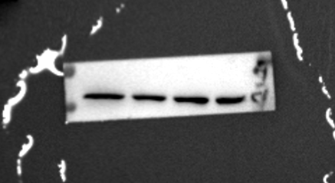
β-actin GSC1+IFNβ
β-actin GSC1+IFNα
Source of Fig S2E
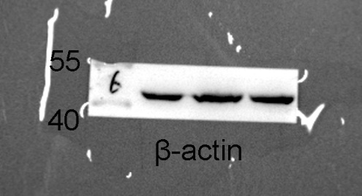
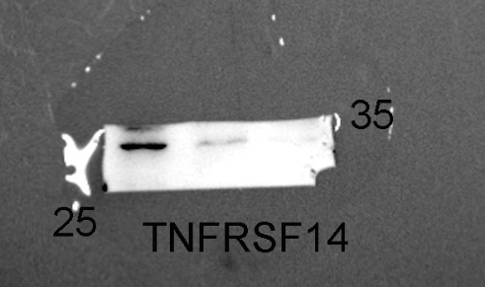
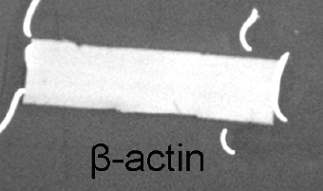
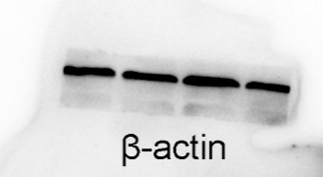
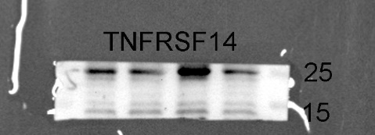
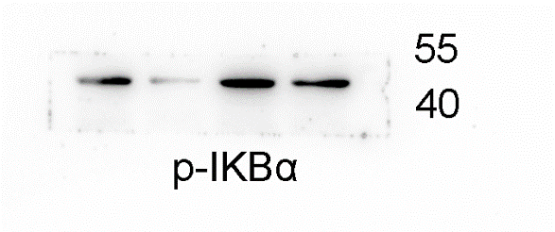
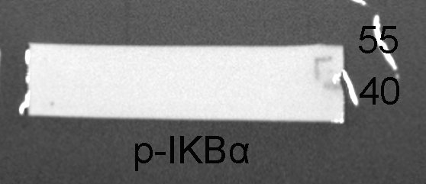
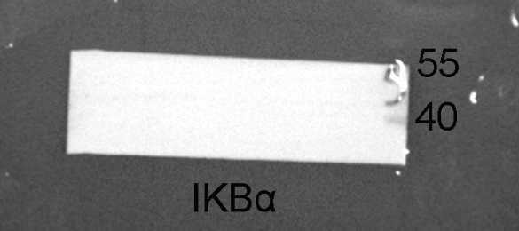
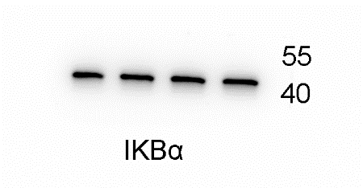
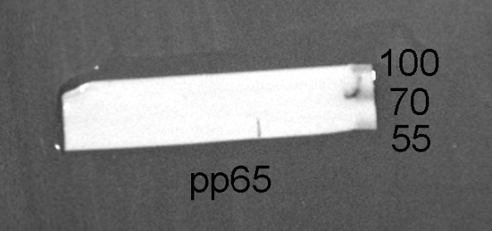
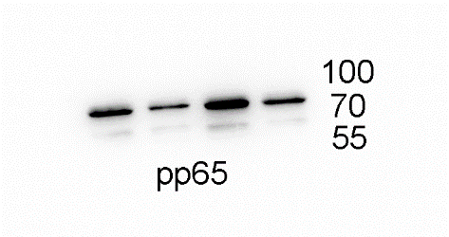
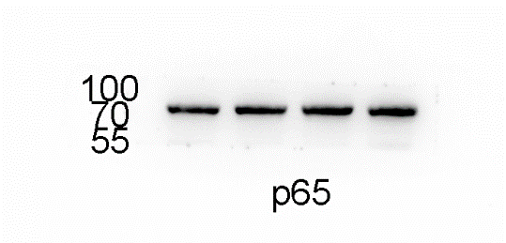
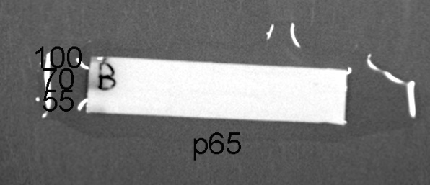
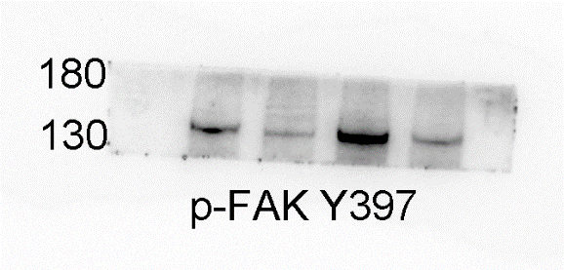
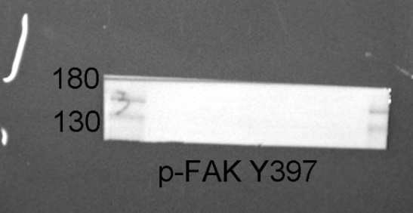
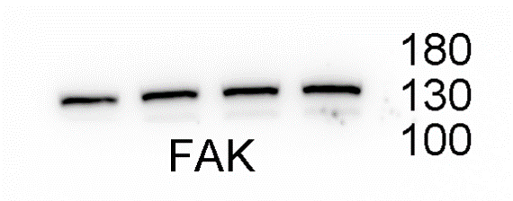
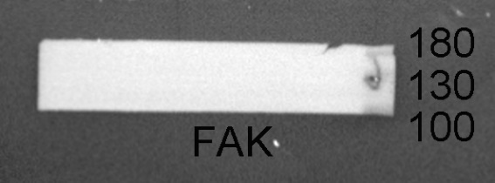
Source of Fig S4D left (GSC1)

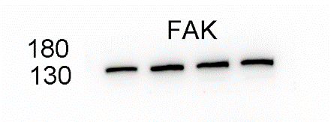
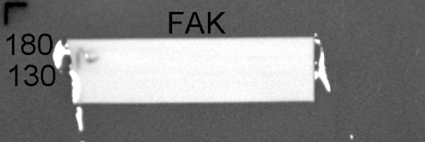
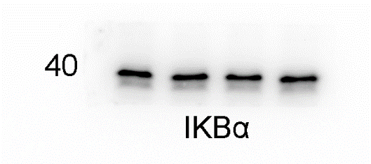
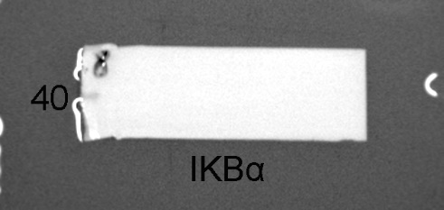
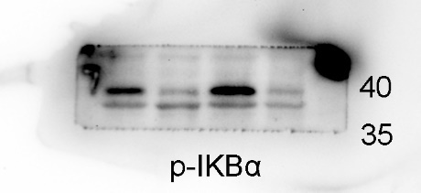
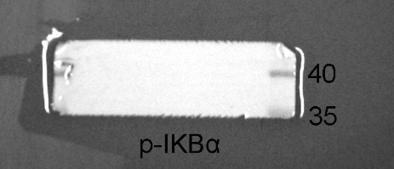
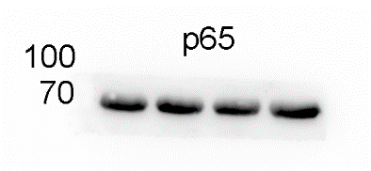
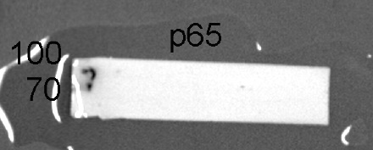
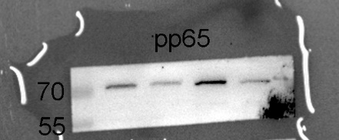
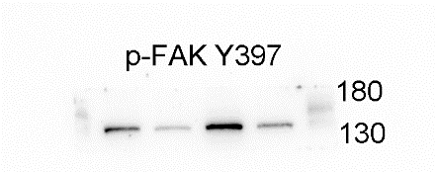
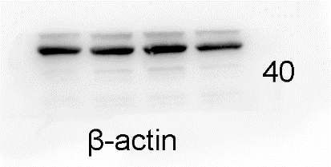
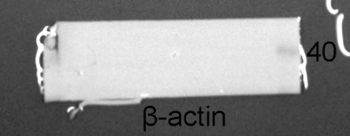
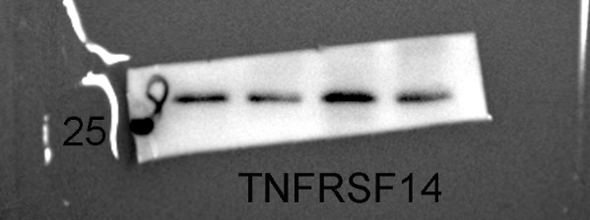
Source of Fig S4D right (U87)

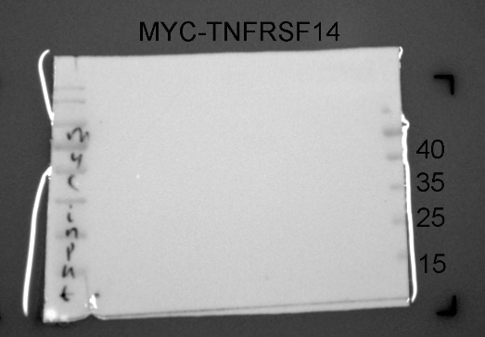
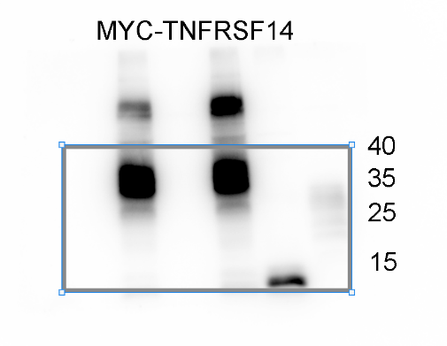
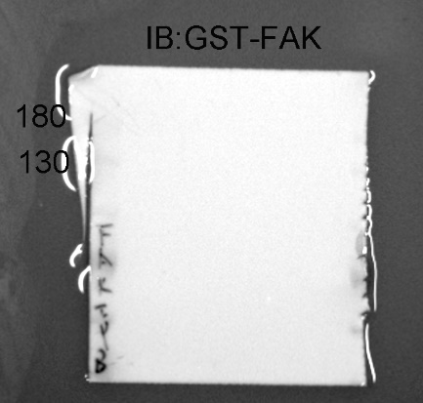
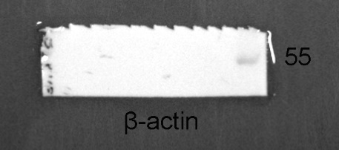
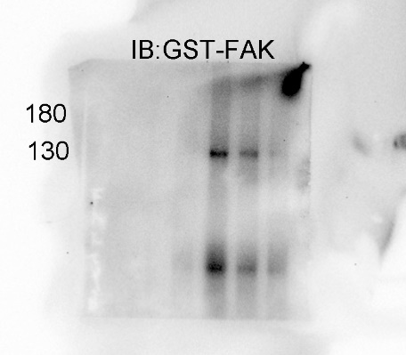
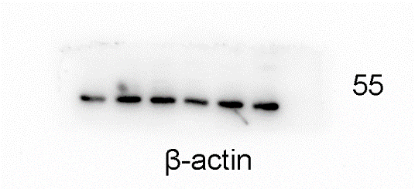
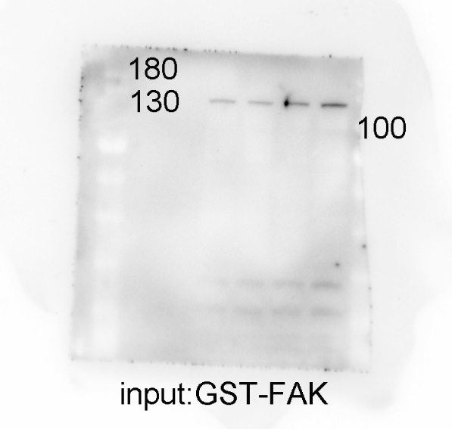
Source of Fig S4E

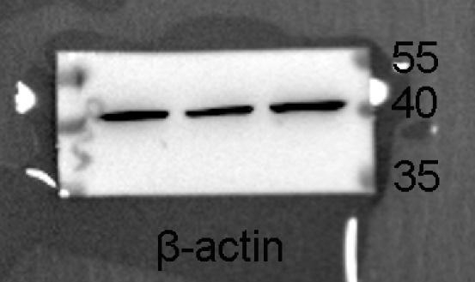
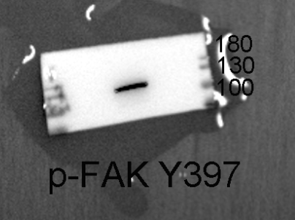
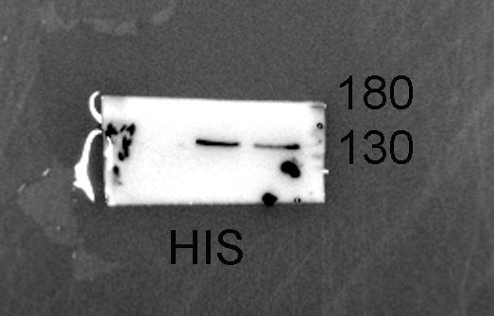
Source of Fig S4F

Source of Fig S4G left (GSC1)
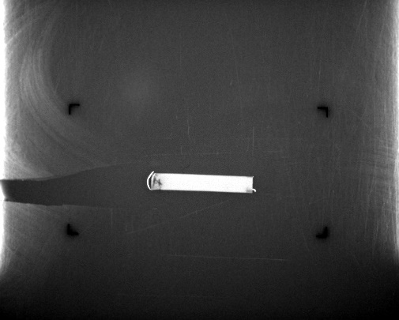
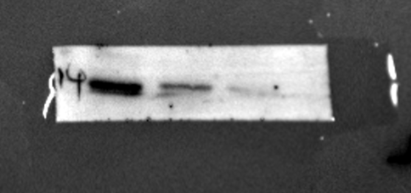
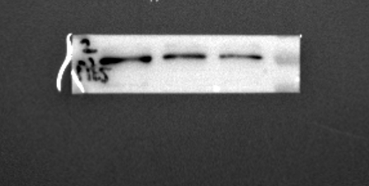
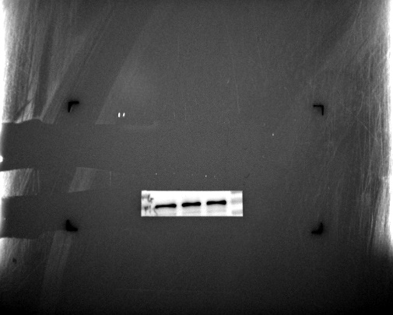
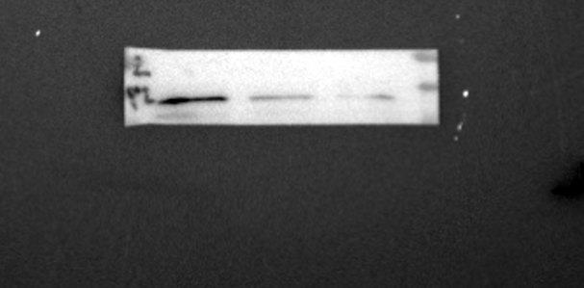
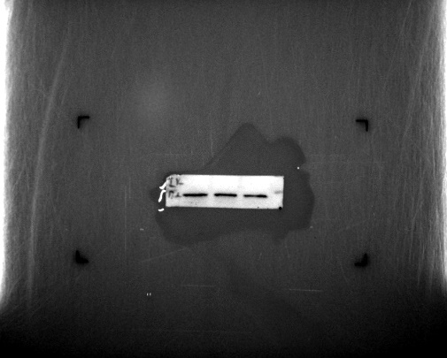
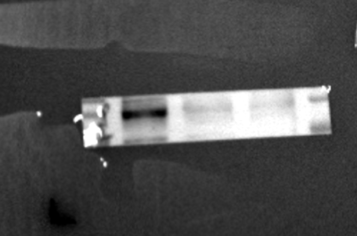
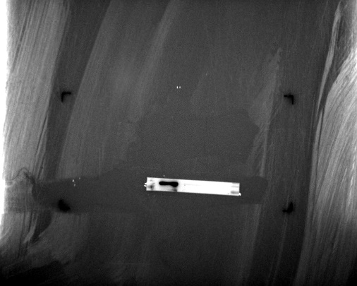
β-Actin
TNFRSF14
p-p65
p65
p-IKBα
IKBα
p-FAK Y397
FAK
Source of Fig S4G right (U87)
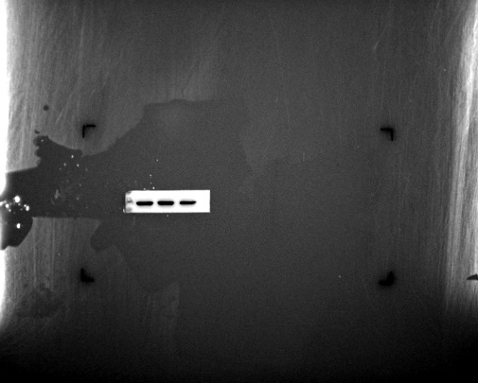
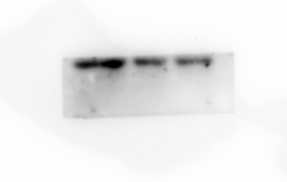
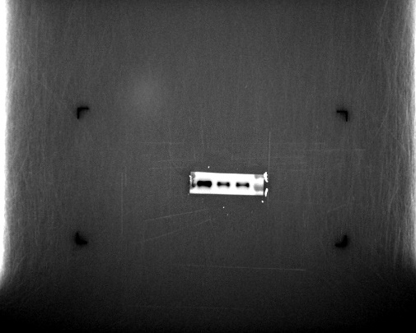
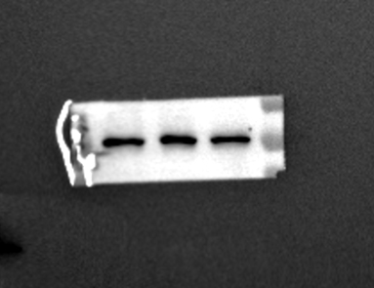
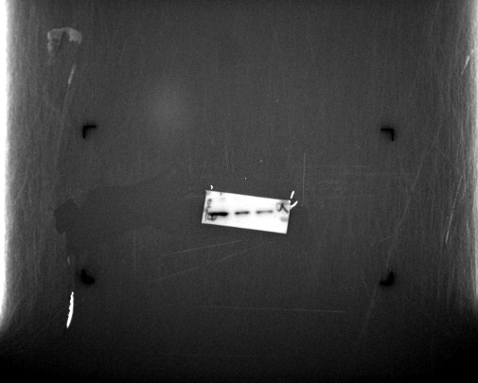
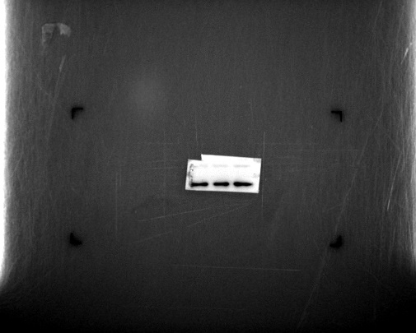
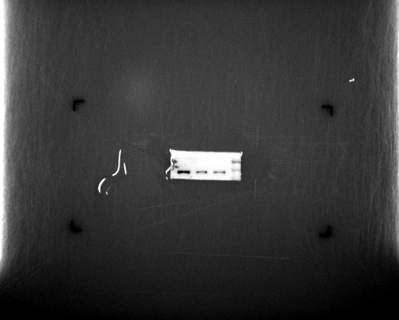
β-Actin
TNFRSF14
p-p65
p65
p-IKBα
IKBα
FAK
p-FAK Y397
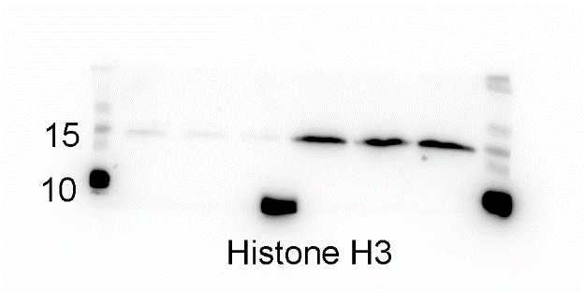
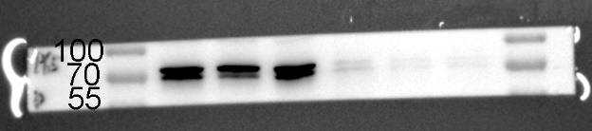
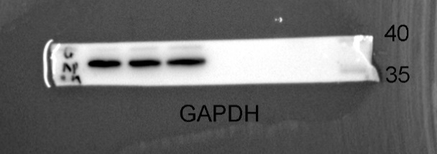
Source of Fig S4H (GSC1)

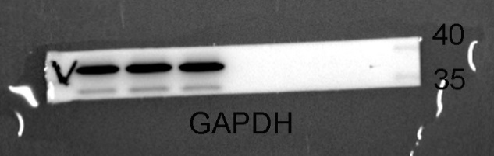
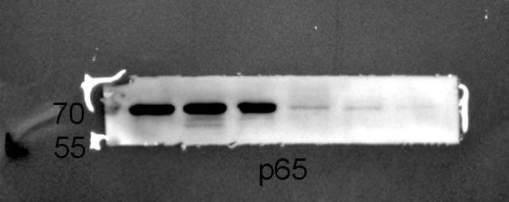
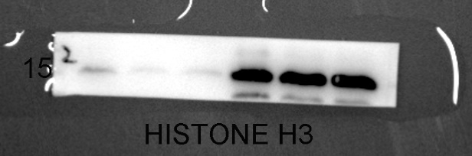
Source of Fig S4H (U87)

Figure S1 related to Figure 1. The characterization of TNFRSF14 expression in glioblastoma.
(A-C) The top 30 immune checkpoints correlated with the score of IFN signaling in GBM datasets (A: CMU n = 208, B: CGGA n = 144, C: TCGA n = 168, Pearson correlation analysis, specific r and p value were showed in Table S6).
(D) Prognosis analysis of CD86, CD48, TIM-3, TNFRSF14 and TNFRSF1B in GBM of CGGA and TCGA (CGGA: n = 69, TCGA: n = 84, log-rank).
(E) Analysis of TNFRSF14 ligands (BTLA and CD160) in single-cell GBM RNA-seq dataset (cell subpopulation distribution map in the left and result of single cell analysis in the right) (GSE131928).
(F) IFN-γ and TNFRSF14 staining analysis of indicated mice brain sections in Fig1L (n = 3, one-way ANOVA).
(G) The expression analysis of IFN-γ and PD-L1 in indicated GBM datasets disclosing that GBM samples with high or low IFN-γ expression didn’t exhibit distinct PD-L1 expression (CGGA: grade II low n =52, high n = 53, grade III low n = 33, high n = 34, grade IV low n = 69, high n = 69; TCGA: grade II low n =111, high n = 112, grade III low n = 122. high n = 123, grade IV low n = 84, high n = 84, t-test).
(H) The combined elevation of IFN-γ and PD-L1 was not correlated with poor survival of GBM (CGGA: low-low n = 42, high-high n = 42, low-high n = 42, high-low n = 42; TCGA: low-low n = 34, high-high n = 35, low-high n = 34, high-low n = 35, log-rank).
(I) Western blotting analysis of TNFRSF14 in indicated GBM cell samples (GSC1 and U87) with indicated IFN-α or IFN-β treatment (0, 20, 50, 100 ng/ml, 48 h).
(n.s. p ≥ 0.05, * p < 0.05, ** p < 0.01, *** p < 0.001, **** p < 0.0001).
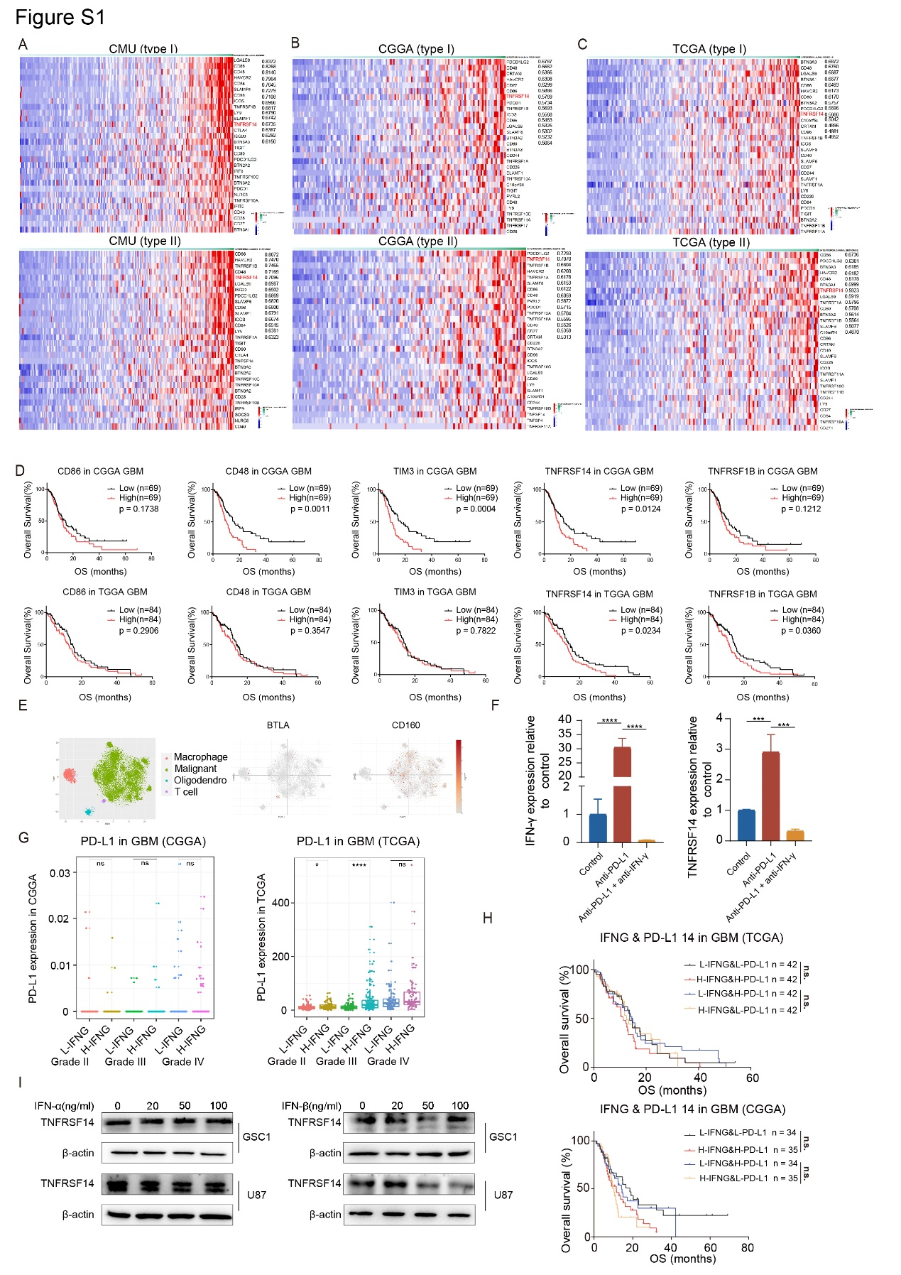

Figure S2 related to Figure 2. TNFRSF14 is involved in regulating migration, invasion, and proliferation of GBM cells.
(A, B) Representative images of in vitro migration (A, representative images related to Fig. 2C) and invasion (B, representative images related to Fig 2D) assays of indicated GBM cells transduced with TNFRSF14 knockdown or control vector, respectively (scale bar, 50 μm).
(C) Representative western blotting images of TNFRSF14 in indicated GBM cells.
(D) MTS assay showing TNFRSF14 overexpression significantly prompted the growth of indicated GBM cells (n = 3, one-way ANOVA).
(E) Representative western blotting images of TNFRSF14 in GL261 cells (relative to shNC).
(F) Survival analysis of mice intracranially transplanted GL261 cells and then with indicated treatment (n = 6, log-rank).
(G) Bioluminescence images of mice brains transplanted with indicated GL261 cells.
(H) H&E and Ki-67 staining images of indicated mice brain section (left scale bar: 500 μm, right scale bar, 25 μm).
(I-K) Analysis of Ki-67 immunohistochemical staining in indicated mice brain sections (n = 3, one-way ANOVA).
(n.s. p ≥ 0.05, * p < 0.05, ** p < 0.01, *** p < 0.001, **** p < 0.0001).
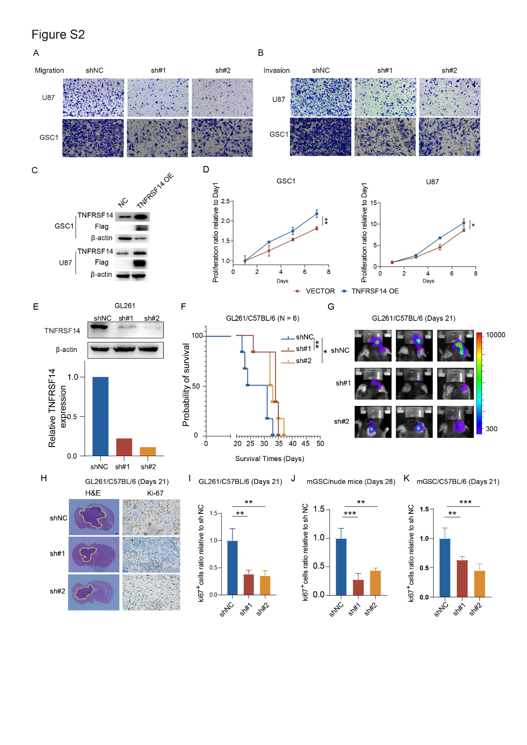

Figure S3 related to Figure 3. Glioma cell TNFRSF14 promotes the recruitment of TAMs in GBM.
(A-C) FACS gating strategy of CD206⁺/MHC-II⁺ macrophages (A, related to Fig. 3A upper panel), CD8⁺/IFN-γ⁺ T cells (B, related to Fig 3A middle panel), and CD8⁺ T cells (C, related to Fig 3A lower panel) detection in tumor samples obtained fromGL261 orthotopic xenografting C57BL/6 mice.
(D) Representative images of in vitro migration assays of THP1- and BMDM-derived macrophages treated with indicated conditioned medium (scale bar, 50 μm; related to Fig 3E and Fig S3F).
(E) Representative immunohistochemical staining images and analysis (n = 3, one-way ANOVA) of indicated markers in brain section of mice intracranially transplanted with indicated GL261 cells (scale bar, 25 μm).
(F) In vitro migration assays of THP1-derived macrophages treated with conditioned medium from indicated GBM cell (relative to shNC, n = 3, one-way ANOVA).
(G) qPCR analyses of indicated markers in THP1-derived macrophages incubated with indicated conditioned medium treatment (relative to shNC, n = 3, one-way ANOVA).
(H) FACS gating strategy of BMDMs.
(I) FACS gating strategy of CD163⁺/CD80⁺ cell detection in THP1-derived macrophages treated with conditioned medium (related to Fig 3G and Fig S3I).
(J) Flow cytometry analysis of CD163 and CD80 in THP1-derived macrophages with indicated conditioned medium treatment (n = 3, one-way ANOVA).
(n.s. p ≥ 0.05, * p < 0.05, ** p < 0.01, *** p < 0.001, **** p < 0.0001).
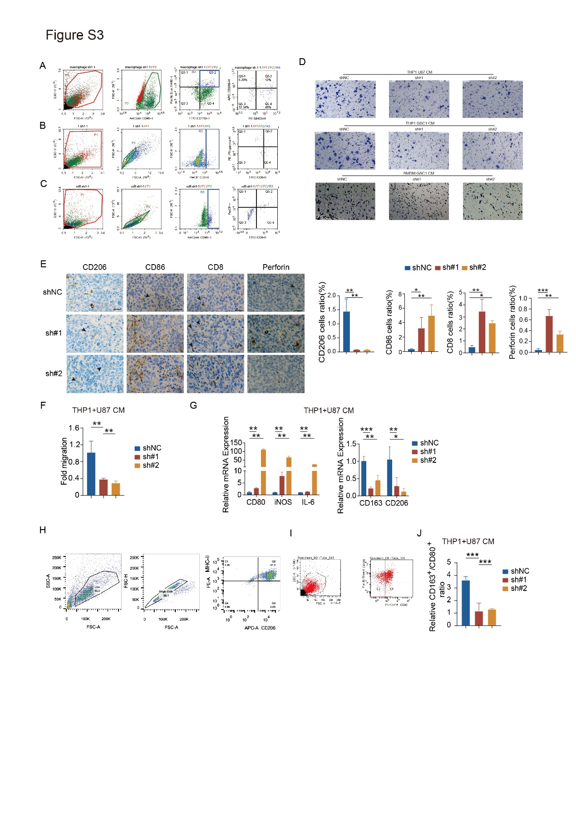
Figure S4 related to Figure 4. Defactinib, a FAK inhibitor, efficiently restrains the migration and invasion of GBM cells.
(A, B) FAK inhibitor, Defactinib, efficiently inhibits enhanced proliferation (A), migration and invasion (B) capabilities of indicated glioma cells inducing by TNFRSF14 overexpression (relative to Vector, n = 3, one-way ANOVA).
(C) Representative images of in vitro cell migration (left) and invasion (right) assay of GSC1 and U87 cells with indicated treatment (related to Fig S4B, scale bar, 50 μm).
(D) Representative western blotting images of indicated markers in GSC1 and U87 treated with Defactinib after TNFRSF14 overexpression.
(E) Co-immunoprecipitation analysis of TNFRSF14 and FAK interaction in HEK293 cells.
(F) Western blotting of indicated markers in HEK293 cells transfected with FAK wild type or Y397F mutant vector.
(G) Western blotting analysis of indicated GBM cells transfected with siFAK or control vector, respectively.
(H) Western blotting analysis of nucleus and cytoplasm p65 expression in indicated GBM cells transfected with siFAK or control vector, respectively.
(I) Transfection validation by IF of HEK293 cell transfected with p65 wild type or nuclear localization sequence mutant vector.
(n.s. p ≥ 0.05, * p < 0.05, ** p < 0.01, *** p < 0.001, **** p < 0.0001).
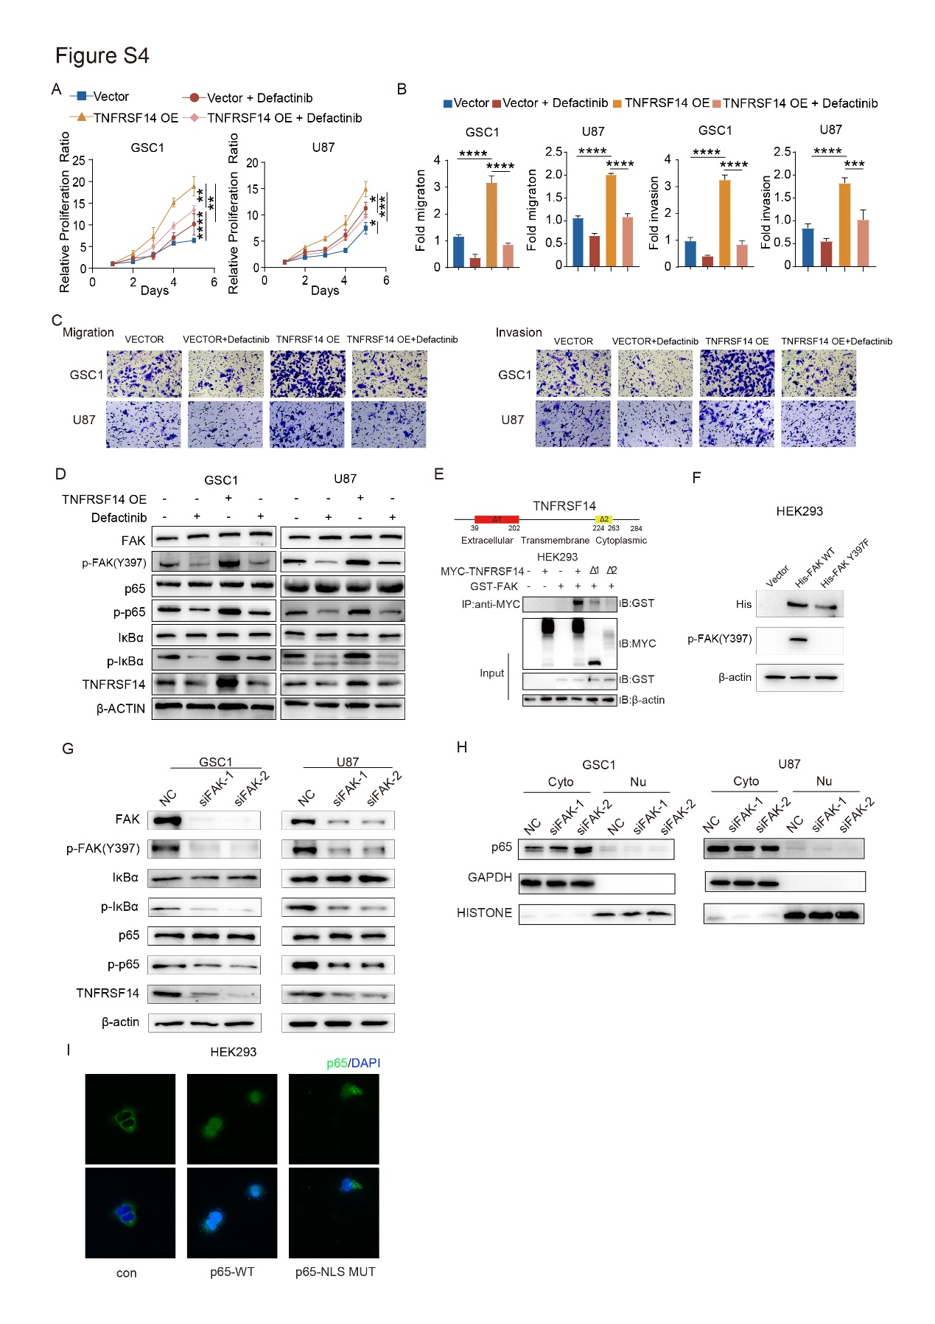

Figure S5 related to Figure 5. Malignant cell TNFRSF14/FAK regulates macrophage migration through NF-κB mediating CXCL1 and CXCL5 transcription.
(A) Representative images of in vitro migration assay of THP1-derived macrophages with indicated treatment (scale bar, 50 μm; related to Fig 5E).
(B) The schematic graph of mutant plasmids of promoter of CXCL1 and CXCL5.

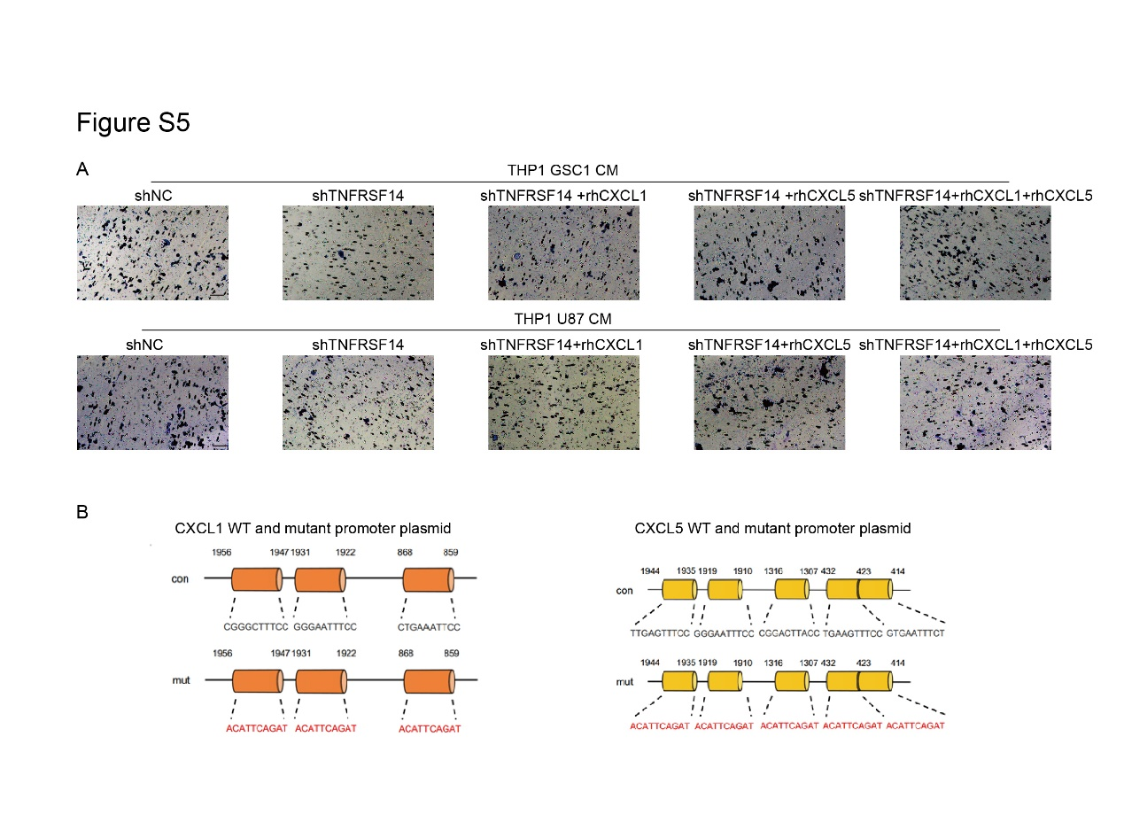

Figure S6 related to Figure 6. Anti-TNFRSF14 treatment remodels GBM tumor environment.
(A, B) Expression analysis of CD206 (A) and ARG1 (B) in macrophage of mouse GBM tissues receiving indicated treatment.
(C-E) Expression analysis of TNF-α (C), CD48 (D) and Ki67 (E) in T cell of mouse glioma tissues receiving indicated treatment.

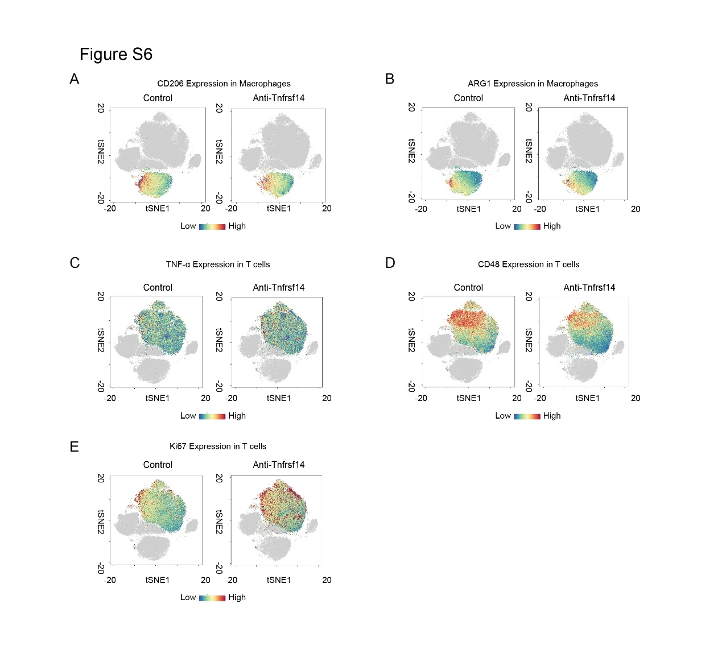

Figure S7 related to Figure 6 Anti-TNFRSF14 and anti-PD-L1 treatment remodeled GBM tumor environment.
(A) Schematic graph of anti-TNFRSF14 and anti-PD-L1 treatment in indicated GBM mice model.
(B) Survival analysis of mice intracranially transplanted GL261 cells and then with indicated treatment (n = 6, log-rank).
(C) Representative images and analysis of H&E (scale bar, 500 μm) and Ki-67 immunohistochemical staining (scale bar, 25 μm) of indicated mice brain section.
(D) Representative bioluminescence brain images of mice intracranially transplanted GL261 cells and then with indicated treatment.
(E) Representative H&E (scale bar, 500 μm) and Ki-67 immunohistochemical staining images (scale bar, 25 μm) of indicated mice brain section.
(F) Analysis of Ki-67 immunohistochemical staining in indicated mice brain sections (n = 3, one-way ANOVA).
(G, H) Representative immunohistochemical staining images (G) and analysis (H) of indicated markers (CD206, CD86, CD8, and perforin) in brain sections from C57BL/6 mice intracranially transplanted with GL261 cells and then received anti-TNFRSF14, anti-PD-L1, or combination treatment indicated in Fig. S7A (scale bar, 25 μm).
(I) Representative immunohistochemical images of TNFRSF14 in indicated GBM mice brain sections of Fig. S6A (n = 3, scale bar, 25 μm).
(J) Representative H&E images of liver and kidney from mice with indicated anti-TNFRSF14, anti-PD-L1, or combination treatment, respectively.
(n.s. p ≥ 0.05, * p < 0.05, ** p < 0.01, *** p < 0.001, **** p < 0.0001).

