Supporting information
Synergistic Intravesical Instillation for Bladder Cancer: CRISPR-Cas13a and Fenbendazole Combination Therapy

Mingkang Liang^{1,2#}, Yongqiang Wang^{3#}, Lisha Liu², Dashi Deng², Yan Zeqin³, Lida Feng², Chenchen Li², Yuqing Li^{1,3}*, Guangzhi Li^{1,2}*

1. Luohu clinical college of Shantou University Medical College, Shantou University Medical College, Shantou, 515000, Guangdong, China
2. Institute of Urology, The Affiliated Luohu Hospital of Shenzhen University, Shenzhen University, Shenzhen, 518000, China
3. Department of Urology, South China Hospital, Health Science Center, Shenzhen University, Shenzhen, 518116, China

*Correspondence: guangzhili@126.com
#These authors contributed equally to this work.

KEYWORD: CRISPR-Cas13a， Flubendazole， Fluorinated Chitosan， Bladder cancer， Programmed Death Ligand 1，Transmembrane peptides

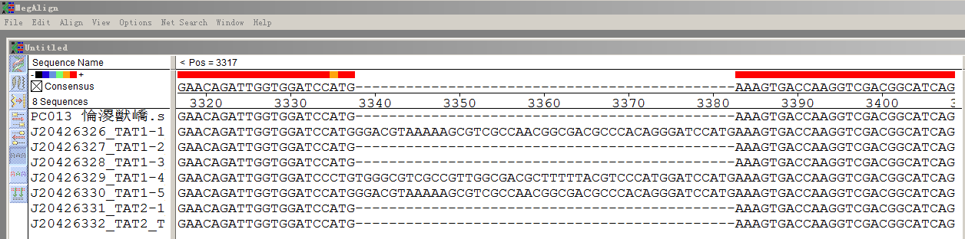

FigureS1 Sequencing result

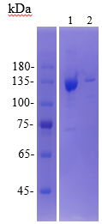
FigureS2 Cas13a-TAT electrophoresis results

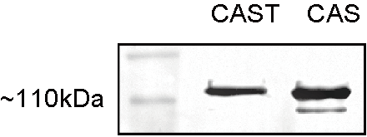
FigureS3 CAST and CAS western blot assay

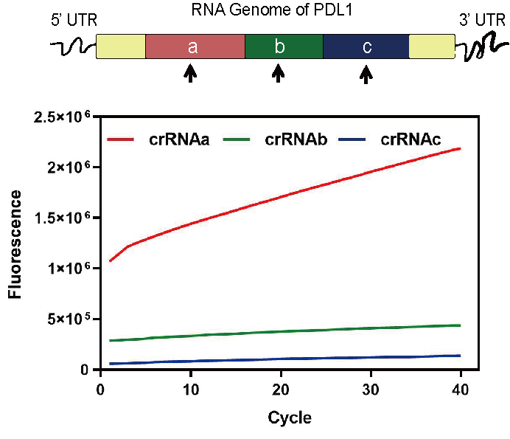
FigureS4 Taqman test results

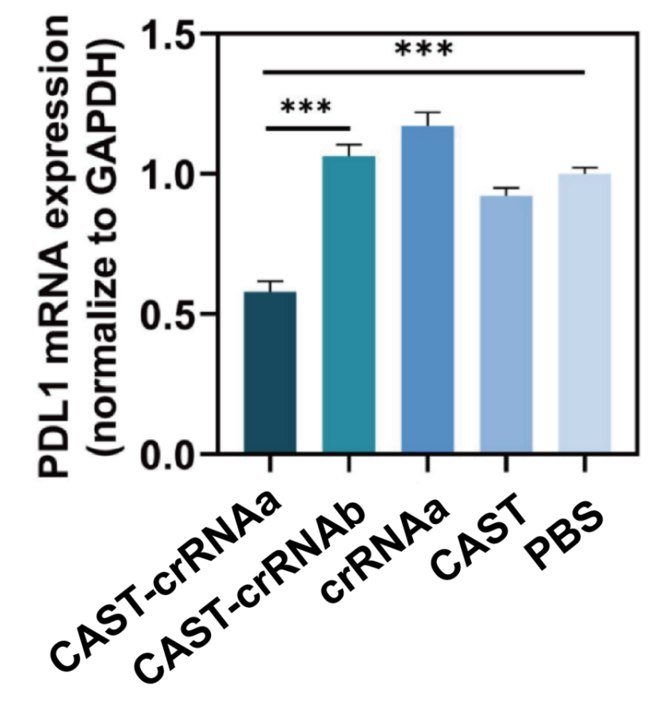
FigureS5 Qpcr result

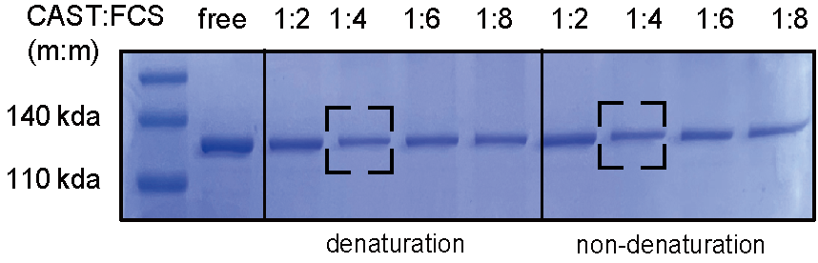
FigureS6 Electrophoretic Coomassie brilliant blue staining in CAST-crRNAa and FCS ratios

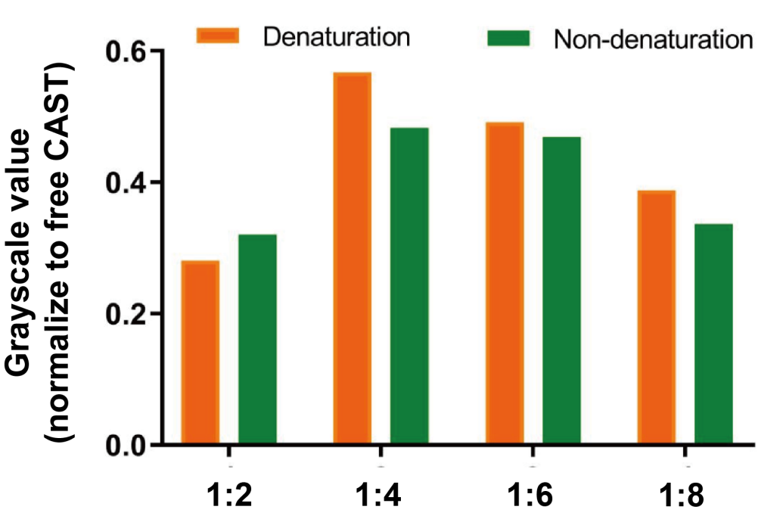
FigureS7 Grayscale statisitics

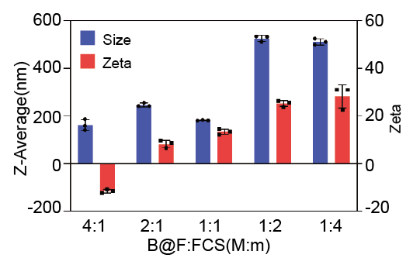
FCS:BSA@FBZ(M:m)
FigureS8 Particle size and potential at each ratio of BSA@FBZ and FCS

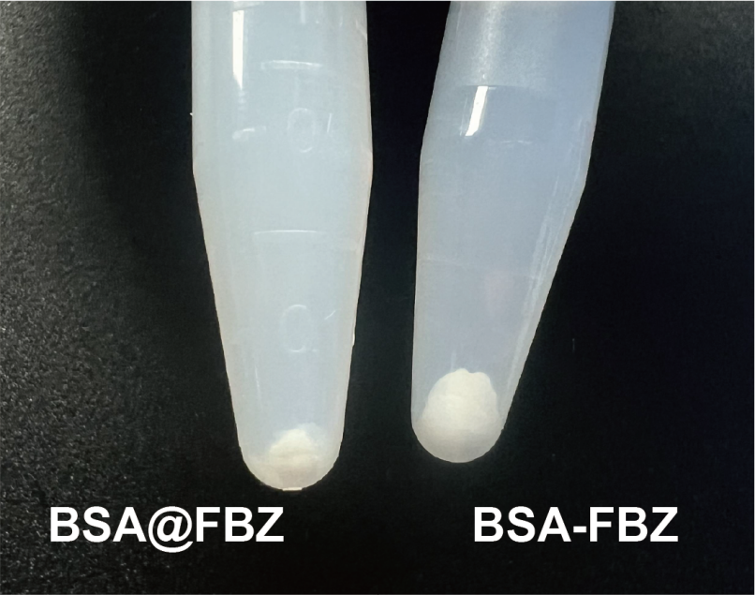
FigureS9 Contrast after impurity removal BSA@FBZand BSA-FBZ

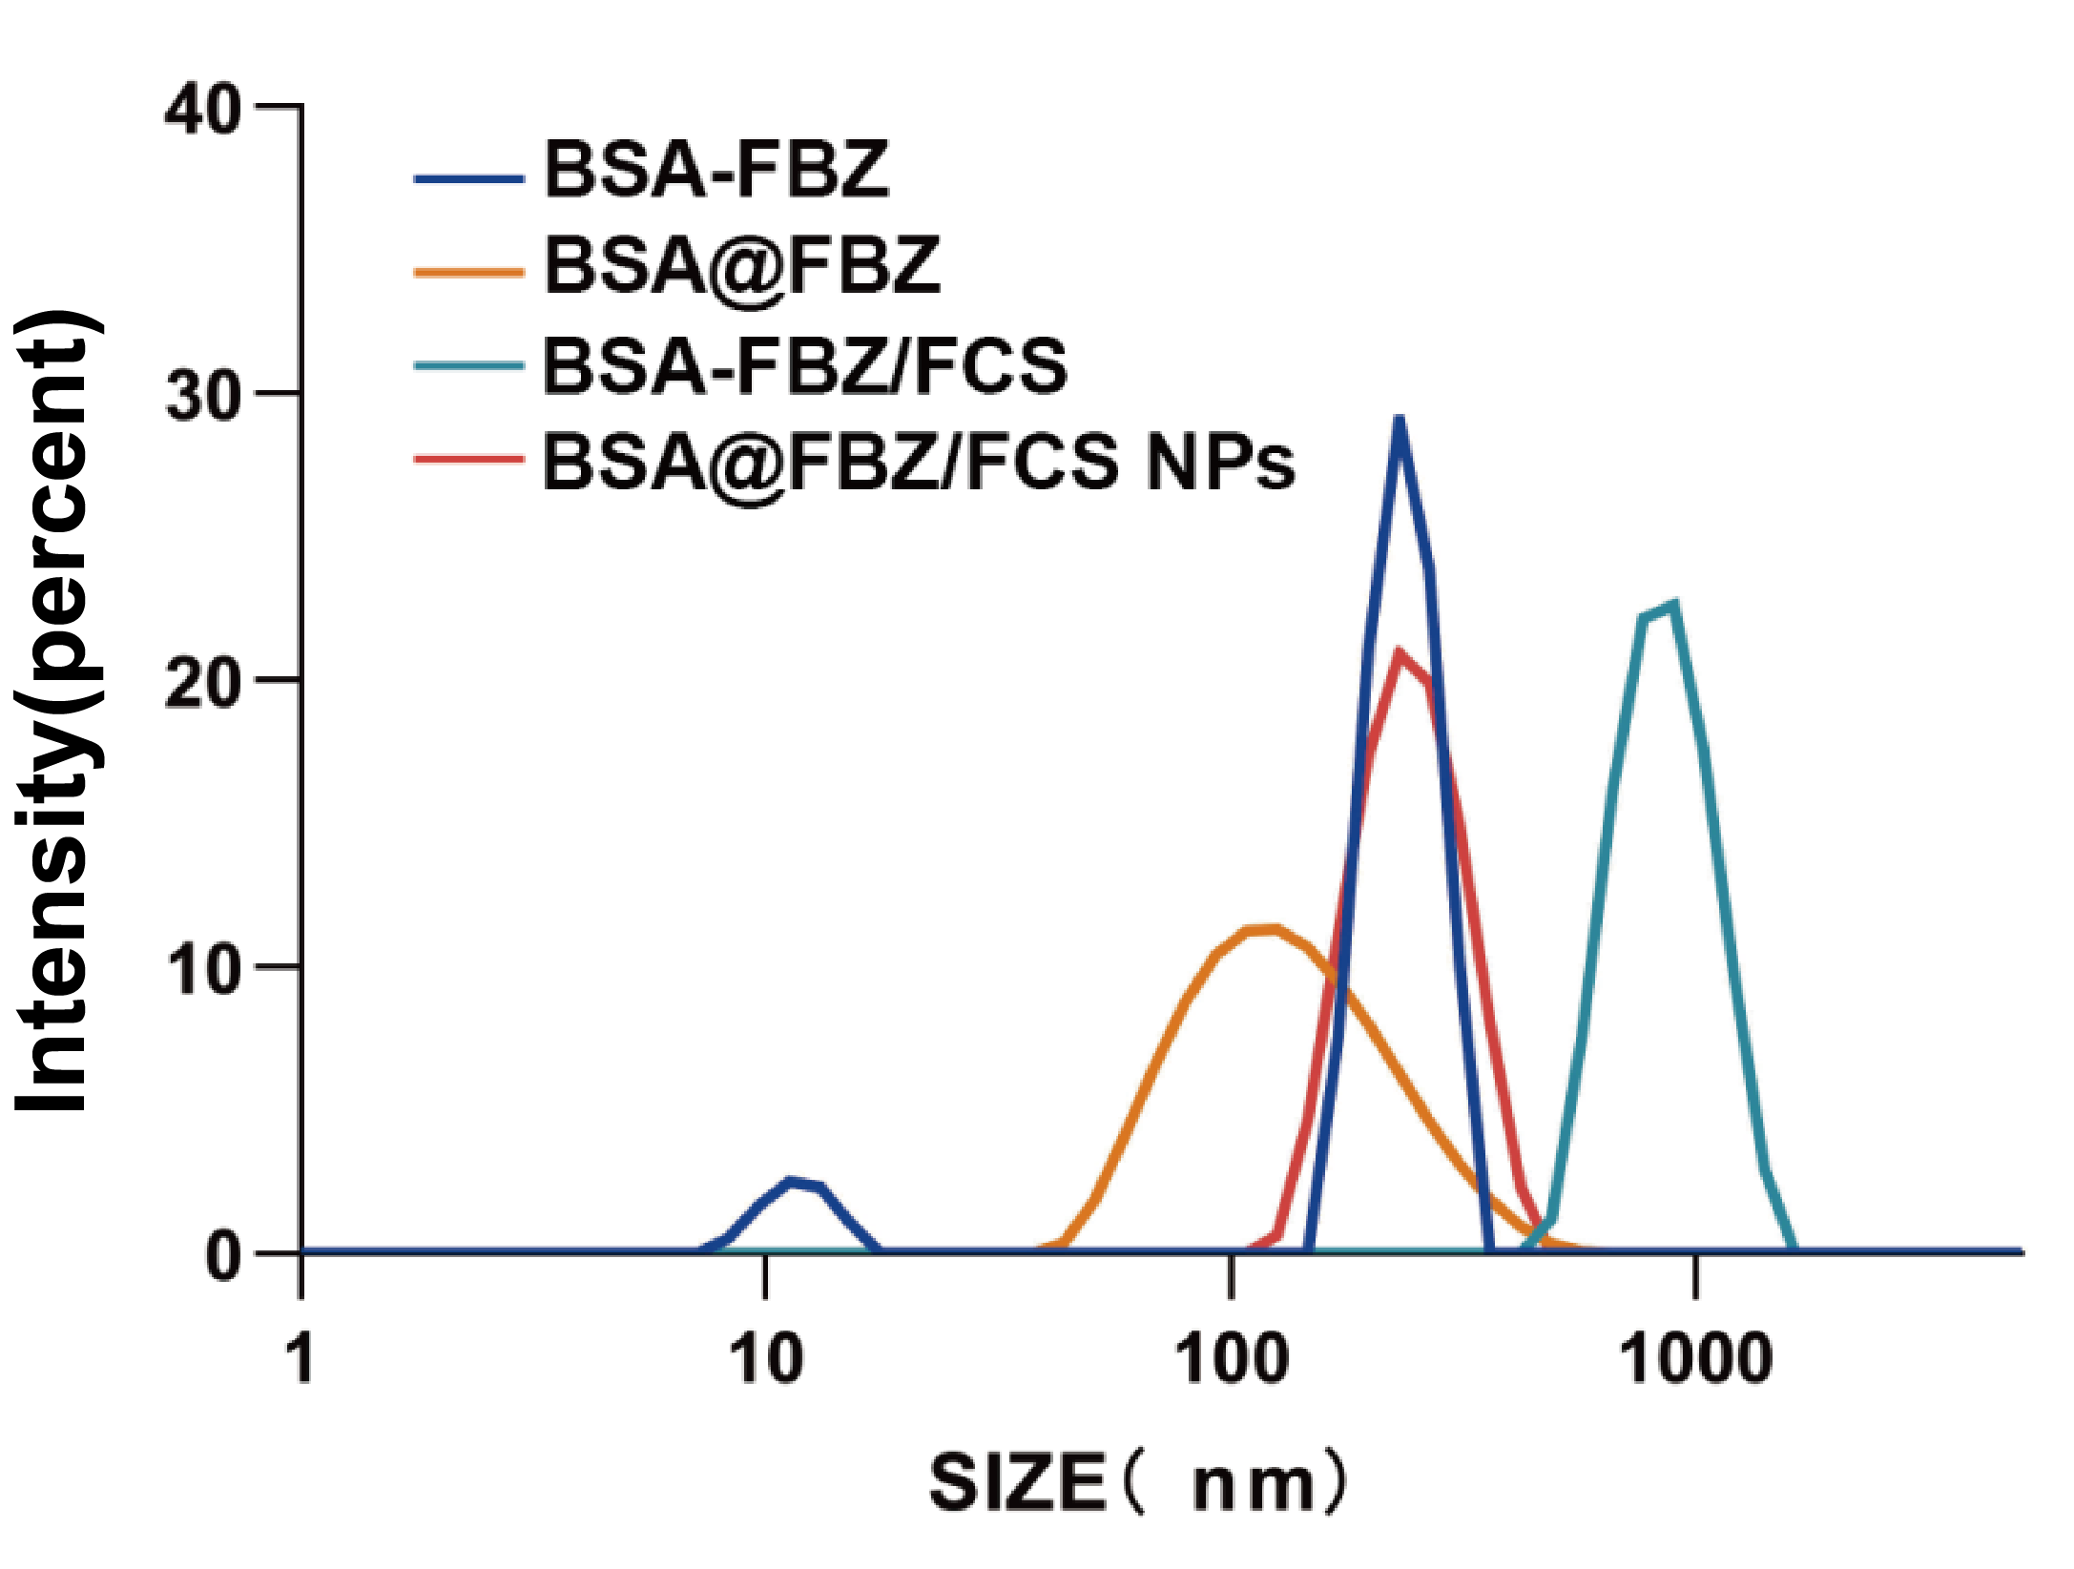
FigureS10 Hydrodynamic diameter of each formula

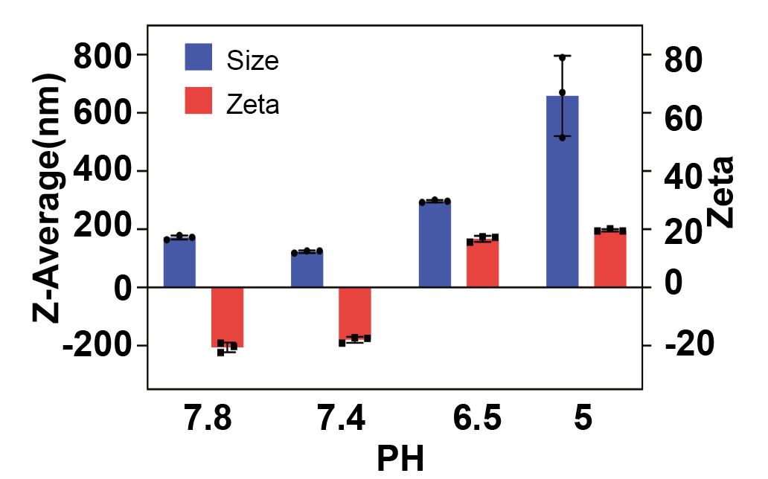
FigureS11 Hydrodynamic diameter and potentiogram of BSA@FBZ at different PH

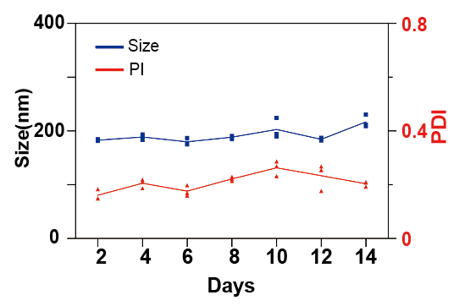
FigureS12 BSA@FBZ's 14-day hydrodynamic diameter
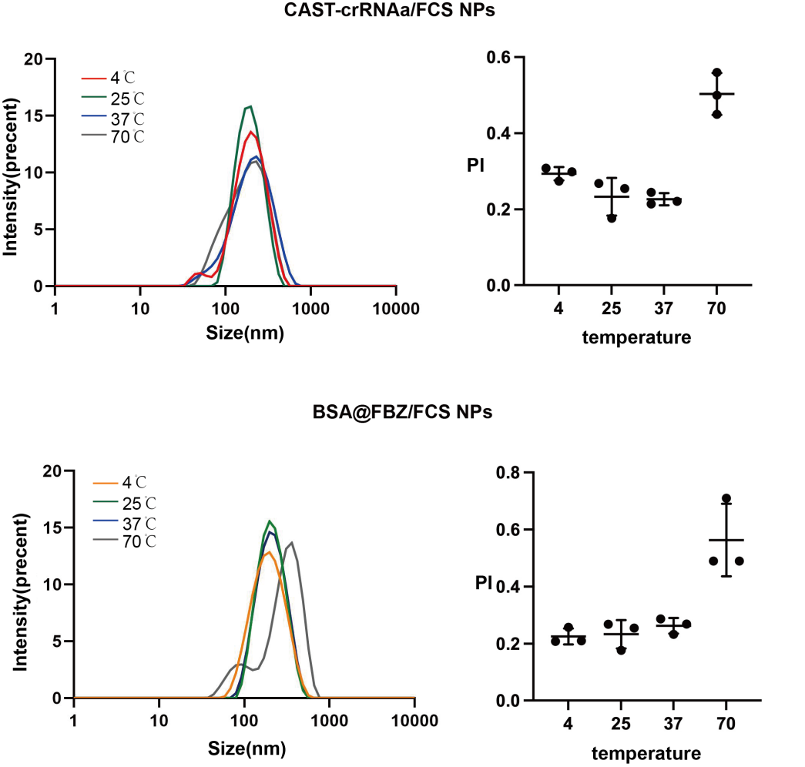
Figure S13 Hydrodynamic diameter and PI of NPs at Different temperature
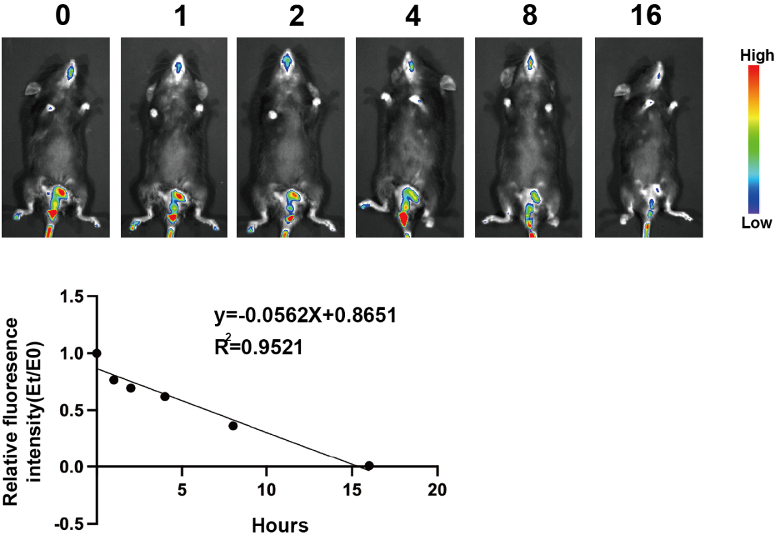
Figure S14 Half-life of BSA/FCS NPs in bladder

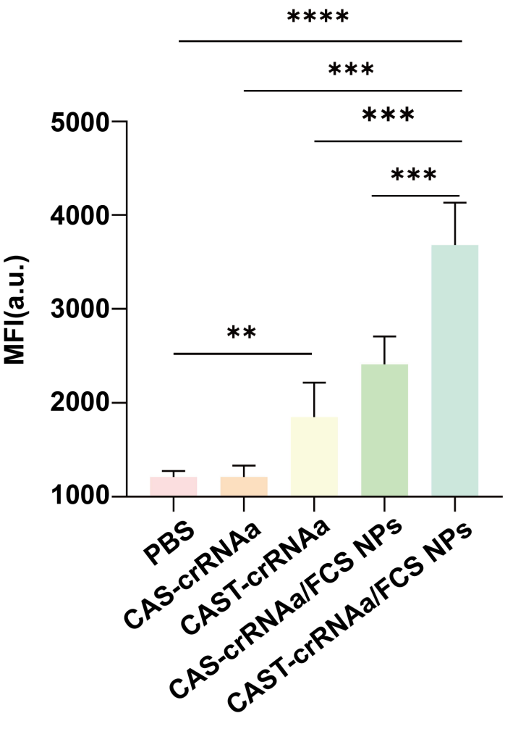
FigureS15 Statistical analysis of MFI value in bladder of CAS and CAST

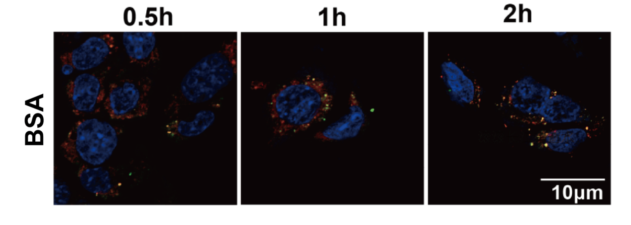
FigureS16 Intracellular fluorescence location of BSA

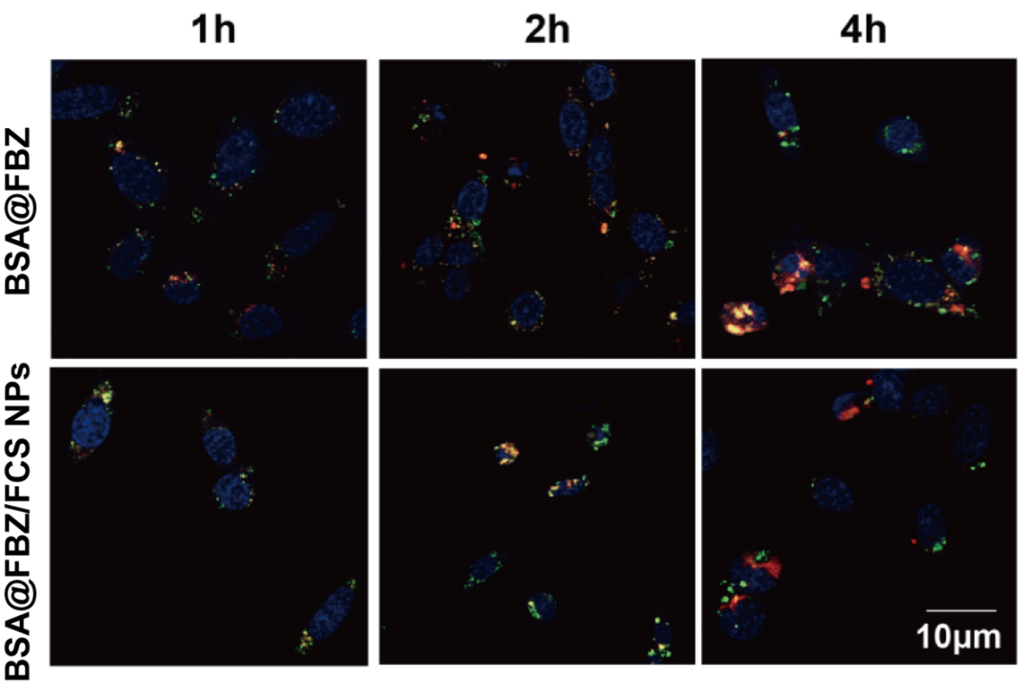
FigureS17 Intracellular fluorescence location of BSA@FBZ

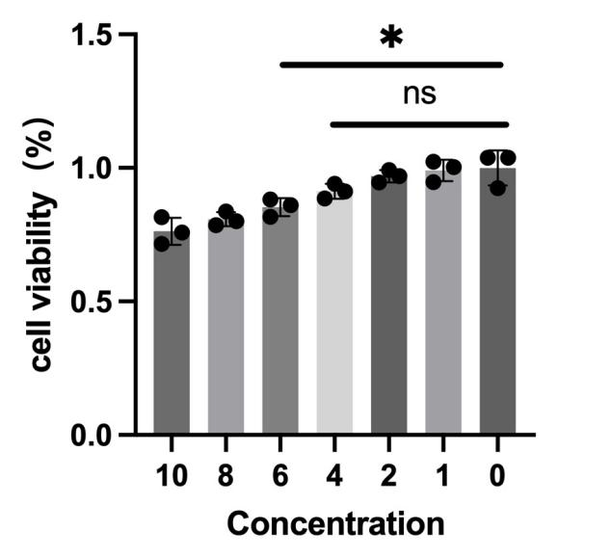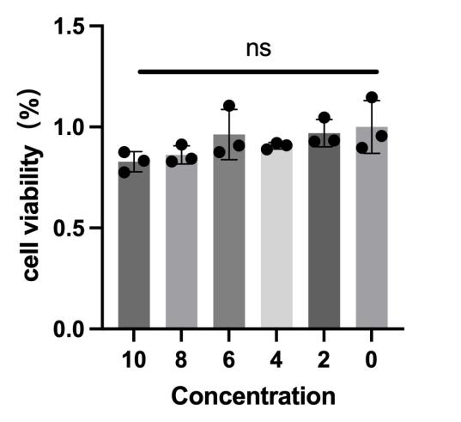
Figure S18 Cell viability of MB49 andSV-HUC1 treated by different concetrations of CAST-crRNAa/FCS NPs
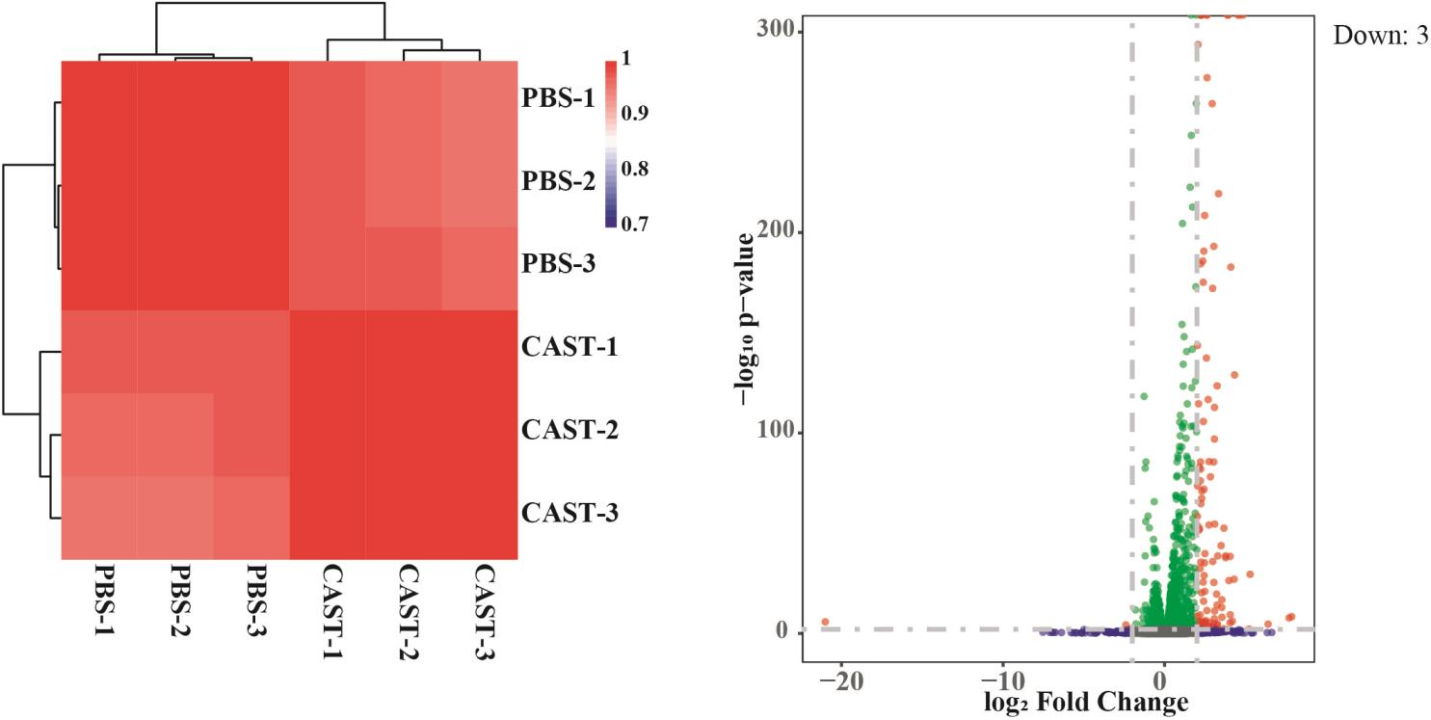
Figure S19 The significantly down-regulated genes of cells treated with CAST-crRNAa/FCS NPs

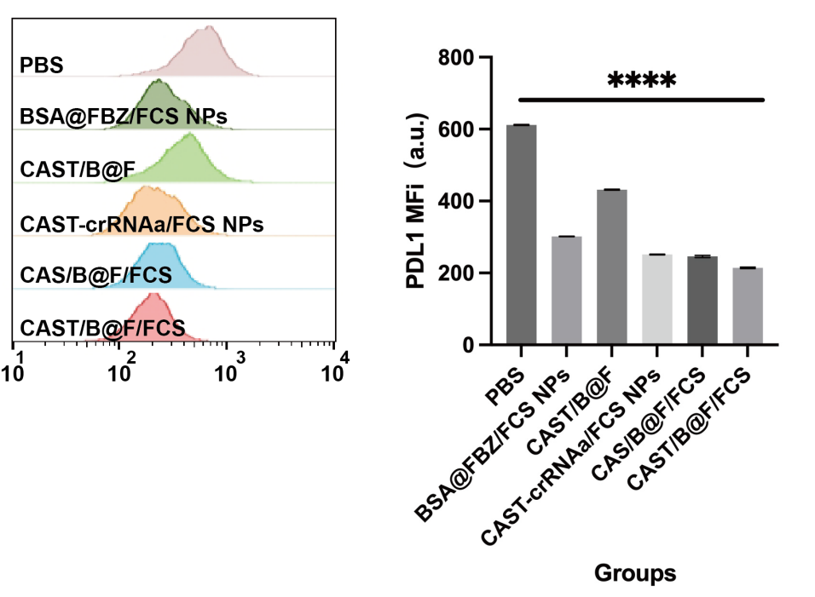
Figure S20 Flow cytometer analysis of PDL1 expression in MB49

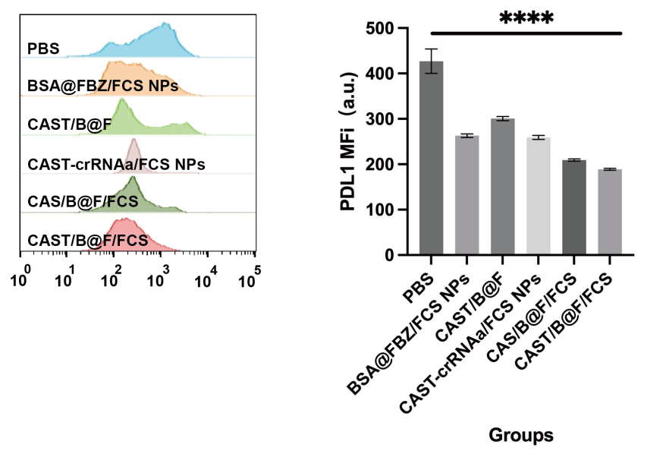
Figure S21 Flow cytometer analysis of PDL1 expression in T24
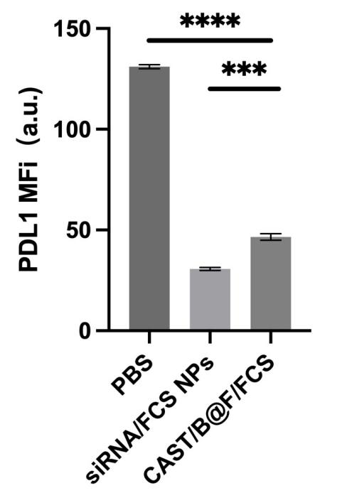
Figure S22Flow cytometer analysis of PDL1 expression of siRNA/FCS NPs group in MB49

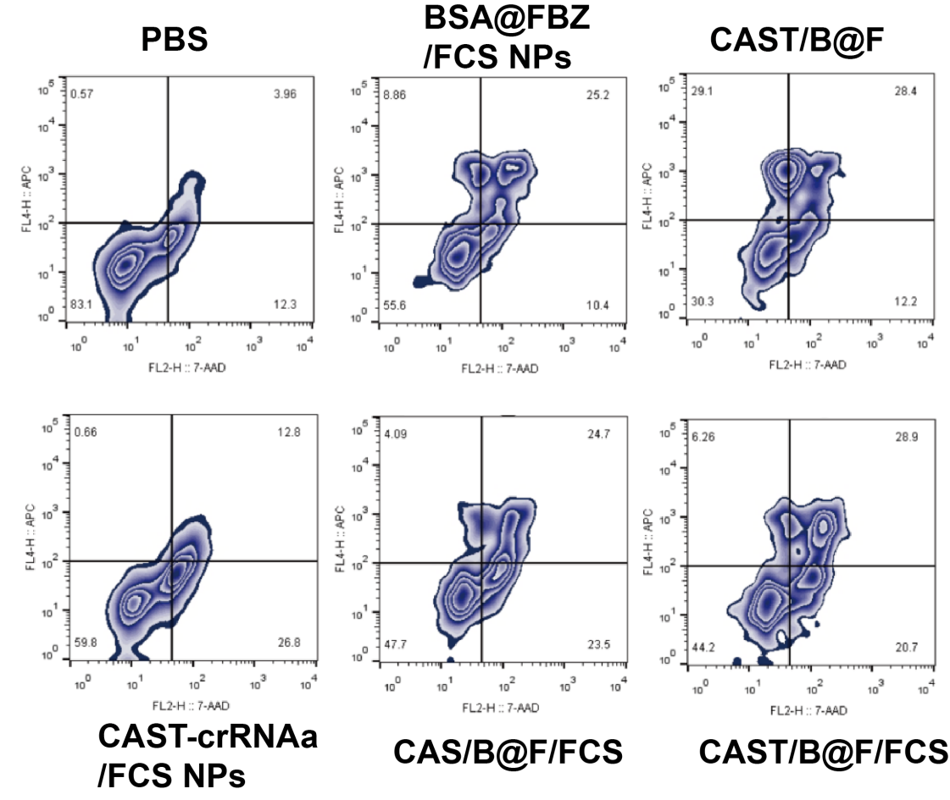
FigureS23 Cell apoptosis in different groups
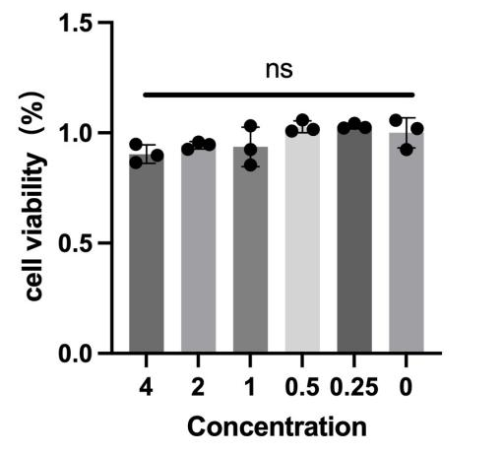
Figure S24 Cell viability of SV-HUC1 treated by BSA@FBZ/FCS NPs

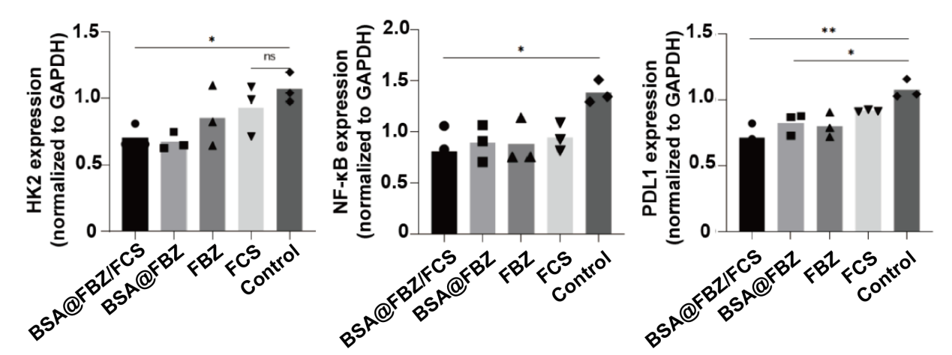
FigureS25 Statistics of grayscale value of western blot
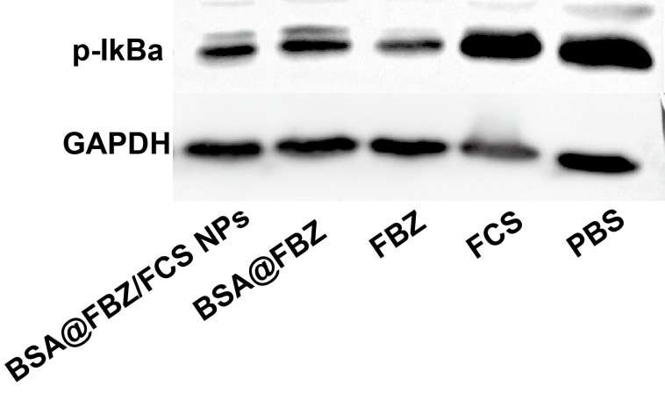
Figure S26 Western blot analysis of IKB-a
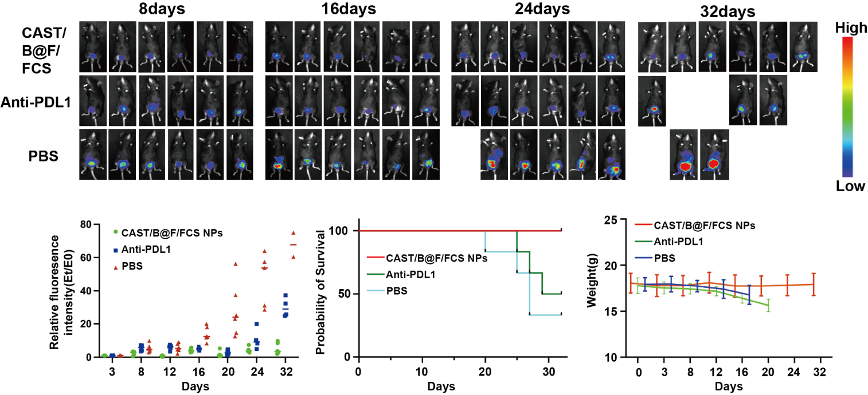
Figure S27 Fluroscence analysis, survival, Weight of CAST/B@F/FCS, Anti-PDL1,PBS groups

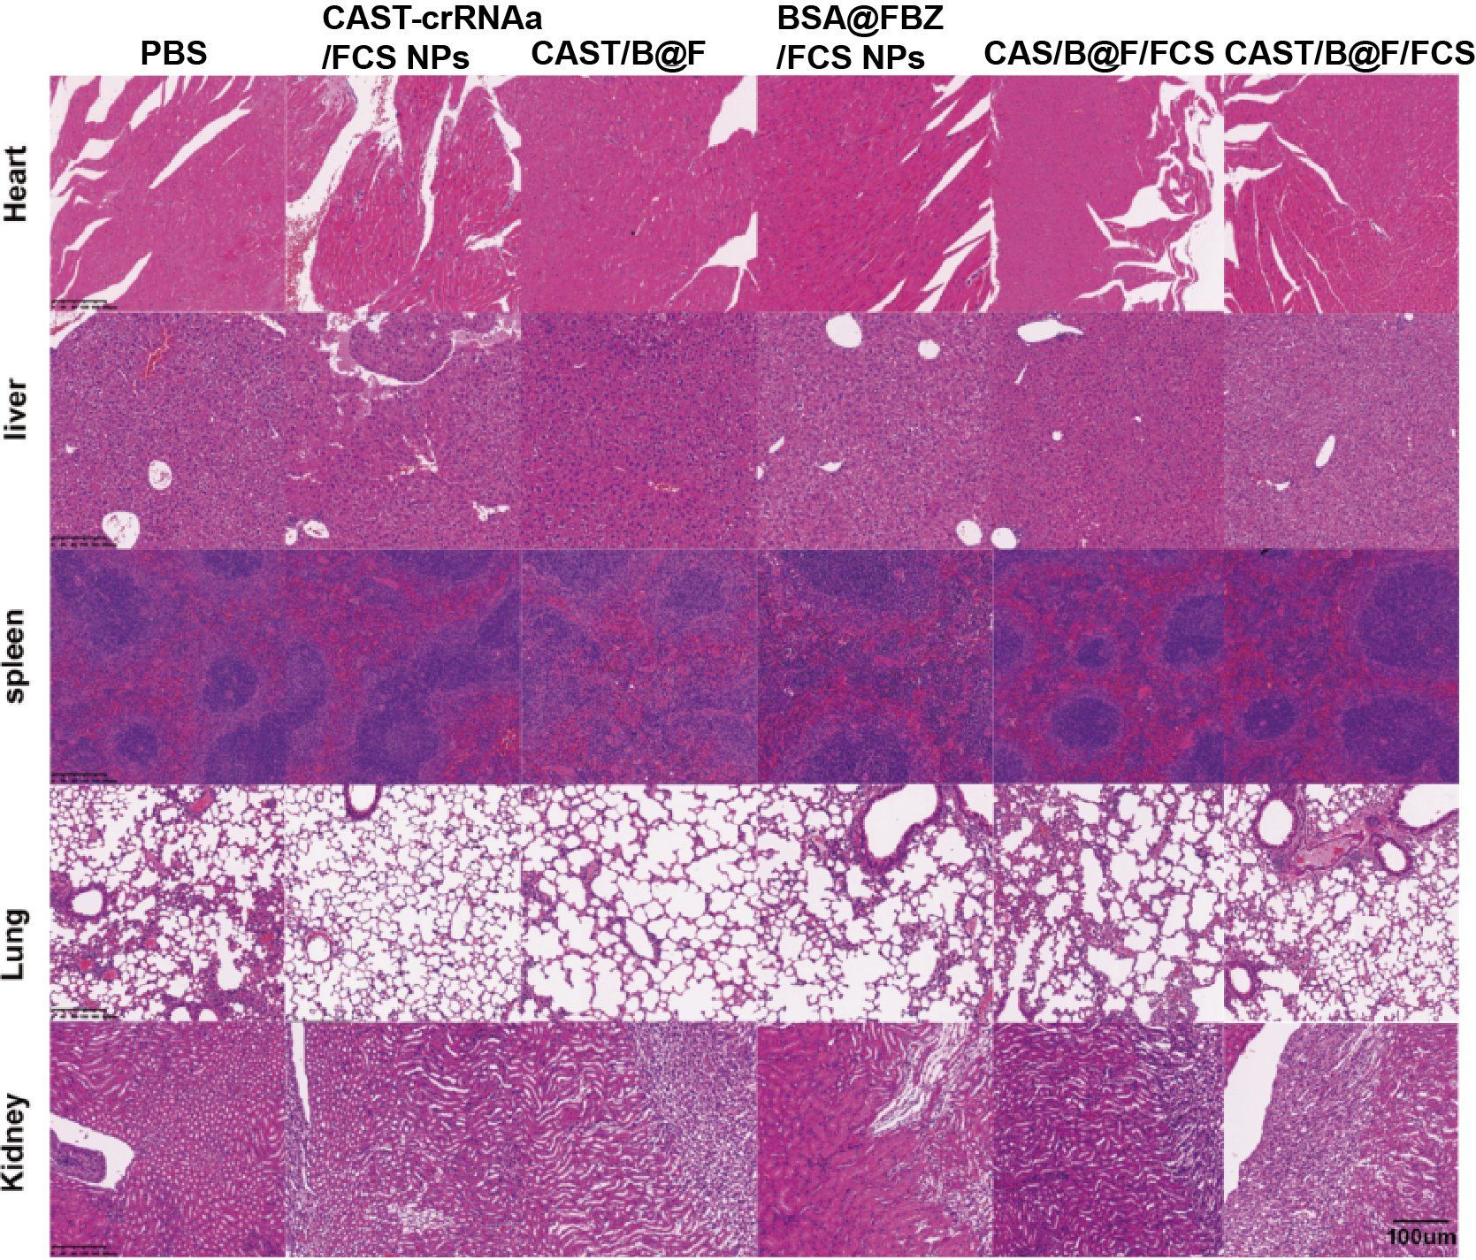
FigureS28 Vital organs H&E staining

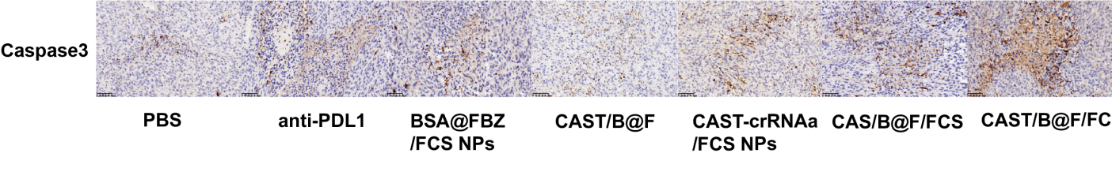
Figure S29 IHC of Caspase3

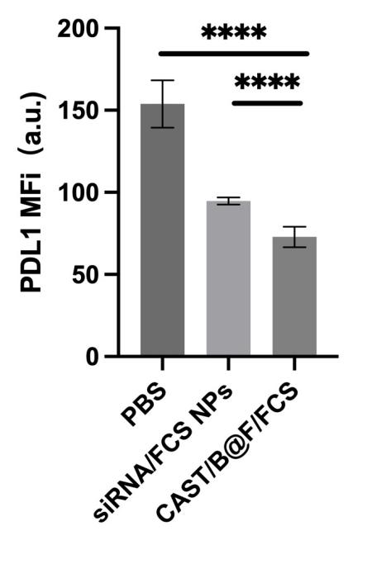
Figure S30 Flow cytometer analysis of PDL1 expression of siRNA/FCS NPs group in tumors

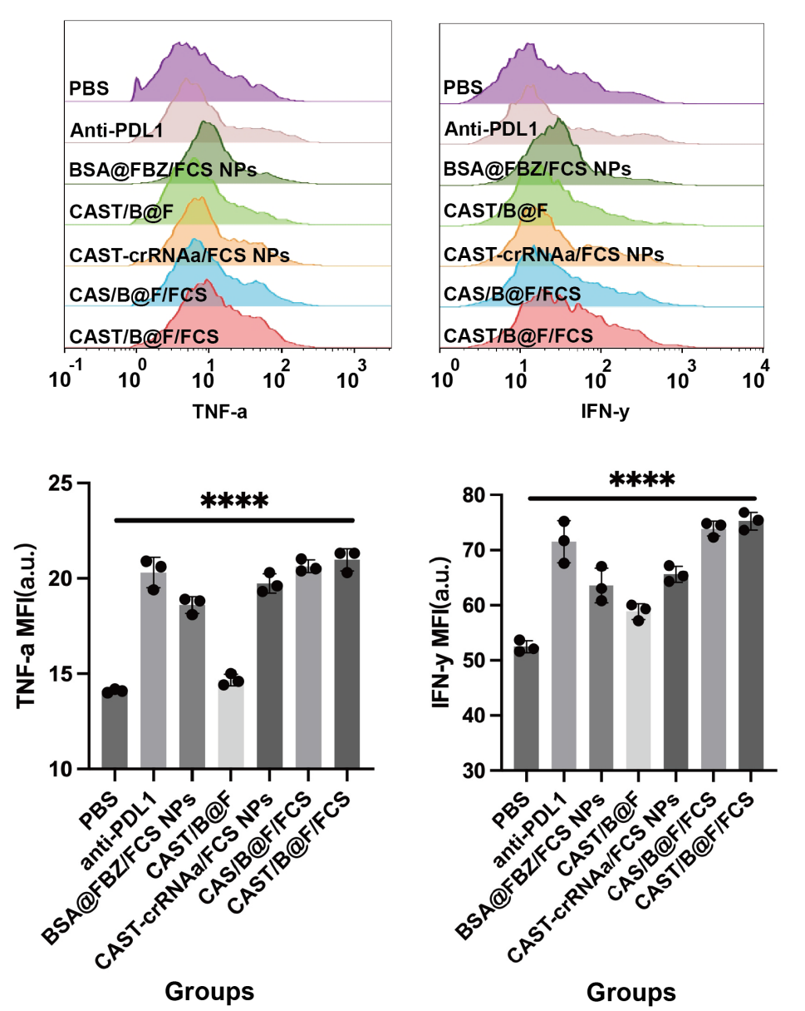
Figure S31 Flow cytometer analysis of TNF-a and IFN-y expression in tumors

