Additional file 2 - Figure S1
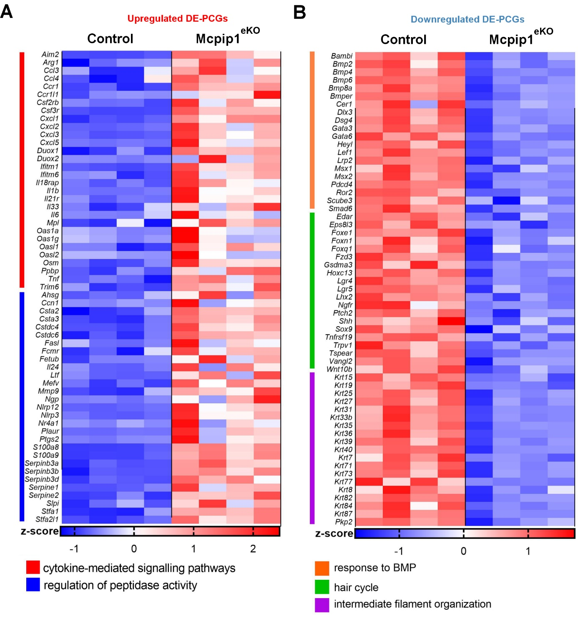
Figure S1. Heatmap showing the expression levels of selected DE-PCGs in Mcpip1^{eKO} papillomas. A. Heatmap showing the expression levels (z scores) of representative DE-PCGs related to the selected upregulated in Mcpip1^{eKO} papillomas GO terms. B. Heatmap showing the expression levels (z scores) of representative DE-PCGs related to the selected downregulated in Mcpip1^{eKO} papillomas GO terms. The top 20-30 DE-PCGs (based on FC scores) from each GO term is shown. DE, differentially expressed.

