Additional file 4 - Figure S2
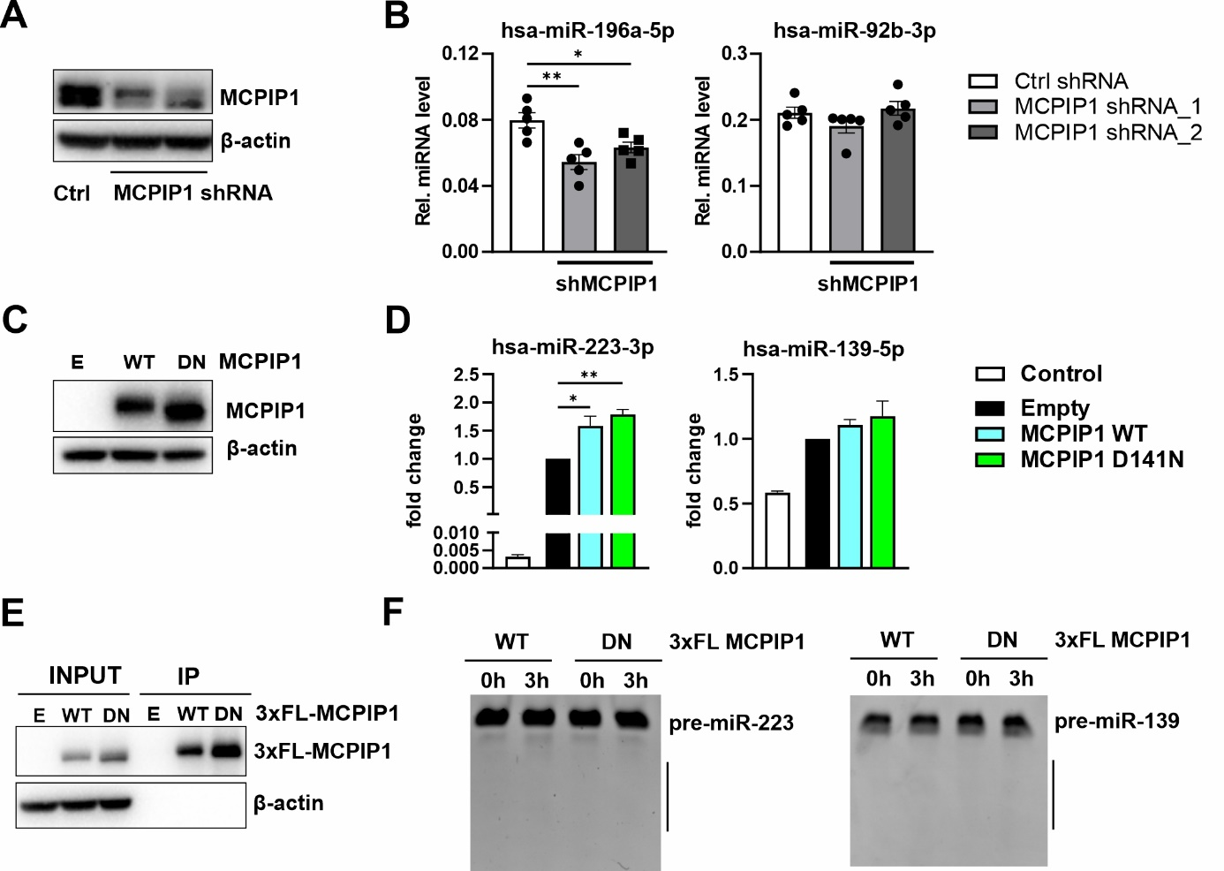

Figure S2. Expression levels of selected miRNAs in malignant keratinocytes and regulation by MCPIP1. A. Western blot for MCPIP1 and β-actin expression in A431 cell lysates stably expressing control or MCPIP1-specific shRNA. B. RT-qPCR analysis of hsa-miR-196a-5p and hsa-miR-92b-3p in A431 cells expressing the control (NC, negative control) or MCPIP1-specific shRNA (n=4-5). C. Western blot for MCPIP1 and β-actin in HEK293 cells transfected with pcDNA3.0 (empty), MCPIP1-WT or MCPIP1-D141N. D. RT-qPCR analysis of miRNA expression in HEK293 cells co-transfected with pcDNA3.0, MCPIP1-WT or MCPIP1-D141N with pcDNA3.0 expressing pre-miR-223 or pre-miR-139 (n=3). E. Western blot for FLAG and β-actin in input and protein lysates following IP with anti-FLAG from HaCaT cells expressing 3xFLAG-MCPIP1-WT or 3xFLAG-MCPIP1-D141N. F. Image of RNA electrophoresis in 8% PAA gel indicating results of degradation assays using 3xFLAG MCPIP1 or 3xFLAG MCPIP1-D141N immunoprecipitated from HaCaT cells with in vitro transcribed pre-miR-223 or pre-miR-139 as a substrate. * – P < 0.05; ** – P<0.01 by Student’s t test t-test. Hsa, Homo sapiens.

