Supplementary Material 1

The KLF16/MYC feedback loop is a therapeutic target in bladder cancer

Lisi Zheng, Jingxuan Wang, Shan Han, Li Zhong, Zefu Liu, Bin Li, Ruhua Zhang, Liwen Zhou, Xianchong Zheng, Zhenhua Liu, Cuiling Zeng, Ruonan Li, Yezi Zou, Liqin Wang*, Yuanzhong Wu*, and Tiebang Kang*

Address Correspondence to: *Tiebang Kang, Tel: 86-20-8734-3183, Fax: 86-20-8734-3170; E-mail: kangtb@sysucc.org.cn. or *Yuanzhong Wu, Tel: 86-20-8734-3183, Fax: 86-20-8734-3170; E-mail: wuyzh@sysucc.org.cn State Key Laboratory of Oncology in South China, Sun Yat-sen University Cancer Center, 651 Dongfeng Road East, Guangzhou, China, 510060 or *Liqin Wang, Tel: 86-20-87340285, Fax: 86-20-8734-3170; E-mail: wanglq1@sysucc.org.cn State Key Laboratory of Oncology in South China, Sun Yat-sen University Cancer Center, OneHub GKC, F-804, Sino-Singapore Knowledge City, HuangPu District, Guangzhou, China, 510555.

Supplemental Figures.
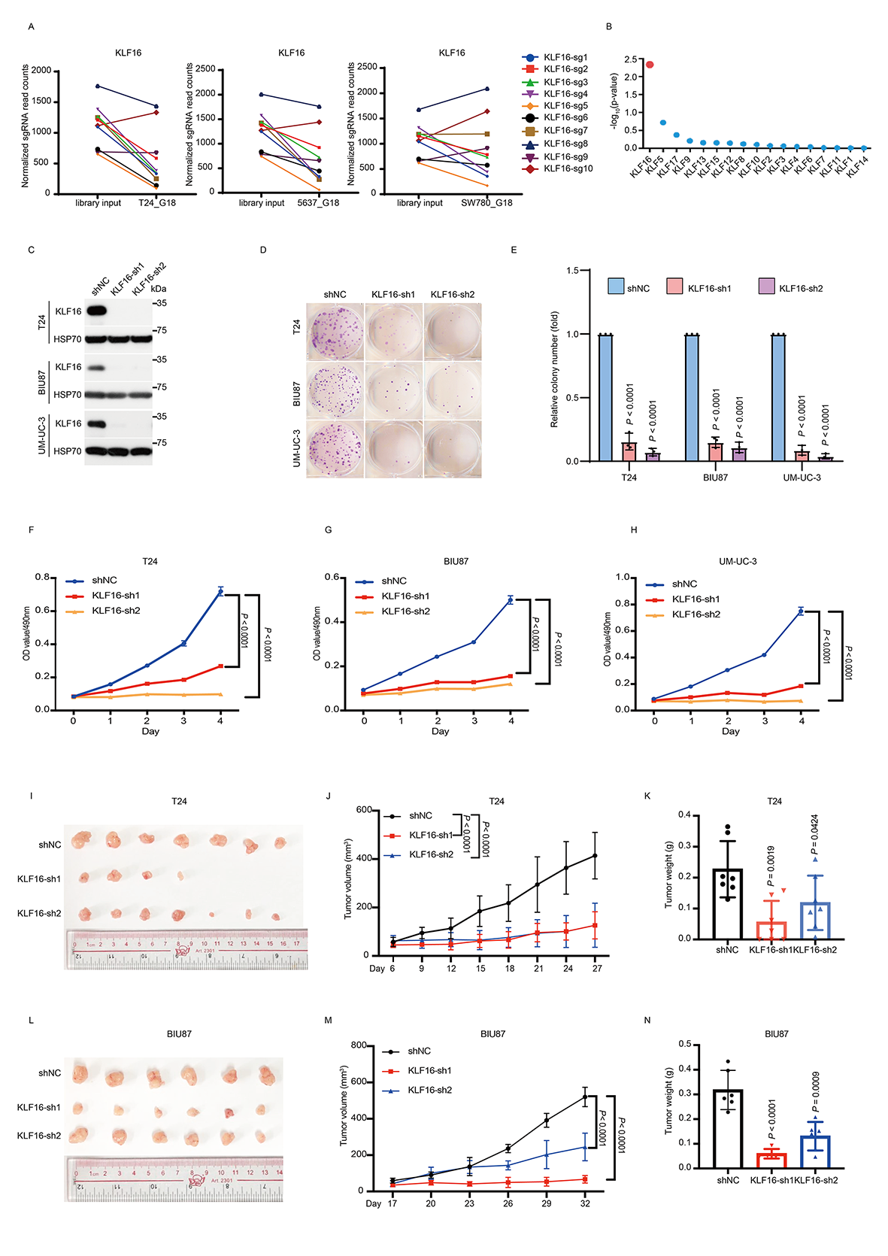
Figure. S1. KLF16 promotes tumor growth in BLCA.
(A). Read counts of individual sgRNAs targeting KLF16 were shown. (B). CRISPR screening results analyzed by MAGeCK of KLF family member genes. (C). Western blotting of the indicated proteins in T24, BIU87 and UM-UC-3 cells expressing KLF16-targeted shRNAs. (D-E). Representative images (D) and quantification (E) of colonies formed by the indicated BLCA cells in (C). The colony numbers were quantified using ImageJ software. n = 3 biologically independent experiments. (F-H). Cell viability of the indicated stable cells in (C) was measured by MTT assay at the indicated time points. n = 3 biologically independent experiments. (I-N). T24 and BIU87 cells expressing KLF16-targeted shRNAs were subcutaneously injected into nude mice. Representative images of subcutaneous xenograft tumors were shown (I and L). Tumor volumes were measured at the indicated time points (J and M). Tumor weights were measured at the end point (K and N). n = 7 nude mice per group were used for T24 experiments, and n = 6 nude mice per group were used for BIU87 experiments. All error bars represent mean ± SD and P values in E-H, K and N were calculated using two-tailed unpaired Student’s t-tests. P values in J and M were calculated by two-way ANOVA analysis followed by Tukey’s multiple comparisons test.

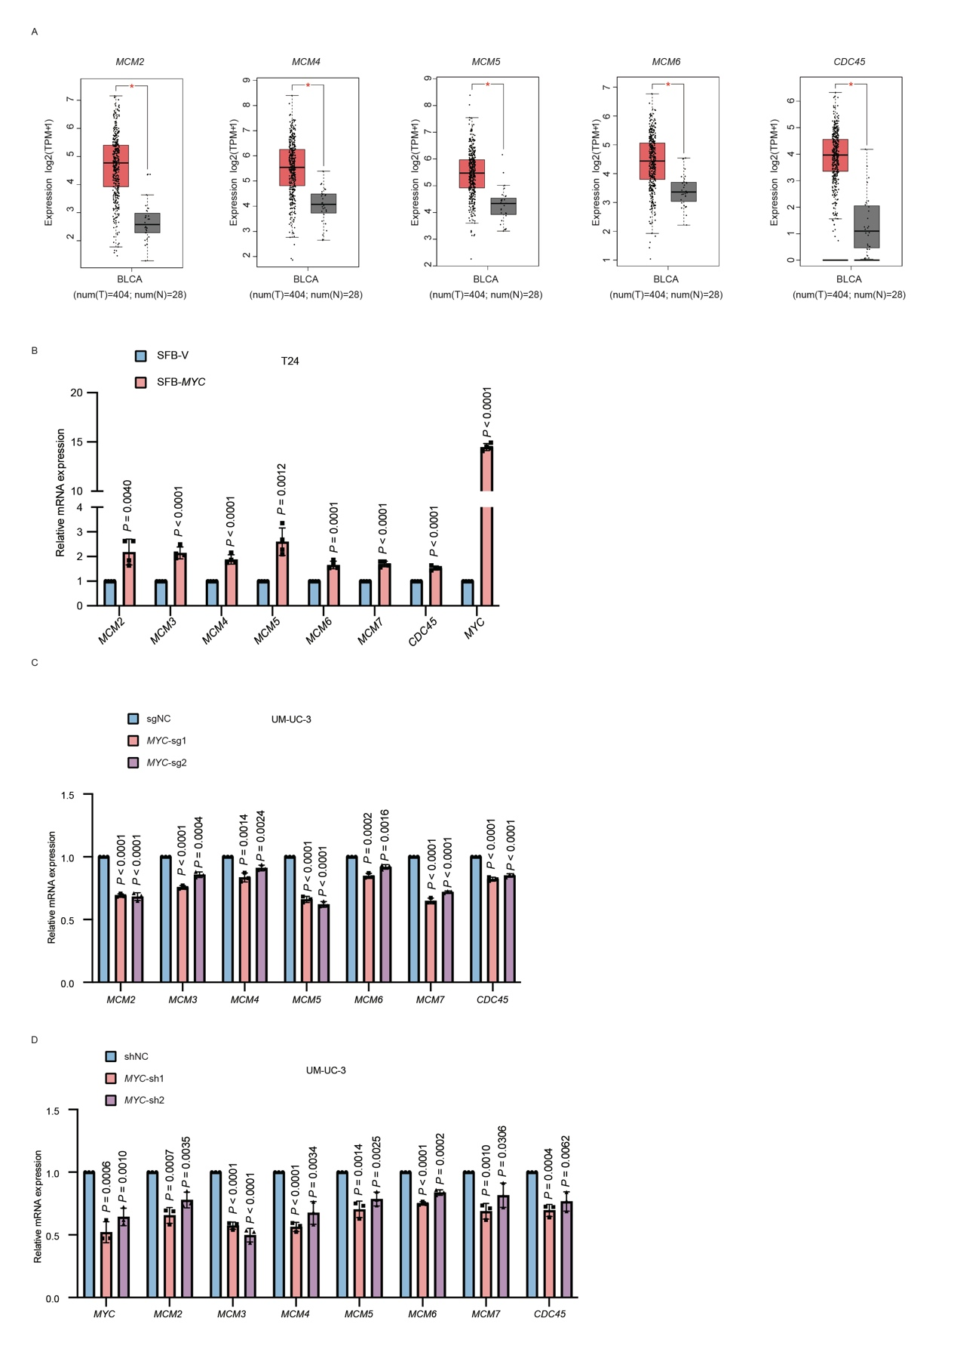
Figure. S2. MYC promotes MCM2-7 and CDC45 transcription in BLCA.
(A). Box plots demonstrate the relative mRNA expression levels (log2 (TPM+1)) of MCM2, MCM4, MCM5, MCM6, and CDC45 in BLCA tumor (T) (red column) and normal (N) (grey column) tissues. Data from Gene Expression Profiling Interactive Analysis (GEPIA) database: http://gepia.cancer-pku.cn/index.html. Single asterisk represents significant difference (P < 0.05). (B-D). qRT–PCR analyzing the mRNA levels of MYC and MYC target genes in T24 cells stably expressing SFB-MYC (B) and UM-UC-3 cells stably expressing negative control (NC) or sgMYC (C) or shMYC (D).
All error bars represent mean ± SD and P values were calculated using two-tailed unpaired Student’s t-tests.

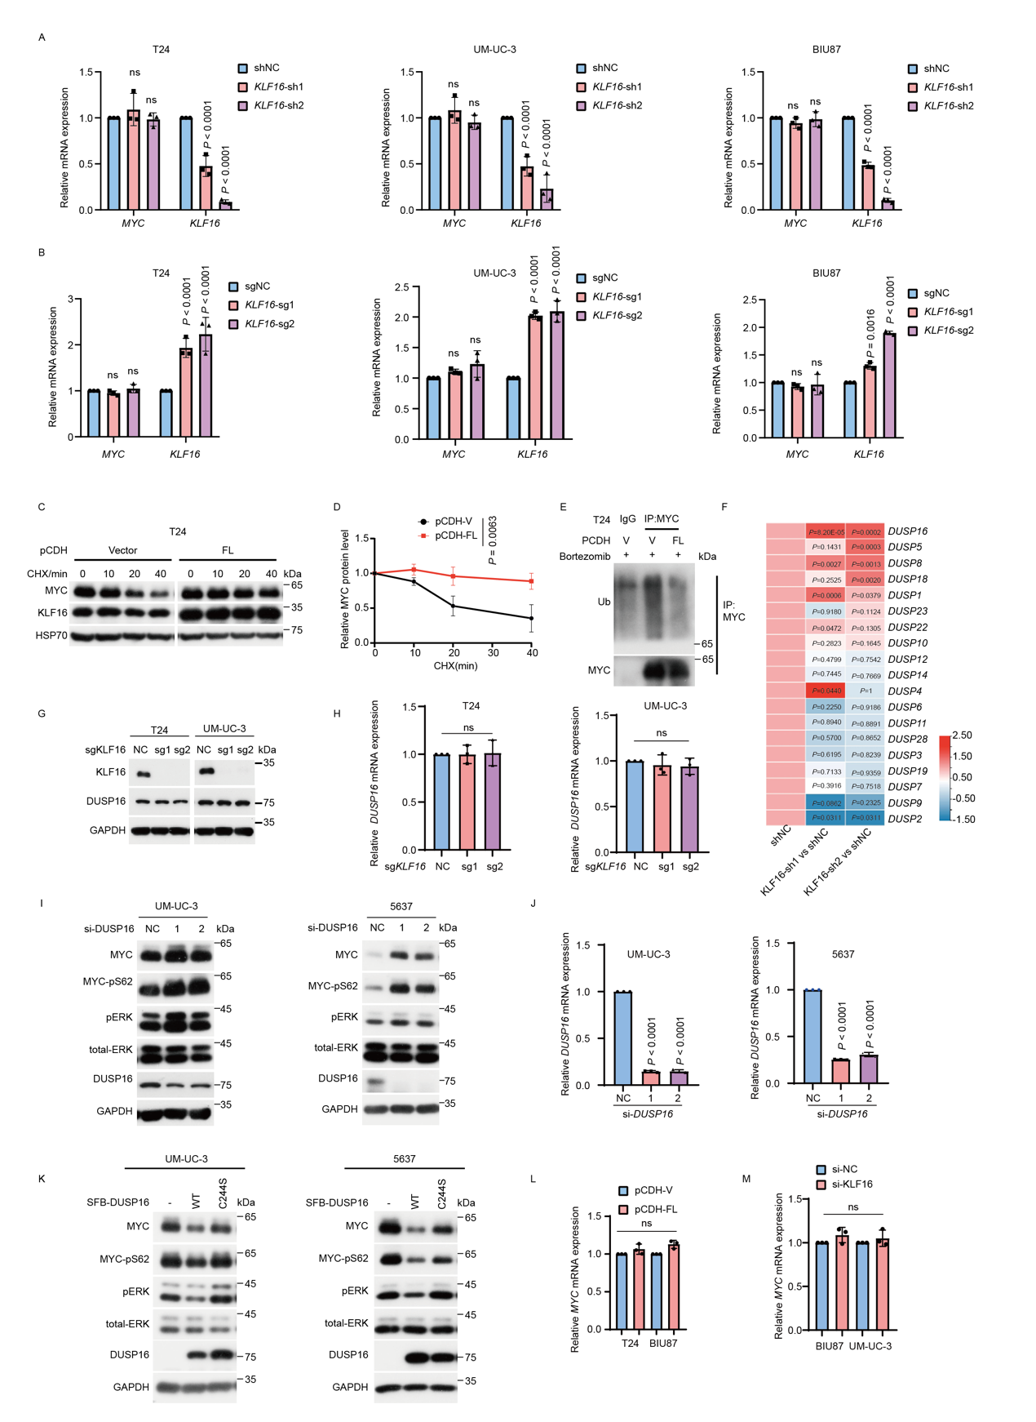

Figure. S3. KLF16 mRNA stabilizes MYC protein via destabilizing DUSP16 mRNA in BLCA.
(A-B). qRT–PCR analyzing the mRNA levels of MYC and KLF16 in the indicated cells stably expressing KLF16-targeted shRNAs (A) or sgRNAs (B). n = 3 biologically independent experiments. (C-D). T24 cells stably expressing vector or KLF16 full length (FL) mRNA were treated with 20 μg mL⁻¹ cycloheximide (CHX) at the indicated time points and then analyzed by Western blotting (C). Quantitation of MYC protein levels was based on the Western blotting results (D). n = 3 biologically independent experiments. (E) T24 cells stably expressing vector or KLF16 FL mRNA were incubated with bortezomib (1 μM) for 8 h, and then subjected to IP with anti-MYC antibody followed by Western blotting to detect MYC’s ubiquitination level. (F). The heatmap shows relative expression levels of DUSP family members in the indicated T24 stable cells. The P values were adjusted using the Benjamini and Hochberg method.
(G-H). T24 and UM-UC-3 cells stably expressing KLF16-targeted sgRNAs were analyzed by Western blotting (G) and qRT–PCR (H). n = 3 biologically independent experiments. (I-J). UM-UC-3 and 5637 cells transfected with DUSP16-targeted siRNAs for 48h were analyzed by Western blotting (I) and qRT–PCR (J). n = 3 biologically independent experiments. (K). UM-UC-3 and 5637 cells were transfected with wild-type (WT) or catalytic dead mutant (C244S) SFB-DUSP16 for 48 h followed by Western blotting for the levels of the indicated proteins. (L). T24 and BIU87 cells stably overexpression of KLF16 full-length mRNA were analyzed by qPCR. n = 3 biologically independent experiments. (M) BIU87 and UM-UC-3 cells transfected with KLF16-targeted siRNAs for 48 h were analyzed by qPCR. n = 3 biologically independent experiments. All error bars represent mean ± SD and P values were calculated using two-tailed unpaired Student’s t-tests unless noted otherwise.
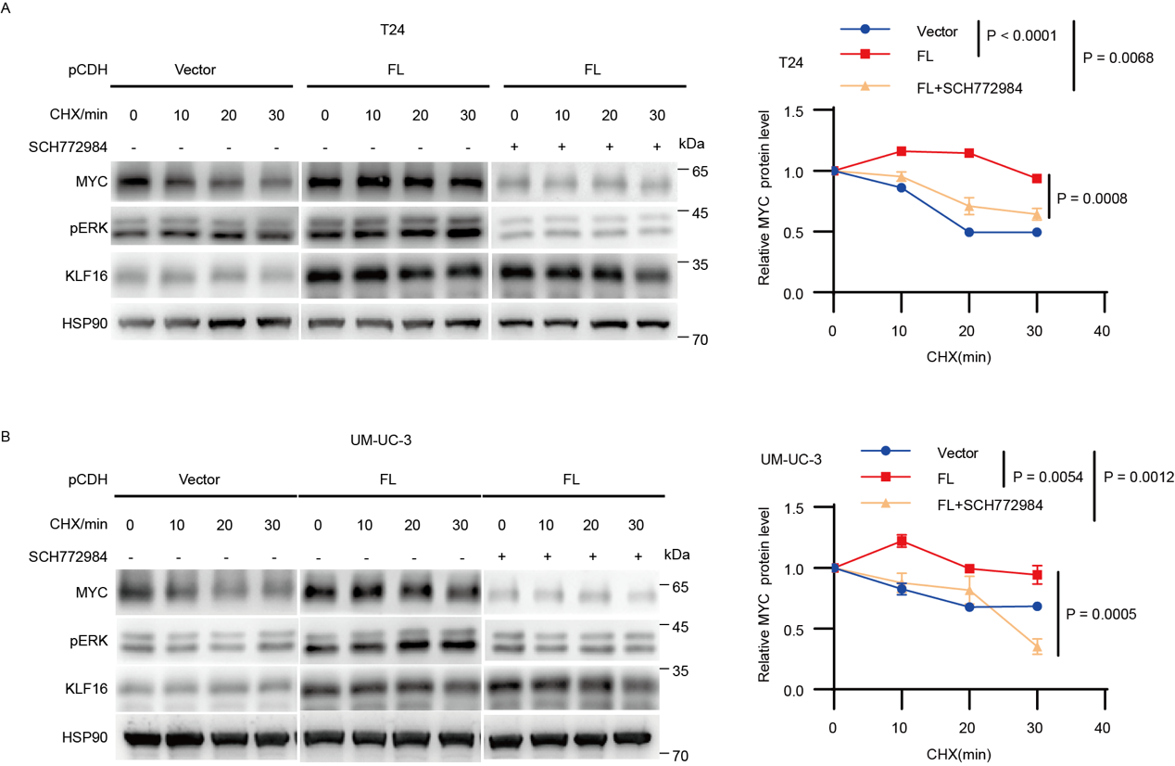

Figure. S4. Inhibition of ERK1/2 reduces MYC protein stability in KLF16-overexpressing cells.
(A-B). T24 (A) and UM-UC-3 (B) cells stably expressing vector or KLF16 full length (FL) mRNA were treated with DMSO or ERK1/2 inhibitor SCH772984 (500 nM) for 60 hours, and then exposed to 20 μg mL⁻¹ cycloheximide (CHX) at the indicated time points. Total protein lysates were subjected to Western blotting (left). Quantitation of MYC protein levels was based on the Western blotting results (right). n = 3 biologically independent experiments.
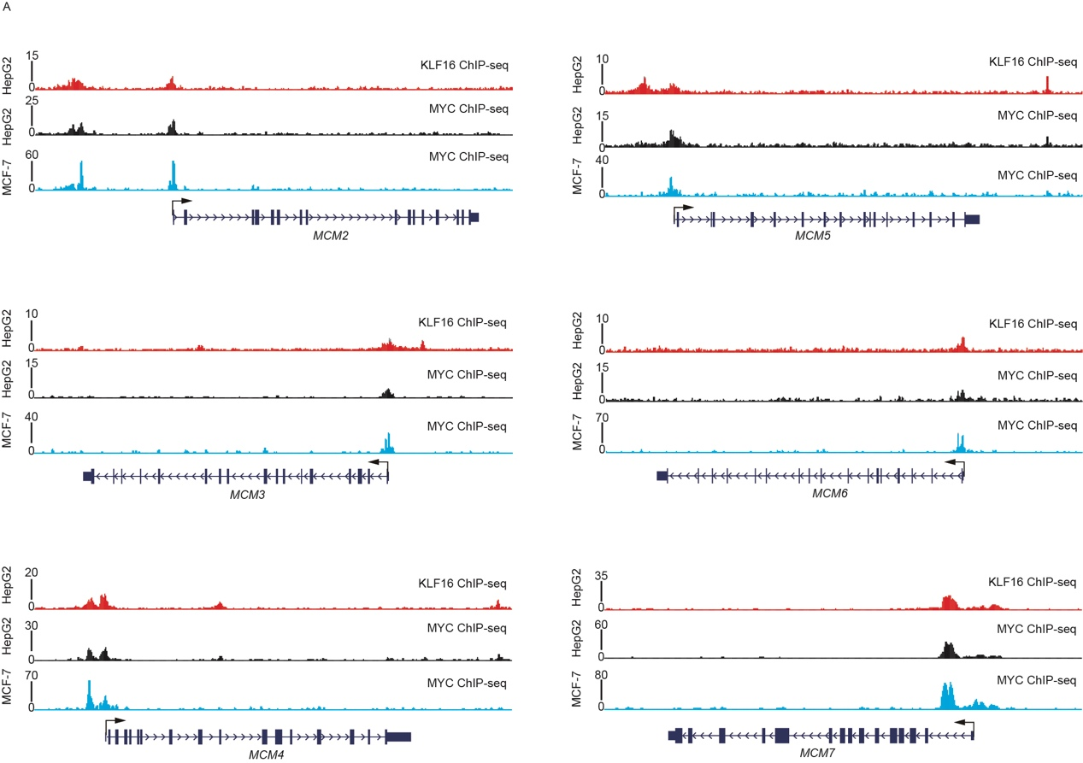

Figure. S5. Both MYC and KLF16 bound to MCM2-7 genes.
(A). Track view of KLF16 and MYC ChIP-seq density profile on MCM2-7 genomic regions in the indicated cell lines from published data sets displayed by UCSC Genome Browser: http://genome.ucsc.edu. Data from the ENCODE database：https://www.encodeproject.org.

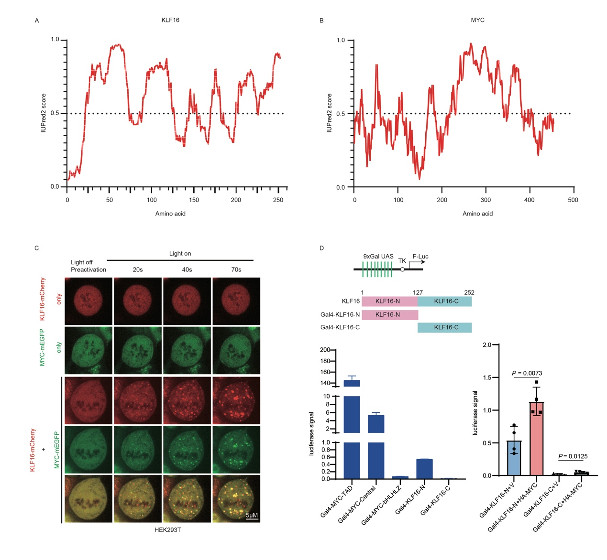

Figure. S6. KLF16 forms nuclear condensates with MYC to enhance the transcriptional activity of MYC in BLCA.
(A-B). IDR analysis of KLF16 (A) and MYC (B) using the IUPred2A tool with default parameters. Scores above 0.5 indicate disorder. (C). HEK293T cells were transfected with KLF16-mCherry-Cry2 and MYC-mEGFP-Cry2 separately or together. Images were collected after illumination by a 488 nm laser at the indicated times. (D). Schematic illustration of the 9 x Gal-TK-luciferase reporter system (upper panel) and Gal4-KLF16 truncations (lower panel). HEK293T cells were transfected with the indicated constructs, along with the 9 x Gal-TK-luciferase reporter and the Renilla control reporter for 24 hours. Then, cells were analyzed for the relative luciferase activity. Luc, luciferase

Figure. S7. OTX015 enhances DDP sensitivity in BLCA.
(A). UM-UC-3 cells were treated with increasing concentration of OTX015 for 48 hours and then subjected to qRT–PCR analysis for the indicated mRNA levels. (B). T24 and UM-UC-3 cells expressing KLF16-targeted shRNAs were treated with the indicated concentration of DDP (0, 0.125 μM, 0.25 μM, 0.5 μM, 1 μM, 2 μM, 4 μM) for 72 hours, and then the cell viability was determined by MTT assays. n = 3 biologically independent experiments. (C). Representative images of colonies formed by the indicated BLCA cell lines treated with DMSO, OTX015 (10 μM for UM-UC-3 and SYBC1, 1 μM for T24) or DDP (2.5 μM) separately or together for about 1 week. n = 3 biologically independent experiments. (D). Flow cytometry analysis of apoptosis in the indicated cells treated with DMSO, OTX015 (10 μM for UM-UC-3 and SYBC1, 1 μM for T24) or DDP (2.5 μM) separately or together for 48 h. (E). Western blotting assay for the levels of KLF16, MYC and apoptosis-related protein (cleaved PARP, c-PARP; cleaved Caspase3, c-Caspase3; cleaved Caspase7, c-Caspase7; cleaved Caspase9, c-Caspase9) in the indicated cells.
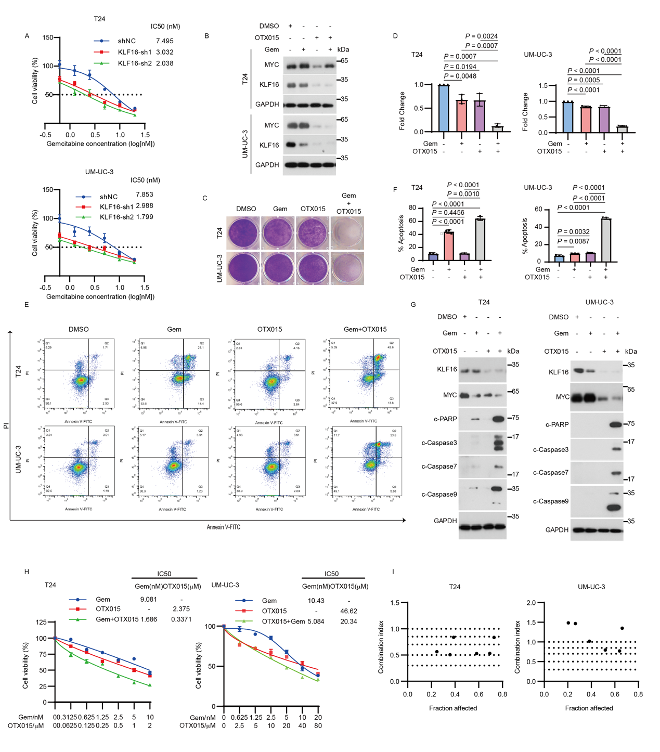

Figure. S8. OTX015 enhances gemcitabine sensitivity in BLCA.
(A). T24 and UM-UC-3 cells expressing KLF16-targeted shRNAs were treated with
the indicated concentration of gemcitabine (0, 0.625 nM, 1.25 nM, 2.5 nM, 5 nM, 10 nM, 20 nM) for 60 hours, and then the cell viability was determined by MTT assays. n = 3 biologically independent experiments. (B). T24 and UM-UC-3 cells were treated with DMSO, gemcitabine (Gem, 5 nM) or OTX015 (10 μM for UM-UC-3 and 1 μM for T24) separately or together for 72 h, the indicated proteins were determined by Western blotting. (C-D). Representative images (C) and quantification (D) of colonies formed by T24 and UM-UC-3 cells used in (B) for about 1 week. n = 3 biologically independent experiments. (E-F). Representative images (E) and quantification (F) of flow cytometry analysis of apoptosis in the indicated cells treated with the indicated drugs for 48 h. (G). Western blotting assay for the levels of KLF16, MYC and apoptosis-related protein (cleaved PARP, c-PARP; cleaved Caspase3, c-Caspase3; cleaved Caspase7, c-Caspase7; cleaved Caspase9, c-Caspase9) in the indicated cells. (H). T24 and UM-UC-3 cells were treated the indicated concentration of OTX015 or gemcitabine alone or in combination for 48 hours, and then the relative cell growth rates were determined by MTT assays. n = 3 biologically independent experiments. (I). The Combination Index (CI) of OTX015 and gemcitabine was calculated based on results from (G) by using CalcuSyn. CI < 1, = 1, and >1 indicate synergism, additive effect, and antagonism, respectively. All error bars represent mean ± SD and P values in D and F were calculated using two-tailed unpaired Student’s t-tests.

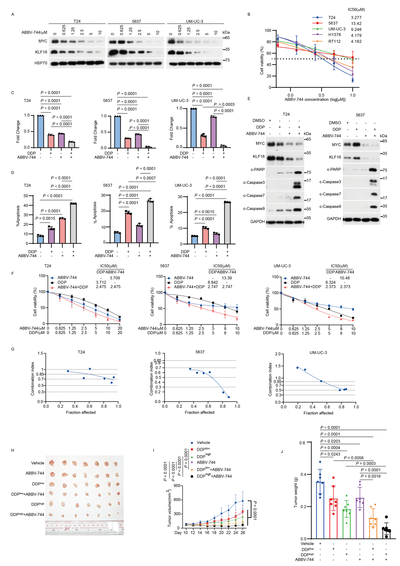

Figure. S9. ABBV-744 enhances DDP sensitivity in BLCA.
(A). T24, 5637 and UM-UC-3 cells were treated with increasing concentration of ABBV-744 for 48 hours and then were analyzed by Western blotting. (B). The indicated bladder cancer cell lines were treated with the indicated concentration of ABBV-744 (0, 0.625 μM, 1.25 μM, 2.5 μM, 5 μM, 10 μM) for 48h, and then the relative cell growth rates were determined by MTT assay. n = 3 biologically independent experiments. (C-D). The indicated cells were treated with DMSO, ABBV-744 (2.5 μM) or DDP (2.5 μM) separately or together, and subsequently subjected to colony formation (C) and flow cytometry analysis of apoptosis (D). n = 3 biologically independent experiments. (E). Western blotting assay for the levels of KLF16, MYC and apoptosis-related protein (cleaved PARP, c-PARP; cleaved Caspase3, c-Caspase3; cleaved Caspase7, c-Caspase7; cleaved Caspase9, c-Caspase9) in T24 and 5637 with the indicated drugs used in (D). (F) BLCA cells were treated the indicated concentration of ABBV-744 or DDP alone or in combination for 48 hours, and then the relative cell growth rates were determined by MTT assays. n = 3 biologically independent experiments. (G) The Combination Index (CI) of ABBV-744 and DDP was calculated based on results from (F) by using CalcuSyn. CI < 1, = 1, and >1 indicate synergism, additive effect, and antagonism, respectively. (H-J). Mice bearing T24 tumors were randomly divided into the indicated groups (n = 7 mice per group). DDP^{low} (3 mg kg⁻¹), DDP^{high} (5 mg kg⁻¹) were injected intraperitoneally twice weekly. ABBV-744 (10 mg kg⁻¹) were daily given via intragastric administration. Tumor volumes (I) and tumor weights (J) were measured. All error bars represent mean ± SD and P values in C, D, J were calculated using two-tailed unpaired Student’s t-tests, P values in I were calculated by two-way ANOVA with Tukey’s multiple comparisons test.

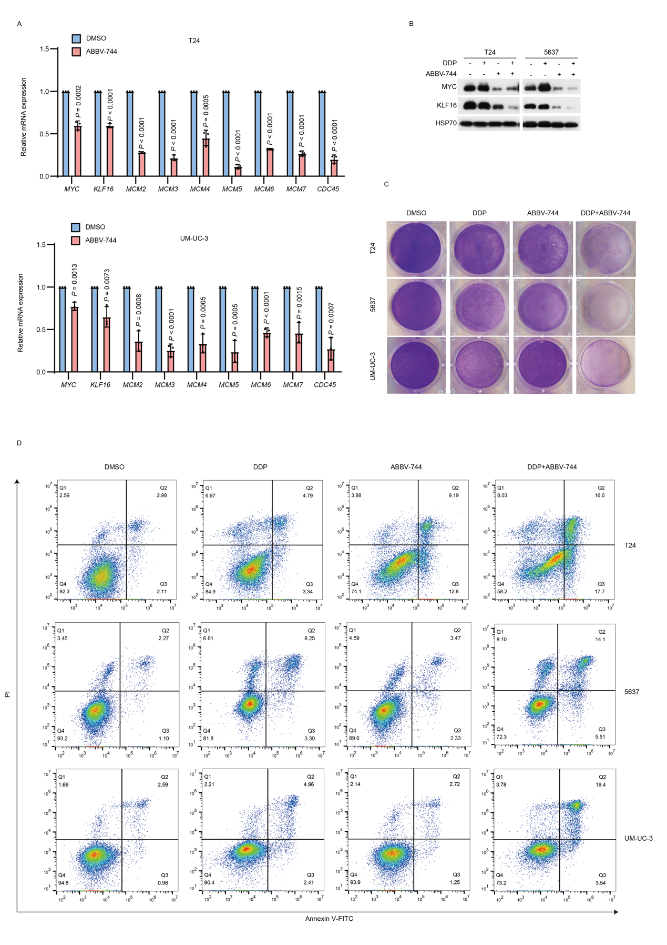

Figure. S10. ABBV-744 enhances DDP sensitivity in BLCA.
(A). T24 and UM-UC-3 cells were treated with ABBV-744 (2.5 μM) for 48 hours and then were analyzed by qRT-PCR. (B). T24 and 5637 cells were treated with DMSO, ABBV-744 (2.5 μM) or DDP (2.5 μM) separately or together and subsequently subjected to Western blotting. (C-D). Representative images of the indicated cells treated with DMSO, ABBV-744 (2.5 μM) or DDP (2.5 μM) separately or together and subsequently subjected to colony formation assays (C) and flow cytometry analysis of apoptosis (D). n = 3 biologically independent experiments. Error bars in (A) represent mean ± SD and P values were calculated using two-tailed unpaired Student’s t-tests.

