Liquid biopsy search strategy

Databases to search:
Embase, Scopus, PubMed & Web of Science
Total articles from search: 4837
- Embase – 1624
- PubMed – 770
- Scopus – 1134
- Web of Science – 1309
Total articles after deduplication:
- 2158 references kept
- 2679 references removed

Embase – 1624

https://simsrad.net.ocs.mq.edu.au/login?url=http://ovidsp.ovid.com/ovidweb.cgi?T=JS&NEWS=N&PAGE=main&SHAREDSEARCHID=3Xx7triQLzRawGteIG6CTCqzMqZO485t7mE0cBpNAxDaLQxjU35OZMcjxpVF8dD19
- 1 and 2 and 3 and 4
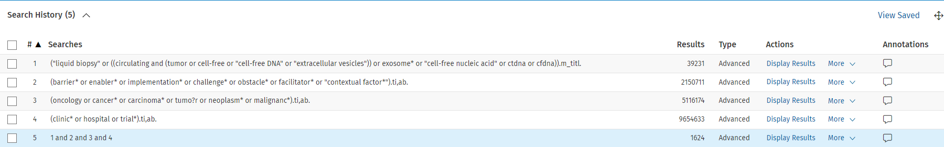

Scopus – 1134
"liquid biopsy" OR ( ( circulating ) AND ( tumor OR cell-free OR "cell-free DNA" OR "extracellular vesicles" ) OR exosome* OR "cell-free nucleic acid" OR ctdna OR cfdna )
AND
barrier* OR enabler* OR implementation* OR challenge* OR obstacle* OR facilitator* OR "contextual factor*"
AND
oncology OR cancer* OR carcinoma* OR tumo?r OR neoplasm* OR malignanc*
AND
clinic* OR hospital OR trial*

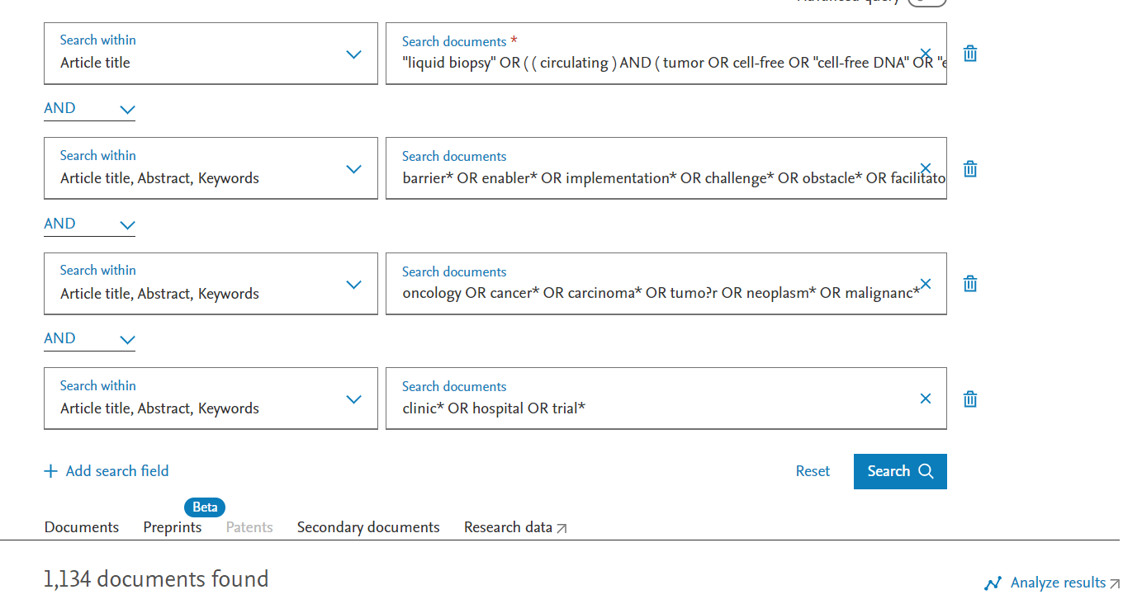

PubMed – 770 results
(((liquid biopsy[Title] OR circulating tumor DNA[Title] OR (circulating tumo?r DNA[Title] OR ctDNA[Title] OR cfdna[Title] OR circulating cell-free tumo?r DNA[Title] OR circulating cell-free DNA[Title] OR circulating tumo?r cell*[Title] OR circulating extracellular vesicles[Title] OR exosome*[Title] OR cell-free nucleic acid [Title])) AND (barrier*[Title/Abstract] OR enabler*[Title/Abstract] OR challenge*[Title/Abstract] OR facilitator*[Title/Abstract] OR implementation[Title/Abstract] OR obstacle*[Title/Abstract] OR contextual factor*[Title/Abstract])) AND (cancer*[Title/Abstract] OR oncology[Title/Abstract] OR carcinoma*[Title/Abstract] OR tumo?r*[Title/Abstract] OR neoplasm*[Title/Abstract] OR malignanc*[Title/Abstract])) AND (clinic*[Title/Abstract] OR hospital[Title/Abstract] OR trial*[Title/Abstract])

Web of Science -1309
https://www.webofscience.com/wos/alldb/summary/8f4a226c-b6f5-4c32-bc7c-f5fad4cf8031-cf5400c1/relevance/1

"liquid biopsy" OR ( ( circulating ) AND ( tumor OR cell-free OR "cell-free DNA" OR "extracellular vesicles" ) OR exosome* OR "cell-free nucleic acid" OR ctdna OR cfdna )
AND
barrier* OR enabler* OR implementation* OR challenge* OR obstacle* OR facilitator* OR "contextual factor*"
AND
oncology OR cancer* OR carcinoma* OR tumo?r OR neoplasm* OR malignanc*
AND
clinic* OR hospital OR trial*

