Supplementary

Figure S1: The results of SNV and InDel among different PDOs
A. The statistics of SNV position type mutations in 5 PDOs were respectively represented. B. The statistics of INDEL position type mutations in 5 PDOs were respectively represented. C. The statistics of INDEL and SNV base substitutions mutations in 5 PDOS.

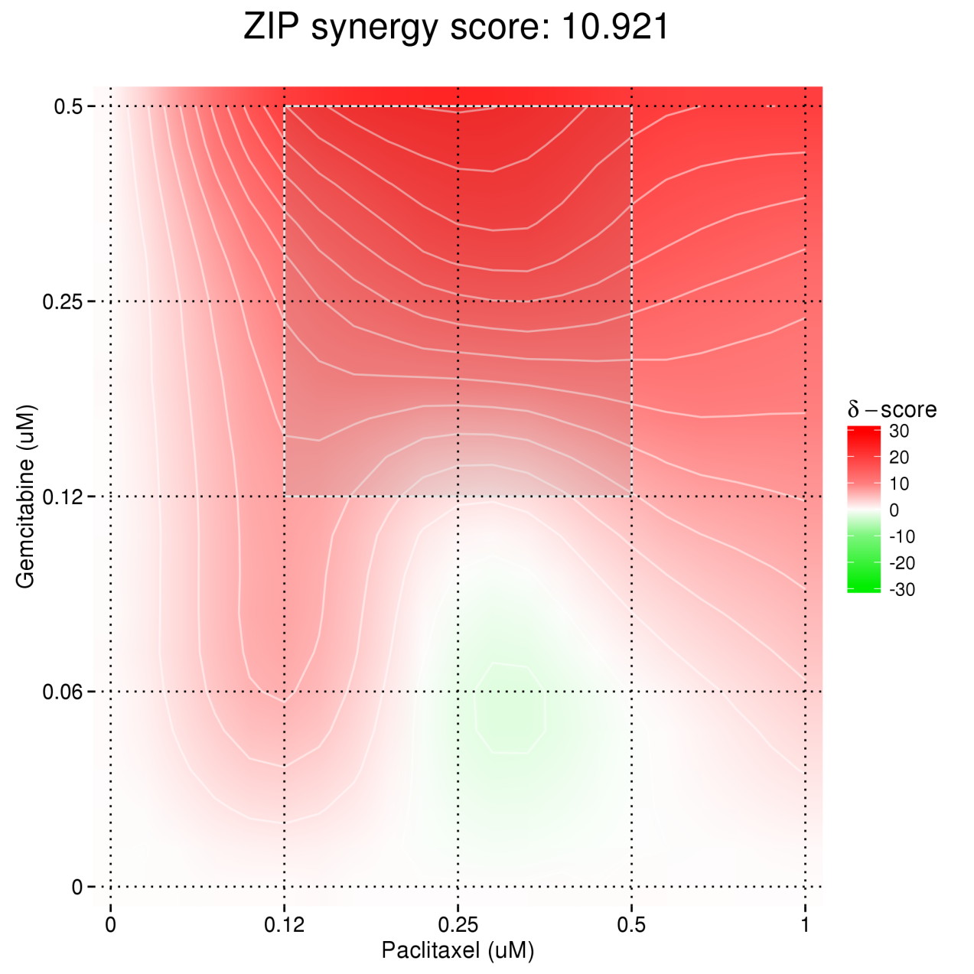

Figure S2: Synergy score of Gemcitabine and Paclitaxel analyzed using Synergyfinder in PDO_1

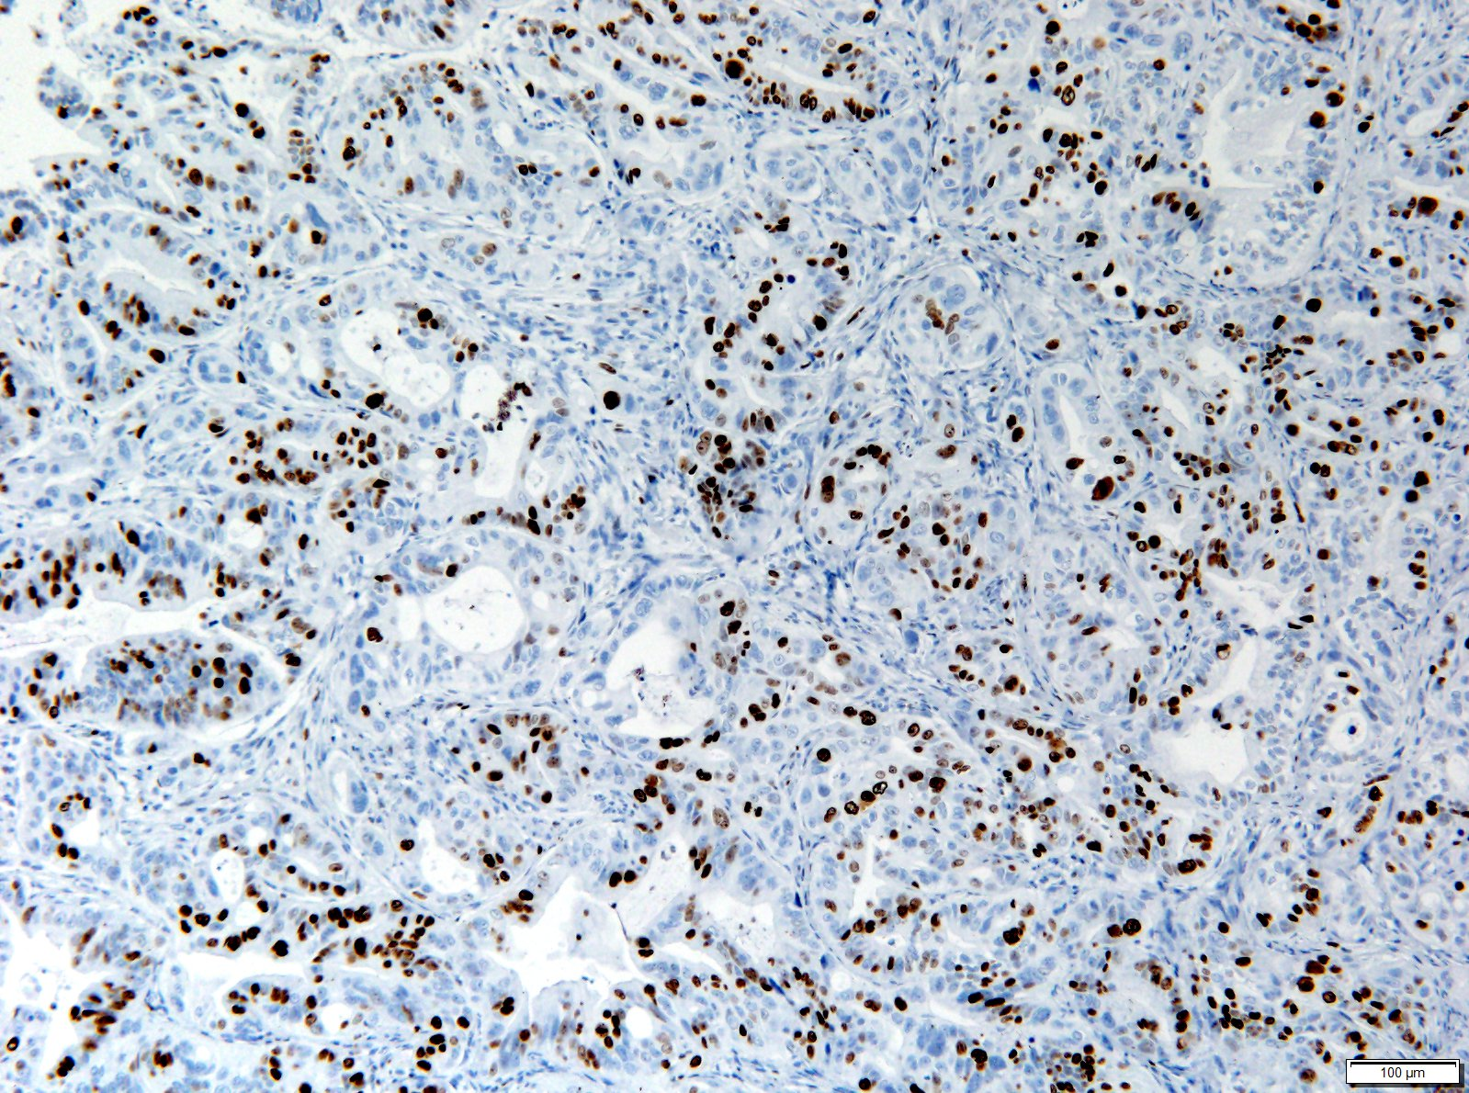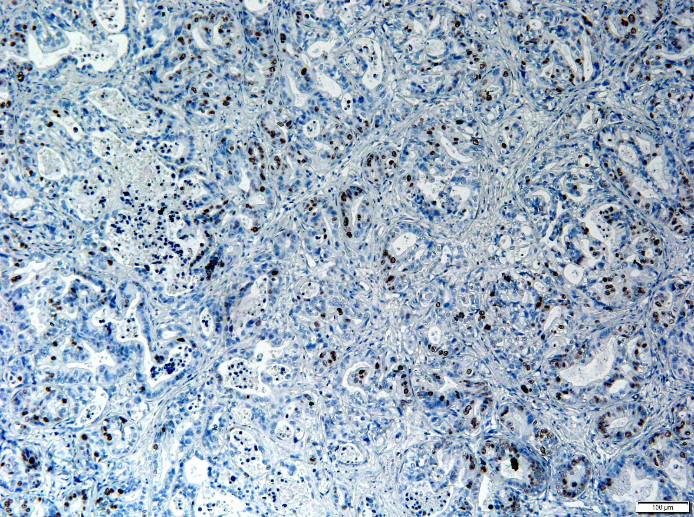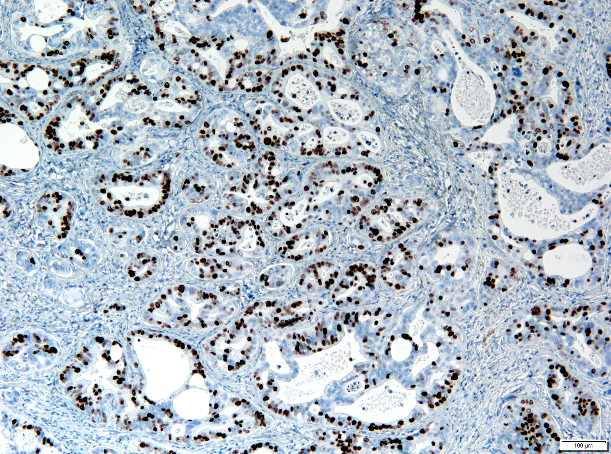
PDOX Ki-67(IHC)

Control
Combination
Gemcitabine
Figure S3: The expression of Ki-67 in PDOX models across different treatment groups: control, gemcitabine-treated, and combination-treated.

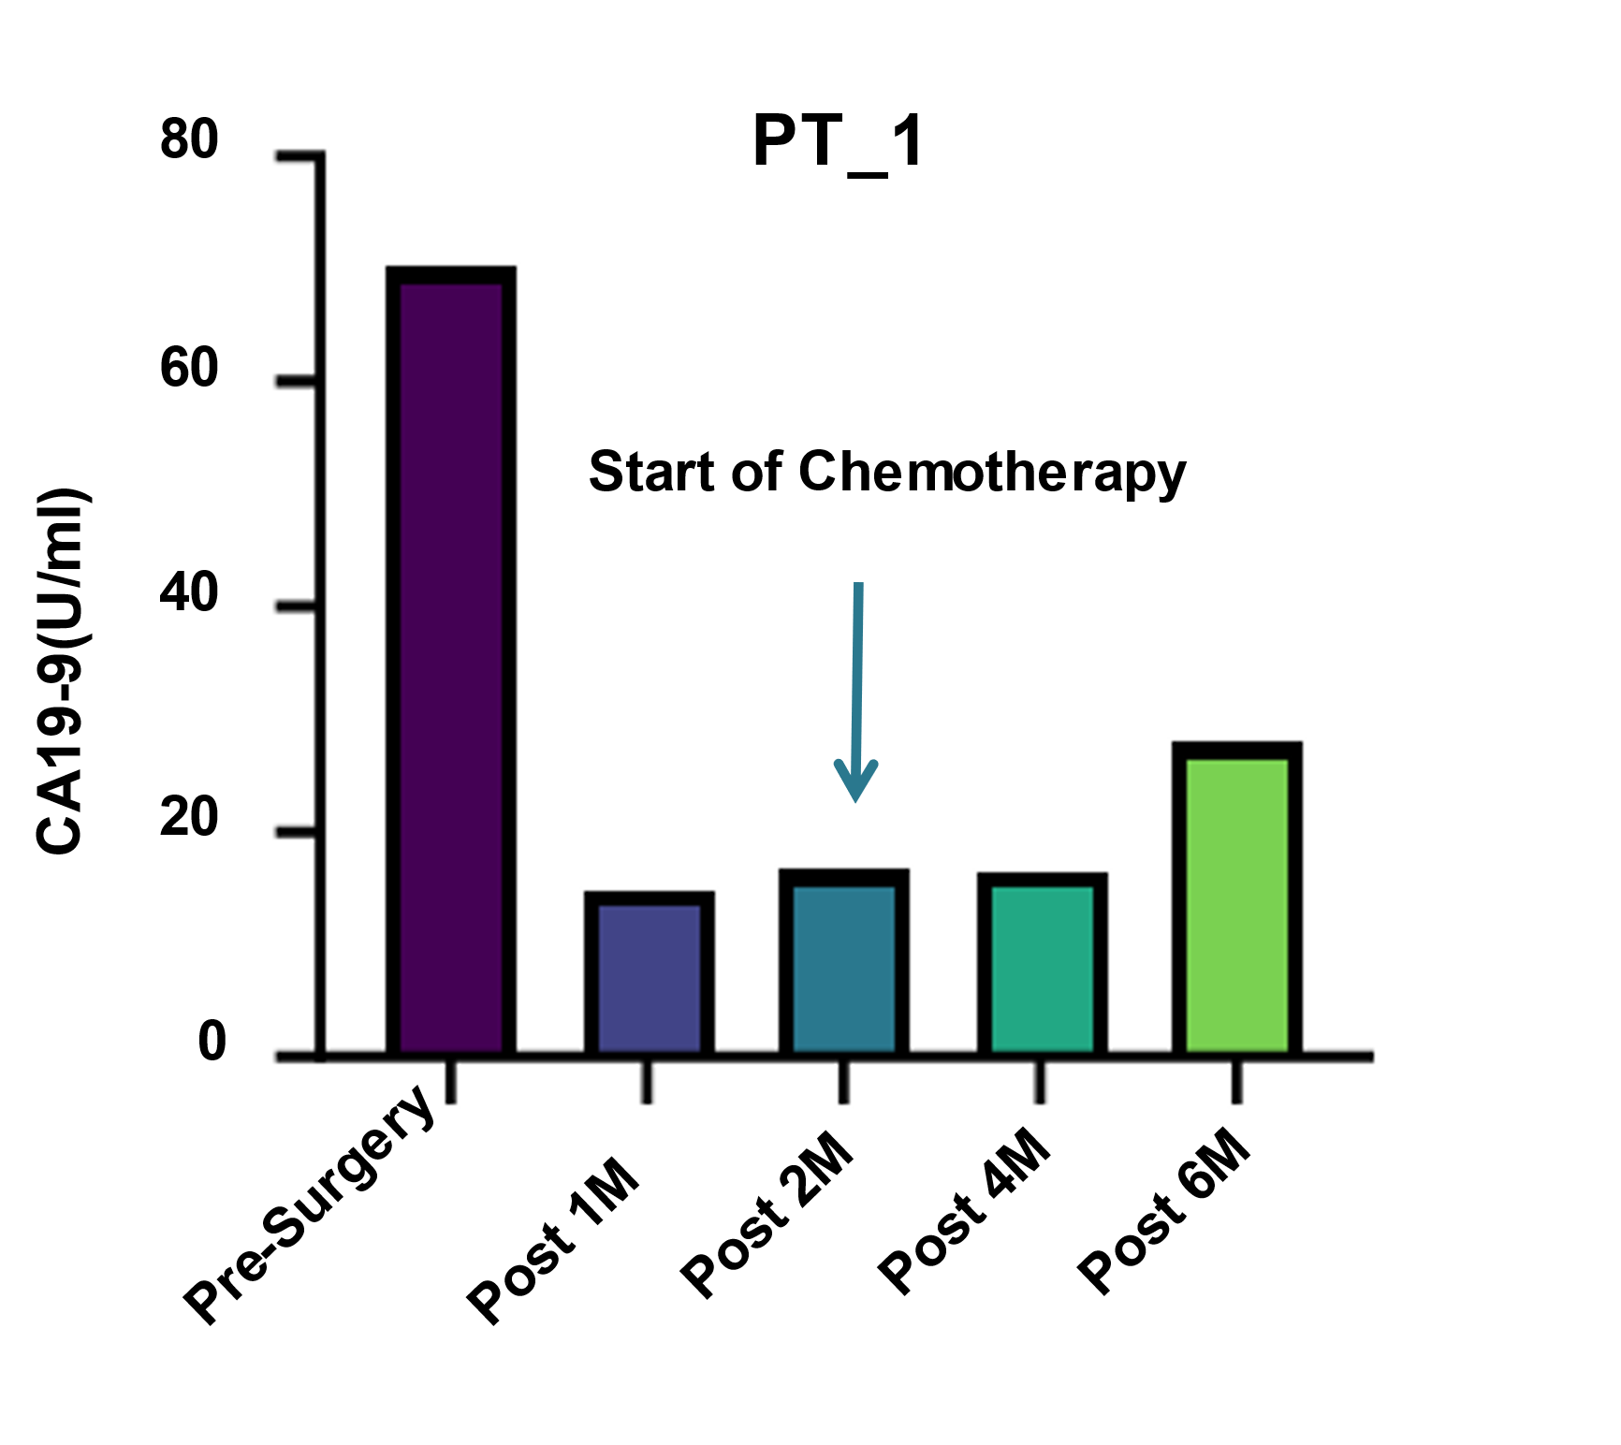
Figure S4: The combination therapy of gemcitabine and paclitaxel effectively reduced the CA19-9 levels in serum of patient PT_1. M means month.

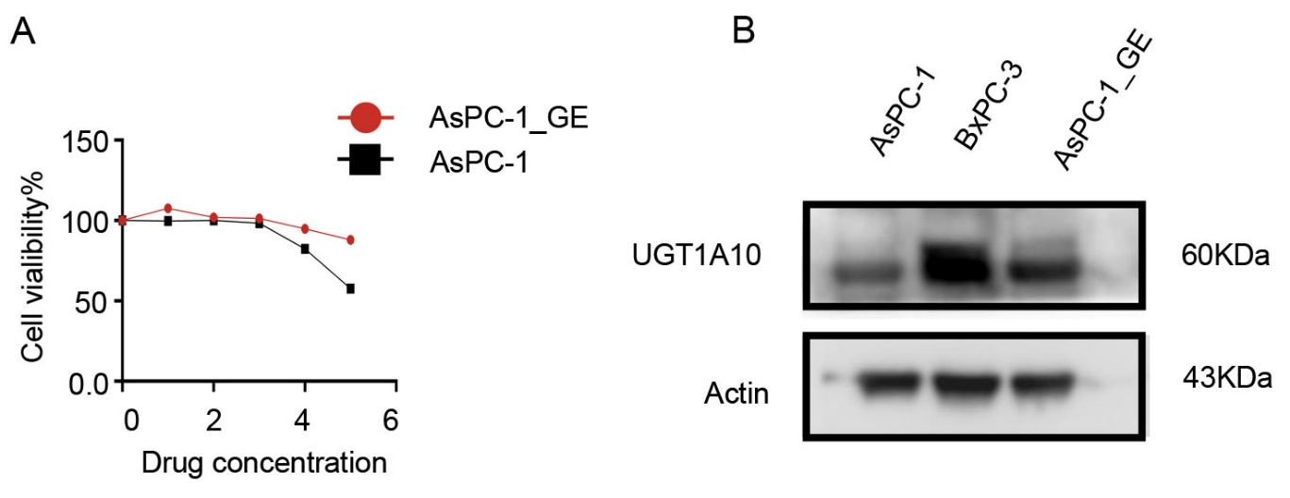

Figure S5: Expression of UGT1A10 is upregulated in gemcitabine-resistant PDAC cell lines
A. PDAC cell line AsPC-1 develops resistance following induction by Gemcitabine.
B. The Gemcitabine-resistant cell line AsPC-1_GE exhibits increased UGT1A10 expression compared to the parental AsPC-1 line. Additionally, the PDAC cell line BxPC-3 shows the high level UGT1A10 expression.

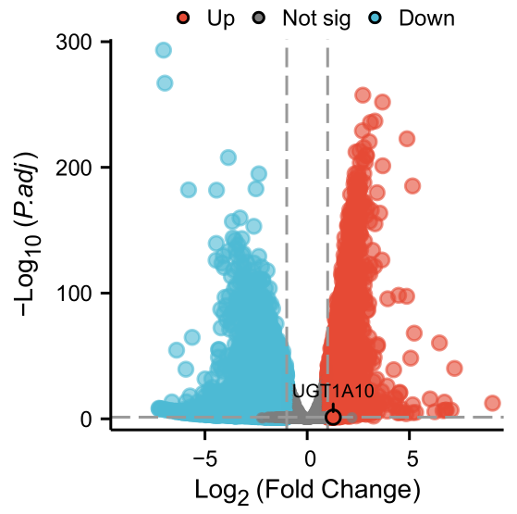

Figure S6: The volcano plot compares bulk RNA-seq data between the human PDAC cell line CFPAC-1 and its gemcitabine-resistant cells.
Red points denote upregulated genes, blue points represent downregulated genes, and gray points signify genes without significant differences. The encircled point highlights the upregulated differential gene UGT1A10.

Figure S7: Research on the role of UGT1A10 in pancreatic cancer pathological grade and drug resistance mechanism.
A. Upon conducting immunohistochemical analysis of clinical pancreatic cancer specimens, we observed that the expression level of UGT1A10 is positively correlated with the pathological grade of pancreatic cancer (n=9). B. In histological analyses of patient-derived organoids (PDOs), the expression level of UGT1A10 was found to exhibit a positive correlation trend with the pathological grade of the corresponding clinical pancreatic cancer. C. After knocking down UGT1A10 in the organoid PDO_3, the related drug-resistant genes (including CDK4, CDK6, CCNL1, DCK, N-cadherin.) also showed a downward trend as detected by q-PCR (Sup Table 5). D. The KEGG enrichment bar - chart shows that UGT1A10 is involved in the regulation of the drug-resistance mechanism through the PI3K-akt pathway. E. Compared with the parental AsPC-1 cell line, the Gemcitabine-resistant cell line AsPC-1_GE shows increased expression of UGT1A10, p-AKT, and AKT. Compared with the NC group, the organoids with UGT1A10 knockdown exhibit decreased expression of p-AKT and AKT.

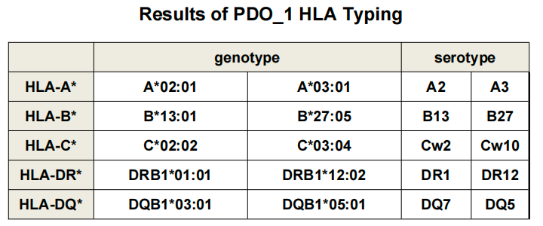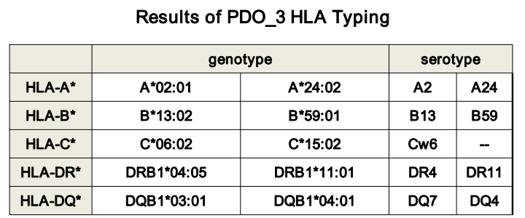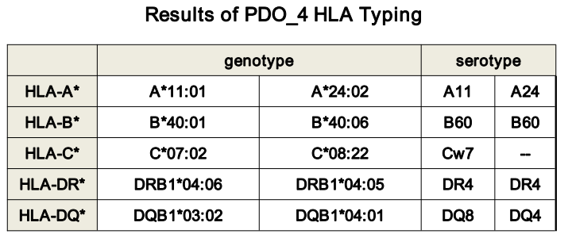
Figure S8: The HLA typing results of PDO_1, PDO_3 and PDO_4.

Figure S9: Comparative analysis of T cell viability and functionality in T cell medium versus PDO medium"
A: The proliferation of T cells in T cell medium (red) and PDO medium (black). The viability and activity of T cells were quantitatively assessed at 0, 24, 48, and 72 hours using the optical density (OD) at 450 nm as an indicator. B: The mRNA expression levels of Granzyme B (Grzm B), CD25, and CD69 (Sup Table 5) in T cells cultured in T cell medium and PDO medium were evaluated.

Bright field
Merge
IF
PDO
CAR-Ms

Figure S10: Immunofluorescence (IF) images demonstrate the interaction between CAR-Ms (in red) and PDOs (in green). From left to right are the bright field image, the fluorescence - labeled image of CAR-Ms, the fluorescence labeled image of PDOs, and the merged (Merge) image of those two.

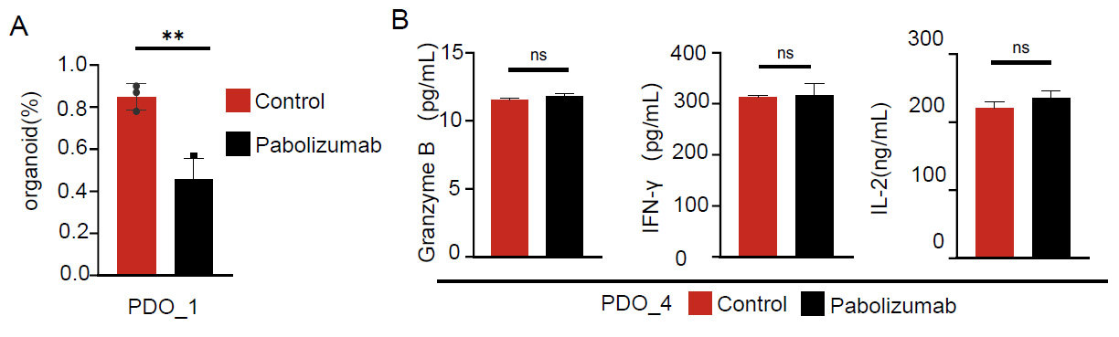

Figure S11: Evaluating the immunotherapy sensitivity of pabolizumab and CAR-Ms through PDOs.
A. Results of organoid spheroid formation analysis of PDO_1 co-cultured with PBMCs. B. Statistical analysis of the level of IL-2, granzyme B, and IFN-γ was conducted after co-culturing with PBMCs in PDO_4.

Table S1. Information on pancreatic cancer patients

Serial No | ID | Gender | Age | Differentiation | Case Subtype | Sample Site | Tumor Stage
1 | PT_1 | Male | 52 | Medium | PDAC | Pancreatic Head | T2NxM1
2 | PT_2 | Female | 60 | Medium | PDAC | Pancreatic Head | T2N0M1
3 | PT_3 | Male | 69 | Medium | PDAC | Pancreatic Head | T3N1Mx
4 | PT_4 | Male | 45 | Medium | PDAC | Pancreatic Head | T2N1Mx
5 | PT_5 | Male | 72 | Medium/High | PDAC | Pancreatic Head | T2N1Mx

Table S2. Drug concentrations of five first-line therapies for pancreatic cancer
Drug Concentration  (ng/mL) | 5 | 4 | 3 | 2 | 1
Gemcitabine | 7900 | 1580 | 316 | 63.2 | 12.64
5-Fluorouracil | 1300 | 260 | 52 | 10.4 | 2.08
Cisplatin | 850 | 170 | 34 | 6.8 | 1.36
Irinotecan | 2000 | 400 | 80 | 16 | 3.2
Irinotecan | 3700 | 740 | 148 | 29.6 | 5.92

Table S3. Information of 111drugs for treatment of PDAC
Serial No | Drug | Serial No | Drug
1 | Axitinib (AG 013736) | 54 | Resminostat
2 | Bortezomib (PS-341) | 55 | Tivantinib (ARQ 197)
3 | Dasatinib (BMS-354825) | 56 | Evofosfamide (TH-302)
4 | Gefitinib (ZD1839) | 57 | Devimistat (CPI-613)
5 | Imatinib (STI571) Mesylate | 58 | Tacedinaline (CI994)
6 | Lenalidomide (CC-5013) | 59 | Icotinib (BPI-2009H)
7 | Nilotinib (AMN-107) | 60 | Daunorubicin (RP 13057) HCl
8 | Sorafenib (BAY 43-9006) tosylate | 61 | Carmustine
9 | Sunitinib (SU11248) malate | 62 | Isoquercitrin
10 | Olaparib (AZD2281) | 63 | (-)-Arctigenin
11 | Masitinib (AB1010) | 65 | Vinorelbine ditartrate (KW-2307)
12 | Crizotinib (PF-02341066) | 66 | 6-Mercaptopurine (6-MP) Monohydrate
13 | Vismodegib (GDC-0449) | 67 | Vinblastine (NSC-49842) sulfate
14 | BI 2536 | 68 | 2-Deoxy-D-glucose (2-DG)
15 | Everolimus (RAD001) | 69 | Ciprofloxacin hydrochloride hydrate
16 | Docetaxel (RP56976) | 70 | Nimustine Hydrochloride
17 | Paclitaxel (NSC 125973) | 71 | Chloropyramine hydrochloride
18 | Capecitabine (RO 09-1978) | 72 | Abemaciclib (LY2835219)
19 | Regorafenib (BAY 73-4506) | 75 | Osimertinib (AZD9291)
20 | Thalidomide (K17) | 76 | PND-1186 (VS-4718)
21 | Doxorubicin (Adriamycin) HCl | 77 | Salirasib
22 | Fluorouracil (5-Fluorouracil | 78 | Dovitinib(TKI258)Lactate monohydrate
23 | Methotrexate (CL-14377) | 79 | Sunitinib (SU11248)
24 | Dacarbazine (NSC-45388) | 80 | Dasatinib Monohydrate
25 | Epirubicin (IMI 28) HCl | 81 | Erlotinib (OSI-774)
26 | Etoposide (VP-16) | 82 | PX-12
27 | Topotecan (NSC609699) HCl | 83 | Napabucasin (BBI608)
28 | Vincristine (NSC-67574) sulfate | 84 | Nirogacestat (PF-03084014)
29 | Carmofur | 85 | Riviciclib hydrochloride (P276-00)
30 | Floxuridine (NSC 27640) | 86 | Samotolisib (LY3023414)
31 | Tegafur (FT-207) | 87 | GSK2256098
32 | Ifosfamide (NSC109724) | 88 | Tucidinostat (Chidamide)
33 | Mercaptopurine (6-MP) | 89 | Harringtonine
35 | Ruxolitinib (INCB018424) | 90 | Talabostat (PT-100)
36 | Pirarubicin (NSC-333054) | 91 | Acelarin (NUC-1031)
37 | Tipifarnib (R115777) | 92 | Irinotecan (CPT-11)
38 | Pimasertib (AS-703026) | 93 | Fluzoparib (SHR-3162)
39 | Gemcitabine (LY-188011) | 94 | Metarrestin (ML246)
40 | Thioguanine (NSC 752) | 95 | Trametinib DMSO solvate
41 | Teniposide | 96 | Irinotecan hydrochloride
42 | Lomustine | 97 | Rucaparib Camsylate
43 | Hydroxyurea (NSC-32065) | 98 | Pimonidazole
44 | Gimeracil | 100 | Oleandrin (PBI-05204)
45 | Cyclophosphamide (NSC-26271) Monohydrate | 101 | Cisplatin (NSC 119875)
46 | Irinotecan (CPT-11) HCl Trihydrate | 102 | Exatecan Mesylate
47 | Momelotinib (CYT387) | 103 | Endovion (NS 3728)
48 | (S)-10-Hydroxycamptothecin | 104 | Relacorilant
49 | Mitoxantrone (NSC-301739) 2HCl | 105 | Gemcitabine (LY-188011) HCl
50 | Rabusertib (LY2603618) | 106 | Carboplatin (NSC 241240)
51 | Rabusertib (LY2603618) | 107 | Cytarabine (U-19920A)
52 | Trametinib (GSK1120212) | 109 | Methotrexate disodium
53 | Ibrutinib (PCI-32765) | 109 | Methotrexate disodium
 |  | 111 | Erlotinib (OSI-774) HCl

Table S4. Statistical indicators of sample sequencing data
sample | PDO_1 | PDO_2 | PDO_3 | PDO_4 | PDO_5 | PT_3 | PT_4
[Total] Mapped Data (Mb) | 46989.82 | 46849.03 | 54846.55 | 46314.16 | 53789.2 | 57707 | 55521.39
[Total] Fraction of Mapped Data (Mb) | 99.75% | 99.69% | 99.75% | 99.70% | 99.77% | 99.72% | 99.71%
[Total] PCR duplicate reads | 98913901 | 1010454141 | 17645285 | 103907484 | 136021227 | 121283700 | 11887979
[Total] Fraction of PCR duplicate reads | 30.49% | 31.39% | 31.30% | 32.79% | 36.91% | 30.60% | 31.26%
[Target] Fraction of Target Reads in all reads | 72.98% | 72.53% | 70.11% | 71.66% | 72.15% | 70.84% | 70.77%
[Target] Average depth | 605.45 | 596.27 | 666.68 | 579.04 | 678.48 | 711.65 | 682.9
[Target] Average depth (rmdup) | 408.37 | 397.18 | 444.5 | 377.56 | 415.22 | 480.65 | 455.81
[Target] Coverage (>0x) | 99.78% | 99.70% | 99.91% | 99.89% | 99.59% | 99.91% | 99.90%
[Target] Coverage (>=4x) | 99.73% | 99.65% | 99.88% | 99.85% | 99.54% | 99.86% | 99.85%
[Target] Coverage (>=10x) | 99.62% | 99.58% | 99.80% | 99.78% | 99.46% | 99.79% | 99.77%
[Target] Coverage (>=30x) | 99.31% | 99.40% | 99.64% | 99.58% | 99.28% | 99.63% | 99.61%
[Target] Coverage (>=100x) | 97.75% | 98.34% | 98.84% | 98.43% | 98.15% | 98.80% | 98.76%

Table S5. Primer sequence
Gene name | Primer sequence（5'→3'）
N-cadherin | Forward Primer | TCAGGCGTCTGTAGAGGCTT
N-cadherin | Reverse Primer | ATGCACATCCTTCGATAAGACTG
CDK4 | Forward Primer | ATGGCTACCTCTCGATATGAGC
CDK4 | Reverse Primer | CATTGGGGACTCTCACACTCT
CDK6 | Forward Primer | GCTGACCAGCAGTACGAATG
CDK6 | Reverse Primer | GCACACATCAAACAACCTGACC
CCNL1 | Forward Primer | TACCATCGACCACTCTCTGATT
CCNL1 | Reverse Primer | GGATGCGTAAGTCCGTCTCAC
DCK | Forward Primer | CCATCGAAGGGAACATCGCT
DCK | Reverse Primer | GGTAAAAGACCATCGTTCAGGT
CD25 | Forward Primer | GTGGGGACTGCTCACGTTC
CD25 | Reverse Primer | CCCGCTTTTTATTCTGCGGAA
CD69 | Forward Primer | ATTGTCCAGGCCAATACACATT
CD69 | Reverse Primer | CCTCTCTACCTGCGTATCGTTTT
Gra B | Forward Primer | CCCTGGGAAAACACTCACACA
Gra B | Reverse Primer | GCACAACTCAATGGTACTGTCG

