Supporting Information

Blockade of αvβ6 and αvβ8 integrins with a chromogranin A-derived peptide inhibits TGFβ activation in tumors and suppresses tumor growth

Supplemental Tables

Supplemental Table S1. Binding affinity of human αvβ6 and αvβ8 integrins for peptide 5a and 5a-HSA.

Code | Compound ª | Ki ^{b}  (by competitive  integrin binding assay, nM) |  |  |  | Kd ^{c}  (by direct integrin  binding assay, nM)
 |  | αvβ6 |  | αvβ8 |  | αvβ6 |  | αvβ8
5a | CFETLRGDLRILSILRX₁QNLX₂KELQD_{-CONH2} | 1.70 ± 0.26 |  | 3.90 ± 1.31 |  | NA ^{d} |  | NA
5a-HSA | 5a-human serum albumin conjugate | 0.102 |  | 1.04 |  | 0.113 |  | 0.62 ± 0.18

a) Single letter code peptide sequence; -CONH2, C-terminal amidated; triazole bridge between residues X₁ and X₂ (propargylglycine and azidolysine, respectively).
b) Ki, inhibition constant. Mean ± SE.
c) Kd, apparent dissociation constant. Mean ± SE.
d) NA, not applicable.

Supplemental Table S2. Plasma half-life of peptide 5a and 5a-HSA.

Code | Administration  route | Mouse  strain | Injected  dose  (nmol) | Plasma  half-life  (min, (h))
5a ª | Intravenous | BALB/c | 1.2 | 8 min (0.133 h)
5a-HSA | Intravenous | C57BL/6 | 0.715 | 100 min (1.66 h)
 | Intraperitoneal | C57BL/6 | 0.715 | 960 min (16 h)

- Coupled to IRDye800 for spectrofluorometric detection.

Supplemental Figures

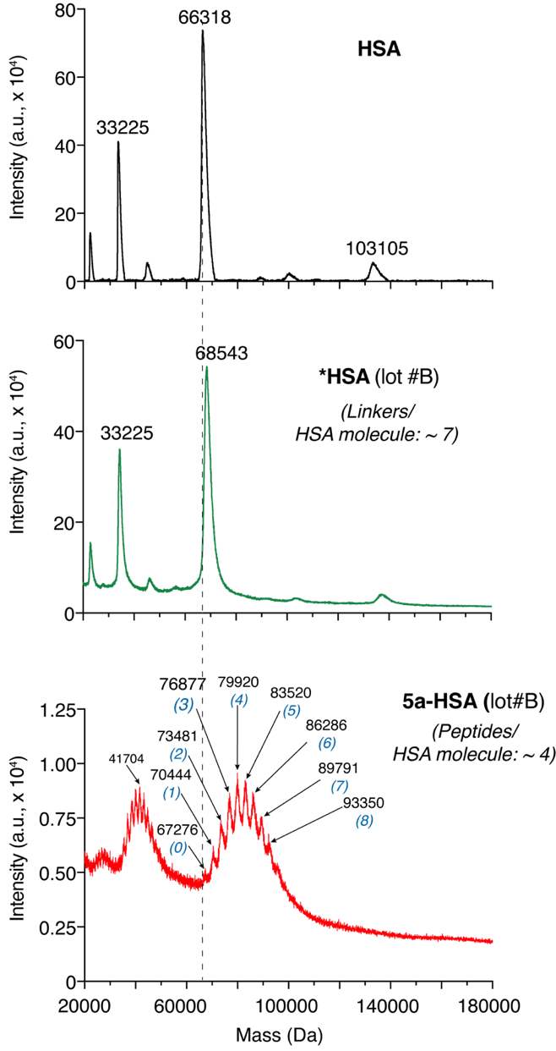

Supplemental Figure S1. Biochemical characterization of 5a-HSA (Lot #B).
MALDI-TOF mass spectra of HSA, *HSA, and 5a-HSA (Lot #B). The average masses of the principal components and the estimated number of peptides coupled to HSA molecules are indicated.

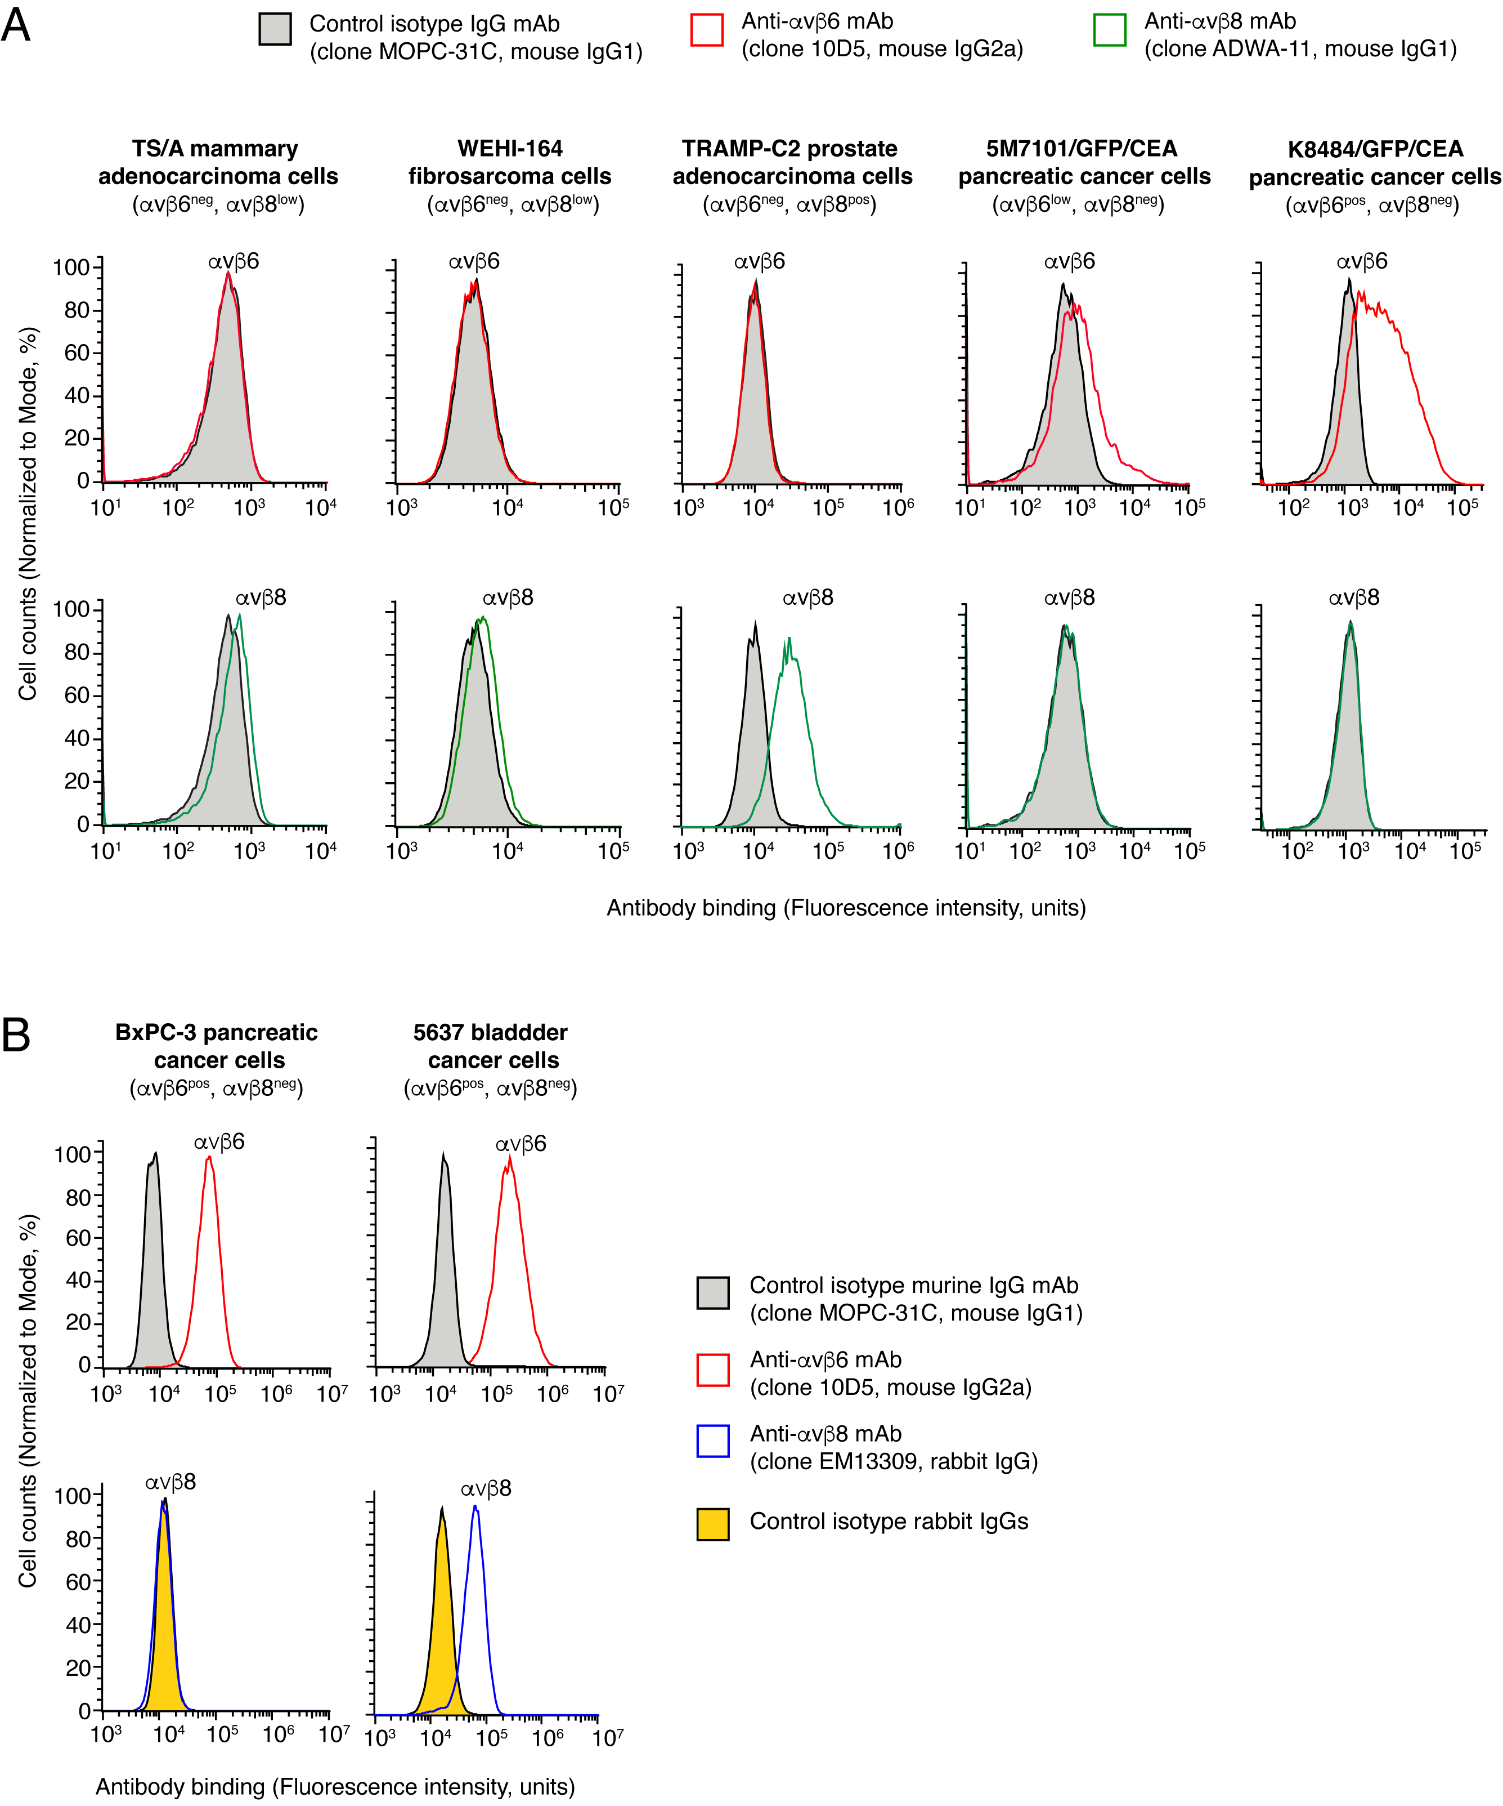
Supplemental Figure S2. Flow cytometry analysis of αvβ6 and αvβ8 expression in TS/A, WEHI-164, TRAMP-C2, 5M7101/GFP/CEA, K8484/GFP/CEA, BxPC-3 and 5637 cells.
Expression of αvβ6 and αvβ8 in murine (A) and human (B) cell lines. Flow cytometry was performed as described previously ²⁰ using the indicated monoclonal antibodies, followed by Alexa Fluor 488-conjugated goat anti-mouse, Alexa Fluor 488-conjugated goat anti-rabbit IgG polyclonal antibody, or an Alexa Fluor 647-conjugated goat anti-mouse polyclonal antibodies (only for 5M7101/GFP/CEA and K8484/GFP/CEA).

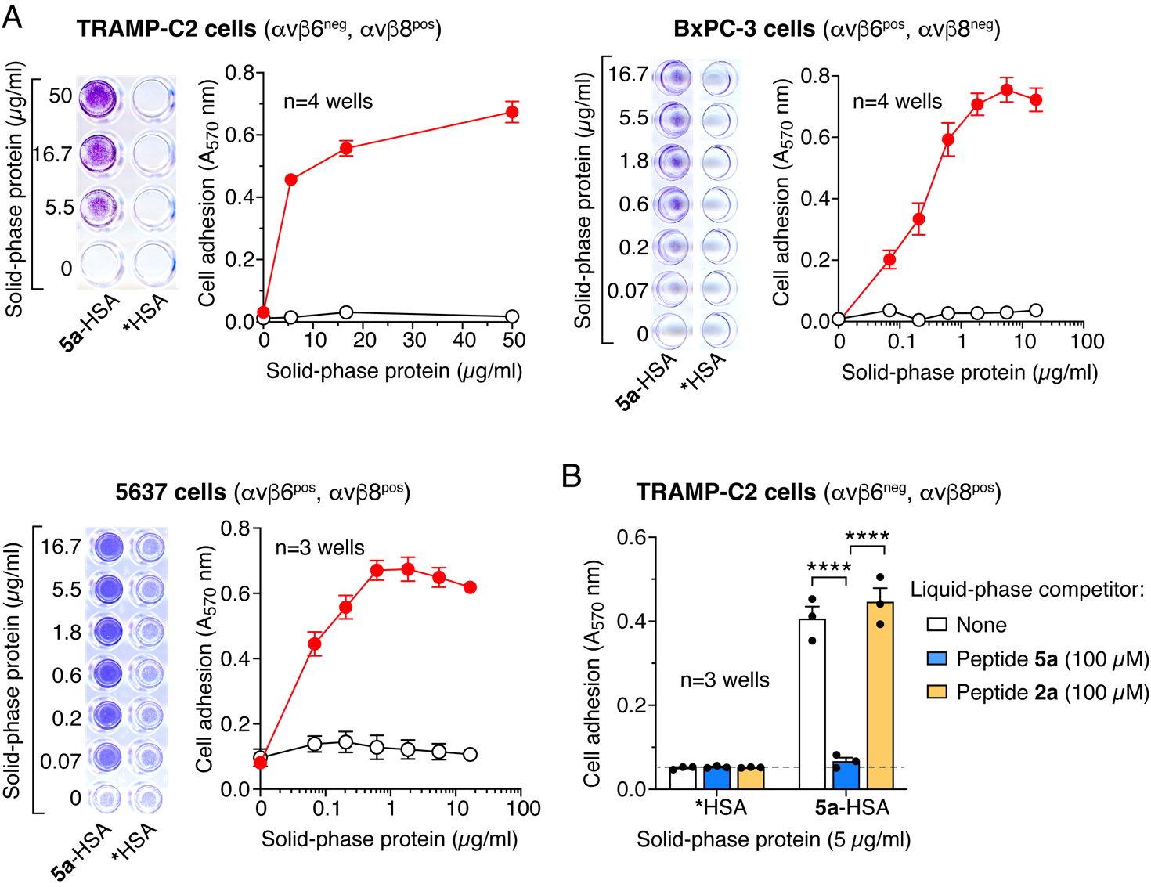

Supplemental Figure S3. 5a-HSA promotes the adhesion of αvβ6/αvβ8 single- or double-positive TRAMP-C2, BxPC-3, and 5637 cell lines.
Ninety-six-well PVC microplates were coated with 5a-HSA or with *HSA, a control conjugate without peptide 5a, and seeded with the indicated cell lines (0.5-1x10⁵ cells/well). After 2-3 h of incubation, non-adherent cells were removed by washing, and adherent cells were stained with crystal violet and quantified by spectrophotometric analysis using an A_{570 nm} filter (iMark Microplate Absorbance Reader, Bio-Rad). In cases of uneven cell adhesion, microtiter plates were treated with 10% acetic acid (150 µL/well) to dissolve crystal violet, and the absorbance of each well was quantified as described above.
A) Representative photomicrographs of wells coated with 5a-HSA or *HSA; quantification of cell adhesion is shown (mean±SE, n=3-4 wells).
B) Effect of peptide 5a and 2a (a control peptide with the RGE sequence instead of RGD) on the adhesion of TRAMP-C2 cells to microtiter plates coated with 5a-HSA or *HSA.

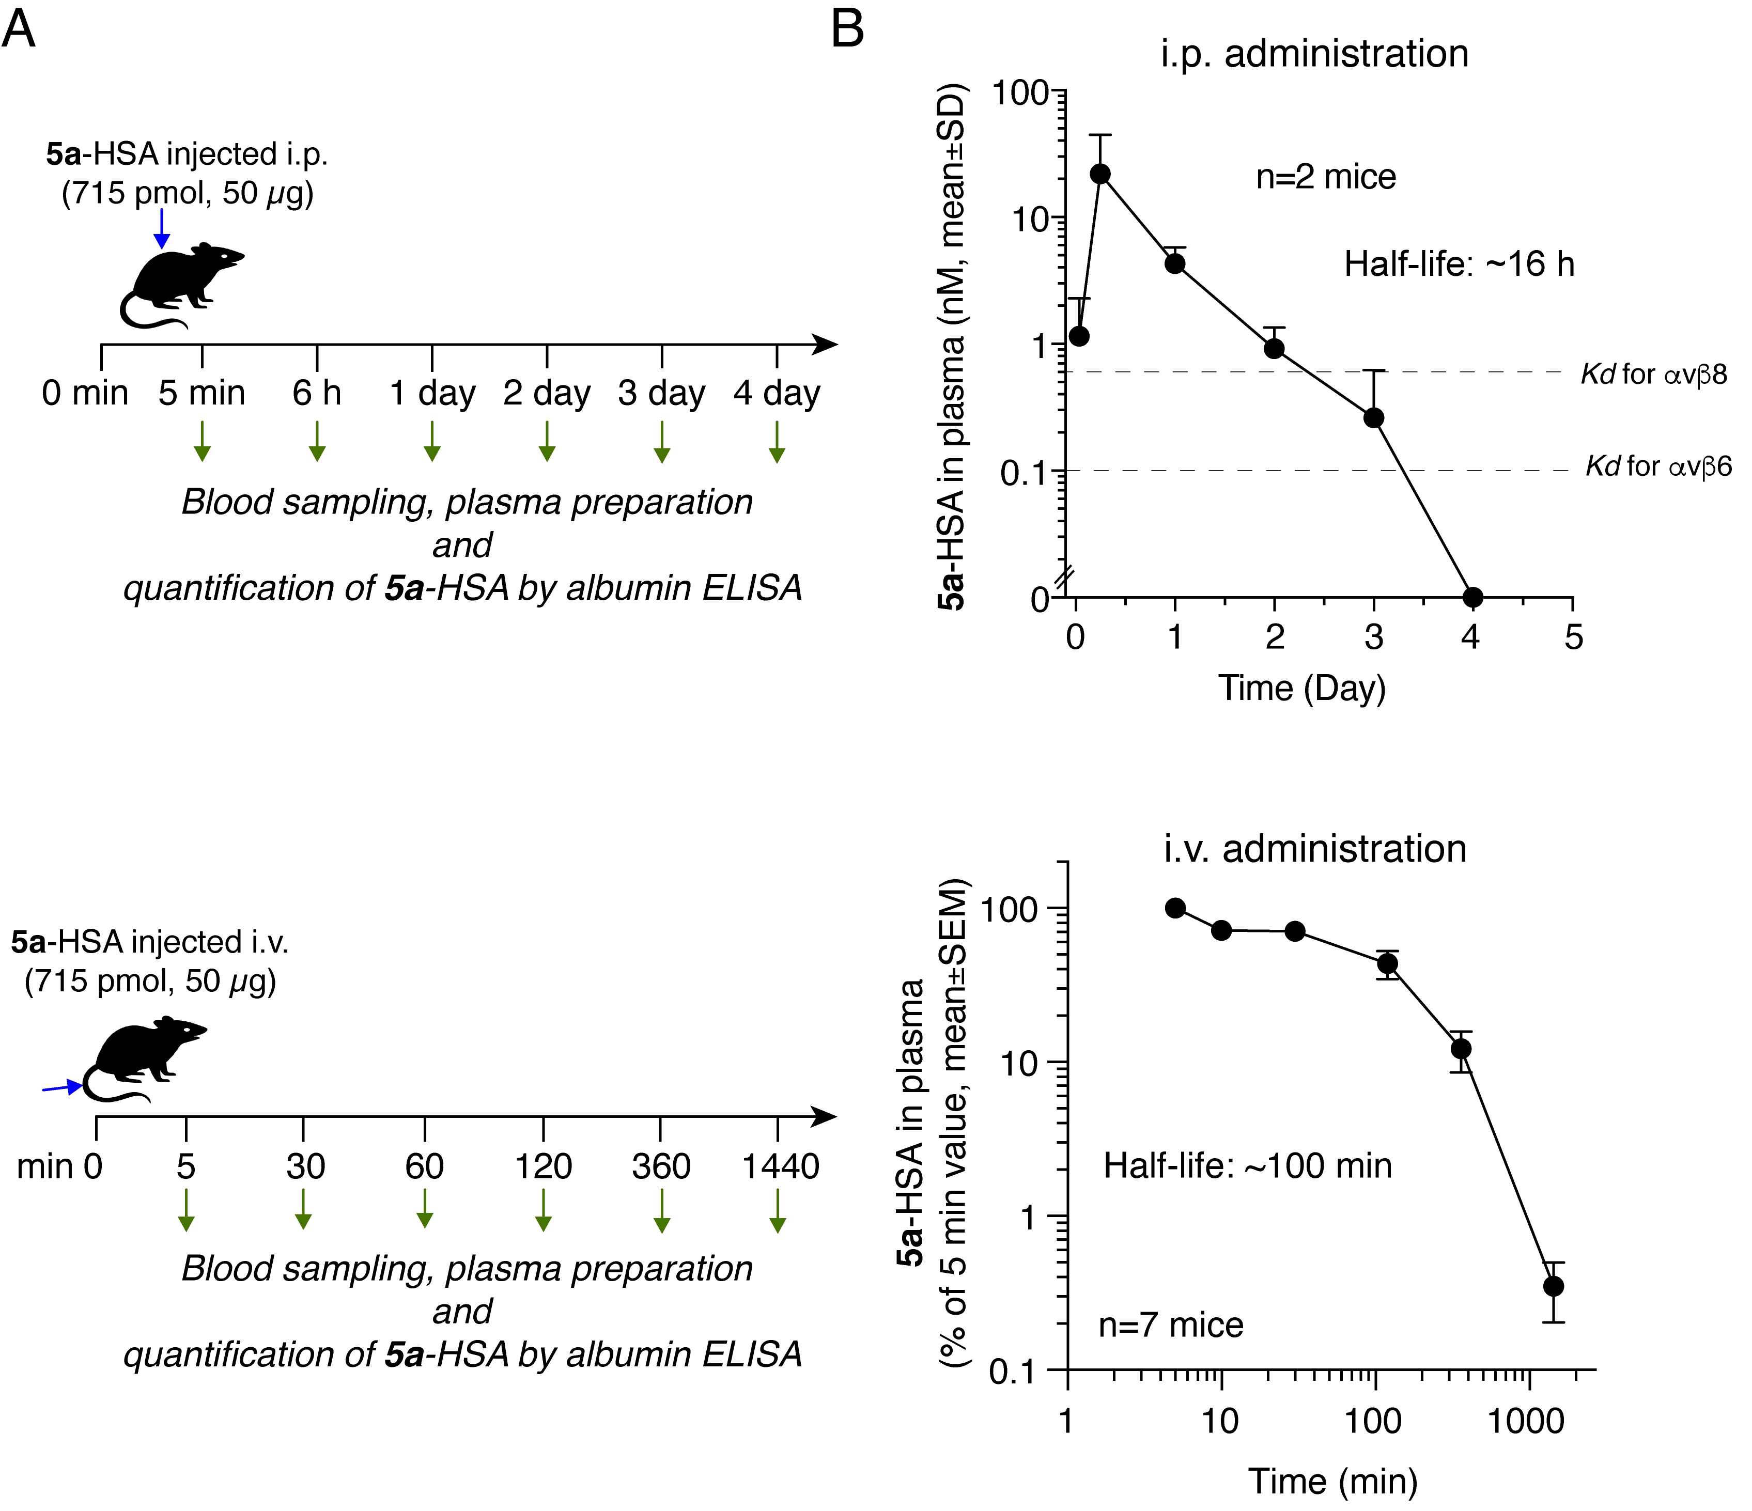
Supplemental Figure S4. Pharmacokinetics of 5a-HSA in mice.
A) Scheme of 5a-HSA administration and blood sampling in healthy mice. BALB/c and C57BL/6 mice were used for intraperitoneal (i.p.) and intravenous (i.v) pharmacokinetic studies, respectively.
B) Plasma levels of 5a-HSA. Plasma levels of 5a-HSA were measured after i.p. or i.v. administration using a homemade sandwich-ELISA for human serum albumin and 5a-HSA as the reference standard.
Dashed lines indicate Kd of 5a-HSA for αvβ6 and αvβ8 integrins.
The plasma half-life of 5a-HSA was calculated using a one-phase exponential decay equation (GraphPad Prism software, San Diego, California, USA).

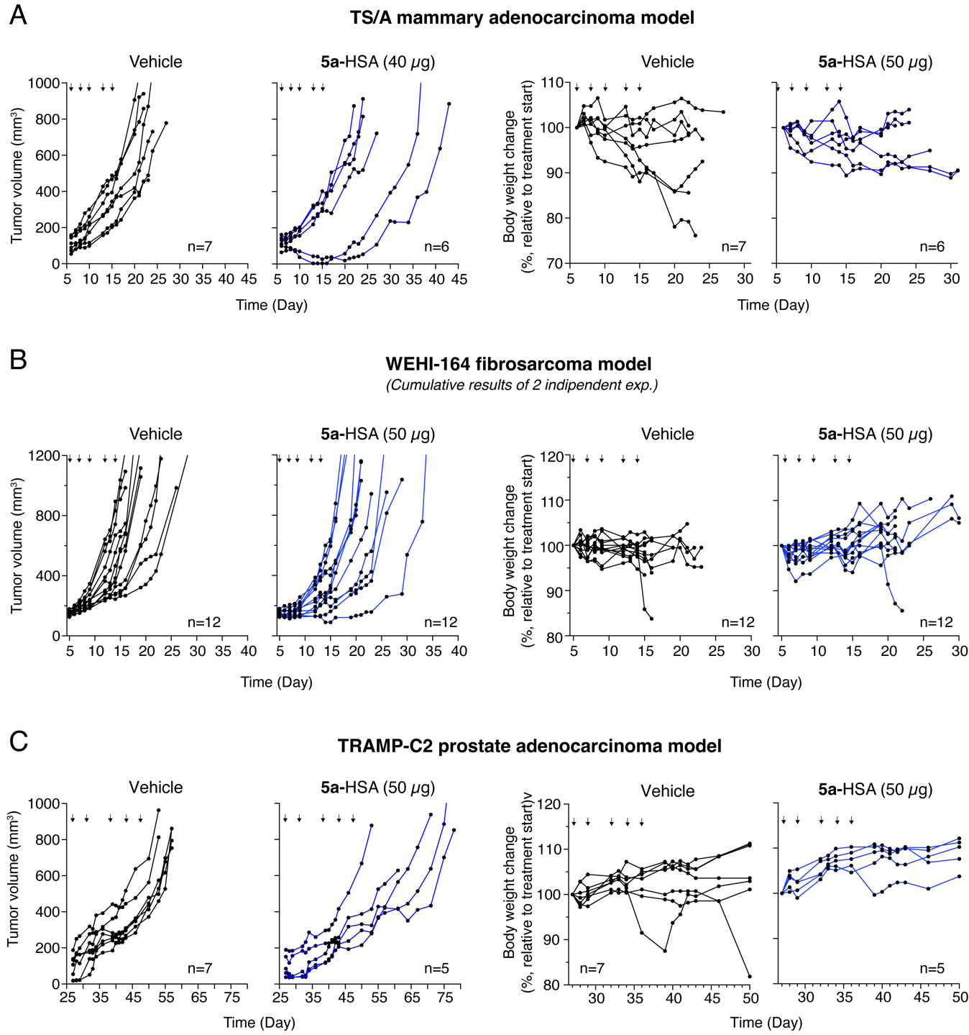

Supplemental Figure S5. Pharmacological and toxicological effects of 5a-HSA in tumor-bearing mice.
Individual tumor growth curves and changes in the body weights of the mice are shown in Figure 8. Mice were euthanized when tumors reached 1000-1200 mm³ or when extensive tumor ulceration or other symptoms were observed
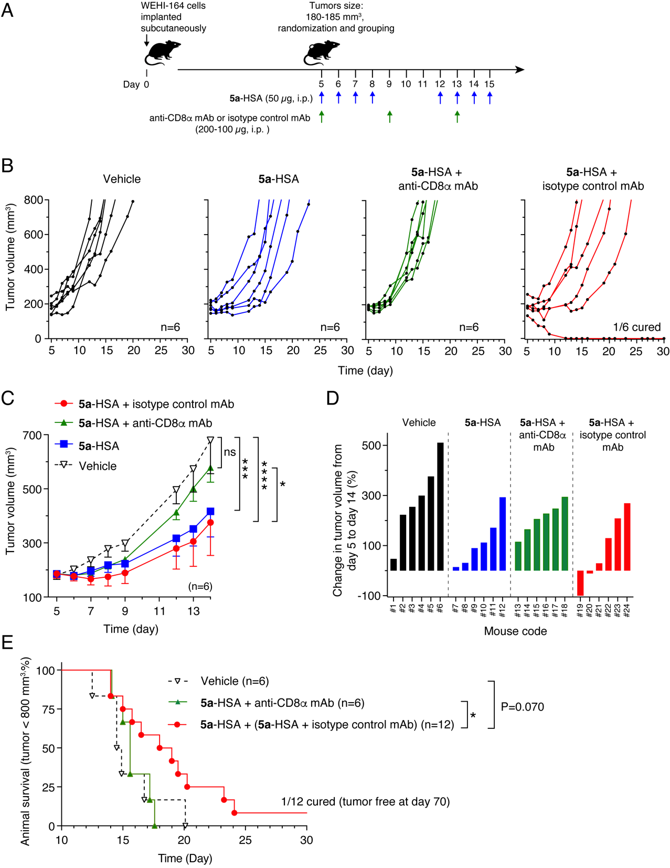

Figure S6. The administration of anti-CD8α antibodies neutralizes the anti-tumor activity of 5a-HSA against subcutaneous WEHI-164 fibrosarcomas.
A) Scheme of the experiment. WEHI-164 tumor-bearing mice (6 mice/group) were injected (i.p.) with 200 µg (day 5 and 9) or with 100 µg (day 13) of an anti-CD8α monoclonal antibody. Ten minutes later, the mice were injected i.p. with 50 µg of 5a-HSA. On the following days (days 6, 7, 8, 12, 14, and 15), the mice were treated with 5a-HSA. B) Individual tumor growth curves. C) Tumor volume (mean±SE). *, P<0.05; ***, P<0.001, ****, P<0.0001 by two-way ANOVA with post-hoc Tukey's multiple comparisons test. D) Waterfall plots of the percentage change in tumor volume for individual mice over the indicated time. E) Kaplan-Meier survival curves. Mice were euthanized when the tumors reached >800 mm³ or when extensive tumor ulceration or other signs of distress were observed. The cumulative data for 5a-HSA with 5a-HSA + isotype control mAb are reported. *P < 0.05; by log-rank (Mantel-Cox) test.

