Tables
Supplemental Table 1. The antibodies used in this study are listed as follows.
Antibodies | Source | Identifier | Application(dilution)
Anti-STIM1 | CST | Cat#5668 | WB (1:1000), IF (1:800), IP
Anti-STIM1 | Proteintech | Cat#11565-1-AP | IHC (1:200)
Anti-TSPAN18 | Thermo Scientific | Cat#PA5-48957 | WB (1:500), IHC (1:100)
Anti-Flag | CST | Cat#14793 | WB (1:1000), IF (1:400), IP
Anti-Myc | CST | Cat#2276 | WB (1:1000), IP
Anti-His | CST | Cat#12698 | WB (1:1000), IP
Anti-HA | CST | Cat#3724 | WB (1:1000)
Anti-E-cadherin | CST | Cat#14472 | WB (1:1000), IF (1:200)
Anti-N-cadherin | CST | Cat#13116 | WB (1:1000), IF (1:200)
Anti-Vinculin | Abcam | Cat#ab129002 | IF (1:100)
Anti-TRIM32 | GeneTex | Cat#113937 | WB (1:1000)
Anti-MIB1 | Proteintech | Cat#11893-1-AP | WB (1:1000)
Anti-GAPDH | CST | Cat#5174 | WB (1:5000)
Normal rabbit IgG | CST | Cat#2729 | IP
Rabbit IgG (H+L) | CST | Cat#14708 | IP
Mouse IgG (H+L) | CST | Cat#14709 | IP
Abbreviation: CST, Cell Signaling Technology; WB, Western blot; IF, Immunofluorescence; IP, Immunoprecipitation; IHC, Immunohistochemistry.

Supplemental Table 2. The primers used in real time qPCR are listed as follows.
Primer Name | Sequence 5’-3’
TSPAN18 Forward | TTCTTCACCAAGGAGCTCACC
TSPAN18 Reverse | CTCCGGCACCTCTTCACTATC
STIM1 Forward | CTTGTCCATGCAGTCCCCTAG
STIM1 Reverse | GTGGTGATGGAAGAGGAGCAA
GPADH Forward | CAAGGCTGAGAACGGGAAG
GPADH Reverse | TGAAGACGCCAGTGGACTC

Supplemental Table 3. Basic characteristics of prostate cancer patients in two cohorts
Variables |  | Training cohort (n=126) |  | Validation cohort (n=113)
Variables |  | Number of cases (%) |  | Number of cases (%)
Age (y, Mean range) | 66(42-89)  <66  ≥66 | 59(46.8%)  67(53.2%) |  | 41(36.3%)  72(63.7%)
T stage | T2  T3  T4 | 76(60.3%)  30(23.8%)  20(15.9%) |  | 80(70.8%)  28(24.8%)  5(4.4%)
N stage | N0  N1 | 116(92.1%)  10(7.9%) |  | 110(97.3%)  3(2.7%)
M stage | M0  M1 | 116(92.1%)  10(7.9%) |  | 105(92.9%)  8(7.1%)
Gleason score | 10  9  8  7(4+3)  7(3+4)  ≤6 | 4(3.2%)  23(18.2%)  16(12.7%)  18(14.3%)  24(19.0%)  41(32.6%) |  | 3(2.7%)  11(9.7%)  9(8.0%)  36(31.9%)  28(24.8%)  26(23.0%)
TSPAN18 | Low  High | 78(61.9%)  48(38.1%) |  | 70(61.9%)  43(38.1%)

Supplemental Table 4. Univariate analysis of prognostic factors correlated with OS and CSS
Variables | OS |  |  |  |  |  | CSS
Variables | Cohort 1 |  |  | Cohort 2 |  |  | Cohort 1 |  |  | Cohort 2
Variables | HR  (95%CI) | p-value |  | HR  (95%CI) | p-value |  | HR  (95%CI) | p-value |  | HR  (95%CI) | p-  value
Age (y)  ≥66/<66 | 1.94  0.98-3.88 | 0.059 |  | 1.62  0.63-4.14 | 0.341 |  | 1.69  0.76-3.76 | 0.197 |  | 1.21  0.43-3.41 | 0.713
Gleason score 7(4+3)-10/6-7(3+4) | 2.58  1.27-5.24 | 0.009 |  | 7.28  2.14-24.67 | 0.001 |  | 2.60  1.13-5.98 | 0.025 |  | 7.06  1.59-31.39 | 0.010
Tumor stage  T3-4/T2 | 2.14  1.10-4.17 | 0.025 |  | 5.50  2.30-13.16 | <0.001 |  | 2.46  1.11-5.43 | 0.026 |  | 6.03  2.06-17.71 | 0.001
Distal metastasis  Present/Absent | 5.83  2.63-12.93 | <0.001 |  | 4.43  1.63-12.03 | 0.003 |  | 6.17  2.45-15.52 | <0.001 |  | 7.27  2.48-21.30 | <0.001
TSPAN18  High/Low | 2.35  1.21-4.54 | 0.011 |  | 2.77  1.18-6.59 | 0.019 |  | 2.39  1.08-5.30 | 0.031 |  | 3.75  1.28-11.00 | 0.016
Abbreviations: OS, overall survival; CSS, cancer-specific survival; HR hazard ratio, CI confidence interval; p-value<0.05 marked in bold font shows statistically significant.

Supplemental Table 5. Multivariate analysis of prognostic factors correlated with OS and CSS
Variables | OS |  |  |  |  |  | CSS
Variables | Cohort 1 |  |  | Cohort 2 |  |  | Cohort 1 |  |  | Cohort 2
Variables | HR  (95%CI) | p-value |  | HR  (95%CI) | p-value |  | HR  (95%CI) | p-value |  | HR  (95%CI) | p-  value
Gleason score 7(4+3)-10/6-7(3+4) | 1.66  0.77-3.57 | 0.192 |  | 4.76  1.35-16.77 | 0.015 |  | 1.56  0.63-3.85 | 0.333 |  | 3.88  0.82-18.41 | 0.088
Tumor stage  T3-4/T2 | 1.84  0.92-3.67 | 0.085 |  | 4.05  1.61-10.18 | 0.003 |  | 1.96  0.85-4.49 | 0.114 |  | 3.80  1.19-12.14 | 0.025
Distal metastasis  Present/Absent | 5.48  2.41-12.43 | <0.001 |  | 1.24  0.42-3.67 | 0.699 |  | 6.28  2.40-16.40 | <0.001 |  | 2.07  0.62-6.86 | 0.236
TSPAN18  High/Low | 2.27  1.11-4.67 | 0.025 |  | 1.98  0.82-4.79 | 0.130 |  | 2.43  1.03-5.77 | 0.044 |  | 2.43  0.80-7.43 | 0.120
Abbreviations: OS, overall survival; CSS, cancer-specific survival; HR hazard ratio, CI confidence interval; p-value<0.05 marked in bold font shows statistically significant.

Figures and Legends
Supplemental Figure 1 (a) Co-IP analysis of interaction between exogenous STIM1 and exogenous TSPAN18 in HEK-293T cells, transfected with Flag-TSPAN18 and Myc-STIM1 plasmid using anti-Myc antibody(left) or anti-Flag antibody (right). (b) Co-IP analysis of interaction between Flag-TSPAN18 and Myc-Orai1 using anti-Flag antibody (left) or anti-Myc antibody (right) in HEK-293T cells. (c) Co-IP analysis of interaction between Flag-TSPAN18 and Myc-Orai1 using anti-Flag antibody in Flag-TSPAN18 overexpressing DU145 cells.
Supplemental Figure 2 The Western Blot analysis of TSPAN18 and STIM1 protein level in DU145 and PC-3 cells treated as indicated. The values are expressed as the mean ± s.d. of three independent experiments. **p<0.01, ***p < 0.001, ANOVA with post hoc test or Student’s t test.
Supplemental Figure 3 The qRT-PCR analysis of TSPAN18 and STIM1 mRNA level in DU145 and PC-3 cells treated as indicated. The values are expressed as the mean ± s.d. of three independent experiments. **p<0.01, ***p < 0.001, ANOVA with post hoc test or Student’s t test.
Supplemental Figure 4 The Western Blot analysis of TSPAN18 and STIM1 protein level in DU145 and PC-3 cells treated as indicated. The values are expressed as the mean ± s.d. of three independent experiments. **p<0.01, ***p < 0.001, ANOVA with post hoc test. Baf: Bafilomycin, ns: no significance.
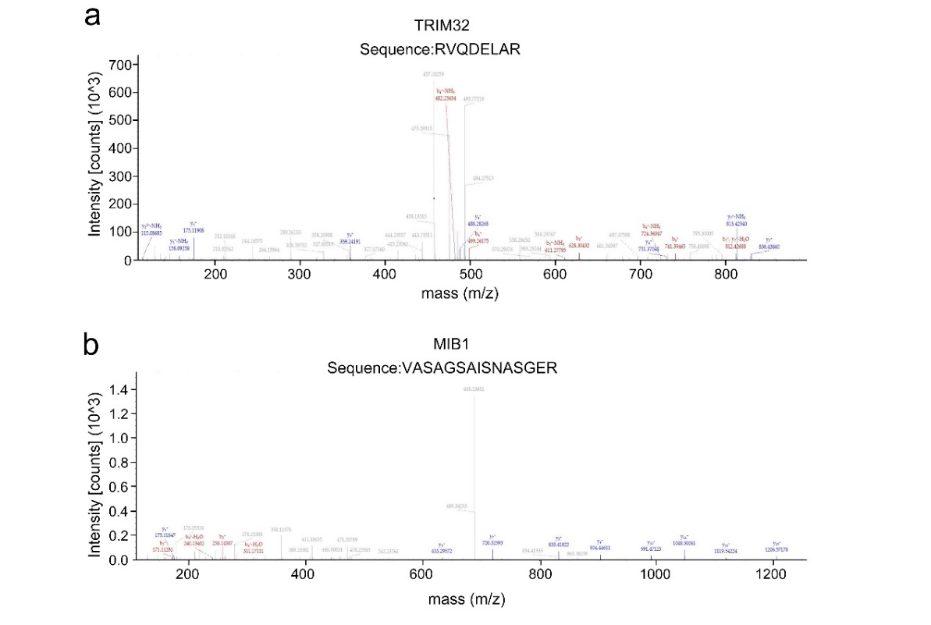
Supplemental Figure 5 The representative peptide of TRIM32 (a) or MIB1 (b) from mass spectrometry.
Supplemental Figure 6 (a) Co-IP analysis of interaction between exogenous STIM1 and
exogenous TRIM32 in HEK-293T cells transfected with His-TRIM32 plasmid and Myc-STIM1 plasmid using anti-Myc antibody(left) or anti-His antibody (right). (b-c) The Western Blot analysis of TRIM32 and STIM1 protein level in DU145 and PC-3 cells treated as indicated. The values are expressed as the mean ± s.d. of three independent experiments. ***p < 0.001, Student’s t test or ANOVA with post hoc test. (d) The protein level of STIM1 in DU145 and PC-3 cells transfected with scramble or si-TRIM32 were monitored by WB at indicated times after cycloheximide (CHX, 20μg/mL).
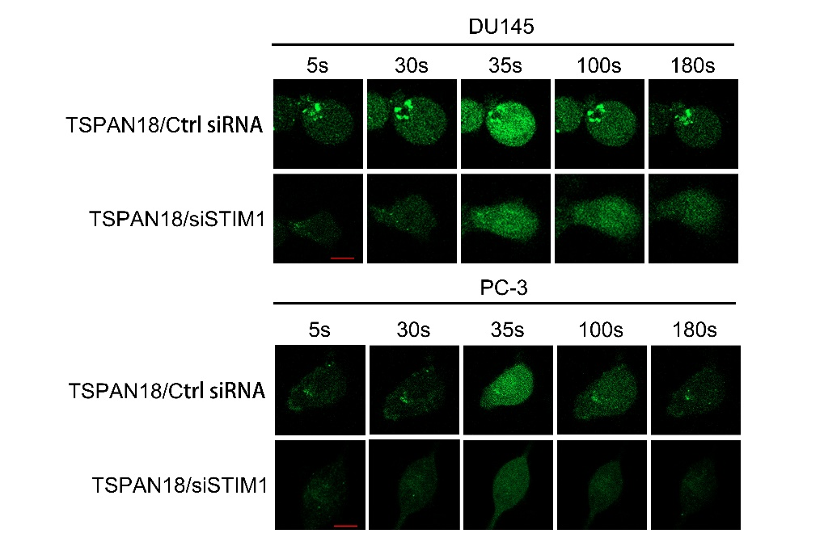
Supplemental Figure 7 The representative time-lapse images of cytosolic Ca²⁺ level within PC-3 cells transfected with indicated siRNAs or plasmids. Scale bars: red, 50 μm.
Supplemental Figure 8 The representative time-lapse images of cytosolic Ca²⁺ level within
indicated cells. Scale bars: red, 50 μm.
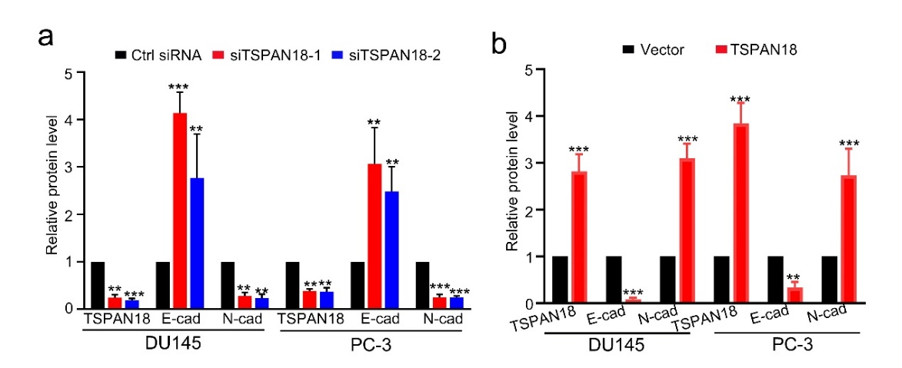
Supplemental Figure 9 (a-b) Cell viability was evaluated in TSPAN18 knockdown or overexpressing DU145 and PC-3 cells. (c) Tumor growth curves are summarized in the line chart. The average tumor volume is expressed as the mean ± SD of six mice. (d) Representative images of the tumors of TSPAN18 knockdown or overexpression groups and their respective controls. (e) Tumor weights were measured after the tumors were surgically dissected. ns: no significance.
Supplemental Figure 10 The Western Blot analysis of E-cadherin and N-cadherin protein level in DU145 and PC-3 cells treated as indicated. The values are expressed as the mean ± s.d. of three independent experiments. **p<0.01, ***p < 0.001, ANOVA with post hoc test or
Student’s t test.
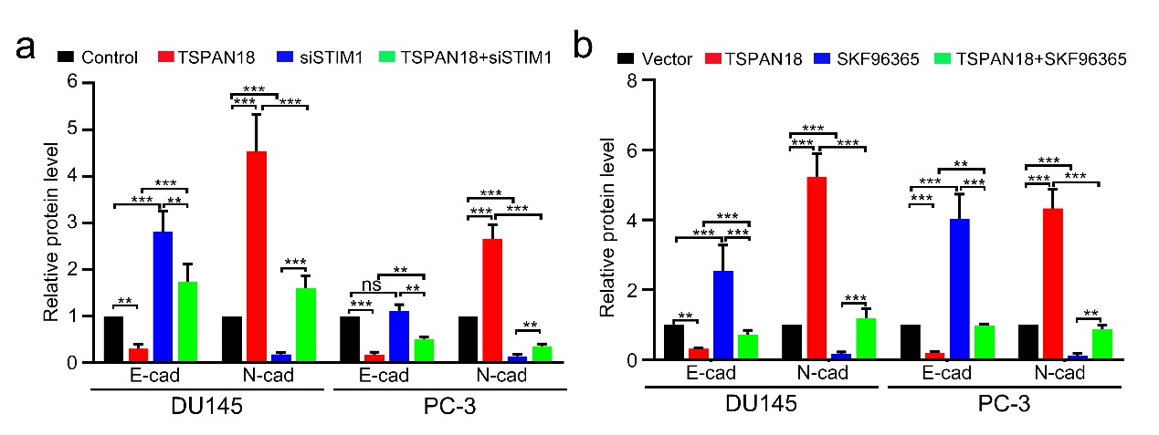
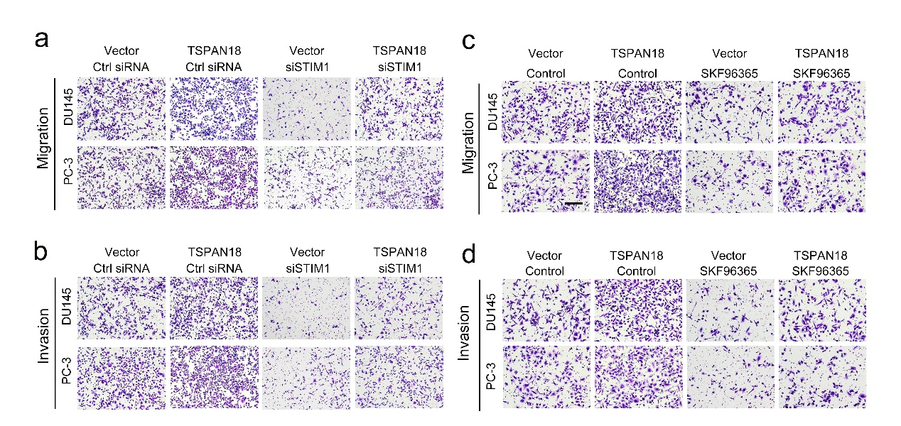
Supplemental Figure 11 The representative images of migration and invasion assays using TSPAN18-overexpressing or control DU145 and PC-3 cells transfected with indicated siRNAs (a, b) or treated with SKF96365 or DMSO (c, d).
Supplemental Figure 12 The Western Blot analysis of N-cadherin and E-cadherin protein level in DU145 and PC-3 cells treated as indicated. The values are expressed as the mean ± s.d. of three independent experiments. **p<0.01, ***p < 0.001, ANOVA with post hoc test. ns: no significance.

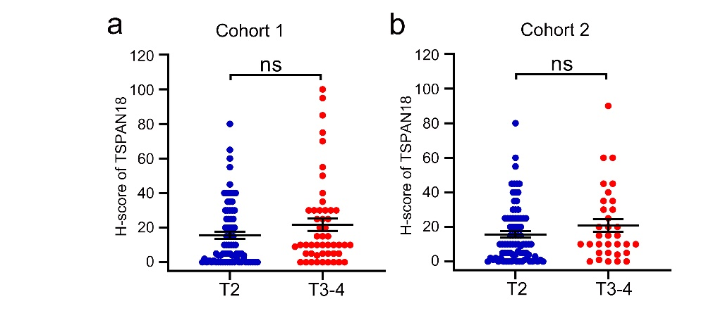
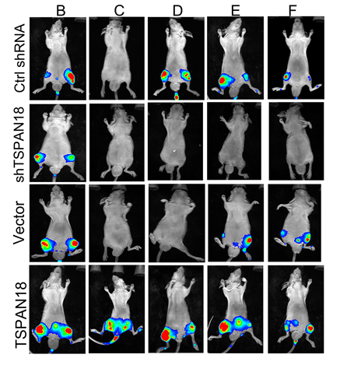
Supplemental Figure 13 The representative bioluminescence images of the mice after 6 weeks of inoculations with indicated PC-3 cells.

Supplemental Figure 14 The expression difference of TSPAN18 between low T stage PCa tissues and high T stage PCa tissues in Cohort 1 (a) and Cohort 2 (b). ns: no significance. Student’s t test.

