Supplementary Figures
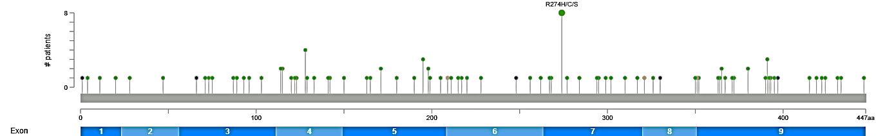
Supp. figure 1. Mutation frequency of PPP2R2C in multiple malignancy reported in cBioPortal. (Access: 20 May 2025)
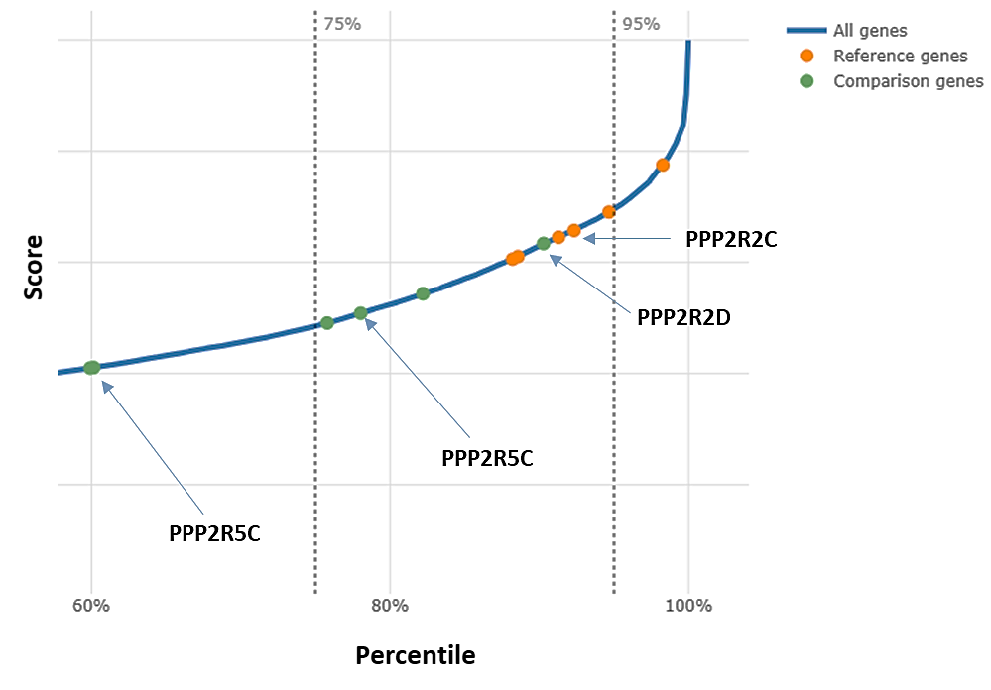

Supp. figure 2. TPE-OLD candidates of PP2A subunits which expression is regulated by telomere length.
https://tpe-old.uni-rostock.de/ (Access: 20 June 2025)

