Title: GSTK1 suppresses HCC aggravation via L-carnitine metabolism by PGAM5/DRP1 complex-mediated mitochondrial quality control
Authors: Yuze Shi^{1,2#}, Jinyao Zhang^{2#}, Bojiao Song^{2#}, Haitian Zhang^{2#}, Jianbo He^{1,2}, Ke Ding², Fei Wang¹, Weiwei Yu³, Guangyan Zhangyuan⁴, Kangpeng Jin^{5*}, Wenjie Zhang^{2*}, Beicheng Sun^{1,2*}

Supplementary Figures
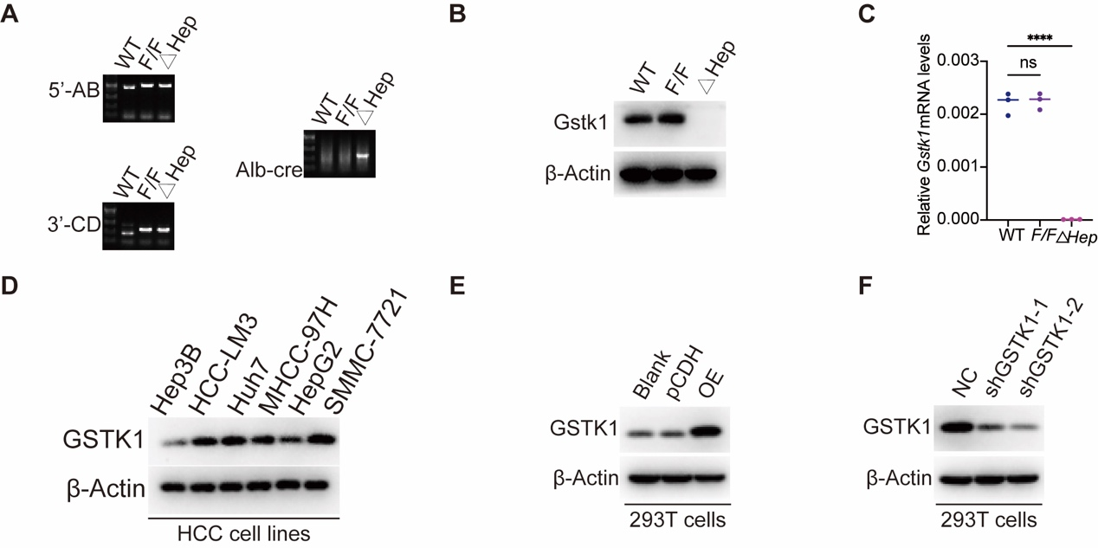
Figure S1. Validation of Gstk1 liver-specific knockout mice and identification of overexpress GSTK1 plasmid or shRNA of GSTK1. (A) Genotyping PCR showing 5’ (left top) and 3’ (left bottom) loxP site insertion and Genotyping PCR for albumin-Cre transgenic mice (right). (B-C) Immunoblotting and RT-qPCR analysis of Gstk1 (Gstk1) in WT, Gstk1^{F/F}, Gstk1^{△Hep} mice. (D) Immunoblotting analysis of GSTK1 in various HCC cell lines. (E) Immunoblotting analysis of GSTK1 in 293T cells transfected with overexpress GSTK1 plasmid and control pCDH plasmid. (F) Immunoblotting analysis of GSTK1 in 293T cells transfected with shRNA of GSTK1 and control NC. Data are presented as mean ± SD. **** p<0.0001

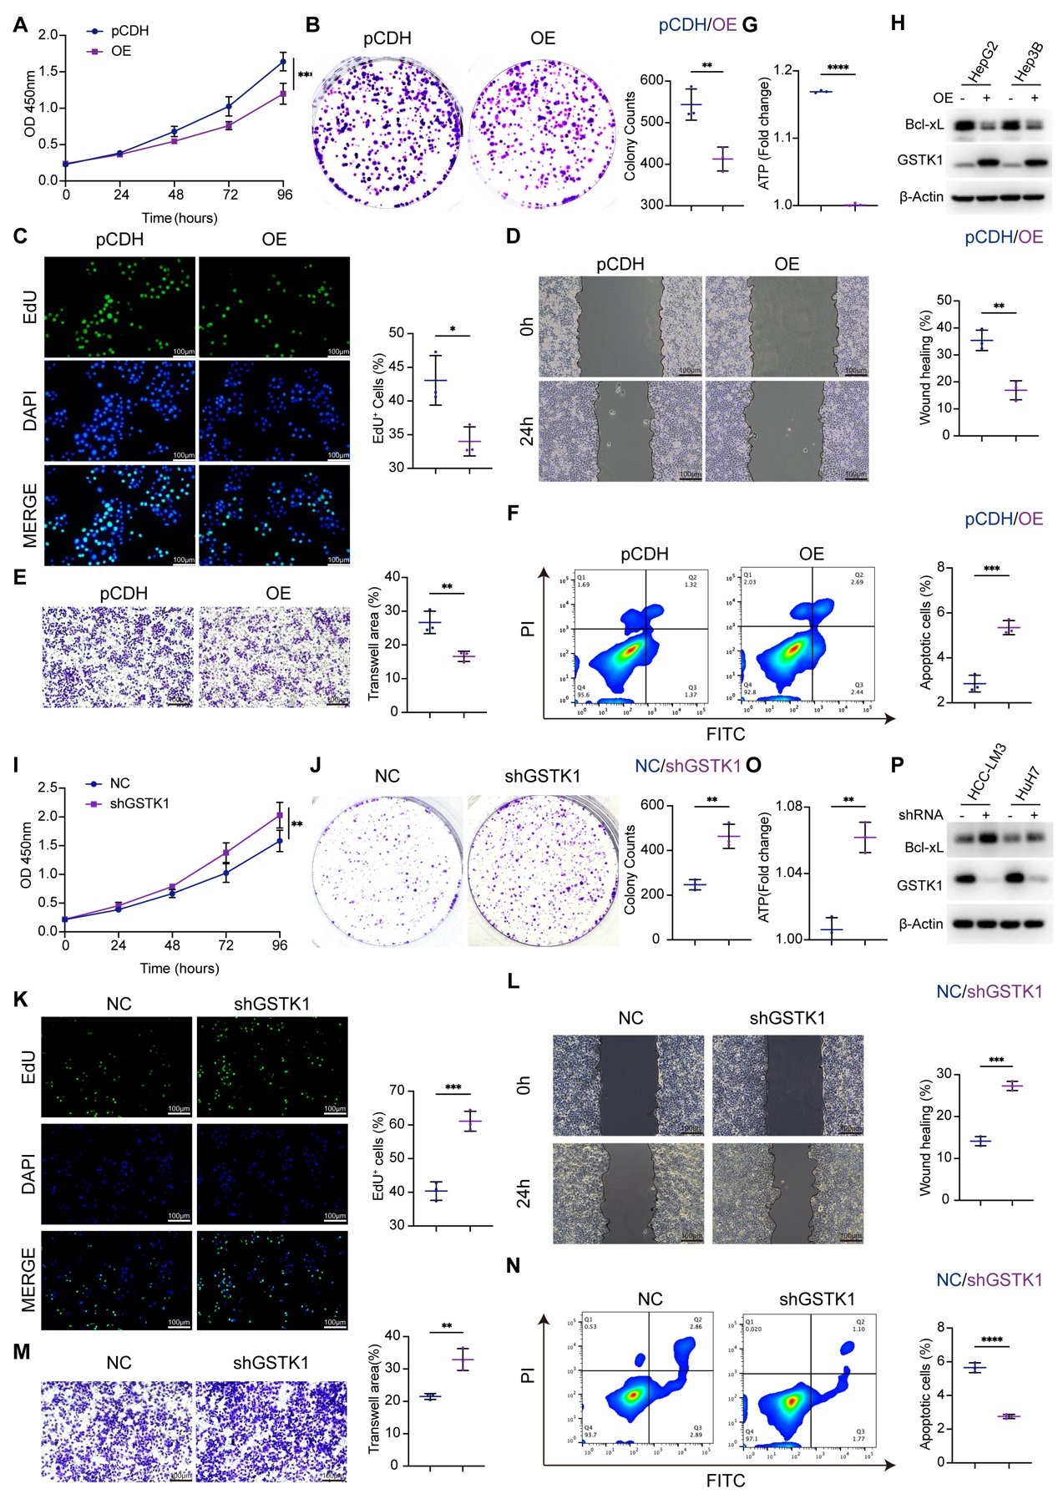
Figure S2. GSTK1 inhibited proliferation and migration in HCC cell lines. (A-C) Cell proliferation ability detection of Hep3B cells after overexpress GSTK1. CCK8 (A), Colony formation (B), EdU (C) (Bar = 100 μm). (D-E) Cell migration ability detection of Hep3B cells after overexpress GSTK1. Wound healing (D), Transwell (E) (Bar = 100 μm). (F) The apoptosis ratio of Hep3B cells after overexpress GSTK1 detected by flow cytometry using the Annexin V-FITC/PI staining kit. (G) The ATP measurement of Hep3B cells after overexpress GSTK1. (H) Immunoblotting analysis of Bcl-xL, Bcl-2 and β-Actin in HepG2 and Hep3B cells after overexpress GSTK1. (I-K) Cell proliferation ability detection of Huh7 cells after knockdown GSTK1. CCK8 (I), Colony formation (J), EdU (K) (Bar = 100 μm). (L-M) Cell migration ability detection of Huh7 cells after knockdown GSTK1.Wound healing(J), Transwell(K) (Bar = 100 μm). (N) The apoptosis ratio of Huh7 cells after knockdown GSTK1 detected by flow cytometry using the Annexin V-FITC/PI staining kit. (O) The ATP measurement of Huh7 cells after knockdown GSTK1. (P) Immunoblotting analysis of Bcl-xL, Bcl-2 and β-Actin in HCC-LM3 and Huh7 cells after knockdown GSTK1. Data are presented as mean ± SD. * p< 0.05, ** p < 0.01, *** p < 0.001 and **** p<0.0001

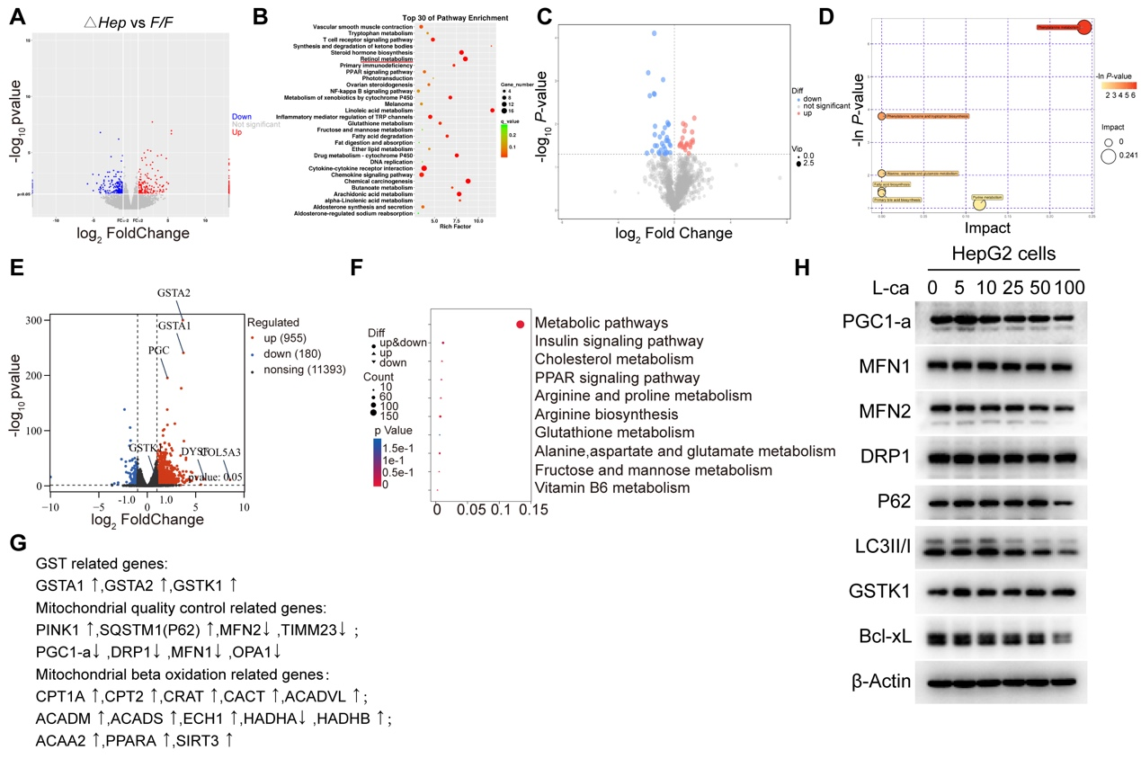
Figure S3. GSTK1 is responsible for L-carnitine metabolism. (A-B) RNA-sequence results of DEN/CCl₄ HCC model related to Figure 1. (C-D) Nor-target metabolomics results of DEN/CCl₄ HCC model related to Figure 1. (E-F) RNA-sequence results of Ctrl and L-carnitine treated (100 mM) HepG2 cell for 48 h. (G) Mitochondrial fatty acid β-oxidation, mitochondrial quality control and GSH related genes analysis of RNA-seq with Ctrl and L-carnitine treated HepG2 cells. (H) Immunoblotting analysis of MFN1, MFN2, DRP1, PGC1-α, P62, LC3II/I, GSTK1, Bcl-xL and β-Actin in HepG2 cells treated with gradient concentration of L-carnitine for 48 h.

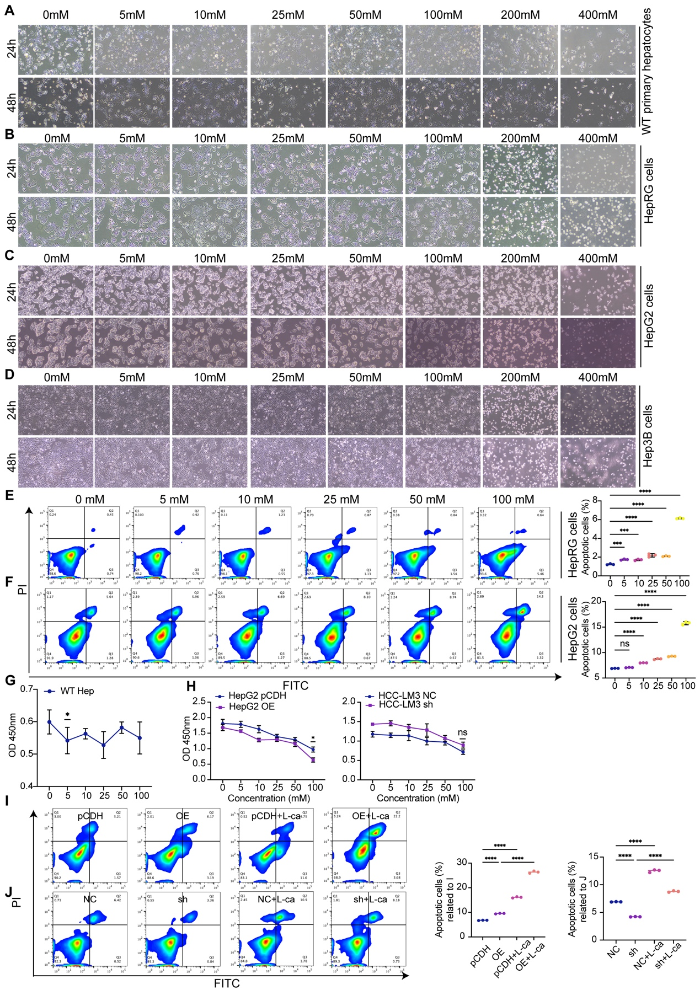
Figure S4. L-carnitine could against HCC cells. (A-D) Images of WT primary hepatocytes (A), HepRG (B), HepG2 (C) and Hep3B (D) cells treated by gradient concentration of L-carnitine for 24 h or 48 h. (E-F) Apoptotic ratio of cells treated by gradient concentration of L-carnitine for 48 h in HepRG (E) and HepG2 (F) cells. Statistical analysis on the Right. (G) Cell proliferation ability detection of WT primary hepatocytes treated by gradient concentration of L-carnitine for 48 h, detected by CCK8. (H) Cell proliferation ability detection of HepG2 cells after overexpress GSTK1 (F), HCC-LM3 cells knockdown GSTK1 (G) treated by gradient concentration of L-carnitine for 48 h, detected by CCK8. (I-J) Apoptotic ratio of HepG2 cells overexpressing GSTK1 or HCC-LM3 cells with GSTK1 knockdown following treatment with L-carnitine (100 mM) for 48 h. Data are presented as mean ± SD. n.s, no significance, * p< 0.05, ** p < 0.01, *** p < 0.001 and **** p<0.0001

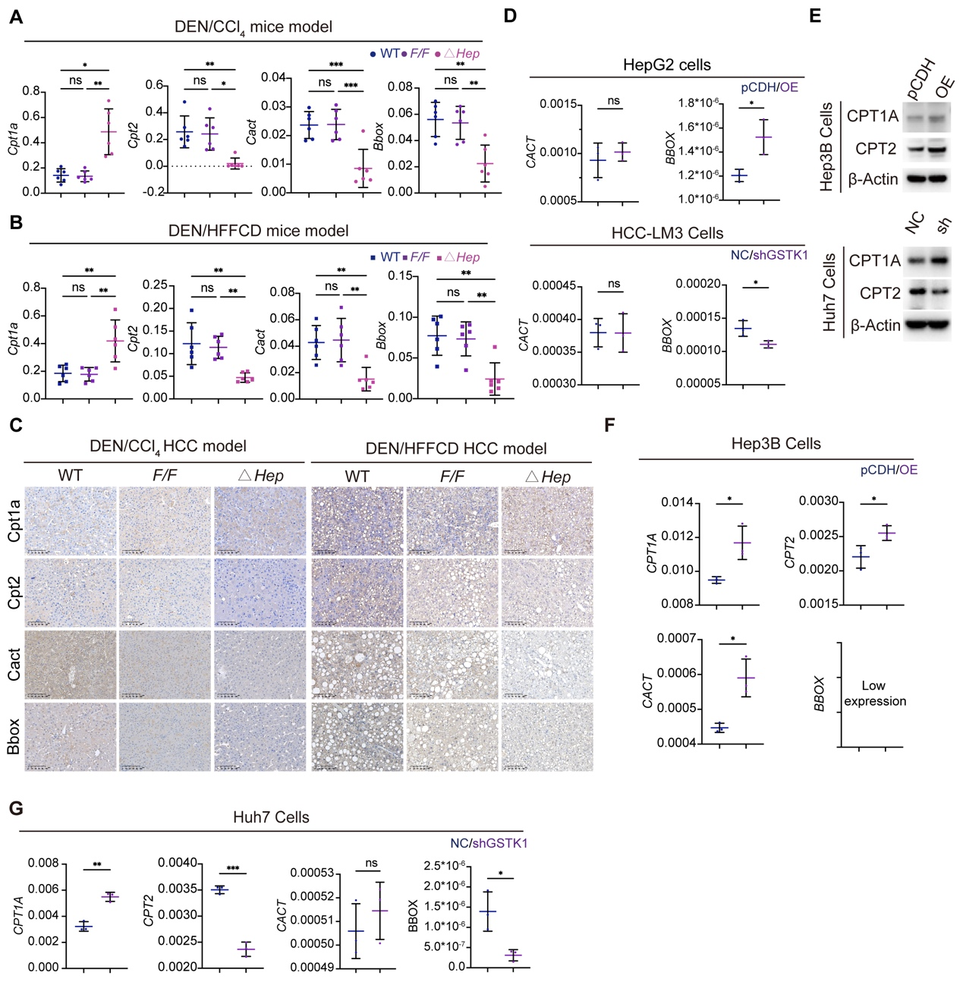
Figure S5. GSTK1 regulates key transporters of L-carnitine metabolism. (A-B) RT-qPCR analysis of Cpt1a, Cpt2, Cact and Bbox in DEN/CCl₄ and DEN/HFFCD HCC model related to Figure 1. (C) Immunohistochemistry staining of Cpt1a, Cpt2, Cact and Bbox in DEN/CCl₄ and DEN/HFFCD HCC model related to Figure 1. (D) RT-qPCR analysis of CACT and BBOX in HCC cell lines related to Figure 2. (E) Immunoblotting analysis of CPT1A, CPT2 and β-Actin in HCC cell lines related to Figure S2. (F-G) RT-qPCR analysis of CPT1A, CPT2, CACT and BBOX in HCC cell lines related to Figure S2. Data are presented as mean ± SD. n.s, no significance, * p< 0.05, ** p < 0.01.

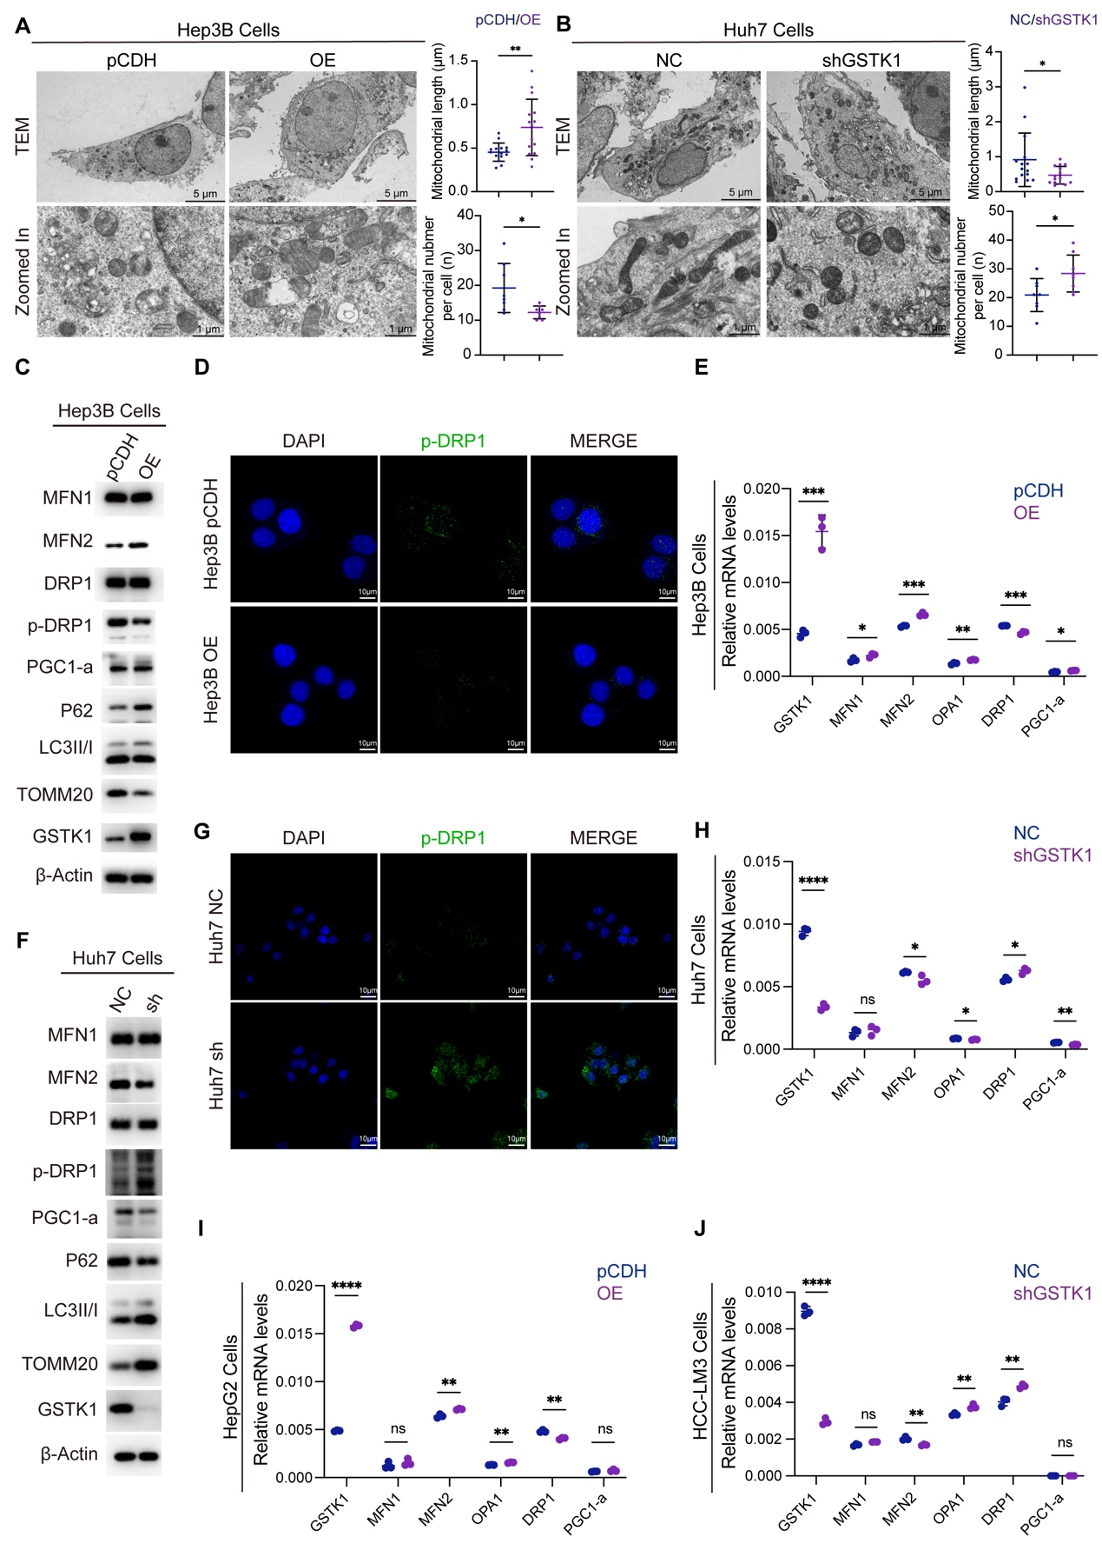
Figure S6. GSTK1 promotes mitochondrial biosynthesis and mitochondrial fusion, while inhibiting mitochondrial fission and mitophagy. (A-B) Representative TEM images of Hep3B cells overexpress GSTK1 (A) or Huh7 cells knockdown GSTK1 (B) (Bar = 5 μm or 1 μm). (C&F) Immunoblotting analysis of MFN1, MFN2, DRP1, p-DRP1, PGC1-α, P62, LC3II/I, TOMM20, GSTK1 and β-Actin in Hep3B cells overexpress GSTK1 (C) or Huh7 cells knockdown GSTK1 (F). (D and G) Immunofluorescent staining of pDRP1(S616) in Hep3B cells overexpress GSTK1 (D) or Huh7 cells knockdown GSTK1 (G) (Bar = 10 μm). (E, H-J) RT-qPCR analysis of GSTK1, MFN1, MFN2, OPA1, DRP1 and PGC1-a mRNA levels in Hep3B (E) and HepG2 (I) cells overexpress GSTK1 or Huh7 (H) and HCC-LM3 (J) cells knockdown GSTK1. Data are presented as mean ± SD. n.s, no significance, * p< 0.05, ** p < 0.01, *** p < 0.001 and **** p<0.0001

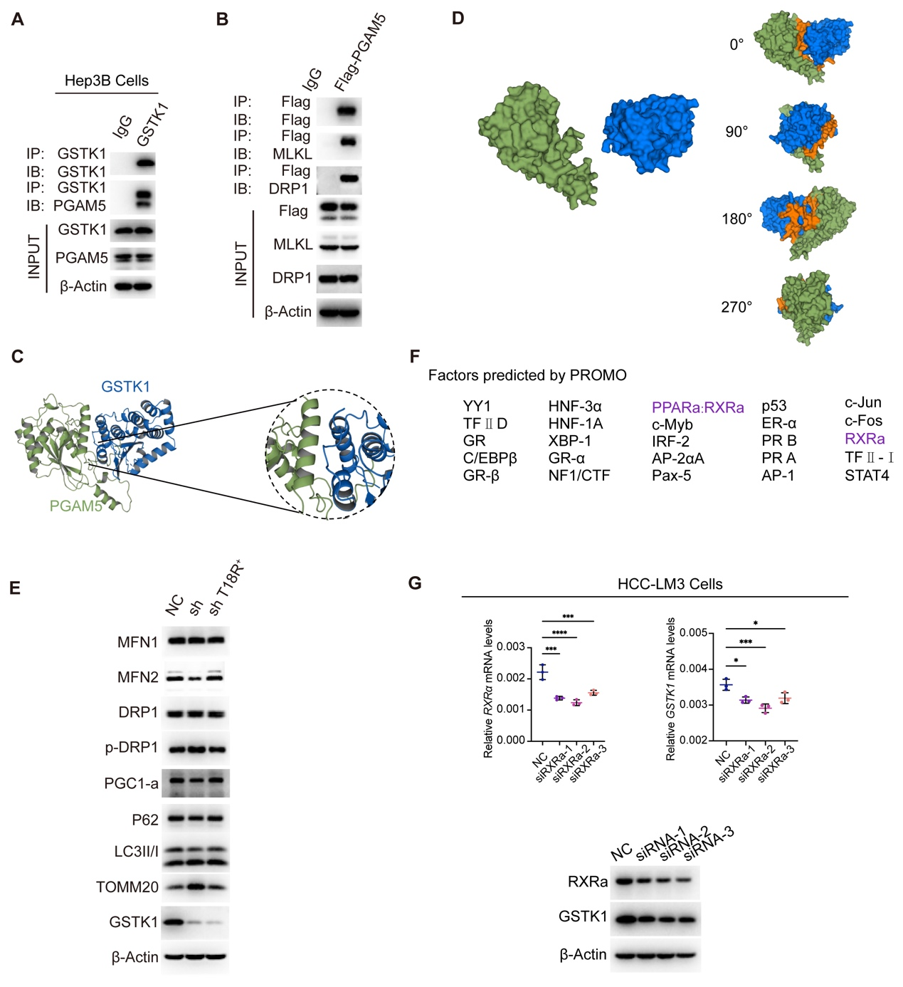
Figure S7. GSTK1 competes with DRP1 for binding to PGAM5, and GSTK1 is regulated by PPARα/RXRα. (A) Immunoblotting analysis of GSTK1 and PGAM5 interaction in Hep3B cells overexpress GSTK1. (B) Immunoblotting analysis of DRP1, MLKL, and Flag-PGAM5 interaction in HepG2 cells stably transfected Flag-PGAM5. (C-D) The prediction of specific binding sites for GSTK1 and PGAM5 interaction, detected by PLIP software. (E) Immunoblotting analysis of MFN1, MFN2, DRP1, p-DRP1, PGC1-α, P62, LC3II/I, TOMM20, GSTK1 and β-Actin in HCC-LM3 cells knockdown GSTK1 and with TYR-18 point mutation. (F) Prediction of GSTK1 transcription factors by PROMO. (G) Immunoblotting and RT-qPCR analysis of RXRα and GSTK1 in HCC-LM3 cells transient transfection of siRXRα. Data are presented as mean ± SD. n.s, no significance, * p< 0.05, *** p < 0.001 and **** p<0.0001

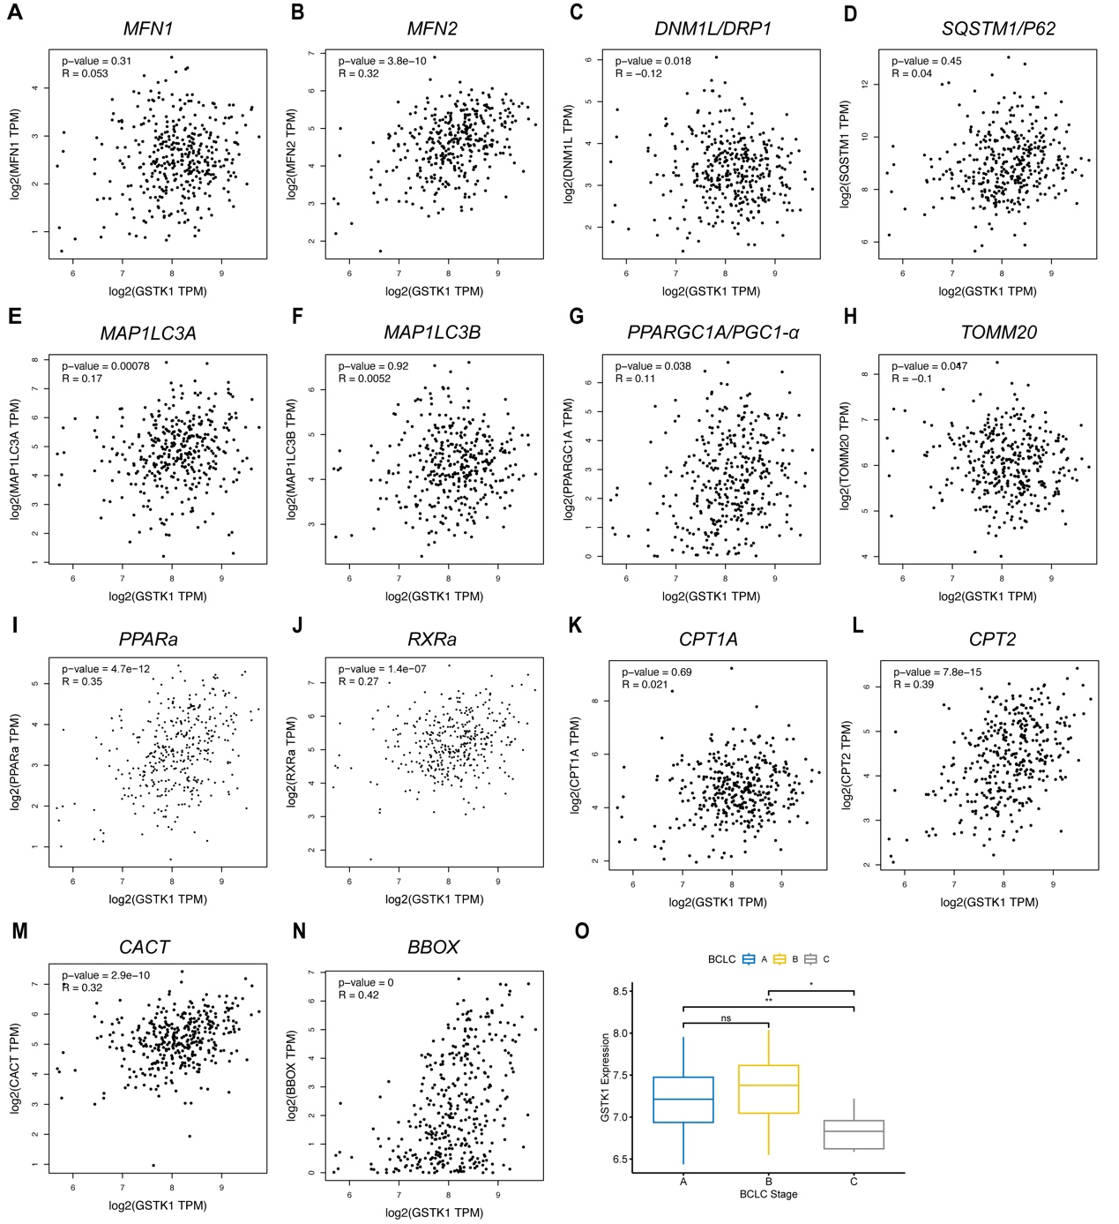
Figure S8. GSTK1 and MQC related or L-carnitine metabolism Related genes or PPARa/RXRa correlation in HCC patients analyzed by database GEPIA2. (A-N) Correlation between GSTK1 and MFN1 (A), MFN2 (B), DRP1 (C), P62 (D), MAP1LC3A (E), MAP1LC3B (F), PGC1-α (G), TOMM20 (H), PPARα (I), RXRα (J), CPT1A (K), CPT2 (L), CACT (M), BBOX (N) in HCC patients analyzed by database GEPIA2. (O) The correlation between GSTK1 expression and the BCLC staging of HCC patients (HCCDB8 cohort). n.s, no significance, * p< 0.05, ** p < 0.01
Table. S1. Correlation analysis between GSTK1 expression and clinical information of HCC patients(n=214)
Characteristic | Number | GSTK1 expression |  | P value
 |  | High | Low
Metastasis risk
High | 103(48.13%) | 25(23.58%) | 78(72.22%) | ＜0.001
Low | 111(51.87%) | 81(76.42%) | 30(27.78%)
Gender |  |  |  | 0.579
Femal | 28(13.08%) | 12(11.32%) | 16(14.81%)
Male | 186(86.92%) | 94(88.68%) | 92(85.19%)
Hepatitis B virus infection
AVR-CC | 55(25.7%) | 19(17.92%) | 36(33.33%) | 0.035
CC | 153(71.5%) | 84(79.25%) | 69(63.89%)
NA | 6(2.8%) | 3(2.83%) | 3(2.78%)
ALT
HIgh(>50U/L) | 87(40.65%) | 42(39.62%) | 45(41.67%) | 0.869
Low(<=50U/L) | 127(59.35%) | 64(60.38%) | 63(58.33%)
Tumor size
>5 cm | 76(35.51%) | 34(32.08%) | 42(38.89%) | 0.369
<=5 cm | 138(64.49%) | 72(67.92%) | 66(61.11%)
Multiple nodules
No | 169(78.97%) | 93(87.74%) | 76(70.37%) | 0.003
Yes | 45(21.03%) | 13(12.26%) | 32(29.63%)
Cirrhosis
No | 18(8.41%) | 11(10.38%) | 7(6.48%) | 0.435
Yes | 196(91.59%) | 95(89.62%) | 101(93.52%)
TNM staging
I | 89(41.59%) | 52(49.06%) | 37(34.26%) | 0.004
II | 77(35.98%) | 40(37.74%) | 37(34.26%)
III | 48(22.43%) | 14(13.21%) | 34(31.48%)
BCLC staging
0 | 20(9.35%) | 10(9.43%) | 10(9.26%) | 0.003
A | 143(66.82%) | 82(77.36%) | 61(56.48%)
B | 22(10.28%) | 5(4.72%) | 17(15.74%)
C | 29(13.55%) | 9(8.49%) | 20(18.52%)
CLIP staging
0 | 95(44.39%) | 69(65.09%) | 26(24.07%) | ＜0.001
1 | 71(33.18%) | 24(22.64%) | 47(43.52%)
2 | 35(16.36%) | 8(7.55%) | 27(25%)
3 | 9(4.21%) | 3(2.83%) | 6(5.56%)
4 | 3(1.4%) | 2(1.89%) | 1(0.93%)
5 | 1(0.47%) | 0(0%) | 1(0.93%)
AFP
High(>300ng/ml) | 96(44.86%) | 26(24.53%) | 70(64.81%) | ＜0.001
Low(<=300ng/ml) | 118(55.14%) | 80(75.47%) | 38(35.19%)
NA, not available; AVR-CC, active viral replication chronic carrier; CC, chronic carrier.

