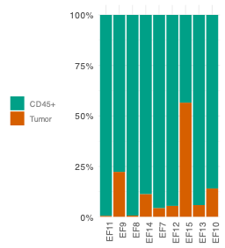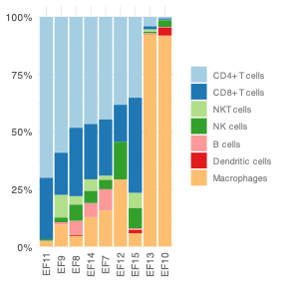
Fig. S1 Cellular composition of effusions used for T cell activation. Stacked bar charts show the proportion of tumor cells versus total CD45⁺ leukocytes, each bar scaled to 100% (n=9). The adjacent bars illustrate the immune subsets within the CD45⁺ compartment, up to 100%.
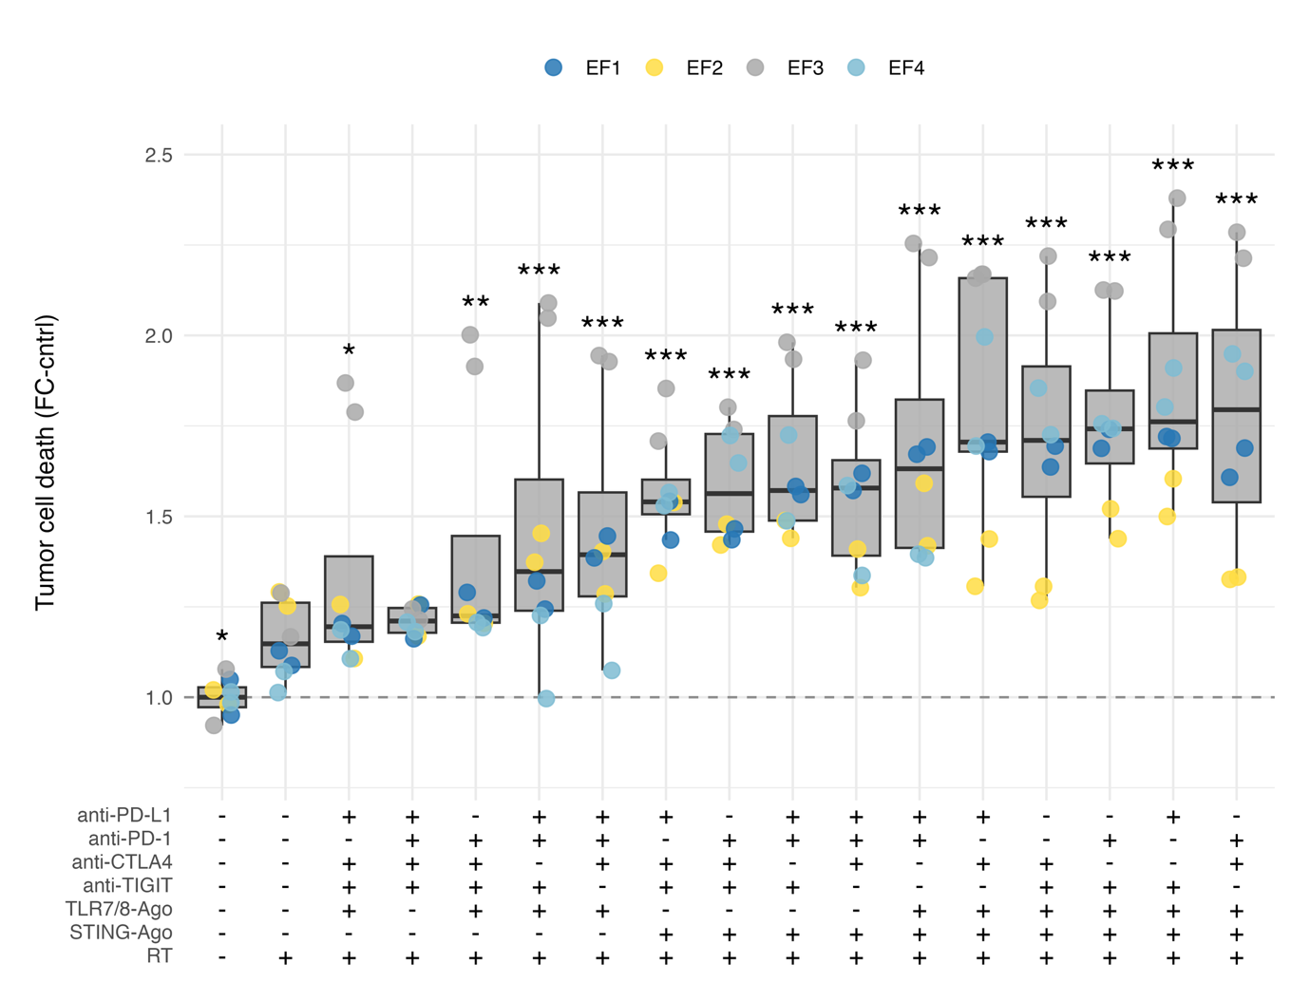 Fig. S2A Quadruple RT–IO screening shows differential efficacies in PATEC. Boxplots show tumor cell death (% Zombie Violet™+ tumor cells; fold change relative to matched cntrl (TuCntrl)) in PATEC (EF1–EF4, n = 4) after 72 h of treatment. Each box represents one unique RT–IO regimen. The matrix below the plot indicates which components were included (+) or absent (−) for each combination. Colored dots denote technical replicates. Boxes show median and IQR; whiskers 1.5×IQR. LMM; patient random intercept and replicate set nested within patient; Holm‑adjusted contrasts comparing each combination to RT alone (8 Gy). *p < 0.05; **p < 0.01; ***p < 0.001.
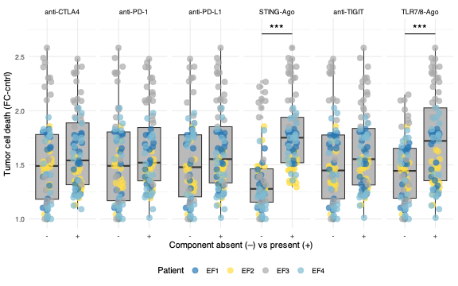
Fig. S2B Component-wise effects of RT–IO screening in PATEC. Boxplots show tumor cell death (fold change) comparing conditions in which the indicated immunotherapeutic component was absent (–) versus present (+) across the RT–IO screen in PATEC (EF1–EF4, n = 4). Colored dots denote technical replicates. Boxes show median and IQR; whiskers 1.5×IQR. Effect of component inclusion (present vs absent) from a multivariable LMM (FoldChange ~ CTLA4 + STING + TLR7/8 + PD L1 + PD 1 + TIGIT + RT + (1|patient)); Holm. *p < 0.05; **p < 0.01; ***p < 0.001.
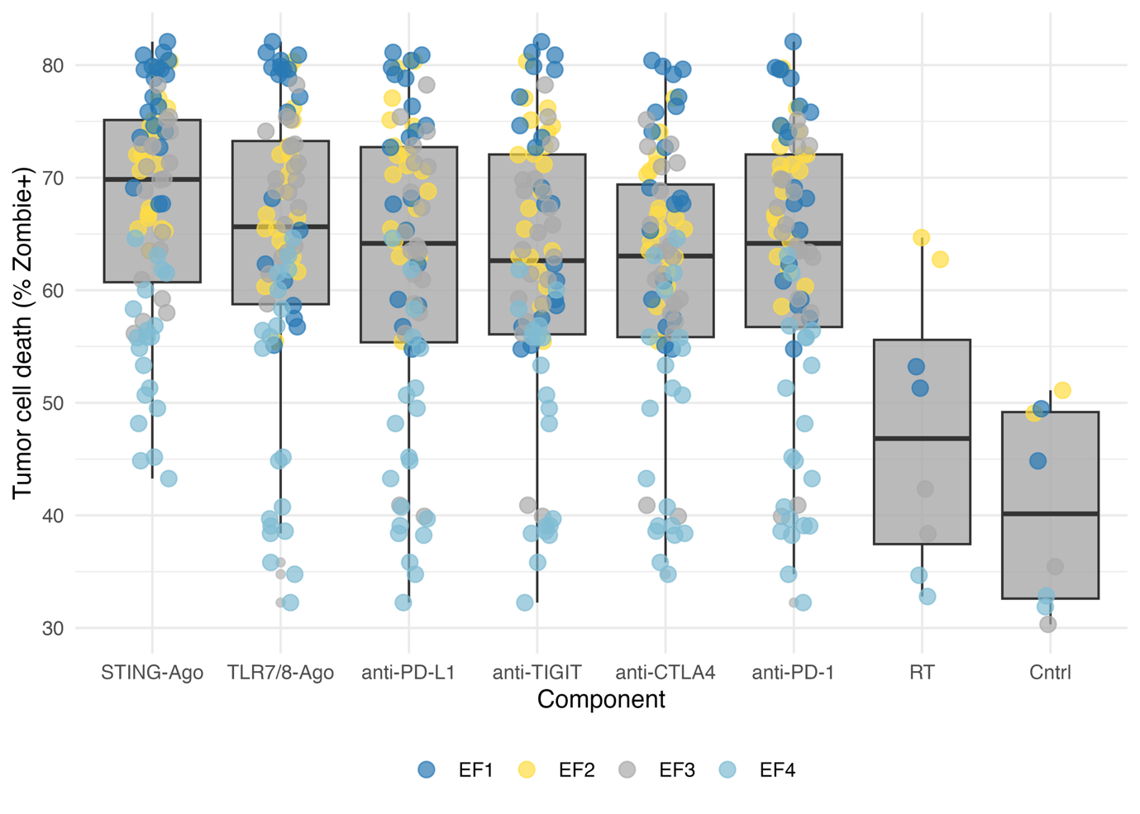 Fig. S2C Raw tumor cell death values across the quadruple RT–IO screen in PATEC. Boxplots show tumor cell death (% Zombie Violet™⁺ tumor cells) across the quadruple RT–IO screen in PATEC (EF1–EF4, n = 4), grouped by the indicated treatment component. Colored dots denote technical replicates, with colors indicating individual PATECs. Boxes indicate median and IQR; whiskers 1.5×IQR.

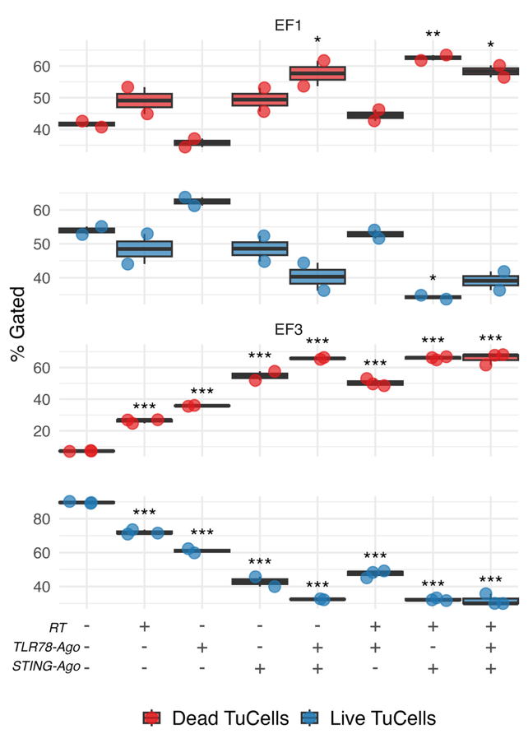
Fig. S2D Raw live and dead tumor cell fractions in representative PATECs treated with STING agonist, TLR7/8 agonist and RT-based combinations. Representative PATECs EF1 and EF3 were treated for 72 h with RT, STING-Ago, TLR7/8-Ago, or their combinations. Red boxplots show dead tumor cells and blue boxplots show live tumor cells, quantified by flow cytometry as % gated tumor cells. Dots indicate technical replicates. Boxes indicate median and IQR; whiskers 1.5×IQR.

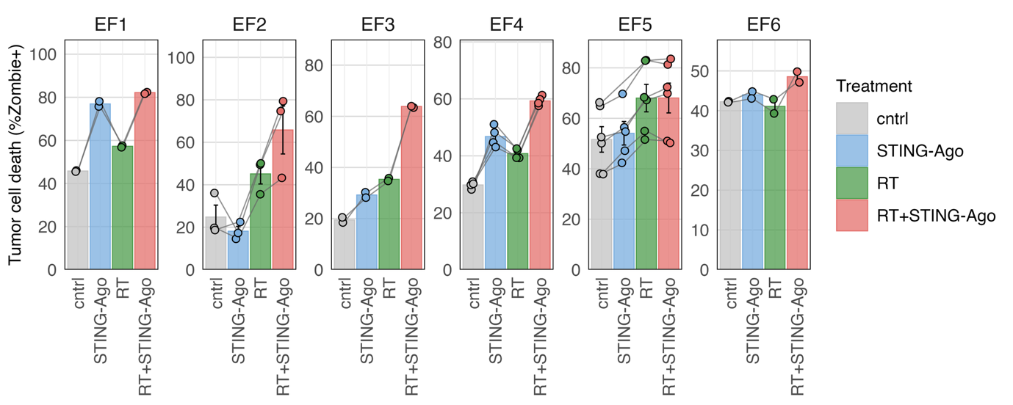
Fig. S3A Raw tumor cell death values in individual PATECs treated with STING agonist and RT. Bar plots show tumor cell death (% Zombie Violet™⁺ tumor cells) in PATECs EF1–EF6 after 72 h of treatment with cntrl, STING-Ago, RT, or RT + STING-Ago. Bars indicate mean values across biological replicates, and dots indicate individual replicates.

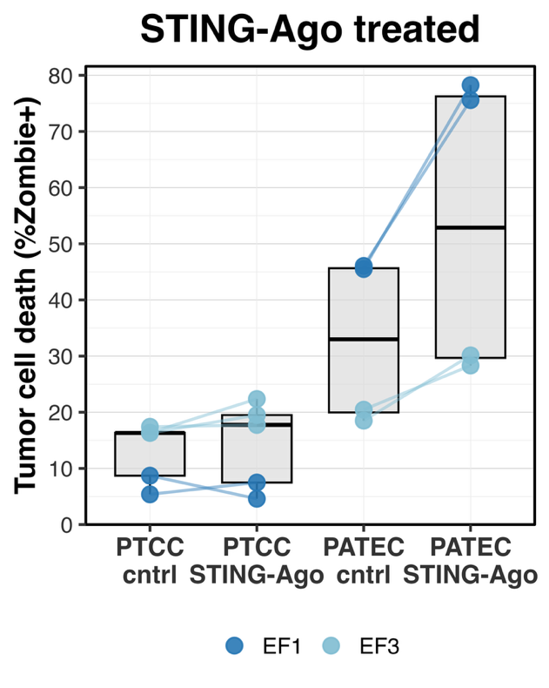
Fig. S3B Raw tumor cell death values in matched PTCC and PATEC after STING agonist treatment. Boxplots show tumor cell death (% Zombie Violet™⁺ tumor cells) at 72 h in primary tumor monocultures (PTCC) and matched autologous co-cultures (PATEC) under cntrl and STING-Ago conditions in EF1 and EF3. Colored dots denote individual replicates and lines connect matched samples. Boxes indicate median and IQR; whiskers 1.5×IQR.

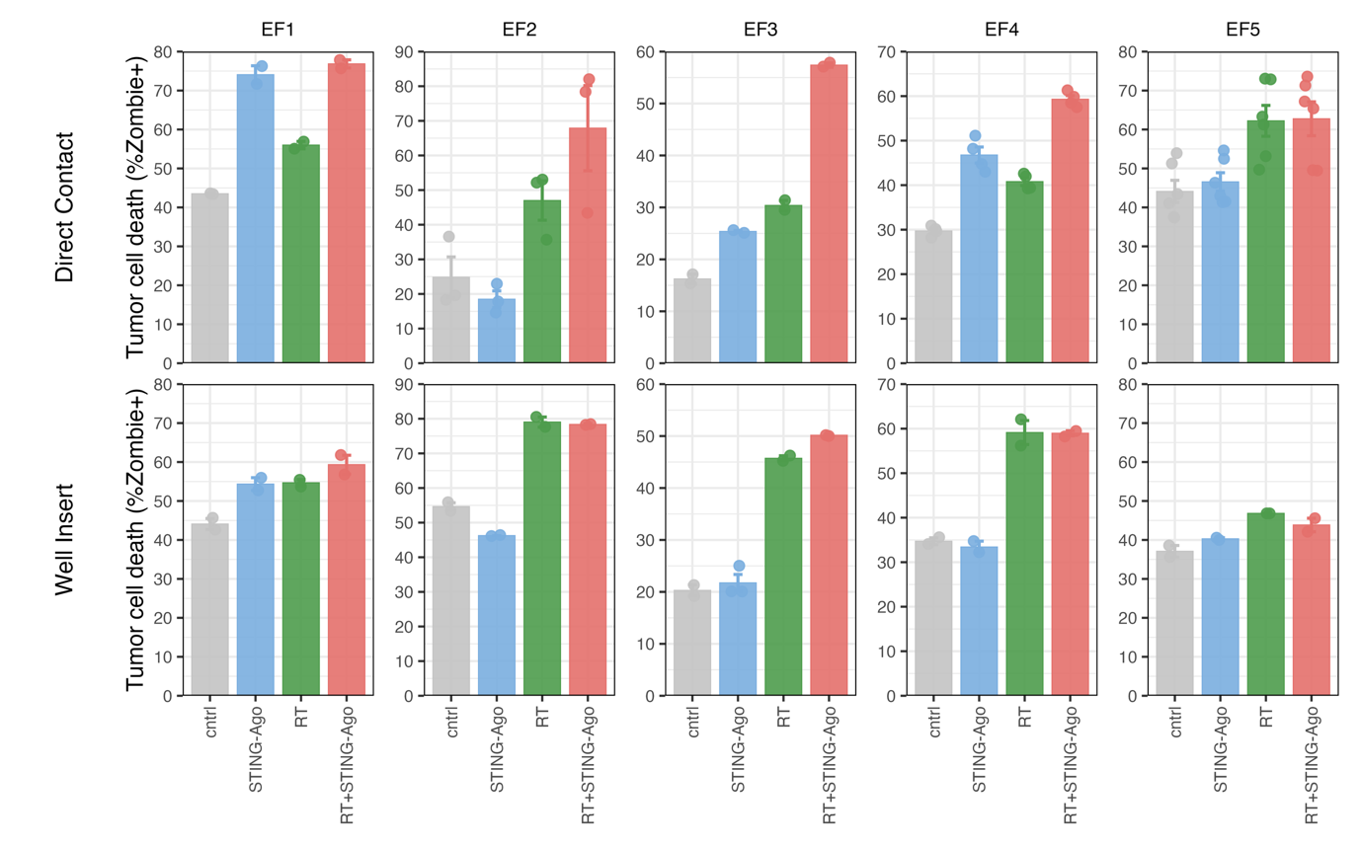
Fig. S4A Raw tumor cell death values in direct and insert-separated PATECs across treatment conditions. Bar plots show tumor cell death (% Zombie Violet™⁺ tumor cells) in PATECs EF1–EF5 after 72 h under direct co-culture or well insert separation with cntrl, STING-Ago, RT, or RT + STING-Ago. Bars indicate mean values across replicates and dots indicate individual technical replicates.
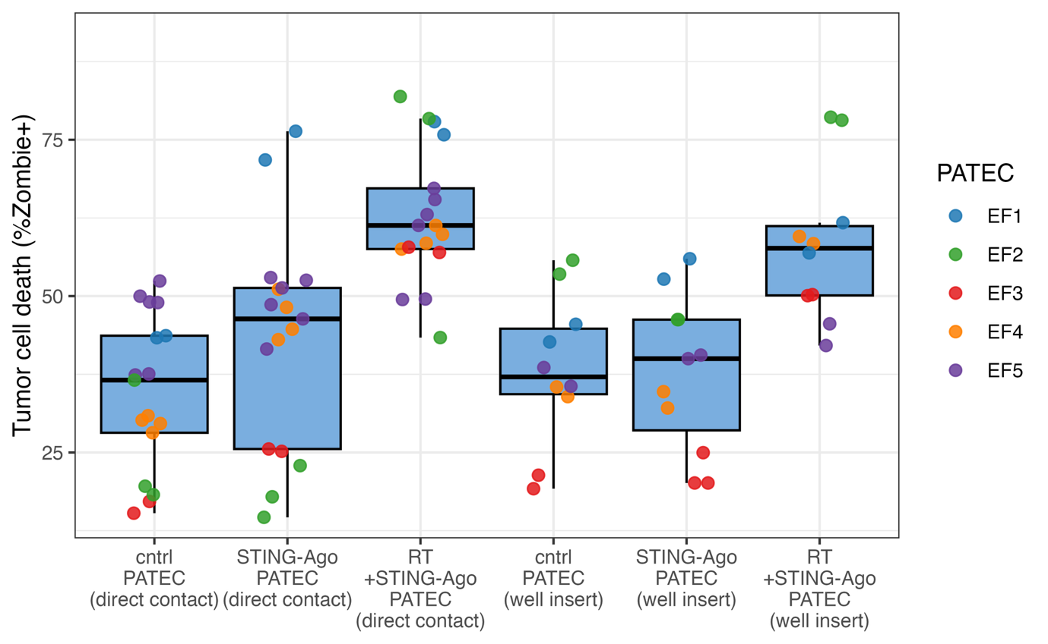
Fig. S4B Pooled raw tumor cell death values for direct versus insert-separated PATECs. Boxplots show tumor cell death (% Zombie Violet™⁺ tumor cells) across PATECs EF1–EF5 at 72 h for cntrl, STING-Ago, and RT + STING-Ago under direct contact and well insert conditions. Colored dots indicate individual PATECs. Boxes indicate median and IQR; whiskers 1.5×IQR.

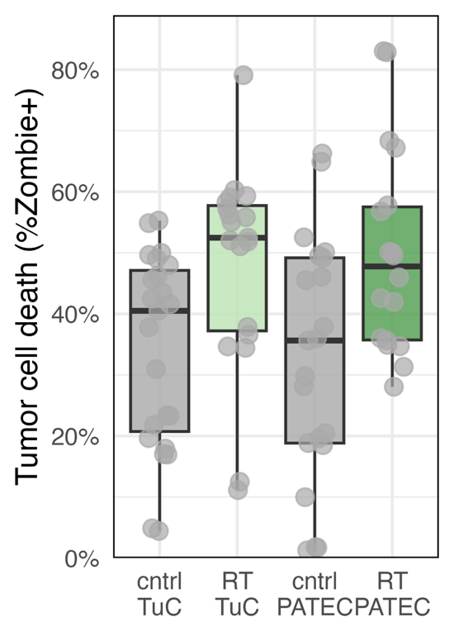
Fig. S4C Raw tumor cell death values in tumor monocultures and co-cultures after RT. Boxplots show tumor cell death (% Zombie Violet™⁺ tumor cells) at 72 h in untreated and RT-treated tumor cell monocultures (TuC) and matched direct PATECs (n = 5). Dots indicate replicates. Boxes indicate median and IQR; whiskers 1.5×IQR.

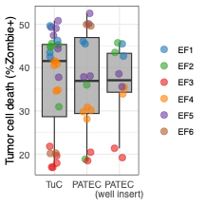
Fig. S4D Baseline tumor cell death in untreated tumor monocultures and co-culture configurations. Boxplots show tumor cell death (% Zombie Violet™⁺ tumor cells) at 72 h in untreated TuC, direct PATEC, and insert-separated PATEC (well) across EF1–EF6. Colored dots indicate individual PATECs. Boxes indicate median and IQR; whiskers 1.5×IQR.

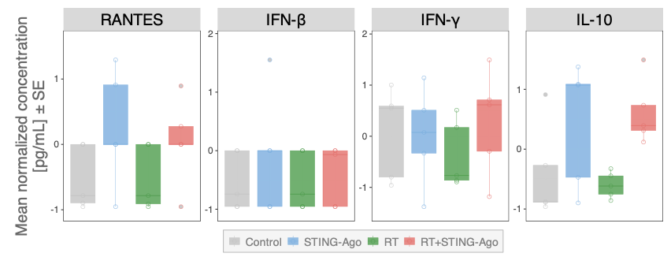
Fig. S5 Cytokines without consistent modulation after STING-Ago + RT. Malignant effusion cultures were treated ex vivo for 24 h with treatments (cntrl, STING-Ago, RT, RT + STING-Ago) and cytokine concentrations in supernatants were quantified using a Luminex® multiplex assay (n = 5 effusions). Boxplots show z-score-normalized mean concentrations for RANTES, IFN-β, IFN-γ and IL-10 across treatments. Boxes indicate median and IQR; whiskers 1.5×IQR; dots are means of replicates per effusion. Treatments: STING-Ago (10 µM ADU-S100), RT (8 Gy), RT + STING-Ago (8 Gy + 10 µM ADU-S100). Two-way ANOVA; Tukey’s multiple comparisons.

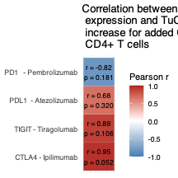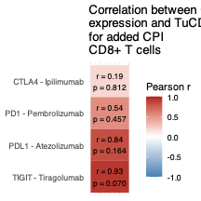
Fig. S6 Correlation between checkpoint induction after STING-Ago + RT and tumor cell death after STING-Ago + RT + CPI in CD8⁺ (left) and CD4⁺ (right) T cells. Heatmaps show Pearson correlation coefficients (r) between STING-Ago + RT –induced checkpoint expression and Δ tumor cell death for STING-Ago + RT + ICI in PATEC by adding the corresponding checkpoint inhibitor to STING-Ago + RT in the quadruple RT-IO experiment (EF1–EF4, n = 4 PATECs). For each antibody target pair (PD-1–Pembrolizumab, PD-L1/PD-1–Atezolizumab, TIGIT–Tiragolumab, CTLA-4–Ipilimumab), Δ tumor cell death is defined as the difference in tumor death fold change between wells containing that antibody and wells lacking it which definitely have treatments STING-Ago + RT. Checkpoint induction is quantified as log₂ fold change in the frequency of the corresponding checkpoint-positive CD8⁺ (left) or CD4⁺ (right) T cell subset at Day 3 in PATEC (STING-Ago+RT vs cntrl). Tile colors encode the strength and direction of Pearson r (red, positive; blue, negative; scale −1 to 1) and each tile is annotated with r and the corresponding P value (Holm-adjusted across checkpoints).

