Supplementary information

Reciprocal signaling-metabolic crosstalk between fibroblasts and tumor cells drives cetuximab tolerance in head and neck cancers

Engy Vigneron, Julie Vignau, Olivier Lowyck, Valentin Van den bossche, Jérôme Ambroise, Yann Kieffer, Fatima Mechta-Grigoriou, Isabella Rizzi, Maria Virginia Giolito, Manon Desgres, Hannah Zaryouh, An Wouters, Antonella Mendola, Hajar Dahou, Marine Leclerc, Romain Boidot, Aurélien Warnant, Yvan Larondelle, Olivier Feron, Jean-Pascal Machiels, Sandra Schmitz, and Cyril Corbet
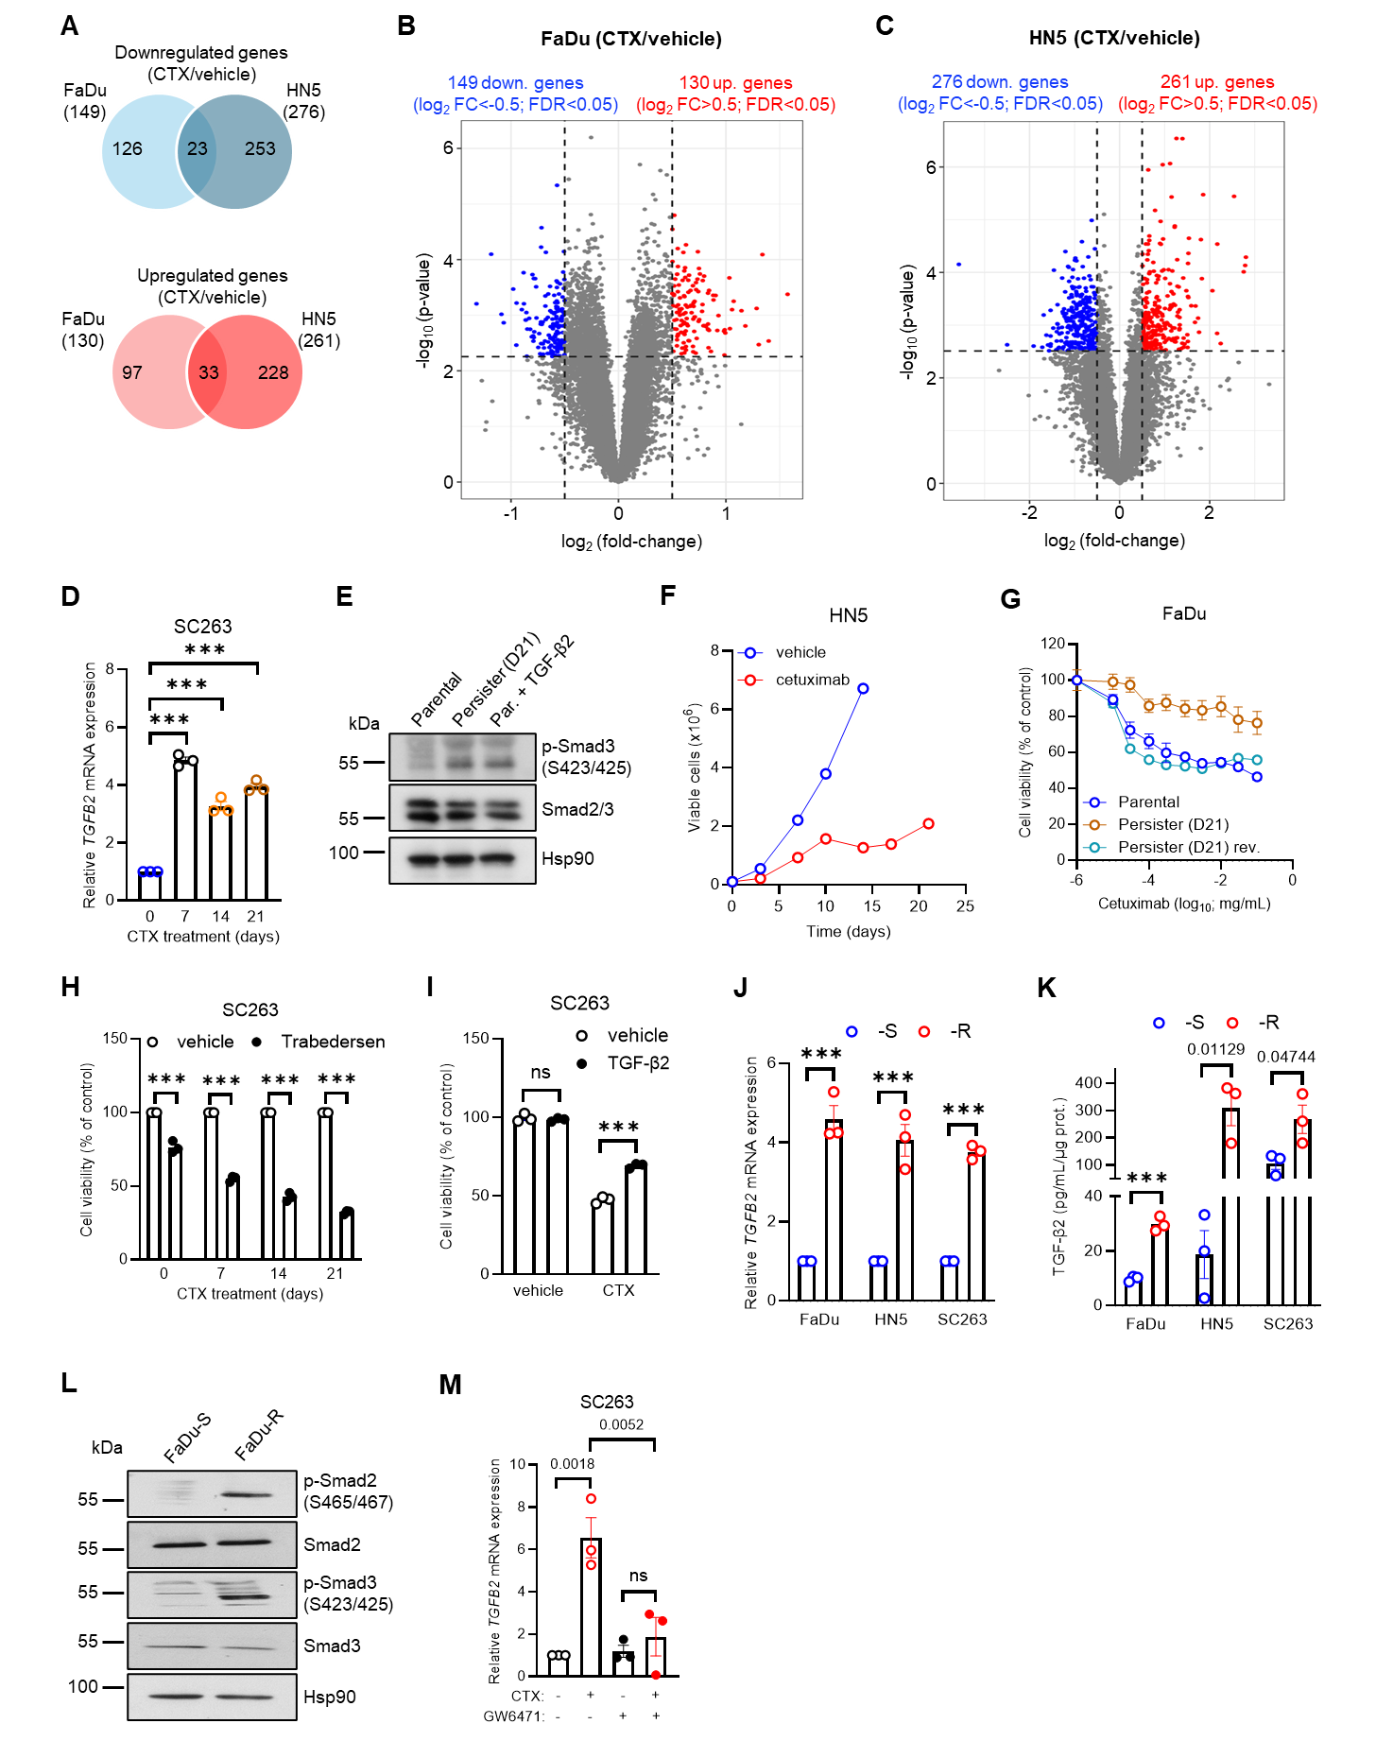
Supplementary Figure 1. Residual HNSCC cells upregulate TGF-β2 under anti-EGFR therapy. (A-C) Venn diagrams (A) and volcano plots (B-C) of differentially expressed genes in RNA-seq data (GSE306480) from FaDu and HN5 cells after treatment with 1 µg/mL cetuximab for 72 h (N=3). (D) mRNA expression levels of TGF-β2 in SC263 cells treated with 1 µg/mL cetuximab for 7, 14, and 21 days (N=3; n=3). (E) Representative immunoblots for phosphorylated and total forms of Smad3 in SC263 cells treated with 1 µg/mL cetuximab for 21 days or with 10 ng/mL TGF-β2 for 6 h (N=3). (F) Follow-up of viable cell number for HN5 cells treated with 1 µg/mL cetuximab up to 21 days. (G) Viability of parental and cetuximab-treated persister FaDu cells after treatment with 1 µg/mL cetuximab for 96 h (N=3). Persister cells were obtained after initial treatment with 1 µg/ml cetuximab for 21 days, and then followed or not with drug withdrawal for 7 days (reversal (rev.) condition). (H) Viability of SC263 cells after treatment with 1 µg/mL cetuximab for 7, 14, or 21 days, and then incubation with 10 µM Trabedersen for 7 days (N=3; n=6). (I) Viability of SC263 cells after treatment with 10 ng/mL TGF-β2 for 48h and then incubation with 1 µg/mL cetuximab for 96h (N=3; n=6). (J-K) mRNA expression (J) and active protein levels (K) for TGF-β2 in cetuximab-sensitive (-S) and -resistant (-R) HNSCC cells (N=3; n=3). (L) Representative immunoblots for phosphorylated and total forms of Smad2/3 in cetuximab-sensitive (-S) and -resistant (-R) FaDu cells (N=3). (M) mRNA expression levels of TGF-β2 in SC263 cells treated with 1 µg/mL cetuximab and 10 µM GW6471 for 72 h (N=3; n=3). Data are plotted as the means ± SEM (D, F-K, and M). N indicates the number of independent biological experiments and n indicates the number of technical replicates (when >1). Significance was determined by one-way ANOVA with Dunnett’s multiple comparison test (D and M), or two-way ANOVA with Sidák’s multiple comparison test (H-K). P-values as indicated or ***P<0.001; ns, not significant.

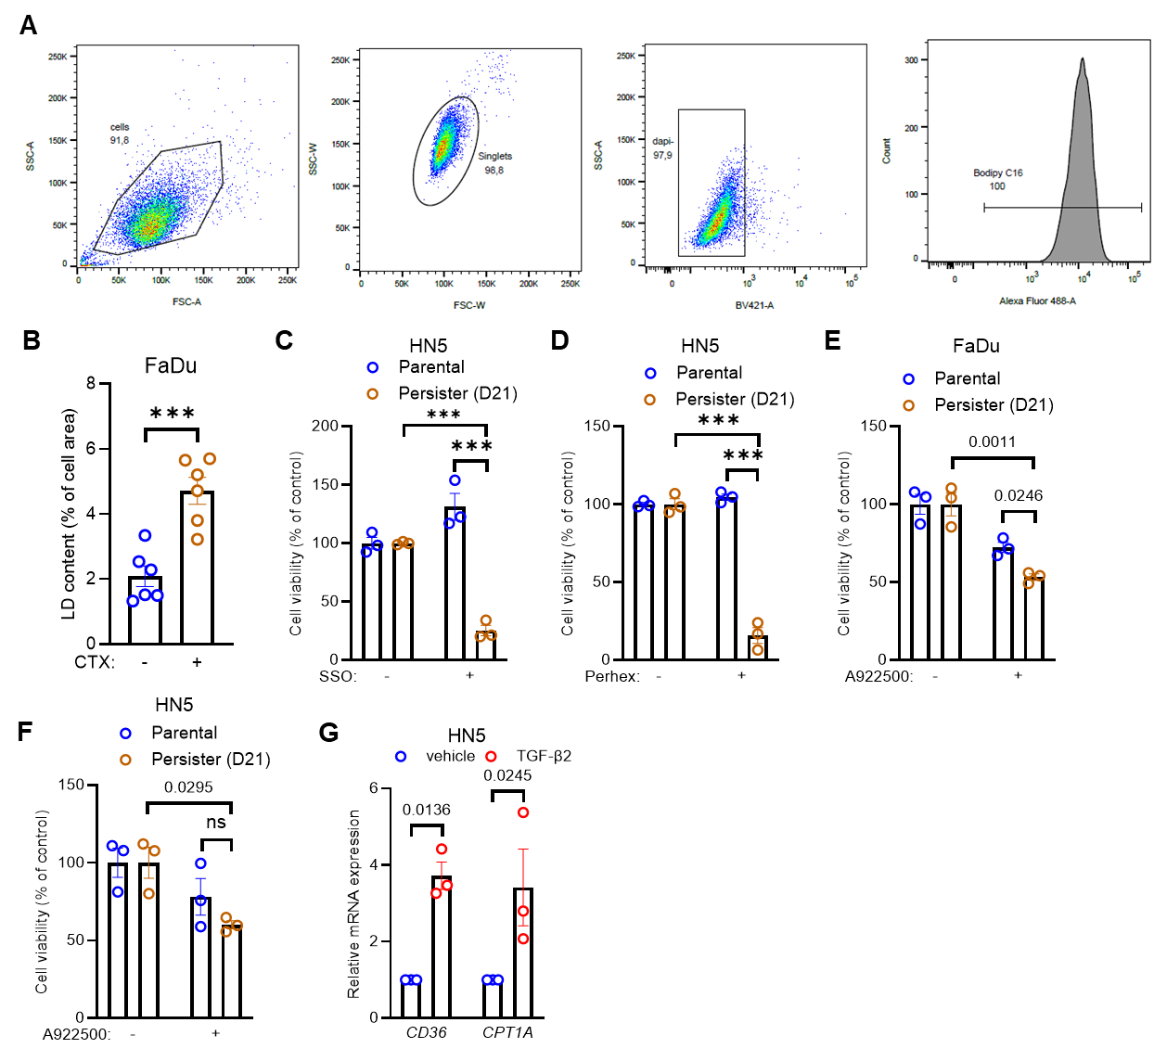
Supplementary Figure 2. Residual HNSCC cells display TGFβ2-dependent enhanced fatty acid metabolism upon anti-EGFR therapy. (A) Gating strategy for flow cytometry analysis of BODIPY-C16 detection (FITC channel) in live single cells (FaDu and HN5 cells, see Fig. 2E). (B) Lipid droplet content in FaDu cells treated or not with 1 µg/mL cetuximab for 21 days (N=6). (C-D) Viability of HN5 cells treated with 1 µg/mL cetuximab for 21 days, and then with 100 µM sulfo-N-succinimidyl oleate (SSO) (C) or 4 µM perhexiline maleate (D) for 96h (N=3; n=6). (E-F) Viability of FaDu (E) and HN5 (F) cells treated with 1 µg/mL cetuximab for 21 days, and then with 40 µM A922500 for 72h (N=3; n=6). (G) mRNA expression for CD36 and CPT1A in HN5 cells upon treatment with 10 ng/mL TGF-β2 for 48h (N=3; n=3). Data are plotted as the means ± SEM (B-G). N indicates the number of independent biological experiments and n indicates the number of technical replicates (when >1). Significance was determined by two-tailed unpaired Student’s t-test (B), and two-way ANOVA with Sidák’s multiple comparison test (C-G). P-values as indicated or ***P<0.001; ns, not significant.

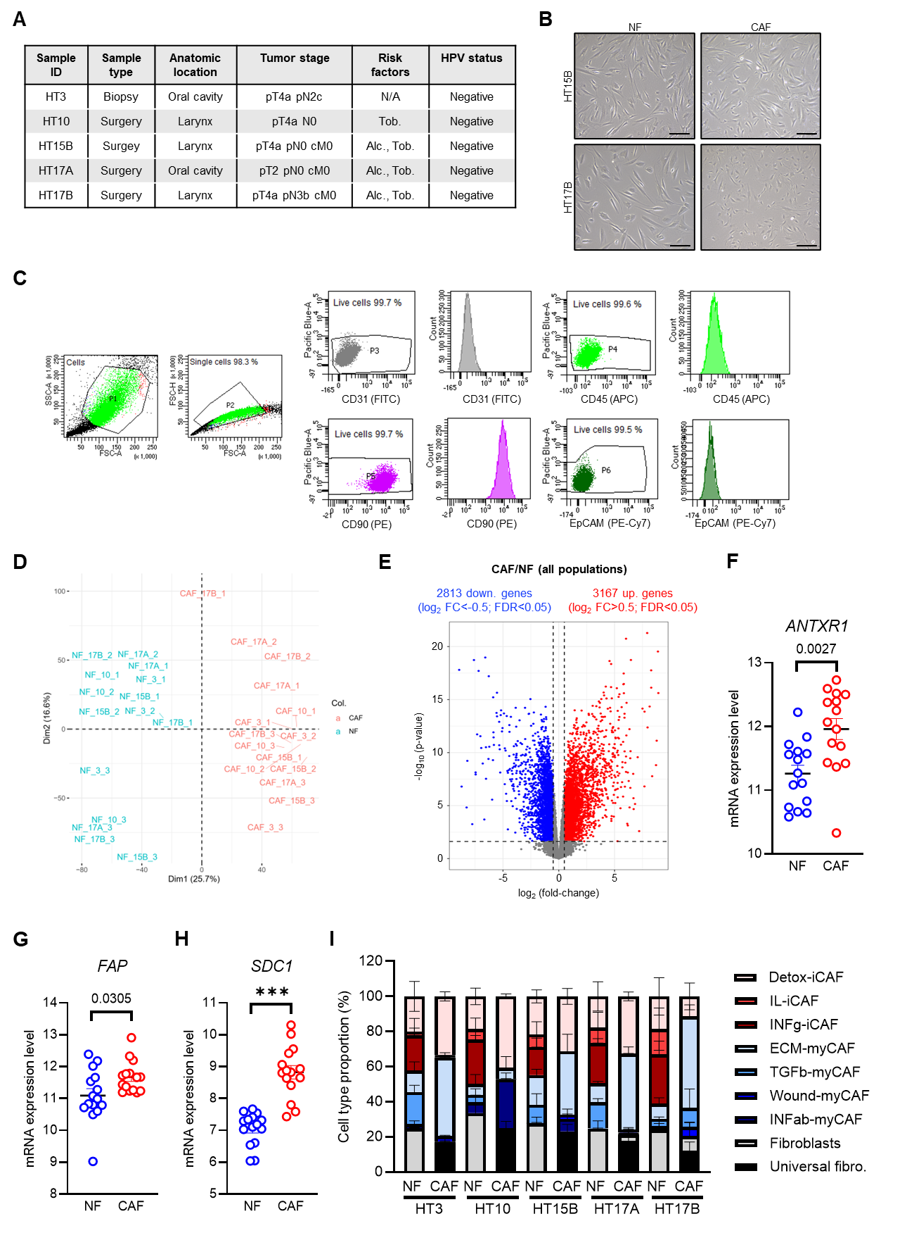
Supplementary Figure 3. TGFβ2-activated myofibroblastic CAFs support anti-EGFR therapy resistance in HNSCC. (A) Clinical data for tissue donor HNSCC patients from whom CAF and NF populations were derived. (B) Representative brightfield images of CAFs and NFs (HT15B and HT17B models). Scale bar: 100 µm. (C) Gating strategy for flow cytometry analysis of CD31, CD45, CD90, and EpCAM detection in live single cells (NFs and CAFs). (D-E) Principal component analysis plot (D) and volcano plot of differentially expressed genes (E) in RNA-seq data (GSE303690) from HNSCC patient-derived NFs and CAFs (N=3). (F-H) Expression levels for ANTXR1 (F), FAP (G), and SDC1 (H) genes in HNSCC-derived NFs and CAFs (N=3). (I) Inferred proportion, after RNA-seq deconvolution, of gene expression-based fibroblast subpopulations in HNSCC-derived CAF and NF cell populations (N=3). Data are plotted as the means ± SEM (F-I). N indicates the number of independent biological experiments and n indicates the number of technical replicates (when >1). Significance was determined by two-tailed unpaired Student’s t-test (F-H). P-values as indicated or ***P<0.001.

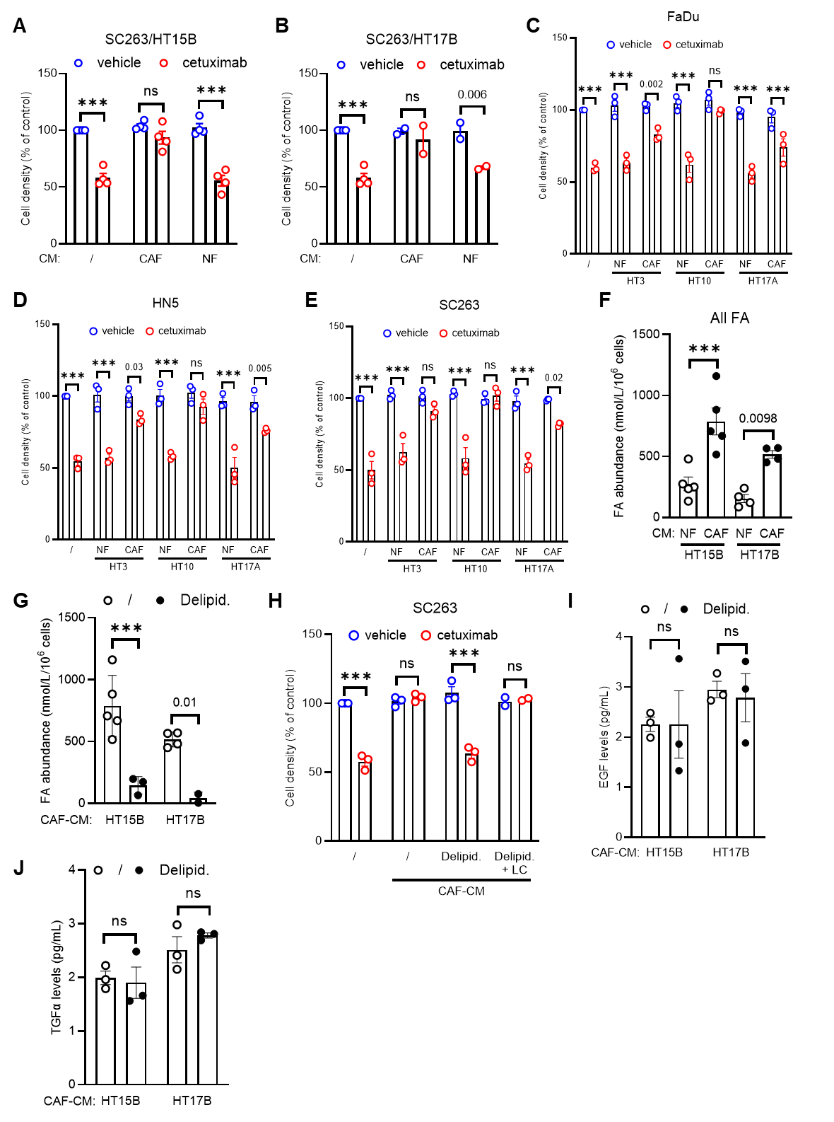
Supplementary Figure 4. myCAFs act as FA providers to support anti-EGFR therapy resistance in HNSCC. (A-B) Viability of SC263 cells after treatment with 1 µg/mL cetuximab for 72h, in presence of conditioned medium (CM; 50% final volume) from NFs or CAFs; HT15B (A) and HT17B (B) models (N=3; n=6). (C-E) Viability of FaDu (C), HN5 (D), and SC263 cells (E) after treatment with 1 µg/mL cetuximab for 72h, in presence of conditioned medium (CM; 50% final volume) from NFs or CAFs (HT3, HT10, and HT17A models) (N=3; n=6). (F) Fatty acid abundance in conditioned medium from NFs or CAFs (HT15B and HT17B models) (N=4-5). (G) Fatty acid abundance in conditioned medium from NFs or CAFs (HT15B model) upon silica-based delipidation (N=2-5). (H) Viability of SC263 cells after treatment with 1 µg/mL cetuximab for 72h, in presence of CAF-CM (50% final volume; HT15B model) upon delipidation, with or without supplementation with chemically defined lipid concentrate (LC) (N=2-3; n=6). (I-J) Levels of EGF (I) and TGFα (J) in conditioned medium from NFs or CAFs (HT15B and HT17B models) upon silica-based delipidation (N=3). Data are plotted as the means ± SEM (A-J). N indicates the number of independent biological experiments and n indicates the number of technical replicates (when >1). Significance was determined by two-way ANOVA with Sidák’s multiple comparison test (A-E, and G-J), or one-way ANOVA with Dunnett’s multiple comparison test (F). P-values as indicated or ***P<0.001; ns, not significant.

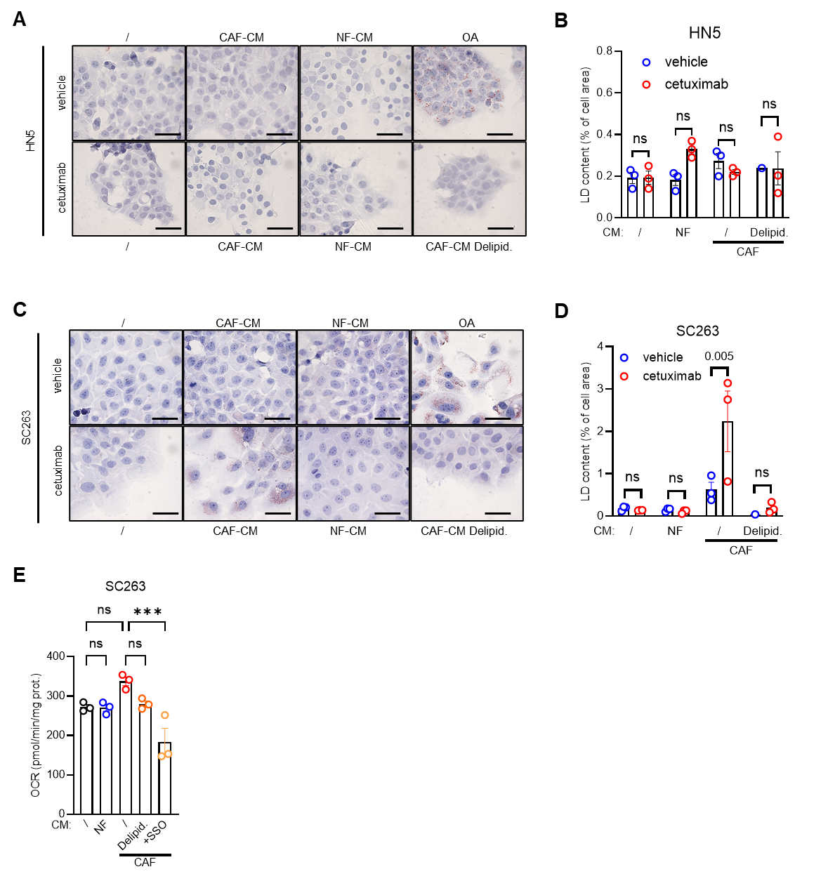
Supplementary Figure 5. myCAF-derived FA support bioenergetic needs and EGFR signaling in HNSCC cells. (A-D) Representative brightfield pictures (A, C) and quantification (B, D) of ORO-stained lipid droplets (LD) in HN5 (A-B) and SC263 cells (C-D) treated with 1 µg/mL cetuximab for 72 h in presence or not of (delipidated) conditioned medium from NFs and CAFs (HT15B model). Treatment with 50 µM BSA-conjugated oleic acid (OA) was used as positive control (N=3). (E) Basal oxygen consumption rate (OCR) in SC263 cells treated with (delipidated) conditioned medium from NFs and CAFs, in presence or not of 10 µM SSO (N=3; n=6). Data are plotted as the means ± SEM (B and D-E). N indicates the number of independent biological experiments and n indicates the number of technical replicates (when >1). Significance was determined by two-way ANOVA with Sidák’s multiple comparison test (B and D), or one-way ANOVA with Dunnett’s multiple comparison test (E). P-values as indicated or ***P<0.001; ns, not significant.
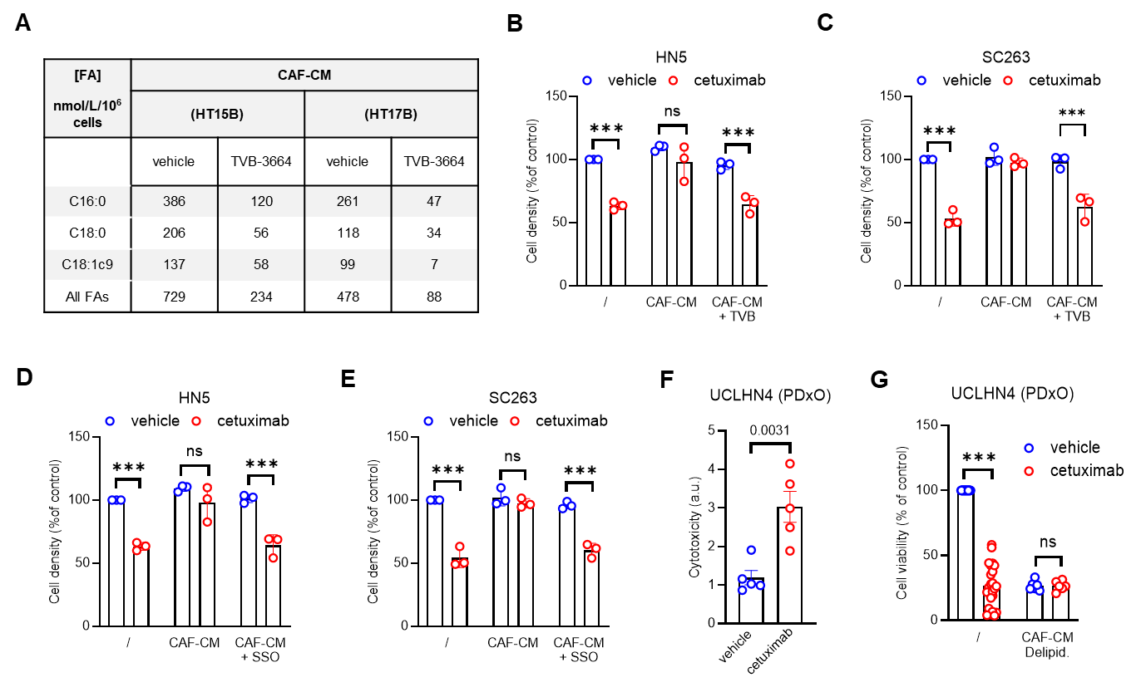
Supplementary Figure 6. Therapeutic targeting of tumor/stroma metabolic crosstalk impairs cetuximab resistance in HNSCC cells. (A) Fatty acid abundance in conditioned medium from CAFs (HT15B model) treated or not with 10 µM TVB-3664 for 72 h (N=2-3). (B-E) Viability of HN5 and SC263 cells upon treatment with 1 µg/mL cetuximab in presence or not of conditioned medium from CAFs (HT15B model) pre-treated or not with 10 µM TVB-3664 (B-C) or 100 µM SSO (D-E) for 72 h (N=3; n=6). (F) Cell death levels in PDX-derived HNSCC organoids (UCLHN4 model) upon treatment with 2 µg/mL cetuximab for 2 weeks. (G) Viability of PDX-derived HNSCC organoids (UCLHN4 model) upon treatment with 2 µg/mL cetuximab in presence or not of delipidated CAF-CM (HT15B model) for 2 weeks (N=6). Data are plotted as the means ± SEM (B-G). N indicates the number of independent biological experiments and n indicates the number of technical replicates (when >1). Significance was determined by two-way ANOVA with Sidák’s multiple comparison test (B-G). P-values as indicated or ***P<0.001; ns, not significant.

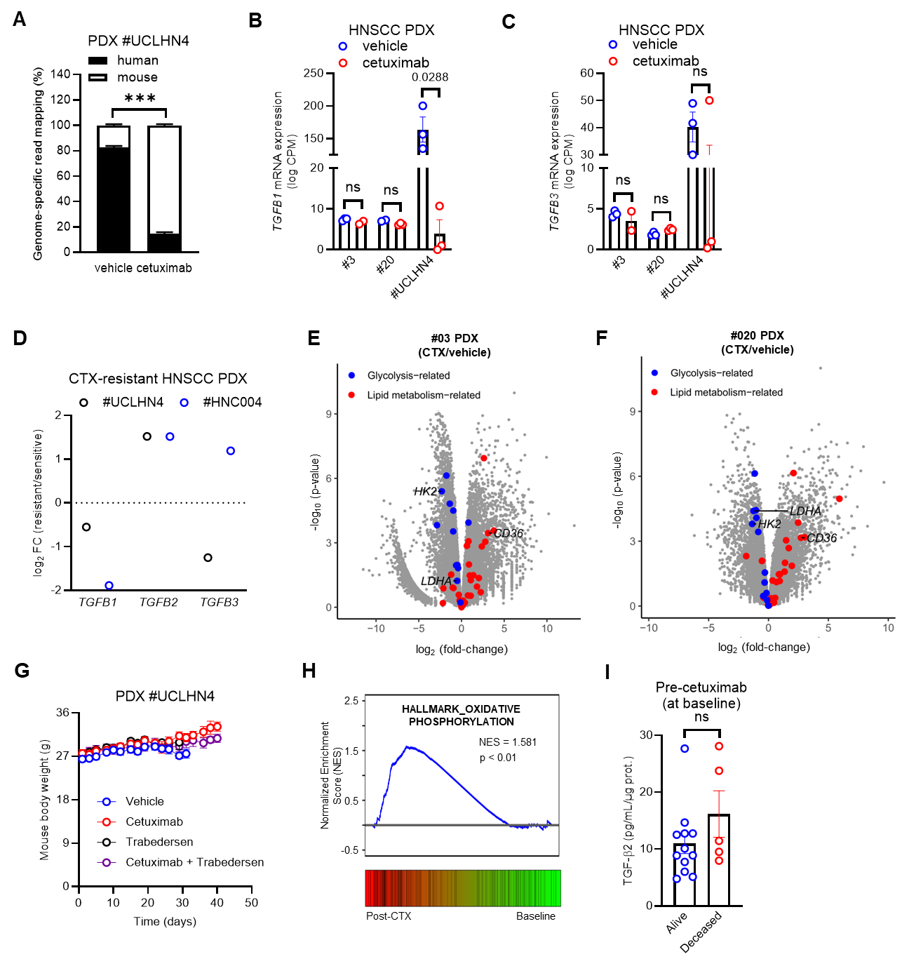
Supplementary Figure 7. TGFβ2-dependent tumor-stroma metabolic crosstalk correlates with cetuximab tolerance in patient-derived HNSCC models. (A) Proportion of read mapping to human or mouse genomes in RNA-seq data (GSE303798) from vehicle- and cetuximab-treated UCLHN4 PDX tissues (N=5-6). (B-C) mRNA expression levels of TGFB1 (B) and TGFB3 (C) in cetuximab-treated UCLHN4, #03 and #20 PDX models (N=3) (GSE303798 and GSE143279). (D) Relative mRNA expression (log₂ fold-change) of TGFB1, TGFB2 and TGFB3 in cetuximab-resistant UCLHN4 and HNC004 PDX models (N=3) (GSE235417 and GSE307896). (E-F) Volcano plots depicting an enrichment for lipid metabolism-related genes in cetuximab-treated #03 (E) and #020 (F) PDX models (GSE142379) (N=3). (G) Body weight follow-up for UCLHN4 PDX-bearing nude mice treated with 30 mg/kg cetuximab, 50 mg/kg Trabedersen (for the first dose and then 16 mg/kg), alone or in combination. (H) GSEA plot of the OXPHOS-related gene signature in tiling array expression data (GSE109756) from cetuximab-treated HNSCC patients (post-cetuximab vs baseline) (N = 15). (I) Pre-cetuximab (baseline) TGF-β2 levels in plasma from HNSCC patients (alive or deceased after surgery) (N=15). Data are plotted as the means ± SEM (A-C, G and I). N indicates the number of independent biological experiments and n indicates the number of technical replicates (when >1). Significance was determined by two-way ANOVA with Sidák’s multiple comparison test (A-C), or two-tailed unpaired Student’s t-test (I). P-values as indicated or ***P<0.001; ns, not significant.

Supplementary Table 1. Sequences of human gene-specific primers for qRT-PCR used in this study.

Gene name | Forward primer (5’ - 3’) | Reverse primer (5’ - 3’) | Amplicon length (bp)
CD36 | GGGAAAGTCACTGCGACATG | TGCAATACCTGGCTTTTCTCA | 79
CPT1A | ATGTACGCCAAGATCGACCC | GACATGCAGTTGGCCGTTTC | 77
GTF2B | ACTACAGAGCCGGTGATATGAT | GTTGCTTTGTCATTGCTGAAAGT | 106
TGFB2 | TGTCCCTGCTGCACTTTTGTA | GGTGCCATCAATACCTGCAAATC | 93

