Cell Culture Conditions
All human and murine BRAF^{V600E}-mutant malignant melanoma cells were cultured in DMEM (4,5g/L of glucose), 10% Fetal bovine serum (FBS), penicillin-streptomycin and fungizone amphotericin B at 37 °C and 5% CO₂ (Barceló et al. 2020). Generation of Vemurafenib-resistant cell lines was performed as previously described (Barceló et al., 2020). Briefly, Vemurafenib-sensitive melanoma cells were exposed to BRAFi Vemurafenib (PLX4032) for up to approximately 3 months until stable resistant populations were obtained. During the selection period, cells were cultured in the presence of Vemurafenib 5 µM, with fresh drug-containing medium replaced every 3 days.
Following acquisition of stable resistance, resistant cell lines were continuously maintained in the presence of vemurafenib to preserve the resistant phenotype. Human resistant melanoma cells were maintained in 1 µM vemurafenib, whereas murine resistant melanoma cells were maintained in 2 µM vemurafenib. These maintenance concentrations were established internally and validated by periodic IC₅₀ determination of each resistant model.

Human cytokine array
Conditioned media (CM) from M3 and M3R cells were incubated in Human Cytokine Antibody Array G-Series 3 (RayBiotech) following the manufacturer’s protocol. Briefly, chips were incubated with a biotinylated detection antibody cocktail, with HRP-conjugated streptavidin and with detection buffers. Glass chip scanning was performed with a laser scanner (Innopsys’ InnoScan®) using cy3 or “green” channel (excitation frequency=532 nm). Results were analyzed with The RayBio® Analysis Tool software.
Cytokine array data were obtained from two independent biological replicates (n = 2), each analysed in technical duplicate; technical duplicates were averaged prior to analysis. Log2-transformed values were compared using paired one-tailed Student's t-tests for the prespecified directional hypothesis M3R > M3. The hypothesis and choice of one-tailed testing were specified before inspection of the array results, reflecting the aim of prioritizing increased secreted factors for downstream functional testing. Decreases could be biologically relevant but would not support this increased-factor hypothesis. Given n = 2 and the number of cytokines examined, the displayed p-values are nominal and unadjusted, and the array is interpreted as exploratory rather than confirmatory. M-CSF was investigated further by ELISA in independent murine conditioned-media and mouse plasma samples (Figure 6a) and by functional blockade in human conditioned-media macrophage assays (Figure 6f–h).

Statistical analysis of the cytokine array
To provide the complete quantitative data supporting Figure 1a, the normalized cytokine array measurements and corresponding statistical analyses are presented in Supplementary Table S1. For each cytokine, the table includes the mean normalized optical density (OD) values obtained from parental (M3) and BRAFi-resistant (M3R) melanoma cells, the calculated log2 fold change (log2FC), and the nominal, unadjusted one-tailed p-value. Cytokines are grouped according to the manufacturer's classification (Inflammatory and Immunomodulatory). Statistical comparisons used the prespecified paired one-tailed Student's t-test (M3R > M3). Labels indicating P < 0.05 identify nominal thresholds under this directional test and do not represent multiplicity-adjusted or confirmatory significance.
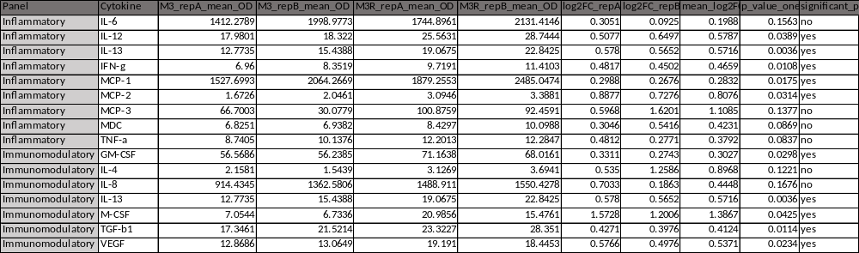
Supplementary Table S1. Quantitative analysis of the cytokine array shown in Figure 1a. Mean normalized optical density (OD) values obtained from two independent biological replicates (n=2), each analysed in technical duplicate, of parental (M3) and BRAFi-resistant (M3R) melanoma cells are presented for each cytokine. Fold changes are expressed as log2 fold change (log2FC) between M3R and M3. Nominal p-values were calculated using prespecified paired one-tailed Student's t-tests (M3R > M3). The last-column annotations identify nominal P < 0.05 under that test; they do not establish confirmatory significance or account for multiple testing. The array is an exploratory screen.

Source Western Blot Images
Source Western blot images corresponding to the representative Western blots in Figure 2g are provided below. Expected molecular weights are annotated and the selected parental and resistant lanes are identified. The parental 5555 cells (P) and BRAFi-resistant 5555R cells (R) used for densitometry quantification are indicated.

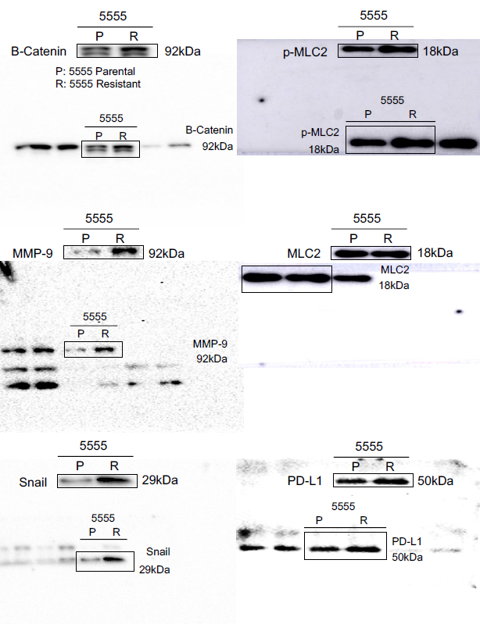
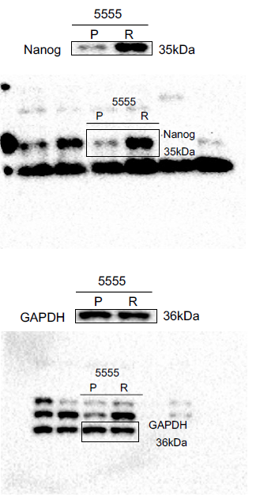

Supplementary Western blot source images corresponding to Figure 2g. Source images for β-catenin, MMP-9, Snail, p-MLC2, MLC2, PD-L1, Nanog and GAPDH are shown. Parental 5555 cells (P) and BRAFi-resistant 5555R cells (R) are indicated. Expected molecular weights are annotated. The lanes corresponding to P and R were used for densitometry quantification presented in Figure 2g and Figure S2h.

